CUSTOMER SENTIMENT ANALYSIS
NLP Analysis, Model Comparison & Evaluation Report
Practical Exam Project

1. Project Overview
The project analyzes customer review text and predicts its sentiment. The target labels in the original dataset are positive, negative, neutral, and mixed. The comparison experiment evaluates four approaches: Bag-of-Words (BoW), TF-IDF, Word2Vec, and a rule-based sentiment classifier.

2. Dataset Overview and Exploratory Data Analysis
The EDA notebook reports 600 rows and 10 columns. The text field used for sentiment prediction is review_text, and sentiment is the target. The notebook reports no missing values and zero duplicate rows. Review dates range from 4 January 2025 to 13 October 2026.
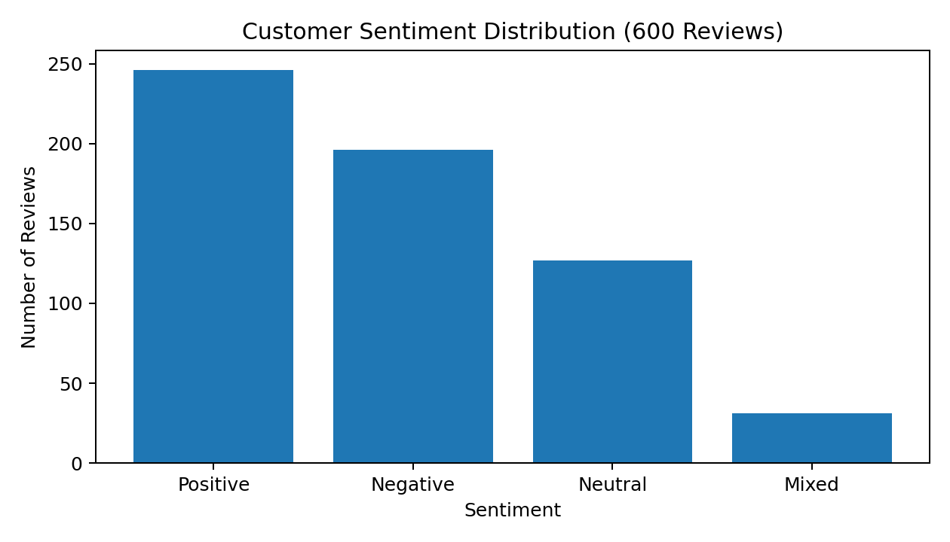
The sentiment distribution is imbalanced: positive reviews are most frequent (246), followed by negative (196), neutral (127), and mixed (31). Mixed reviews form the smallest class and may be harder for a classifier to learn.

3. Data Preparation and Analysis Notes
- The notebook preserves the original dataset and performs analysis on a separate copy.
- Missing-value and duplicate checks found no records requiring removal.
- The review_date column was converted to datetime for date-range analysis.
- The review text is the model input; sentiment is the prediction target.
- The EDA notes class imbalance but does not apply oversampling at this stage.

4. Models Compared
- Bag-of-Words (BoW): Represents a review using word occurrence/count features.
- TF-IDF: Weights words according to their importance across the review collection.
- Word2Vec: Represents words as learned dense vectors and uses document-level vectors for classification.
- Rule-Based: Uses predefined positive and negative word lists, calculates sentiment scores, handles negation, and predicts positive, negative, or neutral.

5. Model Comparison and Evaluation Metrics
The comparison script evaluates all four approaches on the same reported test set of 60 customer reviews. Accuracy is the proportion of correct predictions. Macro F1 is the unweighted average of the F1-score across classes, giving each class equal importance.
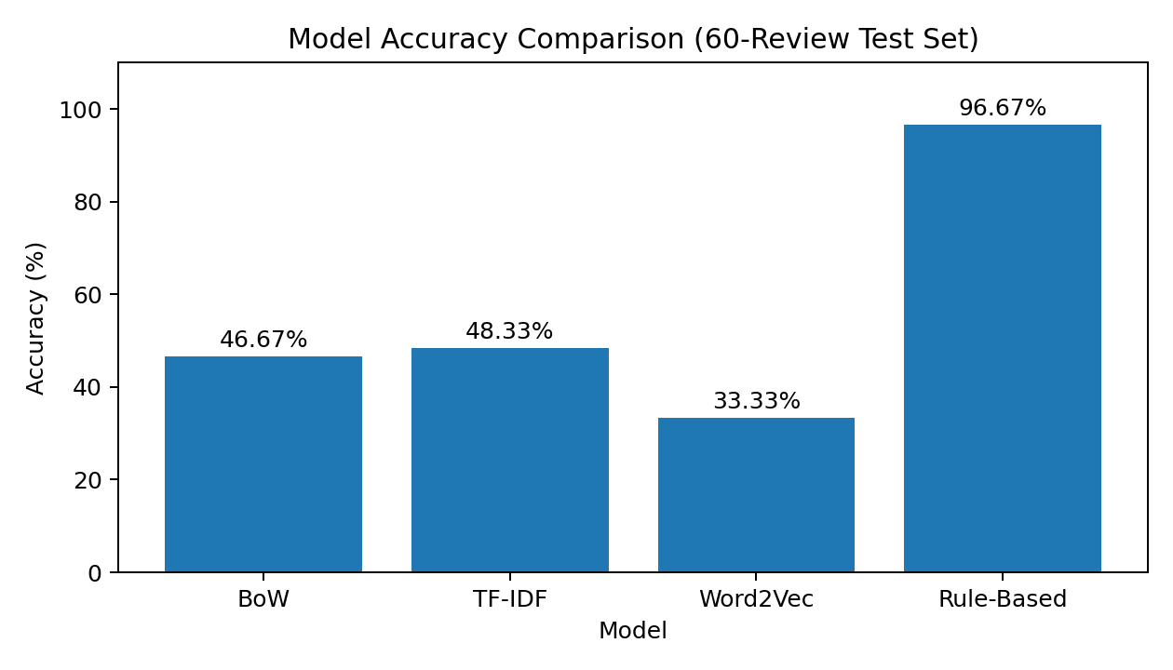
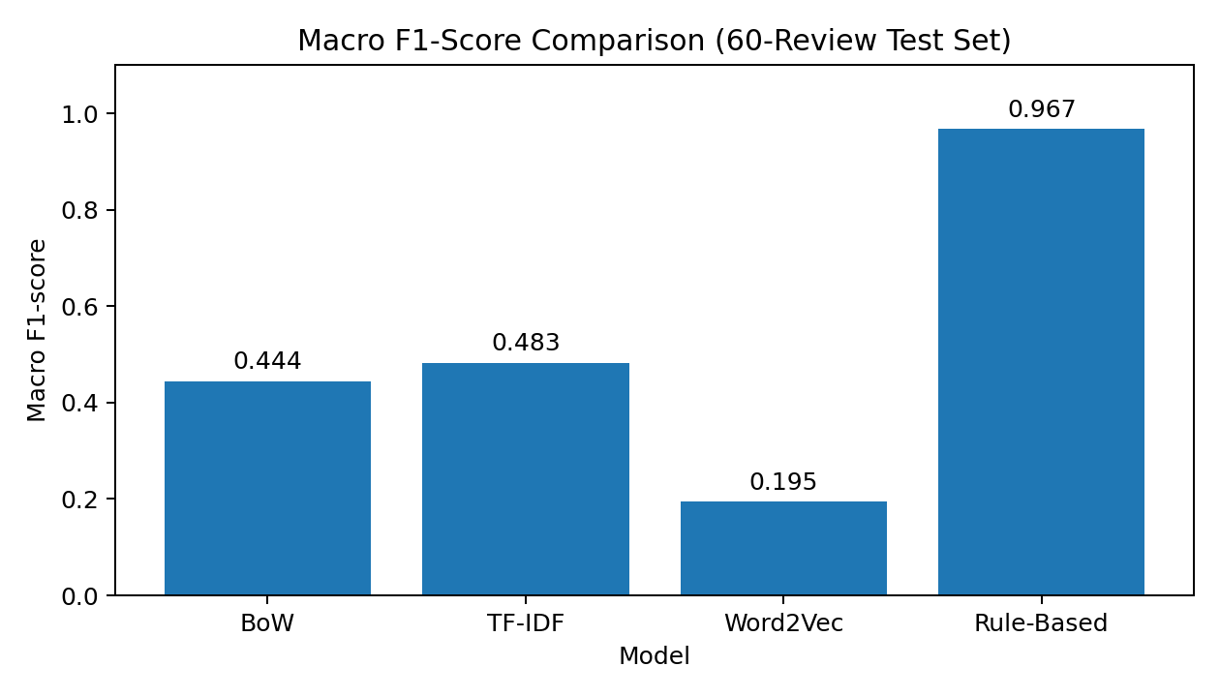
Model | Correct / 60 | Accuracy | Macro F1
BoW | 28 / 60 | 46.67% | 0.444
TF-IDF | 29 / 60 | 48.33% | 0.483
Word2Vec | 20 / 60 | 33.33% | 0.195
Rule-Based | 58 / 60 | 96.67% | 0.967
On this 60-review comparison set, the rule-based approach achieved the highest reported accuracy and macro F1-score, correctly classifying 58 of 60 reviews. TF-IDF slightly outperformed BoW, while Word2Vec had the lowest scores in this experiment.

6. Error Analysis
The rule-based classifier made 2 incorrect predictions out of 60. The uploaded comparison script calculates whether each prediction is correct, but it does not print or save the specific misclassified review rows. Therefore, exact error examples and their individual causes cannot be confirmed from the supplied files.
Likely limitations to investigate when reviewing those two errors:
- Context and mixed opinions: a review can contain both positive and negative statements.
- Negation scope: a negation word may affect more than the nearby word, or the rule window may not capture the intended meaning.
- Sarcasm and implicit sentiment: word matching may miss the real meaning when the wording is ironic or indirect.
- Vocabulary coverage: words absent from the predefined positive/negative lists may not contribute to the correct score.
For a complete error analysis, export rows where Actual differs from each model's prediction and inspect the review text, actual label, predicted label, and likely reason for the error.

7. Conclusion
Based on the reported 60-review test, the rule-based classifier is the best-performing approach among the four tested methods. Its predefined vocabulary and basic negation handling worked particularly well on this test set. This result should be treated as specific to this dataset and evaluation sample, not proof that rule-based methods will outperform machine learning on larger or more varied customer reviews.

8. Evaluation Limitations and Recommendations
- The EDA covers 600 records, while the supplied comparison script describes a separate 60-review test set.
- The comparison script reports accuracy and macro F1, but does not include per-class precision, recall, confusion matrices, or exported error examples.
- Check that the 60-review test set is held out from all model training and tuning.
- For stronger evaluation, report a classification report and confusion matrix for each model, and inspect all incorrect predictions.
- Because the dataset is imbalanced, retain macro F1 alongside accuracy when comparing models.
Source basis: the supplied Eda.ipynb notebook and comparison_testing_data.py script, together with the previously reported 60-review comparison results. No additional dataset records or unreported metrics have been assumed.

