

**МИНОБРНАУКИ РОССИИ**

**Федеральное государственное бюджетное образовательное учреждение**

**Высшего образования**

**«Московский государственный технологический университет «СТАНКИН»**

**(ФГБОУ ВО МГТУ «СТАНКИН»)**

|  |  |
| --- | --- |
| **Институт**  информационных технологий | **Кафедра**  информационных систем |

**Отчет по лабораторной работе №6**

|  |  |  |
| --- | --- | --- |
| **Студент** группа ИДБ–18–08 |  | **Семениченко Д.В.** |
|  | подпись |  |
| **Руководитель**  преподаватель |  | **Сосенушкин С.Е.** |
|  | подпись |  |

Москва 2021 г.

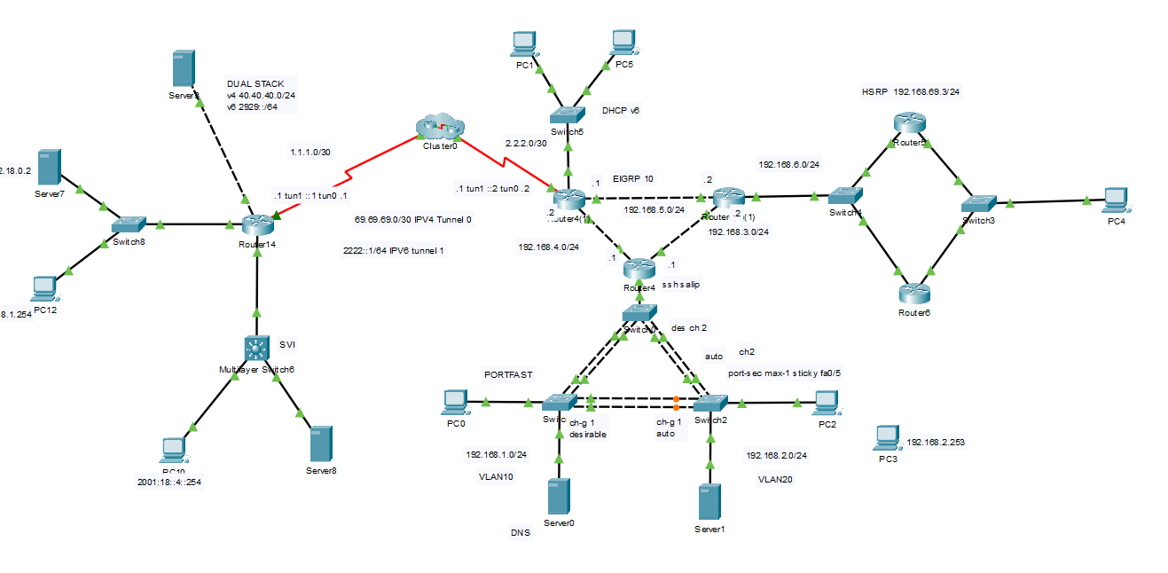

Рис.1 Топология сети

Таблица 1. Документация сети

|  |  |  |  |  |  |  |  |
| --- | --- | --- | --- | --- | --- | --- | --- |
| Устройства | Протокол | Интерфейс | | IP-адрес | Маска подсети | Шлюз по умолчанию | DNS-server |
| Router 4 | SSH  EIGRP10 | Gig0/1 | | 192.168.4.1 | 255.255.255.0 |  |  |
| Gig0/2 | | 192.168.3.1 | 255.255.255.0 |  |
| Gig0/0 | .1 | 192.168.1.1 | 255.255.255.0 |  |  |
| .2 | 192.168.2.1 | 255.255.255.0 |
| Router 4(1)(1) | EIGRP10 | Gig0/0 | | 192.168.5.2 | 255.255.255.0 |  |  |
| Gig0/1 | | 192.168.3.2 | 255.255.255.0 |  |  |
| Gig0/2 | | 192.168.6.1 | 255.255.255.0 |  |  |
| Router 5 | EIGRP10 HSRP | Gig0/0 | | 192.168.69.1 | 255.255.255.0 |  |  |
| Gig0/1 | | 192.168.6.2 | 255.255.255.0 |
| Router 6 | EIGRP10 HSRP | Gig0/0 | | 192.168.69.2 | 255.255.255.0 |  |  |
| Gig0/1 | | 192.168.6.3 | 255.255.255.0 |
| Router 4(1) | DHCP v6 EIGRP 420 EIGRP 10 | Gig0/0 | | 192.168.4.2 | 255.255.255.0 |  |  |
| Tunnel 1 | | 2222::2 | 64 |  |
| Gig0/1 | | 192.168.5.1 | 255.255.255.0 |  |
| Gig0/2 | | 1488::1 | 64 |
| Serial0/3/0 | | 2.2.2.1 | 255.255.255.252 |  |
| Tunnel 0 | | 69.69.69.2 | 255.255.255.252 |  |
| Router18 | DUAL STACK EIGRP 10 EIGRP 420 | Tunnel 0 | | 69.69.69.1 | 255.255.255.252 |  |  |
| Serial0/3/0 | | 1.1.1.1 | 255.255.255.252 |
| Gig0/0 | | 192.168.0.2 | 255.255.255.0 |
| Tunnel 1 | | 2222::1 | 64 |
| Gig0/1.1 | | 2001::1 | 64 |  |
| Gig0/1.2 | | 2002::1 | 64 |  |
| Gig0/2 | | 40.40.40.1 | 255.255.255.0 |  |
| 2929::1 | 64 |
| PC0 | - | NIC | | 192.168.1.254 | 255.255.255.0 | 192.168.1.1 | 192.168.1.2 |
| PC1 | DHCP v6 | NIC | | DHCP v6 | 64 |  |  |
| PC2 | - | NIC | | 192.168.2.254 | 255.255.255.0 | 192.168.2.1 | 192.168.2.2 |
| PC3 | NOT CONNECTED | NIC | | 192.168.2.253 | 255.255.255.0 | 192.168.2.1 |  |
| PC4 | - | NIC | | 192.168.69.254 | 255.255.255.0 | 172.16.9.1 | 192.168.9.254 |
| PC5 | DHCP v6 | NIC | | DHCP v6 | 64 |  |  |
| PC10 | - | NIC | | 10.0.0.254 | 255.255.255.0 | 10.0.0.1 | 10.0.1.2 |
| PC12 | - | NIC | | 2001::254 | 64 | 2001::1 | 2002::2 |
| Server0 | DNS | NIC | | 192.168.1.2 | 255.255.255.0 | 192.168.1.1 |  |
| Server1 | - | NIC | | 192.168.2.2 | 255.255.255.0 | 192.168.2.1 |  |
| Server3 | - | NIC | | 40.40.40.2 | 255.255.255.0 | 40.40.40.1 |  |
| NIC | | 2929::2 | 64 | 2929::1 |
| Server7 | - | NIC | | 2002::2 | 64 | 2002::1 |  |
| Server8 | - | NIC | | 10.0.1.2 | 255.255.255.0 | 10.0.1.1 |  |