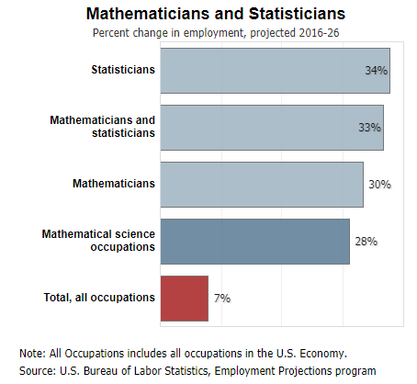

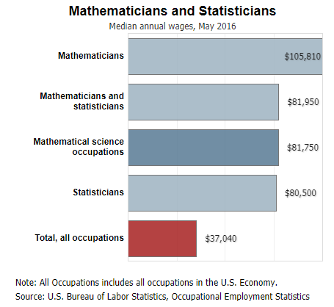

Graphs are cited from U.S. Department of Labor, Bureau of Labor Statistics.

<https://www.bls.gov/ooh/math/mathematicians-and-statisticians.htm#tab-1>

My first time to these two charts was on the statistics introduction session last autumn, while Thomas displayed them in his speech to rise our enthusiasm as being a statistics learner. Honestly, I was impressed by these simple bar charts since I had never expected that the gap was so huge that the demand and the pay for statistician and mathematician are almost three times than overall occupations’ average.

The first one displays the growth of predicted employment growth from 2016 to 2026 for statistician, mathematicians and all occupation’s average level. We could have the information directly from reading data on the bars that the estimated growth of employment for statistician or mathematician is nearly five times the average growth of all jobs.

The second bar chart displays median annual wages for statistician, mathematician and the overall average in 2016. Amazingly, mathematicians, as the graph said, process the highest medium annual salary, which is at least twenty-thousand more than the second highest one. Even though pure statisticians seem to get lower wage than mathematicians or mathematics related scientists, they got a compensation nearly 2.5 times of the overall medium.

On the website of Bureau of Labor Statistics, its claimed that being called as a statistician or mathematician requires at least a master’s degree, also, most of the positions that are included in the data set have an entry level of master’s degree. So literally, I still have a long way to go.