There are two participants in total for now (ID: 15404649, 15406260)
- Check the catch trial accuracy: both = 100%
- Check raw data, get mean of categorization results (d=0, t=1)
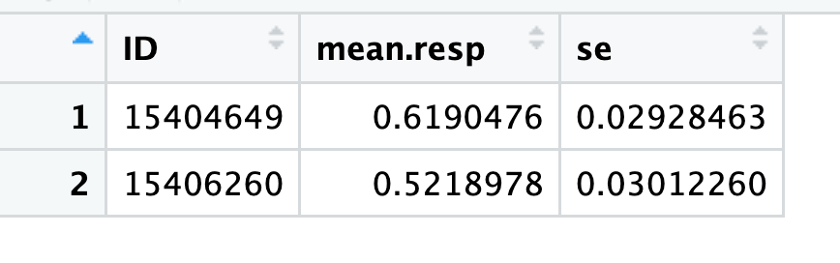
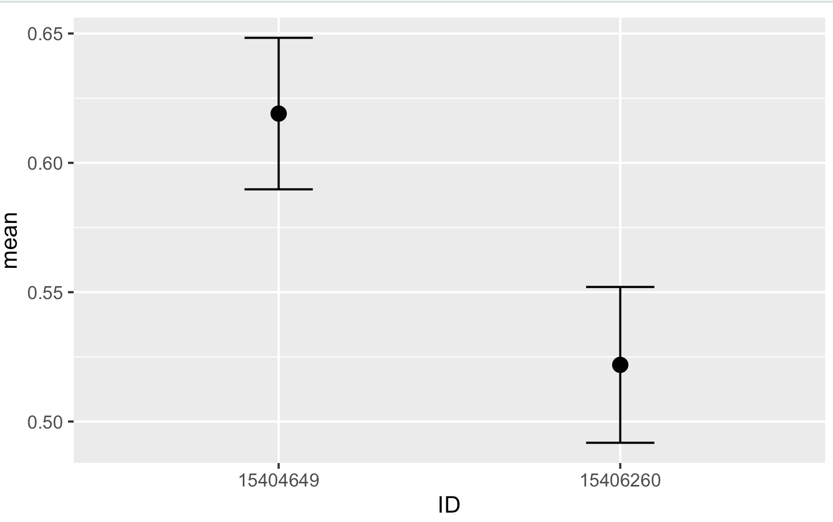

- Check subject-level categorization curve
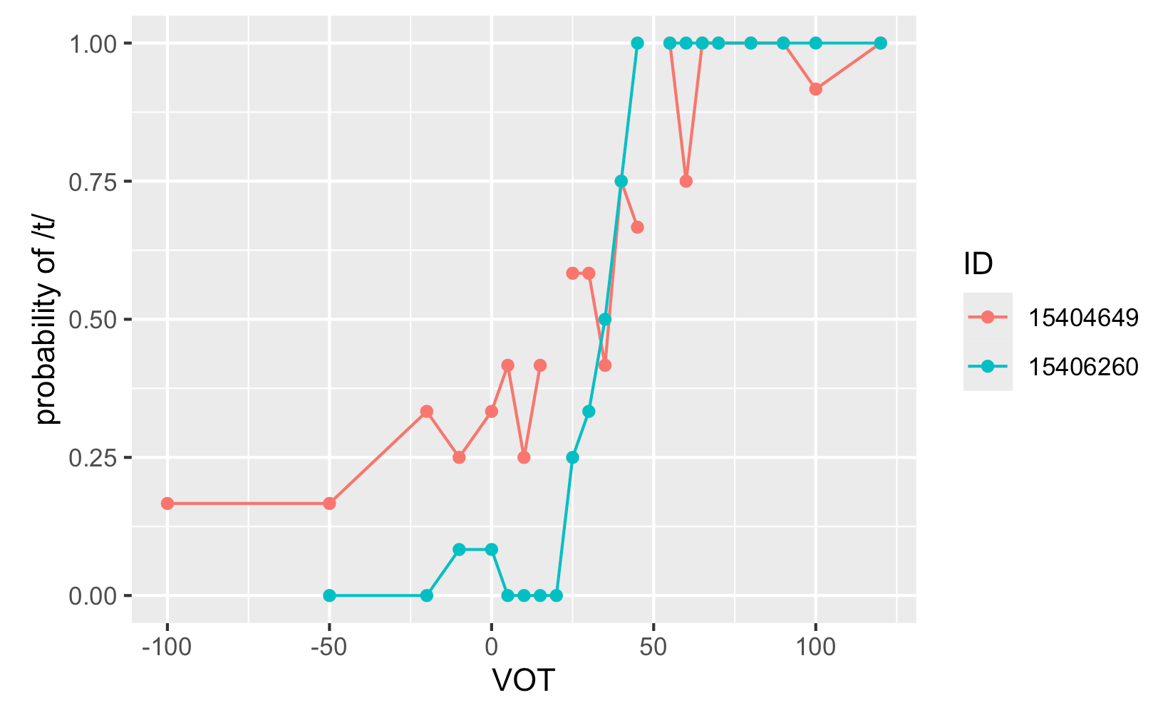

- Group level categorization curve
