generate stimuli

Summarize:
- Record human voice
- Based on the variable we want to manipulate (the perception of /t/, /d/), figure out the most important features we need to modify in the human voice
- Use software to change such features

Features relevant to perception of the minimal pair (Winn, 2004)
- VOT
  - Def: time between stop closure (happen first) and voicing (vocal fold vibration); stop consonant release occurs when the air blocked at a specific place of articulation (such as the lips for /p/, the alveolar ridge for /t/, or the velum for /k/) was suddenly released
  - /d/ has shorter VOT or negative
  - /t/ longer and positive VOT (stop consonant starts firstly)
Different places of articulation have different typical VOT ranges.
Voicing boundaries in English tend to fall around: /b–p/: ~20–25 ms; /d–t/: ~35 ms; /g–k/: ~40 ms
VOT for voiceless sounds generally scatter around 50ms while that for voiced sounds scatter around 15ms
VOT is the onset of burst (aspiration) and the start of voicing (periodicity)
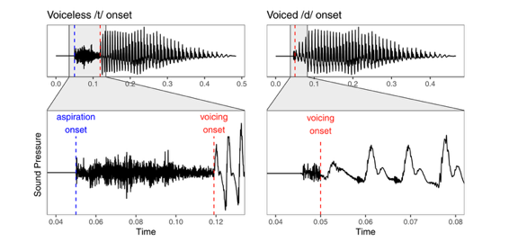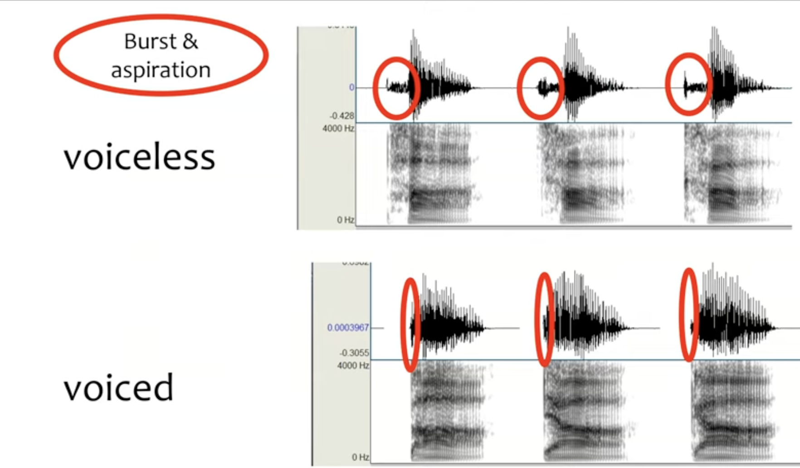
What is pre-voicing
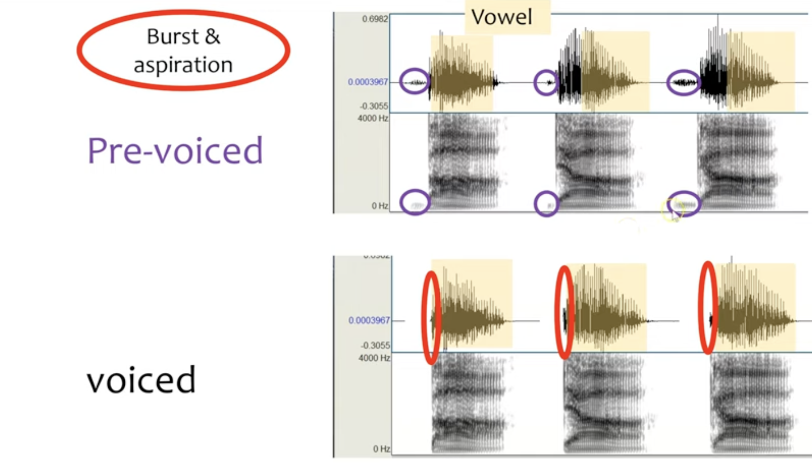

- Fundamental frequency
  - Def: The pitch (Hz) at the start of the vowel.
  - /p, t, k/ has higher F0, with wider glottal opening and more tension
- Vowel duration
  - Def: The length of the vowel segment after the stop.
  - /p, t, k/ has shorter duation (also because of cutting back)
- format frequency
  - Def: 1) F1 tells you how open the mouth is, 2) F2 tells you where the tongue is (front vs. back) and both are frequency peaks. they show how the shape of your mouth changes when going from the stop constriction → into the vowel
  - Voiceless stops → Higher F1 onset and Reduced or absent visible transitions
  - voiced → lower F1 onset but clear transitions
- aspiration intensity
  - Def: the burst of breathy, noisy air that comes out right after releasing a voiceless stop like /p/, /t/, /k/.
  - voiceless stops → longer
- burst spectrum
  - Def: The frequency distribution of the energy in the burst right after stop release
  - Voiceless stops have stronger releases and produce sharper, higher-frequency bursts.
others from Tan
- Duration of pre-voicing (VOT is negative)
  - Def: vocal fold vibration before the release of the stop
  - /d/ has pre-voicing
- the mean F0 of the first 25% of the vowel duration.
  - Def: average pitch of the vowel during its onset
  - /d/ has lower F0
The annotation boundaries were made following approaches reported in prior studies (e.g. Clayards, 2017; Dmitrieva et al., 2015; Francis et al., 2003; Kirby & Ladd, 2016)
#question: how to identify pre-voicing, VOT, vowel duration
A natural approach of modifying sound (Winn, 2004)
Replace the beginning of the voiced vowel with the aspirated segment from the voiceless token.
How to modify:
1/ Take a voiced token and delete its vowel onset and replace it with that from its voiceless minimal-pair counterpart
2/ set the fundamental frequency (F0) to covary with VOT
this might not hold for prevoicing
3/ aspiration intensity covary positively with VOT
Specifically, the F0 at vowel onset of each stimulus was set to respect the linear relation with VOT observed in the original recordings of the talker. The duration of the vowel was set to follow the natural trade-off relation with VOT
/t/ typically has longer VOT (especially in English), meaning the release is followed by a delay before voicing begins

specification in tan & jaeger

Only choose one recorder among five
Record 8 tokens of 4 /d-t/ minimal pairs (dill-till, din-tin, dim-tim, dip-tip) + 20 filler words. These fillers were made up of 10 minimal or near minimal pairs with different sounds at onset.
Stimulus intensity was normalized to 70 dB sound pressure level for all recordings. #question: how to normalize stimulus intensity
The critical minimal pair recordings were used to create four VOT continua ranging from −100 to +130 ms in 5 ms steps.

