# Other

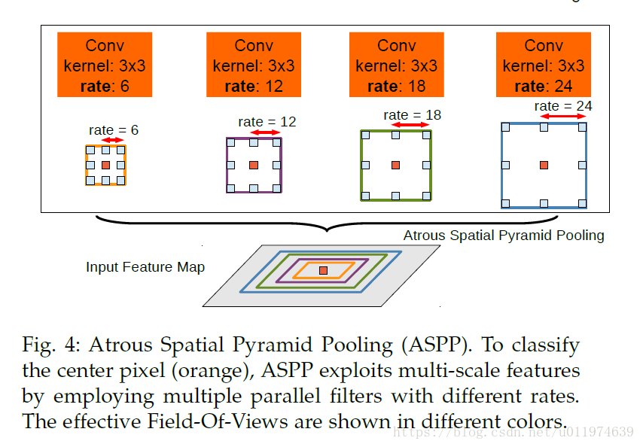

The atrous spatial pyramid pooling. To classify the center pixel, ASPP exploits multi-scale features by employing multiple parallel filters with different rates. The effective of Field-of-view are shown in different colors.