Nana Antwi

CS 195

Prof James Eddy

Assignment 4.

1.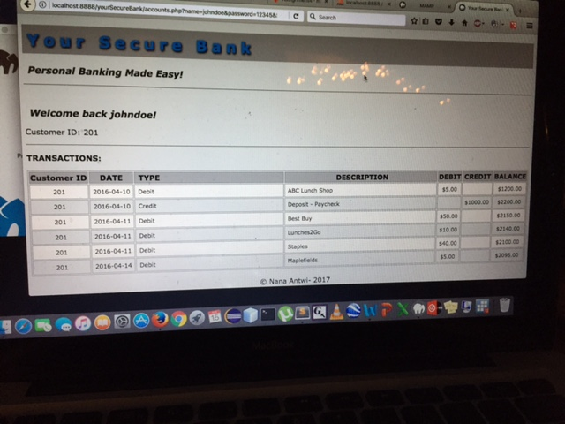

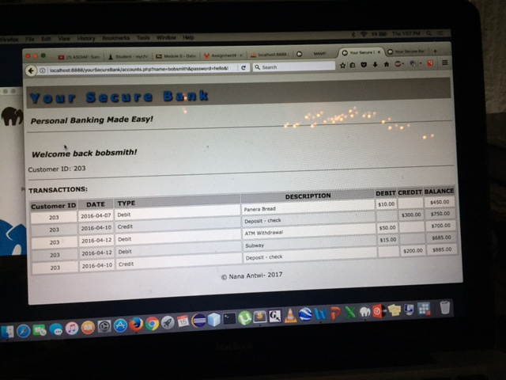

2. To reduce the risk of attacks in the log in code I will add the security feature of html entities to make is difficult for my sql injections like the on demonstrated in this assignment have a had time penetrating the system. I will create debug statements go along with my queries thus ensuring robust protection and the accurate display of the information a user is looking for.

3. This a breach of confidentiality and availability, it is easy for attacker to gain the access to whatever information they need and also take any information, because there is no security ensuring that authorized users are the ones using the system. Also you can have everyone information once you are in the system which violates privacy.