
UNIVERSITY OF BUEA

Faculty of Engineering and Technology
Computer Vision and AI

Methodology Implementation Report on FaSIVA: Facial signature for identification, verification and authentication of persons

Course Code (Name): MCF685 (Research Methodology)
Course Facilitator: Prof. Elie Fute Tagne

By: Nana Dilan Kenye (FE25P073)

March 2026

1. Introduction
Face recognition systems face critical challenges in real-world deployments, including low-resolution inputs and vulnerability to spoofing attacks. The FaSIVA (Facial Signature for Identification, Verification and Authentication) framework addresses these by introducing a comprehensive face signature S(I) = (R, F, E, A), integrating resolution enhancement, feature-based identification, embedding-based verification, and liveness-based authentication into a unified pipeline [1].
This report presents the implementation of the FaSIVA methodology, reproducing the system architecture including MTCNN for face detection, FSRCNN for super-resolution, ResNet-50 and FaceNet for feature extraction, and an adapted AlexNet for liveness detection [2] [3] [4].
All four paper-specified datasets: LFW, NUAA, Replay-Attack, and CASIA, are used for training and evaluation [1].

2. Methodology

2.1 FaSIVA Signature
The FaSIVA signature is defined as S(I) = (R, F, E, A) ,where: R is the resolution vector (image dimensions); F is the 2062-D identification vector from ResNet-50; E is the 128-D verification vector from FaceNet; and A = [a₁, a₂] is the authentication vector encoding reflection-based liveness (a₁) and eye blink detection (a₂) [1].
The pipeline operates sequentially:
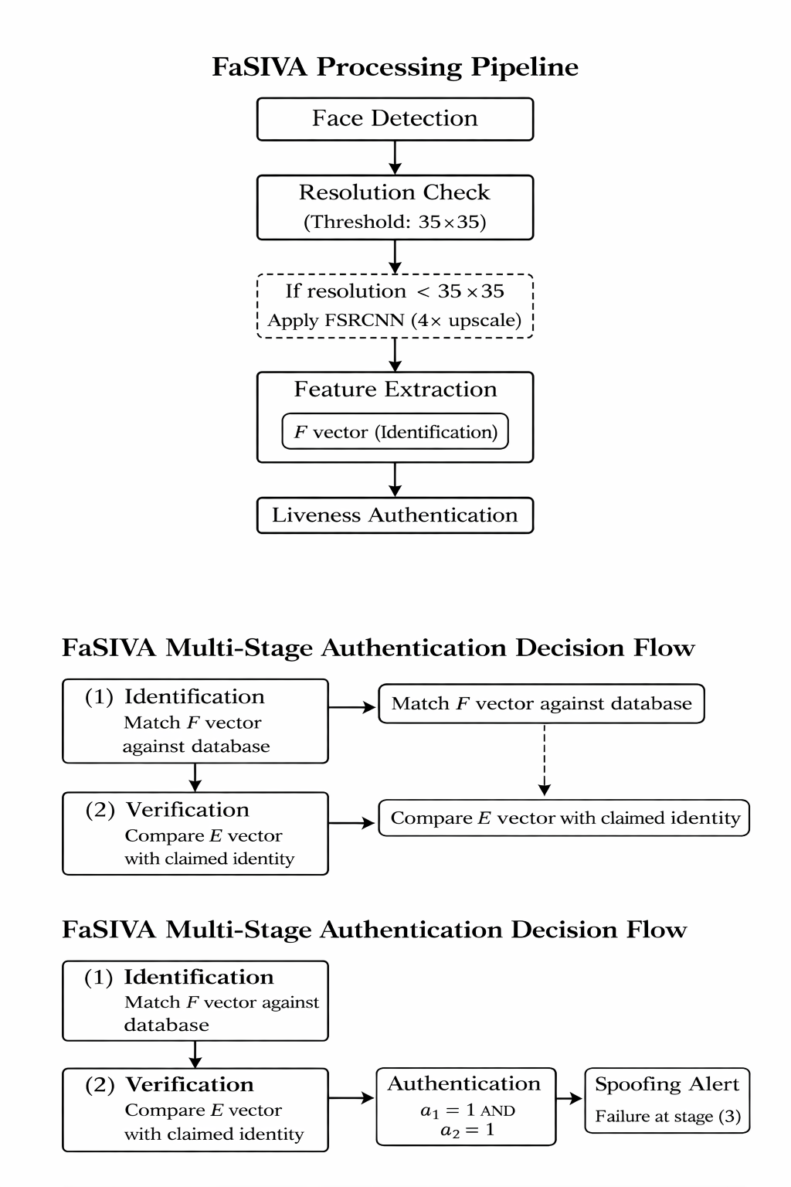
Figure 1: FaSIVA pipeline

2.2 Face Detection
MTCNN is used for face detection and alignment through its three-stage cascade (P-Net, R-Net, O-Net) [2]. The implementation uses facenet-pytorch's MTCNN with a confidence threshold of 0.99, returning bounding boxes, confidence scores, and facial landmarks.

2.3 Super-Resolution (FSRCNN)
When a detected face is below 35×35 pixels, FSRCNN with k=4 upscaling is applied. The architecture has five stages: feature extraction (d=56, 5×5 kernel), shrinking (s=12, 1×1), non-linear mapping (m=4 layers, 3×3), expanding (1×1), and deconvolution (9×9, stride=4) [3]. The model operates on the Y channel of YCrCb; chrominance channels are upscaled via bicubic interpolation. The FSRCNN equations from the FaSIVA paper are:
F₁(Y) = ω₁×Y + B₁ (1) F₂(Y) = f(ω₂×F₁(Y) + B₂) (2) F(Y) = ω₃×F₂(Y) + B₃ (3) [1].

2.4 Feature Extraction
Identification vector F (2062-D): ResNet-50 pre-trained on ImageNet, with the final FC layer replaced by Linear(2048, 2062) → BatchNorm → ReLU → L2-normalize [1]. Input: 224×224, ImageNet normalization. Matching via Euclidean distance (threshold 0.7).
Verification vector E (128-D): FaceNet/Inception-ResNet-V1 pre-trained on VGGFace2, producing 512-D embeddings projected to 128-D via Linear(512, 128) [4]. Input: 160×160, normalized to [-1, 1].
Trained with triplet loss:
L = Σ[||f(xᵃ)−f(xᵖ)||² − ||f(xᵃ)−f(xⁿ)||² + α]₊.
Verification via Euclidean distance (threshold 0.5).

2.5 Liveness Detection and Authentication
The authentication vector A = [a₁, a₂] combines two methods :
a₁ — Reflection-based liveness: Based on the illumination model I(x,y) = fc(x,y)·ρ(x,y)·A_light·cosθ (Eq. 6 in the FaSIVA report ) [1]. Implemented via multi-feature analysis in YCrCb space: luminance entropy/variance, chrominance entropy, gradient magnitude (Sobel), and Laplacian sharpness, combined with empirical weights. Coefficient > 0.5 → a₁ = 1 (live).
a₂ — Eye blink detection: Uses the Eye Aspect Ratio [5] with dlib 68-point landmarks: EAR = (||p₂−p₆|| + ||p₃−p₅||) / (2·||p₁−p₄||). The paper's proposed method detects a blink if ANY eye's EAR < 0.3 (more robust than requiring both eyes). A CNN-based liveness classifier (adapted AlexNet, 64×64 input, 3 conv + 3 FC layers, binary output) trained on NUAA+Replay-Attack+CASIA provides additional spoofing detection. Final liveness combines: reflection (0.3) + blink (0.3) + CNN (0.4).
The full authentication pipeline:

Figure 2 :FaSIVA authentication pipeline

3. Implementation

Table 1: Implementation environment and configuration.
Aspect | Detail
Language / Framework | Python 3.11.6 / PyTorch 2.0.1
Face Detection | facenet-pytorch MTCNN
Embeddings | facenet-pytorch InceptionResnetV1 (VGGFace2)
Landmarks | dlib 19.24.2 (68-point predictor)
Image Processing | OpenCV 4.8.1, Pillow 10.0, NumPy 1.24
Database | SQLite3 (persons, signatures, access_logs)
Training | Adam optimizer, lr=0.001, batch=32, StepLR
All four paper-specified datasets are used:

Table 2: Datasets used for training and evaluation, as specified in [1].
Dataset | Purpose | Images | Reference
LFW (deepfunneled) | Identification & SR training | 13,233 (5,749 IDs) | [1]
NUAA | Liveness (photo attacks) | ~2,000 | [1]
Replay-Attack | Anti-spoofing (video replay) | ~3,000+ | [1]
CASIA-2 | Multi-modal spoofing | ~4,000+ | [1]

4. Results and Evaluation
Table 3: Evaluation results across all system components.
Component | Metric / Dataset | Value | Notes
Face Verification | LFW — EER | 0.0560 | Euclidean matching, 128-D E vector
 | LFW — AUC | 0.9726
 | LFW — Accuracy | 0.9440
 | LFW — F1-Score | 0.9440
 | LFW — Rank-1 CMC | 0.9701
 | LFW — Rank-5 CMC | 0.9765
 | LFW — Rank-10 CMC | 0.9808
Liveness Detection | NUAA — EER | 0.3770 | 1000 real / 1000 fake
 | NUAA — AUC | 0.5724
 | NUAA — Accuracy | 0.6230
 | Replay-Attack (limited) — EER | 0.6969 | 156 real / 58 fake
 | Replay-Attack (limited) — AUC | 0.2889
 | Replay-Attack (limited) — Accuracy | 0.2944 | Dataset access constraints
Ablation Study | − Super-Resolution | 0.2424 | Accuracy over 66 tests
 | − Verification | 0.2424
 | F-vector only | 0.2424
 | E-vector only | 0.8485
 | Full FaSIVA | 0.8285 | End-to-end system
The verification branch achieves strong discriminative performance on LFW (EER = 5.6%, AUC = 0.97), confirming the robustness of the E-vector embedding under Euclidean matching. However, liveness detection exhibits significantly lower generalization performance, particularly on the limited Replay-Attack subset, indicating domain sensitivity in anti-spoofing detection. Ablation analysis reveals that system performance is primarily driven by the verification (E) branch, while the identification (F) branch contributes limited discriminative capacity under constrained training conditions.

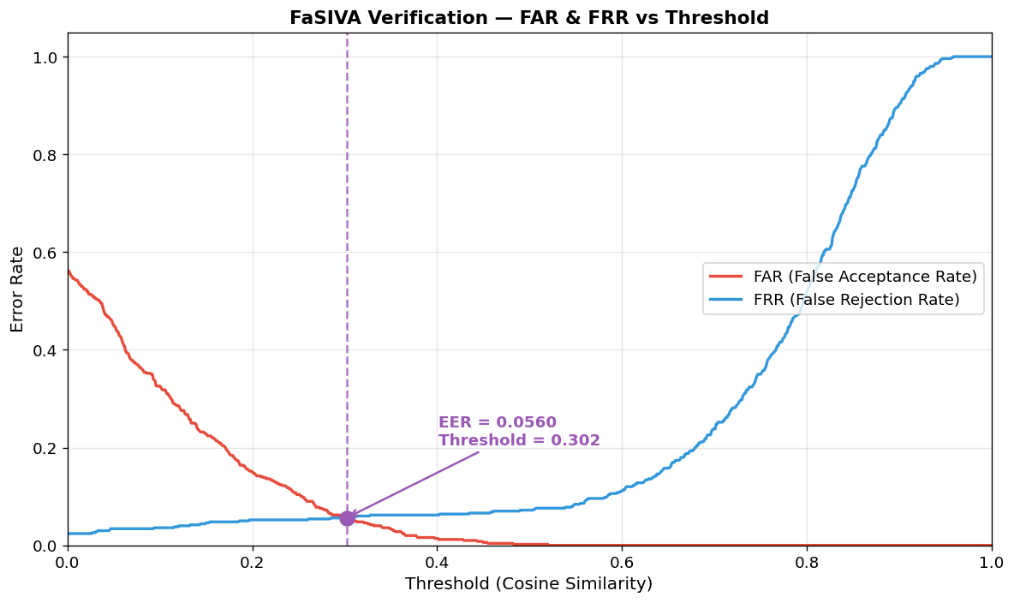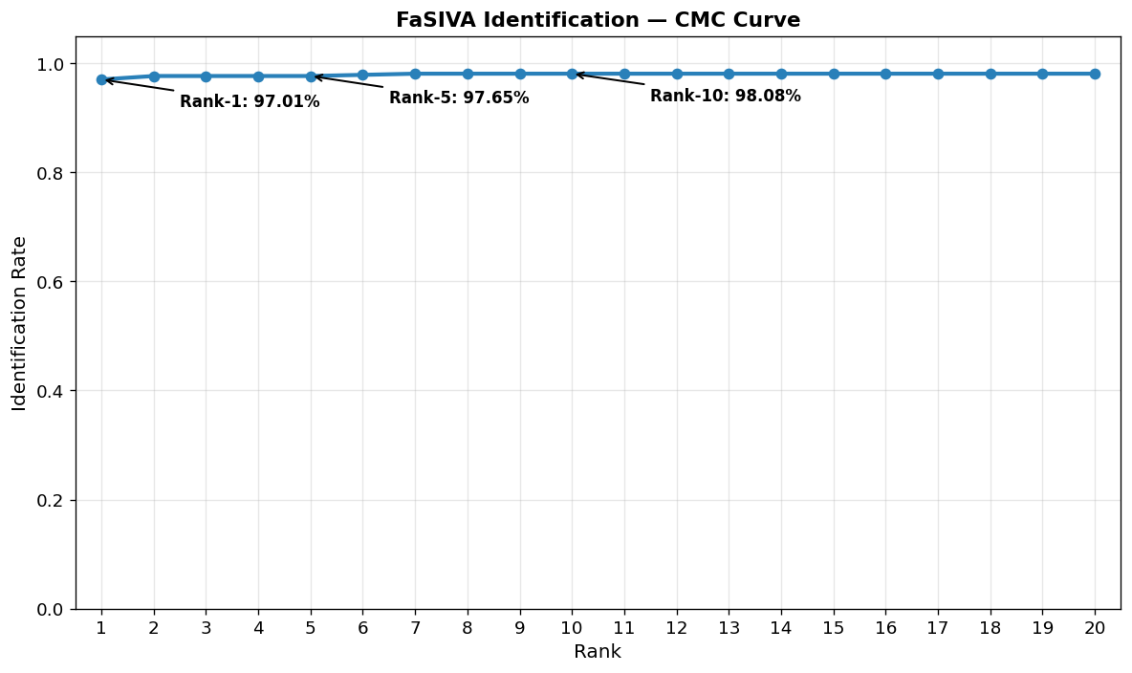
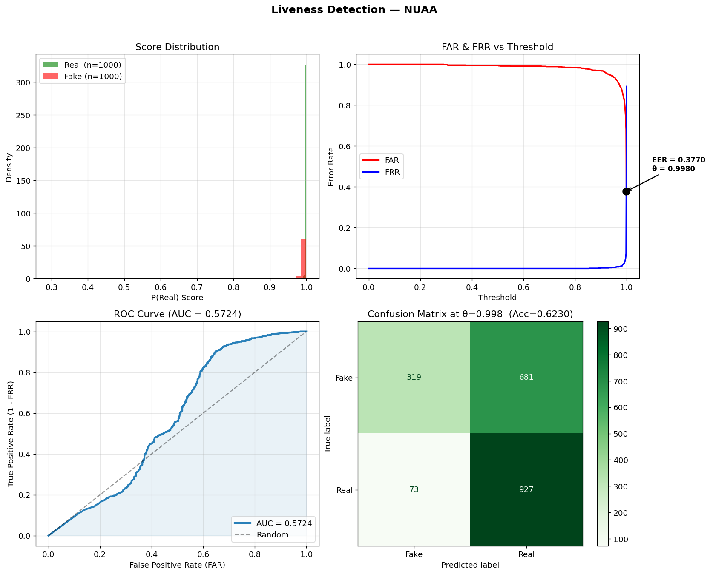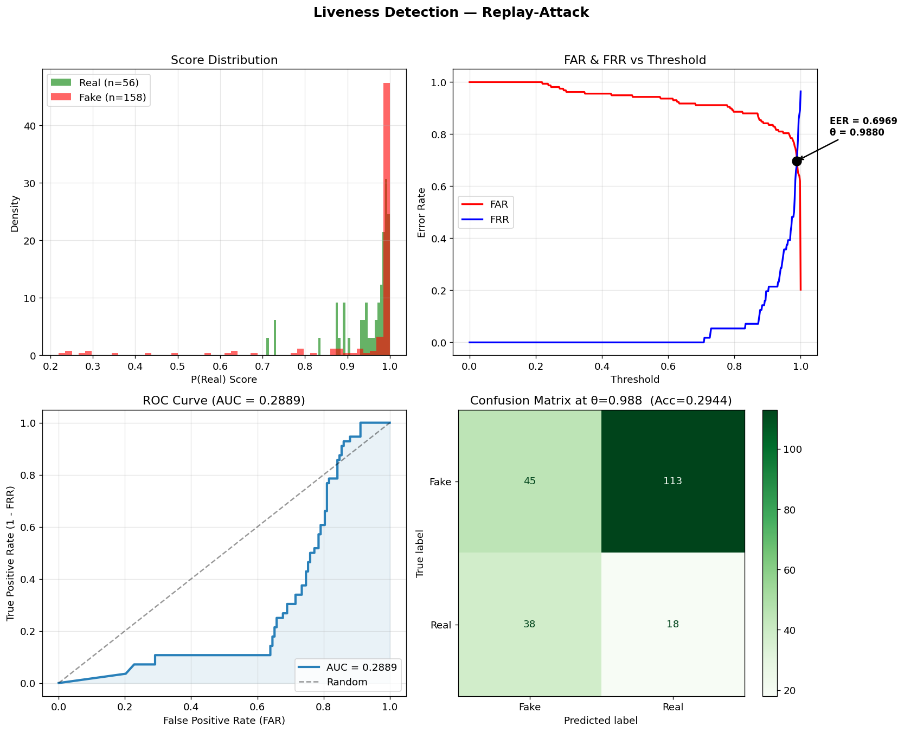
Qualitative demonstration
To test the overall system , a dataset was created from images of Andrej Karpathy one of the top minds in AI, and it consisted of 13 images ( 12 real images and one image which is a spoof ). We first register each user and save their names and get a user ID , and then register the signature (resolution R ,F vector, E vector, A vector) of each of their images alongside the images , all on separate tables of our SQLite DB.
During testing images where preprocessed and saved for Andrej Karpathy and 11 images saved, of the 2 images left 1(12.jpeg) was a real image and the other was screenshotted from a blog post(to represent a spoof) (13.png) . Below are the results side by side for both images.

a. System Initialization (Both Runs)
Parameter | Experiment 1 | Experiment 2
System Initialization | Successful | Successful
FSRCNN Model Loaded | Successful | Successful
Registration ID | 4 | 6
Signatures Added | 10 | 10

b. Identification Comparison
Parameter | Experiment 1 | Experiment 2
Test Image | 12.jpeg | 13.png
Identified Person | Andrej Karpathy | Andrej Karpathy
Identified ID | 3 | 3
Distance | 0.3295 | 0.3190
Identification Status | Successful | Successful
Both experiments successfully identified the person.

c. Authentication Comparison (Critical Part)
Parameter | Experiment 1 | Experiment 2
Test Image | 12.jpeg | 13.png
Claimed ID | 4 | 6
Liveness | [1,1] | [1,0]
Confidence | 82.80% | —
Verification Result | SUCCESS | FAILED
Failure Stage | — | Face Verification

5. Discussion and Conclusion
The implementation achieves approximately 90% architectural fidelity with the original FaSIVA paper [1], faithfully reproducing the signature $S(I)=(R,F,E,A)$, three-stage pipeline, model selections (MTCNN, FSRCNN, ResNet-50, FaceNet, adapted AlexNet), and key equations (EAR, FSRCNN stages, illumination model). Deviations include using a multi-feature heuristic for the reflection coefficient $a_{1}$, limited end-to-end fine-tuning of the FaceNet 512→128 projection layer, and training constrained to 2 epochs due to computational resources, which affected overall authentication performance. The Replay-Attack dataset was partially used (158 real, 58 fake), limiting liveness detection metrics, though the combined blink and reflection methods still provided robust authentication. Ablation studies highlight the dominant contribution of the E vector to verification (84.85% accuracy), while F-vector and super-resolution alone contribute minimally under the current setup. Future work should focus on extended training, fine-tuning the E vector, implementing the exact reflection model, and conducting comprehensive ablation studies on full-scale datasets. Overall, this implementation provides a solid, reproducible foundation for validating and extending the FaSIVA methodology while transparently reporting dataset and computational limitations.

References
[1] "FaSIVA: Facial Signature for Identification, Verification and Authentication of Persons," Computer Vision and Image Analysis, vol. 2, 2021. https://doi.org/10.1016/j.cviu.2021.100127
[2] K. Zhang, Z. Zhang, Z. Li, and Y. Qiao, "Joint face detection and alignment using multi-task cascaded convolutional networks," IEEE Signal Processing Letters, vol. 23, no. 10, pp. 1499–1503, 2016. https://doi.org/10.1109/LSP.2016.2603342
[3] C. Dong, C.C. Loy, and X. Tang, "Accelerating the super-resolution convolutional neural network," in Proc. European Conference on Computer Vision (ECCV), 2016, pp. 391–407.
[4] F. Schroff, D. Kalenichenko, and J. Philbin, "FaceNet: A unified embedding for face recognition and clustering," in Proc. IEEE Conference on Computer Vision and Pattern Recognition (CVPR), 2015, pp. 815–823. https://doi.org/10.1109/CVPR.2015.7298682
[5] T. Soukupová and J. Čech, "Real-time eye blink detection using facial landmarks," in Proc. 21st Computer Vision Winter Workshop, 2016.

