Technical Report
Integrated Data Science and Software Engineering Project
National Electricity Grid Network Analysis · GridCare-Lite · ClinicCare-Lite
Title | National Electricity Grid Network Analysis, GridCare-Lite, and ClinicCare-Lite
Course | CS 112 — Computer Programming for CS (Summer 2026)
Cohort / Team | Cohort A · Team 3
Team members | Nana Kojo Atta-Benyah (90452029), Brian Edem Bedzrah (52722029), Shawn Tei Kpoti (24212029), Nana Ekow Amuah (91262029)
Instructor | Robert Sowah
Date | 28 August 2026
Repository | https://github.com/Nana-Kojo801/cs-final-project

1. Introduction

1.1 Background
Electricity and healthcare are two national-scale systems that depend on good data management and reliable software. An electricity grid is a geographically distributed, safety-critical network whose operation depends on accurate asset records, connectivity analysis, and coordinated maintenance. An outpatient clinic is a human-centred service that depends on secure records, timely communication, privacy protection, and dependable administrative workflows. This project builds one analytical component and two software components that, between them, exercise data cleaning, network science, geospatial visualisation, database design, secure authentication, role-based access control, GUI/web development, testing, and technical communication.

1.2 Objectives
- Produce a reproducible analysis of a synthetic national grid dataset: clean and validate it, integrate the three tables, run exploratory and network analysis (including a simplified N-1 contingency study), and communicate the findings through static and interactive visualisations.
- Build GridCare-Lite, a role-based desktop application that runs the complete outage-to-resolution workflow for a utility, using the cleaned substation data as its reference asset register.
- Build ClinicCare-Lite, a secure role-based clinic administration and communication web application that remains strictly administrative and non-diagnostic.

1.3 Problem statement
Real substation-level grid topology for Ghana is not publicly available in a clean, structured form, and real patient data cannot be used in coursework. The project therefore works from a seeded synthetic dataset and fictional demo accounts, so every result is reproducible and no confidential information is exposed, while still demonstrating the full development lifecycle.

1.4 Summary of approach
- A single seeded generator script (random.seed(42), unchanged) produces byte-identical CSVs for every run.
- The grid analysis is a sequence of standalone Python scripts, each writing a markdown report plus CSV/PNG/HTML artifacts to a dedicated output folder.
- GridCare-Lite separates a testable core/ package (database, auth, RBAC, workflow state machines) from a thin Tkinter GUI.
- ClinicCare-Lite is a Flask app with a models/ + utils/ layer over JSON storage; every privacy and scope rule is enforced in that layer and covered by unit tests.
- 52 automated tests (24 GridCare-Lite, 28 ClinicCare-Lite) plus a documented manual test plan.

2. Dataset overview

2.1 Source
Generated by grid-analysis/generate_grid_data.py, run once with random.seed(42). Output:
File | Rows | Key fields
utilities.csv | 10 | Utility ID, Name, Alias, Code, Type, Country, Active
substations.csv | 44 | Substation ID, Name, Short Name, Region, Country, Latitude, Longitude, Voltage (kV), Capacity (MVA), Commissioning Year, Type, Status
lines.csv | 55 | Line ID, Utility ID, Source/Destination Substation ID + name, Voltage (kV), Length (km), Capacity (MVA), Status, Line Type
The data is grounded in real Ghanaian geography and real utility names (ECG, NEDCo, GRIDCo, VRA) with plausible West African Power Pool cross-border interconnections. All coordinates, capacities, commissioning years and connections are synthetic and illustrative.

2.2 Size and shape
10 utilities · 44 substations across 10 Ghanaian regions plus 8 cross-border nodes · 55 lines (40 overhead, 15 underground). Voltage levels: 11, 33, 69, 161, 330 kV. Substation capacity ranges 6.4–506 MVA (median ≈ 108 MVA, a right-skewed distribution).

2.3 Data-quality checks performed (Task 1)
Even though the generator emits clean data, the cleaning script treats the input as an untrusted asset register and checks:
- Types — Latitude/Longitude/Capacity/Length coerced to numeric with errors='coerce'; commissioning year and voltage checked as integers.
- Missing values — isnull().sum() per column; documented imputation policy (none required for this seed; policy stated for real data).
- Duplicates — full-row duplicate check on all three tables (0 found).
- Coordinate plausibility — every lat/long checked against West African bounds (roughly lat 4–12°N, long −14–3°E).
- Foreign-key integrity — every Source/Destination Substation ID in lines.csv verified against substations.csv; every Utility ID verified against utilities.csv. 0 orphaned references.
- Categorical consistency — Status, Type, Line Type values checked against their allowed sets.
Result: 0 rows dropped, 0 imputations required, 0 orphaned foreign keys. Full detail: grid-analysis/cleaned_data/data_cleaning_report.md.

2.4 Sample (first rows of substations.csv)
ID | Name | Region | Lat | Long | kV | MVA | Year | Type | Status
1 | Achimota Substation | Greater Accra | 5.6085 | −0.2193 | 11 | 6.4 | 2008 | Distribution | Active
2 | Tema Substation | Greater Accra | 5.6596 | −0.0226 | 330 | 48.5 | 1997 | Transmission | Active
3 | Mallam Substation | Greater Accra | 5.5600 | −0.2980 | 11 | 36.4 | … | Distribution | Active

2.5 Integration (Task 1b / Task 4)
A left join keyed on Utility ID and the two substation-ID foreign keys produces a 55-row master line-level table (integrated_data/master_lines.csv, 28 columns) with source/destination region and country and utility metadata attached. Row count is unchanged by the join (55 → 55) and no data is lost, confirming referential integrity.

3. Exploratory data analysis
Charts: grid-analysis/charts/*.png; narrative: grid-analysis/charts/eda_report.md.
Question | Finding
Which regions have the most substations? | Greater Accra (6), then Ashanti (5); Western, Central, Eastern, Volta (4 each).
Most common voltage level? | 161 kV (11 substations), closely followed by 330 kV (10) and 11 kV (9).
Which utility operates the most lines? | GRIDCo — 24 of 55 lines, consistent with its transmission-operator role. NEDCo 14, ECG 10.
Capacity distribution? | Right-skewed: median ≈ 108 MVA, mean ≈ 158 MVA, max 506 MVA — a few large transmission substations pull the mean up.
Oldest infrastructure? | Western region (earliest commissioning year 1967 in this seed).
Line status? | 53 Active, 2 Under Maintenance (≈ 96% active).
Most-connected substation? | Mallam, Kumasi Central and Cape Coast tie at 5 connecting lines.
Statistical note: with n = 44 substations and 55 lines the dataset is small; all “distributions” are described, not inferentially tested, and comparisons between regions are descriptive only.

3.1 Key visualisations
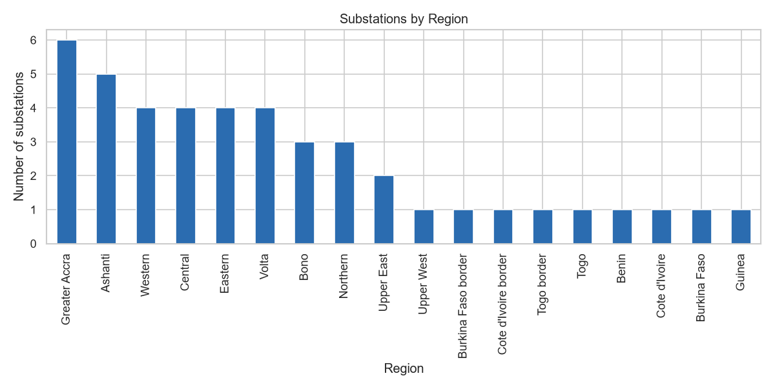
Figure 3.1 — Substations by region.
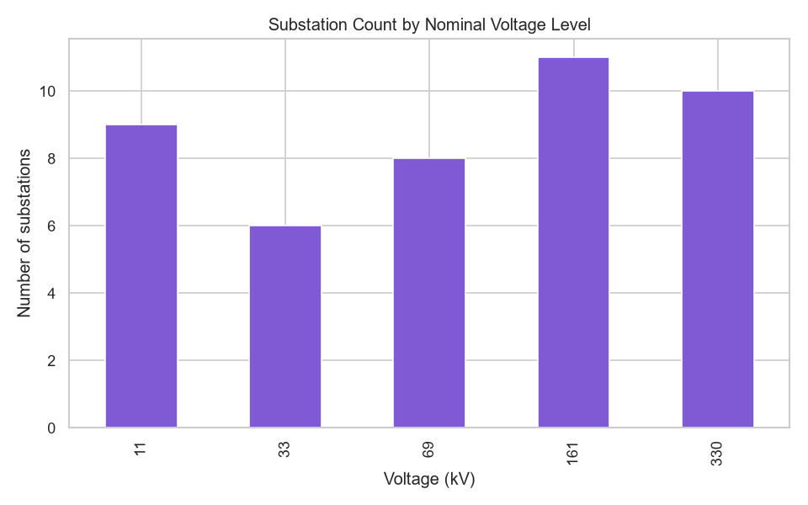
Figure 3.2 — Distribution of voltage levels.
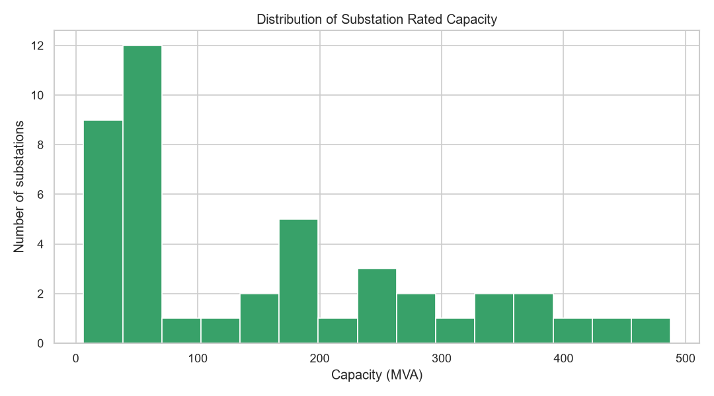
Figure 3.3 — Distribution of substation rated capacity.
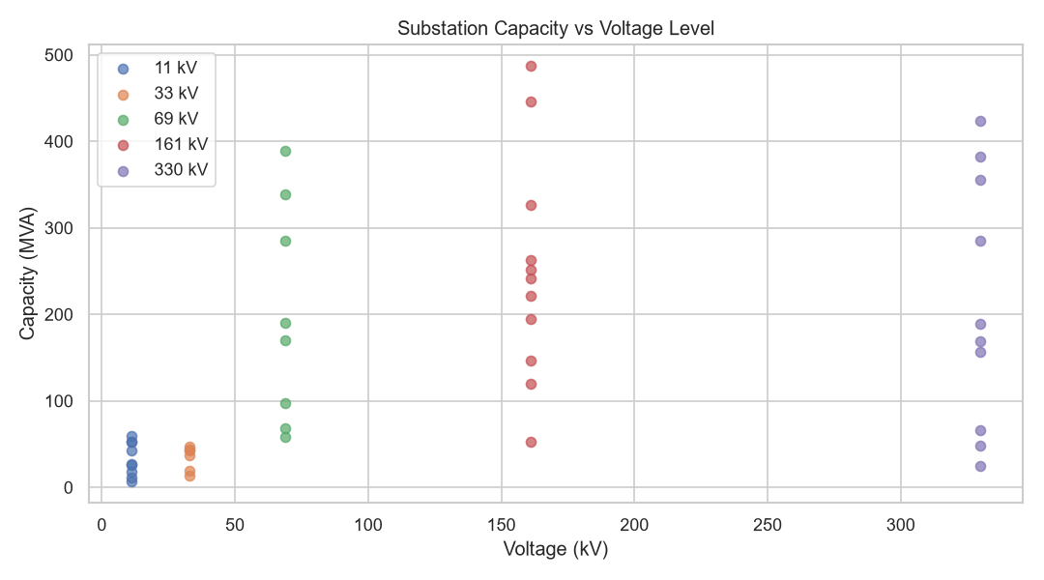
Figure 3.4 — Capacity vs. voltage level.
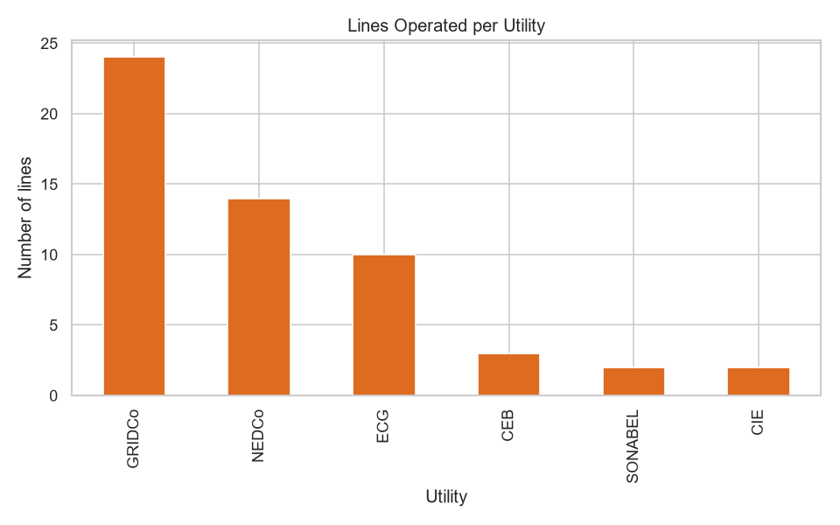
Figure 3.5 — Lines operated per utility.
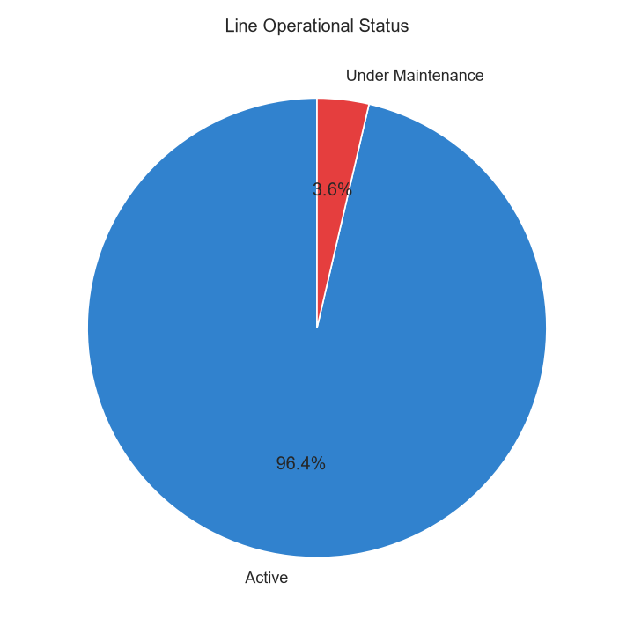
Figure 3.6 — Line operational status.
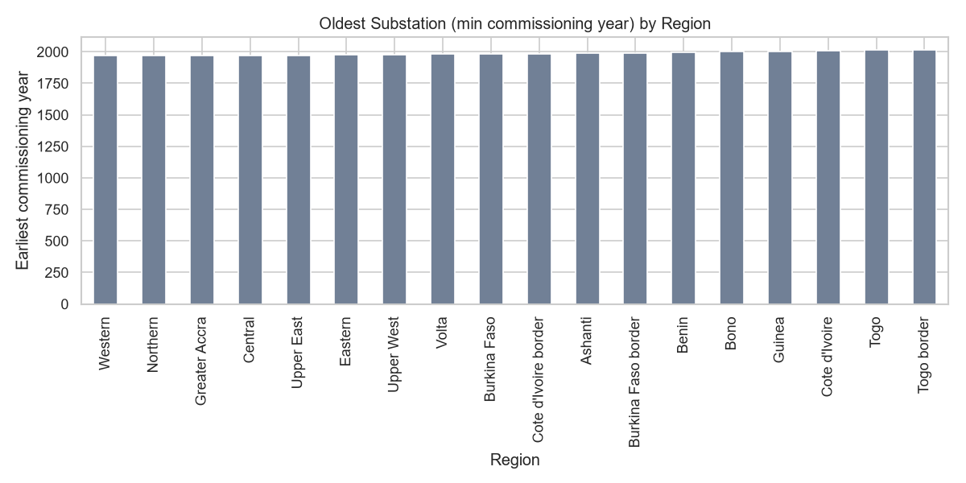
Figure 3.7 — Infrastructure age by region.
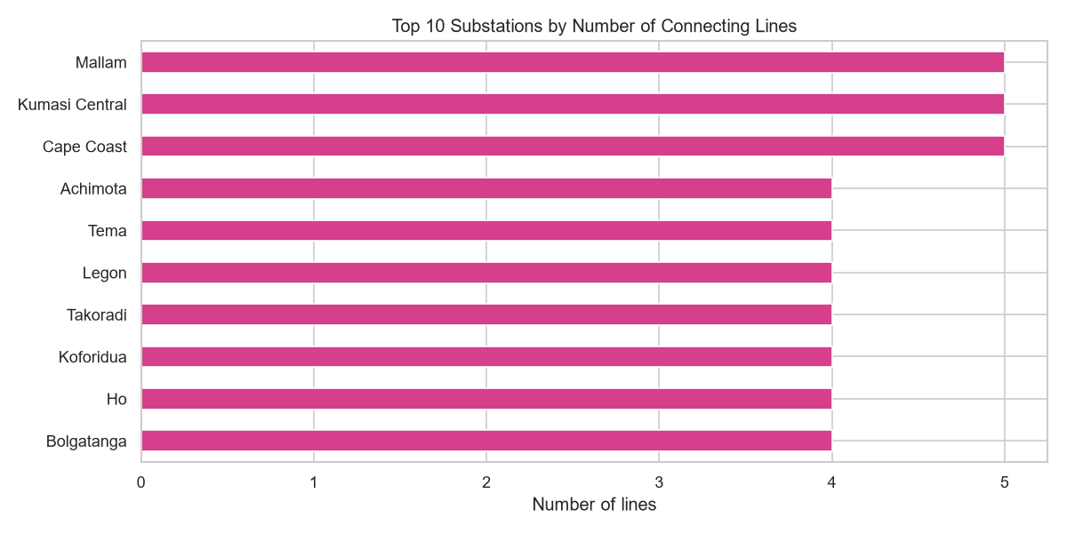
Figure 3.8 — Top connected substations.

4. Network analysis
Graph model: undirected (AC power can flow either way along a line). Nodes = 44 substations (with region, voltage, capacity, coordinates, status attributes). Edges = 55 lines (length, capacity, voltage, status, utility). Code: grid-analysis/task2_networkx_graph.py, n1_contingency.py + interactive_map.py.

4.1 Graph construction
Building the graph from substation IDs (rather than names) preserves every substation, including those with no lines. The resulting graph has 3 connected components: one giant component of 41 substations plus two tiny isolated groups (Savelugu; Conakry Transmission Hub). This is itself a data-structure finding — a name-keyed graph would silently hide the isolates.

4.2 Centrality results
Metric | Top substations
Degree | Mallam, Kumasi Central, Cape Coast (5 each)
Betweenness (length-weighted) | Cape Coast (0.526), Takoradi (0.516), Kumasi Central (0.501), Koforidua (0.498)
PageRank (capacity-weighted) | dominated by the 330 kV transmission and cross-border nodes
High-betweenness substations sit on the single north–south / east–west corridors of this sparsely meshed network, so they carry a large share of the shortest topological paths between other substation pairs.

4.3 Community detection
Greedy modularity finds 10 communities that align closely with administrative regions and with the cross-border clusters (e.g. the Togo/Benin interconnection nodes form one community; the Burkina Faso corridor another). Two singleton communities correspond to the isolated substations.

4.4 Bridges and efficiency
The graph has 21 bridge edges (of 55) — lines whose removal increases the component count. Global efficiency is 0.244 and the length-weighted average shortest path within the giant component is ≈ 819 km, both reflecting a long, thin, lightly meshed topology.

4.5 N-1 contingency findings
Substation removal. Removing Kumasi Central is the most disruptive single-node loss: 3 extra fragments and 15 substations cut from the giant component. Cape Coast and Takoradi each cut ~20 substations into 2 fragments. Removing a peripheral Greater Accra substation (Mallam, Legon) causes no additional fragmentation.
Line removal. 21 of 55 single-line losses split the network — exactly the bridge set from §4.4. Every cross-border interconnection and every inter-regional backbone line is a bridge in this seed.
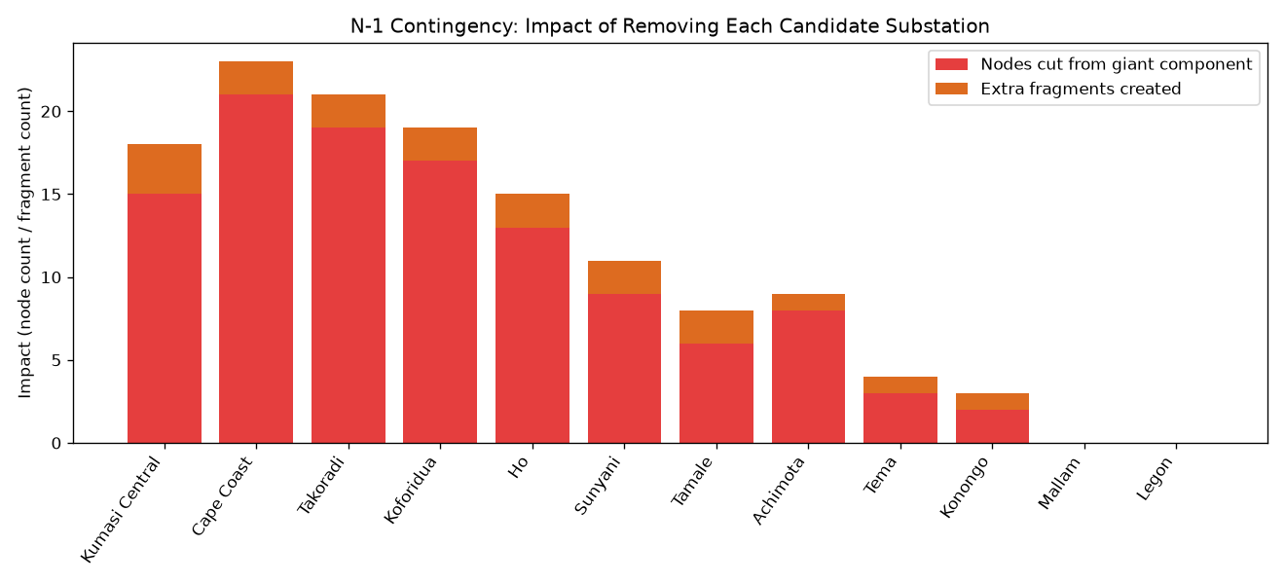
Figure 4.1 — N-1 contingency impact of removing each candidate substation.
Interpretation: this synthetic grid is radial-leaning, not well meshed, so it is not N-1 secure at the topological level. A real operator would respond by building loop connections around the identified bridges. This is a graph-topology approximation — it ignores load flow, thermal limits, voltage stability and protection behaviour, which a real contingency study models.

4.6 Visualisation
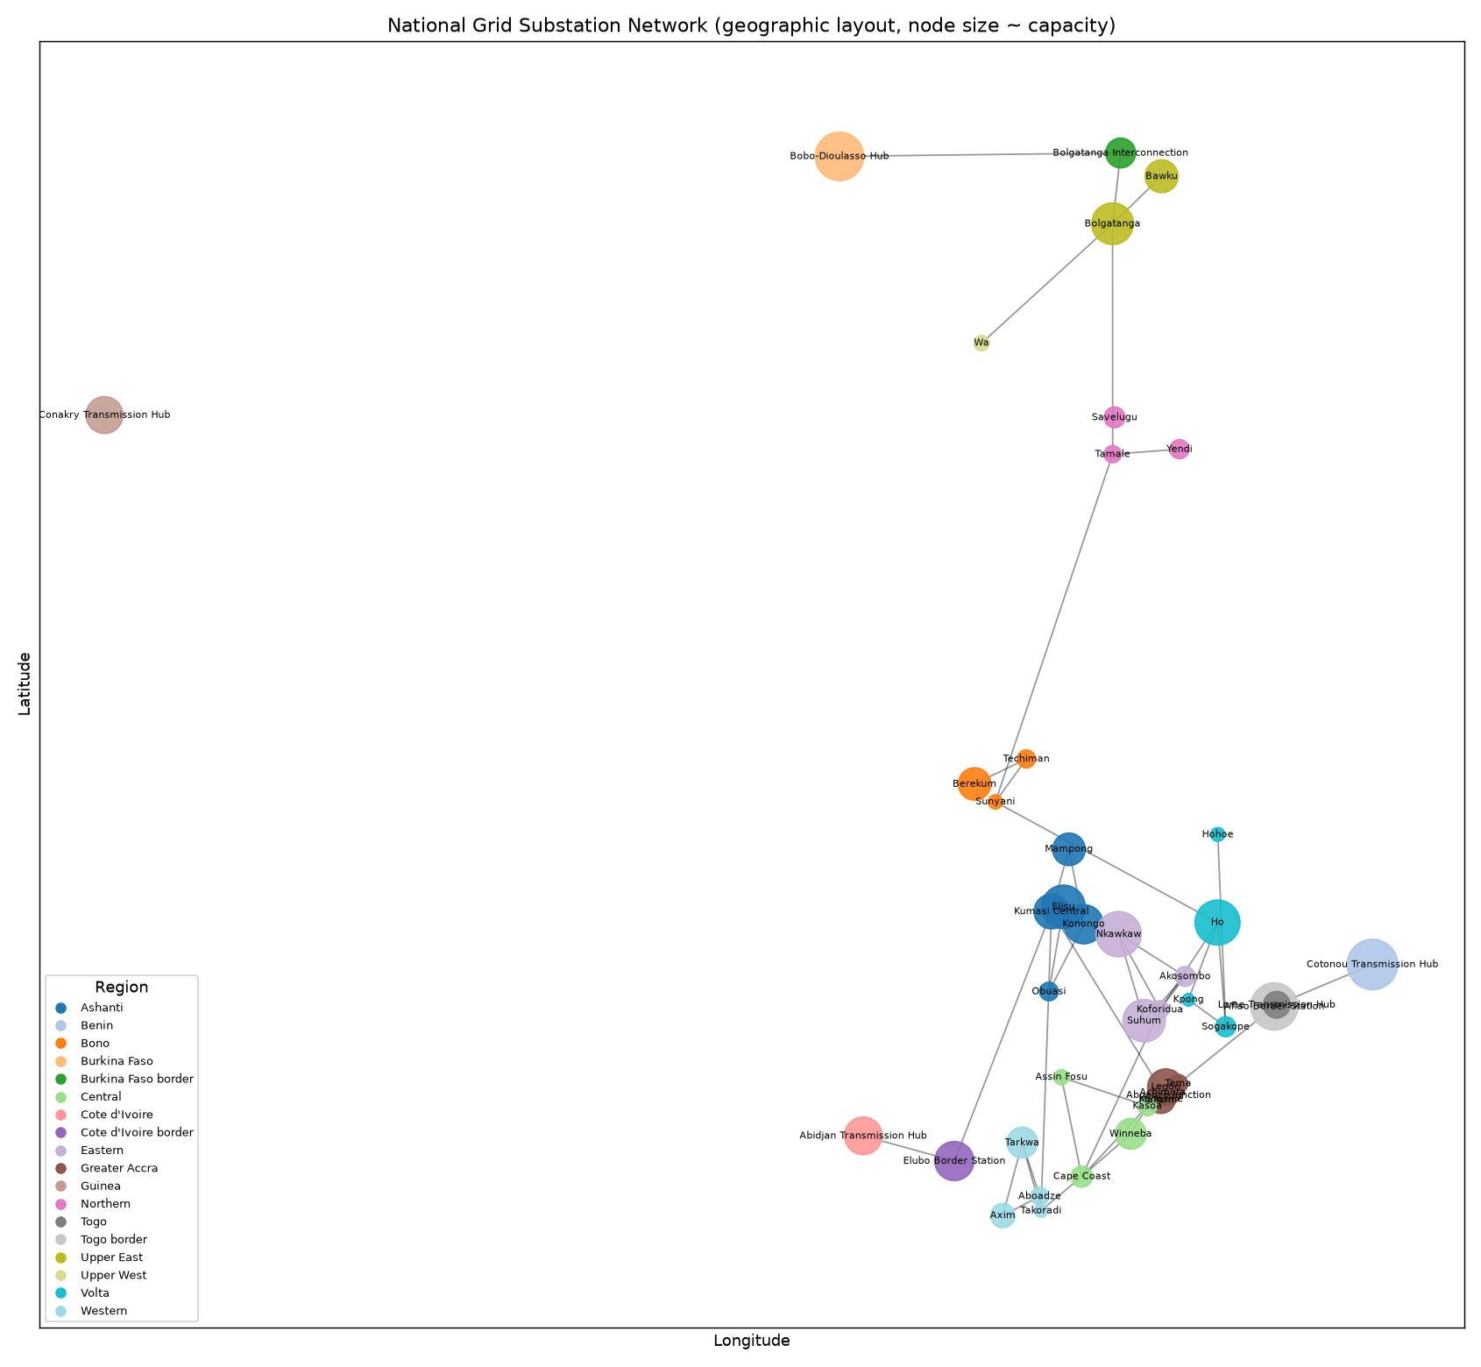
Figure 4.2 — Static network diagram (geographic layout, node size ∝ capacity).
- Interactive Folium map with substation/line layers, voltage colour-coding, and maintenance highlighting: maps/grid_interactive_map.html.
- Plotly scatter-geo map: maps/substation_map_plotly.html.
- Streamlit dashboard (Overview / Network / Geography / Reliability / Search): grid-analysis/dashboard_app.py.

5. GridCare-Lite architecture

5.1 Data model
SQLite, schema in gridcare-lite/schema.sql, dictionary in gridcare-lite/data_dictionary.md. Tables: users, substations, lines (both imported from the grid analysis), outages, work_orders, complaints, status_history (audit trail). Foreign keys are enforced (PRAGMA foreign_keys = ON); severity, status and role are constrained by CHECK clauses.

5.2 Roles and permissions
Four roles — administrator, engineer, technician, customer-service. A permission→roles matrix in core/auth.py is checked by auth.require() in every state-changing service function, and backed by database constraints (e.g. a work order can only be assigned to a user whose role is technician). Role separation is not merely UI hiding: the Tkinter nav is filtered by permission, but the service layer rejects an out-of-role call even if it is made directly.

5.3 Workflow
Outage: Open → In Progress → Resolved and Work order: Pending → Scheduled → Completed are explicit transition maps. The demonstration sequence: engineer logs an outage against a real substation → admin creates and assigns a work order (technician + future date) → technician starts work (outage → In Progress) → technician completes with mandatory resolution notes (work order → Completed, outage → Resolved automatically) → customer-service logs and links a complaint → the reports screen recomputes open counts and average resolution time. Every transition writes a status_history row.

5.4 Security controls
- bcrypt password hashing; login rejects unknown or inactive users with a single generic message.
- Invalid input is rejected with user-facing messages, not crashes: bad substation reference, empty description, invalid severity, past scheduled date, duplicate open outage, assigning a non-technician, completing without notes, invalid state transition, and a technician touching another technician's work order are all covered by tests.
- The DB file is local; the app opens one connection with foreign keys on.

5.5 Integration with the analysis
import_grid_data.py loads substations_clean.csv / lines_clean.csv and sets a critical_flag on the top-5 betweenness-centrality substations from network_metrics.csv. The reports screen surfaces “open outages on critical substations”, clearly labelled as a structural proxy on synthetic data.

6. ClinicCare-Lite architecture

6.1 Data model
JSON files under clinic-lite/data/ (users, clinics, health_tasks, task_assignments, task_submissions, messages, appointments, announcements, engagement, notifications). Every write goes through utils/storage.py, which writes to a temp file and atomically replaces the target with an explicit truncate() + fsync — fixing the r+/seek(0) “Extra data” corruption bug the brief calls out. Schemas are documented in docs/diagrams.md and ClinicCare-Lite's module docstrings.

6.2 Roles and workflow
Two roles — clinician, patient. Clinician creates and assigns health tasks (with an optional structural check spec) → patient uploads a .txt/.csv/.pdf file → the file is renamed patientID_taskID.ext and stored under submissions/<clinic>/<patient>/ → a structural completeness check runs → clinician reviews with a categorical outcome (Pending / Reviewed – Normal / Needs Follow-up / Escalated) plus free-text notes → the patient is notified (in-app inbox + email/log) and can read the outcome. Appointments, reminders, announcements, messaging and analytics run alongside.

6.3 Security controls
- 8-digit ID validation (clinician ends 0000; patient ends in a registration year 2022–2028); password complexity (≥ 8 chars, upper + lower + digit + special); bcrypt hashing.
- Session cookie with a 30-minute inactivity lifetime; login_required and role_required decorators protect every dashboard route; 403 on cross-role access.
- Privacy: a patient can only see their own tasks, submissions, messages, engagement and analytics. message.thread() returns messages only where the requester is a participant; engagement has no cross-patient function (no leaderboard, no rank_patients — asserted by a test); clinician review and download require clinic.shares_clinic(clinician, patient).
- File safety: extension allow-list, 2 MB size cap, empty-file rejection, and path components validated to block traversal (../ rejected).
- Secrets (CLINIC_SECRET_KEY, SMTP credentials) come from environment variables; .env.example is committed, .env is not. With no SMTP set, notifications are logged rather than sent.

6.4 Explicit non-diagnostic scope statement
ClinicCare-Lite is an administrative and communication system only. It does not diagnose patients, interpret symptoms, calculate disease risk, assign health scores, recommend treatment, or prescribe medication. The only automated content feature (utils/completeness.py) is a structural check that expected columns/labels are present and that columns declared numeric parse as numbers — for example it may report “the 'date' column is missing”, and it is explicitly prevented from commenting on the meaning of any value. The review outcome is a categorical administrative triage status set by a human clinician, never an automated result. The wellness-engagement tracker is private to each patient and never ranks or compares patients. This boundary was maintained through analysis, design, implementation, testing and documentation.

7. Testing summary

7.1 Approach
Testing was continuous. Each component has an automated suite (unittest) run before every merge, plus a manual test plan (docs/test_plan.md) executed against the seeded demo data. Results: docs/test_report.md; defects and their fixes: docs/defect_log.md.

7.2 Coverage
Area | Automated tests
grid-analysis | script-level: re-run produces identical row counts (10/44/55), 0 orphaned FKs, graph builds (44 nodes / 55 edges / 3 components), metrics computed, N-1 runs
GridCare-Lite | 24 tests — password rules, bcrypt round-trip, bad login, RBAC matrix, outage/work-order state machines, duplicate rejection, past-date rejection, non-technician assignment, cross-technician block, mandatory notes, full outage-to-resolution, complaint linking, report permission + shape, audit trail
ClinicCare-Lite | 28 tests — ID/password validation, atomic-write/no-trailing-bytes, corrupt-file fail-safe, register/authenticate, duplicate ID, completeness check (missing column / non-numeric / OK), file handler (bad extension / oversize / traversal / naming), submit→review→notify, unassigned-submission block, cross-clinic review block, invalid outcome, messaging privacy, engagement privacy, route protection (login required, patient→clinician 403, weak-password + bad-ID registration)

7.3 Key defects found and fixed
- JSON truncation bug (ClinicCare-Lite) — an early r+/seek(0) save left trailing bytes and caused “Extra data” decode errors. Fixed with atomic temp-file replace + explicit truncate(); regression test added.
- ID-keyed vs name-keyed graph (grid-analysis) — the name-keyed graph in the brief silently drops isolated substations. Switched to ID-keyed construction; the 3-component result is now reported.
- Work-order completion did not advance the outage — completing a work order left its outage Open. Fixed so completion drives the linked outage to Resolved and writes the audit rows; covered by test_full_outage_to_resolution.
- Cross-technician update — any technician could complete any work order. Added an ownership check (assigned_technician == user_id); covered by test_technician_cannot_touch_others_wo.

8. Discussion and challenges
What worked. Separating a testable core from the GUI/web layer let us build confidently — 52 tests catch regressions in seconds (the bcrypt tests are the slow part). The seeded generator made every result reproducible and every bug repeatable. Writing a markdown report from each analysis script kept the analysis auditable.
What was hard. (a) The synthetic network turned out to be radial-leaning, so our first N-1 expectation (“a meshed network won't fragment”) was wrong — we kept the finding and discussed it rather than re-seeding to get a tidier answer. (b) Keeping ClinicCare-Lite strictly non-diagnostic required active restraint: the “obvious” feature (flagging abnormal readings) is exactly the thing the scope forbids, so the completeness check is deliberately limited to structure. (c) Enforcing privacy meant auditing every query for an implicit cross-patient path; we moved all data access into models/ so the checks live in one place.
Lessons learned. Enforce rules in a service layer, not the UI. Write the regression test at the moment the bug is found. Treat “clean” data as untrusted anyway — the validation code is the deliverable, not the (empty) list of problems it found this time.

9. Conclusion and recommendations
The project delivers a reproducible grid analysis and two working, tested role-based applications that share authentication, RBAC, workflow-tracking and testing conventions while keeping domain-specific data models and rules.
Real-world relevance. The N-1 analysis mirrors, in miniature, the redundancy planning a utility like GRIDCo does before scheduling maintenance: identify the bridges, build loops around them. GridCare-Lite mirrors the internal ticketing a utility uses to move a fault from report to resolution. ClinicCare-Lite mirrors the administrative half of a clinic system while deliberately staying out of clinical decision-making.
Future work. grid-analysis: incorporate real load/outage time-series; weight the contingency analysis by capacity; animate grid growth by commissioning year. GridCare-Lite: multi-user server backend, SLA timers, crew scheduling. ClinicCare-Lite: patient self-scheduling, WebSocket messaging, a proper database, deployment hardening (CSRF tokens, rate limiting, audited session store).

10. References
- NetworkX Developers. NetworkX documentation (v3.x). https://networkx.org/
- The pandas development team. pandas documentation. https://pandas.pydata.org/
- Hunter, J. D. (2007). Matplotlib: A 2D graphics environment. Computing in Science & Engineering, 9(3), 90–95.
- Waskom, M. (2021). seaborn: statistical data visualization. Journal of Open Source Software, 6(60), 3021.
- Plotly Technologies Inc. Plotly Python graphing library. https://plotly.com/python/
- python-visualization. Folium documentation. https://python-visualization.github.io/folium/
- Pallets. Flask documentation (v3.x). https://flask.palletsprojects.com/
- Provos, N., & Mazières, D. (1999). A future-adaptable password scheme (bcrypt). USENIX Annual Technical Conference.
- West African Power Pool. About WAPP. https://www.ecowapp.org/
- Ghana Grid Company (GRIDCo). Company overview. https://www.gridcogh.com/
- Dataset: synthetic, generated by grid-analysis/generate_grid_data.py (random.seed(42)), provided with the course project brief.

