Ch7. Forms

Summary

We can use label to hide the default input settings (just turn input display to none in styling).

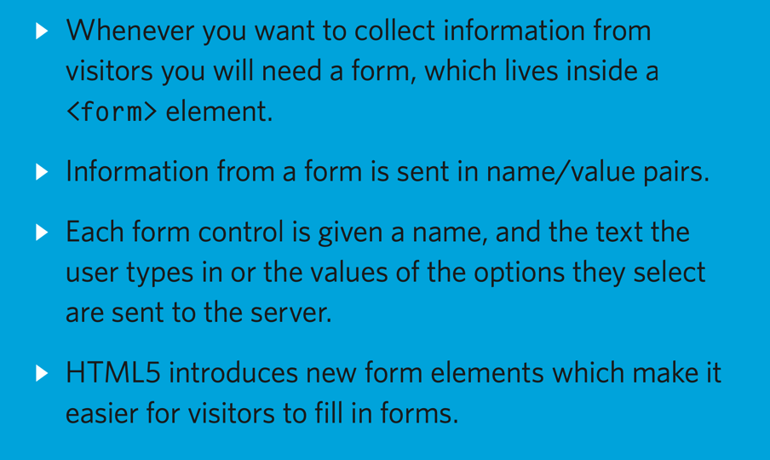

<https://www.phptutorial.net/php-tutorial/php-form/>

HTTP GET or POST

In general, you should use the GET method when the form only retrieves data from the server. For example, a search form that allows users to search for information should use the GET method.

When you have a form that causes a change in the server, you should use the POST method. For example, a form that allows users to subscribe to a newsletter should use the POST method.

用POST method:

html file 內

<form action="form.php" method="post">

<div>

<label for="email">Email:</label>

<input type="email" id="email" name="email" />

</div>

<button type="submit">Submit</button>

</form>

form.php內

<?php

if (isset($_POST['email'])) {

var_dump($_POST['email']);

}

用GET method:

html file 內

<form action="form.php" method="get">

<div>

<label for="email">Email:</label>

<input type="email" id="email" name="email" />

</div>

<button type="submit">Submit</button>

</form>

form.php內

<?php

if (isset($_GET['email'])) {

var_dump($_GET['email']);

// process the variable…

}