Nana Boateng
1 The implementation of Bays-Durham Algorithm for different k values of the table
For different values of k=2,8,16 and 32,it is observed that the sequence gets closer to it’s period as the table size increases.

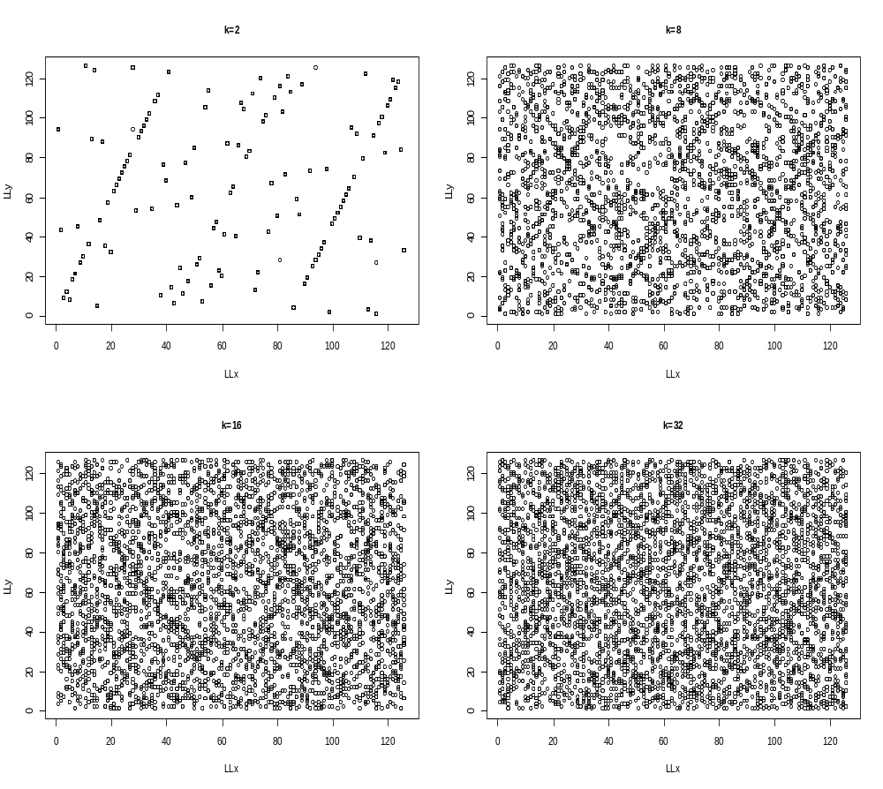

2 The implementation of Bays-Durham Algorithm for different sizes of the sequence
The sequence generated from Bays-Durham shuffling procedure moves closer to its period as the length of the sequence used in the procedure is increased.

