NANA BOATENG
SIMULATION AND COMPUTING

INTRODUCTION

Use of “random numbers" in statistics:

1. random sampling from a population
2. random assignments of treatments to experimental units
3. simulation and evaluation of
(a) stochastic process
(b) a complicated statistical procedure which is mathematically intractable.
(c) re-sampling (bootstrap)

Source of “random numbers"

1. In the older reference books, \Table of Random Number" is very common.
2. Historically, use of some external random physical process (coin tossing, atomic
decay)
3. Recently, almost all computer systems and/or packages will provide random
number generators to generate \random numbers" directly.
Some common and sometime interchangeable terms
1. Simulation
2. Monte Carlo Method
3. Re-sampling Method
Other Use of Simulation
1. engineering: physical process
2. natural sciences: biological process
3. cryptography (requires different criterion than simulation)

Linear Congruential Generator( LCG)

xi $≡$(axi₁ + c) mod m; with 0 $≤$xi < m:
1. a: multiplier
2. c: increment
3. m: modulus
4. x0: initial seed.
It is common to scale xi into (0,1) by

ui = xi/m

Other choice ?

ui = xi=(m - 1)

NOTE: it is transforming xi into (0,1] and it is less common.
LCG using xi can be re-written as
ui = aui-1 + e mod 1;
where e = c/m.

It has interesting relationship with _rst order autoregressive model
ui = _ui-1 + Ei:
AR(1) model in time series model.

Q: How to choose a ?

choose a so that it has the maximum period.

Period

Choice of c:

1. c $≠$ 0 : mixed congruential generator. Possible to have maximum period of m.
2. c = 0 : multiplicative linear congruential generator (MLCG). maximum possible
period is m 􀀀 1.
Choice of m:
1. m = 2^{w} for faster computer arithmetic. Cannot achieve maximum period for
MLCG. Maximum possible period is m=4.
2. m = p, a large prime number can be stored in a computer word. For example,
m = 2³¹ is most popular in 32-bits computers.

Choice of a:

Some mathematical results:
1. If m is a prime number, and a $≠$0 mod m. Then
A^{m-1} $≡$1 mod m:
(Fermat's Little Theorem)
2. If m is any number, and gcd(a;m) = 1. Then
a^{Φ(m)} $≡$ 1 mod m:

3. The smallest k > 0 such that
a^{k} $≡$1 mod m
is called the order (or exponent) of a.
4. If the maximum possible exponent (i.e. Φ(m)) is achieved, a is called a primitive
root modulo m.
5. For a prime number m, Φ(m) = m -1, maximum possible period for a LCG.
6. For a prime number m, how many primitive roots modulo m ? (Φ(m 􀀀 1)).
(a) why ? how to _nd all primitive roots ?
(b) ac mod m is a primitive root if and only if gcd(c;m - 1) = 1
(c) how to find the first primitive root (quickly) ?
(d) a^{(m-1)/q} = 1 for all q$|$(m - 1).
7. m has a primitive root if and only if m = p^{e} or m = 2p^{e-1}, for some e $≥$1.

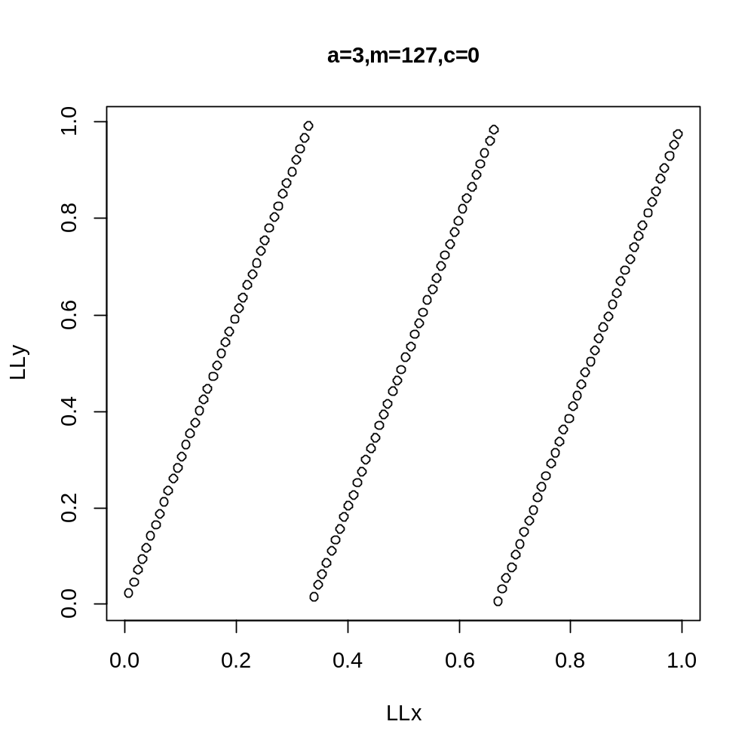

EFFECT OF CHOICE OF ‘a’ ON PERIOD
The choice of increment and modulus has an effect on period of the the LCG sequence generated.Larger increments and modulus generally increases the period as can be observed from the graphs.

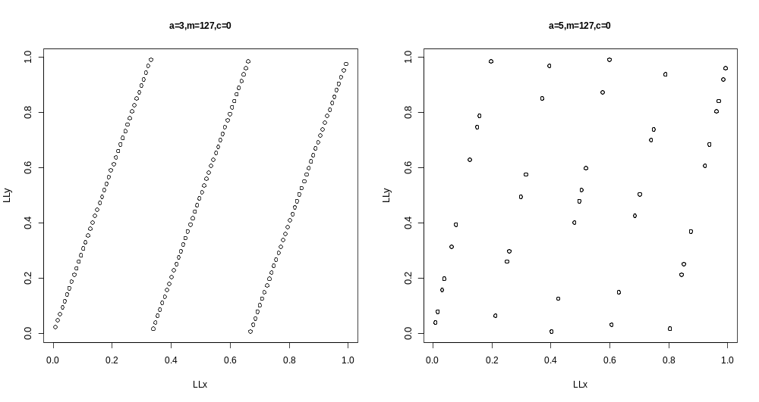

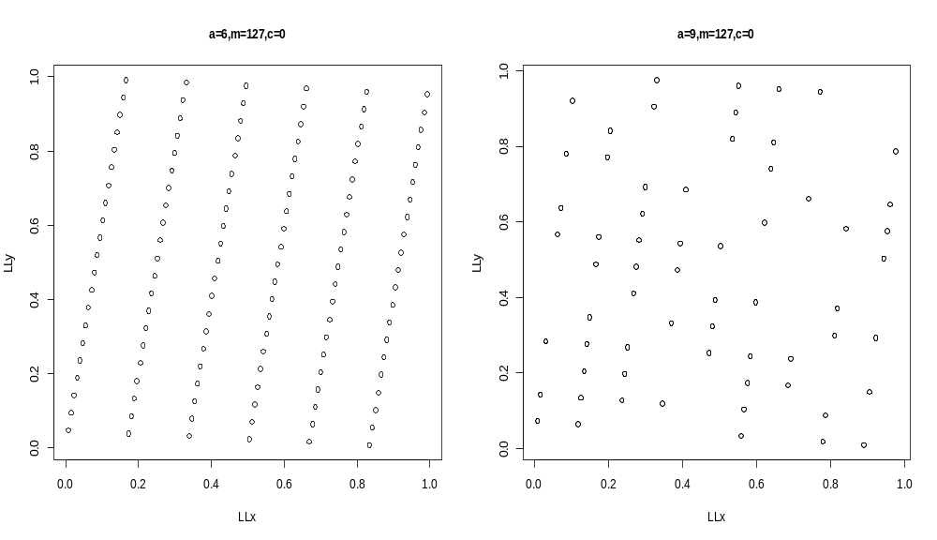

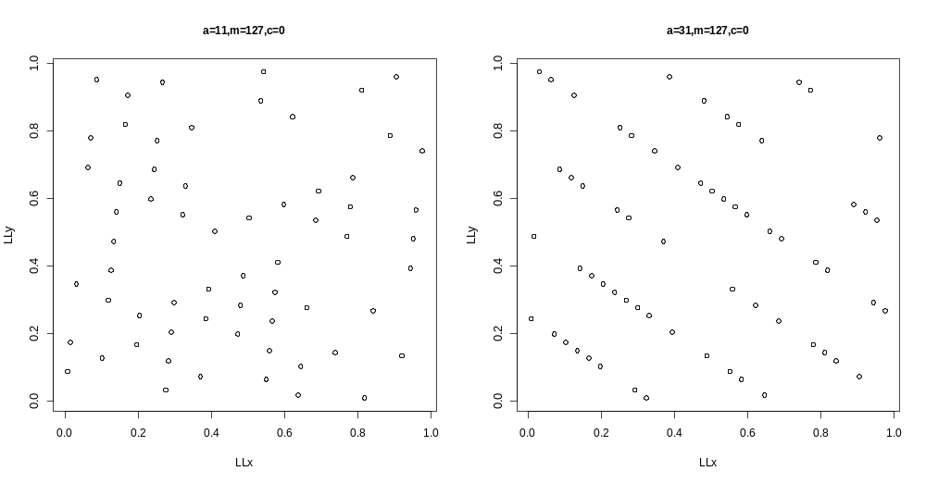

EFFECT OF CHOICE OF ‘m’ ON PERIOD

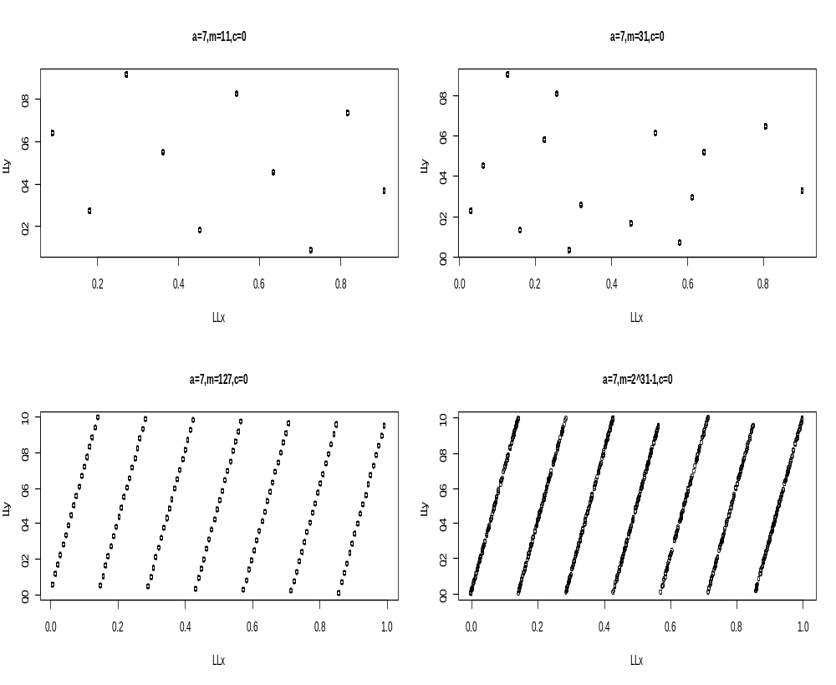

TWO DIMENSIONAL LATTICE POINTS PLOT
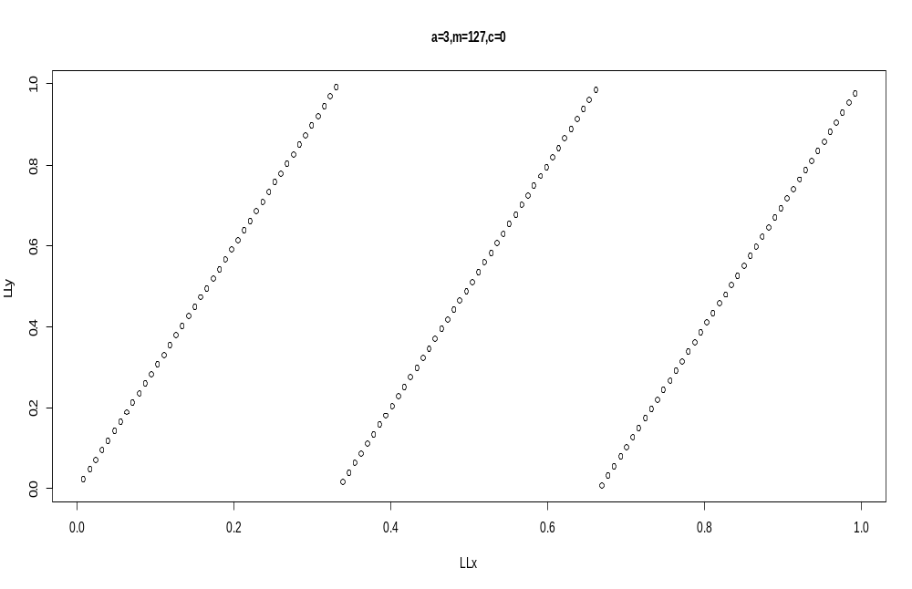

Tests of Simple LCG

There are two types of tests for a generator:
1. Theoretical - global property over the full cycle. e.g. period, or lattice structure:
number of parallel lines, shortest distance
(a) lattice test

(b) spectral test

2. Empirical - local property over a random sample selected.
(a) goodness-of-_t test
(b) many tests are available and many more can be constructed.

IMPROVEMENT ON THE LCG GENNERATOR
BAYS-DURHAM SHUFFLING GENERATOR
1. input auxiliary (baseline) sequence x1; x2; …
2. Output is y1; y2; …
3. using additional table/array (T) of k entries.
4. store x1; x2; …xk in table T, choose y1 = xk+1 as output
5. whenever an output (yi) is produced,
(a) use it to find the next entry j for which T[j] is selected as the next output.
(b) replace T[j] with next number in LCG sequence xi

Algorithm:
1. (Initialization) For i from 1 to k, T[i] = xi. Output y with xk+1.
(a) We use the LCG to generate x.
(b) In theory, it can be any initial sequence.
27
2. Select an entry j \randomly" (how?) from 1 to k. (T[j] is selected)
(a) In theory, it can be any RNG to generate the index j.
(b) For efficiency, we use the newly generated y to choose j as
j = (y mod k) + 1
3. Output y = T[j] and replace T[j] with next number by LCG.
4. Repeat (2)-(3)

IMPLEMENTATION
Comparison of the Bays-Durham shuffling generator to the simple LCG shows a great improvement in the rate at which the generator approaches it’s period.
EFFECT OF DIFFERENT SIZE N/ LENGTH OF SEQUENCE

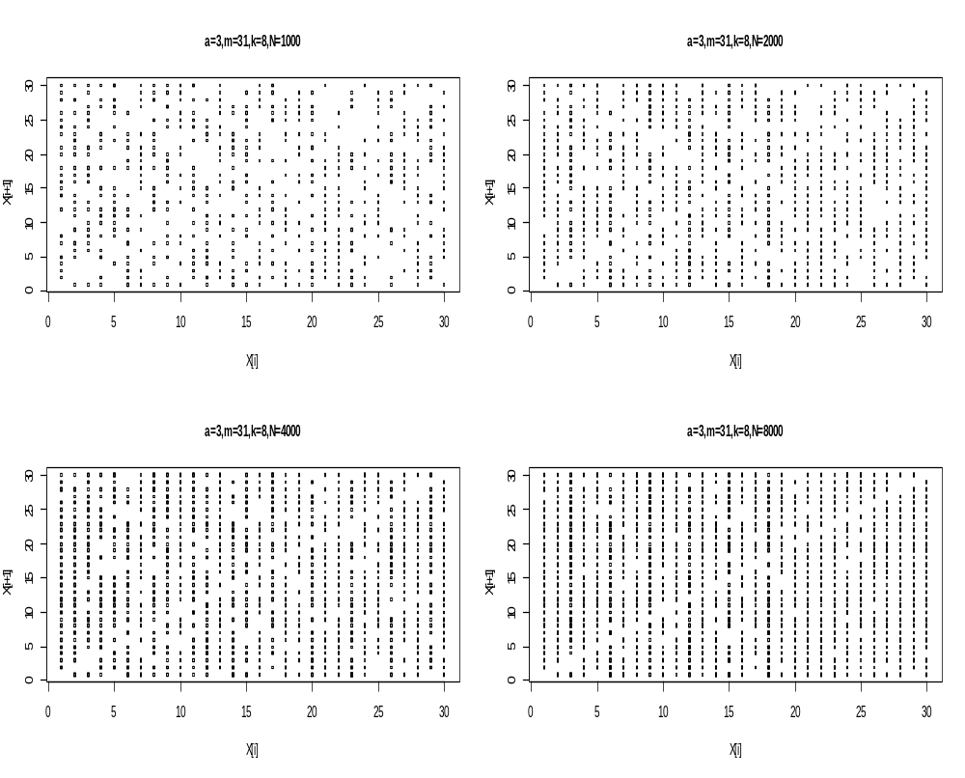
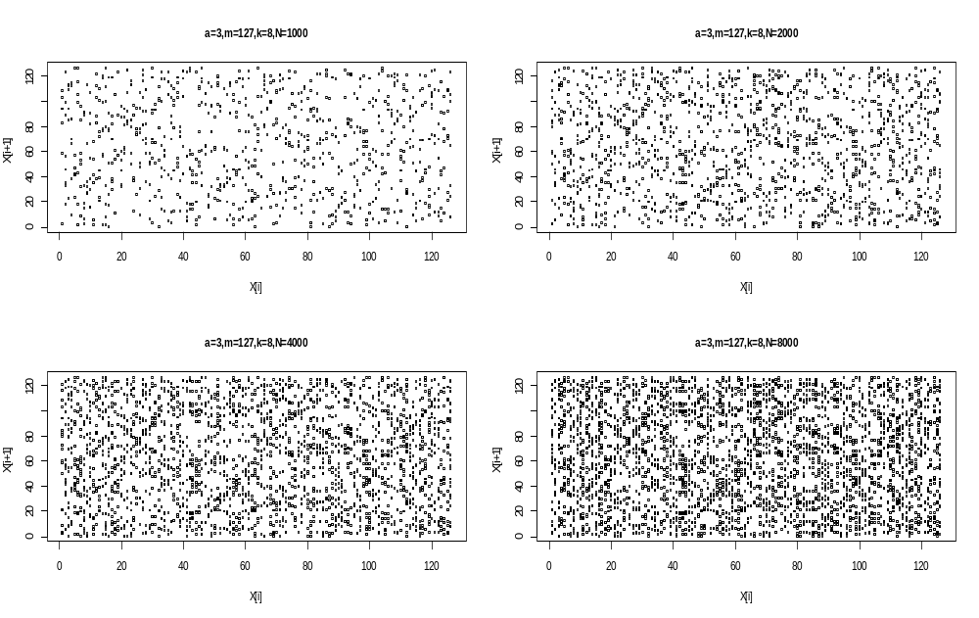

EFFECT OF DIFFERENT TABLE SIZE,K ON THE BAYS-DURHAM GENERATOR
For different values of k=2,8,16 and 32,it is observed that the sequence gets closer to it’s period as the table size increases.

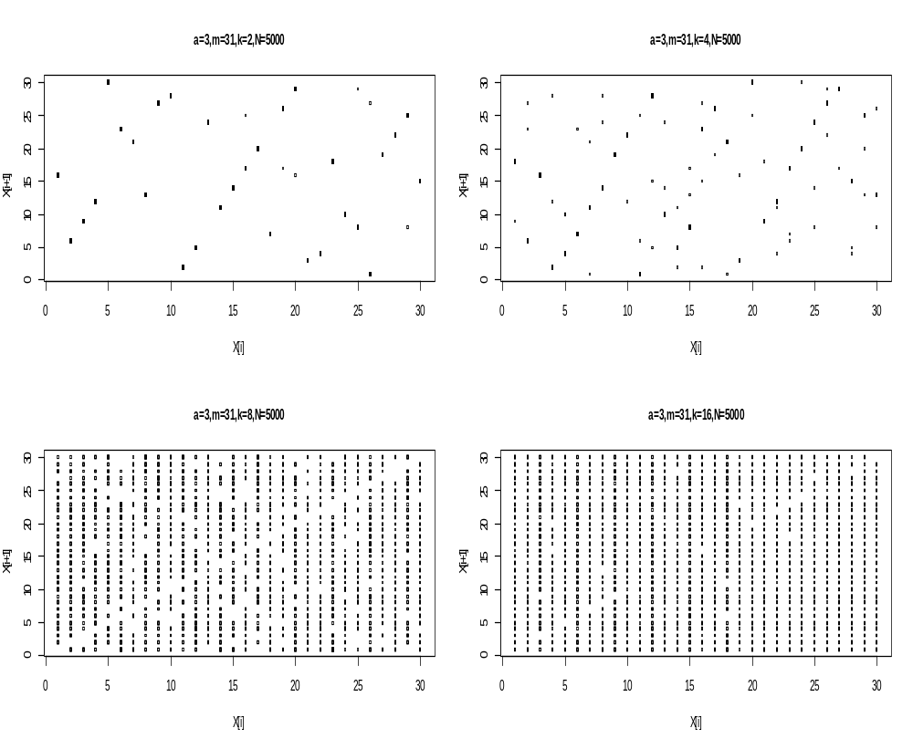

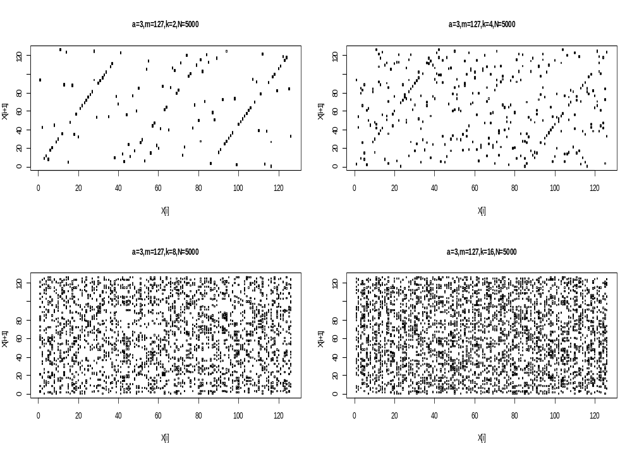

Metropolis-Hastings Method
Hastings (1970) extended Metropolis algorithm to form a more general
chain for acceptance/rejection step.

Define
r_{i}=min$\left(1,\frac{p(y)}{p(xi)}\frac{g(xi|y)}{g(y|xi)}\right)$
where g(y | x_{i}) is the transition probability from x_{i} to y.

Metropolis-Hastings Algorithm:
1. Start with any y₀, X₀ = y₀.
2. At the (i + 1)-th stage, generate y _{i+1} from g(y| x_{i}).
3. Generate u from U(0; 1).
4. If r_{i}$≥$ u
then X_{i+1} = y_{i+1}, else X_{i+1} = X_{i.}

Popular Choices of g(y|x_{i}):
- independence chain

- random walk chain

independence chain
- g(y|x_{i}) does not depend on xi, i.e., g(y|x_{i}) = g(y).
- Best choice" of g(y) is g(y) = p(y) because

r_{i}=min$\left(1,\frac{p(y)}{p(xi)}\frac{g(xi|y)}{g(y|xi)}\right)$=1

But, if we know how to generate g(y) = p(y), then we don't
need MHA to generate p(y).
- Choose g(y), is easy to generate, and is as close approximate to
p(y), if possible.
- Compare with Acceptance/Rejection method ?

random walk chain

Y = Xi + ϵ ,ϵ$\sim$ g(.)

where g(:) is usually a symmetric function around 0.
- e.g. g(y|x_{i}) $\sim$ N(x_{i},σ²).
i.e. Y = X_{i} + ϵ ,ϵ$\sim$ N(x_{i},σ²).

g(y|x_{i})=$\frac{1}{\sqrt{2πσ}}exp⁡\left(-\frac{1}{2}\frac{{(y-x_{i})}^{2}}{σ^{2}}\right)$

g(y|x_{i})= g(x_{i} |y)

r_{i}=min$\left(1,\frac{p(y)}{p(xi)}\right)$

- Improper choices of σ² may increase ρ₁:
1. σ² too small
2. σ² too large
- e.g. g(y|x_{i}) $\sim$ U(-a,a).

Implementation of Metropolis-Hastings Algorithm
e.g. posterior distribution (w/ uniform prior) of the linkage model:

p(θ|y)$∝{(2+θ)}^{125}{(1-θ)}^{38}θ^{34}$

The beta(56,34) seems to be the best performing in terms of convergence to the theoritical mean of about 0.622 which is closely followed by beta(55,30).
For different starting initial values of y0=0.95,0.5 and 0.05,all three starting initial values converged closely to the theoritical mean illustrating that the initial values are not greatly significant in the implementation of the metropolis hastings algorithm.

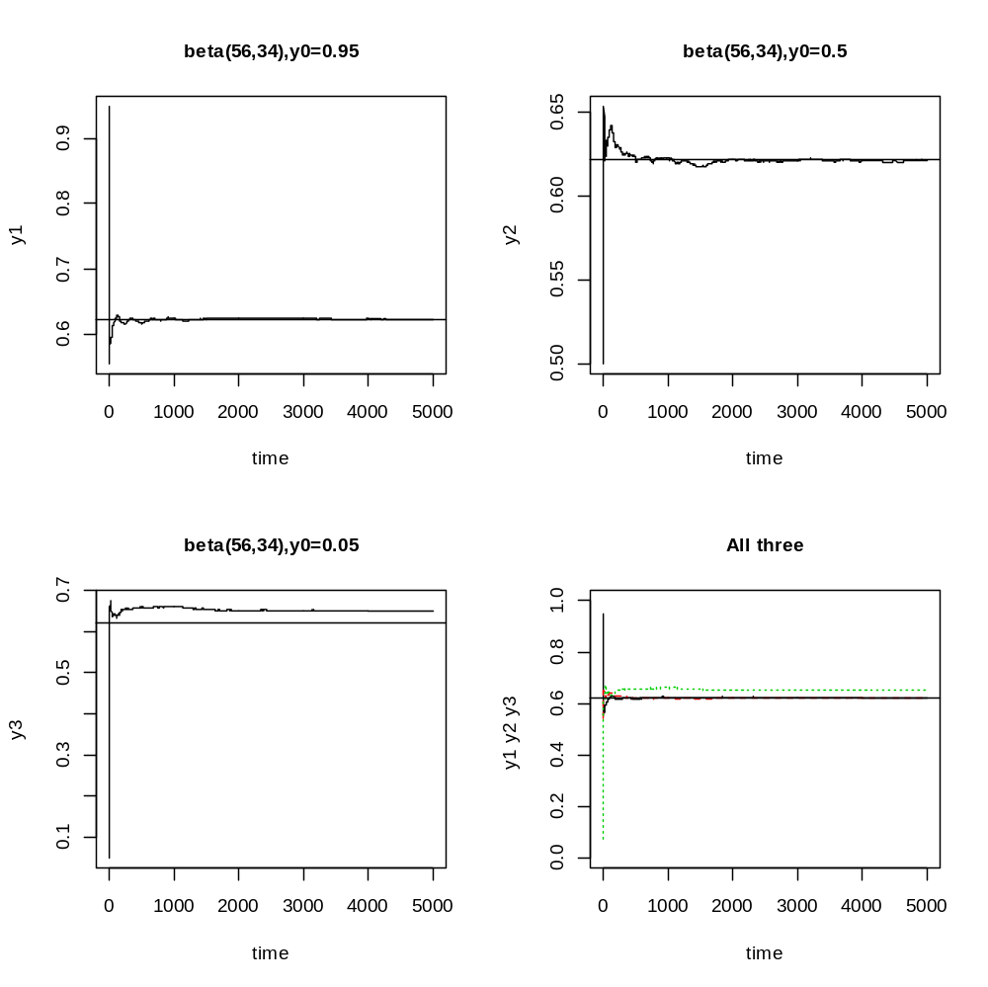

Slice Sampler Algorithm
If
P(x) ∝$\prod_{j=1}^{k}{f_{j}(x)}$, $f_{j}(x)≥0,$ 1$≤$j$≤k$

e.g. posterior distribution (w/ uniform prior) of the linkage model:

p(θ|y)$∝{(2+θ)}^{125}{(1-θ)}^{38}θ^{34}$

Goal: Estimation of its posterior mean via Slice/Gibbs Sampler
Define:
f₁₌ ${(2+θ)}^{125}$
f₂=${(1-θ)}^{38}$
f₃=$θ^{34}$
Starting with any 0 $≤ θ ≤$ 1, repeat steps (1)-(5)

- Generate z₁$\sim$_{U}$\left(0,{(2+θ)}^{125}\right)$
- Generate z₂$\sim$_{U}$\left(0,{(1-θ)}^{38}\right)$
- Generate z₃$\sim$_{U}$\left(0,θ^{34}\right)$
- For each z1; z2; z3 generated, find the range of θ

θ$≥z_{1}^{\frac{1}{25}}$-2

θ$≤1-z_{2}^{\frac{1}{38}}$

θ$≥z_{3}^{\frac{1}{34}}$

- . Generate θnew $\sim$ U(A;B), where (A;B) is
A=max$\left(z_{1}^{\frac{1}{25}}-2,z_{3}^{\frac{1}{34}}\right)$
B=$1-z_{2}^{\frac{1}{38}}$

SLICE SAMPLER OUTPUT
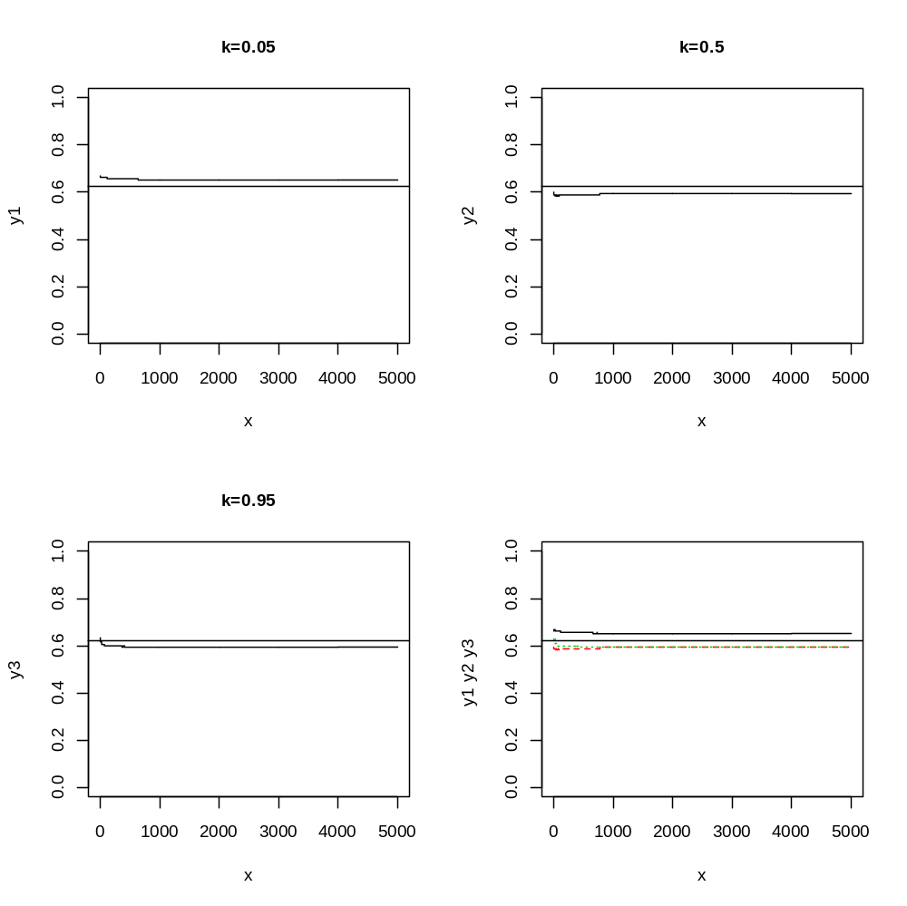I

GENERATING RANDOM SAMPLES FROM NORMAL DISTRIBUTION

BOX-MULLER ALGORITHM
X$\sim N(µ,σ^{2}$) with probablity density function
$$\frac{1}{\sqrt{2πσ^{2}}}exp\left(\frac{{\left(x-µ\right)}^{2}}{2σ^{2}}\right)$$

Standard normal distribution: Z $\sim$N(0; 1) with p.d.f
$$\frac{1}{\sqrt{2π}}exp\left(\frac{x^{2}}{2}\right)$$

X₁=$\sqrt{-2log(U_{1})}$cos(2π$U_{2}$)

X₂=$\sqrt{-2log(U_{1})}$sin(2π$U_{2}$)

If U1; U2 are i.i.d. U(0; 1), then X1;X2 are i.i.d. N(0; 1).

IMPLEMENTATION OF THE BOX-MULLER ALGORITHM
SUMMARY OF OUTPUT WITH GRAPHS
Two uniform U(0,1) sequences are generated from an LCG method with different initial points but the same multiplier ,increment and size.These two uniform sequences are the used in the Box-Muller algorithm to generate x and y.From the graphs it is clear the nature of the standard normal distribution generated greatly depends of the choice of LCG sequence used in generating x and y.In thye various LCG’s used I found out the LCG sequence with increment c=0,a=16807 and m=2^31-1 performed considerably better than the others.The worst perfomance was from the LCG sequence with m=2048,a=1229 and c=1.It’s graph looked much normal with no observable clear pattern.Each of the different LCG sequences used produced different graphs confirming the fact that normality in the Box-Muller algorithm greatly rest on the particular LCG sequence chosen.The Polar Method was computationally faster to generate because unlike the Box-Muller,there were no computations of trigonometric functions sine and cosine involved in the Box-Muller method which are comparatively expensive in many computing environments. The polar method differs from the basic method in that it is a type of rejection sampling.

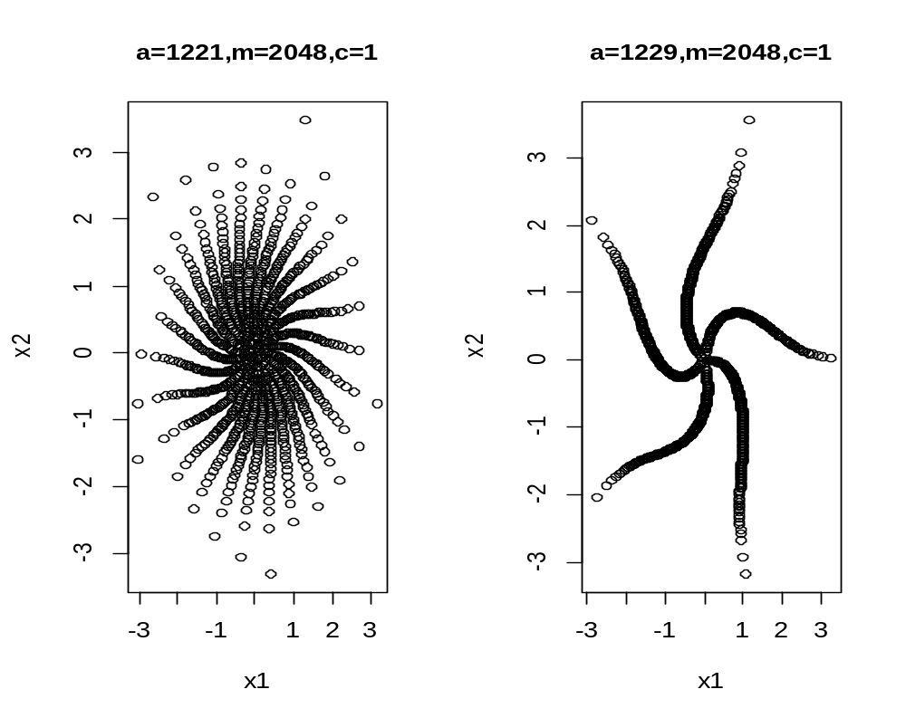

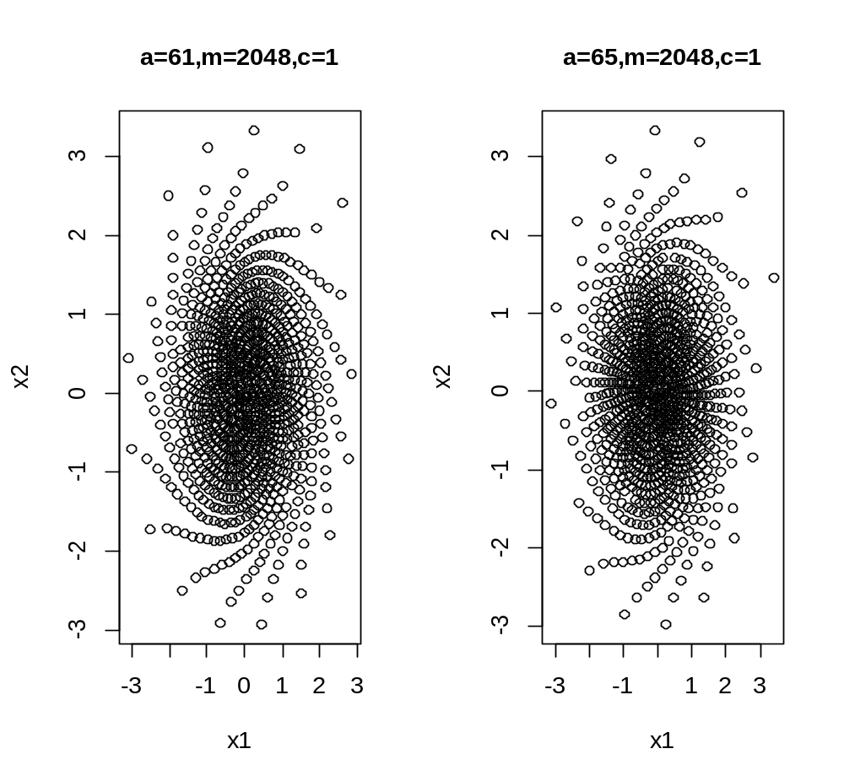

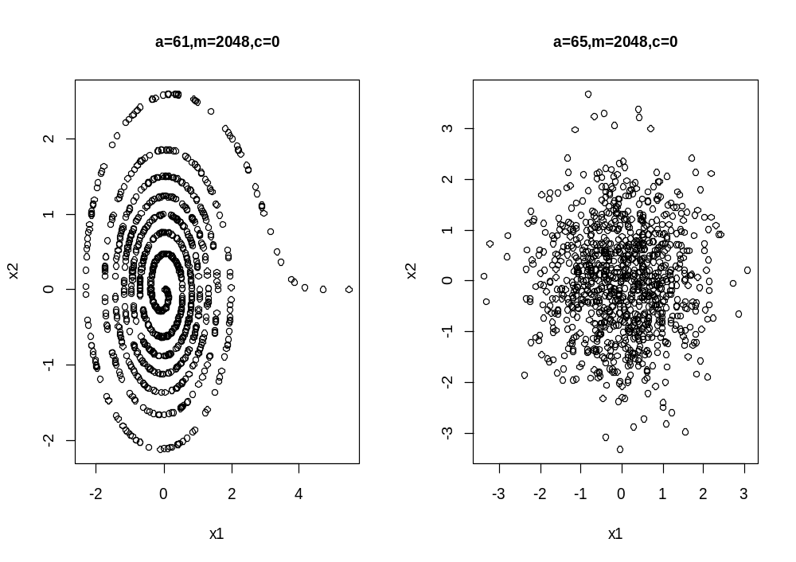

THE POLAR METHOD
