NANA BOATENG
MATH 7685-8685: SIMULATION AND STATISTICAL COMPUTING

Spring, 2013

SUMMARY
Through MATH 7685-8685 class, I have been exposed to some very important techniques which are commonly used in random number generation. Random number generation is a very important tool in Applied Statistics and Mathematics. They are greatly used in fields such as stock simulation and other stochastic process. Among them include the Linear Congruential Generator, Bays Shuffling Algorithm, and Multiplicative Recursive Generator, Matrix Congruential Generator, Non-Linear Congruential Generators, linear Feedback Shift Register Generator, Generalized Feedback Shift Register Generator and others which are a combination of these aforementioned generators. The LCG is very sensitive to parameter choices. A bad parameter choice can lead to very poor output and also linearity in the lattice structure. The Bays-Durham Algorithm is an improvement on the LCG which resolves its sensitivity to parameter choices. Markov Chain Monte Carlo (MCMC) is method of estimating a distribution and also finding its mean and variance. Among some of the MCMC discussed in class were the MLE and EM Algorithm, ayes Estimator and Data Augmentation, Rejection and Metropolis Method, Gibbs Sampler, Metropolis Hastings Algorithm and the Slice Sampler Method. These two methods were used to estimate the mean of a genetic linkage model. Both methods resulted in the same result of 0.622.In terms of computational efficiency the Metropolis Hasting Algorithm was much faster than the Slice Sampler Algorithm. We further discussed simulation of random numbers from specific distributions. We found out that the Box-Muller and Polar Methods were a means by which we can generate the standard normal distribution. The Polar Method is an improvement on the Box-Muller and is computationally efficient because it does not involve the computation of trigonometric functions.
INTRODUCTION
Random numbers have applications in many areas such as computer simulation of stochastic processes, resampling methods(bootstrap), completely randomized design , random sampling from a population, game-playing, cryptography, statistical sampling, evaluation of multiple integrals, particle transport Calculations and computations in statistical physics.
Common sources of random numbers include table of random numbers, external physical random process such as tossing a coin and atomic decay and computer systems.
There are a variety of random generators with each having its own advantages and disadvantages. The commonest generator is The Linear Congruential generator.

Computer systems cannot truly generate random numbers because the computer algorithms used in the process is based solely on deterministic computation cannot be regarded as a "true" random number generator, since its output is inherently predictable. A measurement of a physical process such as tossing an unbiased coin is truly random.

A more practical approach to generating random numbers is the pseudo-random sequence, a series of numbers generated by a deterministic process that is intended merely to imitate a random sequence but which, of course, does not rigorously obey such things as the laws of large numbers.

OUTLINE
- Linear congruential Generator
- Bays-Durham Shuffling Generator
- Metropolis Hastings Algorithm
- Slice Sampler Method
- Simulating Random Numbers from The Normal Distribution
- The Box-Mueller Method
- The polar Method

Linear Congruential Generator (LCG)

The Linear congruential generator is one of the most common ways pseudorandom numbers are generated. It is common despite it’s severe defect of being sensitive to the choice of multiplier, increment and modulus. because, it is easy to implement.

- Xn+1$≡$(axn + c) mod m; with 0 $≤$xi < m:
- a: the integer multiplier
- c: increment
- m: modulus for the modular arithmetic
- x0: initial seed.
- x_{n+1}: n+1 ^{th} random integer
- X_{n}: n ^{th} random integer

- The next random integer X_{n+1} is generated using the previous random integer X_{n}, the integer constants a and c, and the integer modulus m.

- After the integer (aX_{n}+ c) is generated, modulo arithmetic using the modulus m is performed, to yield the new “random” integer X_{n+1}

- The method requires an initial seed, X₀, to get started

- The entire LCG sequence is characterized by the multiplier, a; the additive constant, c; the modulus, m; and the initial seed X_{0.}

- The case c ≠ 0 is termed a mixed congruential random number generator

- The case c = 0 is termed a multiplicative congruential random number generator
.

- The period of the LCG can be at most m when it has an increment and m-1 if the increment is 0. The quality of the generator strongly depends on the choice of the parameters in the LCG.

- linear, congruential generators with a prime modulus, using a non-zero c does not increase the period.

- m=2^{w} is common choice of modulus because it provides faster computer arithmetic in the process of performing the modulus operation it is very efficient. Large prime numbers are also suitable because they can be stored in computer word.

- The different choice of the initial seed shifts the starting point in the sequence which is already determined by a, c and m.

- Fermat Little Theorem tells us that if the modulus m is a prime number and a$≠0 mod m$ ,then
$a^{m-1}≡1 mod m$

- For a prime number m,the first set of primitive roots are found by

${ a}^{(m-1)/q}≠1$ for all $q | m-1$

The Euler’s totient function is defined as the number of integers between 1 and m ,that are relatively prime to m.

$$Φ\left(m\right)=m\prod_{i=1}^{c}{\left(1-p_{i}\right)}$$
Where
$m=p_{1}^{r1}p_{2}^{r2}{….p}_{c}^{rc}$

IMPLEMENTATION OF A SIMPLE LCG

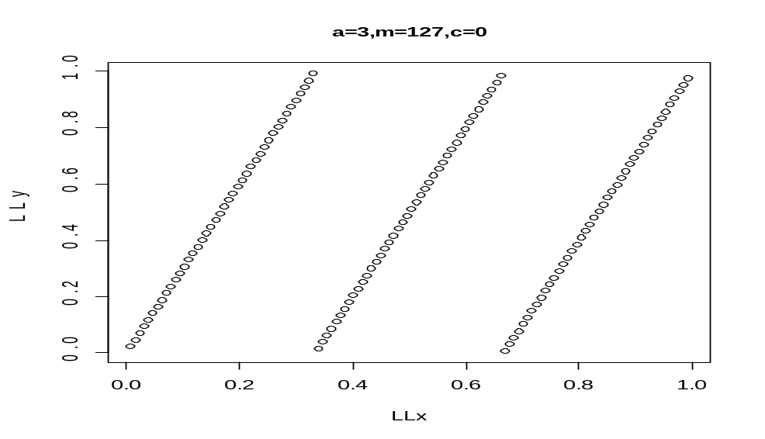

The figure above shows the set of points produced by the output of LCG the generator with a=3,m=127 and c=0.Note that the points form one set of rows. The best situation
is to have the maximum spacing of the rows, when viewed over all angles, as small as possible.

EFFECT OF CHOICE OF MULTIPLIER, MODULUS AND INCREMENT ON PERIOD OF LCG
The choice of increment and modulus has an effect on period of the LCG sequence generated. Larger increments and modulus generally increases the period as can be observed from the graphs below.
When the maximum spacing is large, as it certainly is in LCG(a=3,m=127,c=0), LCG(a=6,m=127,c=0), then clearly the unit square is not well covered by this set of points, and the results of Our simulation may be adversely affected by this “striping”.

Figures LCG(a=1101,m=12007,c=0) and LCG(a=1108,m=12007,c=0), shows the effect of a good choice of LCG parameters for which the maximum spacing between rows is clearly smaller than it is in the first two cases, and where the points cover the unit square with nearly optimal uniformity, given that with this generator we can generate only a small number of points.

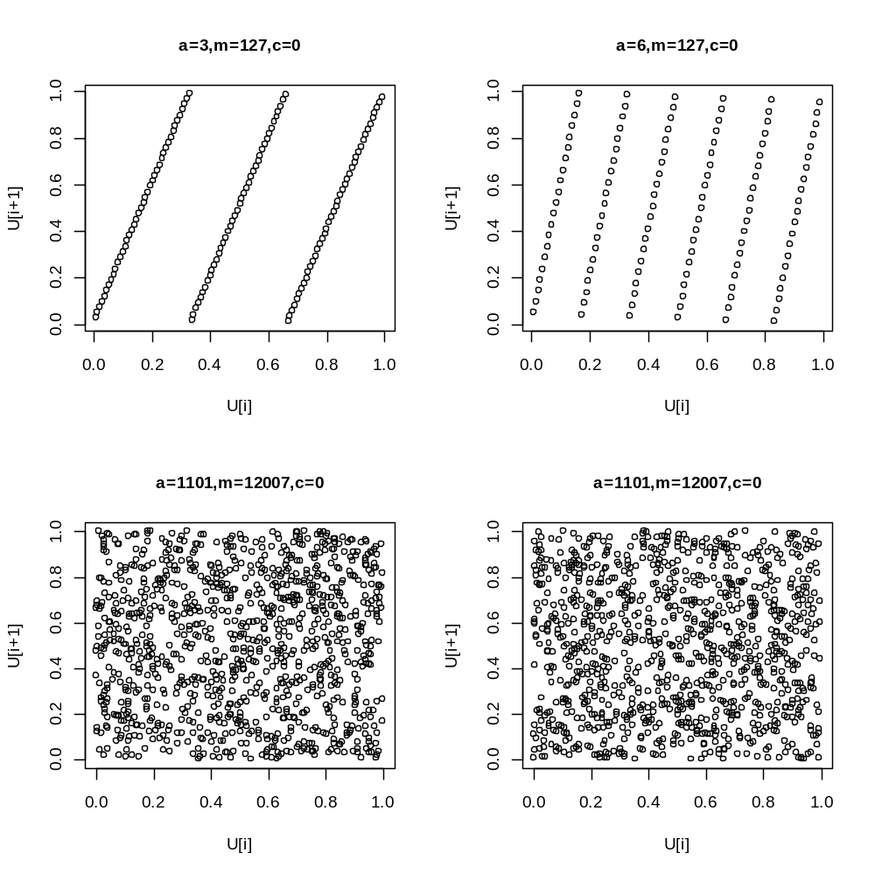

LATTICE STRUCTURE
In general a generator with a bad lattice structure in lower dimension will have a bad lattice structure in higher dimension whereas a generator with a bad lattice structure may have a bad lattice structure in a higher dimension.

TWO DIMENSIONAL LATTICE POINTS PLOT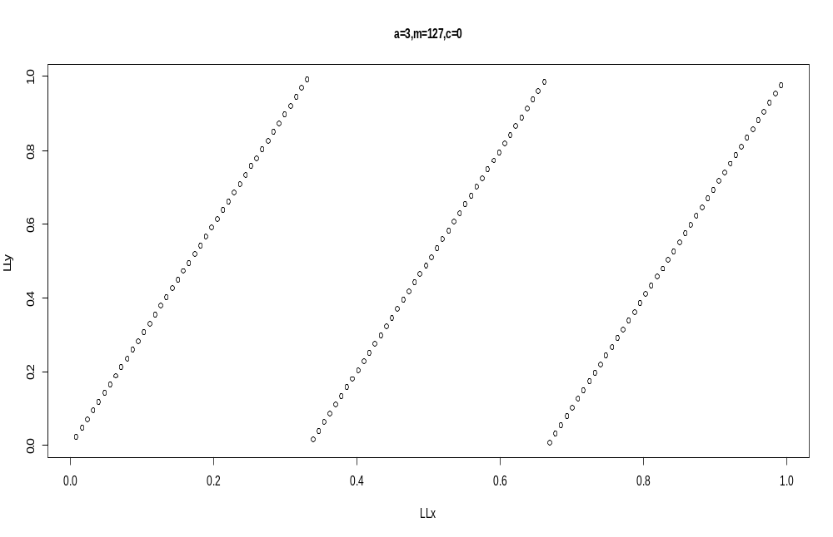

TEST OF LCG
The theoretical or global property of LCG over the full cycle is investigated the spectral and lattice test.
The empirical or local property over a random sample selected can be achieved by a goodness- of- fit test and several others which can be constructed.

IMPROVEMENT ON THE LCG GENNERATOR
BAYS-DURHAM SHUFFLING GENERATOR
The Bays-Durham shuffling algorithm is an improvement of the linear Congruential operator. The period of the simple LCG generator is greatly increased by Bays-Durham shuffling algorithm. It also breaks up the linear lattice structure. On the other hand, because it uses two generators, it can be very slow. The period of the shuffled generator can be increased${ O\left(k!c\right)}^{1/2}$ where c is the period of the original LCG and k is the length of the table used in the shuffling.

IMPLEMENTATION
Comparison of the Bays-Durham shuffling generator to the simple LCG shows a great improvement in the rate at which the generator approaches its period. The linear lattice structure in the LCG is also broken in Bays-Durham implementation
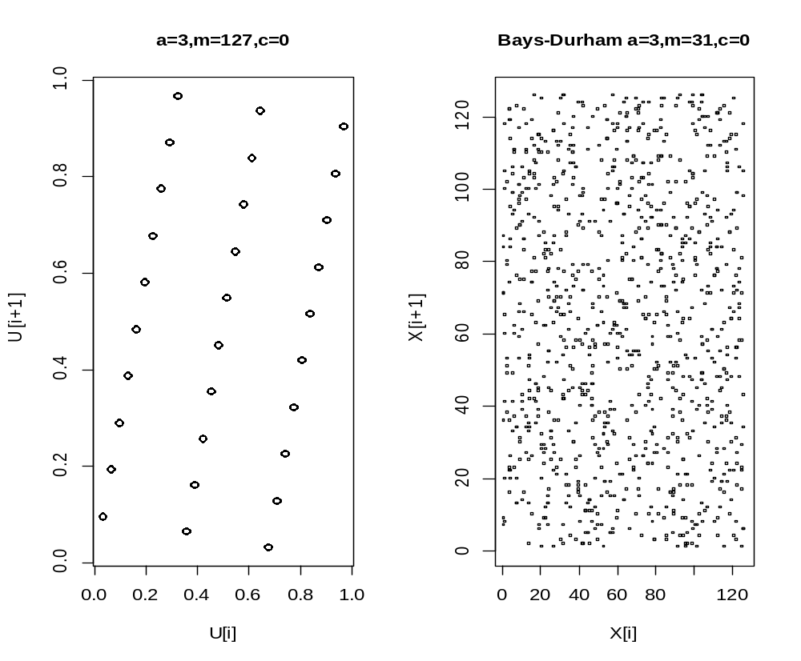

EFFECT OF DIFFERENT SIZE N/ LENGTH OF SEQUENCE
The period of the LCG sequence increases as the length of the sequence increases. This can be clearly demonstrated by the figures below.

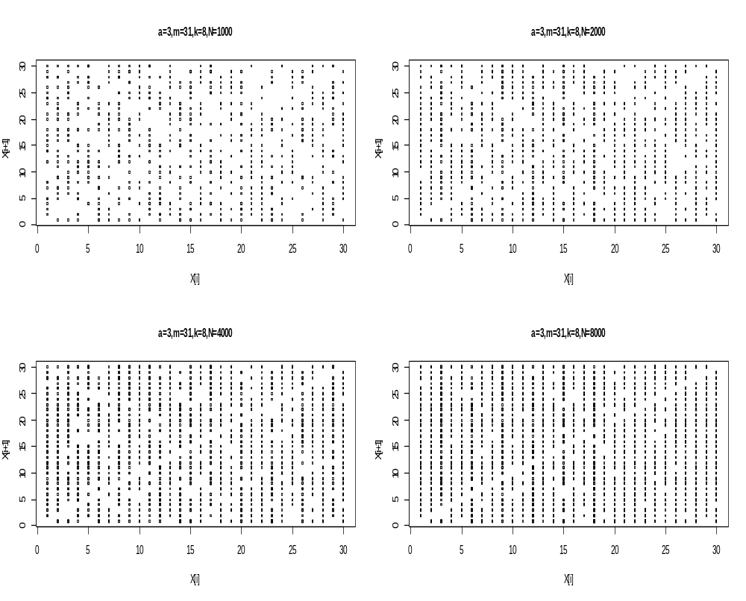
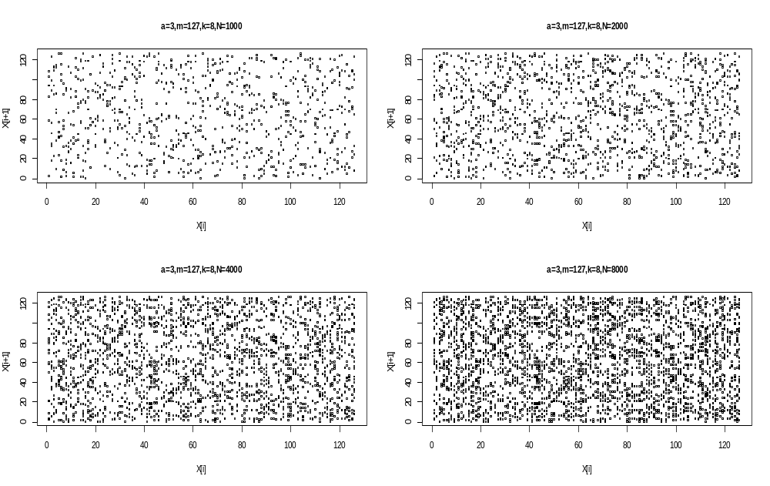

EFFECT OF DIFFERENT TABLE SIZE,K ON THE BAYS-DURHAM GENERATOR
For different values of k=2,8,16 and 32,it is observed that the sequence gets closer to it’s period as the table size increases.This is clearly demonstrated by the figures below.

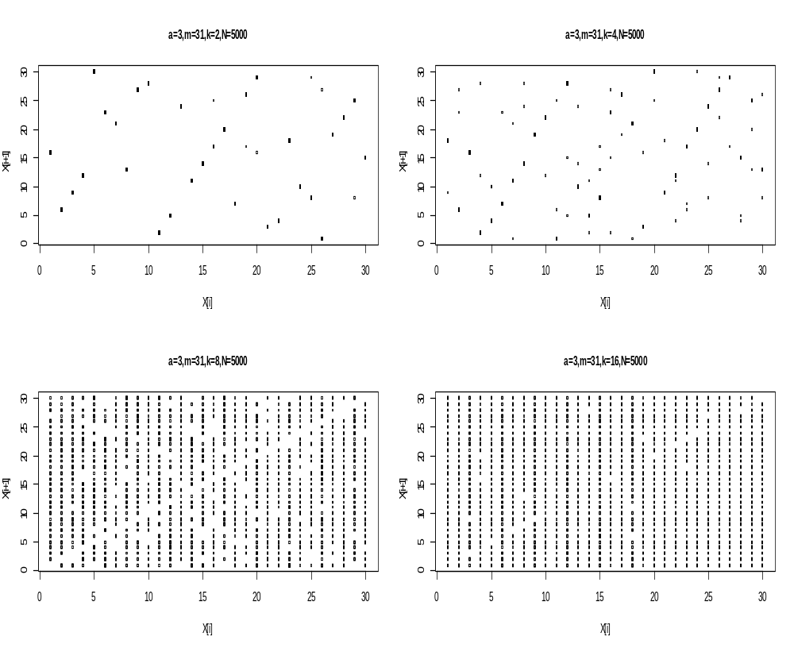

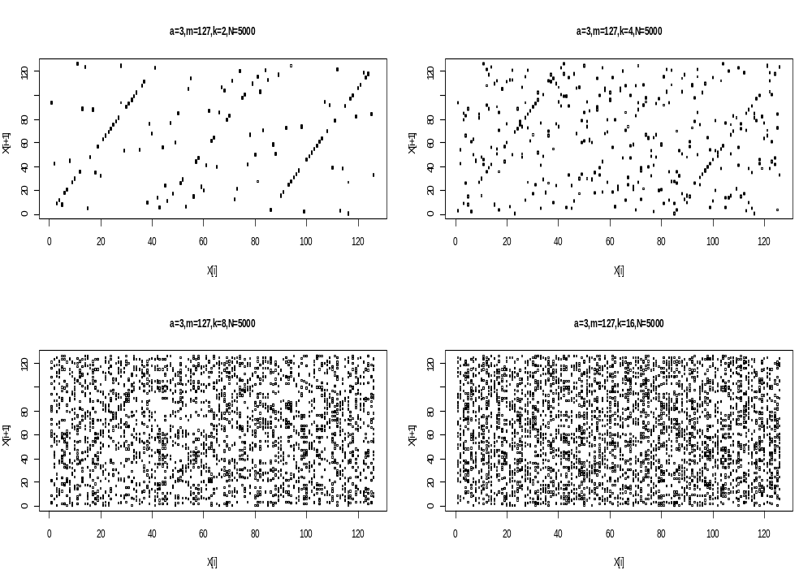

Metropolis-Hastings Method

Implementation of Metropolis-Hastings Algorithm
The posterior distribution (w/ uniform prior) of the linkage model below is implemented.

p(θ|y)$∝{(2+θ)}^{125}{(1-θ)}^{38}θ^{34}$

The beta(56,34) seems to be the best performing in terms of convergence to the theoritical mean of about 0.622 which is closely followed by beta(55,30).
For different starting initial values of y0=0.95,0.5 and 0.05,all three starting initial values converged closely to the theoritical mean illustrating that the initial values are not greatly significant in the implementation of the metropolis hastings algorithm.

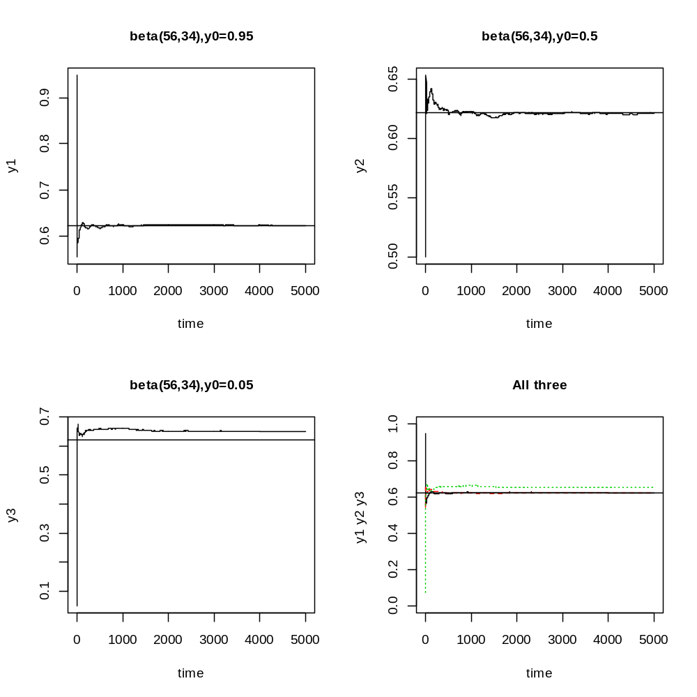

Slice Sampler Algorithm
If
P(x) ∝$\prod_{j=1}^{k}{f_{j}(x)}$, $f_{j}(x)≥0,$ 1$≤$j$≤k$

The posterior distribution (w/ uniform prior) of the linkage model below is implemented by the slice sampler algorithm.

p(θ|y)$∝{(2+θ)}^{125}{(1-θ)}^{38}θ^{34}$

THE SLICE SAMPLER OUTPUT
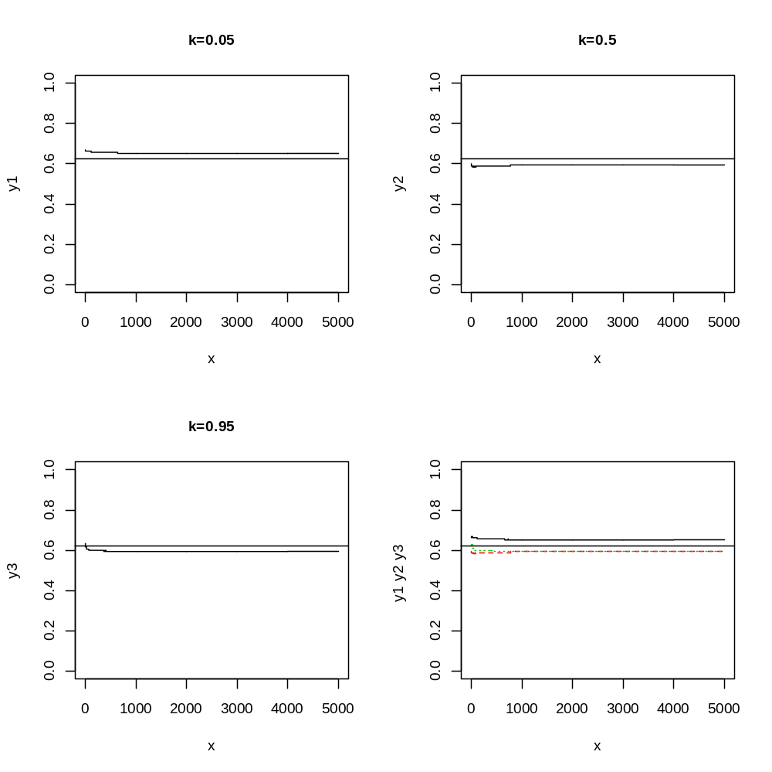

GENERATING RANDOM SAMPLES FROM NORMAL DISTRIBUTION

BOX-MULLER ALGORITHM

X$\sim N(µ,σ^{2}$) with probablity density function
$$\frac{1}{\sqrt{2πσ^{2}}}exp\left(\frac{{\left(x-µ\right)}^{2}}{2σ^{2}}\right)$$

Standard normal distribution: Z $\sim$N(0; 1) with p.d.f
$$\frac{1}{\sqrt{2π}}exp\left(\frac{x^{2}}{2}\right)$$

X₁=$\sqrt{-2log(U_{1})}$cos(2π$U_{2}$)

X₂=$\sqrt{-2log(U_{1})}$sin(2π$U_{2}$)

If U1; U2 are i.i.d. U(0; 1), then X1;X2 are i.i.d. N(0; 1).

IMPLEMENTATION OF THE BOX-MULLER ALGORITHM
SUMMARY OF OUTPUT WITH GRAPHS
Two uniform U(0,1) sequences are generated from an LCG method with different initial points but the same multiplier ,increment and size.These two uniform sequences are the used in the Box-Muller algorithm to generate x and y.From the graphs it is clear the nature of the standard normal distribution generated greatly depends of the choice of LCG sequence used in generating x and y.In thye various LCG’s used I found out the LCG sequence with increment c=0,a=16807 and m=2^31-1 performed considerably better than the others.The worst perfomance was from the LCG sequence with m=2048,a=1229 and c=1.It’s graph looked much normal with no observable clear pattern.Each of the different LCG sequences used produced different graphs confirming the fact that normality in the Box-Muller algorithm greatly rest on the particular LCG sequence chosen.The Polar Method was computationally faster to generate because unlike the Box-Muller,there were no computations of trigonometric functions sine and cosine involved in the Box-Muller method which are comparatively expensive in many computing environments. The polar method differs from the basic method in that it is a type of rejection sampling.

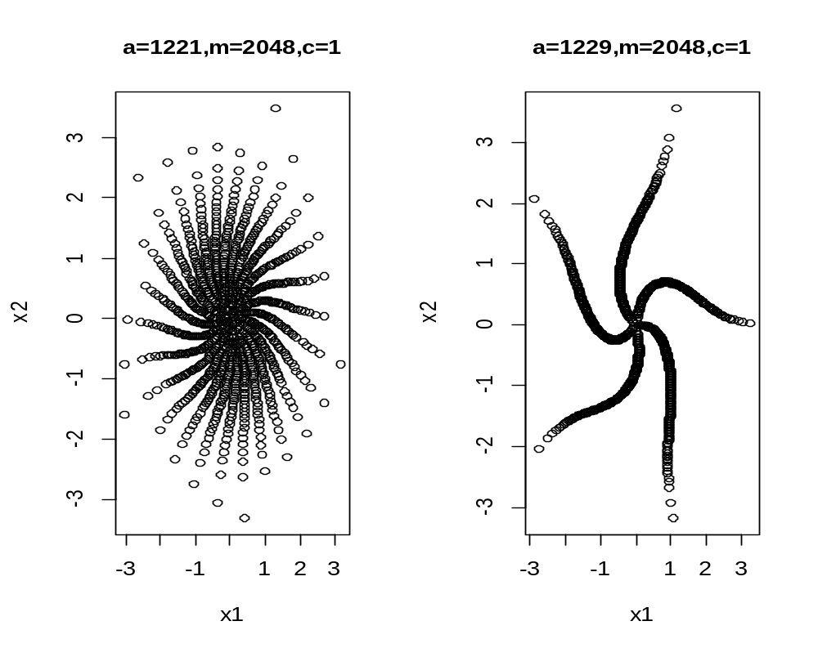

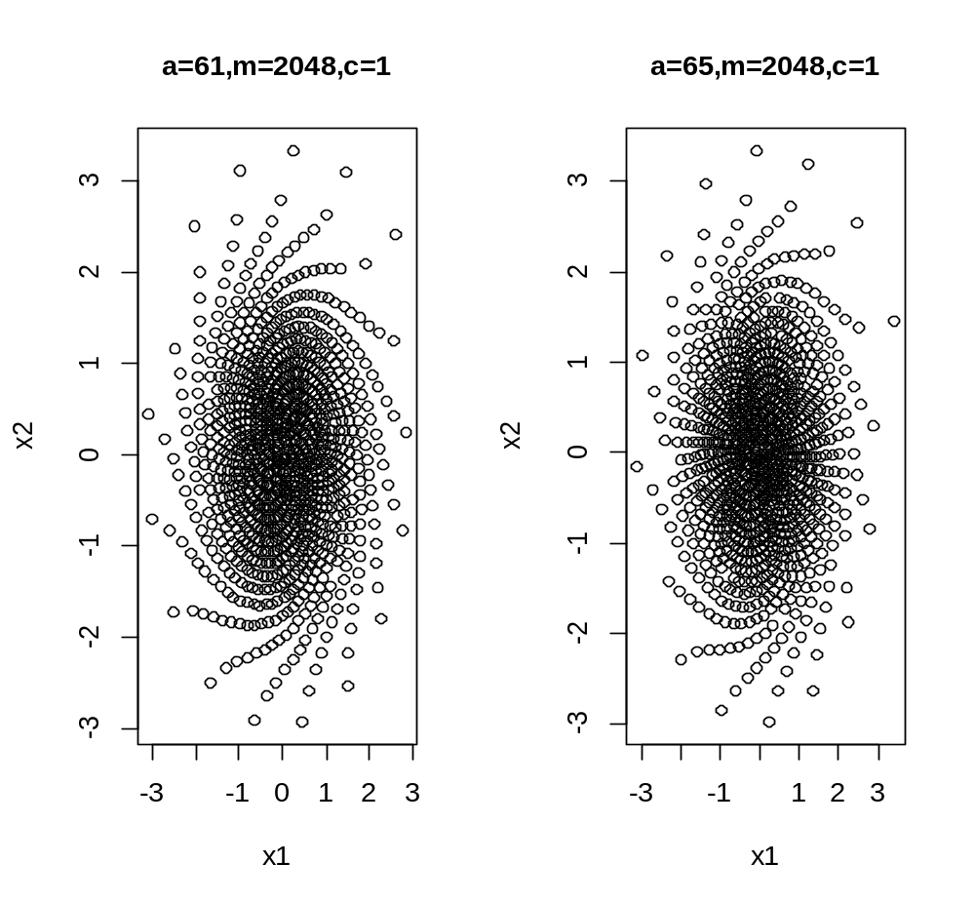

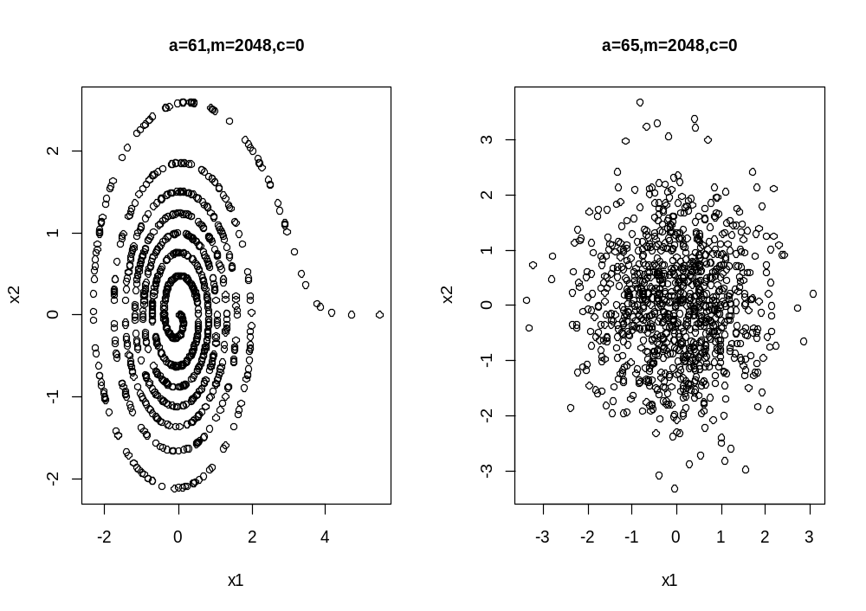

THE POLAR METHOD
