**Internal Consistency Measurement, Patient Survey Data**

**\* Satisfaction with treatment plan (p. 3 patient survey);**

ptsumsattxplan= sum(xpt_sat_treatment_plan, xpt_sat_treatment_compl);

The internal consistency check on this variable is good. The Cronbach coefficient alpha is greater than 0.8 and kappa test is also significant.

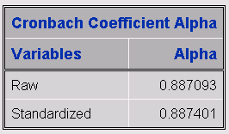

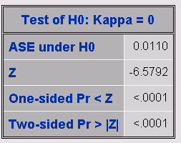

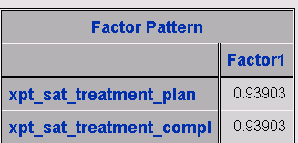

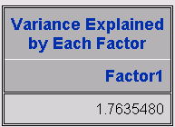

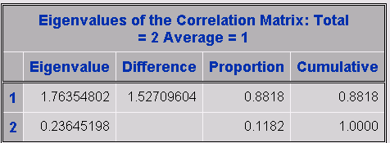

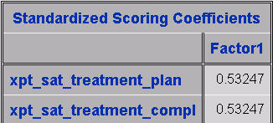

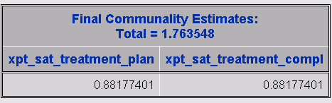

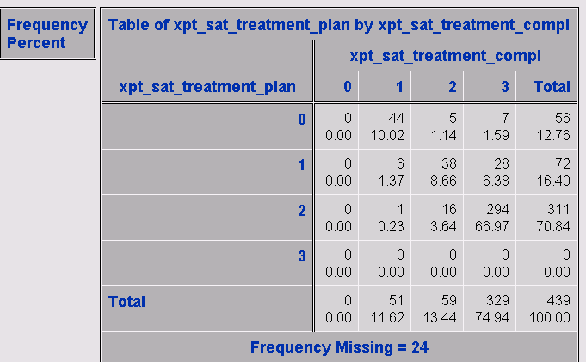

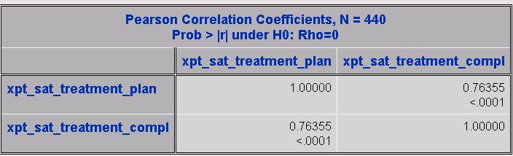

**\* Barriers to completing treatment plan (p. 4 patient survey);**

**sumbarriers= sum(xpt_issues_a, xpt_issues_b, xpt_issues_c, xpt_issues_d, xpt_issues_e, xpt_issues_f, xpt_issues_g, xpt_issues_h);**

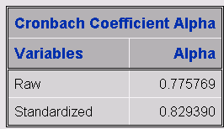

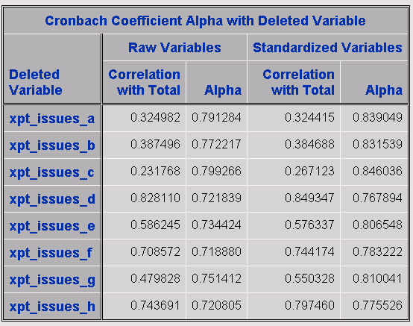

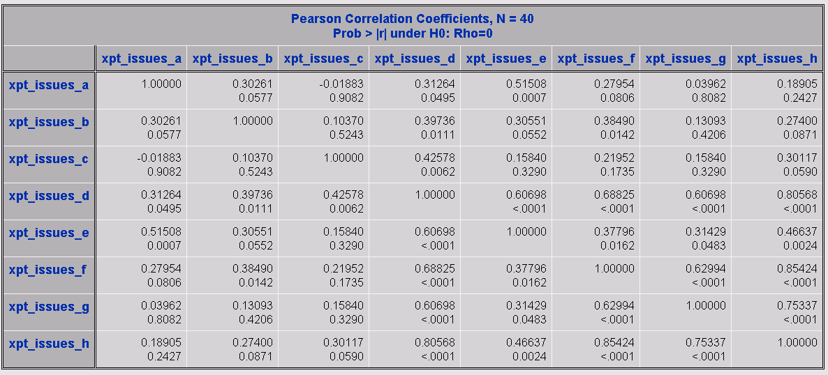

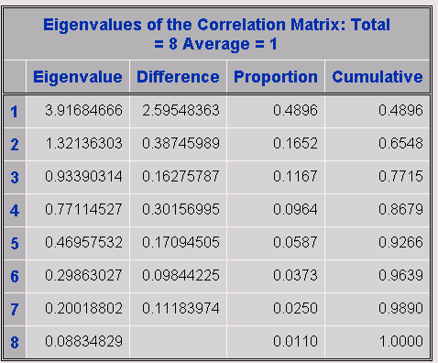

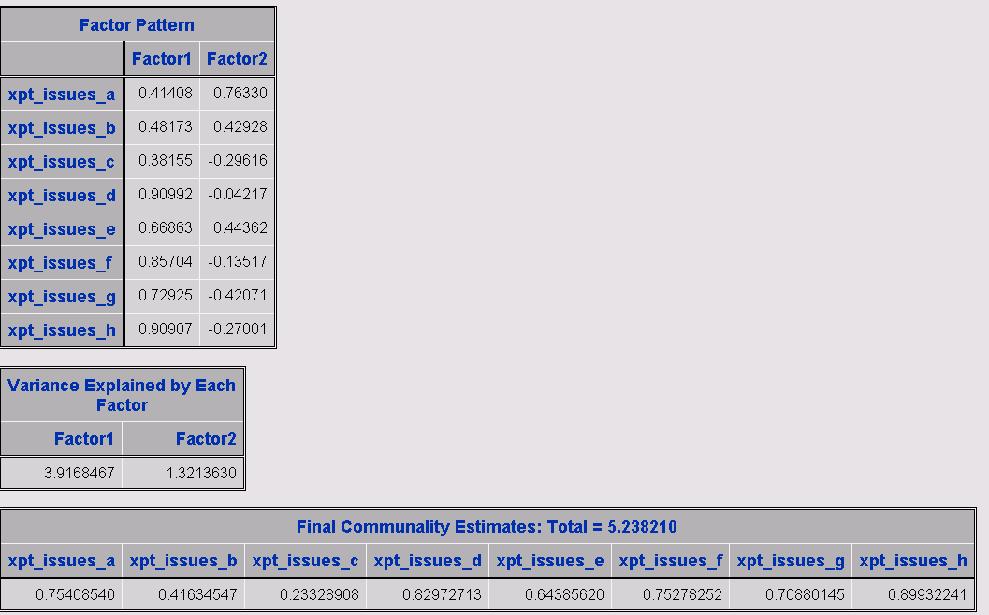

**\* Satisfaction with quality of care from various team members (p. 4 patient survey);**

sumsatqc= sum(xpt_sat_care_pcc, xpt_sat_care_onc, xpt_sat_care_pulm, xpt_sat_care_surgeon, xpt_sat_care_nurse_nav, xpt_sat_care_other_nurses, xpt_sat_care_nonclinic, xpt_sat_care_whole_team);

The Cronbach coefficient alpha for this item is lower than 0.7 indicating that this item measurement is questionable. The xpt_sat_care_surgeon has negative correlation with total

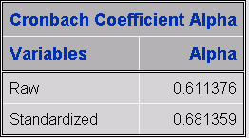

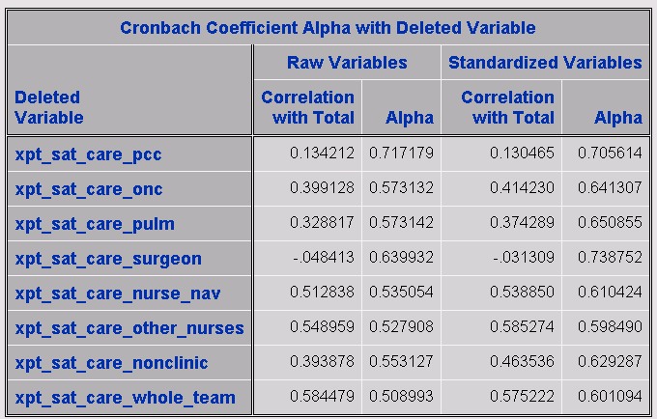

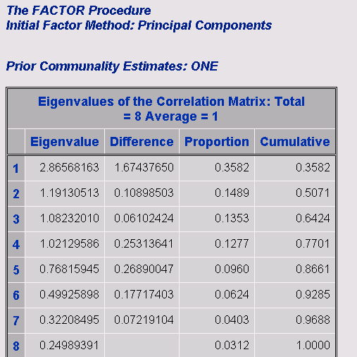

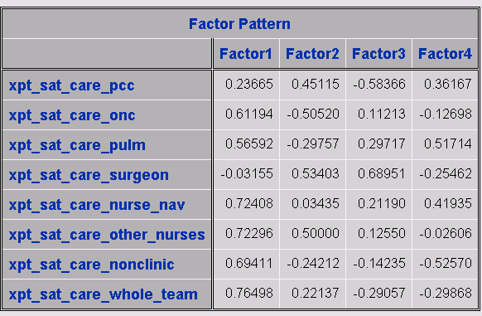

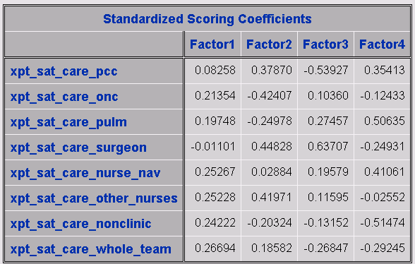

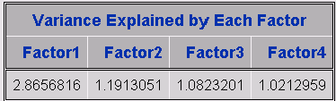

Removing the variable xpt_sat_care_pcc increases the standardized Cronbach coefficient alpha to an acceptable value of 0.709306.

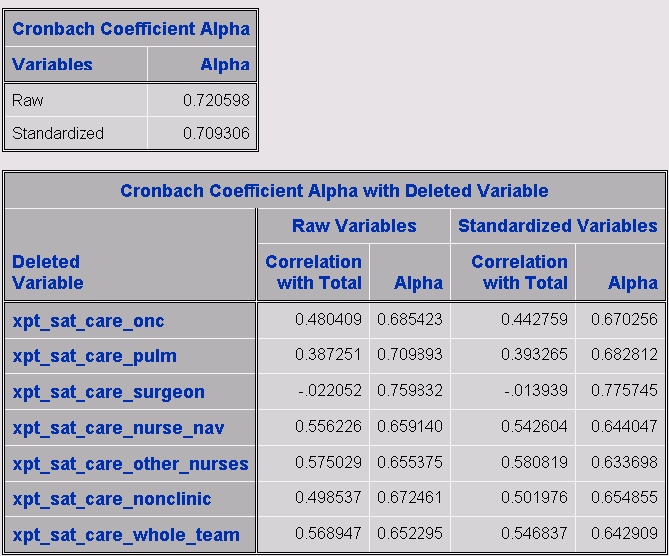

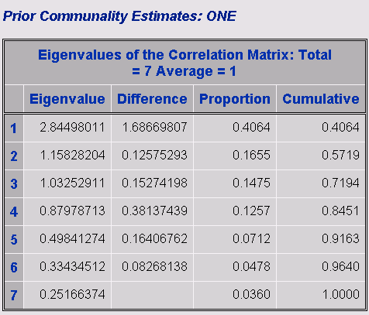

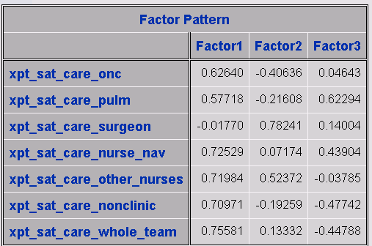

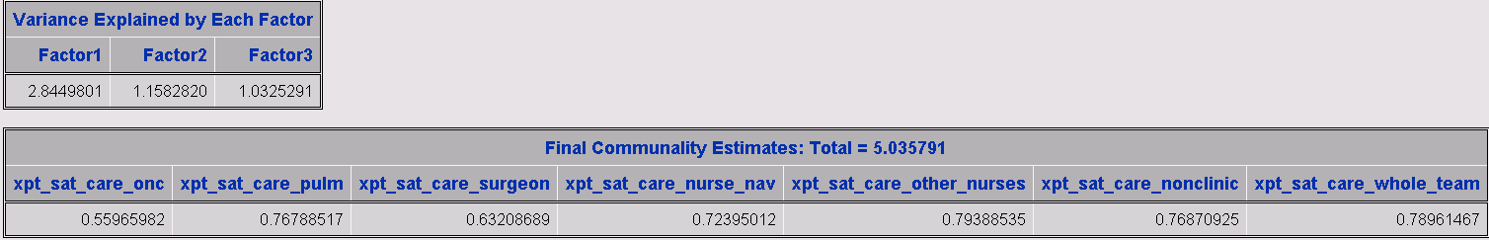

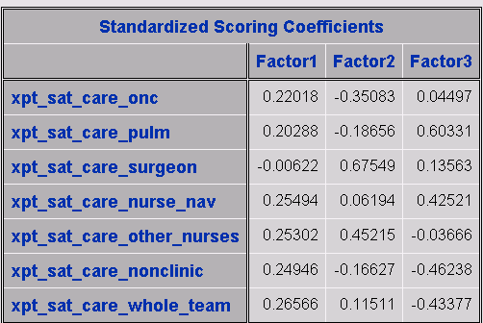

Removing the variable xpt_sat_care_surgeon increases the standardized Cronbach coefficient alpha to an acceptable value of 0.719669.

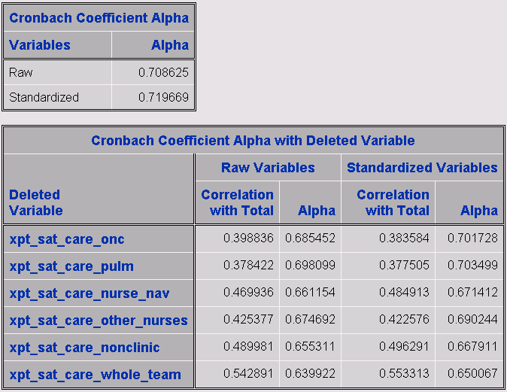

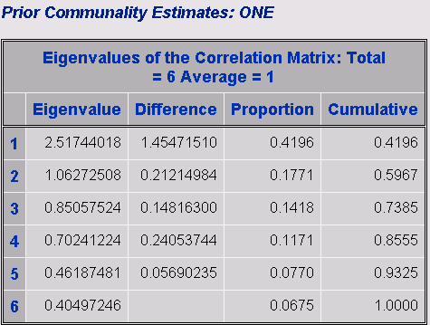

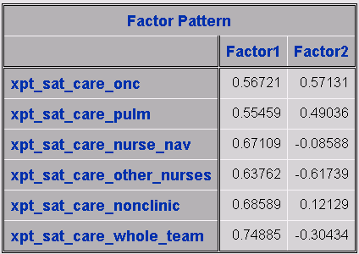

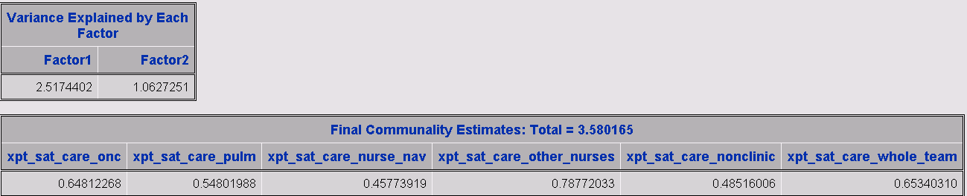

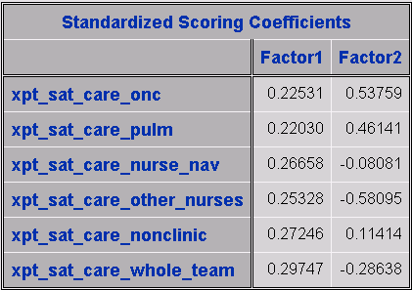

**\* CAHPS items – Physician communication – 5 item version (p. 5 patient survey);**

sumphyscomm7= sum(xpt_exp_phys_listen, xpt_exp_phys_explain, xpt_exp_phys_tx_inform,

xpt_exp_phys_encourage, xpt_exp_phys_respect, xpt_exp_phys_helpful, xpt_exp_phys_aware);

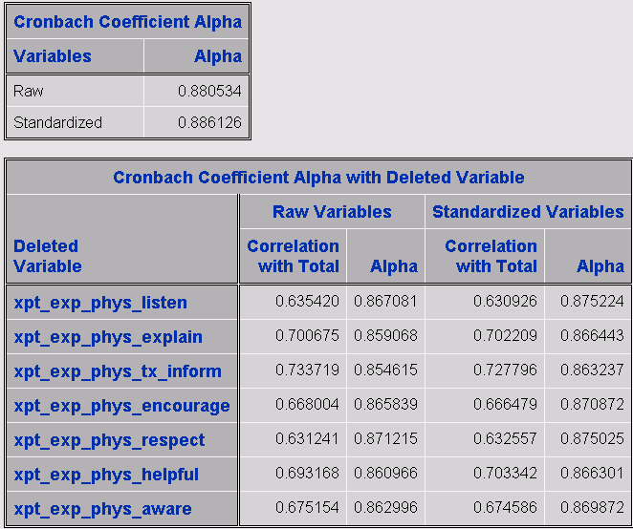

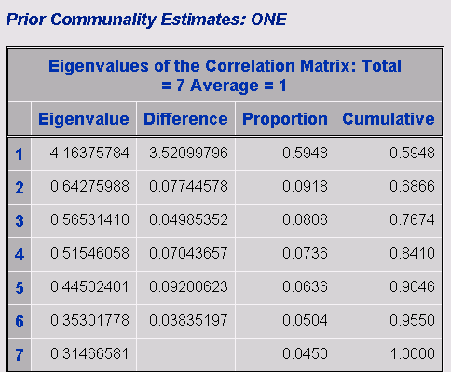

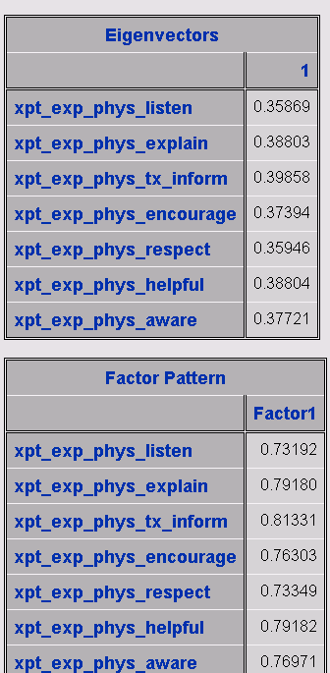

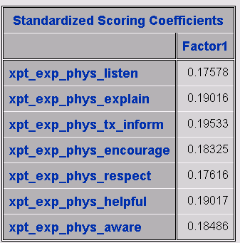

**\* We created a 6-item nurse communication measure based on the CAHPS Physician Communication items (pp 5-6 patient survey);**

sumnursecomm= sum(xpt_exp_nurse_listen, xpt_nurses_often_explain, xpt_nurses_often_info, xpt_nurses_often_encourage, xpt_nurses_often_treat,

xpt_nurses_often_help);

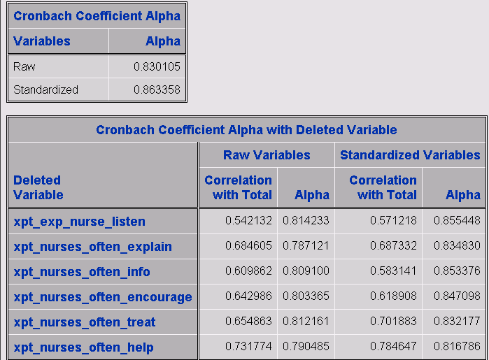

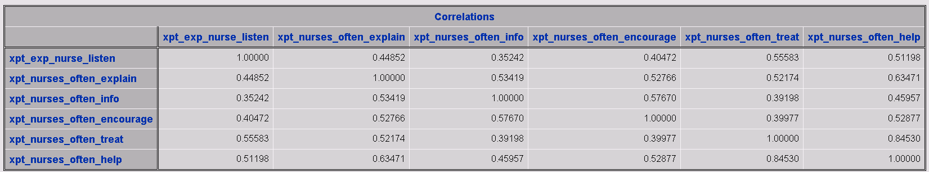

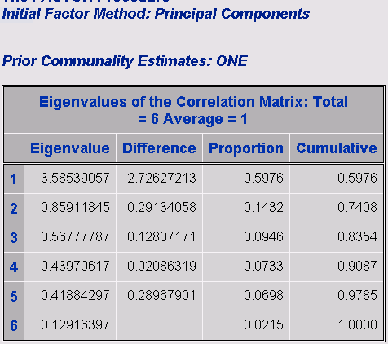

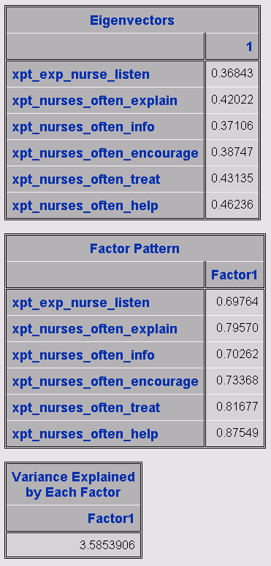

**/* 4 items (p. 6 of patient survey) plus 1 item (item 7 on p. 7 patient survey) ask about satisfaction with care from the team as a whole; */**

sumteamsat= sum(xpt_nurses_often_handle, xpt_nurses_often_team,

xpt_nurses_often_discomfort, xpt_nurses_often_understand, xpt_inform_all_they_could);

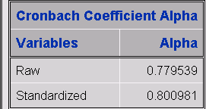

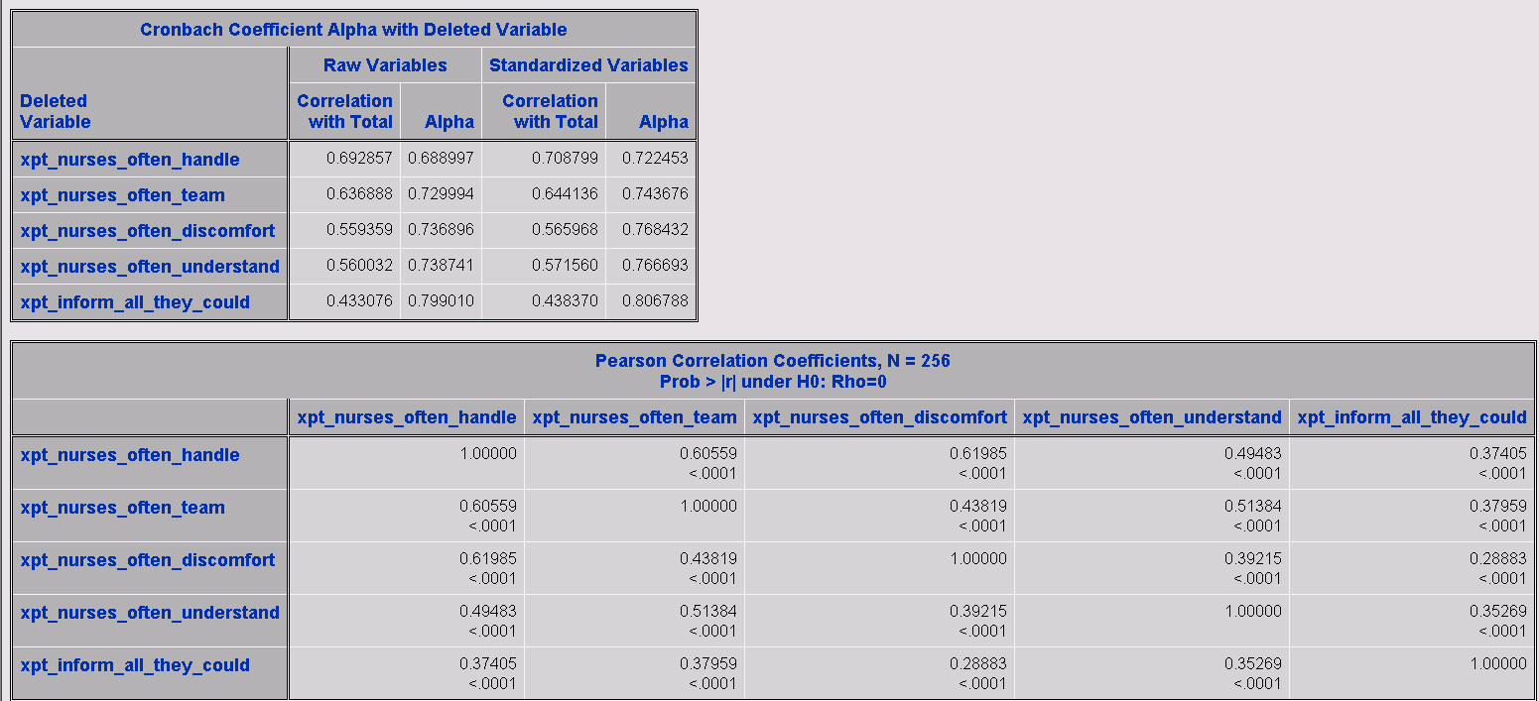

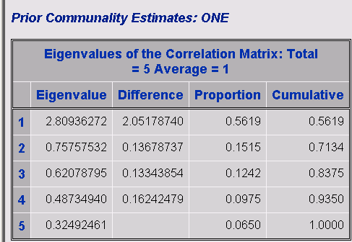

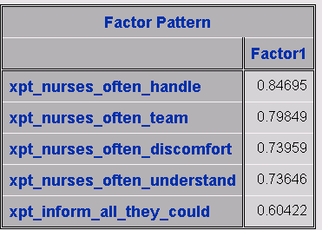

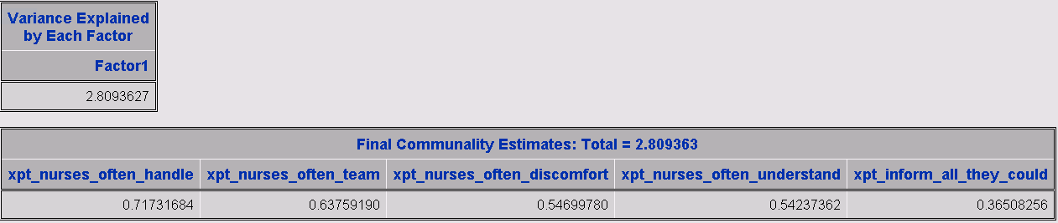

**\* Communication about disease-specific information;**

sumptinfo= sum(xpt_inform_diagnosis, xpt_inform_tx_options, xpt_inform_cure_chance, xpt_inform_life_expectancy, xpt_inform_palliative_care, xpt_inform_end_of_life);

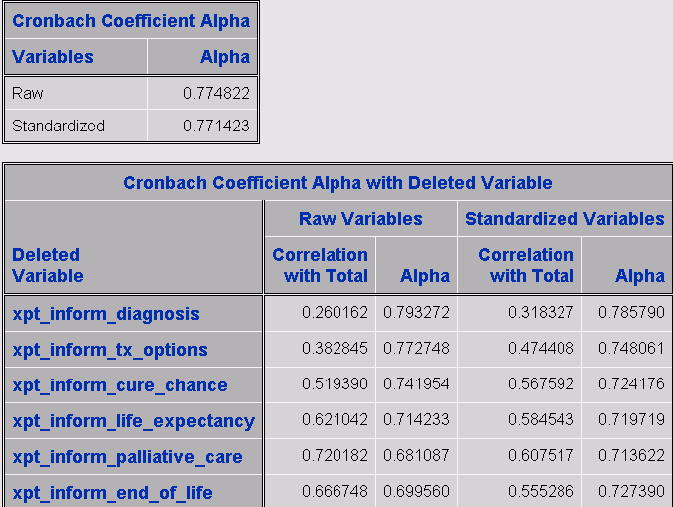

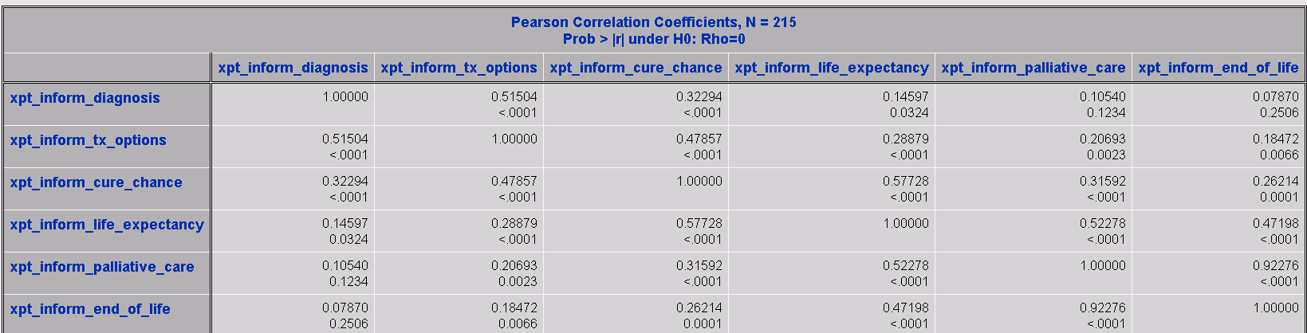

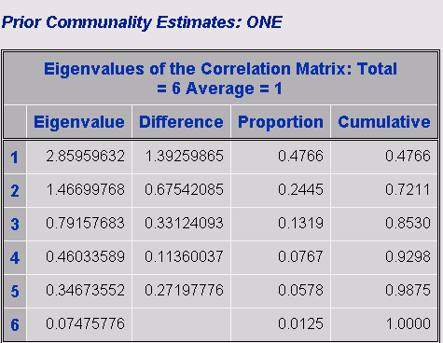

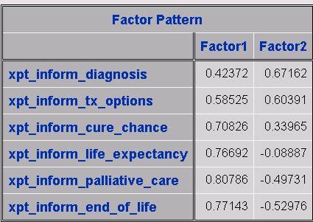

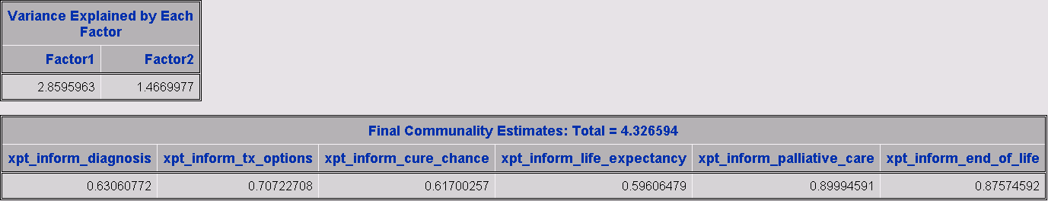

**\* Functional Assessment of Cancer Therapy – Lung (FACT-L) – Version 4;**

*create the 5 sub-scales;

**\* Physical well-being (PWB) sub-scale;**

PWB= sum(xpt_factl1, xpt_factl2, xpt_factl3, xpt_factl4, xpt_factl5, xpt_factl6, xpt_factl7);

* Social well-being (SWB) sub-scale;

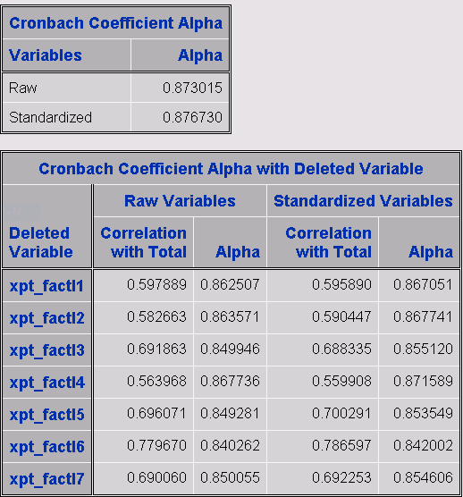

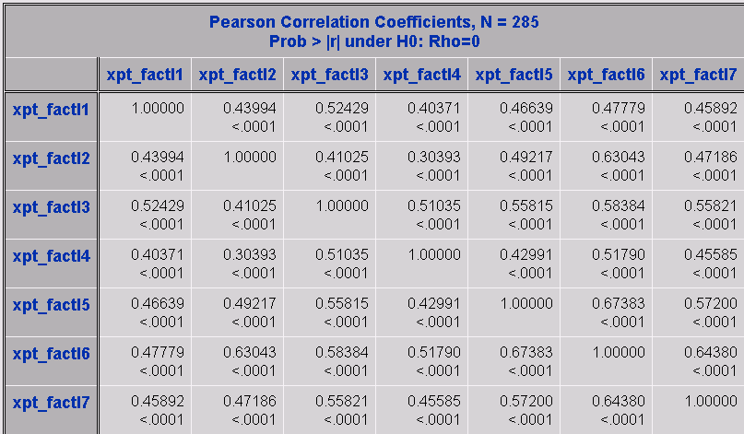

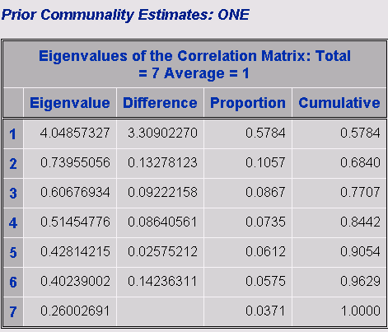

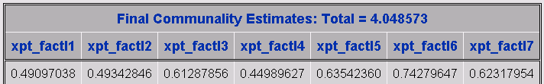

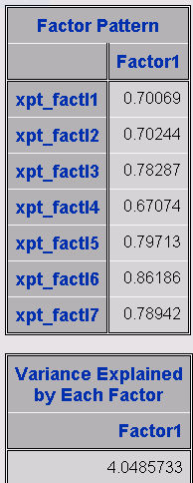

**\* Social well-being (SWB) sub-scale;**

SWB= sum(pt_factl8, pt_factl9, pt_factl10, pt_factl11, pt_factl12, pt_factl13, pt_factl14);

* Emotional well-being (EWB) sub-scale;

* missing observations.

**pt_factl12 and pt_factl13 all missing values , pt_factl14 has missing values**

**\* Emotional well-being (EWB) sub-scale;**

EWB= sum(xpt_factl15, pt_factl16, xpt_factl17, xpt_factl18, xpt_factl19, xpt_factl20);

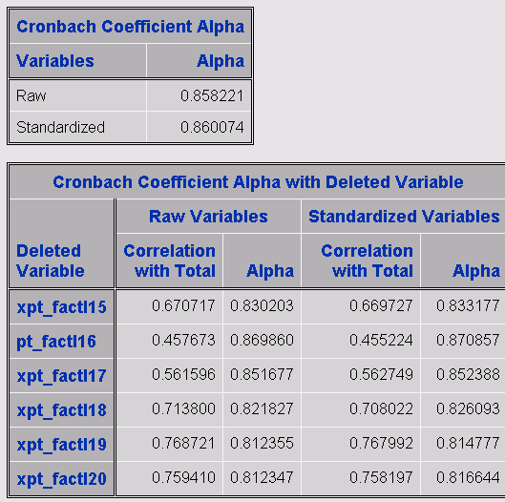

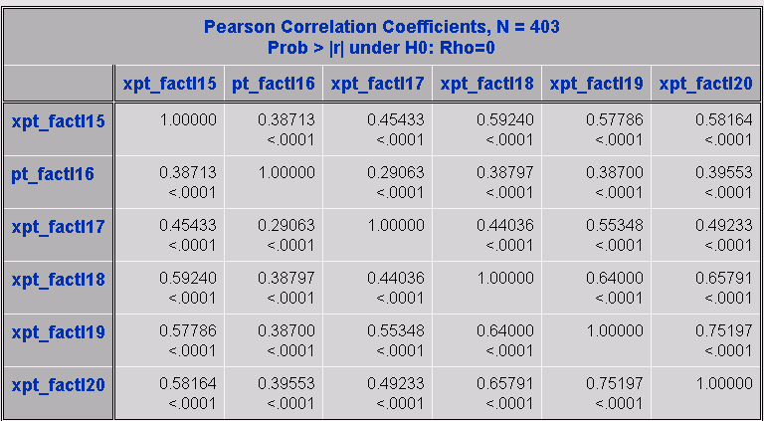

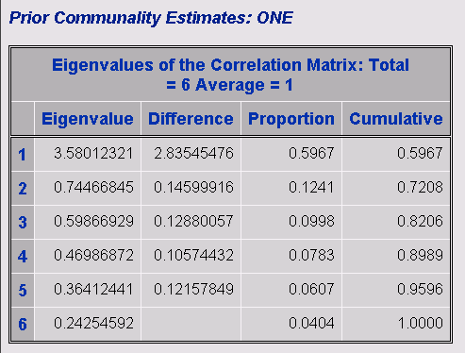

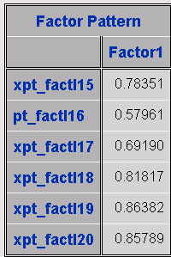

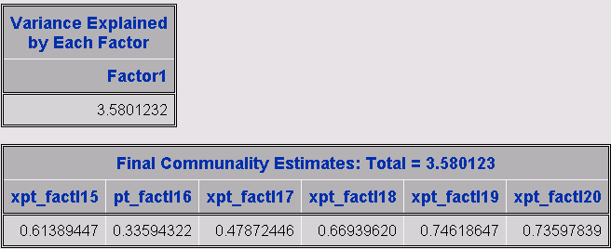

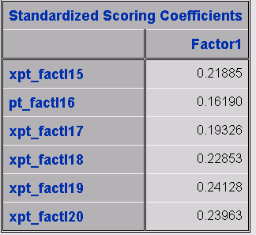

**\* Functional well-being (FWB) sub-scale;**

FWB= sum(pt_factl21, pt_factl22, pt_factl23, pt_factl24, pt_factl25, pt_factl26, pt_factl27);

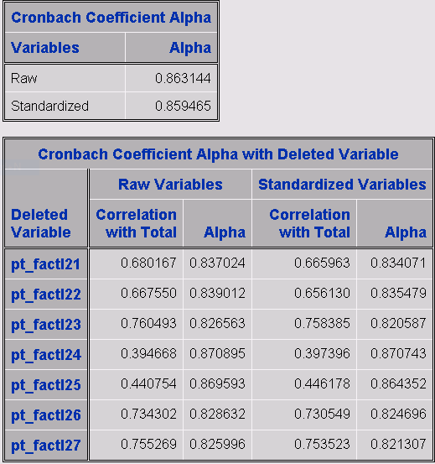

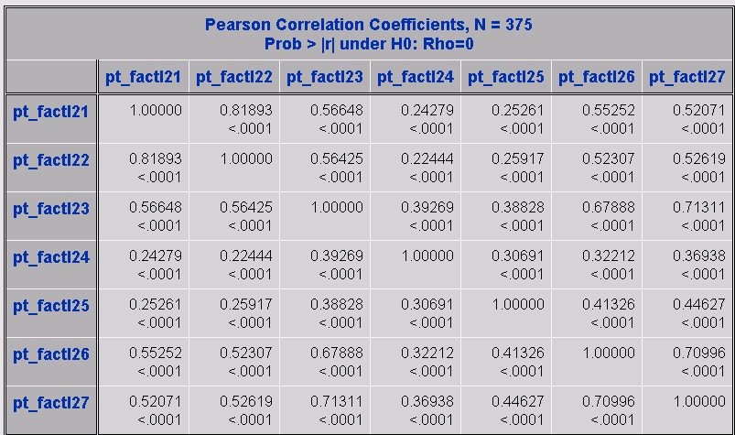

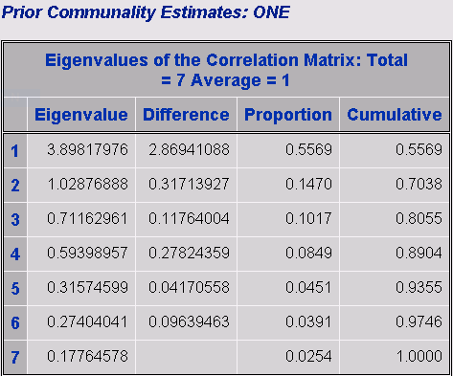

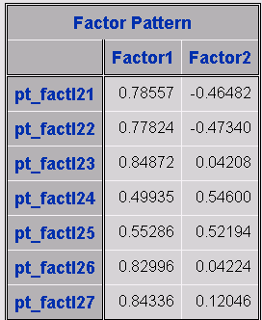

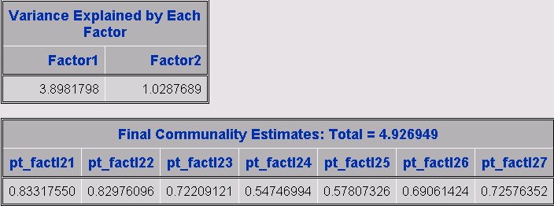

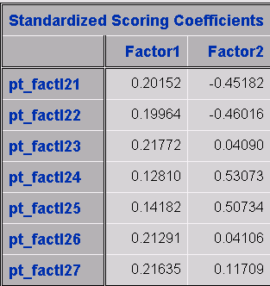

* **Lung cancer scale (LCS) sub-scale;**

LCS= sum(xpt_factl28, xpt_fctl_29, pt_fctl_30, xpt_fctl_31, xpt_fctl_32, pt_fctl_33, xpt_fctl_34, pt_fctl_35, pt_smoking_regret);

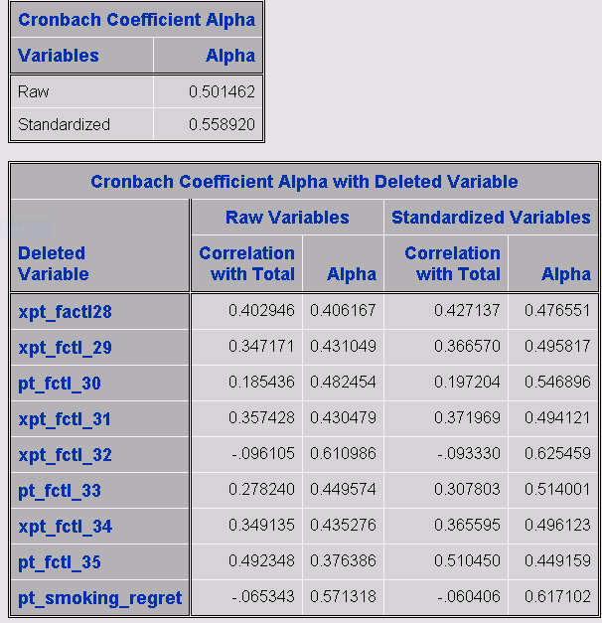

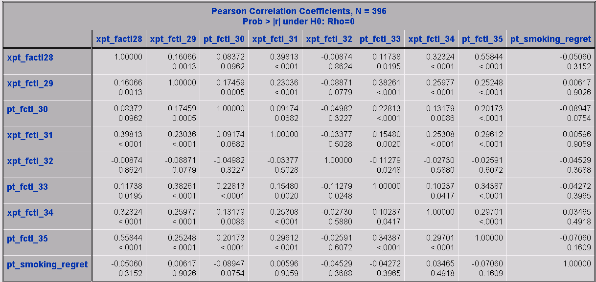

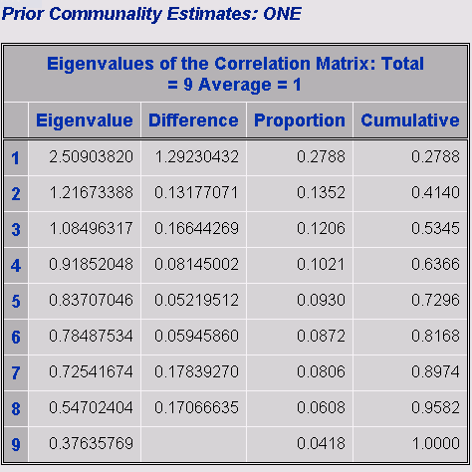

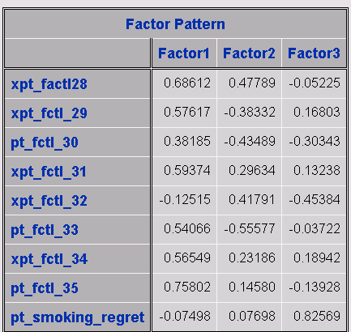

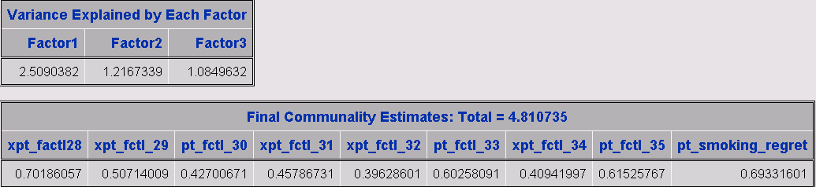

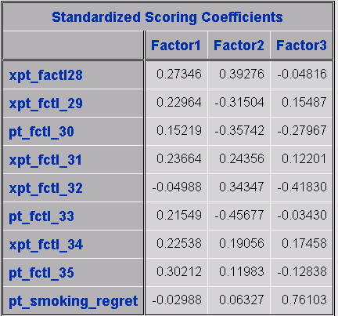

The Cronbach coefficient alpha is very much less 0.7 which indicates this variable is very poor. Removing the two items with negative correlations (xpt_fctl_32 and pt_smoking_regret) increases the Cronbach coefficient alpha to nearly 0.7 which is still questionable.

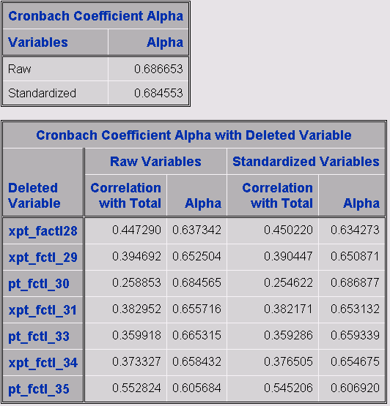

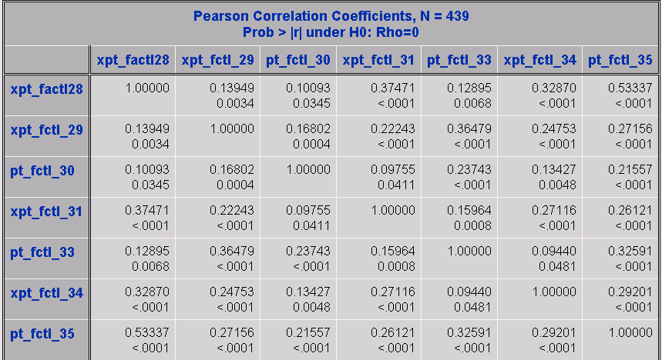

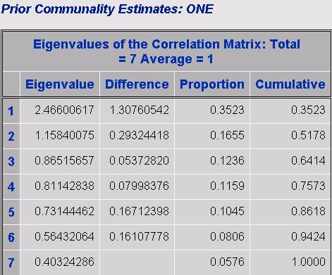

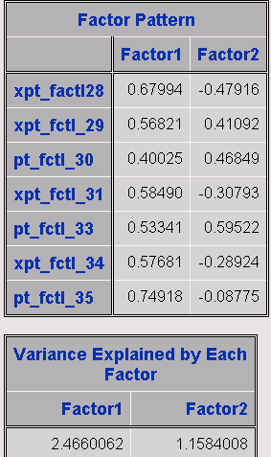

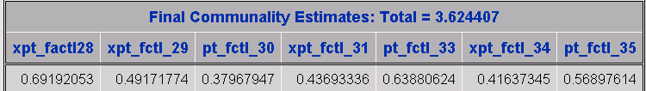

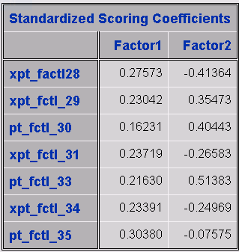

**\* Hospital Anxiety and Depression Scale (HADS; Zigmond & Snaith, 1983)**

HADS_d has all observations missing.

**\* Financial burden of medical care;**

Financialburden= sum(pt_burden_past_12, pt_burden_paid_off, pt_burden_not_paid);

End;

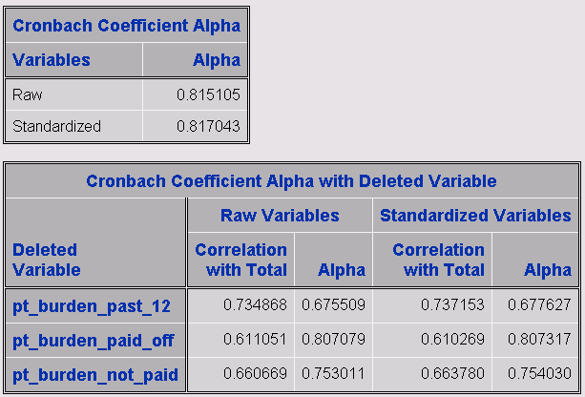

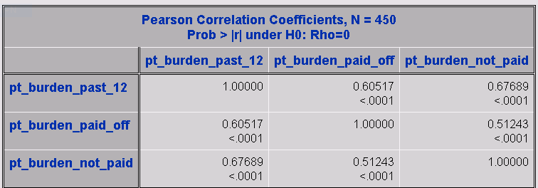

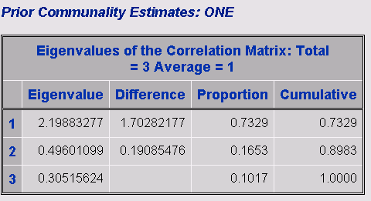

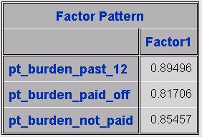

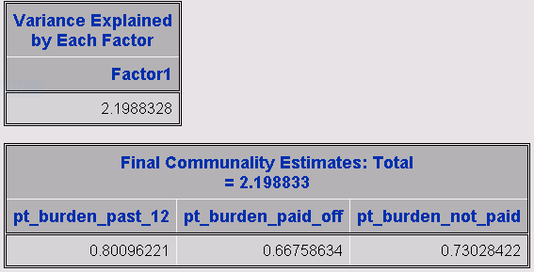

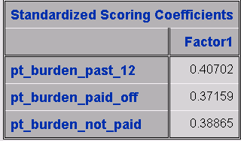

**\* Barriers to completing treatment plan (pp 3-4 caregiver survey);**

sumcgbarriers= sum(cg_issues_a, cg_issues_b, cg_issues_c, cg_issues_d, cg_issues_e, cg_issues_f, cg_issues_g, cg_issues_h);

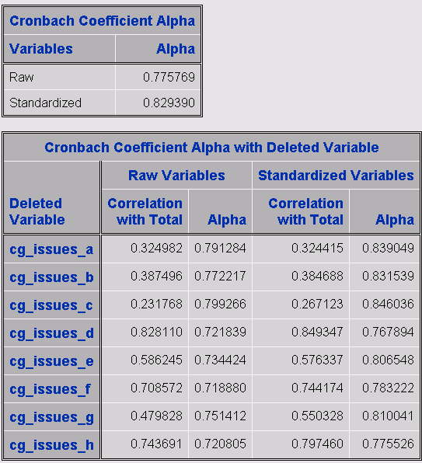

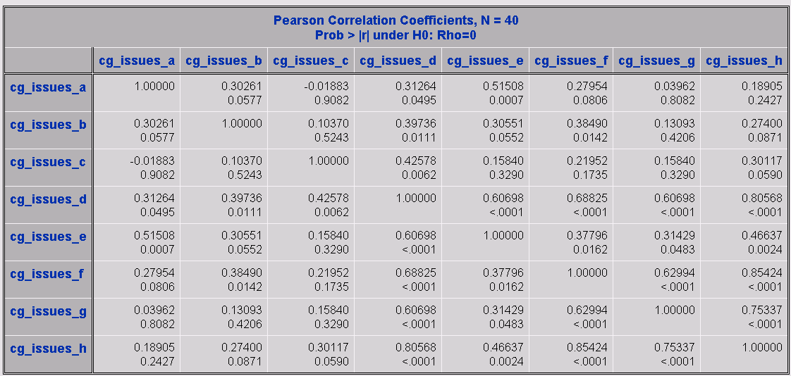

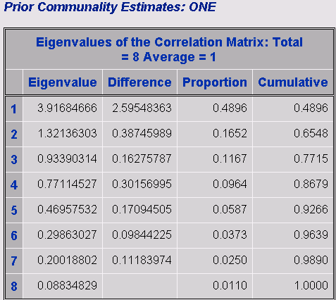

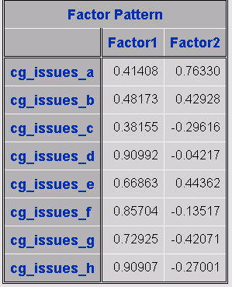

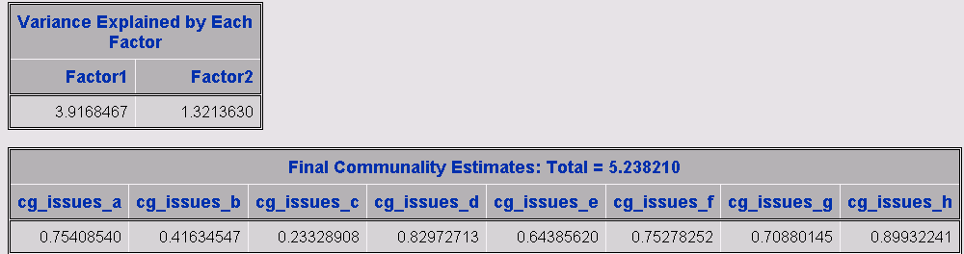

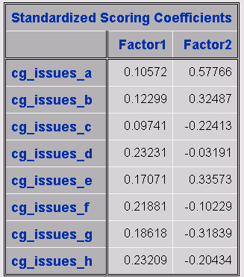

**\* Communication about disease-specific information (p 4 caregiver survey);**

sumcginfo= sum(xcg_inform_diagnosis, xcg_inform_tx_options, xcg_inform_cure_chance, xcg_inform_life_expectancy,

xcg_inform_palliative_care, xcg_inform_end_of_life)

missing observations

**\* Satisfaction with quality of care from various team members (p. 4 patient survey);**

* create sum score for overall satisfaction with quality of care;

sumcgsatqc= sum(xsat_caregiver_pc, xsat_caregiver_onc, xsat_caregiver_pulmo, xsat_caregiver_surg, xsat_caregiver_nurse, xsat_caregiver_nav, xsat_caregiver_other_staff, xsat_caregiver_whole);

missing observations

**\* CAHPS items – Physician communication – 5 item version (p. 5 caregiver survey)**

*sumcgphyscomm5= sum(xcaregiver_pt_1, xcaregiver_pt_2 xcaregiver_pt_3,

xcaregiver_pt_4, xcaregiver_pt_5)

too many missing observations

**\*\* CAHPS items – Physician communication – 7 item version (p. 5 patient survey)**

sumcgphyscomm7= sum(xcaregiver_pt_1, xcaregiver_pt_2 xcaregiver_pt_3,

xcaregiver_pt_4, xcaregiver_pt_5, xcaregiver_pt_6, xcaregiver_pt_7)

too many missing observations

**\* We created a 6-item nurse communication measure based on the CAHPS Physician Communication items (pp 5-6 caregiver survey);**

sumcgnursecomm= sum(xcg_careteam_8, xcg_careteam_9, xcg_careteam_10, xcg_careteam_11, xcg_careteam_12, xcg_careteam_13);

missing observations

**Items about satisfaction with care from the team as a whole (pp 10-11 caregiver survey)**

sumcgteamsat= sum(xcaregiver_often_14, xcaregiver_often_15, xcaregiver_often_16

sumcgteamsat= sum(xcaregiver_often_14, xcaregiver_often_15, xcaregiver_often_162

missing observations

**Caregiver Burden: 14-item Brief Assessment Scale for Caregivers (BASC) (pp 6-7 caregiver survey)**

basc= sum(xqol_caregiver_worried, xqol_caregiver_illness, xqol_caregiver_upset,

xqol_caregiver_overwhelmed, xqol_caregiver_seeing, xqol_caregiver_decisions,

xqol_caregiver_hosp, xqol_caregiver_procedures, xqol_caregiver_change, xqol_caregiver_family, xqol_caregiver_drawn, xqol_caregiver_meaning, xqol_caregiver_mem, xqol_caregiver_feel);

missing observations

**Hospital Anxiety and Depression Scale (HADS; Zigmond & Snaith, 1983);**

**\* p 7-8 caregiver survey;**

cgHADS_d= sum(cghads2, cghads4, cghads6, cghads8, cghads10, cghads12, cghads14); *depression;

**Hospital Anxiety and Depression Scale (HADS; Zigmond & Snaith, 1983);**

**\* p 7-8 caregiver survey;**

cgHADS_a= sum(cghads1, cghads3, cghads5, cghads7, cghads9, cghads11, cghads13); *anxiety;

missing observations

*------------------------------------------------------------------------------------------------------------------*;

/*

Hospital Anxiety and Depression Scale ;

*create HADS sub-scales;

*/;

*------------------------------------------------------------------------------------------------------------------*;

HADS_d= sum(hads2, hads4, hads6, hads8, hads10, hads12, hads14); depression;

missing observations

HADS_a= sum(hads1, hads3, hads5, hads7, hads9, hads11, hads13); *anxiety;

missing observations