**Internal Consistency, Caregiver Satisfaction Survey**

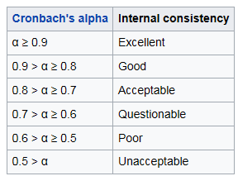

|  |  |  |  |
| --- | --- | --- | --- |
| Scale | Items |  | Standardized Cochran’s Alpha |
|  |  |  |  |
| **Physical functioning scale**  PHYFUN10 | sf3,sf4,sf5,sf6,sf7,sf8,sf9,sf10,sf11,sf12 |  | 0.939175 |
|  |  |  |  |
| **Physical health problems scale**  ROLEP4 | sf13,sf14,sf15,sf16 |  | 0.917640 |
|  |  |  |  |
| **SF-36 pain scale**  SFPAIN2 | sf21,sf22 |  | 0.915794 |
|  |  |  |  |
| **SF-36 general health perceptions scale**  SFGENH5 | sf1,sf33,sf34,sf35,sf36 |  | 0.823852 |
|  |  |  |  |
| **Emotional health problems**  **scale**  ROLEE3  **Social functioning scale**  SOCFUN2 | sf17,sf18,sf19  sf20,sf32 |  | 0.905194  0.389817 |
|  |  |  |  |
|  |  |  |  |
| Energy/fatigue scale  ENFAT4  Emotional well-being scale  EMOT5 | sf23,sf27,sf29,sf31  sf24,sf25,sfI26,sf28,sf30 |  | 0.731060  0.562968 |