|  |  |  |  |  |
| --- | --- | --- | --- | --- |
|  | **All (n=316)** | **Without enlarged spleen (n=235 )** | **With enlarged spleen (n=81 )** | **P-value(Wilcoxon Rank Test)** |
| **Gender**  Male  Female | 175(55%)  141(45%) | 108 (46%)  127 (54%) | 48(59%)  33(41%) | 0.4166 |
| **Age at Diagnosis(months)**  Mean  Median(range) | 174.5  185.07(37.16- 263.95) | 168.5  177.87(37.16-263.95) | 192  193.9(51.12-260.30) | 7.838e-05 |
| **Race**  Black  White  Other | 70(22%)  234(74%)  12(4%) | 63(27%)  10(4%)  162 (69%) | 7 (9%)  72 (89%)  O (2 (2%) | 0.0005511 |
| **Stage**  1  2  3  4 | 49(16%)  147(47%)  46(15%)  74(23%) | 42(18%)  113(48%)  30(13%),  50(21%) | 7 (9%)  34(42%)  16(20%)  24(30%) | 0.00897 |
| **Spleen Involvement**  No  Yes | 279(88%)  37 (12%) | 214(91%)  21(9%) | 65(80%)  16 (20%) | 0.009169 |
| **B_sx**  **A**  **B** | 211 (67%) 105(33%) | 166 (71%)  69(29%) | 45(56%)  36(44%) | 0.01312 |
| **Risk**  favorable  intermediate unfavorable  inrmediate | 74(23%)  74 (23%)  167(53%)  1( 0%) | 64 (27%)  57(24%)  113(48%)  1(0%) | 10(12%)  17 (21%)  54(67%) | 0.2133 |
| **Histology**  Classical HL NOS  classical type  Hodgkin's disease NOS  lymphocyte depleted  lymphocyte predominant  lymphocyte rich  mixed cellularity  nodular sclerosis  nodular sclerosis/ EBV positive  syncytial variant/nodular sclerosis | 2(1%)  10 (3%)  13(4%)  2(1%)  34(11%)  2(1%)  35(11%)  216 (68%)  1(0%)    1 (0%) | 1(1%)  5 (6%)  4(5%)  5(6%)  66(81%) | 2(1%)  9 (4%)  8 (3%)  2(1%)  30(13%)  2 (1%)  30 (13%)  150(64%)    1 (0%)  1(0%) |  |
| **Weight**  Mean  Median(range) |  | 59.03  55.90(13.8-156.2) | 68.52  68.2(11.8- 129.9) | 0.0002555 |
| **Height**  Mean  Median(range) | 160.1  165.1(51.5- 196.1) | 157.6  162.6(51.5-196.1) | 167.2  171.0(83.6- 187.6) | 7.982e-07 |
| **Length**  Mean  Median(range) | 102.9  104.0(40- 224) | 91.44  91(40.0-117.4) | 136.1  130.0(120.0- 224.0) | 2.2e-16 |
| **Width**  Mean  Median(range) | 10.92  10.80(5.30-21.98) | 10.52  10.460(5.30-16.18) | 12.09  11.89(7.51- 21.98) | 6.391e-08 |
| **Volume(cm3)**  Mean  Median(range) | 359.3  317.1(52.79- 1781.4) | 279.8  262.7(52.79-869.38) | 593.7  514.0(237.1- 1781.4) | 2.2e-16 |
| **Thickness**  Mean  Median(range) | 359.3  317.1(52.79- 9.43) | 4.069  3.90(2.07-9.43) | 5.142  5.00(3.42- 8.04) | 2.552e-16 |

**Event Free Survival**

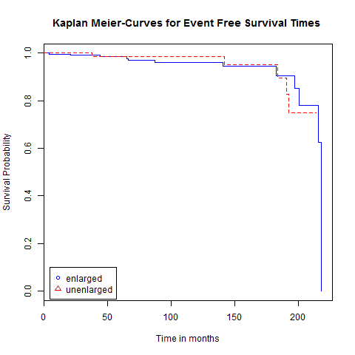

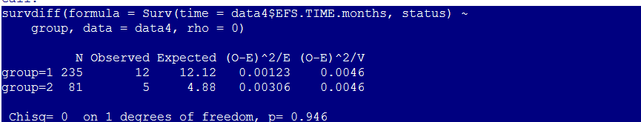

**Overall Survival Time**

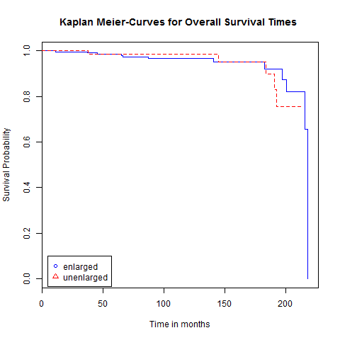

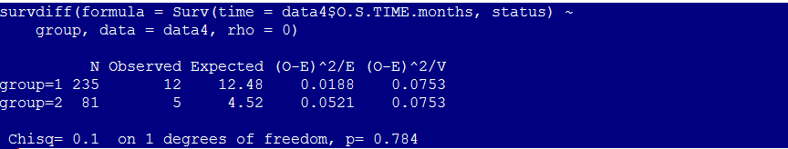

**Cox Regression Model**

**1 Event Free Survival**

|  |  |  |  |  |  |
| --- | --- | --- | --- | --- | --- |
| **Coefficient** | **Estimate** | **Exponent Estimate** | **Standard Error** | **Z-Score** | **Pr > ChiSq** |
| Race  white  other | 3.344e-02  -1.516e+01 | 1.034e+00  2.607e-07 | 1.019e+00  4.893e+03 | 0.034  -14.788 | 0.972827  < 2e-16 |
| Gender  Ref=M | -2.940e-01 | 7.453e-01 | 6.699e-01 | -0.435 | 0.66369 |
| Risk  Inrmediate  Intermediate  unfavorable | -1.580e+01  9.395e-02  -6.720e-01 | 1.368e-07  1.099e+00  5.107e-01 | 2.387e+04  1.028e+00  9.964e-01 | -5.521  0.087  -0.841 | 3.38e-08  0.930742  0.400363 |
| spleen_involvement  Ref=yes | -2.691e-01 | 7.641e-01 | 1.438e+00 | -0.170 | 0.865113 |
| Length | 1.387e-03 | 1.001e+00 | 3.091e-02 | 0.042 | 0.966500 |
| Width | 2.345e-01 | 1.264e+00 | 2.698e-01 | 0.855 | 0.392315 |
| Thickness | 5.218e-01 | 1.685e+00 | 4.410e-01 | 1.052 | 0.292798 |
| Stage  Stage=2  Stage=3  Stage=4 | 9.993e-01  7.551e-01  8.826e-01 | 2.716e+00  2.128e+00  2.417e+00 | 1.201e+00  1.418e+00  1.469e+00 | 1.060  0.868  0.740 | 0.288927  0.385519  0.459125 |
| Weight(kg) | 4.037e-02 | 1.041e+00 | 1.611e-02 | 3.819 | 0.000134 |
| Height(cm) | -4.223e-02 | 9.587e-01 | 2.275e-02 | -2.134 | 0.032860 |
| Volume(cm3) | 1.997e-01 | 1.221e+00 | 3.011e+02 | 7.903 | 2.78e-15 |
| B_sx  Ref=B | 1.520e+00 | 4.574e+00 | 8.891e-01 | 1.742 | 0.081438 |
| Histology  classical type  Hodgkin's disease NOS  lymphocyte depleted  lymphocyte predominant  lymphocyte rich  mixed cellularity  nodular sclerosis  nodular sclerosis/ EBV positive  syncytial variant/nodular sclerosis | 6.154e-01  1.640e+01  3.046e-01  1.685e+01  -2.417e-02  1.497e+01  1.564e+01  3.841e-01  4.125e-01 | 1.850e+00  1.319e+07  1.356e+00  2.073e+07  9.761e-01  3.180e+06  6.175e+06  1.468e+00  1.511e+00 | 5.339e+04  5.251e+04  5.549e+04  5.251e+04  5.510e+04  5.251e+04  5.251e+04  6.133e+04  5.273e+04 | 0.264  6.051  0.147  6.087  -0.010  5.239  5.677  0.196  0.156 | 0.792067  1.44e-09  0.882961  1.15e-09  0.992273  1.62e-07  1.37e-08  0.844938  0.876029 |
| Enlarged  Ref=with enlarge | -1.003e-01 | 9.046e-01 | 9.183e-01 | -0.140 | 0.889025 |
| Age(months) | 7.413e-03 | 1.007e+00 | 1.008e-02 | 0.683 | 0.494320 |

**2 Overall Survival Time**

|  |  |  |  |  |  |
| --- | --- | --- | --- | --- | --- |
| **Coefficient** | **Estimate** | **Exponent Estimate** | **Standard Error** | **Z-Score** | **Pr > ChiSq** |
| Race  white  other | 3.625e-01  -1.622e+01 | 1.437e+00  9.041e-08 | 1.034e+00  9.039e+03 | 0.356  -14.210 | 0.722078  < 2e-16 |
| Gender  Ref=M | -2.787e-01 | 7.567e-01 | 6.365e-01 | -0.451 | 0.652203 |
| Risk  Inrmediate  Intermediate  unfavorable | -1.688e+01  4.248e-01  -4.098e-01 | 4.648e-08  1.529e+00  6.638e-01 | 4.221e+04  1.046e+00  9.484e-01 | -6.216  0.378  -0.548 | 5.10e-10  0.705217  0.583532 |
| spleen_involvement  Ref=yes | -5.214e-01 | 5.937e-01 | 1.357e+00 | -0.357 | 0.720791 |
| Length | -8.102e-03 | 9.919e-01 | 3.045e-02 | -0.248 | 0.804341 |
| Width | 1.365e-01 | 1.146e+00 | 2.612e-01 | 0.477 | 0.633267 |
| Thickness | 5.451e-01 | 1.725e+00 | 4.270e-01 | 1.144 | 0.252587 |
| Stage  Stage=2  Stage=3  Stage=4 | 8.982e-01  9.305e-01 | 2.455e+00  2.536e+00 | 1.204e+00  1.373e+00 | 0.948  1.079 | 0.342944  0.280713 |
| Weight(kg) | 3.800e-02 | 1.039e+00 | 1.540e-02 | 3.682 | 0.000231 |
| Height(cm) | -3.997e-02 | 9.608e-01 | 2.319e-02 | -2.061 | 0.039312 |
| Volume(cm3) | 1.898e-01 | 1.209e+00 | 9.803e+01 | 13.474 | < 2e-16 |
| B_sx  Ref=B | 1.596e+00 | 4.932e+00 | 8.307e-01 | 1.905 | 0.056757 |
| Histology  classical type  Hodgkin's disease NOS  lymphocyte depleted  lymphocyte predominant  lymphocyte rich  mixed cellularity  nodular sclerosis  nodular sclerosis/ EBV positive  syncytial variant/nodular sclerosis | -5.416e-01  1.554e+01  -1.140e+00  1.678e+01  -1.095e+00  1.482e+01  1.530e+01  -9.626e-01  -1.176e+00 | 5.818e-01  5.603e+06  3.198e-01  1.934e+07  3.346e-01  2.724e+06  4.430e+06  3.819e-01  3.086e-01 | 7.509e+04  7.325e+04  8.084e+04  7.325e+04  7.927e+04  7.325e+04  7.325e+04  9.104e+04  7.380e+04 | -0.243  5.765  -0.524  6.495  -0.478  5.390  5.560  -0.465  -0.448 | 0.808275  8.18e-09  0.600225  8.29e-11  0.632712  7.04e-08  2.69e-08  0.641718  0.654361 |
| Enlarged  Ref=with enlarge | 2.786e-01 | 1.321e+00 | 9.037e-01 | 0.383 | 0.701645 |
| Age(months) | 1.004e-02 | 1.010e+00 | 9.877e-03 | 0.943 | 0.345620 |