Ziel der Spezifikation ist es, Anforderungen zu definieren.

Initial state rules:

• Transition cannot go to initial state

• Transition cannot go from final state

• Transition cannot go directly from initial to final state

• Transition should elaborate an event if

* it is on the root state machine (its source/target belongs to root)
* it is in nested state machine and not initial or final (its source/target is initial or final state)

• Initial state should have outgoing transitions

• Final state should have incoming transitions

• Root state machine must have an initial state

• State machine can only have one initial state

• State machine can only have one final state

• State machine must have an initial state if

* its parent state has incoming transitions
* it has outgoing local transitions (going from a state to parent state or ANY state)

in INIT case, sollte kein Event geschedulet warden?? Oder?

http://www.idi.ntnu.no/emner/tdt4250/Slides/statemachine-case-study1026.pdf

**GMF.graph Einstellungen**

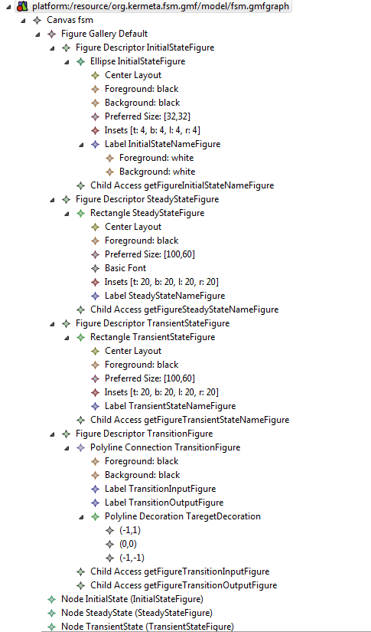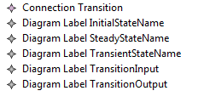

**GMF.map Einstellungen**

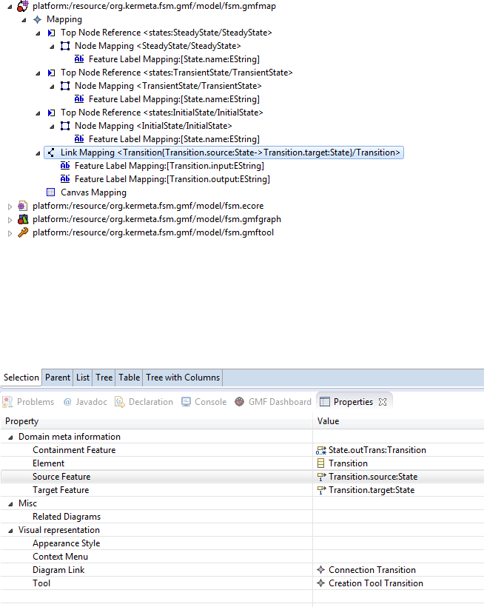

**Ecore Diagram**

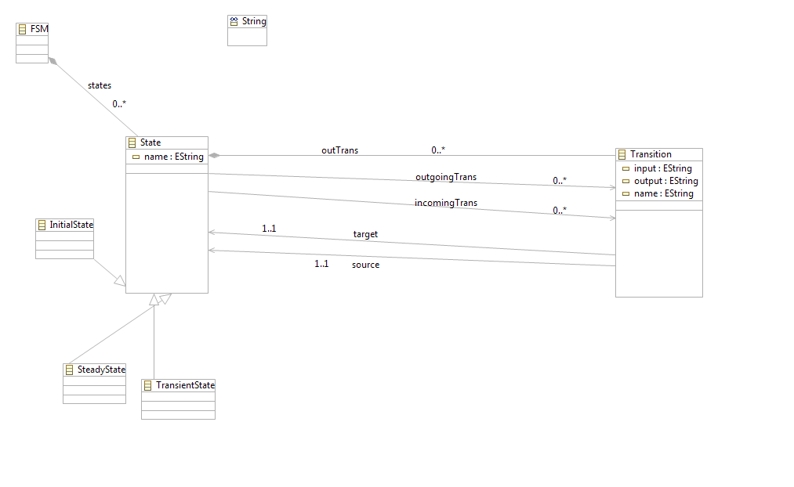

**State name in XML-file**

Damit der Statename in dee XML-Datei steht, muss die Aggregation (FSM-> Satete) so modifiziert werden, dass unte EKeys der Name vom State steht.