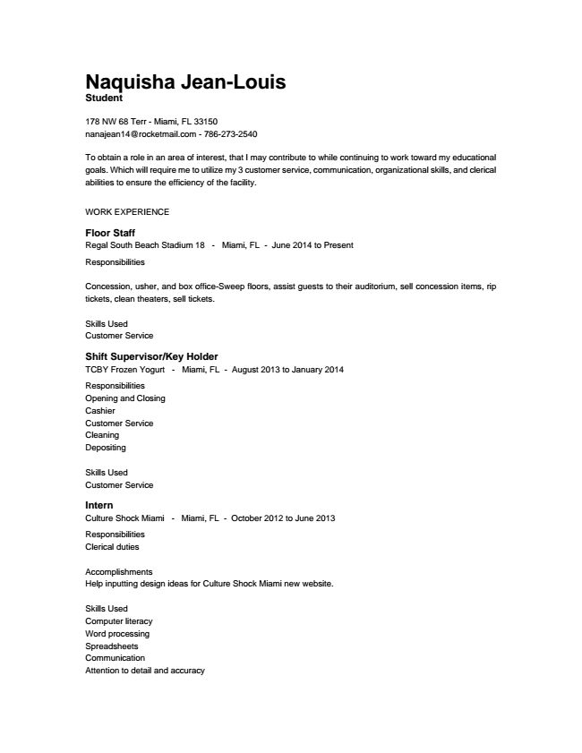

**Naquisha Jean-Louis Student**

178 NW 68 Terr - Miami, FL 33150 nanajean14@rocketmail.com - 786-273-2540

To obtain a role in an area of interest, that I may contribute to while continuing to work toward my educational goals. Which will require me to utilize my 3 customer service, communication, organizational skills, and clerical abilities to ensure the efficiency of the facility.

WORK EXPERIENCE

Floor Staff Regal South Beach Stadium 18 - Miami, FL - June 2014 to Present

Responsibilities

Concession, usher, and box office-Sweep floors, assist guests to their auditorium, sell concession items, rip tickets, clean theaters, sell tickets.

Skills Used Customer Service

Shift Supervisor/Key Holder TCBY Frozen Yogurt - Miami, FL - August 2013 to January 2014

Responsibilities Opening and Closing Cashier Customer Service Cleaning Depositing

Skills Used Customer Service

Intern Culture Shock Miami - Miami, FL - October 2012 to June 2013

Responsibilities Clerical duties

Accomplishments Help inputting design ideas for Culture Shock Miami new website.

Skills Used Computer literacy Word processing Spreadsheets Communication Attention to detail and accuracy

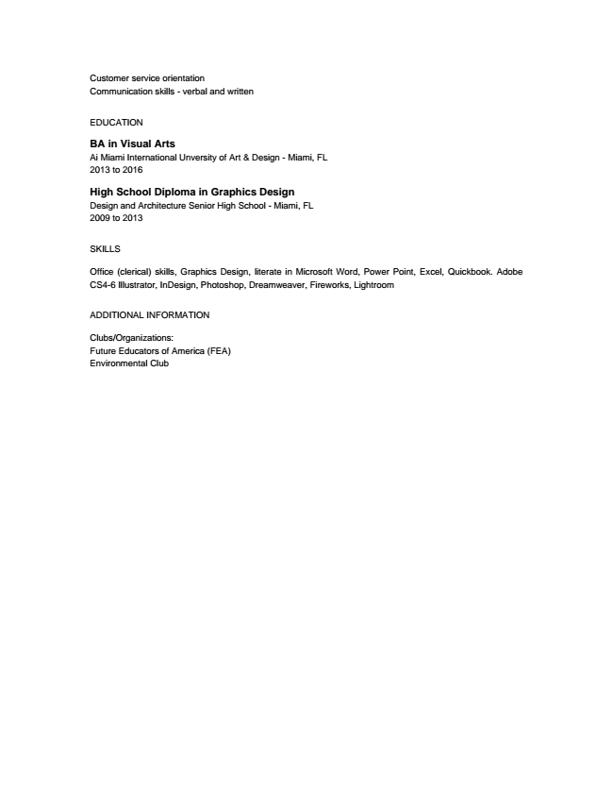

Customer service orientation Communication skills - verbal and written

EDUCATION

BA in Visual Arts Ai Miami International Unversity of Art & Design - Miami, FL 2013 to 2016

High School Diploma in Graphics Design Design and Architecture Senior High School - Miami, FL 2009 to 2013

SKILLS

Office (clerical) skills, Graphics Design, literate in Microsoft Word, Power Point, Excel, Quickbook. Adobe CS4-6 Illustrator, InDesign, Photoshop, Dreamweaver, Fireworks, Lightroom

ADDITIONAL INFORMATION

Clubs/Organizations: Future Educators of America (FEA) Environmental Club