1. Introduction
HematoVision is a deep learning web application that automatically classifies microscopic blood cell images into four distinct categories: Eosinophil, Lymphocyte, Monocyte, and Neutrophil. The system uses Transfer Learning on the MobileNetV2 architecture - a pre-trained convolutional neural network - to achieve high classification accuracy with minimal training time and computational cost.
Manual blood cell classification is a time-intensive task that requires trained pathologists. HematoVision automates this process, enabling faster and more consistent diagnostic results. The trained model is served through a Flask web application accessible from any browser - no technical expertise is required from the end user.

1.1. Project Objectives
- Develop an accurate blood cell classification model using Transfer Learning.
- Apply MobileNetV2 pre-trained weights to reduce training time and improve performance.
- Build a user-friendly web application using Flask to enable real-time predictions.
- Demonstrate a complete end-to-end ML pipeline from data loading to deployment.

1.2. Real-World Applications
1. Automated diagnostic systems in clinical and hospital settings.
2. Telemedicine platforms for remote blood analysis and consultation.
3. Educational tools for medical students and laboratory technicians.
Property | Value
Model | MobileNetV2 (Transfer Learning)
Dataset | 9,957 blood cell images - 4 classes
Framework | TensorFlow 2.21.0 / Keras
Backend | Flask (Python)
Frontend | HTML5, CSS3, JavaScript
Best Val. Accuracy | 86.15%
Model File | blood_cell.h5 (11.83 MB)
GitHub | https://github.com/nanak011/HematoVision

2. System Architecture
The project follows a three-layer architecture: a data processing layer, a model inference layer, and a web application layer. These layers communicate through a Flask server that acts as the central hub between the trained model and the browser interface.

2.1. Architecture Overview
Layer | Component | Technology
Data Layer | Image Loading & Augmentation | TensorFlow ImageDataGenerator
Model Layer | Feature Extraction | MobileNetV2 (pre-trained, frozen)
Model Layer | Classification Head | Dense (4 units, Softmax)
App Layer | Web Server | Flask (Python)
App Layer | Frontend | HTML5 + CSS3 + JavaScript

2.2. Project Folder Structure

HematoVision/
│
├── output/
├── project_report/
│ └── report.pdf
├── static/
│ └── uploads/ ← uploaded images saved here temporarily
├── templates/
│ ├── home.html ← upload page
│ └── result.html ← result page
├── app.py ← Flask backend
├── blood_cell.h5 ← pre-trained model (included)
├── HematoVision_Model.ipynb ← model training notebook
└── README.md

3. Dataset
The dataset is sourced from Kaggle (dataset2-master) and contains 9,957 annotated blood cell images in JPEG format. Images are organized into four subfolders, one per class. Labels are assigned automatically from folder names by TensorFlow's ImageDataGenerator.

3.1. Dataset Summary
Property | Value
Source | Kaggle - Blood Cell Images (dataset2-master)
Total Images | 9,957 (training set)
Image Format | JPEG
Classes | 4
Input Size | 224 × 224 pixels (resized for MobileNetV2)
Batch Size | 32
Dataset Link | https://www.kaggle.com/datasets/paultimothymooney/blood-cells

3.2. Per-Class Image Count
Class | Image Count
EOSINOPHIL | 2,497
LYMPHOCYTE | 2,483
MONOCYTE | 2,478
NEUTROPHIL | 2,499
TOTAL | 9,957

3.3. Cell Type Descriptions
Cell Type | Description | Clinical Significance
Eosinophil | Granulocyte with bi-lobed nucleus and pink granules | Elevated in allergic reactions and parasitic infections
Lymphocyte | Small round cell, large nucleus, minimal cytoplasm | Key adaptive immune cell; fights viral infections
Monocyte | Largest WBC, kidney-shaped nucleus | Differentiates into macrophages; clears pathogens
Neutrophil | Multi-lobed nucleus, most abundant WBC | First responder to bacterial infections

4. Data Preprocessing
All images are normalized and resized before being fed to the model. Augmentation is applied only to the training set to increase diversity and reduce overfitting. The test set uses only normalization to ensure unbiased evaluation.

4.1. Preprocessing Steps
Step | Applied To | Details
Rescale ÷ 255 | Train + Test | Normalize pixels from [0, 255] to [0.0, 1.0]
Rotation (±20°) | Train only | Random rotation to increase variety
Zoom (±20%) | Train only | Random zoom in/out
Horizontal Flip | Train only | Mirror images randomly
Resize to 224×224 | Train + Test | Required input size for MobileNetV2
Batch Size | Train + Test | 32 images per batch

5. Model Architecture
Transfer Learning is used to leverage MobileNetV2's pre-existing knowledge of image features from ImageNet training (1.2 million images, 1,000 classes). The MobileNetV2 base is loaded with frozen weights, and a custom classification head is added for 4-class blood cell output. This significantly reduces training time and improves performance compared to training from scratch.

5.1 Model Layers

Layer | Type | Output Shape | Parameters
MobileNetV2 Base | Convolutional (frozen) | 7 × 7 × 1280 | 2,257,984 (non-trainable)
Flatten | Reshape | 62,720 | 0
Dropout (0.3) | Regularization | 62,720 | 0
Dense (Softmax) | Fully Connected | 4 | 250,884 (trainable)

Parameter Count | Value
Total | 2,508,868 (9.57 MB)
Trainable | 250,884 (980 KB)
Non-trainable | 2,257,984 (8.61 MB)

5.2 Training Configuration
Parameter | Value
TensorFlow Version | 2.21.0
Optimizer | Adam
Loss Function | Categorical Cross-Entropy
Metric | Accuracy
Epochs | 5
Batch Size | 32
Image Size | 224 × 224 pixels
Callbacks | ModelCheckpoint + EarlyStopping (patience = 3)
Saved Model | blood_cell.h5 (11.83 MB)

5.3 Why MobileNetV2?
1. Lightweight architecture - efficient on standard hardware without GPU.
2. Pre-trained on ImageNet - strong general image understanding out of the box.
3. Faster training via Transfer Learning compared to building a CNN from scratch.
4. Proven performance on medical image classification tasks.

6. Implementation

6.1 Tech Stack
Category | Technologies
Backend | Python, Flask
ML | TensorFlow 2.21.0, Keras, MobileNetV2
Frontend | HTML5, CSS3, JavaScript
Tools | Jupyter Notebook, Anaconda

6.2 Libraries
Library | Purpose
TensorFlow / Keras | Model building, training, and inference
Flask | Web server and routing
NumPy | Numerical array operations
Pillow | Image loading and preprocessing in Flask
Pandas | Data handling
Matplotlib | Accuracy and loss visualization
Seaborn | Statistical visualization
Scikit-learn | Evaluation metrics

6.3 Training Workflow
The full training pipeline is contained in HematoVision_Model.ipynb and follows these steps:
1. Import libraries (TensorFlow, Keras, NumPy, OS, Matplotlib).
2. Set dataset paths and verify image counts per class.
3. Create ImageDataGenerator instances with augmentation for training set.
4. Load data using flow_from_directory() - auto-labels by subfolder name.
5. Initialize MobileNetV2 base model with frozen ImageNet weights.
6. Add Flatten, Dropout (0.3), and Dense Softmax (4 units) layers on top.
7. Compile with Adam optimizer and categorical cross-entropy loss.
8. Train for 5 epochs with ModelCheckpoint and EarlyStopping callbacks.
9. Plot accuracy and loss graphs per epoch.
10. Confirm model saved as blood_cell.h5.

6.4 Flask Application - app.py

Route | Method | Description
/ | GET | Renders home.html - the image upload page
/predict | POST | Receives image, runs model inference, renders result.html

Prediction pipeline: receive uploaded file → save to static/uploads/ → resize to 224×224 → normalize pixels → model.predict() → return class with highest Softmax probability + confidence percentage.

7. Setup & Run
Step 1 - Clone the repository

git clone https://github.com/nanak011/HematoVision
cd HematoVision

Step 2 - Check Python version

python --version

Python 3.11 or lower → Skip to Step 3.
Python 3.12, 3.13, or 3.14 → Install Python 3.11.5 (Windows 64-bit). During installation check "Add Python 3.11 to PATH". Then create a virtual environment:

py -3.11 -m venv venv
venv\Scripts\activate
Step 3 - Install dependencies

pip install tensorflow flask numpy pillow
Step 4 - Run the application

python app.py

Open browser and go to: http://127.0.0.1:5000
The trained model (blood_cell.h5) is already included - no extra download needed.

8. Web Application
The web application provides a minimal browser interface. The user uploads a blood cell image and receives the predicted class and confidence score without needing to write any code or use the command line.

8.1 Pages
File | Purpose | Key Elements
home.html | Upload interface | File picker, image preview, predict button
result.html | Results display | Predicted class, confidence score, animated bar, cell description

8.2 User Flow
1. User opens http://127.0.0.1:5000 in browser.
2. Clicks upload area and selects a blood cell image (JPG/PNG).
3. Preview of selected image appears on screen.
4. User clicks Predict - image sent via POST to /predict.
5. Flask preprocesses image and runs model.predict().
6. result.html renders with predicted class, confidence %, and clinical description.
7. User clicks 'Classify Another Image' to start again.

9. Results & Evaluation

9.1 Training Results - Epoch by Epoch

Epoch | Train Accuracy | Train Loss | Val Accuracy | Val Loss | Model Saved?
1 | 58.78% | 3.4329 | 77.27% | 1.4620 | Yes
2 | 72.25% | 2.3729 | 77.79% | 1.6469 | Yes
3 | 75.13% | 2.3331 | 84.89% | 1.2650 | Yes
4 | 78.07% | 2.2202 | < 84.89% | - | No
5 | 79.21% | 2.3834 | 86.15% | 1.2917 | Yes

Final Metric | Value
Best Validation Accuracy | 86.15% (Epoch 5)
Best Validation Loss | 1.2917
Final Training Accuracy | 79.21%
Total Epochs Completed | 5

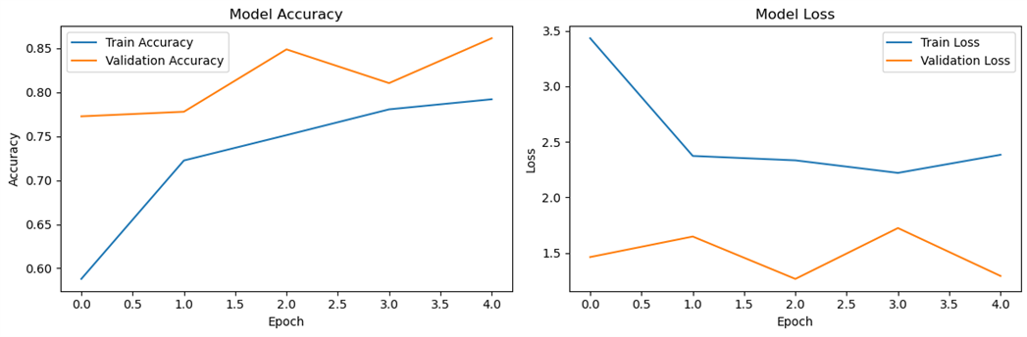

9.2 Web App Test Predictions
All 9 test images classified correctly across all 4 classes via the Flask web interface.
Test # | Actual Class | Predicted | Confidence | Correct?
1 | LYMPHOCYTE | LYMPHOCYTE | 99.64% | Yes
2 | MONOCYTE | MONOCYTE | 99.96% | Yes
3 | LYMPHOCYTE | LYMPHOCYTE | 72.64% | Yes
4 | NEUTROPHIL | NEUTROPHIL | 51.82% | Yes
5 | EOSINOPHIL | EOSINOPHIL | 61.47% | Yes
6 | EOSINOPHIL | EOSINOPHIL | 100.0% | Yes
7 | LYMPHOCYTE | LYMPHOCYTE | 100.0% | Yes
8 | LYMPHOCYTE | LYMPHOCYTE | 91.15% | Yes
9 | EOSINOPHIL | EOSINOPHIL | 100.0% | Yes

9/9 correct. Confidence ranged from 51.82% to 100%. Lower confidence on some images is normal - it reflects visual similarity between classes and does not indicate an incorrect prediction.

10. Outputs

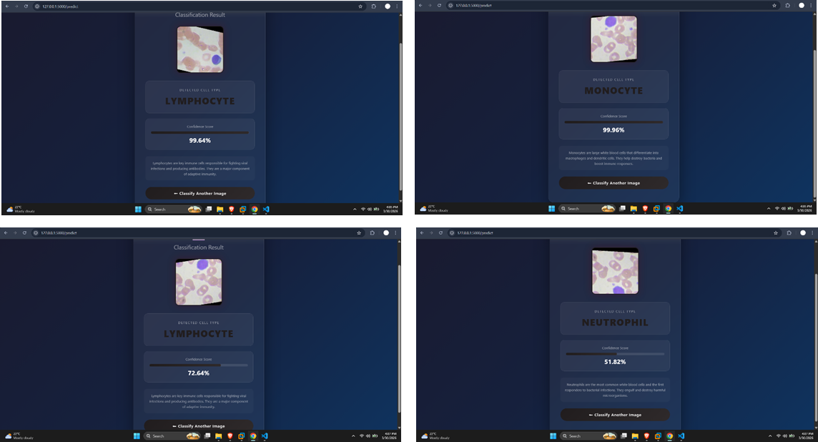
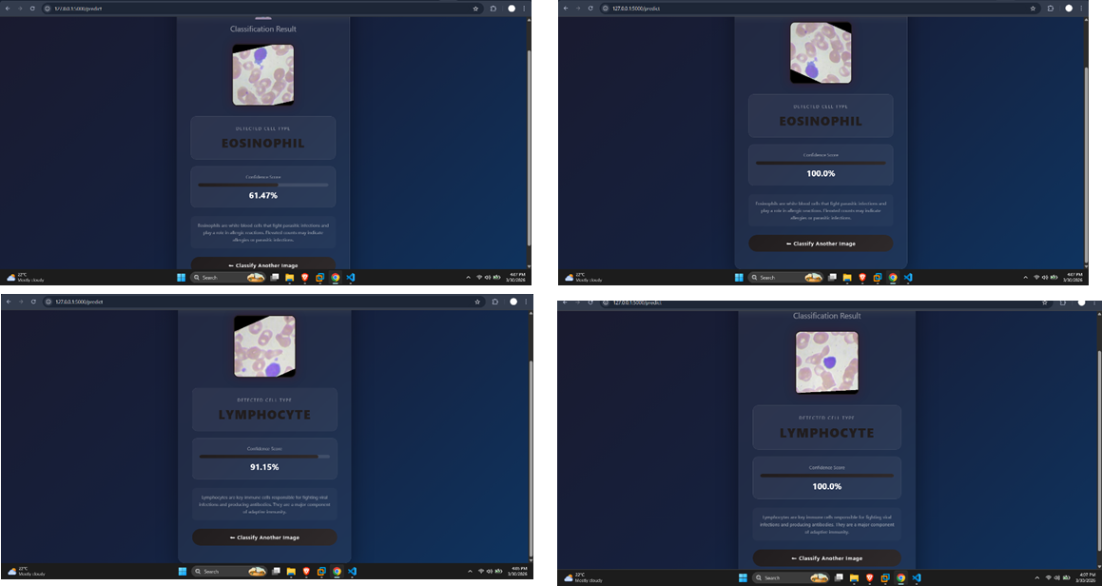

11. Links

Resource | URL
GitHub Repository | https://github.com/nanak011/HematoVision
Dataset (Kaggle) | https://www.kaggle.com/datasets/paultimothymooney/blood-cells
Video Demo | https://drive.google.com/file/d/1Gm_fNMi2hbPTAsaVb5HICGdNFRYlON_5/view?usp=sharing

12. Conclusion
HematoVision demonstrates a complete end-to-end machine learning pipeline - from data loading and preprocessing, through model training using Transfer Learning, to deployment as an interactive web application.
By leveraging MobileNetV2's pre-trained weights, the project achieves 86.15% validation accuracy across four blood cell types without requiring GPU hardware. All 9 web application test cases were classified correctly, with the majority above 90% confidence.
This project covers the core skills of applied machine learning: data engineering, deep learning with Transfer Learning, model evaluation, and web deployment using Flask.
Key Takeaways
1. MobileNetV2 Transfer Learning is an efficient strategy for medical image classification.
2. Data augmentation improves generalization and reduces overfitting.
3. Flask enables rapid deployment of ML models as web services.
4. ModelCheckpoint and EarlyStopping ensure optimal model selection during training.
5. The complete project is reproducible from the public GitHub repository.

