Programming Languages Research Report

Course: CST 8002-040 Programming Languages Research Proj.
Assignment: Reflective Report 01
Instructor: Tyler DeLay
Student Name: Qinyu Luo
Student ID: 041137796
Due Date: 10/18
Submitted: 10/19

What was learned about my programming language
Programming Language: Node.js
Topics learned and implemented:
- Node.js file I/O with fs module
- readline module for user input
- Callback-based approaches vs promise-based approaches
- Asynchronous programming with async/await
- Code organization using module.exports
- Express framework
- File I/O operations
- Database handling and integration
Strengths of Node.js:
- Excellent for building server-side applications and APIs
- Asynchronous, non-blocking I/O makes it highly efficient for handling multiple requests
- Large ecosystem with npm (Node Package Manager) providing access to thousands of packages
- JavaScript on both frontend and backend allows for full-stack development with one language
- Strong community support and extensive documentation
- Database integration is convenient and straightforward
Weaknesses of Node.js:
- Single-threaded nature can be a limitation for CPU-intensive tasks
- Asynchronous programming has a steep learning curve for beginners
- Callback hell can occur if not using promises or async/await properly
- Not ideal for heavy computational tasks compared to languages like Python or Java

The Best Resources for Me to Learn Are
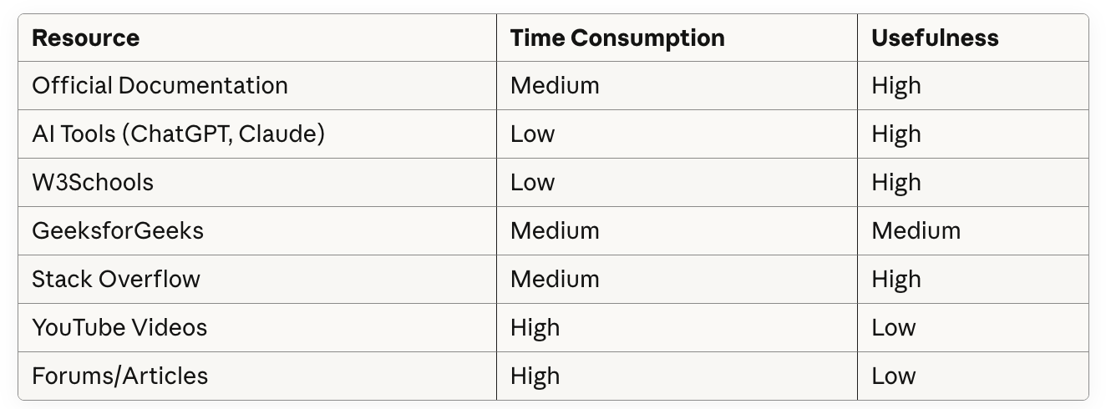
Most effective resources:
AI tools were the most effective resource for me due to their low time consumption and high usefulness. They provide quick, personalized explanations and can clarify concepts immediately when I get stuck. I can ask follow-up questions and get targeted answers without wading through irrelevant content.
W3Schools was also highly effective because the examples were practical and I could run them immediately to see results. This hands-on approach helped me learn faster than just reading theory.
Official documentation, while sometimes dense, was reliable and accurate. Combined with AI tools to help interpret the documentation, this became a powerful learning combination.
YouTube videos were less effective for me because they were either too fast or too slow, and I found myself wasting time searching for the right part of the video. Forums and repetitive articles were the least effective - many were verbose and contained content copied from other sources with no original value.

WBS, Project Management Software, Reflection on Time Estimation
Time estimation accuracy:
My time estimation was inconsistent throughout the first half of the course. In Research Assignment 1, I underestimated everything, especially learning new concepts and debugging time. However, in Research Assignment 2, I overestimated the time needed for most tasks and allocated more time than was actually required.
What I learned:
I learned that time estimation is challenging because it depends on many factors:
- New programming concepts take significantly longer to learn than familiar ones
- Debugging should be treated as a separate task, not just part of coding time
- Life interruptions and unexpected events need to be accounted for
- My WBS in the first assignment was too general - I wrote broad tasks like "Research file I/O" instead of breaking it down into learning modules, user interface, testing, etc.
- In the second assignment, my WBS became too detailed, though this helped with tracking progress
Improvements for the second half of the course:
For the second half of this course, I will:
- Use my experience from these first two assignments to create more realistic baseline estimates
- Add buffer time specifically for unexpected life events and interruptions, rather than padding every single task
- Break programming tasks into smaller, more specific steps (finding the middle ground between too general and too detailed)
- Add 50% more time for completely new programming concepts
- Treat debugging as a separate line item with its own time allocation
- Track actual time spent versus estimated time to continuously refine my estimation skills

Discussion Board Post Archive
Discussion Forum 1 Post
Recent knowledge learned:
- Node.js file I/O with fs module and readline for user input
- Difference between callback and promise-based approaches
- Why async/await is needed (JavaScript is asynchronous)
- module.exports to organize code into separate files
What was interesting: Understanding why my program didn't wait for user input was like solving a puzzle! Learning that JavaScript doesn't naturally "wait" and needs async/await finally made everything click.
Learning Resources: Most effective: W3Schools Node.js tutorials and Stack Overflow for debugging Less effective: YouTube videos (too fast/slow) Most time-consuming: Debugging syntax errors with async/await Most time-saving: W3Schools examples I could run immediately
WBS Reflection: My WBS was too general. I wrote "Research file I/O" instead of breaking it down into learning modules, user interface, testing, etc. Improvement: Break programming tasks into smaller steps and include separate time for debugging.
Time Estimation Reflection: I underestimated everything, especially learning new concepts and debugging time. Improvement: Add 50% more time for new programming concepts and treat debugging as a separate task, not part of coding time.
Discussion Forum 2 Post
- What I Learned About Node.js
Topics learned:
- Express framework
- File I/O operations
- Database handling and integration
What was interesting: I found database handling particularly interesting and convenient. The way Node.js integrates with databases made the development process much smoother than I expected.
- Learning Resources Reflection
Resources used:
- Official documentation (Node.js, Express)
- GeeksforGeeks
- AI tools
Most effective resources: AI tools were the most effective for me - low time consumption and high usefulness. Official documentation was also helpful, though sometimes dense. Forums and some articles were less successful because they were often verbose and repetitive, with content copied between sources.
- WBS and Gantt Chart Reflection
WBS accuracy: My WBS was a bit too detailed, but this wasn't a major issue as it helped me track progress precisely.
Time estimation: I overestimated the time needed for tasks. In the future, I will build in buffer time specifically for unexpected life events rather than padding every task, and use this experience to create more realistic estimates.

