Programming Language Research Project

Course: CST 8002-040 Programming Languages Research Project
Assignment: Practical Project 01
Instructor: Tyler DeLay
Student Name: Qinyu Luo
Student ID: 041137796
Due Date: 09/21
Submitted: September 21

Evidence of Learning

Variables
const records = [];
const STUDENT_NAME = "Qinyu Luo";

This code shows how I use variables to store data. The records array holds all the data objects, and STUDENT_NAME stores my name as a constant.

Methods
getSiteIdentification() {
return this.siteIdentification;
}
This is a getter method in my RecordObjects class. It returns the site identification data from an object.

Loop Structure
for (let i = 0; i < records.length; i++) { console.log(`Record ${i + 1}:`); console.log(` Site: ${records[i].getSiteIdentification()}`); // ... more output lines }
This for loop goes through each record in the array and prints the data to the screen. It repeats for each record.

File-IO
fs.createReadStream('dataset.csv')
.pipe(csv())
This code reads the CSV file from my computer. It opens the file and reads the data line by line.

Exception Handling
.on('error', (err) => {
console.error('Error reading file:', err.message);
});
This handles errors if the file cannot be read. It will show an error message instead of crashing the program.

Use of an API library
const fs = require('fs');
const csv = require('csv-parser');
These lines import external libraries. The fs library reads files, and csv-parser helps parse CSV data.

Array
const records = [];
This creates an empty array to store all my RecordObjects. I add new objects to this array as I read the CSV file

Program Demonstration via Screen Shots
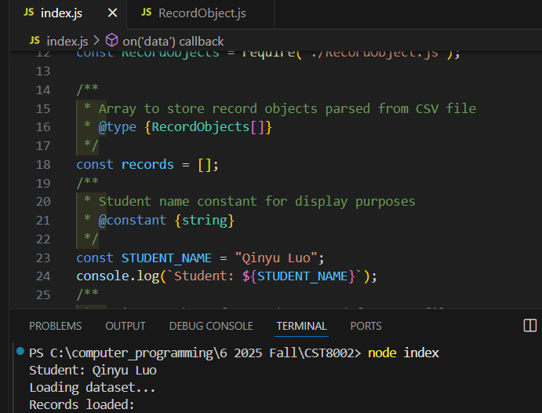
This screenshot shows the program starting up and beginning to read the CSV dataset. My full name "Qinyu Luo" is displayed as required.
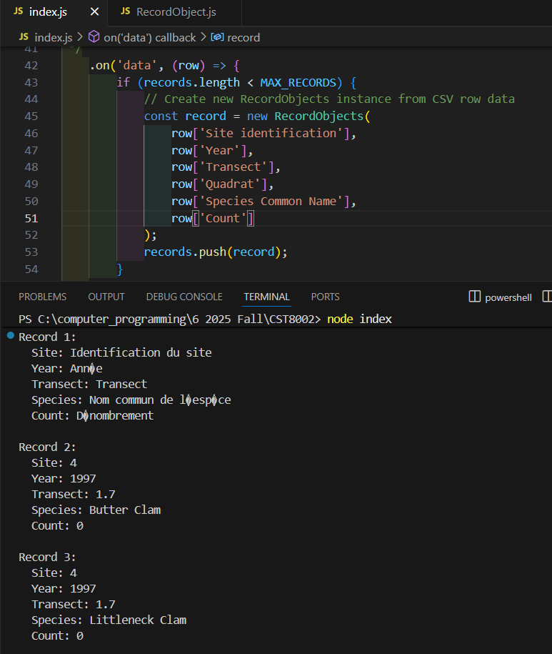
This screenshot demonstrates the program successfully reading and displaying records from the dataset. The output shows site identification, year, transect, and species data from the CSV file.
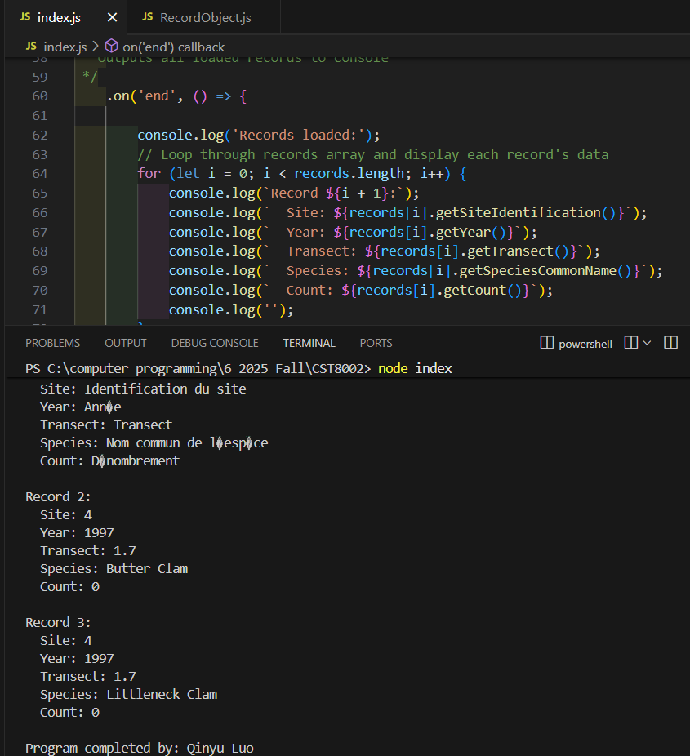
This screenshot shows the program completion message with my name displayed, confirming all records have been processed successfully.

