Programming Language Research Project

Course: CST 8002-040 Programming Languages Research Project
Assignment: Practical Assessment 05
Instructor: Tyler DeLay
Student Name: Qinyu Luo
Student ID: 041137796
Due Date: 11/22
Submitted: 11/22

Research
[1] "Array.prototype.filter() - JavaScript | MDN", MDN Web Docs. [Online]. Available: https://developer.mozilla.org/en-US/docs/Web/JavaScript/Reference/Global_Objects/Array/filter [Accessed: Nov. 22, 2025]. [2] "How to Implement Search and Filtering in a REST API with Node.js and Express.js", GeeksforGeeks, Jul. 23, 2025. [Online]. Available: https://www.geeksforgeeks.org/node-js/how-to-implement-search-and-filtering-in-a-rest-api-with-node-js-and-express-js/ [Accessed: Nov. 22, 2025]. [3] "JavaScript filter array multiple conditions - Stack Overflow", Stack Overflow. [Online]. Available: https://stackoverflow.com/questions/31831651/javascript-filter-array-multiple-conditions [Accessed: Nov. 22, 2025].

Program Demonstration via Screen Shots
The multi-column filter program was successfully implemented and tested with sample student data. The program demonstrates the ability to filter an array of objects based on multiple criteria simultaneously.
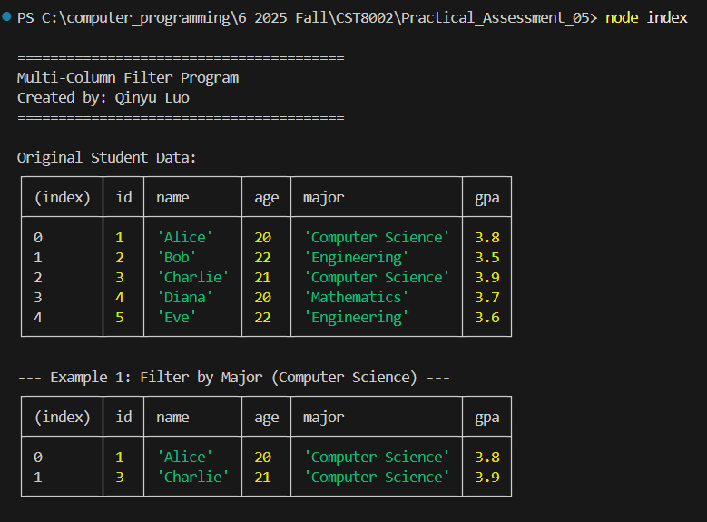
Figure 1: Program Initialization and Original Data Display This screenshot shows the program startup displaying the author's name and the original student dataset before any filtering is applied. The data includes student information such as ID, name, age, major, and GPA.
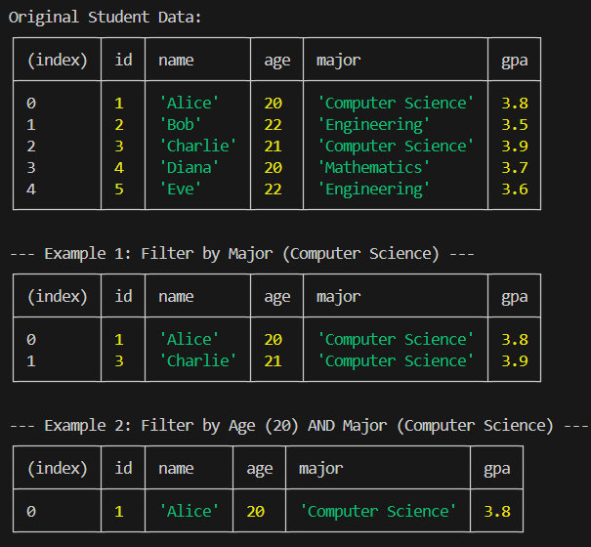
Figure 2: Single Column Filter Example This screenshot demonstrates filtering the student data by a single criterion (Major = "Computer Science"). The output shows only the students whose major matches the filter condition.
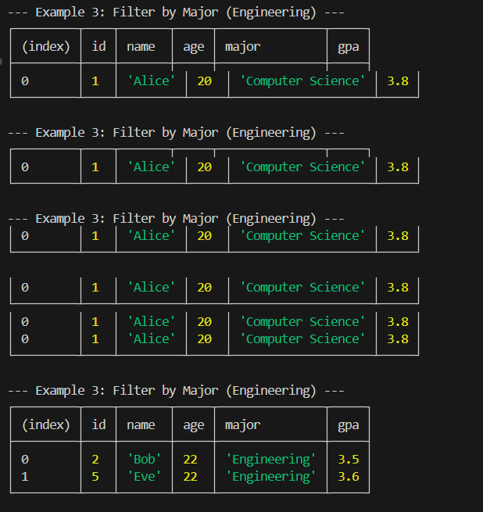
Figure 3: Multi-Column Filter Example This screenshot illustrates the multi-column filtering capability, where the data is filtered by two criteria simultaneously (Age = 20 AND Major = "Computer Science"). The program successfully returns only the records that match both conditions, demonstrating the AND logic operation across multiple columns.
The proof-of-concept program successfully demonstrates multi-column filtering functionality using Node.js. The implementation leverages JavaScript's native Array.prototype.filter() method combined with the Object.keys().every() pattern to check multiple filter conditions.

Key features implemented:
- Dynamic multi-column filtering based on user-defined criteria
- Support for both string (partial match, case-insensitive) and numeric (exact match) filtering
- Clean console output using console.table() for improved readability
- Proper code documentation and IEEE-style references

The program provides a solid foundation for understanding how to implement search and filter operations in JavaScript/Node.js applications, which can be extended to more complex scenarios such as web APIs or database query systems.

