Programming Language Research Project

Course: CST 8002-040 Programming Languages Research Project
Assignment: Practical Assessment 03
Instructor: Tyler DeLay
Student Name: Qinyu Luo
Student ID: 041137796
Due Date: 10/02
Submitted: 10/02

Research
API Reference [1]:Node.js Assert module documentation provides the complete API reference for built-in assertion methods such as assert.strictEqual().
Best Practices [2]: Node.js test runner guide introduces best practices for organizing test files, writing test cases, and running tests.
Implementation Tutorial [3]:** Jest unit testing tutorial demonstrates how to install Jest, configure the project, and implement test cases. This tutorial was used to create the proof-of-concept program with one passing and one failing test.

[1] Node.js Foundation, "Assert," Node.js v12.22.12 Documentation. [Online]. Available: https://nodejs.org/docs/latest-v12.x/api/assert.html. [Accessed: Oct. 2, 2025].
[2] Node.js Foundation, "Using Node.js's test runner," Node.js Documentation. [Online]. Available: https://nodejs.org/en/learn/test-runner/using-test-runner. [Accessed: Oct. 2, 2025].
[3] B. Johnson, "Node.js Unit Testing with Jest," Medium, Feb. 18, 2023. [Online]. Available: https://medium.com/@ben.dev.io/node-js-unit-testing-with-jest-b7042d7c2ad0. [Accessed: Oct. 2, 2025].

Proof of Concept
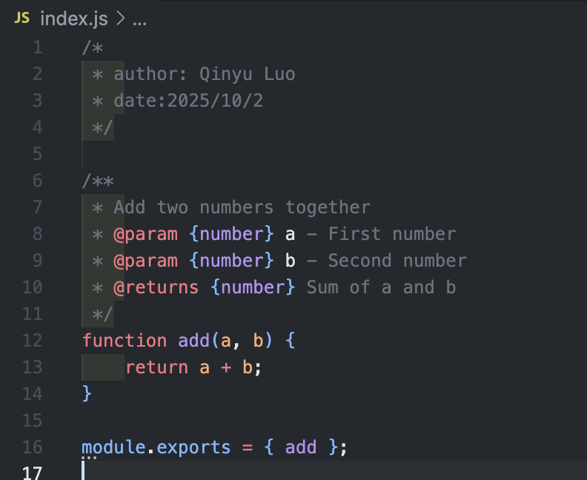
Figure 1: Implementation of the add() function in calculator.js. This simple function takes two parameters and returns their sum. The function includes JSDoc documentation comments describing its purpose, parameters, and return value.
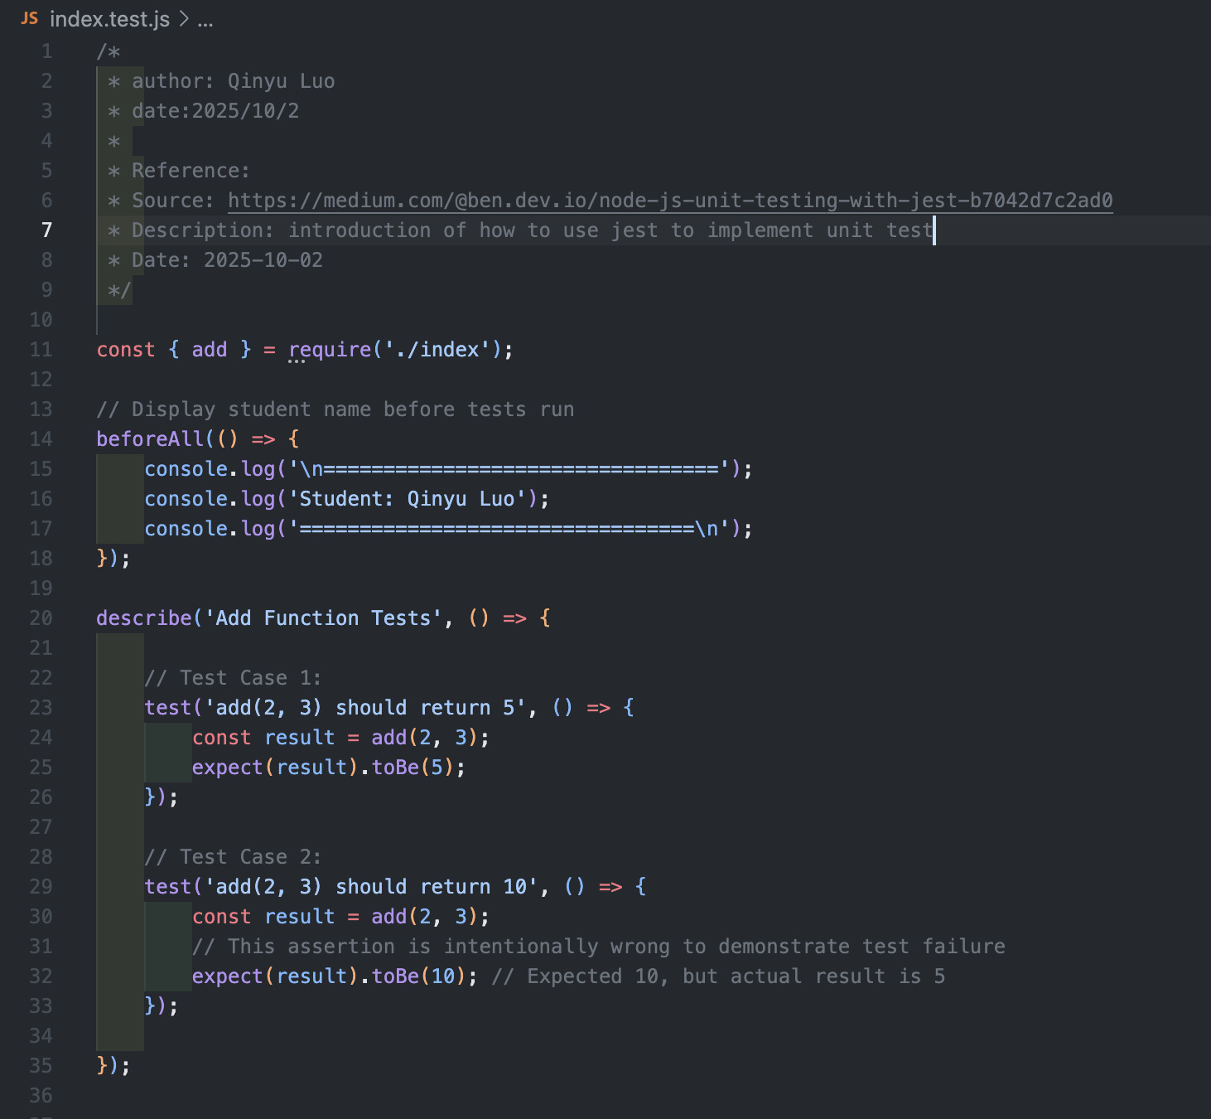
Figure 2: Unit test implementation in calculator.test.js using Jest framework and Node.js assert module. The test suite includes two test cases: one that passes (verifying add(2,3) equals 5) and one that intentionally fails (expecting add(2,3) to equal 10). 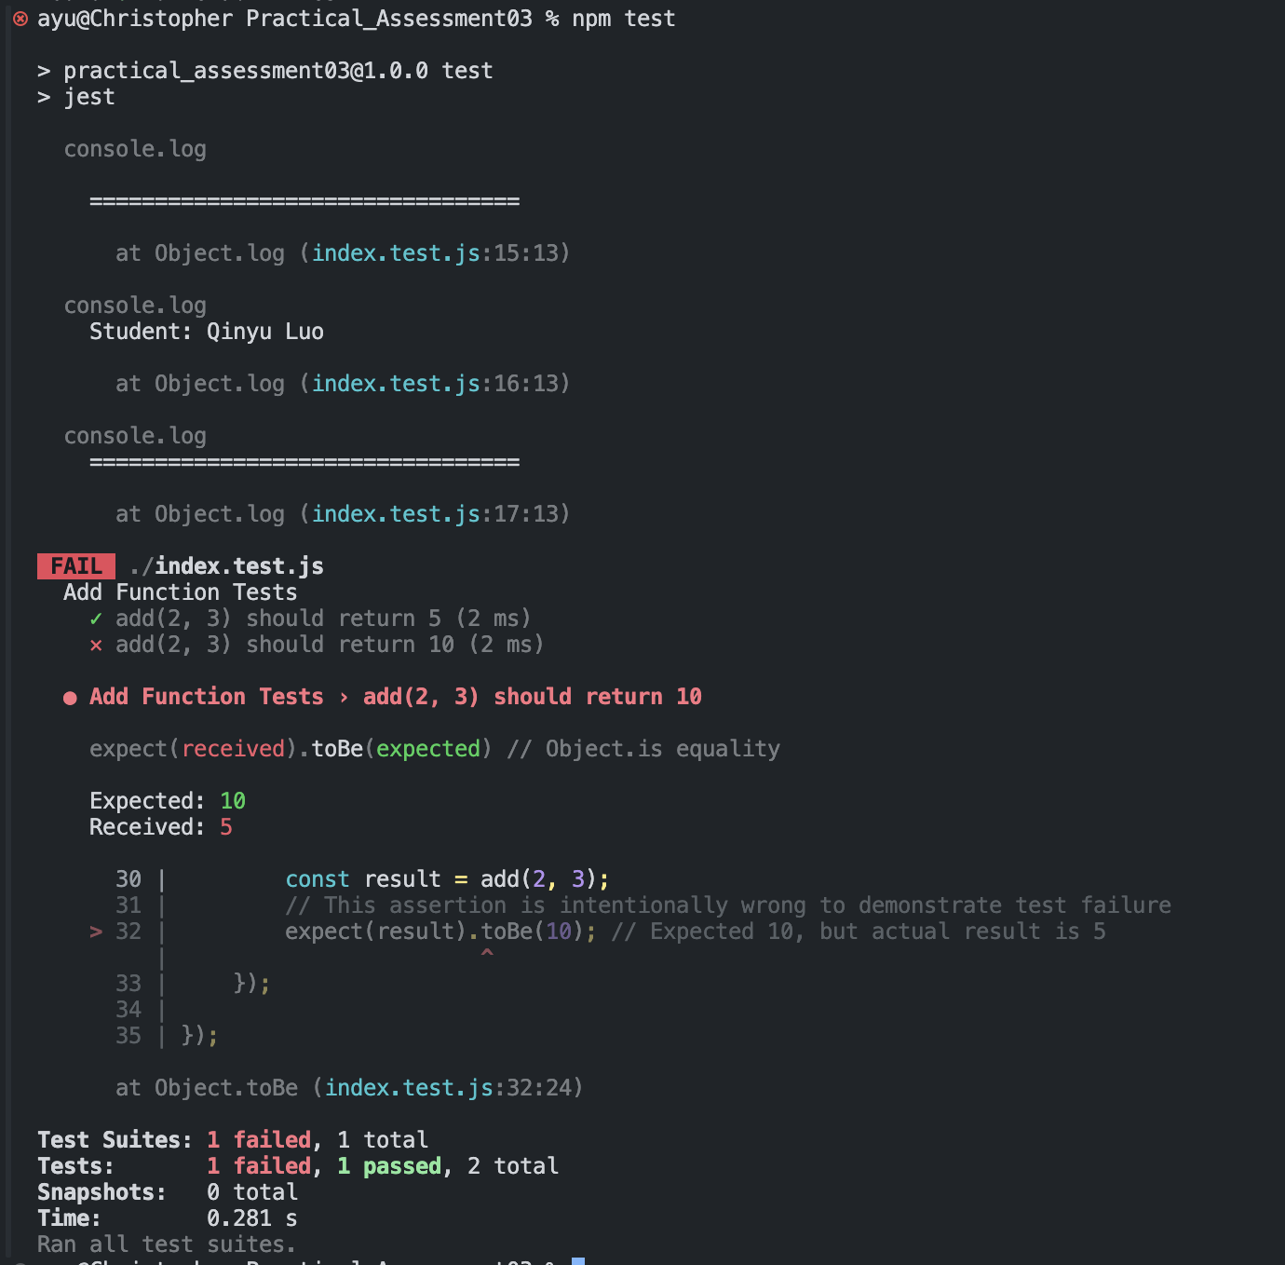
Figure 3: Jest unit test execution showing two test cases for the add() function. Test 1 passes (2+3=5), Test 2 fails intentionally (expecting 10 but receiving 5). Student name "Qinyu Luo" is displayed in the console output.

