Name: Nancy Abi Farah (211988)

GitHub Link Repository: <https://github.com/Nancy-222/Servlet_Devoir>

This Java servlet class, named "Greeting", extends HttpServlet to handle HTTP GET requests. When a GET request is received, it retrieves parameters "nom" (surname) and "prenom" (name) from the request URL, constructs an HTML response with a greeting message including the provided name and surname, and sends it back to the client.

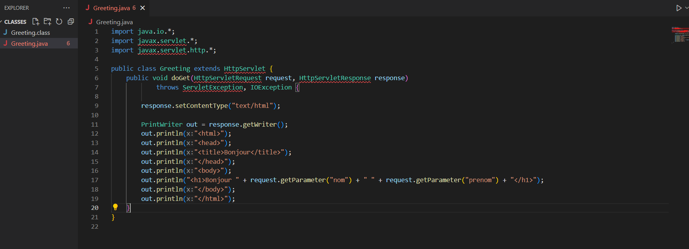

This HTML code represents a simple web page with a hyperlink. When clicked, the hyperlink navigates to a URL "http://localhost:8080/Server/Greeting" with two parameters: "nom" set to "Nancy" and "prenom" set to "AbiFarah". This URL is likely pointing to a servlet named "Greeting" on a local server running on port 8080.

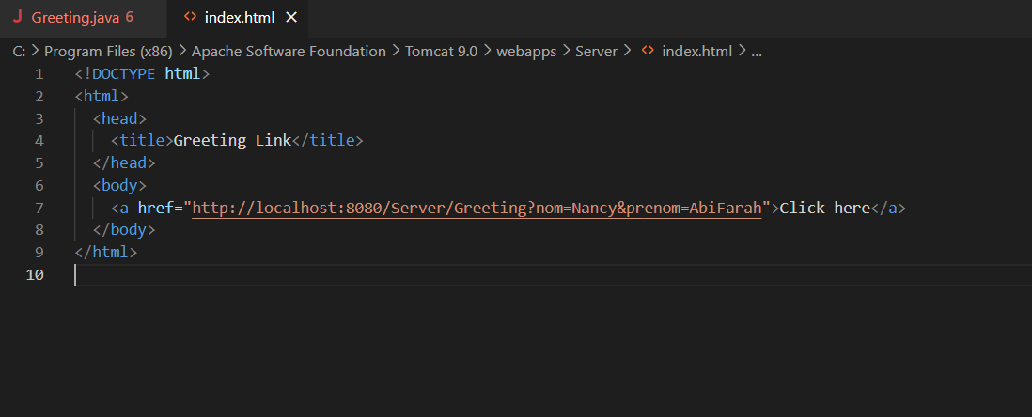

Result:

