**Name: Nancy Abi Farah (211988)**

**Link to GitHub Repository:**

**Imports Used:**

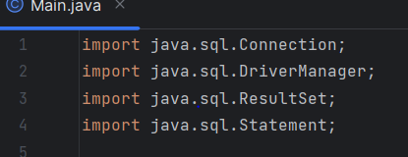

**Execution of the program:**

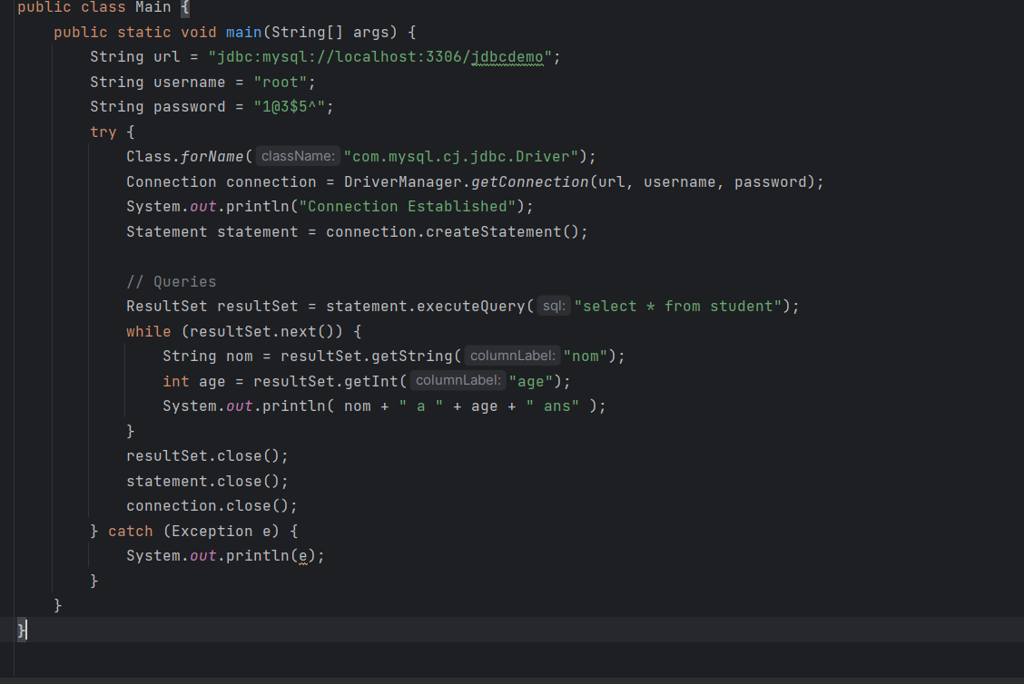

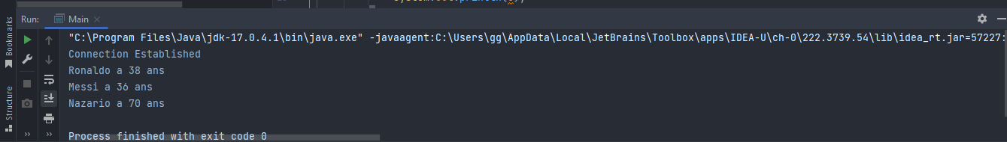

**Creating a Database in MySQL Workbench:**

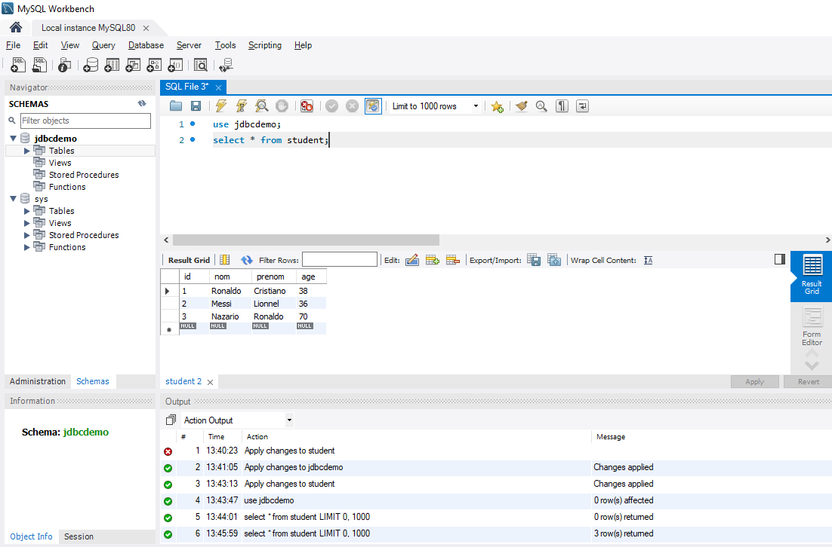

**Steps to add the JDBC JAR file in IntelliJ:**

1. **Download the JDBC Driver JAR File:** **First, you need to download the JDBC driver JAR file for the database you want to connect to.**
2. **Open Your IntelliJ IDEA Project:** **Open your IntelliJ IDEA project where you want to add the JDBC driver JAR file.**
3. **Add the JDBC Driver JAR File to Your Project:** **Navigate to File > Project Structure select Modules > Dependencies > click the "+" button > choose "JARs or directories..." > navigate to the location of the JDBC driver JAR file, select it, and click "OK" > Apply > OK to close the dialog.**

