ABC Dental Clinic — AI Receptionist

1. Overview
The ABC Dental Clinic AI Receptionist is a real-time voice bot that answers inbound patient calls on a web page. A patient clicks 'Start Conversation', speaks naturally, and the bot books appointments, answers clinic FAQs, and escalates emergencies — all without a human receptionist. The entire conversation is saved to a database, and a post-call AI analysis report is generated automatically after every call.
End-to-end response latency is under one second. This is achieved through model prewarming, sentence-level TTS streaming, preemptive LLM generation, and non-blocking async database writes.

System Architecture Overview
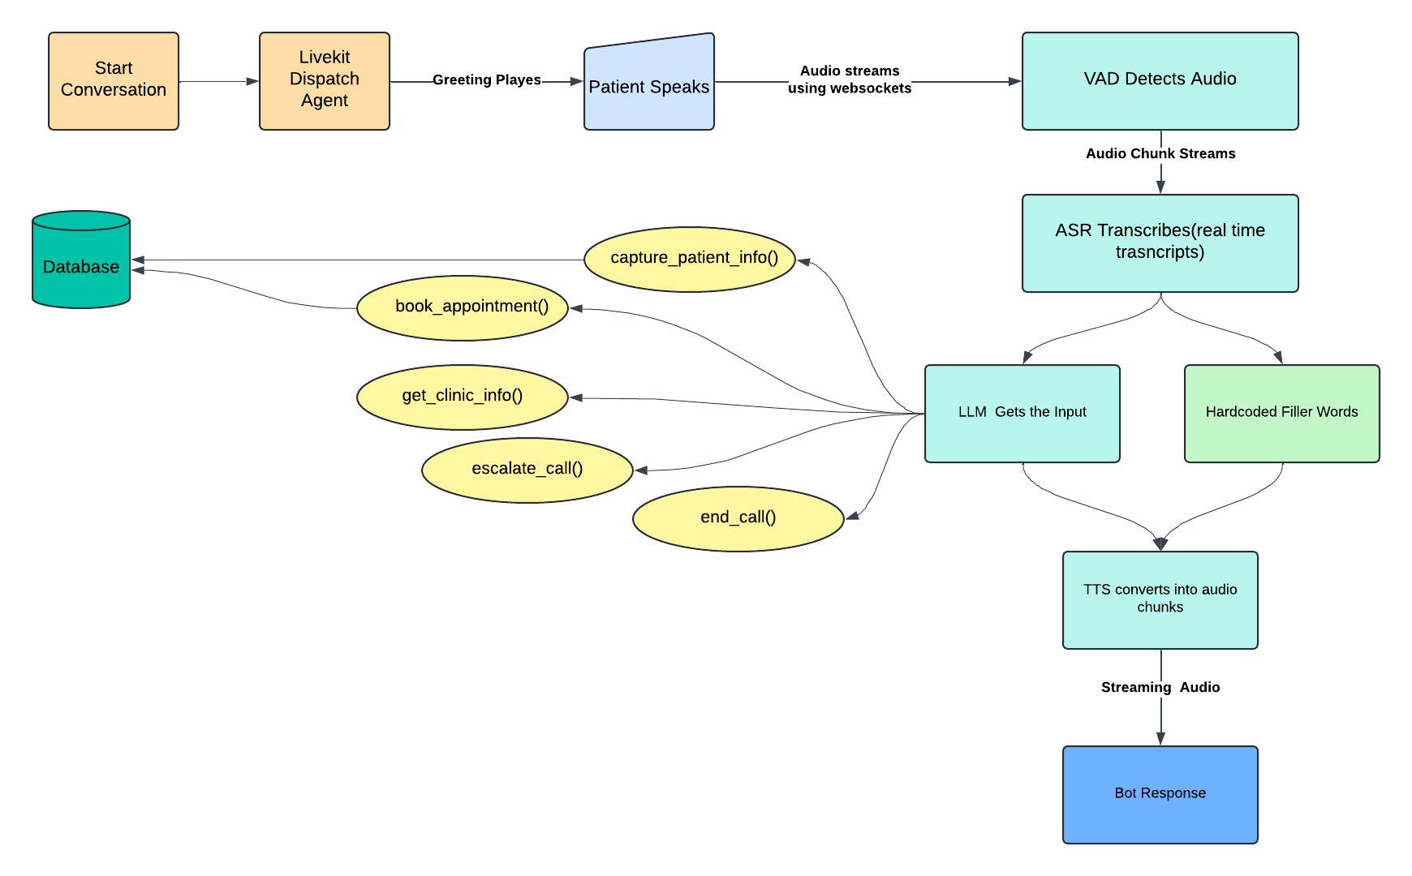
Figure 1 — Voice pipeline and LLM tool dispatch. Audio flows left-to-right: VAD → ASR → LLM → TTS → patient. The LLM branches into five tools; capture_patient_info and book_appointment persist data to the database.

2. System Components

Patient Browser (React)
A single-page React app. The patient's microphone audio streams directly to LiveKit Cloud over WebRTC — the browser does no audio processing itself. On load, the browser calls POST /token on the FastAPI backend to receive a room token and LiveKit URL, then connects.

FastAPI Backend
A lightweight Python API server with three jobs:
- POST /token — Creates a LiveKit room and returns a signed JWT token to the browser.
- GET /health — Simple uptime check.
- Static file server — Serves the compiled React app on port 8000.
The agent dispatch is embedded inside the JWT token itself (RoomAgentDispatch). When the browser connects to LiveKit using that token, LiveKit reads the configuration and automatically routes a job to the agent worker — the backend never calls the agent directly.

LiveKit Cloud
The real-time audio routing layer. It handles WebRTC negotiation, NAT traversal, room lifecycle, and audio routing between the browser and the agent worker. The agent connects to LiveKit over a persistent WebSocket and receives audio as a stream.

Agent Worker (Python)
The core of the system. A Python process that:
- Pre-loads all models at startup (Silero VAD, Deepgram STT client, OpenAI LLM client, Cartesia TTS WebSocket) so no cold-start penalty hits the first call.
- Runs the VAD → STT → LLM → TTS pipeline for every patient turn.
- Maintains a PatientMemory dataclass (name, DOB, reason, preferred time, insurance) for the call duration and injects collected fields back into the LLM system prompt so the bot never re-asks for information.
- Dispatches tool calls chosen by the LLM: capture_patient_info, book_appointment, get_clinic_info, escalate_call, end_call.
- Writes conversation turns, patient data, and stats to PostgreSQL via fire-and-forget async tasks so DB latency never blocks the voice pipeline.

PostgreSQL Database
Six tables, all timestamps in IST:
Table | Purpose
call_metadata | One row per call. Primary key = LiveKit room name. Parent for all FK relationships.
patient_data | Patient profile captured incrementally during the call. Upserted on each capture_patient_info tool call.
appointments | Confirmed booking records. Created only when book_appointment succeeds with all required fields.
conversations | Every user/assistant turn with role, content, and sequence number.
evaluation_statistics | Per-session latency and cost summary (LLM/STT/TTS tokens, durations, INR cost).
call_analysis | Post-call AI quality report: intent, satisfaction signal, bot accuracy, unanswered questions.

3. Voice Pipeline — How One Turn Works
Every time the patient speaks, the following sequence runs inside the Agent Worker:
- VAD (Silero) — Detects speech start and end. Prevents the pipeline from running on silence or background noise.
- STT (Deepgram nova-2) — Streams audio chunks and returns a real-time transcript over WebSocket.
- Filler word — Plays immediately ('Sure, one moment...') while the LLM is processing so the patient never hears dead silence.
- LLM (GPT-4o-mini) — Receives the transcript, decides whether to call a tool or reply directly. preemptive_generation=True means it starts generating before speech fully ends.
- Tool call (if any) — LLM calls one of the five tools. capture_patient_info and book_appointment write to the DB asynchronously.
- TTS (Cartesia sonic-english) — Converts the LLM reply to audio using a persistent WebSocket, flushing sentence-by-sentence for first-audio latency under 300ms.

4. Sequence Diagram — Full Call
The diagram below shows every message exchanged across all five participants during a complete call — from the browser's first token request through to post-call analysis:
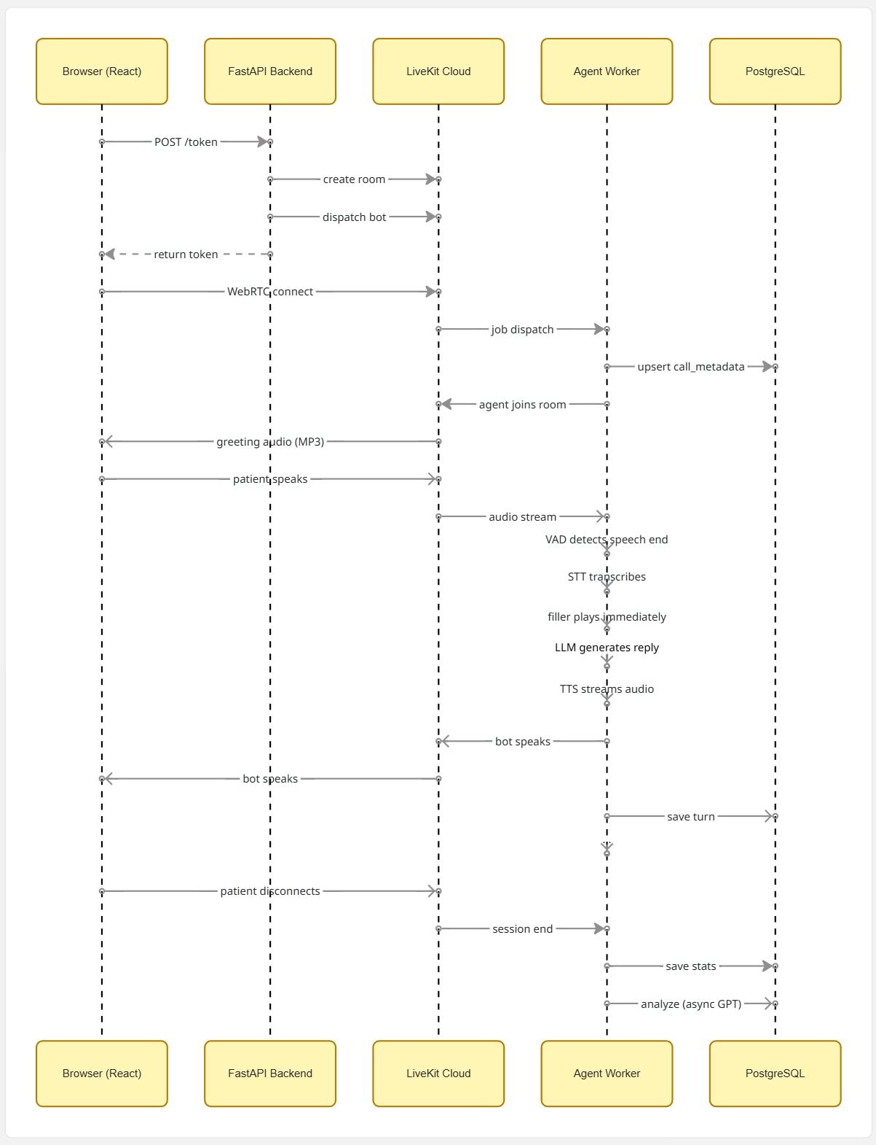
Figure 2 — Full call sequence diagram. Time flows top to bottom across five lifelines: Browser (React), FastAPI Backend, LiveKit Cloud, Agent Worker, and PostgreSQL. Key phases: (1) token request and room setup, (2) WebRTC connect and agent dispatch, (3) greeting MP3 playback, (4) conversation loop with async DB saves, (5) disconnect, stats save, and async post-call GPT analysis.

5. LLM Tools
GPT-4o-mini drives the conversation and decides when to call tools. The bot is not a rule engine — it handles natural variation, multi-field answers, and off-topic questions without extra code.
Tool | Triggered when
capture_patient_info() | Patient shares any detail — name, DOB, reason, preferred time, or insurance. Called immediately, even mid-sentence.
book_appointment() | All four required fields (name, DOB, reason, preferred time) are collected. Insurance is optional.
get_clinic_info(topic) | Patient asks any FAQ — hours, address, insurance accepted, services offered, emergency guidance.
escalate_call() | Severe pain, dental emergency, or explicit request for a human staff member.
end_call() | Patient says goodbye or signals the conversation is over.

6. Post-Call AI Analysis
After every call ends, a background task sends the full transcript to GPT-4o-mini with a structured prompt. It returns a JSON report saved to the call_analysis table:
- call_intent — booking / faq / reschedule / emergency / other
- appointment_confirmed — true / false
- customer_satisfaction_signal — Satisfied / Neutral / Dissatisfied
- bot_response_accuracy — Accurate / Partially Accurate / Incorrect
- did_bot_fail_to_answer — Yes / No — flags unanswered questions
- conversational_issue_detected — Free-text description of any problem in the call
This layer enables quality monitoring and data-driven prompt improvement without manually listening to calls.

7. Full System Architecture
The diagram below shows all system components and their connections — the Agent Worker (Python), FastAPI Backend, LiveKit Cloud, PostgreSQL database, External AI APIs, and the Patient Browser — with all data flows between them.
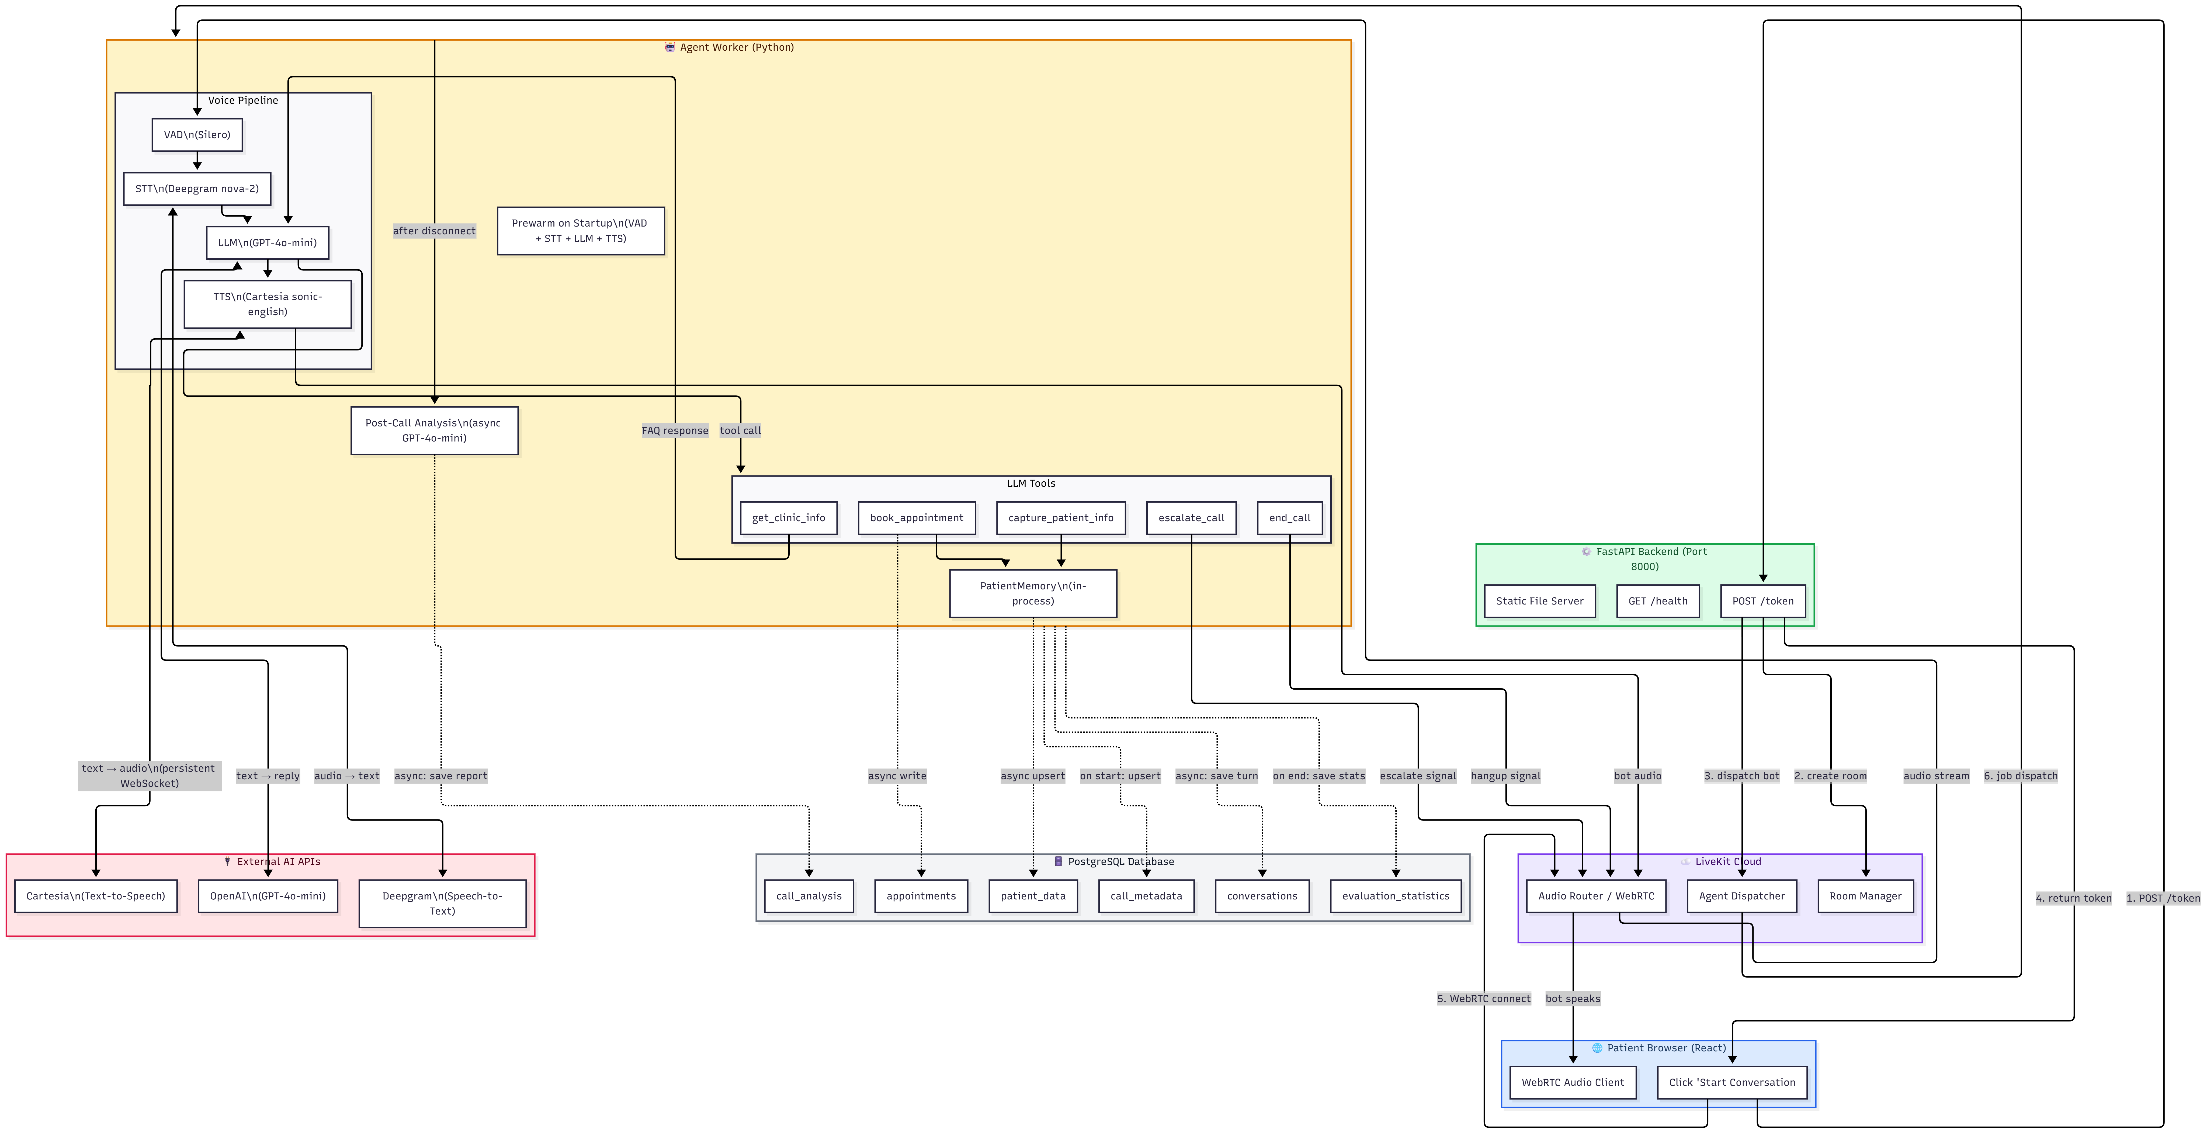
Figure 3 — Complete system architecture. Orange: Agent Worker. Green: FastAPI Backend. Purple: LiveKit Cloud. Gray: PostgreSQL. Red: External AI APIs (Cartesia, OpenAI, Deepgram). Blue: Patient Browser.

