**PROGRAMMING IN C**

**ASSIGNMENT**

**SUBMITTED BY**

**NANCY JOHNSON**

**STRING**

A string is a sequence of characters that is treated as a single data item. C does not support string as a data type,instead it allows us to represent strings as character arrays. A string can be defined as a one dimensional array of characters terminated by a null character ‘/0’. These are often used to create meaningful and readable programs

**String Handling Functions**

String handling functions can be used to carry out many of the string manipulations. These functions are packed in the **string.h** library. We have to include **string.h** in programs to use these functions. Mostly used string functions are :

1.strcat(): used to combine two strings

Program:

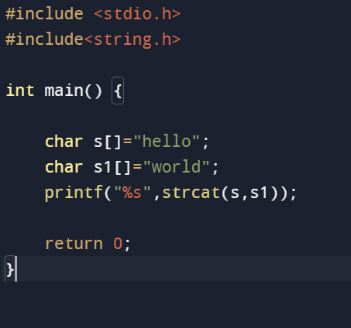

Output:



2.strlen(): used to show the length of string

Program:

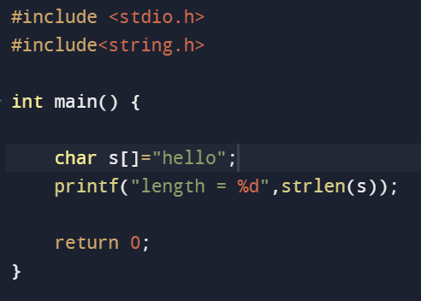

Output:



3.strcmp(): used to compare two strings

Program:

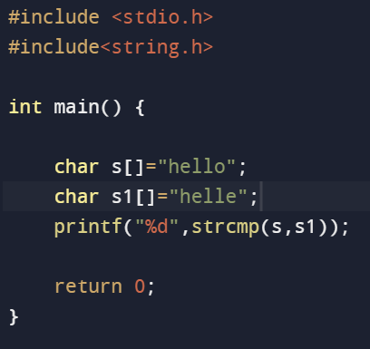

Output:



4.strcpy(): copies one string to another

Program:

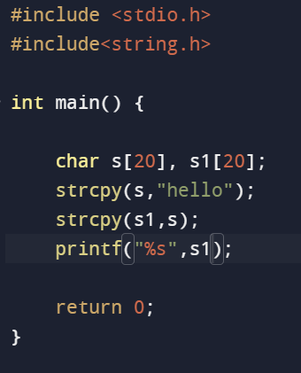

Output:



5.strlwr() & strupr() : used to convert the input to lower case and upper case

Program:

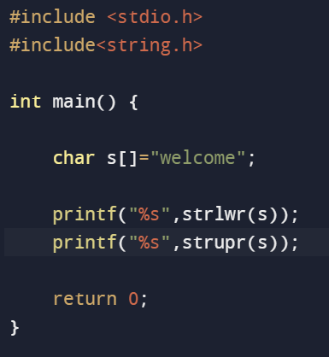

Output:

WelcomeWELCOME

6.strncat():It is used to concatenate n characters of second string to first string.

Program:

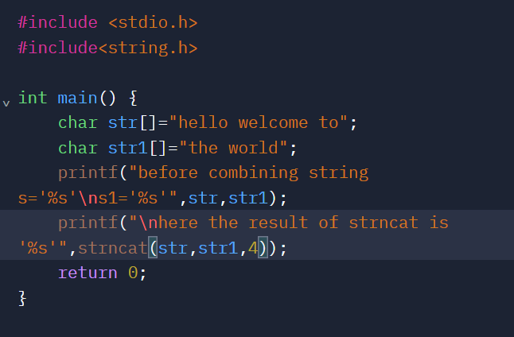

Output:

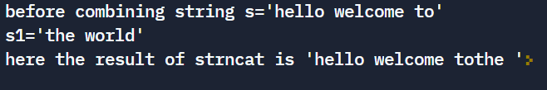

7.strncpy():It copies a given number of characters of one string into another.

Program:

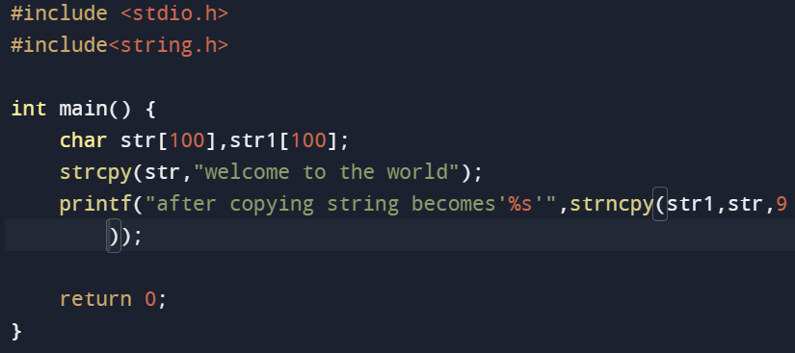

Output:



8.strstr():It returns the pointer of first occurrence of str2 in str1.

Program:

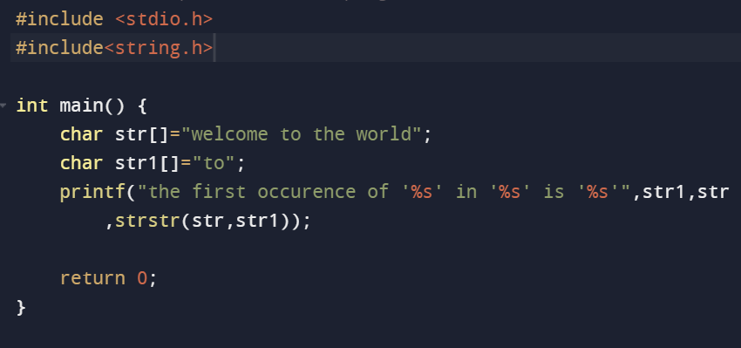

Output:

