Distributed Systems Midterm Report
Nancy Faour – 202210686
Step 1
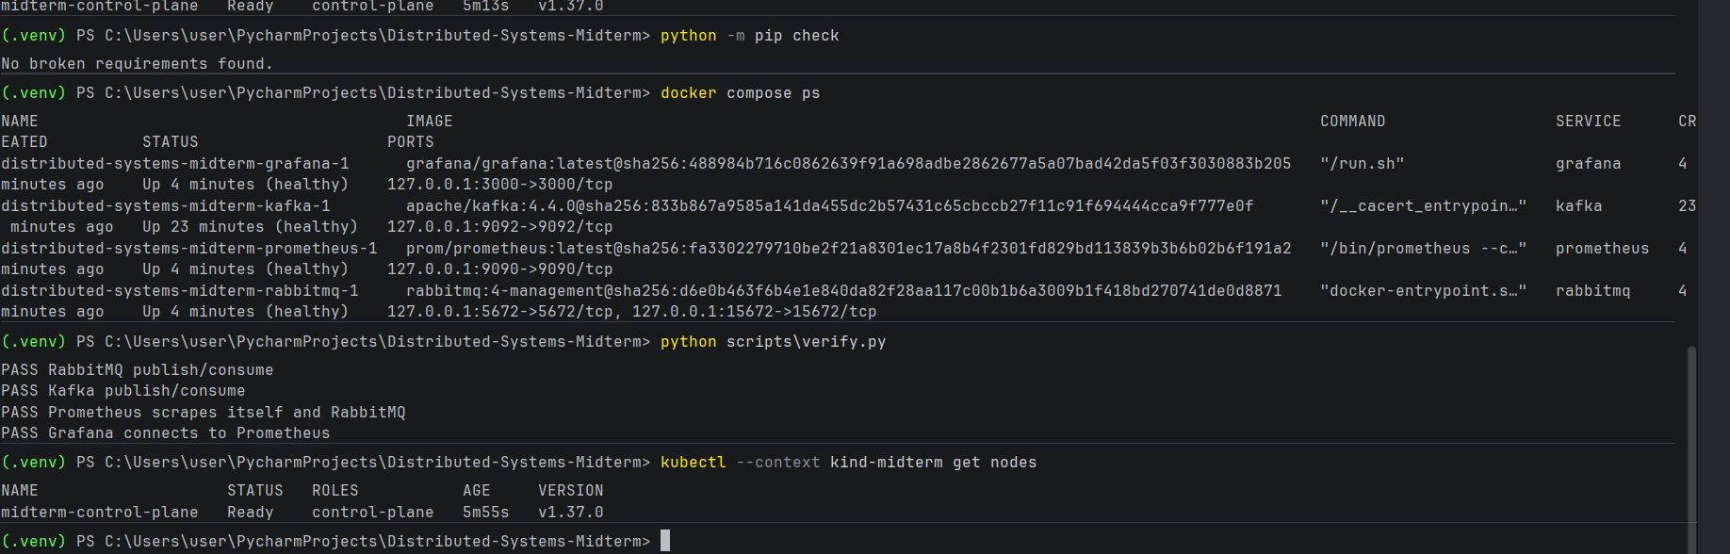
I use a Python virtual environment, Docker Compose to run the four supporting services, and kind to run a local Kubernetes cluster.”
Github NancyFaour/Distributed-Systems-Midterm
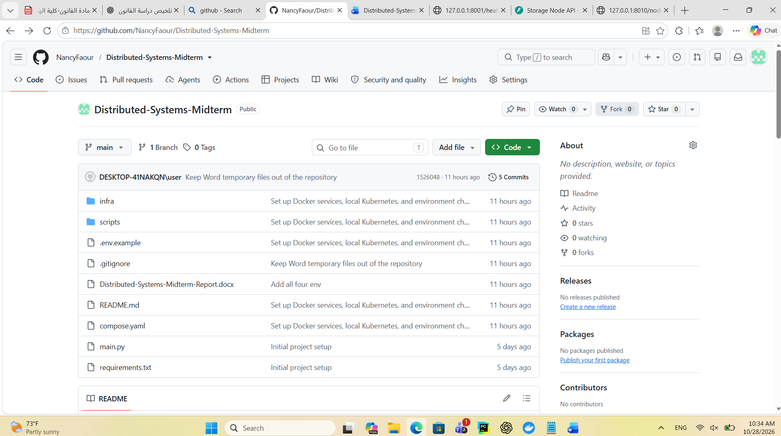
Step 2
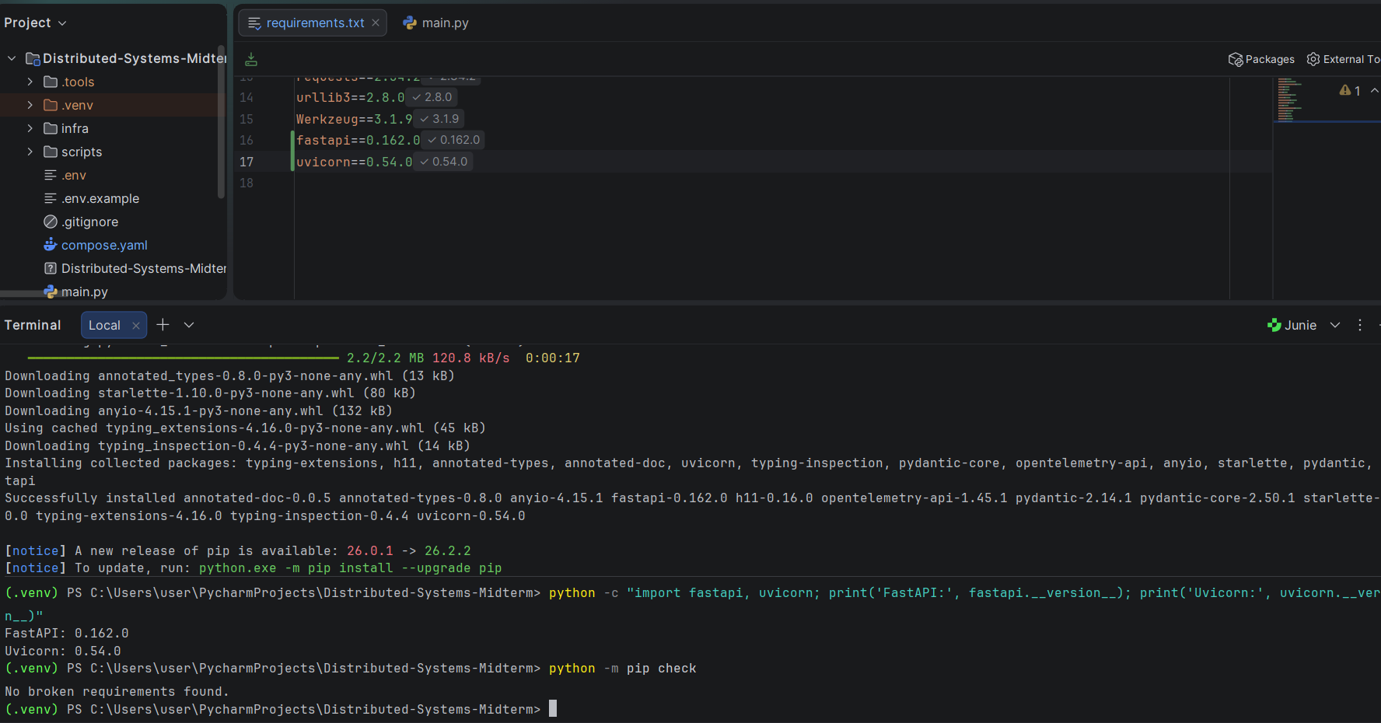
Install Fast API and verify
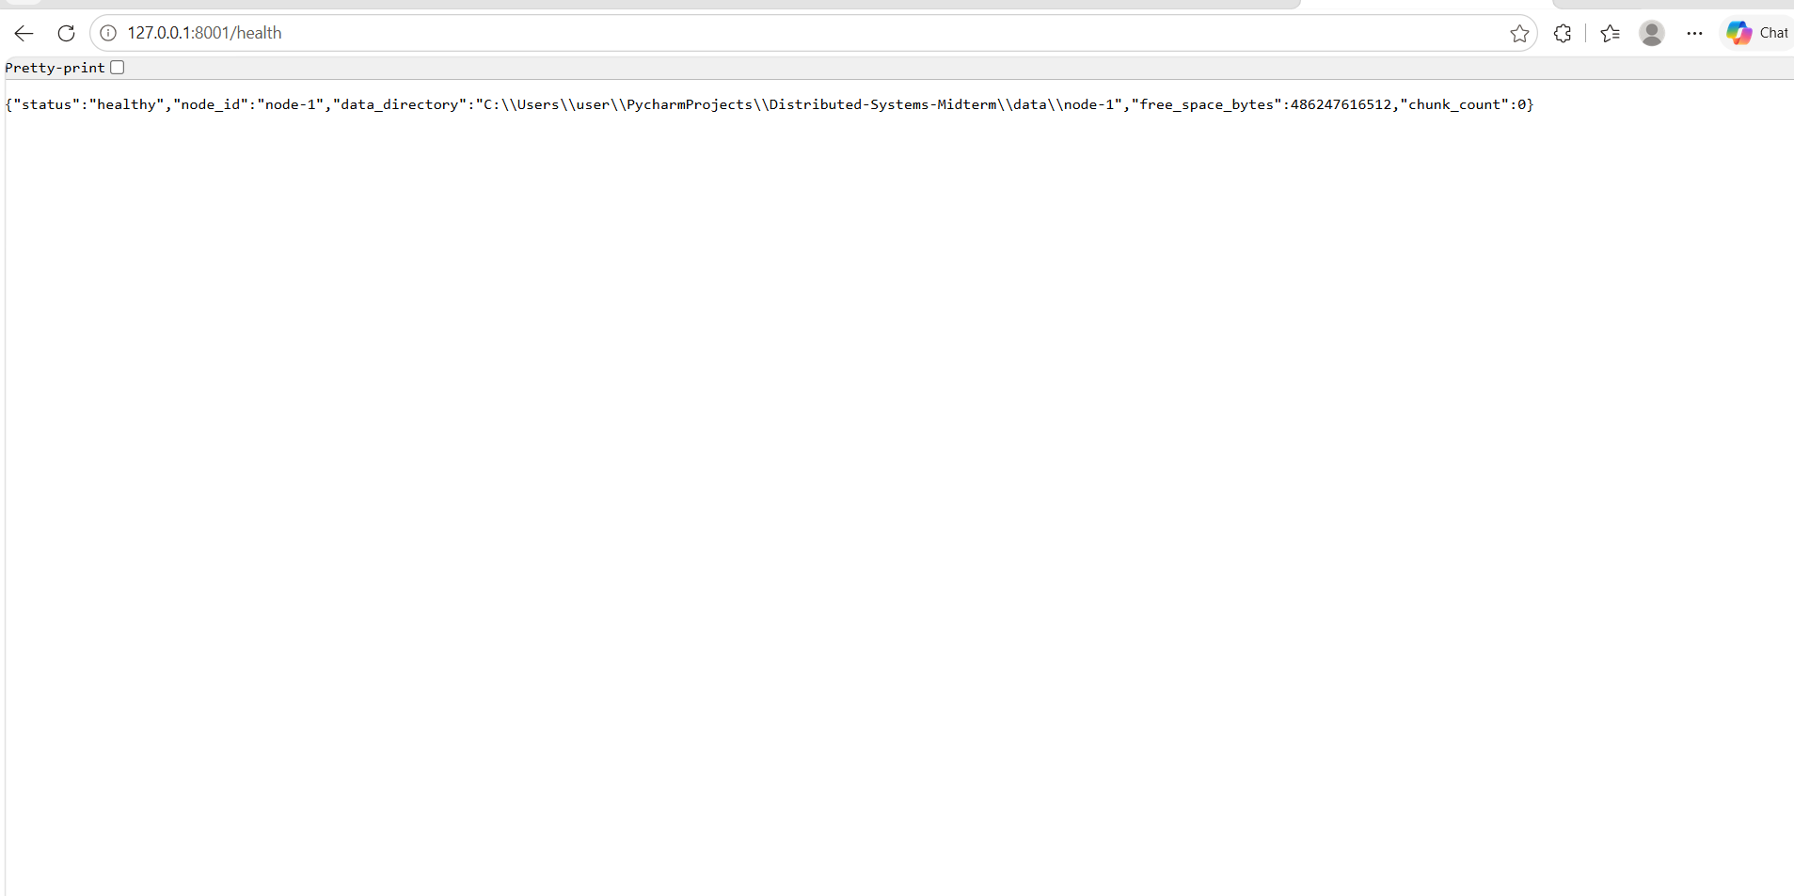check /health
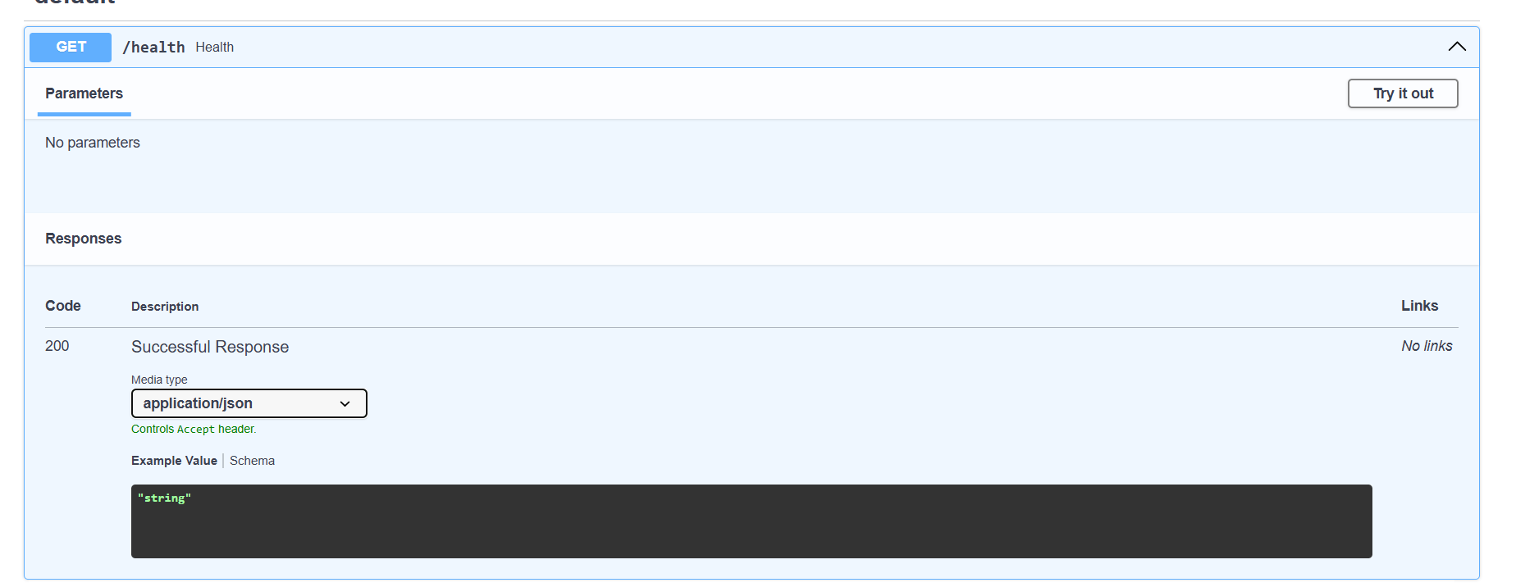
First 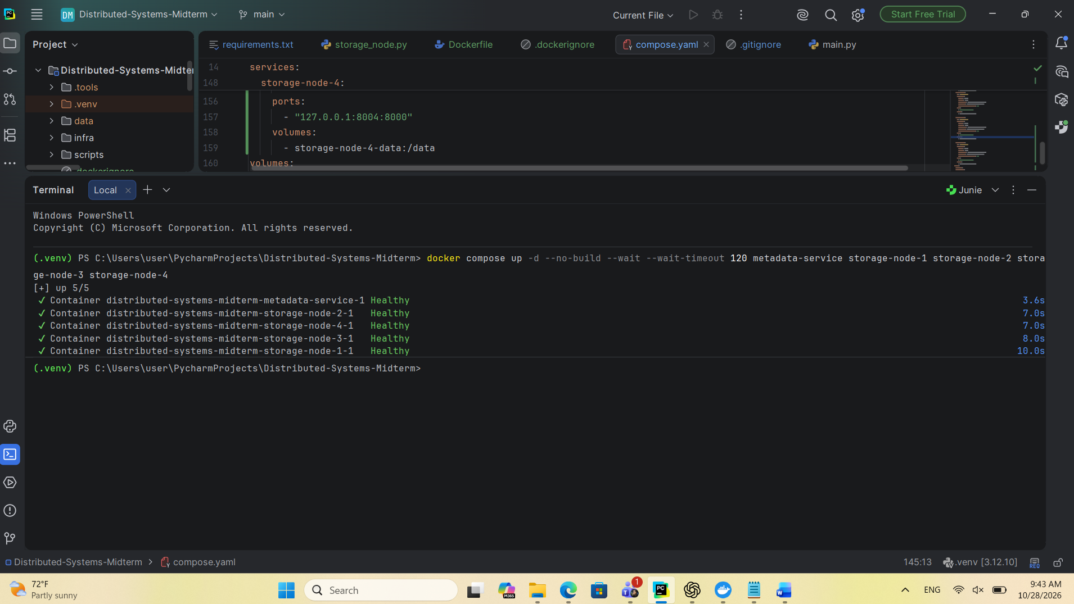
Create and check
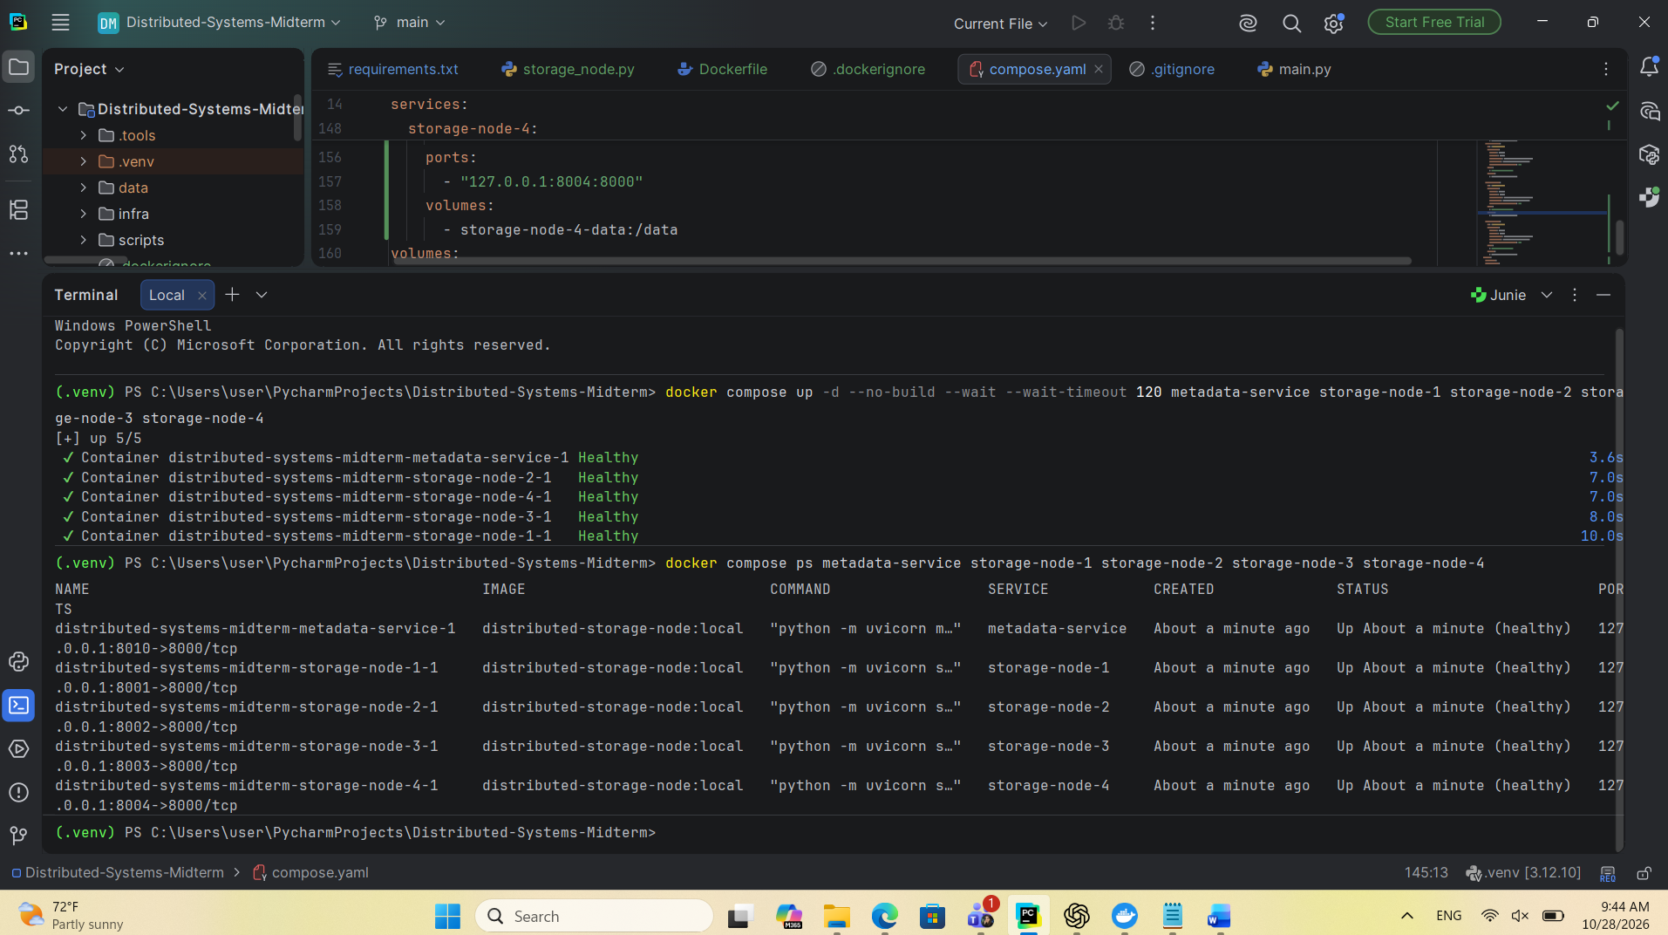

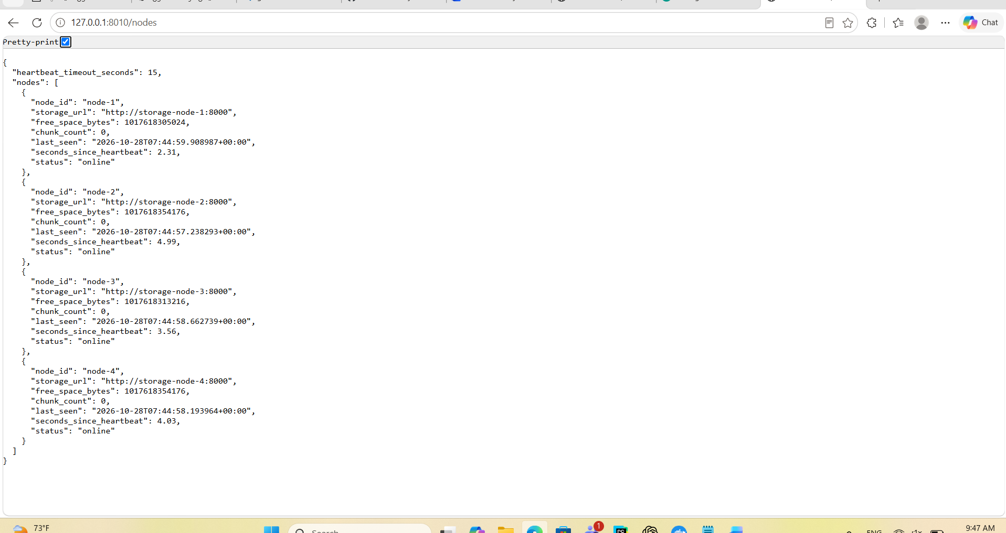

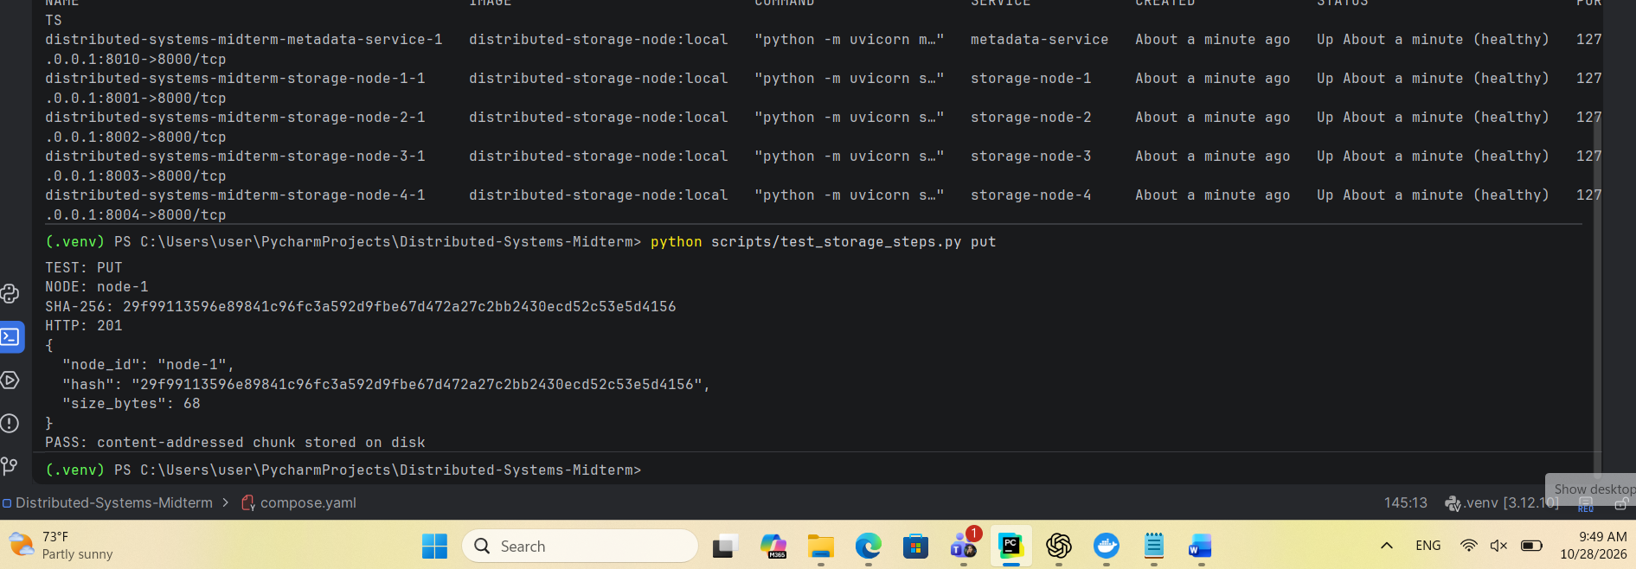
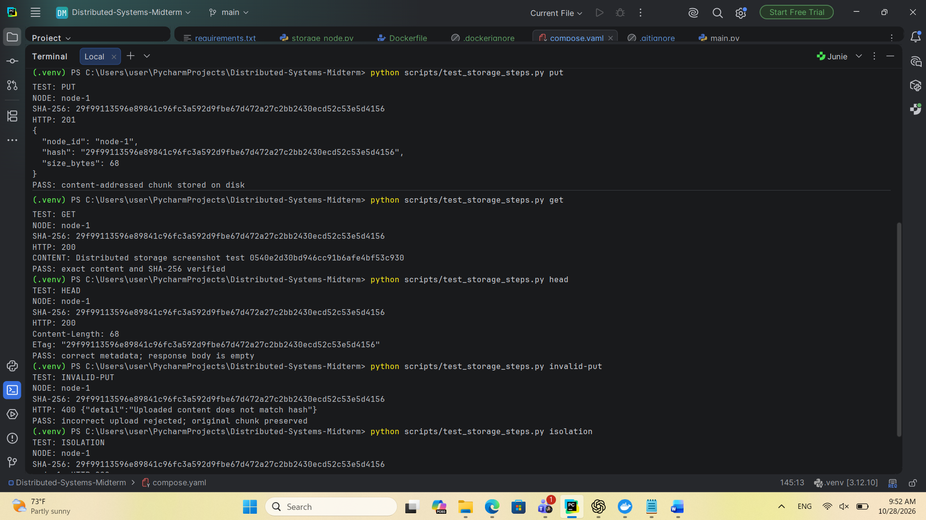

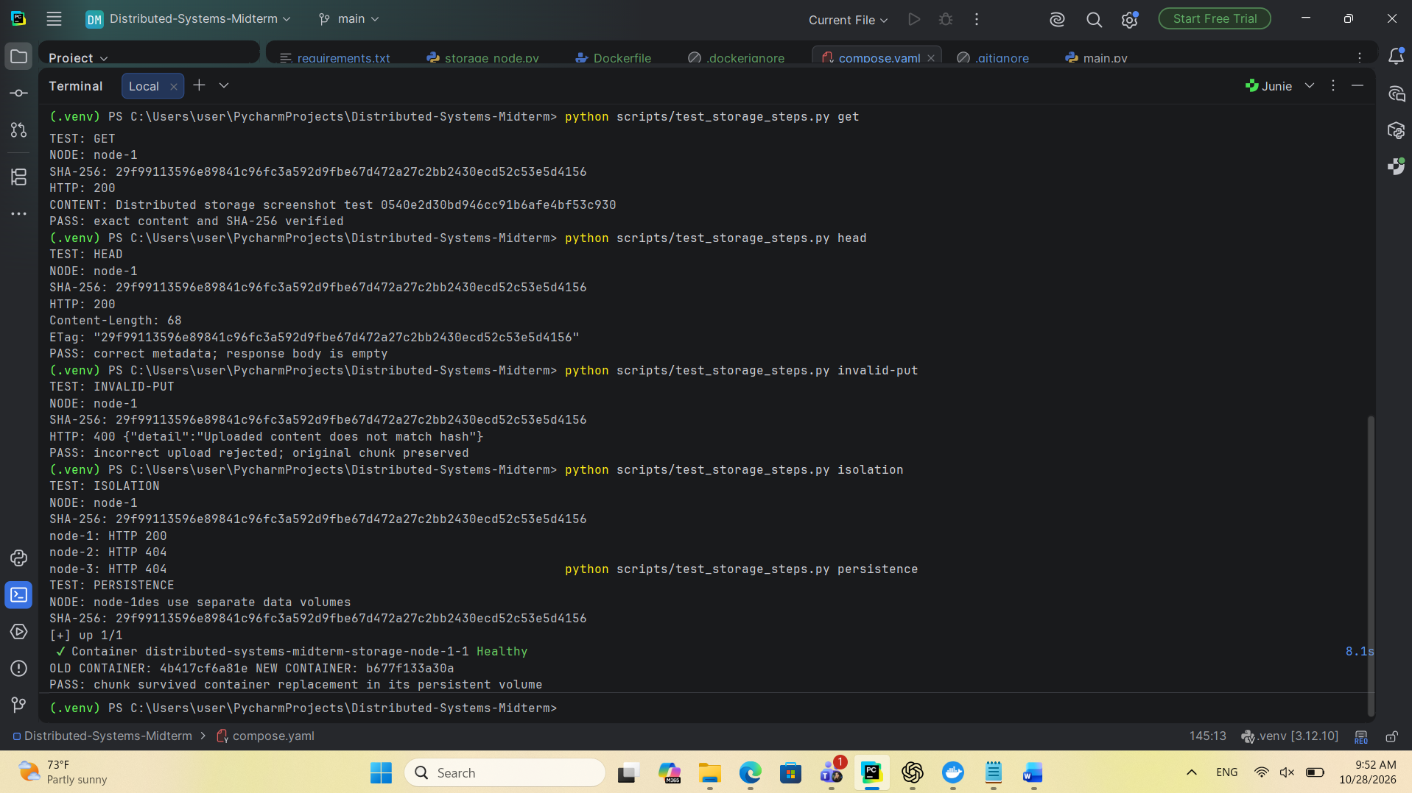
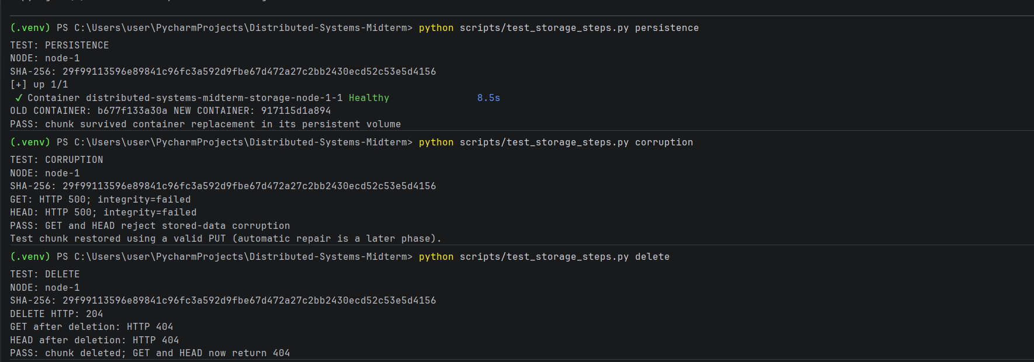
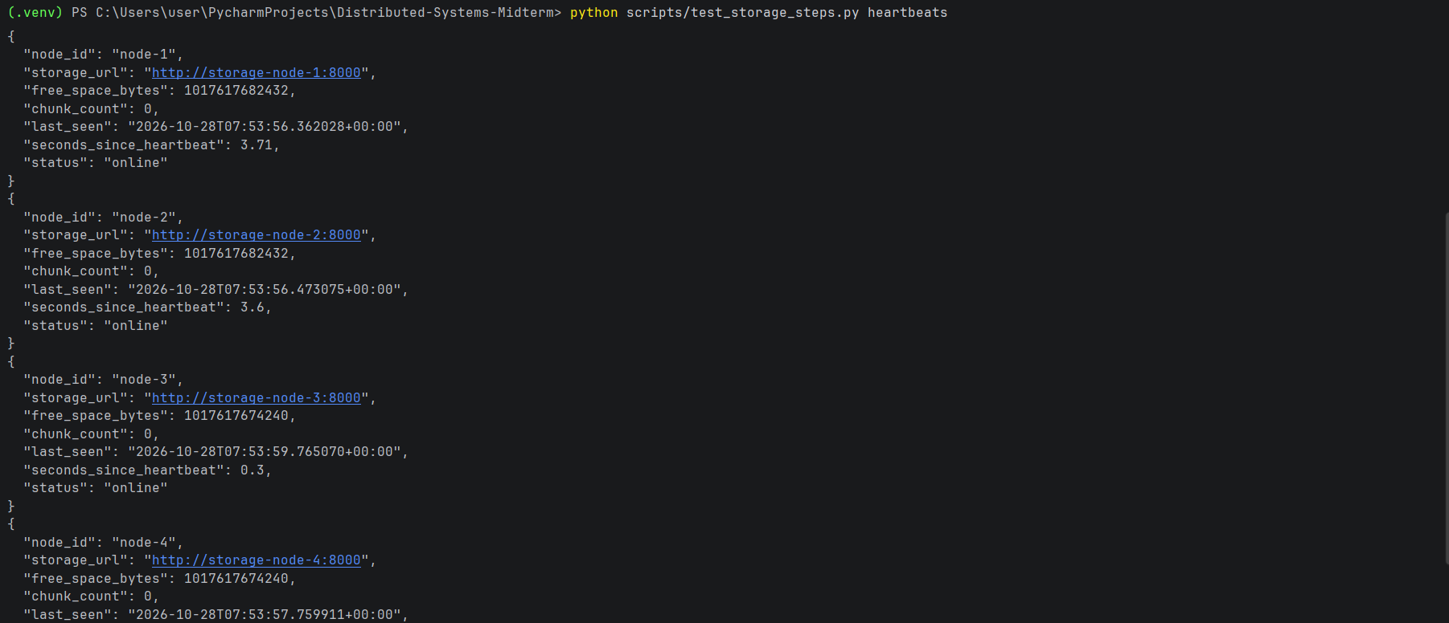
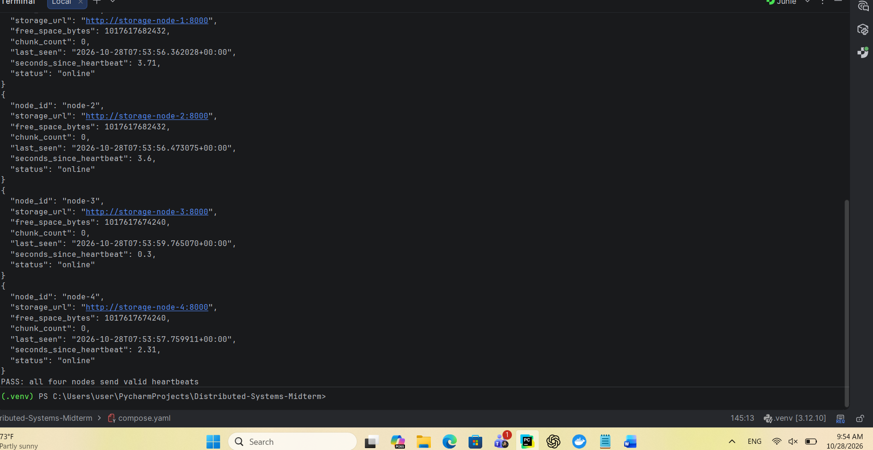Storage-node implementation and testing
The storage layer uses FastAPI and runs four storage nodes in separate Docker containers. Each node has a unique identifier and a dedicated persistent Docker volume mounted at /data. Chunks are addressed using the SHA-256 hash of their content. The node exposes PUT, GET, HEAD, and DELETE endpoints.
- Chunk upload — PUT
A 68-byte test chunk was uploaded to node-1 using its SHA-256 hash as the identifier. The service verified that the uploaded content matched the supplied hash before saving it to disk. HTTP 201 Created confirmed successful storage.
- Chunk retrieval — GET
The stored chunk was retrieved using the same SHA-256 identifier. The service returned HTTP 200 OK. The test confirmed that the downloaded bytes matched the original content and produced the same SHA-256 hash.
Screenshot caption: Successful retrieval and SHA-256 verification.
- Chunk metadata — HEAD
The HEAD request returned HTTP 200 OK, a Content-Length of 68 bytes, and an ETag containing the chunk hash. The response body was empty, allowing the client to inspect chunk metadata without downloading its content.
Screenshot caption: Chunk size and checksum retrieved without a response body.
- Incorrect upload rejection
Different content was uploaded using the original chunk’s hash. The service detected the mismatch and returned HTTP 400 Bad Request. A subsequent retrieval confirmed that the original chunk remained unchanged.
Screenshot caption: Incorrect content rejected while preserving the existing chunk.
- Storage-node isolation
The test chunk was available on node-1, which returned HTTP 200. Nodes 2, 3, and 4 returned HTTP 404, confirming that the chunk was not accessible through their separate storage directories.
Screenshot caption: Independent storage across four logical nodes.
- Persistent storage
The node-1 container was replaced. The test confirmed that its container identifier changed and that the previously uploaded chunk remained retrievable with its original content. This demonstrates that chunk data survives container replacement through the persistent Docker volume.
Screenshot caption: Chunk persistence after container replacement.
- Stored-data corruption detection
The test deliberately modified its stored chunk directly on disk. Both GET and HEAD rejected the corrupted chunk with HTTP 500 and the integrity indicator failed. The test then restored the original content through a valid PUT request.
Screenshot caption: SHA-256 verification detects and rejects corrupted stored data.
- Chunk deletion — DELETE
The DELETE request returned HTTP 204 No Content. Subsequent GET and HEAD requests returned HTTP 404 Not Found, confirming that the chunk was removed.
Screenshot caption: Successful deletion and verification that the chunk is unavailable.
- Periodic heartbeats
Each storage node sends a heartbeat to the metadata service every five seconds. Heartbeats include the node identifier, free disk space, and chunk count. The metadata registry displayed all four nodes as online, together with their most recent heartbeat timestamps.
These tests evaluate the storage-node foundation. The four containers represent logical nodes running on one development computer; replication, erasure coding, and automatic repair belong to subsequent implementation phases.

Implement the Metadata AND Replacement Module
First step PostgreSQL
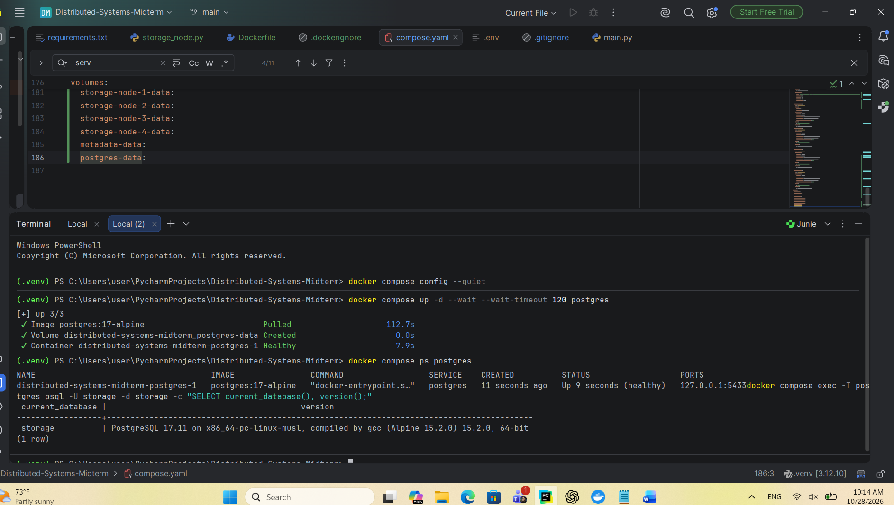Done successfully
Create sql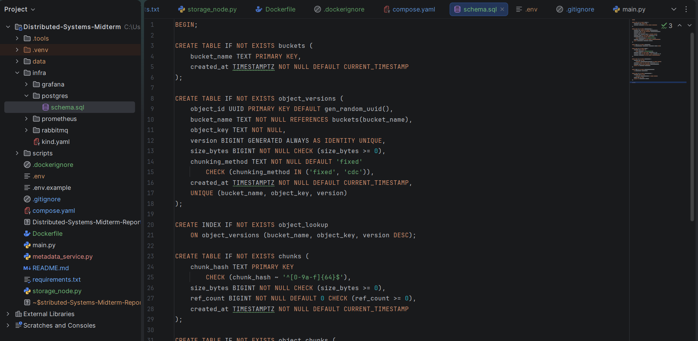

Tables created successfully
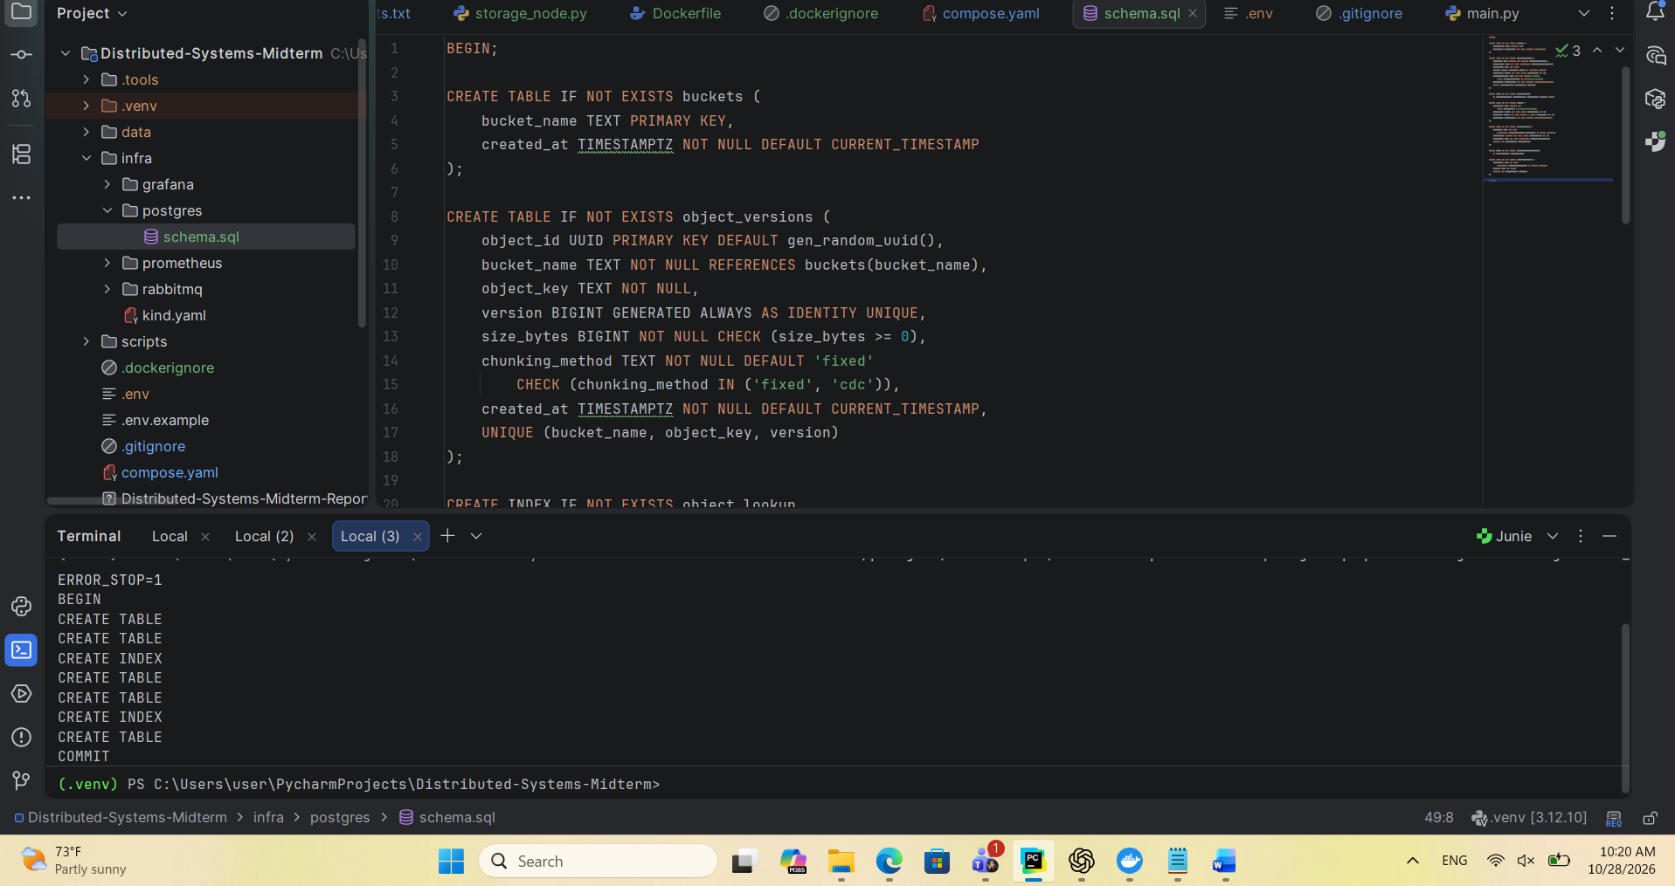
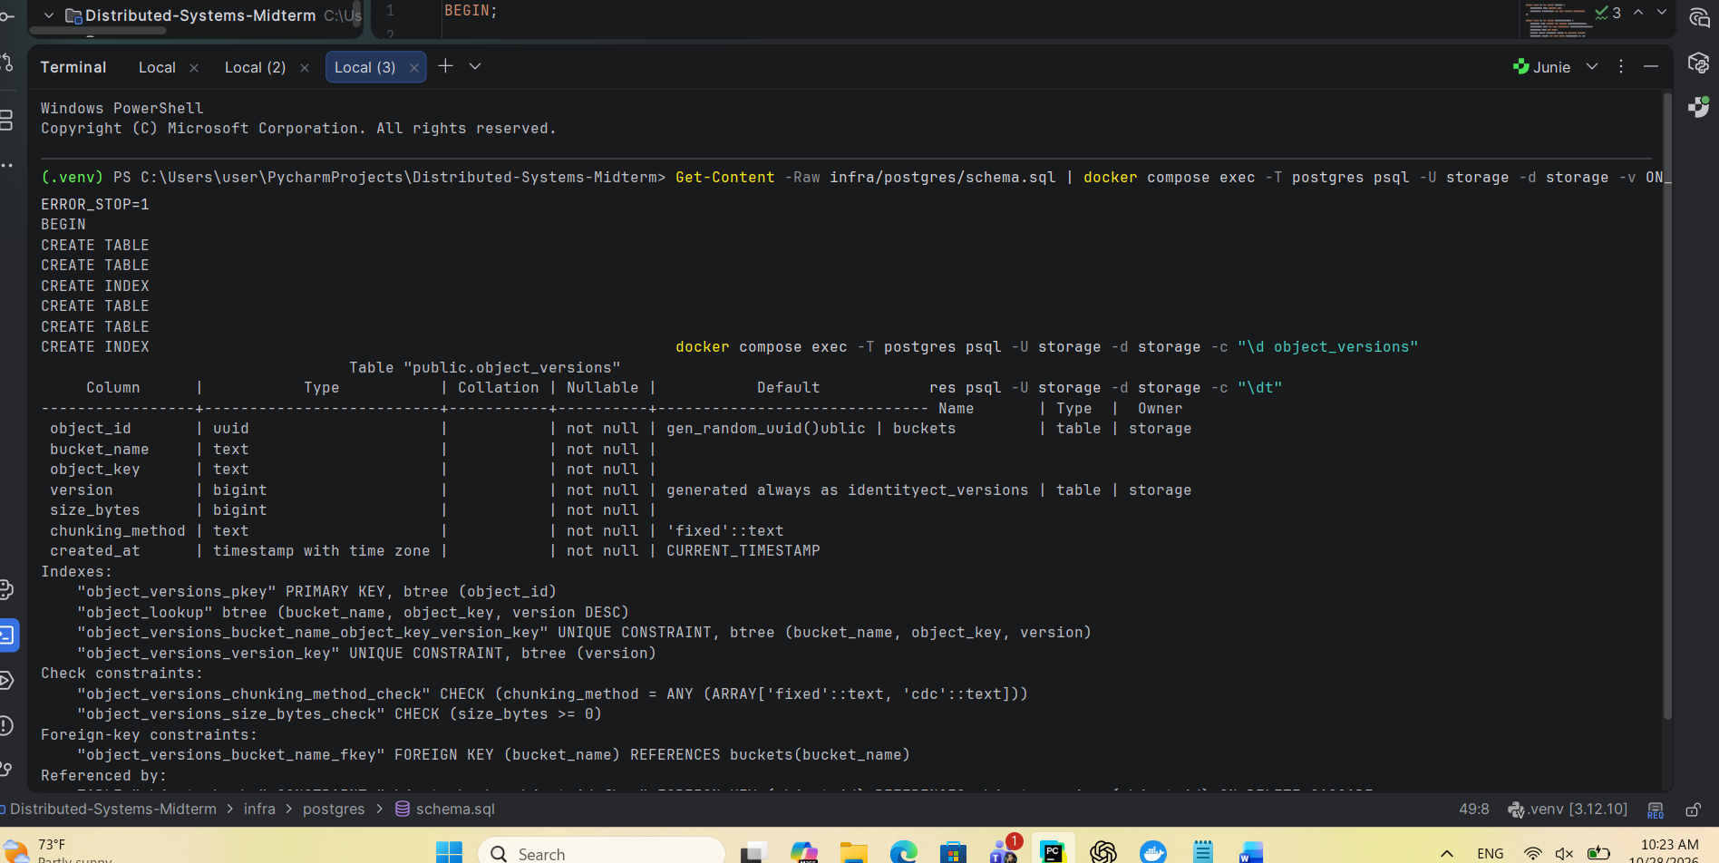
Now create chunking.py and test_fixed_chunking.py and testing test_fixed_chunking.py 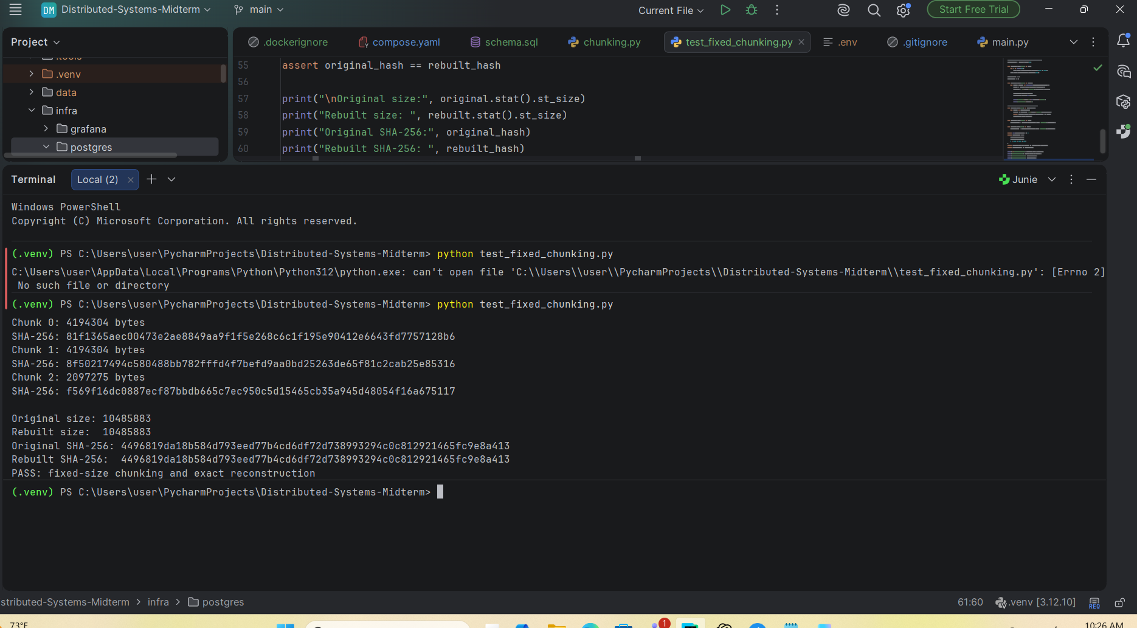
Chunk 0: 4194304 bytes
Chunk 1: 4194304 bytes
Chunk 2: 2097275 bytes

Consistent hashing with 128 virtual nodes per storage node, measuring placement changes during node addition and removal 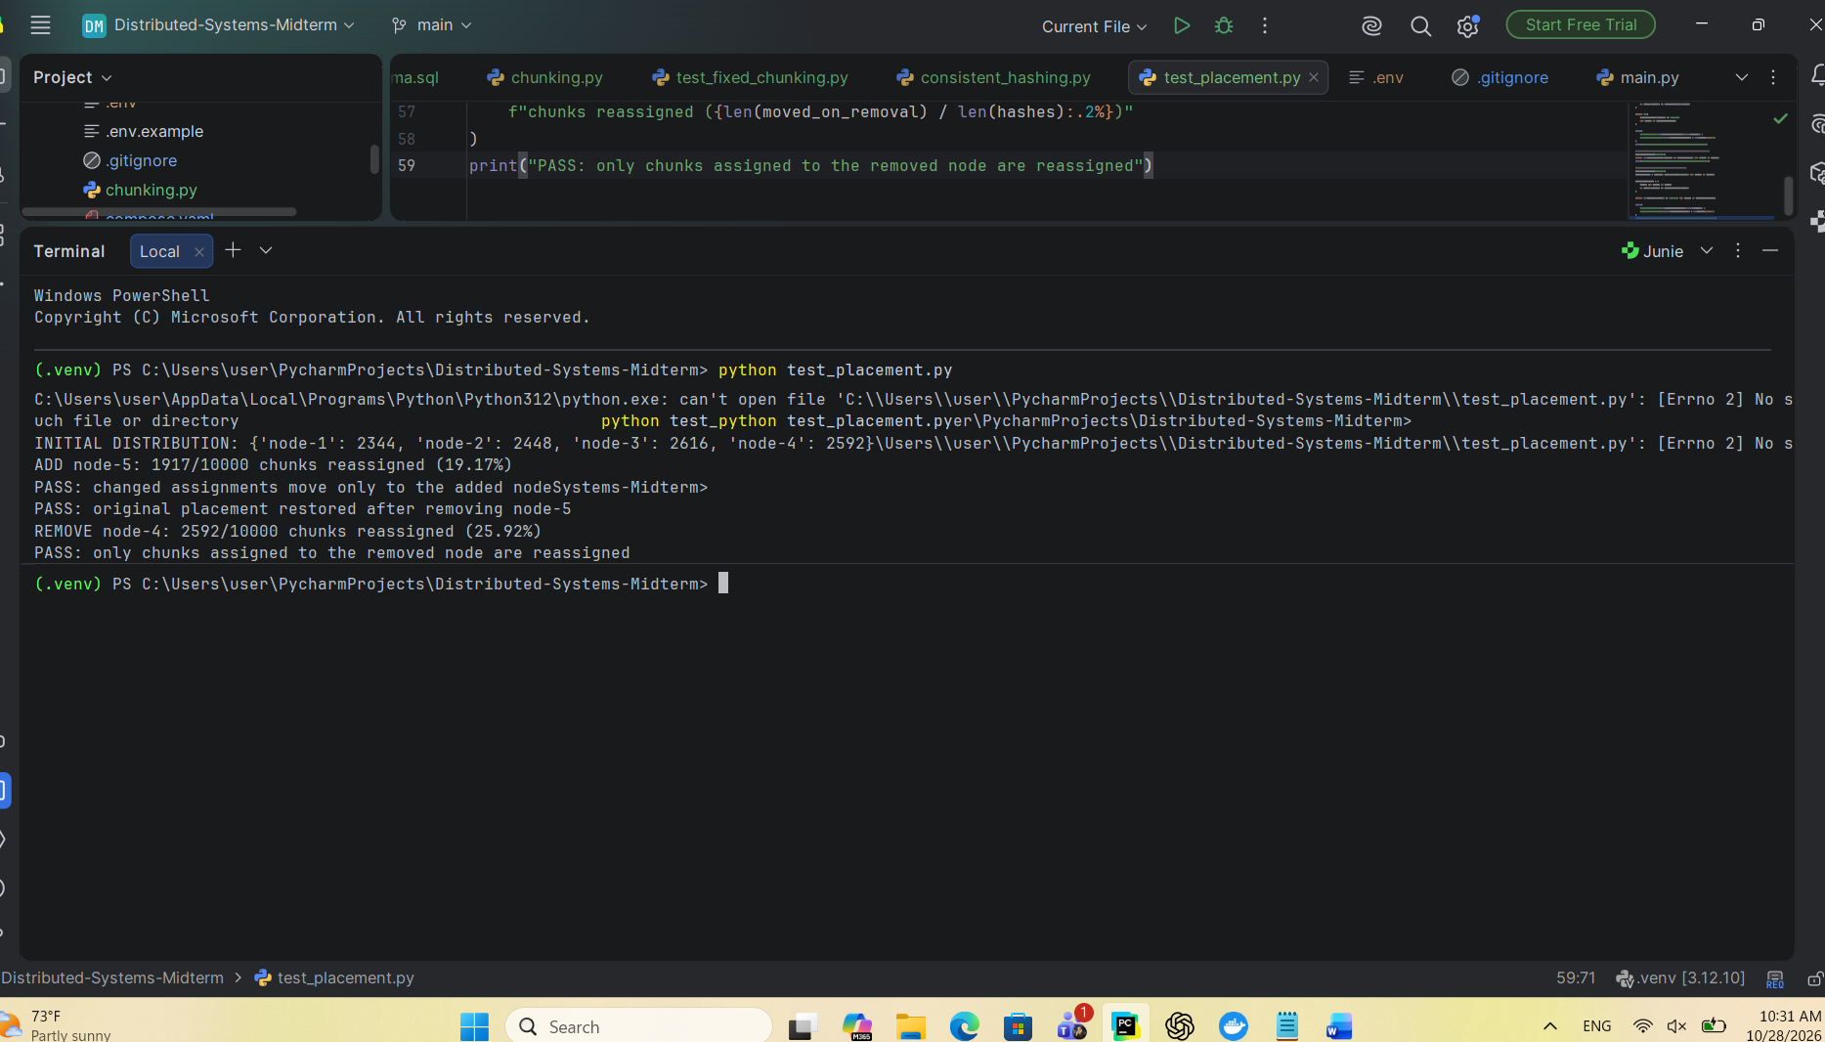

Python connection to the PostgreSQL object metadata database.
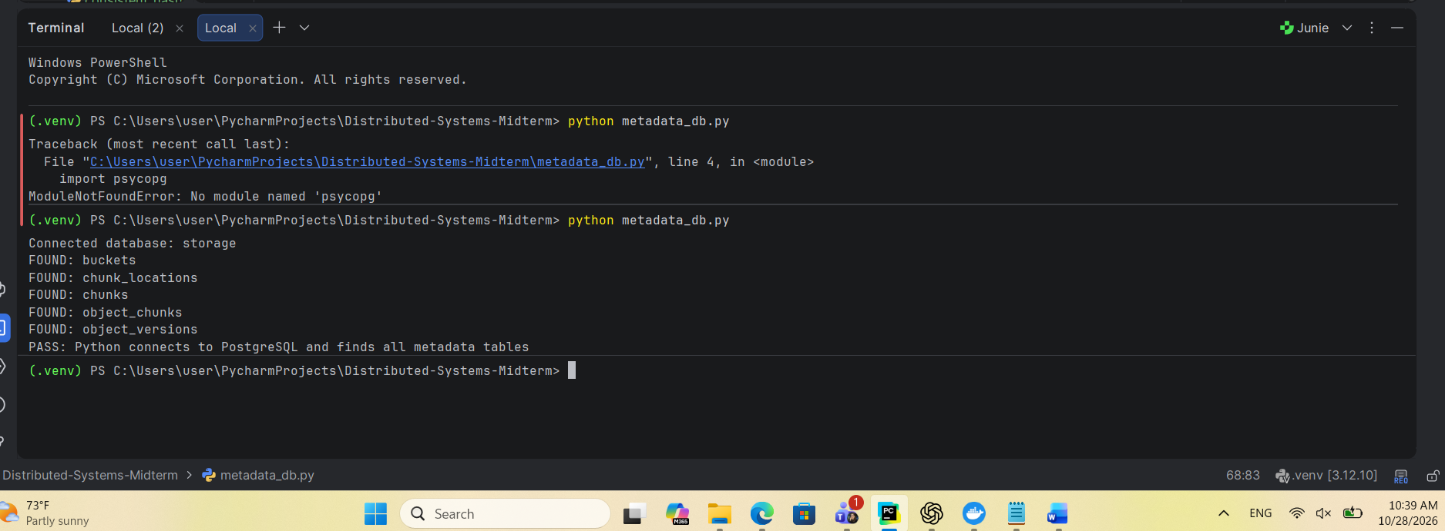
Upload 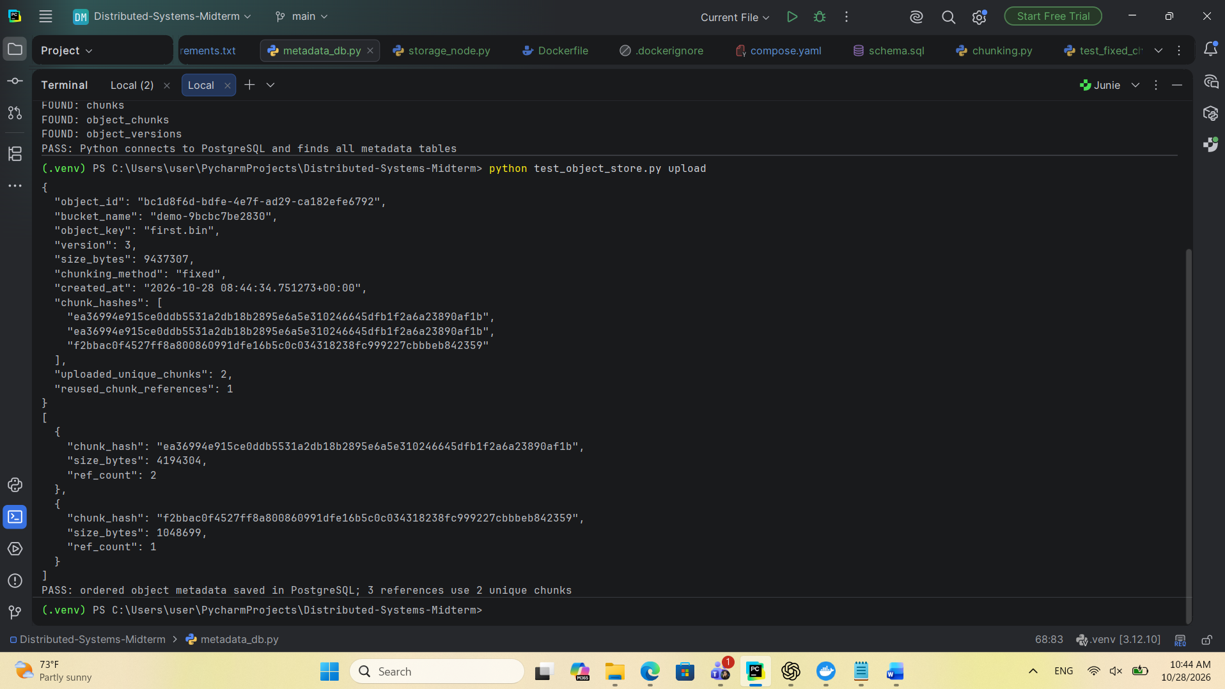
Test dup
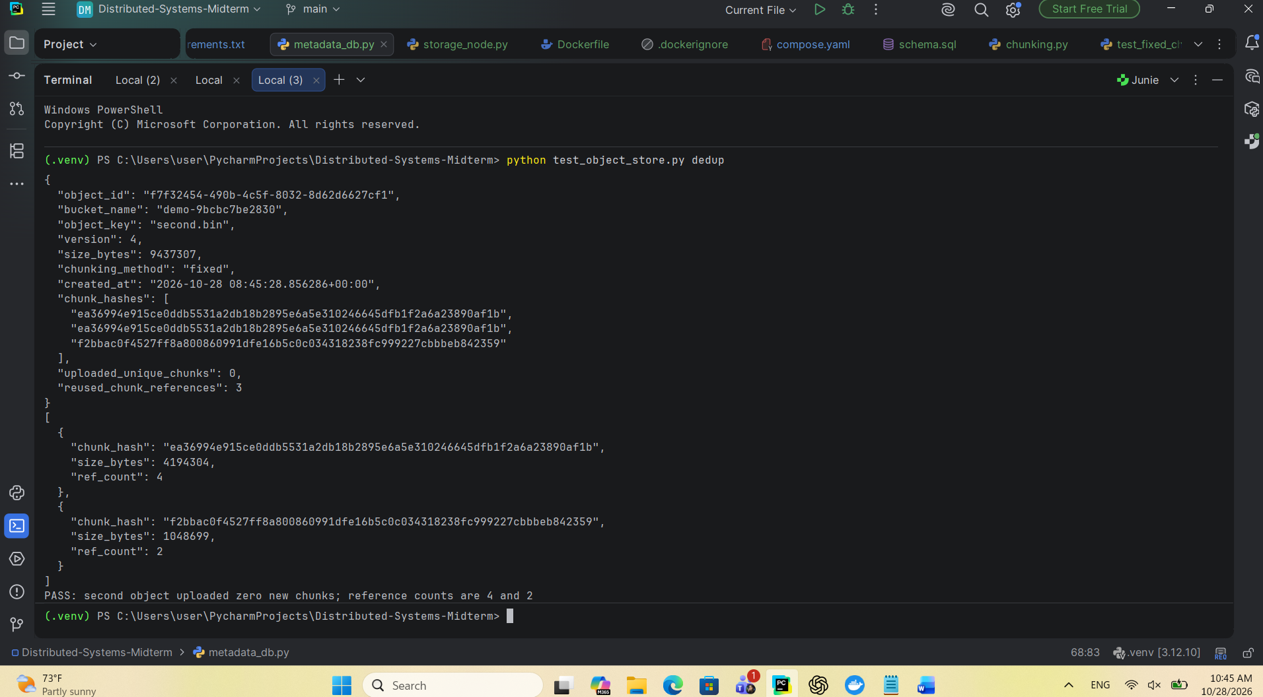
Read
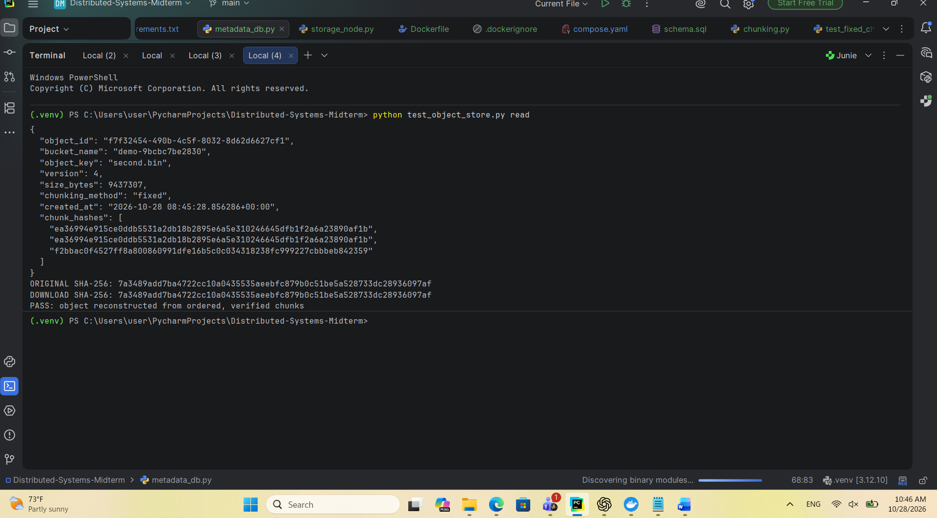
Delete first
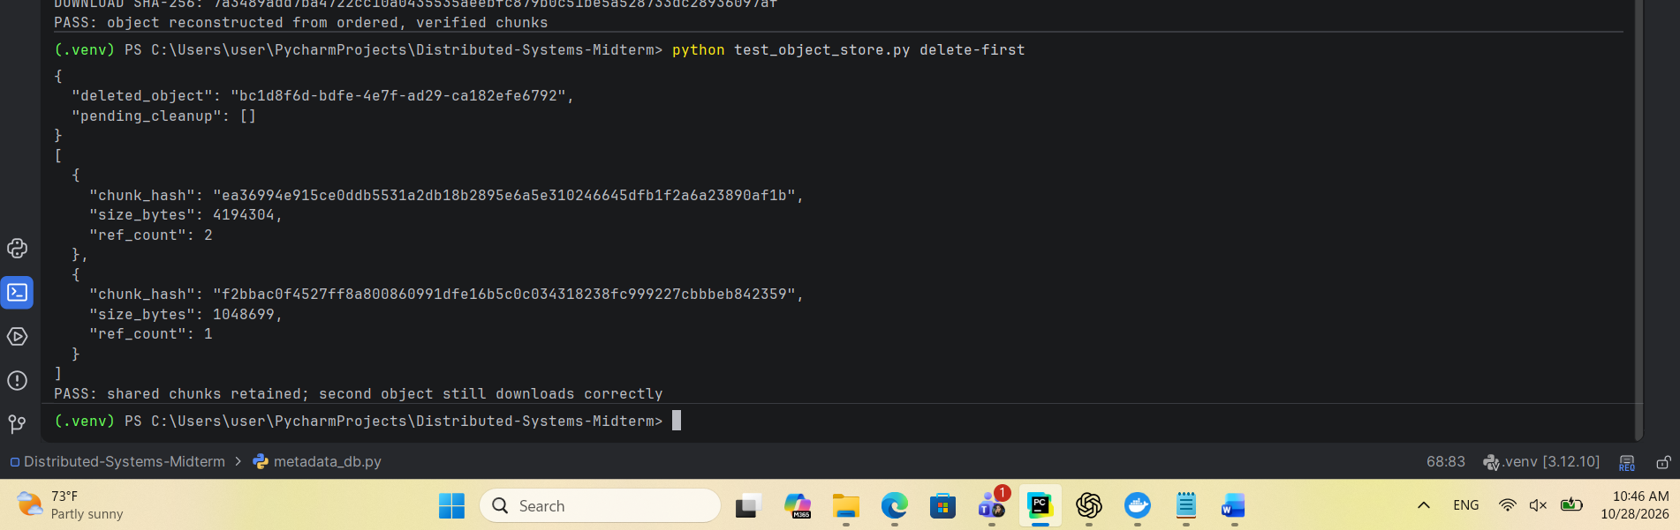

Delete last
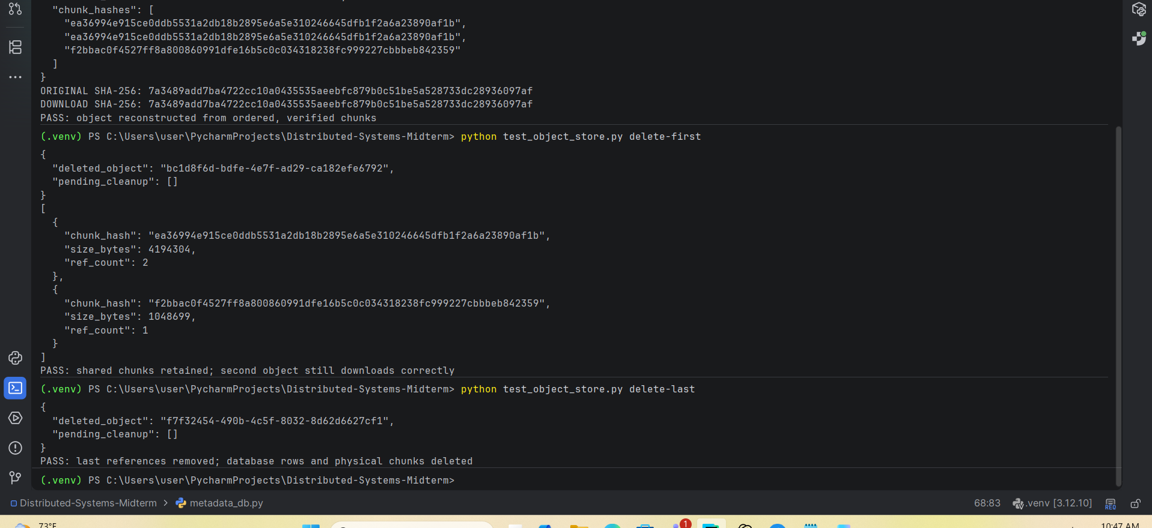
Rolling
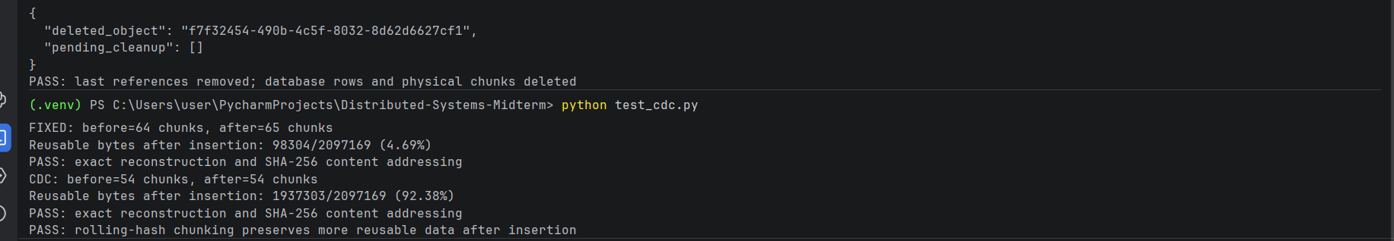
Lastly store
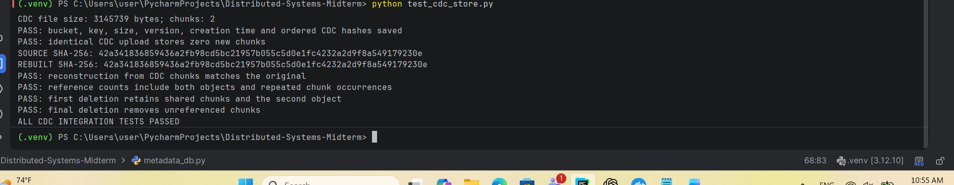

Implement Redundancy and recovery

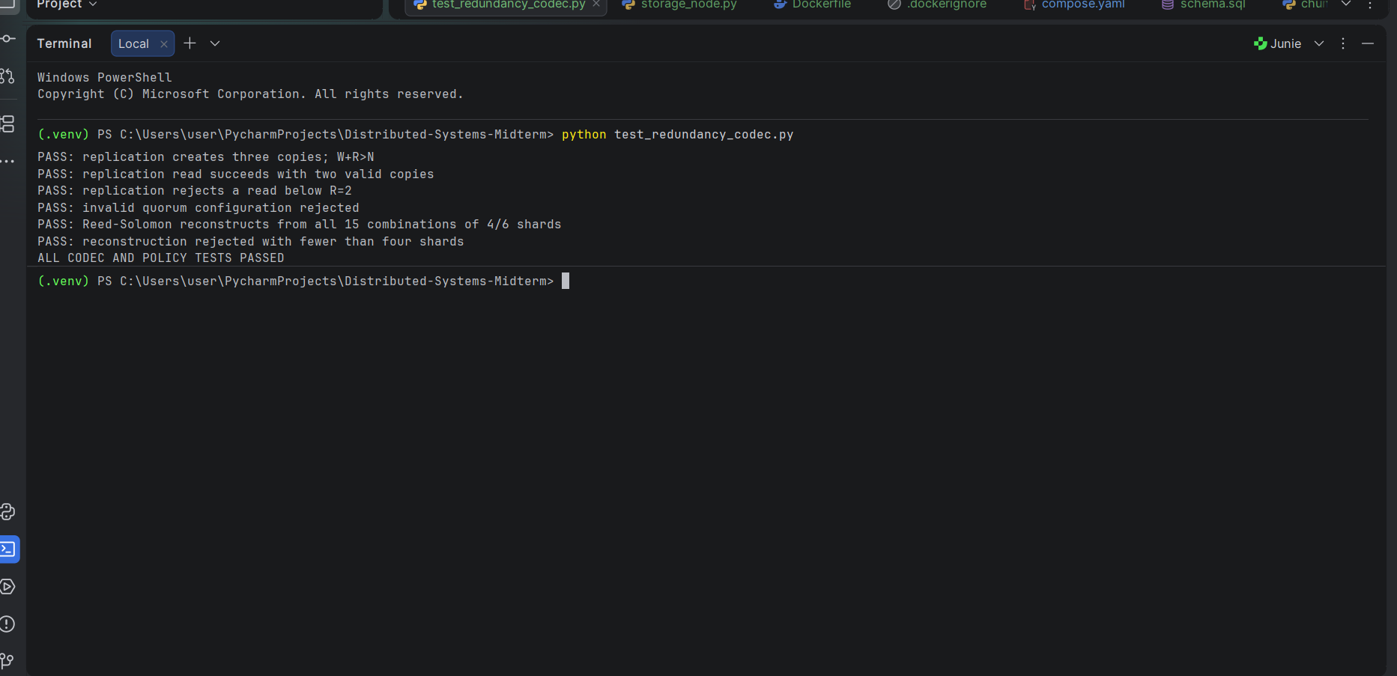
Replication across Docker nodes
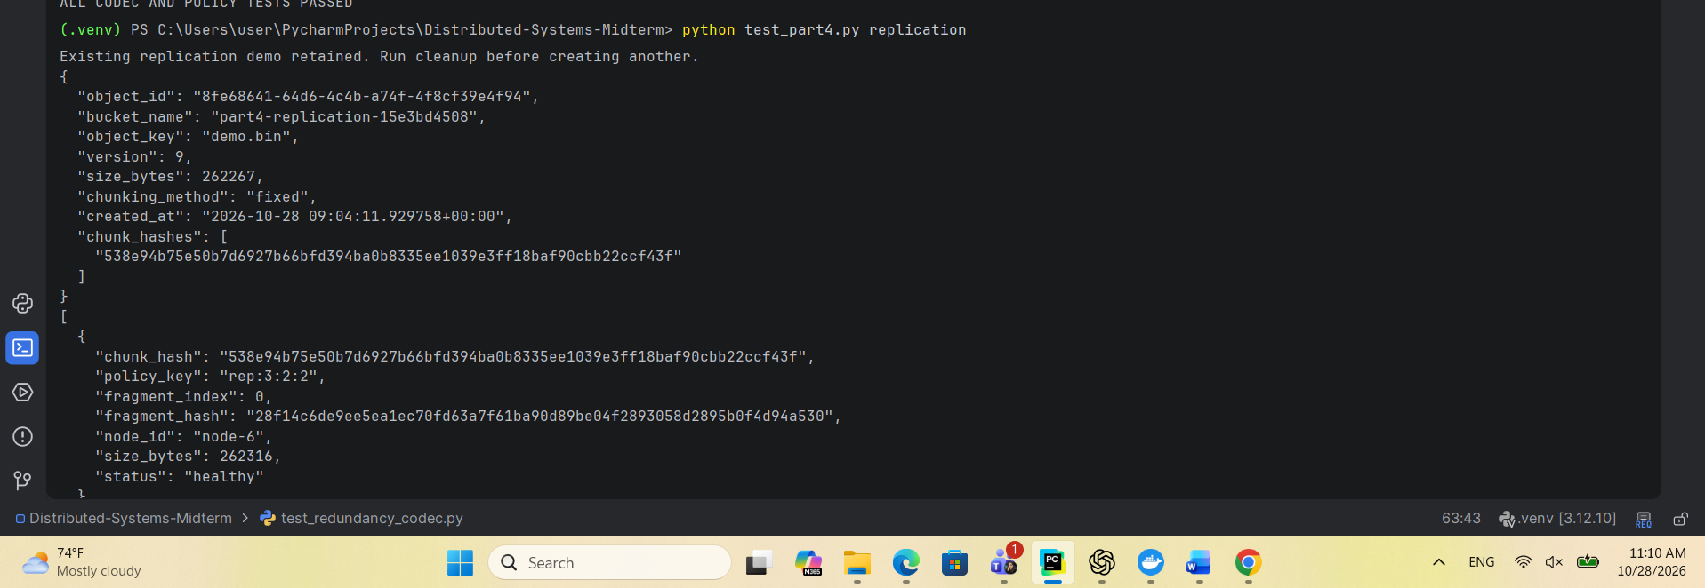
. Reed–Solomon 4+2

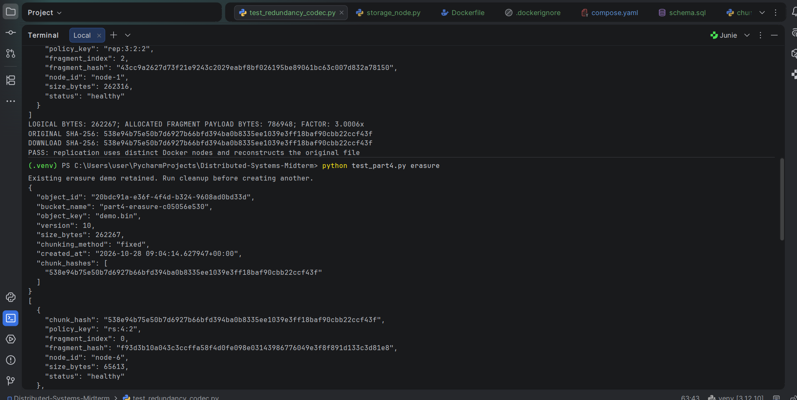
Real quorum failures
