package javabasic1;

import javax.xml.parsers.DocumentBuilder;

import javax.xml.parsers.DocumentBuilderFactory;

import org.w3c.dom.Document;

import org.w3c.dom.Element;

import org.w3c.dom.NodeList;

public class Bianli {

/\*\*

\* 遍历xml文档

\*\*/

public static void queryXml() {

try {

// 得到DOM解析器的工厂实例

DocumentBuilderFactory dbFactory = DocumentBuilderFactory.newInstance();

// 从DOM工厂中获得DOM解析器

DocumentBuilder dbBuilder = dbFactory.newDocumentBuilder();

// 把要解析的xml文档读入DOM解析器

Document doc = dbBuilder.parse("5.4.xml ");

System.out.println("处理该文档的DomImplementation对象 = " + doc.getImplementation());

// 得到文档名称为 Node的元素的节点列表

NodeList nList = doc.getElementsByTagName(" Node");

// 遍历该集合，显示结合中的元素及其子元素的名字

for (int i = 0; i < nList.getLength(); i++) {

Element node = (Element) nList.item(i);

System.out.println(

"First: " + node.getElementsByTagName("First").item(0).getFirstChild().getNodeValue());

System.out.println(

"Second: " + node.getElementsByTagName("Second").item(0).getFirstChild().getNodeValue());

}

} catch (Exception e) {

// TODO: handle exception

e.printStackTrace();

}

}

public static void main(String[] args) {

Bianli.queryXml();

}

}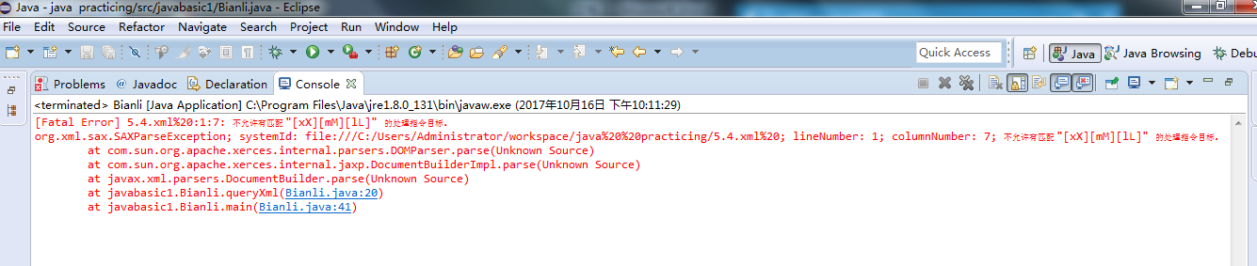

这样的报错我解决不了啊啊啊