Image and Video Processing
Mini-Project Report

AI Virtual Mouse: Hand-Gesture Cursor Control and Air Drawing using a Webcam

Course Image and Video Processing

Student Name(s) Tanmay Paliwal , Nancy Khurana
Roll Number(s) F036 , F043
Programme BTECH CE A
Faculty Name Raj Gaurav Sir

Institute / Department NMIMS , Indore

Abstract
This project presents AI Virtual Mouse, a real-time system that lets a user control the Windows mouse and draw in the air with bare-hand gestures captured by an ordinary webcam. The problem addressed is touch-free interaction without special hardware such as depth cameras or gloves. The proposed solution mirrors each video frame, converts it from BGR to RGB, detects 21 hand landmarks with MediaPipe Hands, turns the landmarks into stable gestures using palm-normalised distance thresholds, hysteresis, multi-frame confirmation and finite-state machines, and maps them to cursor movement, left click, right click or pen strokes. Further techniques are exponential-moving-average smoothing, coordinate transformation, curve rendering and alpha blending. An earlier version with drag-and-drop and scrolling suffered from conflicting gestures, so the final version keeps only reliable left and right clicks and an index-finger drawing mode. In simulated tests, left-click latency fell from 700 ms to 67 ms, stroke roughness fell by up to 69%, and all 15 automated tests passed.
Keywords: hand tracking, MediaPipe, gesture recognition, virtual mouse, air drawing, OpenCV, real-time video processing.

Introduction
Background. The keyboard and mouse have been the main way of controlling a computer for decades. They are reliable, but they require physical contact with a device. In situations such as a classroom presentation, a smart-board lecture, a sterile medical environment or for users who find a conventional mouse uncomfortable, a touch-free alternative is attractive. Cameras are already built into almost every laptop, so a vision-based interface needs no extra hardware.
Why the problem is relevant. Gesture-based interfaces are growing in augmented reality, smart TVs, kiosks and public displays, where touching shared surfaces is undesirable. A virtual mouse is a simple and measurable example of this kind of human-computer interaction: the user can see immediately whether the system understood the gesture. It also shows the main difficulty of the field, which is that a small error in recognising a gesture produces a wrong click or a shaky pointer that the user notices at once.
Role of image and video processing. A webcam delivers a stream of frames, so the task is naturally a video-processing problem. Each frame is mirrored for a natural selfie view, converted between colour spaces, analysed to find the hand and its 21 landmarks, and then converted into measurable features such as finger angles and fingertip distances. Across frames, temporal filtering removes noise from the hand position, and multi-frame confirmation separates real gestures from tracking glitches. The result is drawn back on the frame using blending and drawing primitives. Every stage of the image and video processing pipeline discussed in the course is therefore present in this project.
Motivation. Our first version supported many gestures (left click, double click, drag and drop, right click and scrolling). In practice, several of them used similar hand poses, so they interfered with each other and clicking felt unreliable. This motivated us to study why the gestures conflicted, simplify the gesture set to the two most useful actions, and make those work smoothly. We also wanted the air-drawing feature to feel more natural by drawing with the index finger alone.

Problem Statement and Objectives
Real-world problem. Controlling a computer pointer without touching any device, using only a standard webcam, in a way that is accurate enough for everyday use: the pointer should follow the hand steadily and a click should happen exactly when the user intends it, and only once.
Problem statement. To design and implement a real-time system that detects a single hand in webcam video and translates simple, distinguishable hand gestures into mouse movement, left click and right click, and into smooth freehand drawing, using image and video processing techniques.

Objectives
- O1 - Hand tracking: detect one hand in every frame of a 640x480 webcam stream and extract 21 landmarks in real time.
- O2 - Cursor control: move the cursor smoothly with the index fingertip, mapping the camera region to the full screen and suppressing hand tremor.
- O3 - Reliable clicks: implement left click (thumb + index pinch) and right click (thumb + middle pinch) that fire instantly, exactly once per pinch, and land on the point the user aimed at.
- O4 - Smooth air drawing: draw on a transparent canvas using the index finger only, with jitter-free, rounded strokes.
- O5 - Verification: validate the gesture logic with repeatable automated tests and measure latency, click accuracy and stroke smoothness against the earlier version.

Scope of the Project

What the project covers
- Real-time tracking of one hand from a single webcam.
- Cursor movement from the index fingertip; left click and right click through pinch gestures.
- A separate drawing mode (key D) with index-finger drawing, pen colours (keys 1 to 5) and clear (key C).
- On-screen feedback: landmarks, current mode, gesture label, pinch distance and FPS.
- Safety features: hand-loss grace period, fail-safe corner of PyAutoGUI and a clear error if the webcam cannot be opened.

What it does not cover
- Drag and drop, scrolling and double-click gestures were removed deliberately, because they conflicted with reliable clicking (a double click is still possible by pinching twice quickly).
- Multi-hand gestures, zoom, keyboard input and gesture customisation by the end user.
- Training a new hand-detection model: the pre-trained MediaPipe Hands model is used as-is.
- Operating systems other than Windows, and controlling windows that run with administrator rights unless the program itself is run as administrator.
- Recognition in very poor light, with gloves, or with the hand far from the camera.
Type of images / videos used. Live colour video from a standard webcam (640x480, about 30 frames per second), showing a single bare hand in front of the camera in an indoor setting. No pre-recorded dataset is used.
Application domain. Human-computer interaction: touch-free presentations, smart classrooms, public kiosks, accessibility support and creative air-drawing or annotation tools.

Dataset / Input Description
The system works on a live video stream, so there is no fixed image dataset to download. Table 1 summarises the input.
Table 1: Description of the input data

Item | Description
Source of images / videos | Live capture from the laptop's built-in or a USB webcam through  cv2.VideoCapture (DirectShow backend on Windows).
Dataset name | None for the application (live input). The MediaPipe Hands palm-detection and hand-landmark models are pre-trained by Google and were not retrained.
Number of images / videos | One continuous video stream; about 1,800 frames per minute at 30 fps. For testing, 15 scripted scenarios of 0.3 to 3 s each (about 10 to 90 frames each) at a simulated 30 fps.
Image resolution | 640x480 pixels captured (configurable). The window is enlarged to 1000x750 for display only.
Image format | 8-bit, 3-channel BGR arrays (OpenCV); converted to RGB for MediaPipe.
Video resolution and duration | 640x480 at about 30 fps; duration is open-ended (runs until the user quits).
Landmark data | 21 points per hand with (x, y, z); x and y are converted to pixels and used for all measurements.
Test inputs. Because the gesture logic must be tested repeatably and without a camera, the test suite builds a synthetic hand with 21 landmarks (palm size 100 pixels) in three poses: open hand, thumb touching the index finger and thumb touching the middle finger (Figure 1). Frames were also produced by running the application's own display code on a synthetic background (Figure 2 in Section 9).
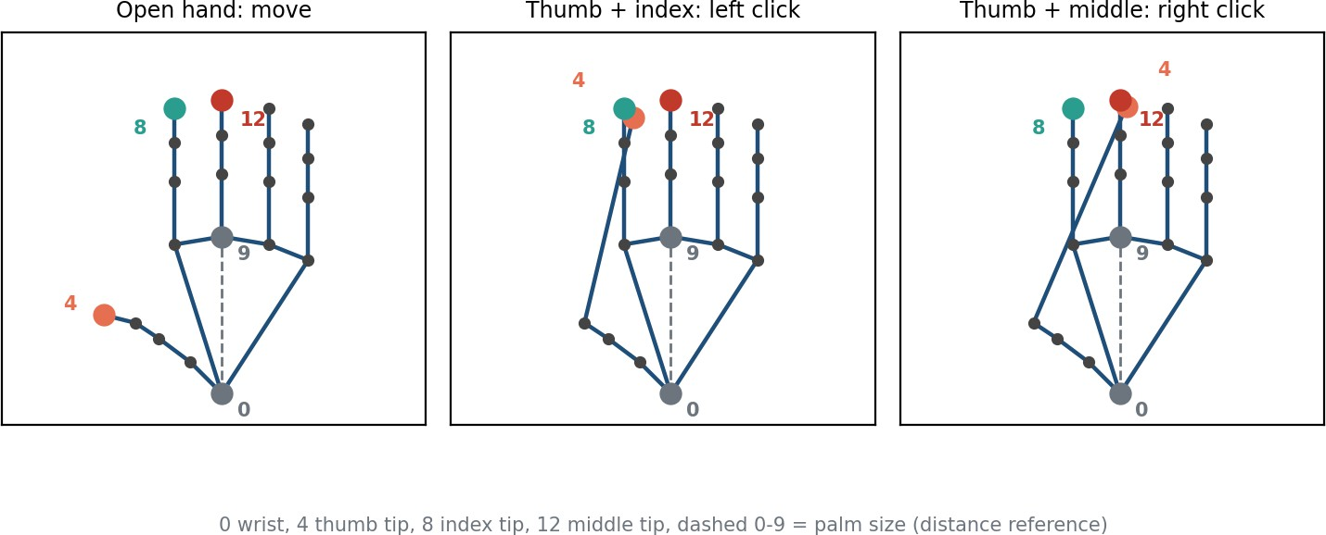
Figure 1: Sample input: synthetic 21-landmark hand in the three poses used for testing. Landmark 0 = wrist, 4 = thumb tip, 8 = index tip, 12 = middle tip.

Methodology / Proposed Approach
Figure 2 shows the complete processing pipeline. Each frame passes through the following stages:
- Acquisition and mirroring. A frame is grabbed from the webcam and flipped horizontally so that moving the hand to the right moves the pointer to the right.
- Colour conversion. OpenCV frames are BGR; MediaPipe expects RGB, so cv2.cvtColor
converts each frame.
- Hand landmark detection. MediaPipe Hands detects the palm and returns 21 landmarks. After the first detection it tracks the hand, which is faster than detecting every frame.
- Feature extraction. Palm size (wrist to middle-finger knuckle) is used as a scale reference. The thumb-index and thumb-middle distances are divided by the palm size, so the gestures work at any distance from the camera. Finger extension is judged from the angle at the PIP joint.
- Gesture recognition. Each click has its own finite-state machine (Figure 3): the pinch must be confirmed for several consecutive frames, has different thresholds for closing and opening (hysteresis), obeys a cooldown, and must be released before it can fire again.
- Action. In mouse mode the index fingertip is mapped to screen coordinates, smoothed and sent to the OS; clicks are sent where the user aimed. In drawing mode the fingertip is smoothed and drawn as a curved stroke on a separate canvas.
- Display. The canvas is blended with the frame (cv2.addWeighted), a heads-up display is added and the result is resized for the window.

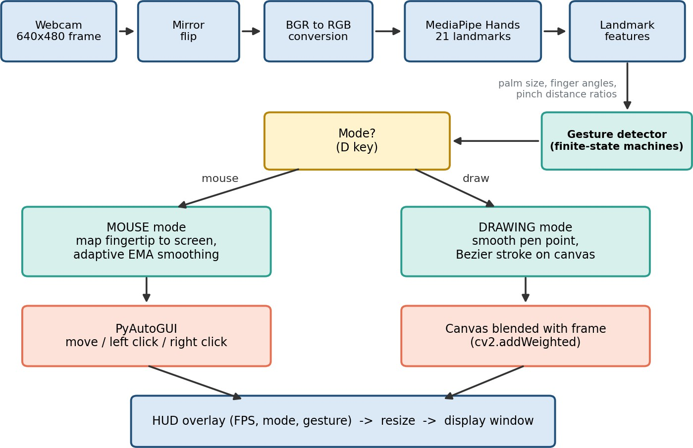

Figure 2: Block diagram of the proposed pipeline.

Key equations

Pinch ratio: r = |P
- P | / |P - P
|. A pinch starts when r < 0.30 and ends when r >

0.45.
thumb
index wrist
middle-MCP

Cursor mapping: sx = (x - m ) / (W - 2m ) x screen width, with a 15% margin m on each side of the
x x
frame.
Smoothing (exponential moving average): st = st-1 + a (xt - st-1), where the factor a is small for tiny movements (to remove tremor) and large for fast movements (to avoid lag).
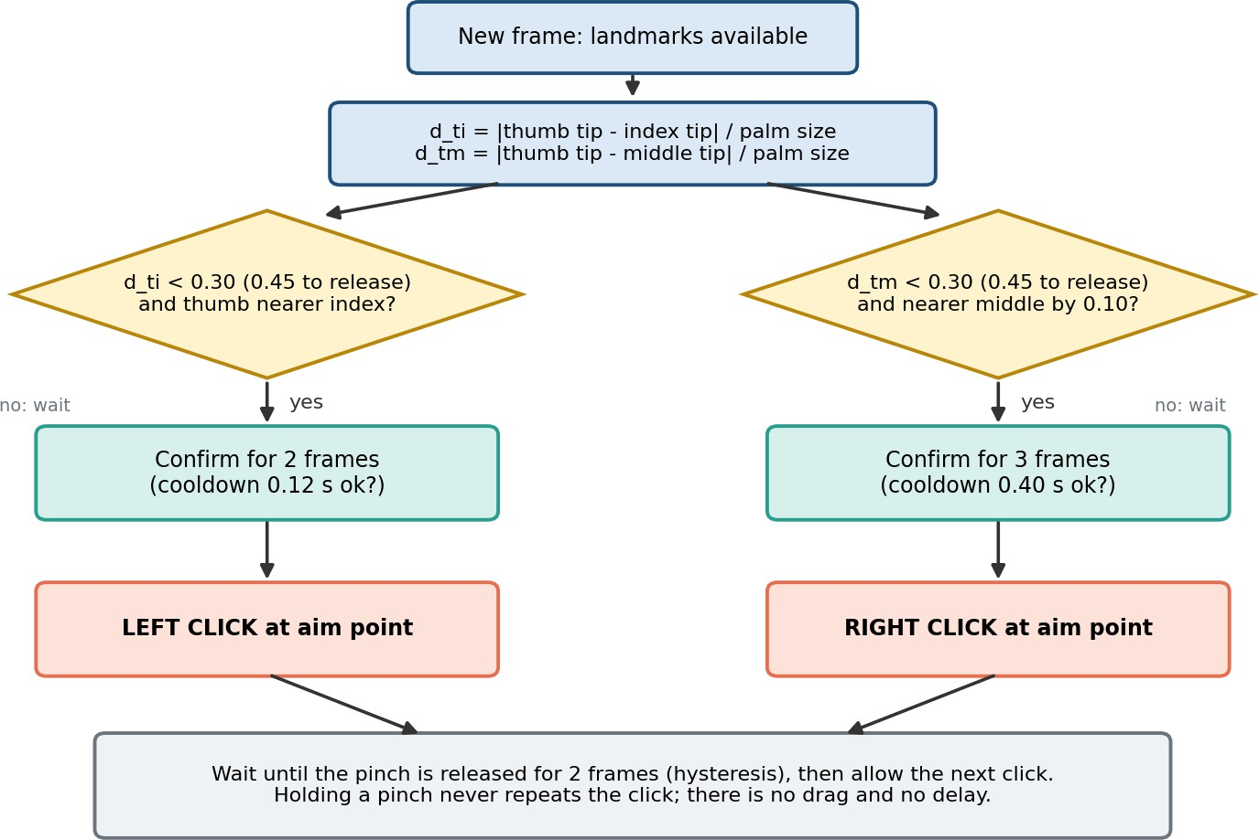

Figure 3: Decision flow for left and right click.

Algorithm (pseudocode)
for each frame:
frame = flip(camera.read())
hand = mediapipe_hands(bgr_to_rgb(frame)) # 21 landmarks or None if hand is None: clear states after 0.3 s; continue
palm = dist(wrist, middle_mcp)
r_left = dist(thumb_tip, index_tip) / palm r_rght = dist(thumb_tip, middle_tip) / palm if mode == MOUSE:
cursor = adaptive_ema(map_to_screen(index_tip))
for pinch in (left, right): # each has its own state machine if pinch_confirmed(N frames) and cooldown_ok and not blocked:
click(button, at = cursor position just BEFORE fingers closed) wait until pinch released (r > 0.45) for 2 frames
else: # DRAWING
pen_down = index_extended and not middle_extended # thumb ignored if pen_down: draw_curve(adaptive_ema(index_tip)) else: lift_pen()
show(blend(frame, canvas) + HUD)

Techniques / Algorithms Used

Image processing techniques
Table 2: Image processing techniques

Technique | How it is used in this project
Mirroring (flip) | Horizontal flip of every frame for a natural selfie view.
Colour-space conversion | BGR to RGB before MediaPipe inference.
Feature extraction | 21 hand landmarks; palm size, PIP-joint angles and normalised fingertip distances computed from them.
Thresholding (on features) | Pinch detected when the normalised distance falls below 0.30 and released above  0.45 (two-level threshold = hysteresis).
Filtering (smoothing) | Adaptive exponential moving average on the fingertip position for the cursor and for the pen.
Geometric (coordinate) transformation | Active camera region mapped linearly to screen pixels with edge clamping.
Drawing primitives and curve rendering | Anti-aliased polylines and circles; quadratic Bezier curves through stroke midpoints for rounded strokes.
Image blending | cv2.addWeighted blends the drawing canvas over the live frame.
Resizing | Bilinear interpolation to enlarge the displayed window without changing the processing resolution.

Video processing techniques
Table 3: Video processing techniques

Technique | How it is used in this project
Frame extraction / acquisition | A continuous capture loop reads one frame at a time with a buffer size of 1 to keep latency low.
Object tracking | MediaPipe detects the palm once and then tracks the 21 landmarks from frame to frame, falling back to detection only when tracking is lost.
Temporal filtering | The EMA combines the current and previous frames to remove jitter from the hand position.
Temporal confirmation | A gesture must persist for 2 to 3 consecutive frames before it is accepted; a hand-loss grace period of 0.3 s ignores brief tracking drop-outs.
Finite-state machines | IDLE, CONFIRMING, FIRED and BLOCKED states make each click happen once and only after release.
Techniques not used. Background subtraction, frame differencing and optical flow were not needed, because the hand-landmark model gives the hand pose directly and is robust to a changing background. Morphological operations, histogram equalisation and DFT/DCT were also not required for this approach.

Implementation
Language and tools. The system is written in Python 3.11 and runs from the command line on Windows. Libraries: OpenCV (opencv-contrib-python 4.8 to 4.11) for capture, colour conversion, drawing and display; MediaPipe 0.10.21 (mp.solutions.hands) for hand landmarks; NumPy (below 2.0) for vector and array maths; PyAutoGUI for moving the pointer and clicking; Matplotlib was used to prepare the figures of this report; unittest for the tests. Hardware: a Windows computer with an integrated or USB webcam; no GPU is needed because the lightweight model (complexity 0) runs on the CPU.
Table 4: Project structure

File | Purpose | Lines
main.py | Application loop, modes, heads-up display, keyboard handling | 218
hand_tracker.py | Camera and MediaPipe wrapper (BGR to RGB, landmark extraction) | 88
hand_data.py | Container for the 21 landmarks and landmark indices | 37
gesture_detector.py | Finger states, pinch state machines, pen-down logic (pure logic, no I/O) | 284
mouse_controller.py | Screen mapping, smoothing, click placement, PyAutoGUI calls | 123
drawing.py | Canvas, smoothed curved strokes, blending | 104
utils.py | FPS counter and smoothing filters | 67
config.py | All tunable thresholds in one place | 86
tests/test_gestures.py | 15 headless tests using a synthetic hand and a fake PyAutoGUI | 247

Important implementation steps
- Separated recognition (gesture_detector.py, pure logic) from action (mouse_controller.py). This made the logic testable without a camera or screen.
- Removed drag-and-drop and scrolling, and replaced the delayed single-click (waiting 0.35 s for a possible double click) by an instant click fired when the pinch is confirmed.
- Click placement: the cursor positions of the last 60 frames are stored. When a click fires, it is sent to the position from the moment the fingers were last clearly apart, and the cursor is held still while the pinch stays closed. A second click within 0.6 s on nearly the same spot snaps to the same pixel so that Windows registers a double click.
- Drawing: pen down when the index finger is extended and the middle finger is folded (thumb ignored); an adaptive filter smooths the fingertip, and each stroke piece is a quadratic curve between midpoints of successive points.
- Added a display-width setting (default 1000 px) that enlarges only the shown window, not the processing resolution.

How to run (Windows, Python 3.11)
python -m venv venv venv\Scripts\activate
python -m pip install --upgrade pip pip install -r requirements.txt python main.py

Table 5: Gesture controls of the final system

Gesture | Action
Index fingertip | Move cursor
Thumb + index pinch | Left click (two quick pinches = double click)
Thumb + middle pinch | Right click
Key D, then index finger up (middle folded) | Draw; raising index and middle together lifts the pen; D again returns to mouse mode
Keys C, 1 to 5, H, Q | Clear drawing, pen colour, help, quit

Results and Discussion
Evaluation method. The results below come from two sources: (a) the application's own display code run on a synthetic hand model, which shows the input, intermediate and output stages, and (b) 15 automated tests and measurements in which the same scenarios were run on the earlier and the final version of the program, with a recorder in place of PyAutoGUI. These measurements verify logic, timing and smoothness; they are not a user study with real webcam footage. Frame timing is based on a simulated 30 fps stream (33 ms per frame).

Input, intermediate and output frames
Figure 4 shows the heads-up display produced by the final program in each situation: pointer movement, a left click, a right click and drawing. The skeleton is the 21-landmark hand model; the blue dot is the thumb tip and the yellow dot the index fingertip. When the thumb touches the index finger the gesture label changes to LEFT CLICK, and the pinch distance falls from 139 px to 8 px.

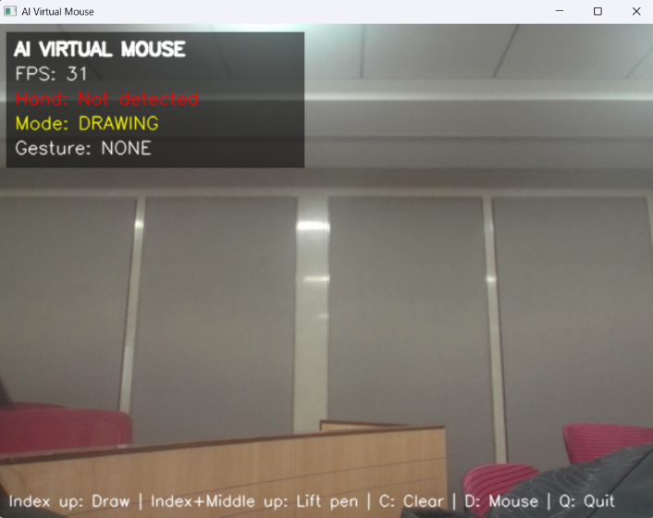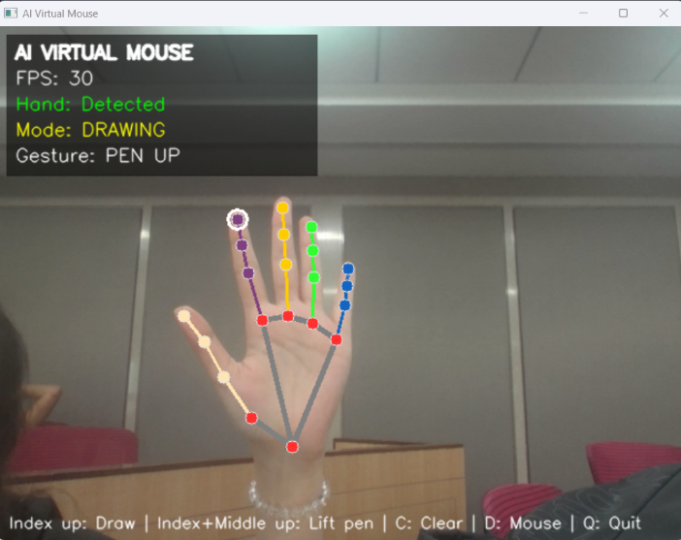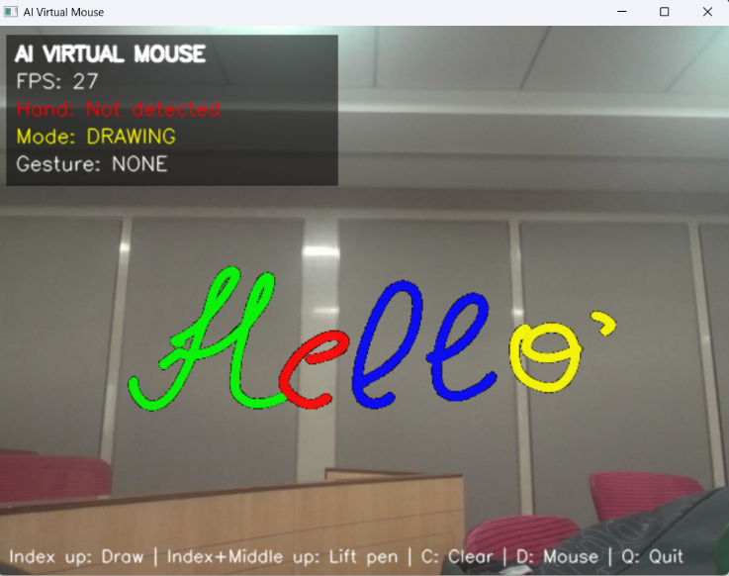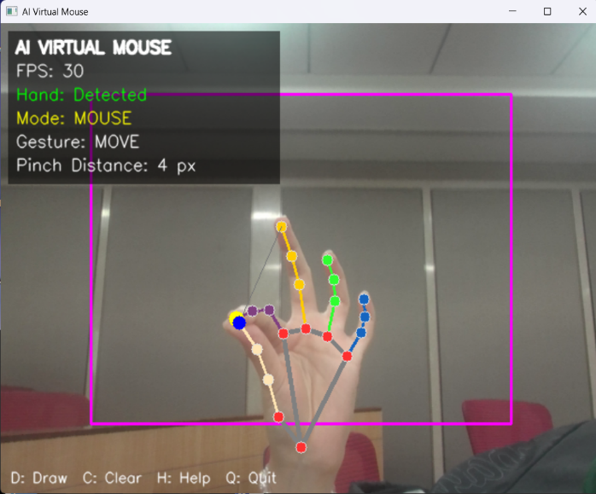

Pinch distance and click timing
Figure 5 plots the normalised distances during one left-click pinch followed by one right-click pinch, both held longer than needed. Each pinch produces exactly one click, fired as soon as the distance has stayed below 0.30 for two frames (three for the right click). Holding the pinch does not repeat the click, and the click can be repeated only after the distance rises above 0.45 again. The gap between the

two thresholds prevents flicker near the limit.
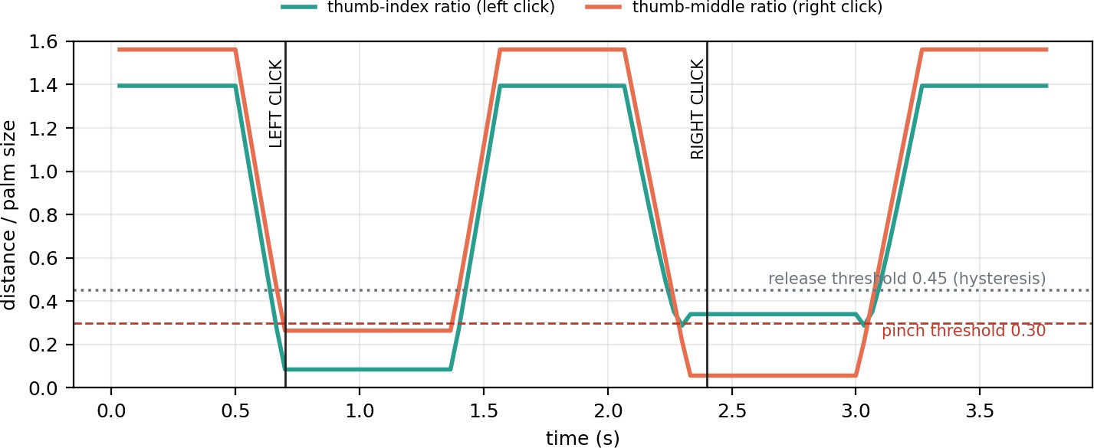

Figure 5: Normalised thumb-index and thumb-middle distance with the click events detected by the program.

Quantitative comparison with the earlier version
Table 6: Before / after measurements in the simulated test environment

Measure | Before | After | Change
Left-click latency (pinch start to click, 0.27 s pinch) | 700 ms | 67 ms | -90%
Right-click latency | 133 ms | 100 ms | -25%
Result of a 1.5 s held pinch | Starts a drag (mouse button pressed), no click | One left click, no drag | No accidental drag
Left-click position error, slow / medium / fast drift | 1 / 5 / 41 px | 1 / 1 / 5 px | Lower at medium and fast drift
Right-click position error, slow / medium  / fast drift | 0 / 5 / 30 px | 1 / 5 / 12 px | Lower at medium and fast drift
Stroke roughness (mean turning angle), jitter 0 / 2 / 4 px | 4.2 / 6.3 / 9.7 deg | 2.4 / 2.6 / 3.0 deg | -43% / -59% /  -69%
Deviation of drawn points from an ideal circle (RMS), jitter 0 / 2 / 4 px | 0.90 / 1.14 / 1.59 px | 1.09 / 1.25 / 1.59 px | About the same
Processing time per frame (logic, cursor, drawing, display) | 6.8 ms | 6.1 ms | No extra cost

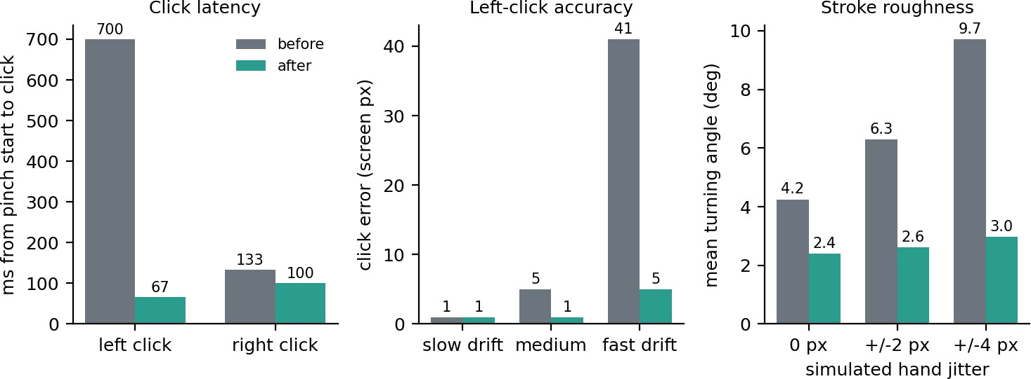

Figure 6: Click latency, left-click accuracy (error in screen pixels) and stroke roughness before and after the changes.
Lower is better in every chart.

Drawing quality
Figure 7 shows the same noisy input drawn by the old and the new code. The old code connected smoothed points with straight segments, which leaves visible corners. The new code uses a stronger filter when the finger is nearly still and a weaker one when it moves fast, and draws curved segments. The mean turning angle between consecutive segments drops from 9.7 to 3.0 degrees at 4 px of jitter. The RMS deviation from the true circle is about the same, which shows that the smoother stroke does not lag behind or shrink the shape.
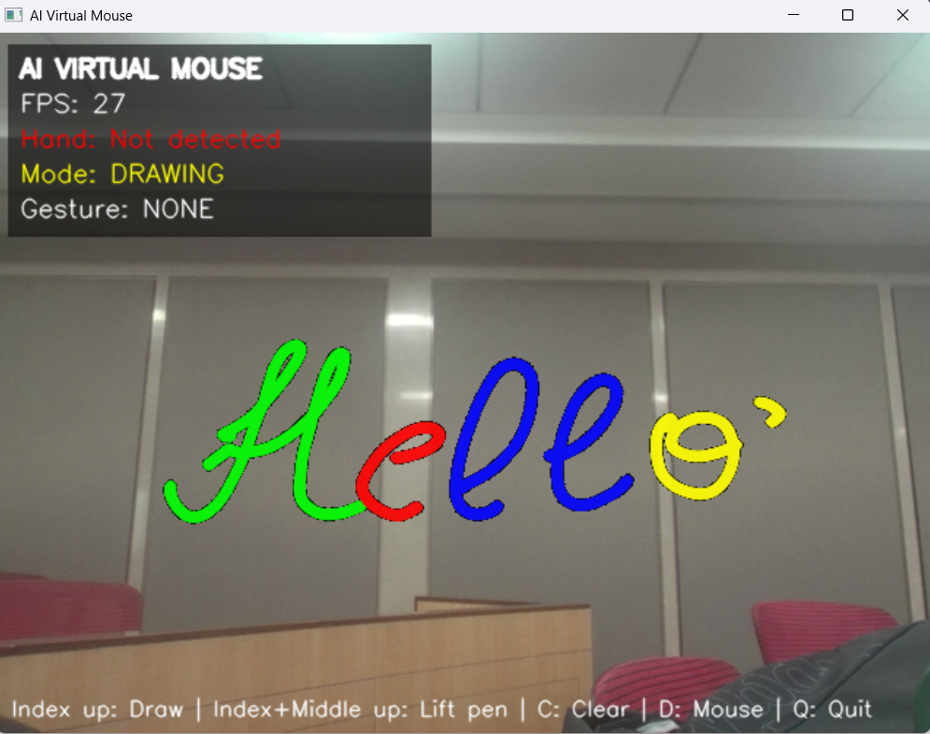

Automated tests

Table 7: Automated test results (15 of 15 passed)

# | Test | What it verifies | Result
1 | Cursor follows index finger | Pointer moves monotonically with the fingertip and no click occurs | Pass
2 | Single pinch | Exactly one left click, sent while the pinch is still held; no drag | Pass
3 | Open hand | Holding an open hand for 3 s never clicks | Pass
4 | Two quick pinches | Two clicks on the same pixel (recognised as a double click by Windows) | Pass
5 | Right click | Exactly one right click even if held; second pinch gives a second click | Pass
6 | Click accuracy | Click lands near the aimed point although the fingertip drifts | Pass
7 | Cursor hold | Cursor stays still during a held pinch (tremor) and moves again afterwards | Pass
8 | Index-only drawing | Stroke appears without a pinch; thumb position ignored; peace sign lifts the pen; C clears | Pass
9 | Stroke smoothness | Jittery input still produces a stroke without gaps | Pass
10 | Hand removed | State is cleared and the system works again when the hand returns | Pass
11 | Short drop-out | A 3-frame tracking loss causes no extra click | Pass
12 | Fist | A closed fist does not click | Pass
13 | Removed features | No mouse-down or scroll call is ever made | Pass
14 | Mode switch | Switching modes is safe and clicks keep working | Pass
15 | Safety release | release_all() is safe to call at any time | Pass

Discussion
    - Instant clicks. Removing the double-click wait and the drag timer brought left-click latency to about 67 ms (two frames at 30 fps). The earlier design needed 700 ms for a 0.27 s pinch because it waited for the release and a further 0.35 s.
    - No gesture conflicts. Scrolling used the same pose as the original right-click idea (index and middle extended), and a long pinch could turn into a drag. With only two pinch types, each uses a different finger, so they cannot be confused.
    - Click accuracy. The fingertip moves while the fingers close. Using the cursor position from just before closing reduced the error at fast drift from 41 to 5 pixels. At very slow closing, both versions are equally accurate.
    - Smoother drawing. Drawing with the index finger only is faster to start and does not depend on a pinch, which also moved the fingertip while drawing in the old design.
    - Limits of the evidence. The numbers describe the program logic with simulated hands. Real-world accuracy also depends on MediaPipe's detection quality, lighting and the webcam, which were not measured here.

Challenges / Limitations
- Conflicting gestures. Scroll and right click shared a hand pose, and long pinch (drag) overlapped with click. Resolving this required removing features rather than tuning them.
- Fingertip drift. The index fingertip moves while the thumb approaches it, so a naive click lands off target. This needed the aim-point (look-back) method and a sticky region.
- Tracking drop-outs. MediaPipe sometimes loses the hand for a few frames in motion blur or low light. A 0.3 s grace period and frame confirmation were added to avoid false clicks.
- Difficult cases. A fist, a hand turned sideways, or a hand partly outside the frame can mislead the finger-state rules; a pinch with the palm facing away from the camera is less reliable.
- Computational limits. The lightweight model (complexity 0) was chosen for speed on a CPU; it is slightly less accurate than the larger model. Frame rate depends on the webcam and the machine.
- Dataset limits. No labelled hand-gesture dataset was collected, so thresholds (0.30, 0.45 and others) were set from geometry and testing, not learned from data.
- Platform limits. Designed for Windows; controlling an administrator-level window requires running the program as administrator; only one hand is supported.
- Where the method can fail. If the user's thumb and index finger are naturally close (small distance ratio) the pinch threshold may need adjusting in config.py; very fast hand motion can cause a small lag in the cursor.
- Evaluation limit. The reported measurements use simulated landmark sequences; a study with several users on real webcam video is future work.

Conclusion
What was implemented. A real-time AI Virtual Mouse that controls the Windows cursor with the index fingertip, performs left and right clicks with thumb-index and thumb-middle pinches, and offers an index-finger air-drawing mode on a transparent canvas.
Techniques used. Frame mirroring, BGR-to-RGB conversion, MediaPipe hand-landmark detection and tracking, landmark-based feature extraction normalised by palm size, two-level thresholding, multi-frame confirmation, finite-state machines, adaptive exponential smoothing, coordinate transformation, curved stroke rendering and alpha blending.
What was achieved. The gesture set was simplified to the actions that can be recognised reliably. In the simulated tests, left-click latency dropped from 700 ms to 67 ms, a held pinch no longer starts an accidental drag, click placement became more accurate under fingertip drift, and stroke roughness fell by up to 69%. All 15 automated tests passed.
Learning. We learned that in gesture interfaces fewer, clearly different gestures work better than many similar ones; that normalising distances by palm size makes a system independent of camera distance; that hysteresis and multi-frame confirmation are essential against noisy tracking; and that separating recognition logic from the actions makes a real-time system testable. We also learned to measure improvements instead of judging by feel.
Future work. Testing with real users and recorded video, a calibration wizard, the One Euro filter for smoothing, two-hand gestures and an on-screen keyboard.

References
- F. Zhang, V. Bazarevsky, A. Vakunov, A. Tkachenka, G. Sung, C.-L. Chang and M. Grundmann, "MediaPipe Hands: On-device Real-time Hand Tracking," arXiv:2006.10214, 2020.
- Google, "MediaPipe Hands (Solutions guide)," https://google.github.io/mediapipe/solutions/hands.html (accessed 2026).
- G. Bradski, "The OpenCV Library," Dr. Dobb's Journal of Software Tools, 2000; OpenCV documentation, https://docs.opencv.org.
- C. R. Harris et al., "Array programming with NumPy," Nature, vol. 585, pp. 357-362, 2020.
- A. Sweigart, "PyAutoGUI documentation," https://pyautogui.readthedocs.io.
- R. C. Gonzalez and R. E. Woods, Digital Image Processing, 4th ed., Pearson, 2018.
- G. Casiez, N. Roussel and D. Vogel, "1 Euro Filter: A Simple Speed-based Low-pass Filter for Noisy Input in Interactive Systems," in Proc. ACM CHI, 2012, pp. 2527-2530.
- J. D. Hunter, "Matplotlib: A 2D graphics environment," Computing in Science and Engineering, vol. 9, no. 3, pp. 90-95, 2007.

