1)

#include <stdio.h>

int main() {

int x[4] = {1, 2, 3, 4};

int *p[4];

int i, sum = 0;

for (i = 0; i < 4; i++) {

p[i] = &x[i];

}

for (i = 0; i < 4; i++) {

sum = sum + (*p[i]);

}

printf("array elements\n");

for (i = 0; i < 4; i++) {

printf("%d ", (*p[i]));

}

printf("\nTotal sum: %d\n", sum);

return 0;

}

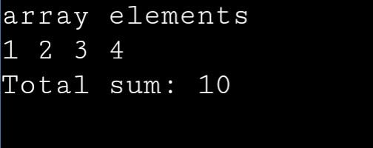

2)

#include <stdio.h>

int main()

{

int x, y, *a, *b, temp;

printf("Enter the value of x and y\n");

scanf("%d%d", &x, &y);

a = &x;

b = &y;

temp = *b;

*b = *a;

*a = temp;

printf("After Swapping\nx = %d\ny = %d\n", x, y);

return 0;

}

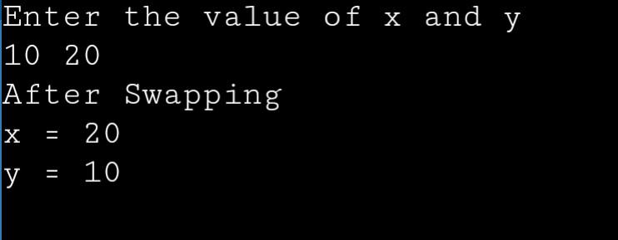

3)

#include <stdio.h>

#include <string.h>

int main() {

char name[] = "jayanti khathri";

char *ptr = name;

int L = strlen(ptr);

int i;

printf("length=%d\n", L);

for (i = 0; i <= L; i++) {

printf("%c", *(ptr + L - i));

}

return 0;

}

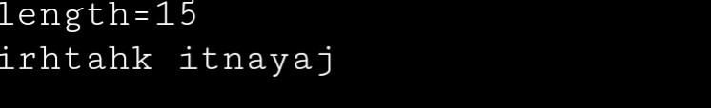

4)

#include <stdio.h>

void power(int *a, int *b, int **result);

int main() {

int a, b, *result_ptr;

printf("Enter the values of a and b: ");

scanf("%d %d", &a, &b);

power(&a, &b, &result_ptr);

printf("Result: %d\n", *result_ptr);

return 0;

}

void power(int *a, int *b, int **result) {

int count = 1;

for (int i = 1; i <= *b; i++) {

count *= *a;

}

*result = &count;

}

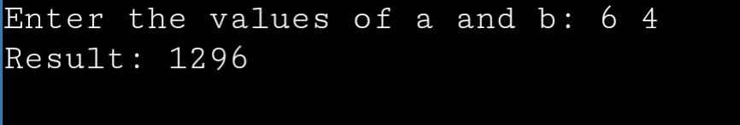

5)

#include <stdio.h>

#include <stdlib.h>

int main() {

int *a, i, j;

int rows = 4, cols = 3;

a = (int *)malloc(rows * cols * sizeof(int));

printf("Enter elements for the 1st matrix:\n");

for (i = 0; i < rows; i++) {

for (j = 0; j < cols; j++) {

scanf("%d", &a[i * cols + j]);

}

}

printf("1st matrix:\n");

for (i = 0; i < rows; i++) {

for (j = 0; j < cols; j++) {

printf("%d ", a[i * cols + j]);

}

printf("\n");

}

free(a);

return 0;

}

