

**October 6th University**

**Faculty of Information System and Computer Science**

**Hotel Reservation**

**Course title**:

Software Engineering

**Course instructor:**

*DR. Hesham Sakr*

**Supervision of:**

*Eng. Ahmed Khaled and*

*Eng. Mohamed Ahmed Helmy*

**Prepared by**

|  |  |  |  |
| --- | --- | --- | --- |
| Name | ID | GPA | Grade |
| Kareem Ayman Salama | 202119883 | 2.42 |  |
| Nancy Khaled Sayed | 202124689 | 3 |  |
| Merna Mohamed Ibrahim | 202016382 | 2.32 |  |
| Mohamed Osama Mamdouh | 202013001 | 2.2 |  |
| Moataz Ibrahim Gaber | 202124938 | 3.83 |  |
| Ali Farouk Ali | 202116264 | 2.66 |  |
| Mario Emad Edward | 202116342 | 2.73 |  |
| Amar Abdelkarm Abdelhalem | 202122953 | 3.19 |  |
| Heba Mohamed Mahmoud | 202120964 | 2.92 |  |
| Mohamed Ibrahim Elsayed | 202116137 | 2.87 |  |
| Noor Mohamed Abdelhamid | 202101302 | 3.42 |  |

**Table of contents:**

INTRODUCTION: ..............................................................................................4 GLOSSARY:........................................................................................................5  
 SOFTWARE PROCESS MODEL: .........................................................................6_7  
 USE RREQUIREMENTS:.....................................................................................8_9

FUNCTIONAL:....................................................................................................8  
 NON-FUNCTIONAL:..........................................................................................8_9   
SYSTEM ARCHITECTURE: ..................................................................................10  
SYSTEM REQUIREMENTS:.……………………..........................................................11  
INTERACTION DIAGRAM:..................................................................................12  
 Use-case diagram: ...........................................................................................12  
 Sequence diagram: ..........................................................................................13   
STRUCTURAL DIAGRAM:...................................................................................14   
Class diagram: ..................................................................................................14  
 BEHAVIORAL DIAGRAM:..................................................................................15  
Activity diagram:...............................................................................................15  
State diagram: ..................................................................................................16  
 APPENDICES:....................................................................................................17

**Introduction:**

**A hotel reservation system** is a software application that**allows guests to book directly with the hotel online**, with no intermediaries necessary. The software essentially processes online reservations made via the hotel’s website and then passes this information to the hotel’s own backend so that the information can be easily accessed. Bookings are then managed by hotel staff.

With the boom of the Millennial traveler, now **more than 700 million people are expected to book primarily online by 2023**, so having an online reservation system is key to reaching a widespread audience. It is also key to generating a good first impression because guests are able to place bookings without having to navigate to another domain. Keeping the whole process internally prevents clients from navigating away from the page before making the final booking.

**Glossary:**

* **UML:** Unified Modelling Language is a standard language for documentation of software system.
* **URD:** User Requirements Definition.
* **SRS:** System Requirements Specification.
* **SD:** Sequence Diagram, show interactions in order.
* **UCD**: Use Case Diagram is used to describe the interaction between the system and its external actors.
* **UML CD**: Class Diagram, is a type of static structure diagram that describes the structure of a system.
* **UML AD**: Activity Diagram, is a type of diagram used in Unified Modeling Language (UML) that shows the flow of control between activities within a system.
* **UML SD**: State Diagram, is used to describe the behavior of a single system.

**Software process model:**

***Waterfall model*..**

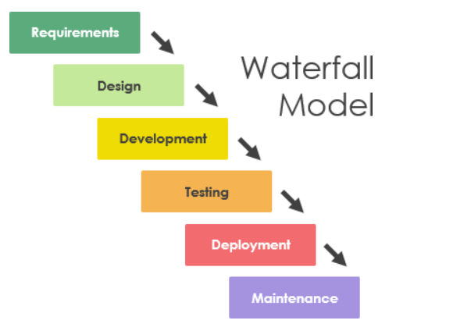

* **Requirements Analysis and Definition**

The system's services, constraints and goals are established by

consultation with system users. They are then defined in a manner that is understandable by both users and development staff.

This phase can be divided into:

* Feasibility study (often carried out separately)
* Requirements analysis
* Requirements definition
* Requirements specification
* **Discussion of the Waterfall Model**

**Advantages:**

* Process visibility
* Dependence on individuals
* Quality control
* Cost control

**Disadvantages:**

In principle, a phase has to be complete before moving onto

the next phase. **Inflexible partitioning** of the project into

**distinct stages** makes it **difficult to respond to changing**

**customer requirements.**

* **Waterfall model**
* Therefore, this model is **only appropriate when the requirements are well-understood and changes will be fairly limited** during the design process.
* Few business systems have stable requirements.
* The waterfall model is **mostly used for large systems engineering projects** where a system is developed at several sites.
* In those circumstances, the **plan-driven** **nature** of the waterfall model helps coordinate the work.

**User requirements:**

**Functional requirements : -**

1. System must be able to search for available rooms based on user-specified criteria.
2. Admin shall be allowed to book and cancel rooms.
3. System shall generate a report at the end of the month with Reservations made and number of customers who booked rooms in the hotel.
4. The system shall integrate with the hotel database.
5. Each customer shall have his own account.
6. Accept date and time to check available rooms for that particular time.
7. The customer shall be able to make a feedback .
8. The user should choose his payment.

**Non-Functional requirements : -**

**1. Security :** system must be secure, where a customer can’t access another one’s account.

**2. Reliability**: system shouldn’t lose customer’s data in case of failure.

**3. Portability :** When appearing a new customer, it can extend the function of the system on the basis of the original one and will not affect the existing function.

**4. Maintainability :** changes in some data should be performed without affect the whole system.

**5.Robustness:** the system must be able to restart after the event of failure in a very small amount of time that doesn’t exceed 3 seconds.

**6. Usability:** interface design must be easy and clear for user to use.

* **System architecture:**

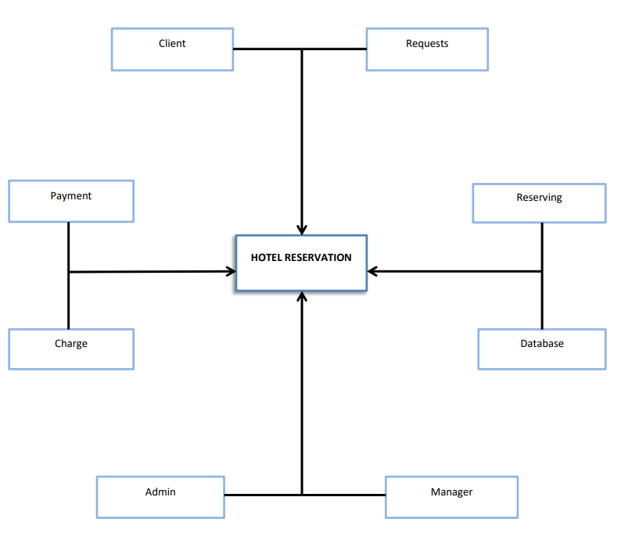

**System requirements specification:**

1. System must allow customer to make an account.
2. System shall show a different user interface with guests and allow them to see rooms.
3. The system shall provide a feedback mechanism to take feedback from customers ,so the system will be upgraded.
4. The system must save the information of the customers .
5. The system must store and save rooms booked in database.
6. The system must check for the payment methods and its validation, and generate a recite of payment confirmation for the customer.
7. The system shall give a variety of room services and ways to satisfy all customers and their needs.
8. Make a report of every entry costumer ,rooms ,charges, benefits and customer’s feedback.

* **Interaction diagrams…**

**Use case diagram :-**

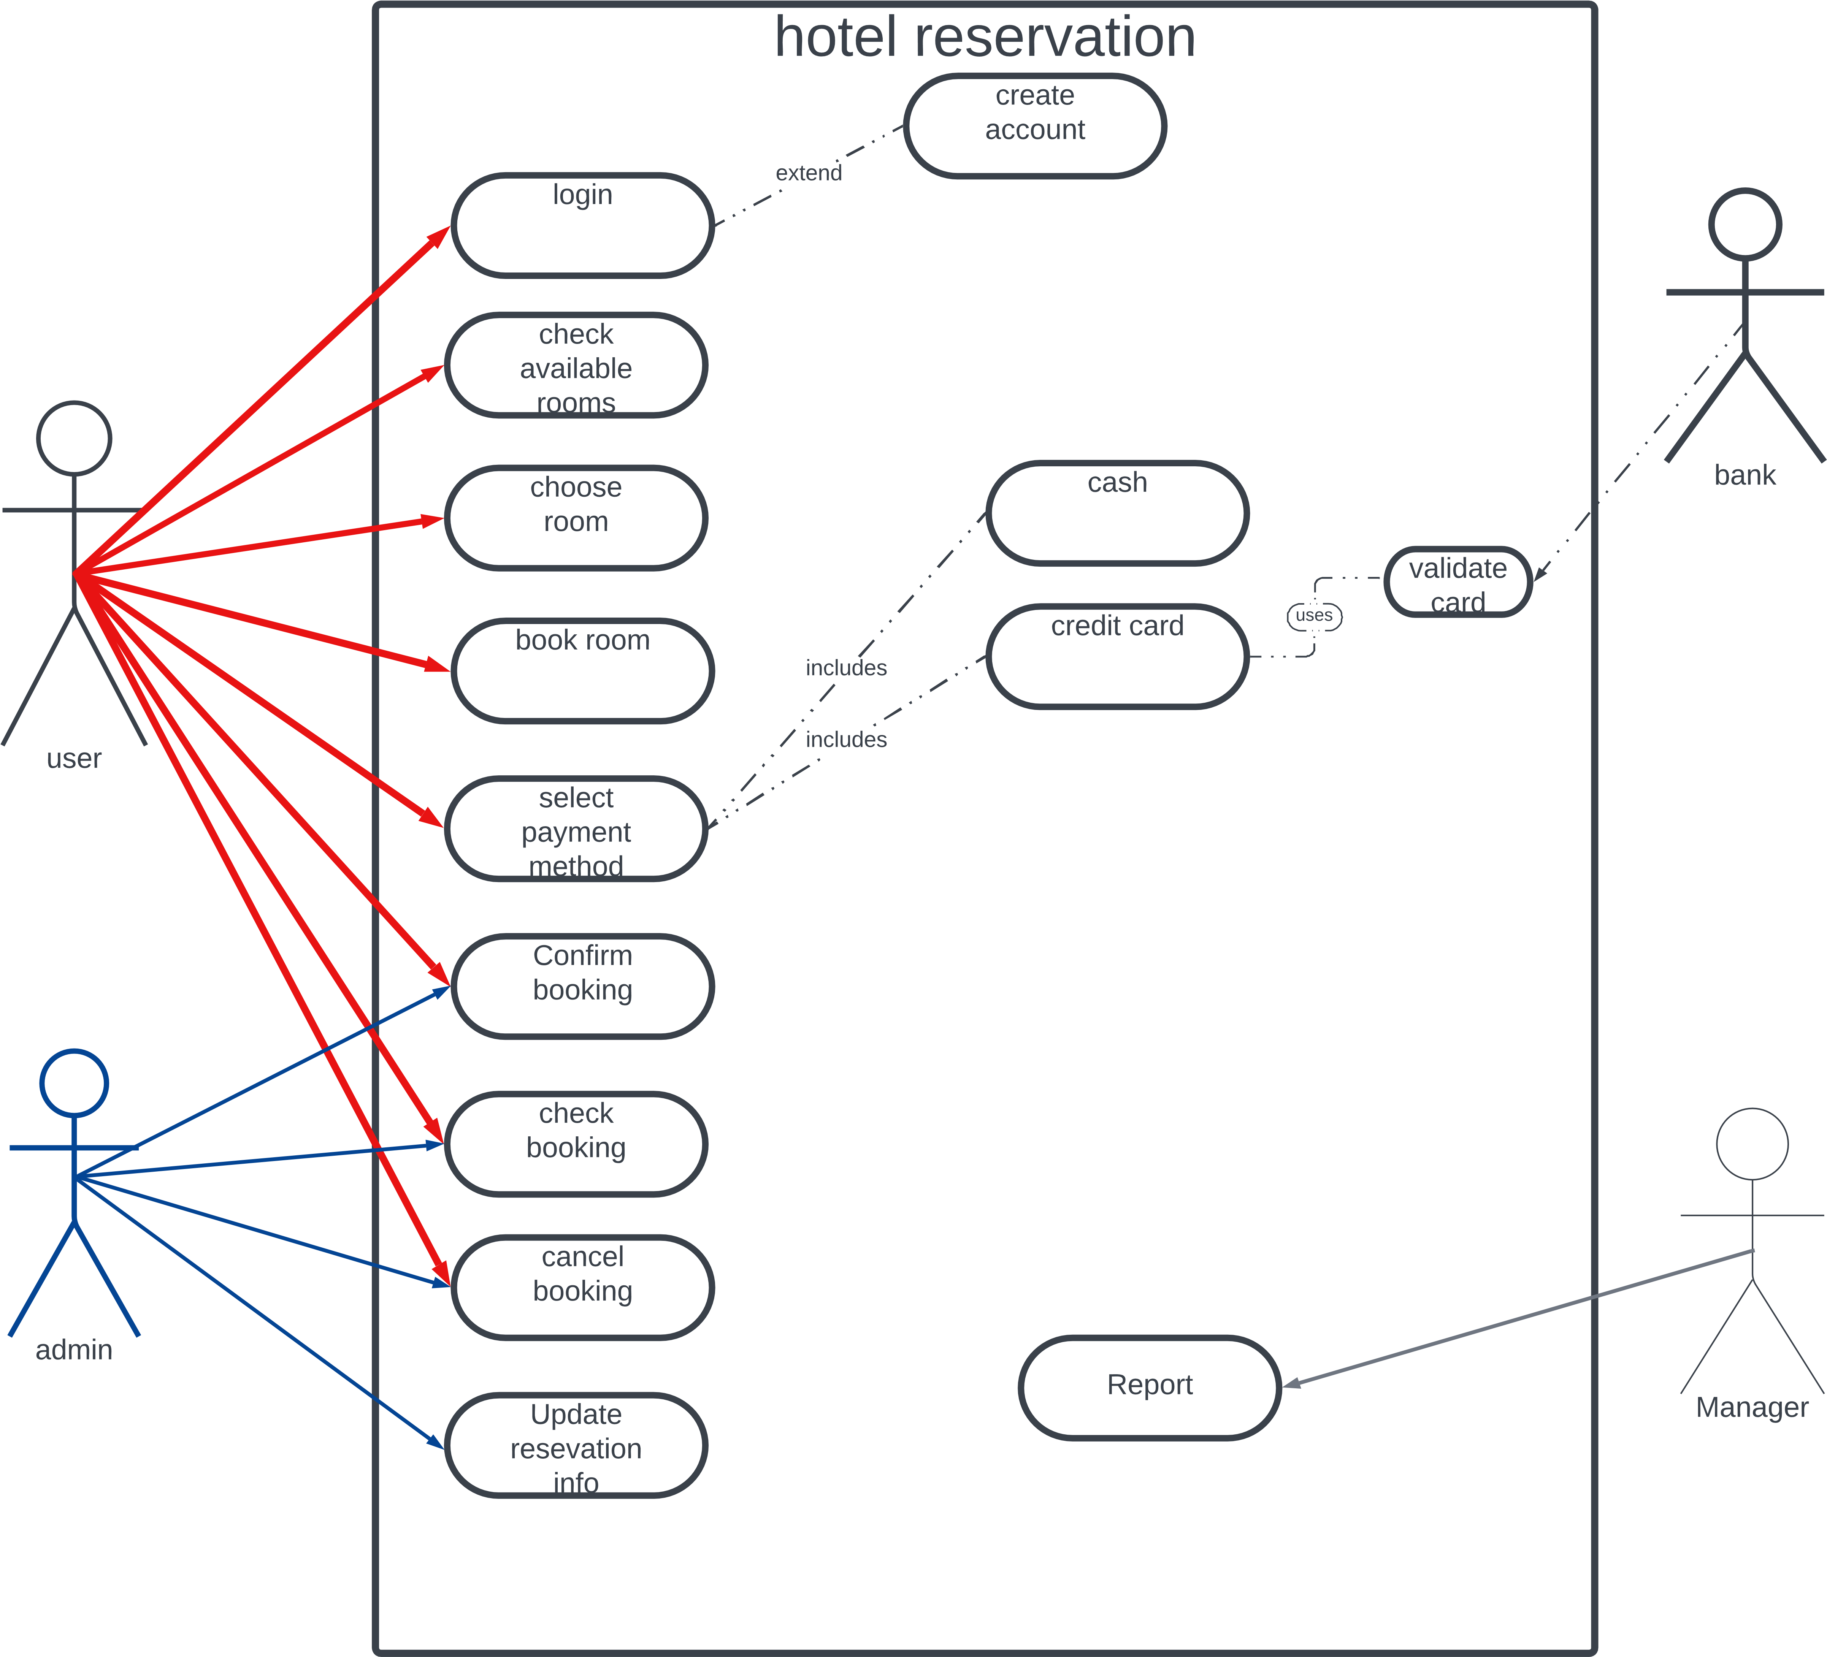

**Sequence diagram:-**

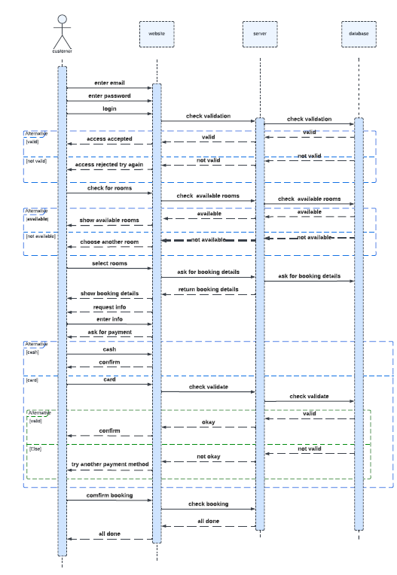

**Class diagram:-**







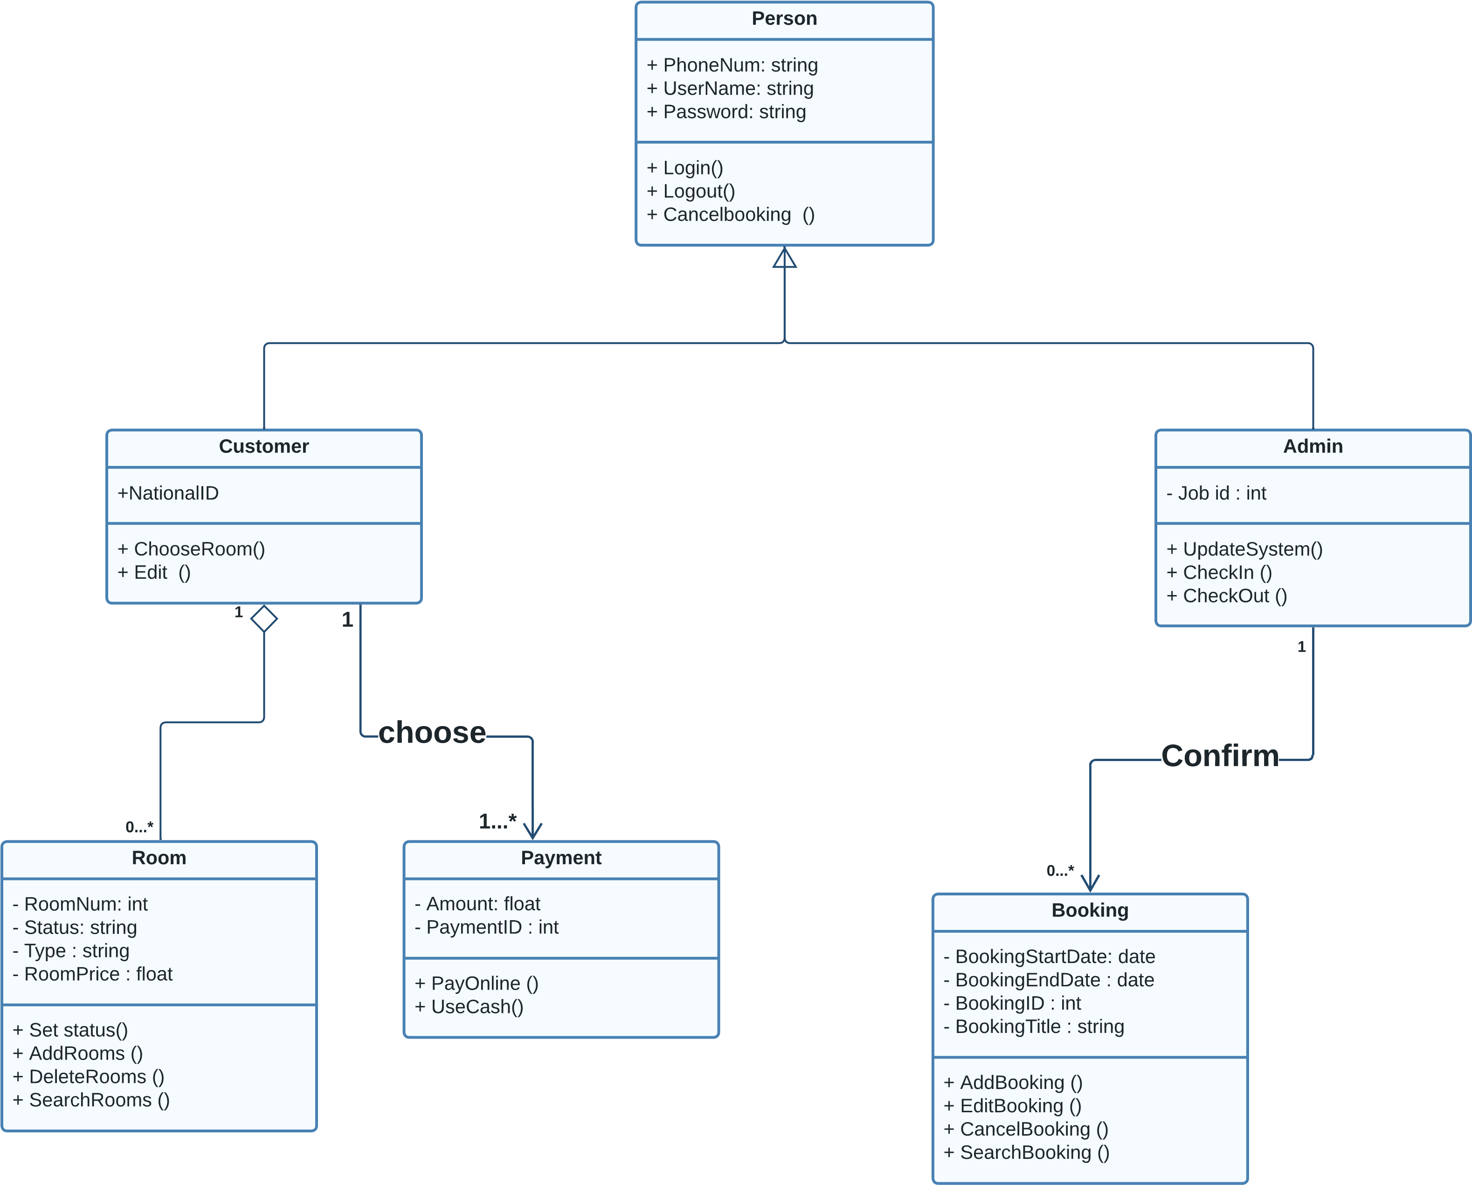

**Activity diagram :-**

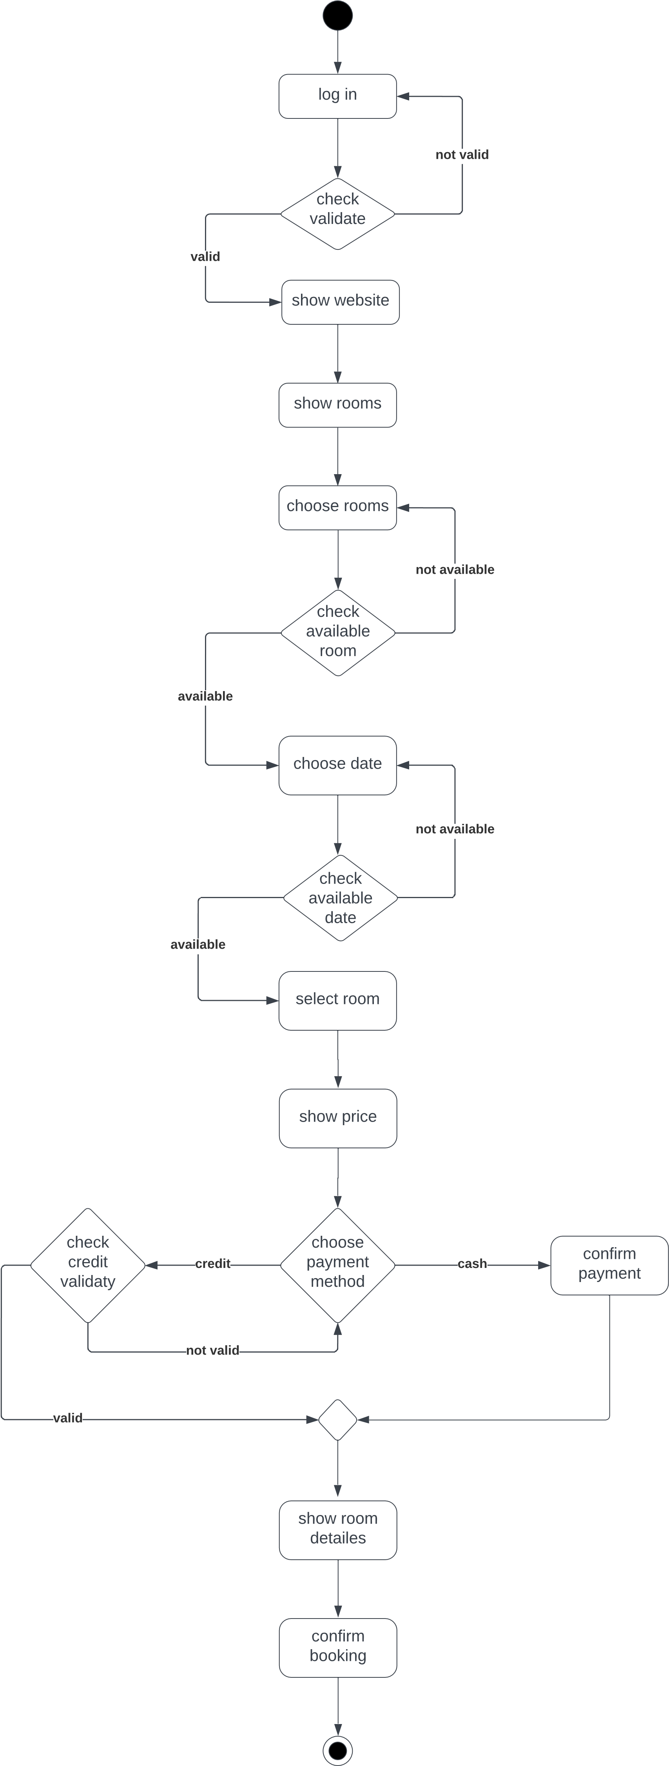

**State diagram:-** 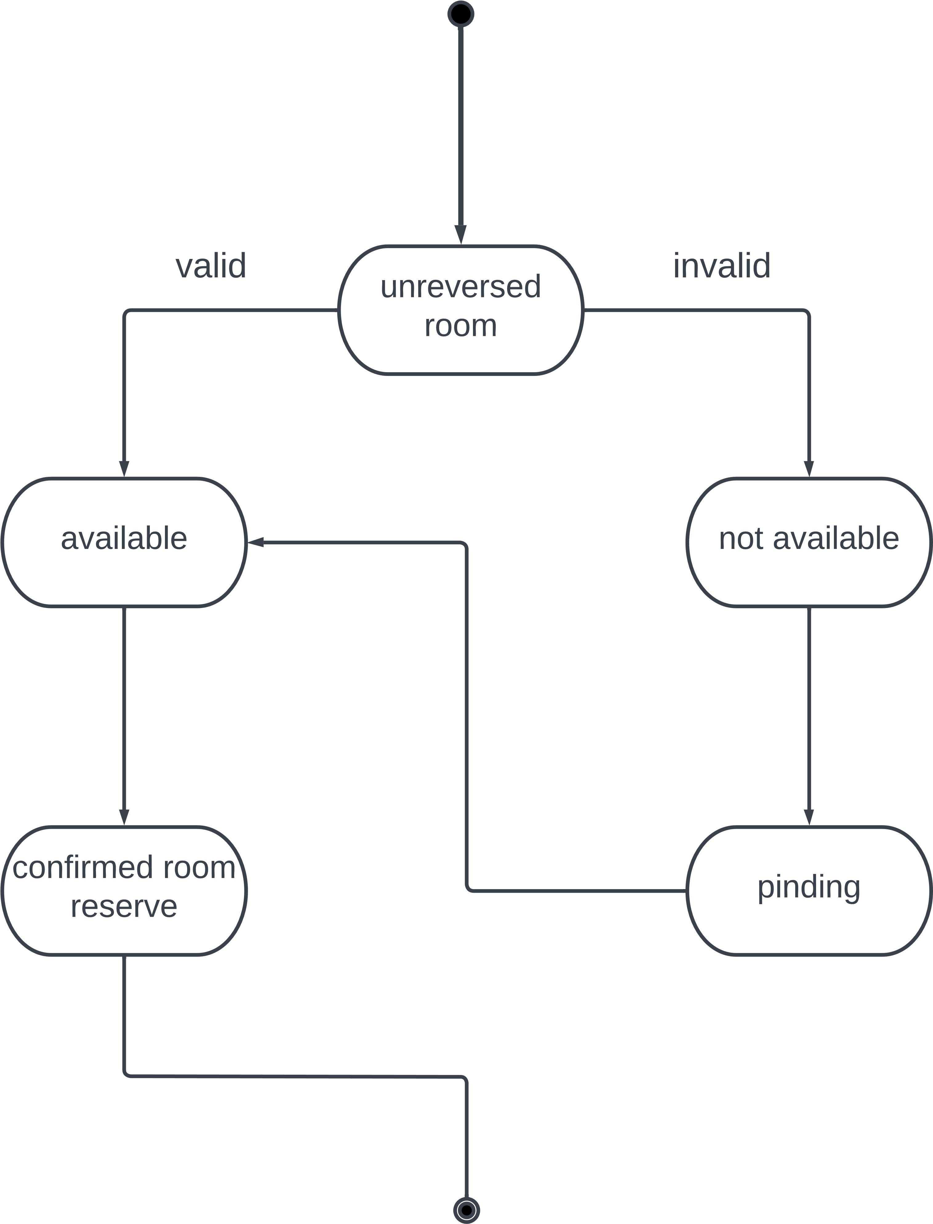

* **Appendices…..**

-A site with an eascy interface and available for all the operating system platforms.

-A database that is secure ,it’s protected by a layered architectural pattern that asks the users for their id and password.

- A credit card machine is available for credit payment.

- A printing mechanism for printing reports and bills.