How to use ACR in AZURE for repository

Step1 : login in Azure portal (portal.azure.com) and search for “container registry”

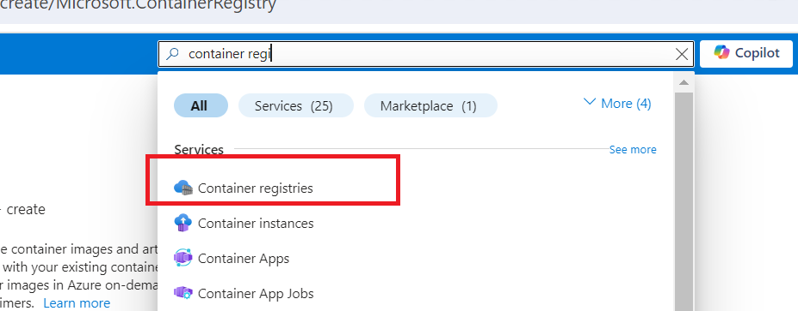

Step2 : Go inside Container Registries, and then click on to create container registry.

Put resource group, registry name and location and then click next tab to create container registry.

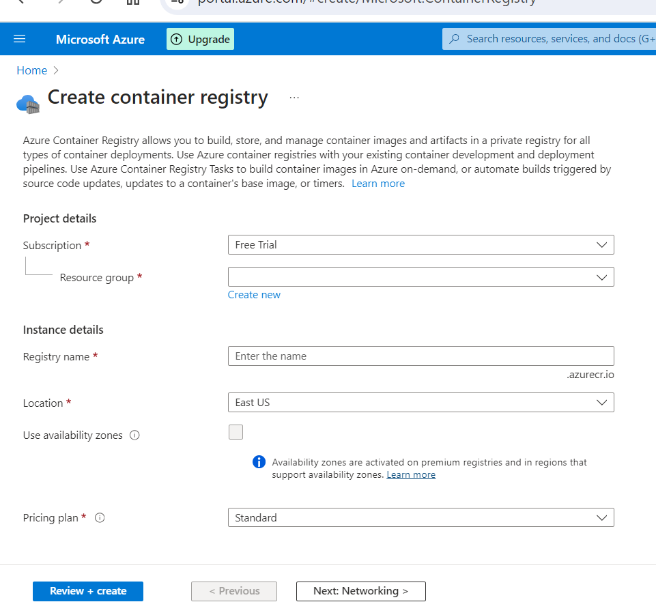

Step3: Once deployment done in acr registry, click on search with the created acr registry name “devopsinsiderregistry”.

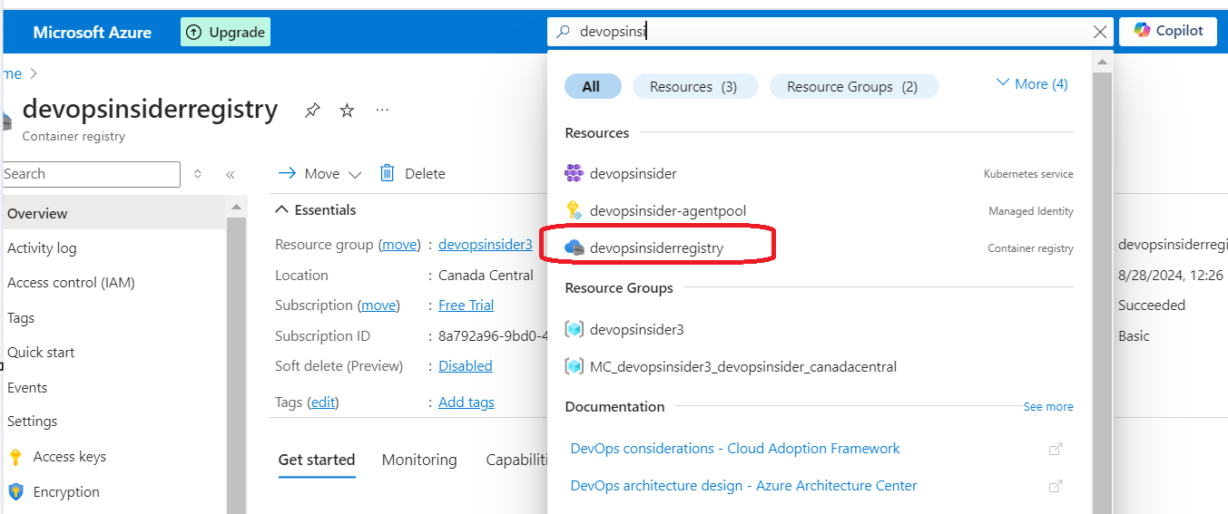

Step4: Go to devopsinsiderregistry and then clicked on adminuser for publically access our image in kubernetes.

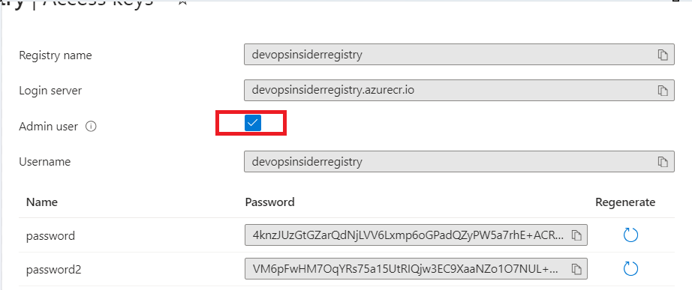

Step5: Import the image from other repo (Eg: docker registry) to our acr registry:

az acr import --name <AcrRegistryName> --source <SourceRepoimageFilePath/Imagename:tag> --image <imageName>

Eg: az acr import --name devopsinsiderregistry --source docker.io/library/nginx:latest --image nginx:v1

Step6: Now go to azure portal, search registryname in search bar “devopsinsiderregistry” and go inside the registry. Click in repository, image is present which imported in previous step.

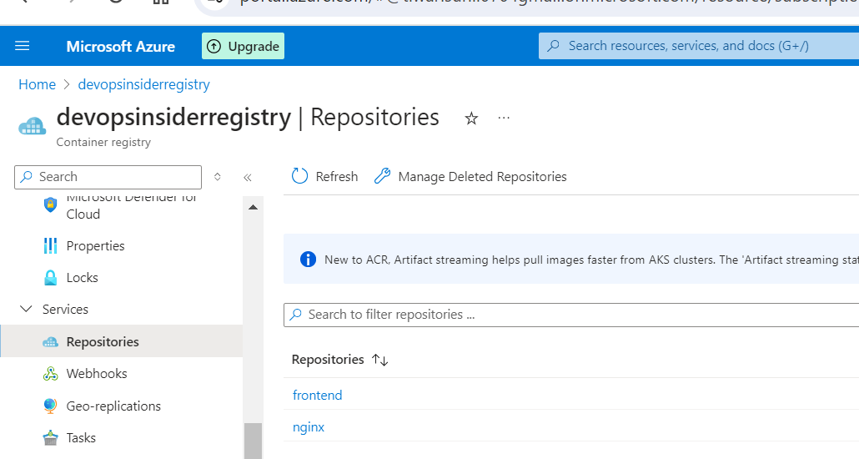

Step7: Create service principal for resourcegroup:

az ad sp create-for-rbac

az ad sp create-for-rbac --name myServicePrincipalName1 --role reader --scopes /subscriptions/8a792a96-9bd0-41cd-bb14-cbed745e3244/resourceGroups/devopsinsider3

Step8: Attach this ACR registry to our cluster:

az aks update --name <clustername> --resource-group <Clusterresourcegroup> --attach-acr <ACRRegistryName>

az aks update --name devopsinsider --resource-group devopsinsider3 --attach-acr devopsinsiderregistry

Step9: Now go to ACR registry “devopsinsiderregistry” 🡪 then go to repository 🡪 click on images 🡪 copy complete image path

devopsinsiderregistry.azurecr.io/nginx:v1

Step10: Now We can use this image in our deployment, or we can use our ACR registry image in our deployment:

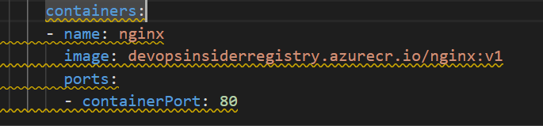

Step11: Now We can deploy nginx and pod showing in running status

