**Manage Azure PowerShell and Azure CLI**

**Manage Azure PowerShell**

1. **Install powershell module using visual Studio code**

Below command for installing powershell module

Set-ExecutionPolicy -ExecutionPolicy RemoteSigned -Scope CurrentUser

Install-Module -Name Az -AllowClobber -Force -Scope CurrentUser

1. **PowerShell code to connect to Azure Subsription**

Connect-AzAccount -DeviceCode

1. **Powershell command to Create/delete/list resource group**

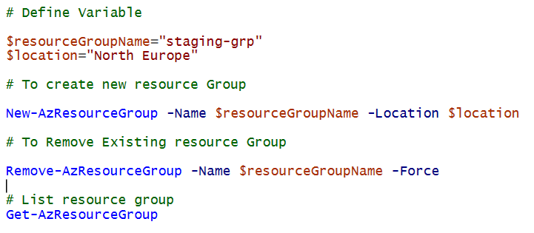

# Define Variable

$resourceGroupName="staging-grp"

$location="North Europe"

# To create new resource Group

New-AzResourceGroup -Name $resourceGroupName -Location $location

# To Remove Existing resource Group

Remove-AzResourceGroup -Name $resourceGroupName -Force

# List resource group

Get-AzResourceGroup

1. **Powershell command to Create/delete/list Virtual Network**

#Define variable

$resourceGroupName="staging-grp"

$location="North Europe"

$networkName="app-network"

$addressPrefix="10.0.0.0/16"

#Create a New Resource Group

New-AzResourceGroup -Name $resourceGroupName -Location $location

#Create a New Virtual Network, tild (`) for Next line

New-AzVirtualNetwork -Name $networkName -ResourceGroupName $resourceGroupName `

-Location $location -AddressPrefix $addressPrefix

#To list Virtual Network

$VirtualNetwork=Get-AzVirtualNetwork -Name $networkName -ResourceGroupName $resourceGroupName

write-Host $VirtualNetwork.Location

write-Host $VirtualNetwork.AddressSpace.AddressPrefixes

#To delete Virtual Network

Remove-AzVirtualNetwork -Name $networkName -ResourceGroupName $resourceGroupName -Force

1. **Powershell command to Create subnet in existing virtual network**

#Define variable

$resourceGroupName="staging-grp"

$location="North Europe"

$networkName="app-network"

$addressPrefix="10.0.0.0/16"

$subnetName="SubnetA"

$subnetAddressPrefix="10.0.0.0/24"

#Create a New Resource Group

New-AzResourceGroup -Name $resourceGroupName -Location $location

#Create a New Virtual Network, tild (`) for Next line

New-AzVirtualNetwork -Name $networkName -ResourceGroupName $resourceGroupName `

-Location $location -AddressPrefix $addressPrefix

#to list Virtual Network and store in variable name virtualNetwork

$VirtualNetwork=Get-AzVirtualNetwork -Name $networkName -ResourceGroupName $resourceGroupName

# add a subnet configuration to an existing virtual network (VNet)

Add-AzVirtualNetworkSubnetConfig -Name $subnetName -VirtualNetwork $VirtualNetwork `

-AddressPrefix $subnetAddressPrefix

# apply changes made to a virtual network object ($VirtualNetwork) in Azure

$VirtualNetwork | Set-AzVirtualNetwork

1. **Powershell command to delete subnet in existing virtual network**

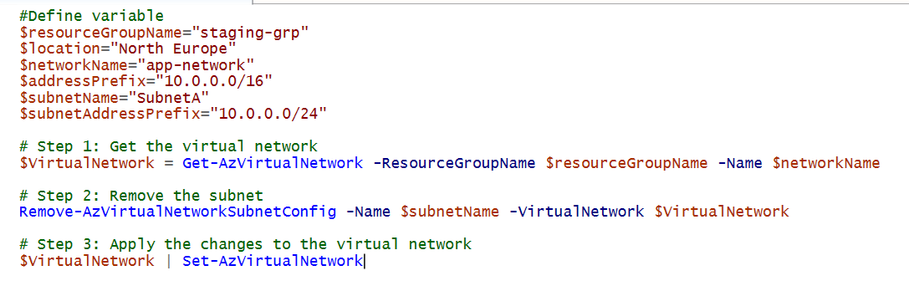

#Define variable

$resourceGroupName="staging-grp"

$location="North Europe"

$networkName="app-network"

$addressPrefix="10.0.0.0/16"

$subnetName="SubnetA"

$subnetAddressPrefix="10.0.0.0/24"

# Step 1: Get the virtual network

$VirtualNetwork = Get-AzVirtualNetwork -ResourceGroupName $resourceGroupName -Name $networkName

# Step 2: Remove the subnet

Remove-AzVirtualNetworkSubnetConfig -Name $subnetName -VirtualNetwork $VirtualNetwork

# Step 3: Apply the changes to the virtual network

$VirtualNetwork | Set-AzVirtualNetwork

1. **Powershell command to Create New subnet in New virtual network**

$resourceGroupName="staging-grp"

$networkName="app-network"

$subnetName="SubnetA"

$subnetAddressPrefix="10.0.0.0/24"

$addressPrefix="10.0.0.0/16"

$location="North Europe"

$subnet=New-AzVirtualNetworkSubnetConfig -Name $subnetName -AddressPrefix $subnetAddressPrefix

New-AzVirtualNetwork -Name $networkName -ResourceGroupName $resourceGroupName `

-Location $location -AddressPrefix $addressPrefix -Subnet $subnet

1. **Powershell command to Create New NIC in existing subnet and existing virtual network**

$resourceGroupName="staging-grp"

$networkName="app-network"

$subnetName="SubnetA"

$networkInterfaceName="app-interface"

$VirtualNetwork = Get-AzVirtualNetwork -Name $networkName -ResourceGroupName $resourceGroupName

$subnet=Get-AzVirtualNetworkSubnetConfig -VirtualNetwork $VirtualNetwork -Name $subnetName

New-AzNetworkInterface -Name $networkInterfaceName -ResourceGroupName $resourceGroupName `

-Location $location -SubnetId $subnet.Id -IpConfigurationName "IpConfig"

1. **Powershell command to Create New NIC in New subnet and New virtual network**

$nicLocation = "North Europe"

$networkInterfaceName = "app-interface"

$resourceGroupName = "staging-grp"

$location = "North Europe"

$networkName = "app-network"

$addressPrefix = "10.0.0.0/16"

$subnetName = "app-subnet"

$subnetAddressPrefix = "10.0.1.0/24"

# Step 1: Create the Resource Group (if it doesn't already exist)

New-AzResourceGroup -Name $resourceGroupName -Location $location

# Step 2: Create the Virtual Network with the Address Prefix

$virtualNetwork = New-AzVirtualNetwork -ResourceGroupName $resourceGroupName `

-Location $location -Name $networkName -AddressPrefix $addressPrefix

# Step 3: Create the Subnet and Add it to the Virtual Network

$virtualNetwork | Add-AzVirtualNetworkSubnetConfig -Name $subnetName `

-AddressPrefix $subnetAddressPrefix | Set-AzVirtualNetwork

# Step 4: Get the Subnet reference (to use in the NIC configuration)

$virtualNetwork = Get-AzVirtualNetwork -ResourceGroupName $resourceGroupName -Name $networkName

$subnet = Get-AzVirtualNetworkSubnetConfig -VirtualNetwork $virtualNetwork -Name $subnetName

# Step 5: Create the NIC configuration with correct Subnet reference

$nicConfig = New-AzNetworkInterfaceIpConfig -Name "IpConfig" -SubnetId $subnet.Id

# Step 6: Create the Network Interface with the Subnet reference

$nic = New-AzNetworkInterface -Name $networkInterfaceName `

-ResourceGroupName $resourceGroupName -Location $nicLocation -IpConfiguration $nicConfig

# Output the created Network Interface details

$nic

1. **Powershell command to Create New PublicIP in Existing Resource Group**

$resourceGroupName="staging-grp"

$location="North Europe"

$publicIPAddressName="app-ip"

New-AzPublicIpAddress -Name $publicIPAddressName -ResourceGroupName $resourceGroupName `

-Location $location -AllocationMethod Static

1. **Powershell command to Create New PublicIP in New Resource Group**

# Define the necessary variables

$resourceGroupName = "YourResourceGroupName"

$location = "YourLocation"

$publicIpName = "YourPublicIpName"

# Step 1: Create the Resource Group (if it doesn't already exist)

New-AzResourceGroup -Name $resourceGroupName -Location $location

# Step 2: Create the Public IP Address

$publicIp = New-AzPublicIpAddress -ResourceGroupName $resourceGroupName `

-Location $location -Name $publicIpName -AllocationMethod Static -Sku Standard

# Output the created Public IP Address details

$publicIp

1. **Powershell command to Create a NSG**

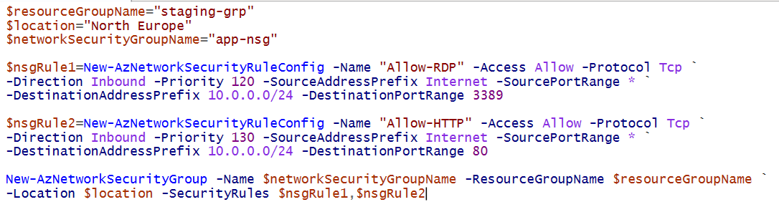

$resourceGroupName="staging-grp"

$location="North Europe"

$networkSecurityGroupName="app-nsg"

$nsgRule1=New-AzNetworkSecurityRuleConfig -Name "Allow-RDP" -Access Allow -Protocol Tcp `

-Direction Inbound -Priority 120 -SourceAddressPrefix Internet -SourcePortRange * `

-DestinationAddressPrefix 10.0.0.0/24 -DestinationPortRange 3389

$nsgRule2=New-AzNetworkSecurityRuleConfig -Name "Allow-HTTP" -Access Allow -Protocol Tcp `

-Direction Inbound -Priority 130 -SourceAddressPrefix Internet -SourcePortRange * `

-DestinationAddressPrefix 10.0.0.0/24 -DestinationPortRange 80

New-AzNetworkSecurityGroup -Name $networkSecurityGroupName -ResourceGroupName $resourceGroupName `

-Location $location -SecurityRules $nsgRule1,$nsgRule2

1. **Powershell command to Adding a New VM**

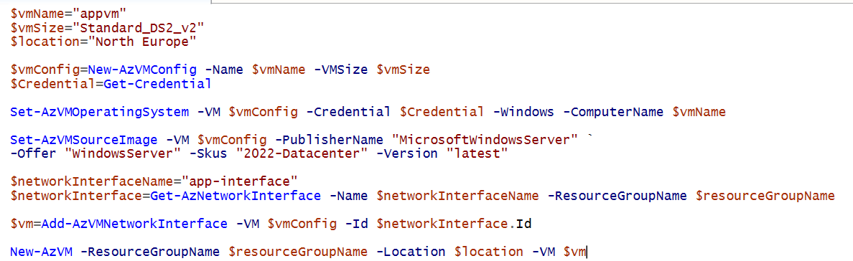

$vmName="appvm"

$vmSize="Standard_DS2_v2"

$location="North Europe"

$vmConfig=New-AzVMConfig -Name $vmName -VMSize $vmSize

$Credential=Get-Credential

Set-AzVMOperatingSystem -VM $vmConfig -Credential $Credential -Windows -ComputerName $vmName

Set-AzVMSourceImage -VM $vmConfig -PublisherName "MicrosoftWindowsServer" `

-Offer "WindowsServer" -Skus "2022-Datacenter" -Version "latest"

$networkInterfaceName="app-interface"

$networkInterface=Get-AzNetworkInterface -Name $networkInterfaceName -ResourceGroupName $resourceGroupName

$vm=Add-AzVMNetworkInterface -VM $vmConfig -Id $networkInterface.Id

New-AzVM -ResourceGroupName $resourceGroupName -Location $location -VM $vm

1. **Powershell command to Adding a New disk in existing VM**

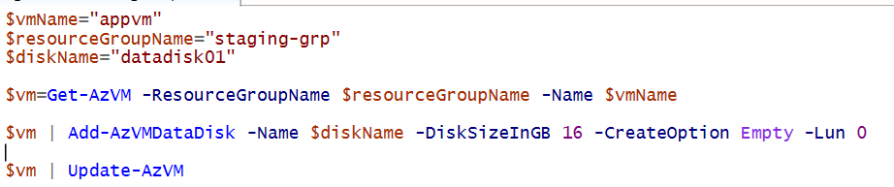

$vmName="appvm"

$resourceGroupName="staging-grp"

$diskName="datadisk01"

$vm=Get-AzVM -ResourceGroupName $resourceGroupName -Name $vmName

$vm | Add-AzVMDataDisk -Name $diskName -DiskSizeInGB 16 -CreateOption Empty -Lun 0

$vm | Update-AzVM

1. **Powershell command to create from resource group till vm**

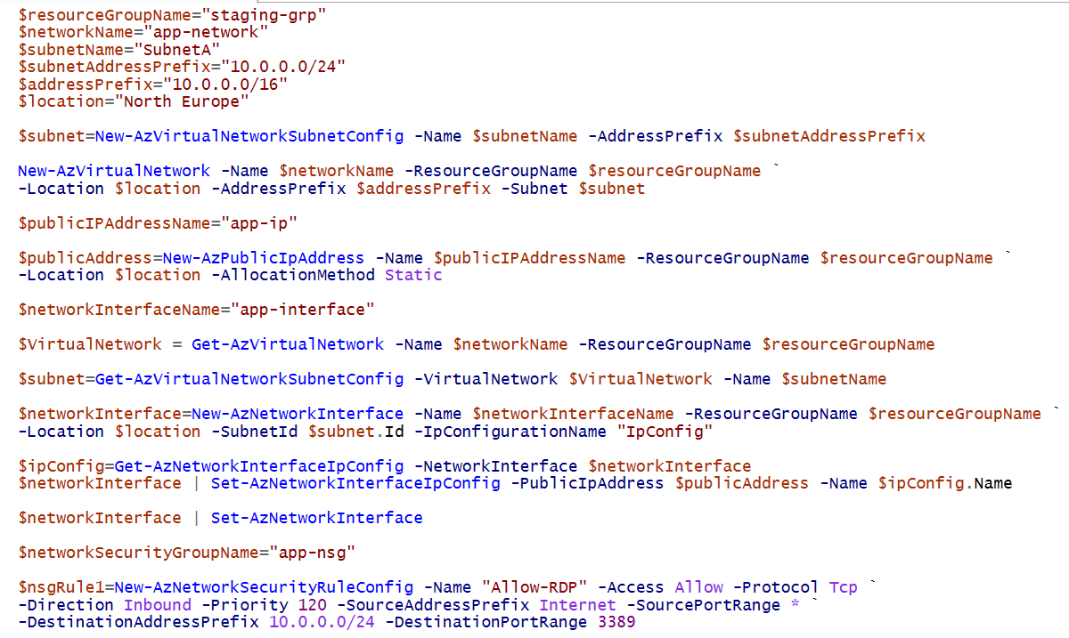

1. **Powershell command to create a storage account**

$resourceGroupName="staging-grp"

$location="North Europe"

$storageAccountName="appstore443554554"

$storageAccountKind="StorageV2"

$accountSku="Standard_LRS"

New-AzStorageAccount -ResourceGroupName $resourceGroupName -Name $storageAccountName `

-Location $location -Kind $storageAccountKind -SkuName $accountSku

1. **Powershell command to create an Azure WebApp**

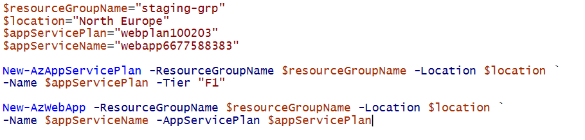

$resourceGroupName="staging-grp"

$location="North Europe"

$appServicePlan="webplan100203"

$appServiceName="webapp6677588383"

New-AzAppServicePlan -ResourceGroupName $resourceGroupName -Location $location `

-Name $appServicePlan -Tier "F1"

New-AzWebApp -ResourceGroupName $resourceGroupName -Location $location `

-Name $appServiceName -AppServicePlan $appServicePlan

**Manage Azure CLI**

1. **Azure CLI command to create an Azure Resource Group**

az group create --location "North Europe" --name "new-grp"

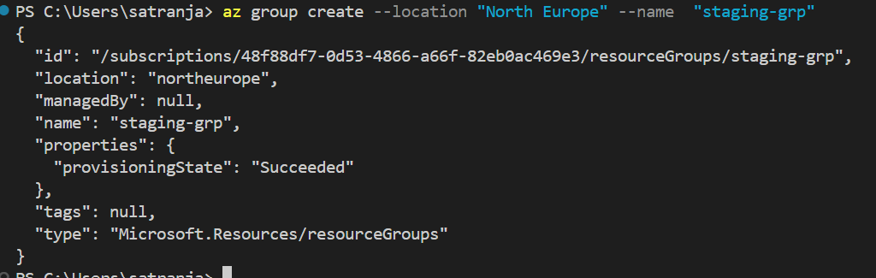

1. **Azure CLI command to create an Azure vnet**

az network vnet create --name "app-network" --resource-group "app-grp" --subnet-name "SubnetA" --address-prefixes 10.0.0.0/16

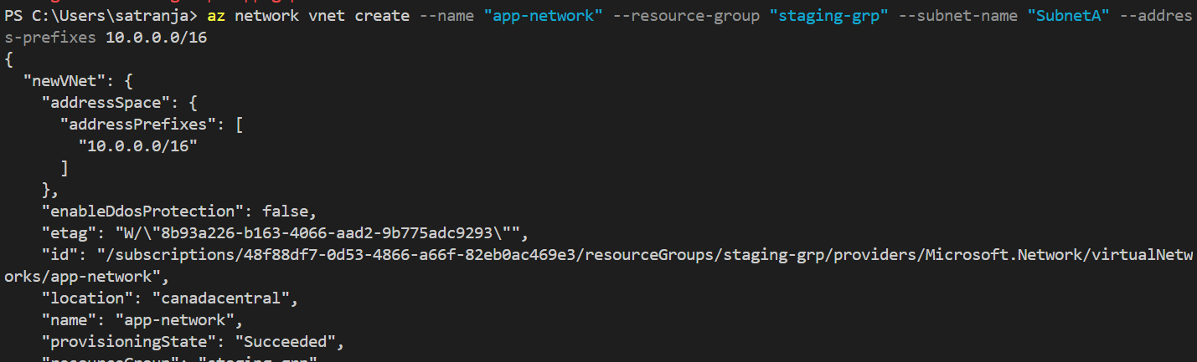

1. **Azure CLI command to create a subnet in existing vnet**

az network vnet subnet create -n "SubnetB" --address-prefixes 10.0.1.0/24 -g "app-grp" --vnet-name "app-network"

1. **Azure CLI command to create a vm**

**Quick create VM**

az vm create -g "app-grp" -n "appvm" --image Win2022Datacenter --admin-username "appusr"

**VM Creation with more parameters**

az vm image list --output table

az vm list-sizes --location "North Europe"

az vm create -g "app-grp" -n "appvm" --image Win2022Datacenter

--admin-username "appusr" --size "Standard_DS2_v2" --vnet-name "app-network" --subnet "SubnetA"

1. **Azure CLI command to create a disk and attach**

**Create Data Disk**

az disk create -n "data-disk" -g "app-grp" -l "North Europe" --size-gb 16

**attached above disk with VM**

az vm disk attach --vm-name "appvm" --lun 0 -g "app-grp" -n "data-disk"

1. **Azure CLI command to create a storage account**

az storage account create -n "newstore44333" -g "app-grp" --kind "StorageV2" --sku "Standard_LRS"

1. **Azure CLI command to create a web app**

**App Service Plan Creation**

az appservice plan create -n "demoplan4434" -g "app-grp" --sku F1

**Web App Creation**

az webapp create -n "webapp5434" -g "app-grp" --plan "demoplan4434"

1. **Azure CLI command to create a vmss**

az vmss create -n "app-set" -g "app-grp" --admin-username "appusr" --image Win2022Datacenter --vm-sku "Standard_DS2_v2"

1. **Azure CLI command to create a linux vm**

az vm create -g "app-grp" -n "linuxvm"

--image "Canonical:0001-com-ubuntu-server-jammy:22_04-lts-gen2:latest" --admin-username "linuxusr" --admin-password "AzurePassword@123" --custom-data config.txt

**Config.txt file which will run in same directory where this command run**

