**Manage Azure Resource Manager Template**

1. **Azure Resource Manager Template**

1. **Azure Resource Manager Template Structure**

{

"$schema": "https://schema.management.azure.com/schemas/2019-04-01/deploymentTemplate.json#",

"languageVersion": "",

"contentVersion": "",

"apiProfile": "",

"definitions": { },

"parameters": { },

"variables": { },

"functions": [ ],

"resources": [ ], /* or "resources": { } with languageVersion 2.0 */

"outputs": { }

}

1. **Building an ARM Template**

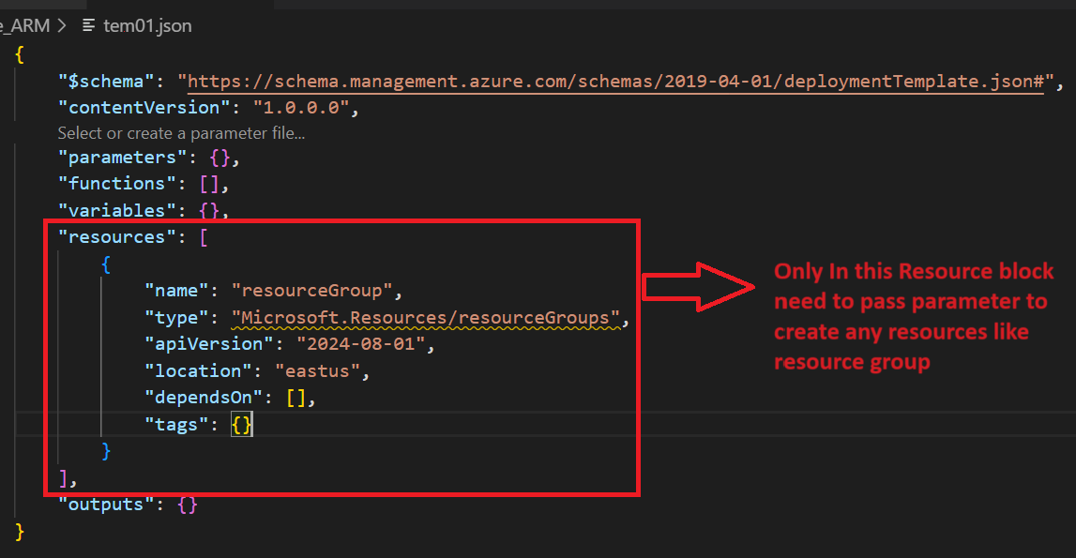

1. **Using PowerShell To deploy Resource Group using the ARM Template**

Step1: Create ARM Template to deploy the resource group

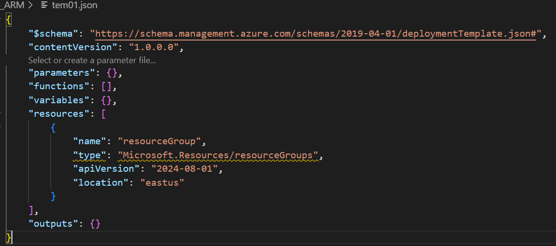

Step2: Connect Azure Account by using below command:

Connect-AzAccount

Or

Connect-AzAccount -TenantId 8839fa1a-72d2-4f19-8736-4c73cf13d7a6

Get-AzContext

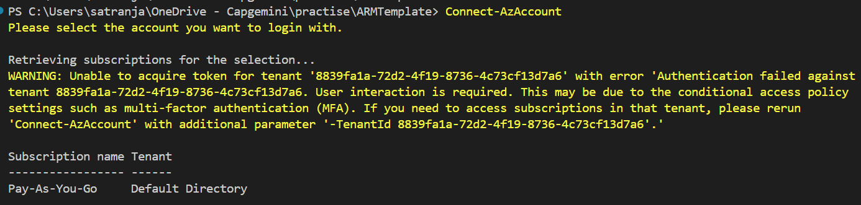

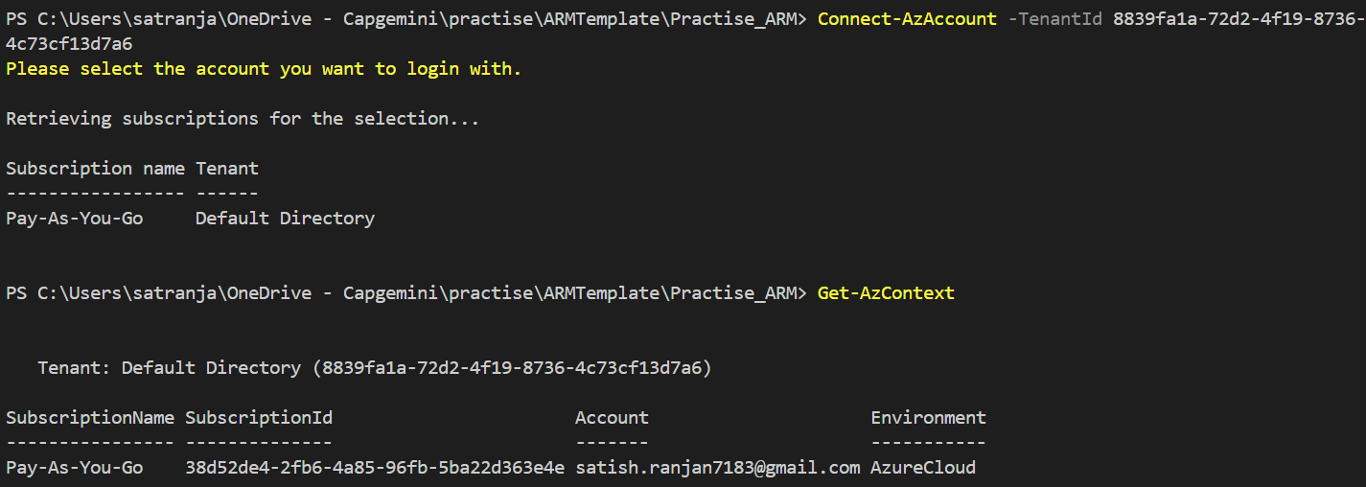

Step3: Run Below Powershell command to deploy resource group

New-AzDeployment -Location eastus -TemplateFile .\tem01.json

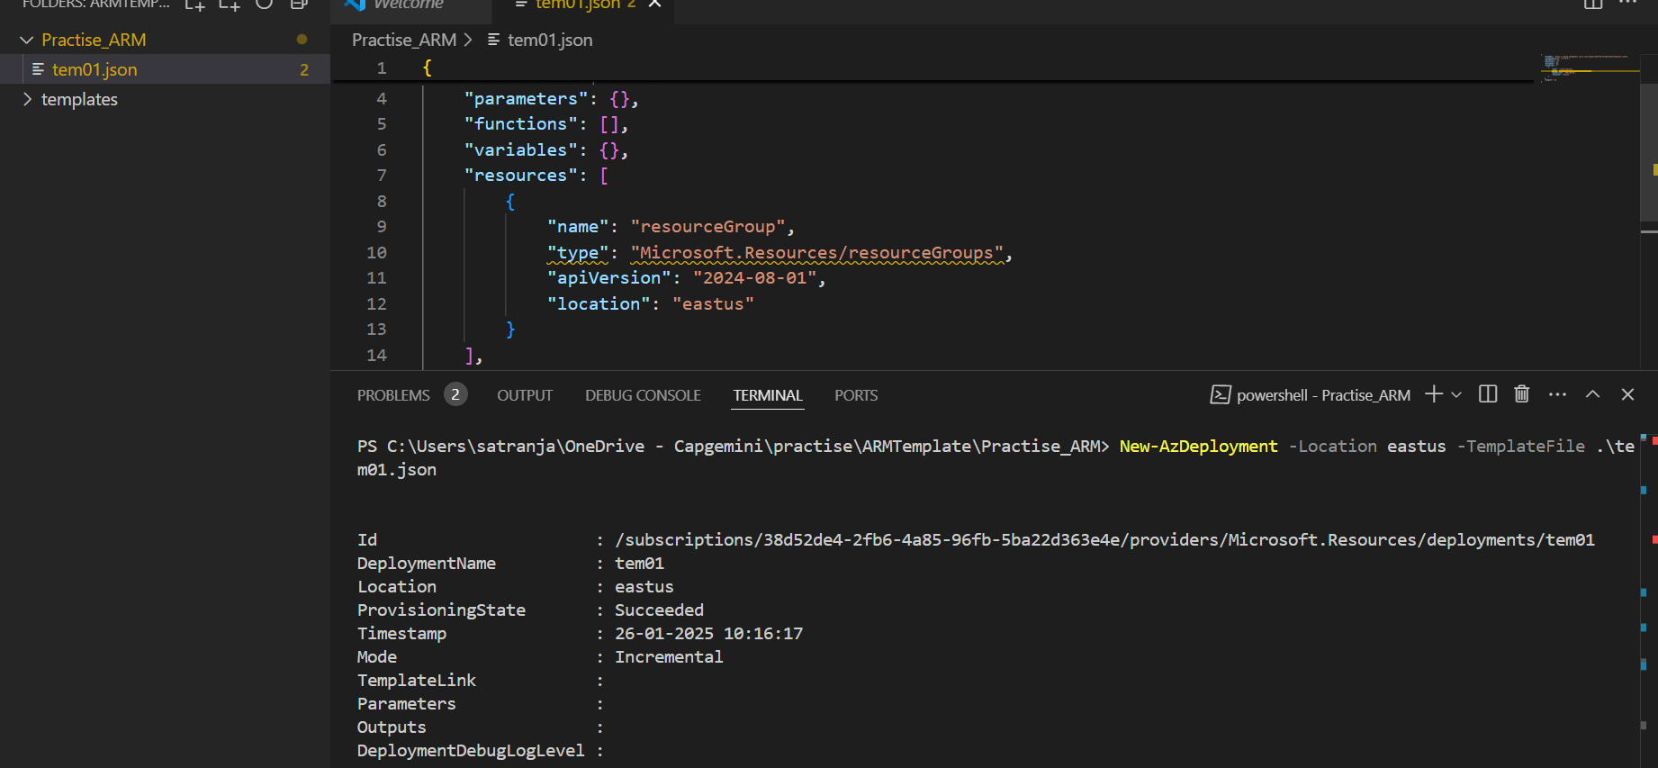

1. **Using Azure To deploy Storage Account using the ARM Template**

Step1: Login in Azure Portal and search All Resources

Step2: Create a new resources in All resources

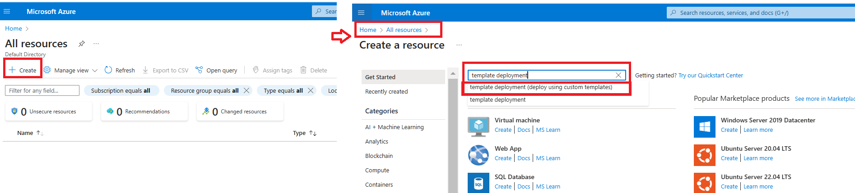

1. **Multiple Copies of a Resource using the ARM Template**

Step1: Write a JSON file for storage configuration that includes a copy parameter with a count of 3. For the name field, use indexing to generate unique names for each storage account.

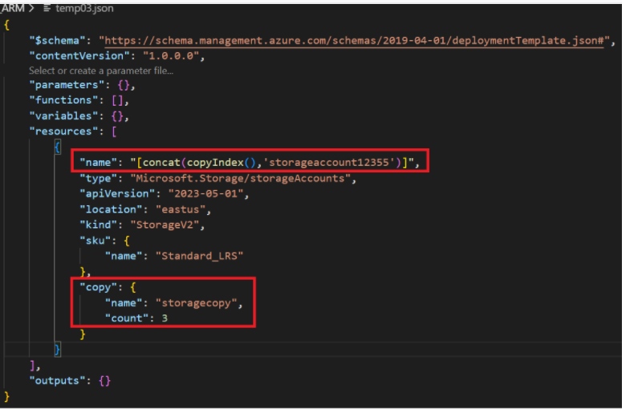

Step2: Write powershell command to create storage in existing resource group arp-grp

New-AzResourceGroupDeployment -ResourceGroupName satrg -TemplateFile ./temp03.json

New-AzResourceGroupDeployment PowerShell cmdlet is used to deploy resources to an Azure resource group from a template. It allows you to deploy infrastructure as code by applying an Azure Resource Manager (ARM) template to a specific resource group.

You would use this cmdlet when you want to:

1. **Deploy resources** like virtual machines, storage accounts, networks, etc., to a resource group using an ARM template.
2. **Automate deployments**: It helps automate infrastructure provisioning by running predefined templates, making deployments repeatable and consistent.
3. **Parameterize deployments**: You can pass parameters to the template during deployment to customize resource configurations.
4. **Update existing resources**: If you need to modify the resources in a resource group based on updated template definitions, this cmdlet will apply those changes.
5. **Virtual Network Creation in using the ARM Template in existing resource group**

Step1: Write a JSON file for Vnet

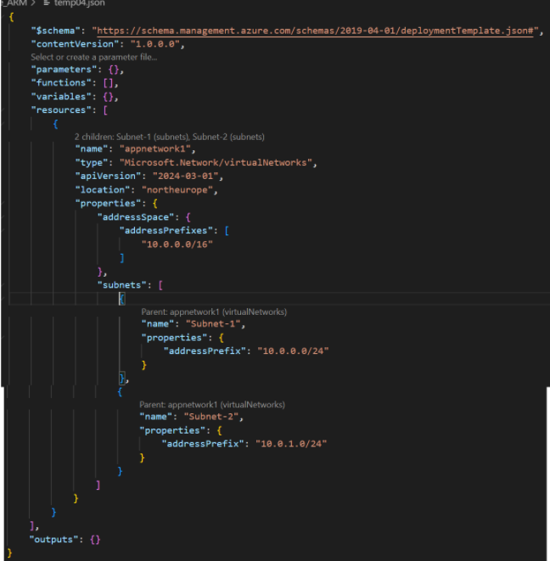

Step2: Write powershell command to create vnet in existing resource group arp-grp

New-AzResourceGroupDeployment -ResourceGroupName satrg -TemplateFile ./temp04.json

1. **Public IP Creation in using the ARM Template in existing resource group**

Step1: Write a JSON file for Public IP

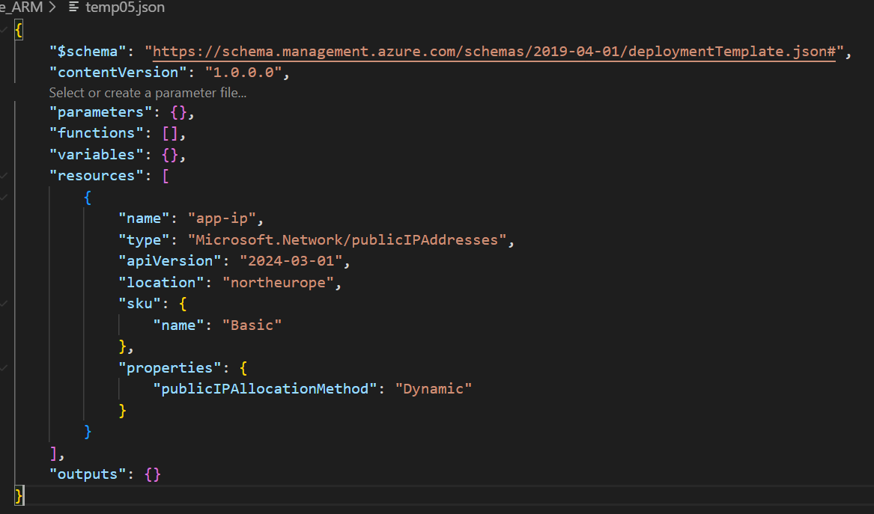

Step2: Write powershell command to create PublicIP in existing resource group arp-grp

New-AzResourceGroupDeployment -ResourceGroupName satrg -TemplateFile ./temp05.json

1. **Network Interface Creation in using the ARM Template in existing Virtual Network**

Step1: Write a JSON file for Network Interface

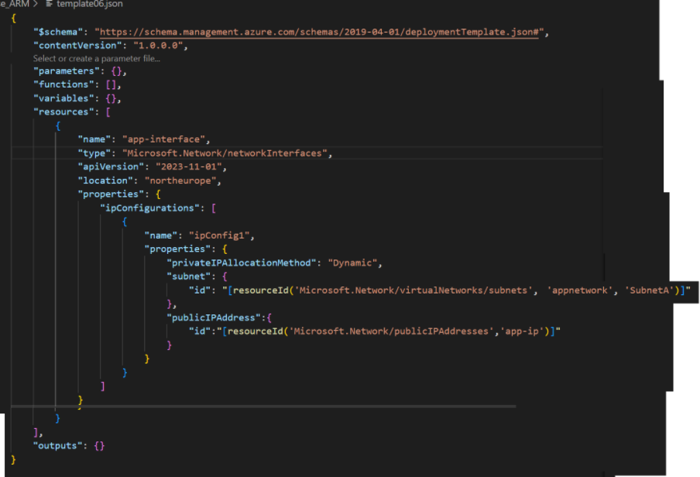

Step2: Write powershell command to create Network Interface in existing resource group arp-grp

New-AzResourceGroupDeployment -ResourceGroupName satrg -TemplateFile ./template06.json

1. **Network Interface Creation in using the ARM Template in new Virtual Network or Multiple Resource Creation**

Step1: Write a JSON file for Network Interface creation or Multiple Resource Creation

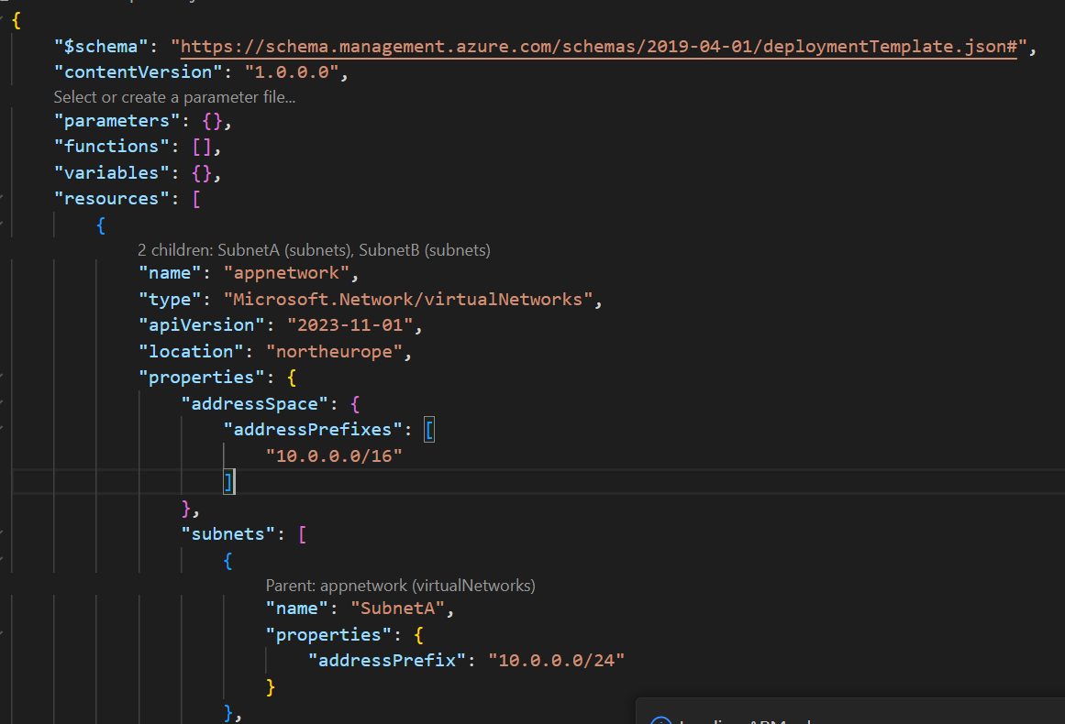

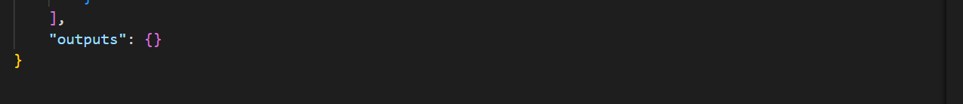

Step2: Write powershell command to create multiple resources like vnet, subnet, Network Interface in existing resource group arp-grp

New-AzResourceGroupDeployment -ResourceGroupName satrg -TemplateFile ./template07.json

1. **Use resourceGroup().location to reference the location (region) of the resource group where the resources are being deployed.**

Step1: In an ARM (Azure Resource Manager) template, you can use resourceGroup().location to reference the location (region) of the resource group where the resources are being deployed.

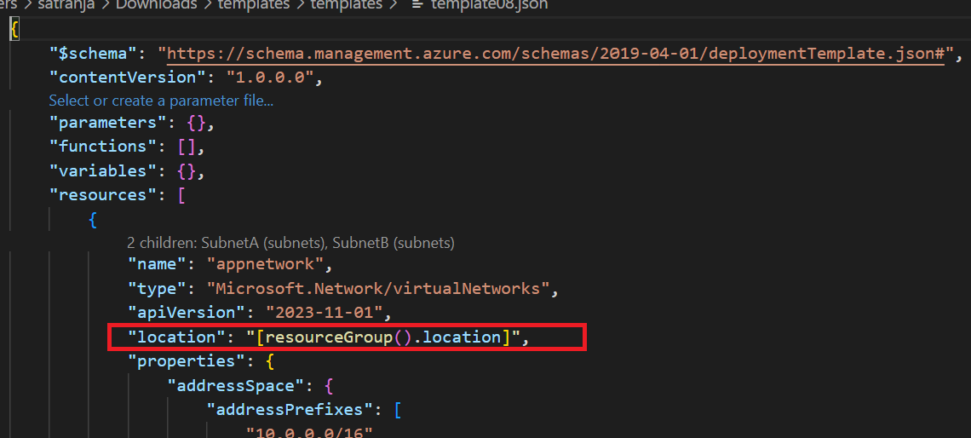

Step2: Write powershell command to create multiple resources like vnet, subnet, Network Interface in existing resource group arp-grp

New-AzResourceGroupDeployment -ResourceGroupName satrg -TemplateFile ./template08.json

1. **Define Variables in an ARM Template**

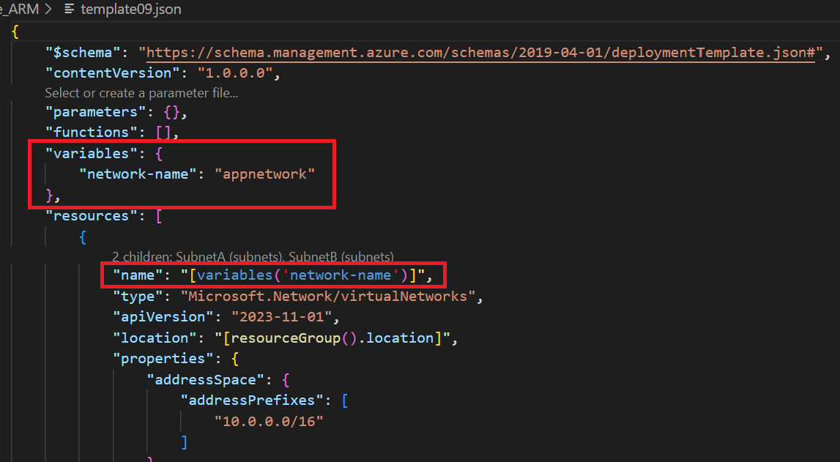

1. **Define Parameter in an ARM Template using Azure portal**

Step1: In an ARM (Azure Resource Manager) template, we can parameterize resource location and use in place of location

Step2: Login in Azure Portal and search All Resources

Step3: Create a new resources in All resources

1. **Define Parameter in an ARM Template using Powershell CLI**

Step1: Create two separate JSON files—one for the resource template and another for the parameters. In parameter json, specify the values that need to be set at the appropriate locations.

Step2: Run below command to pass runtime value using powershell command:

New-AzResourceGroupDeployment -ResourceGroupName satrg -TemplateFile ./template10.json -TemplateParameterFile .\template10.parameters

1. **Create a NSG using ARM Template using Powershell CLI**

Step1: Write a JSON file for NSG

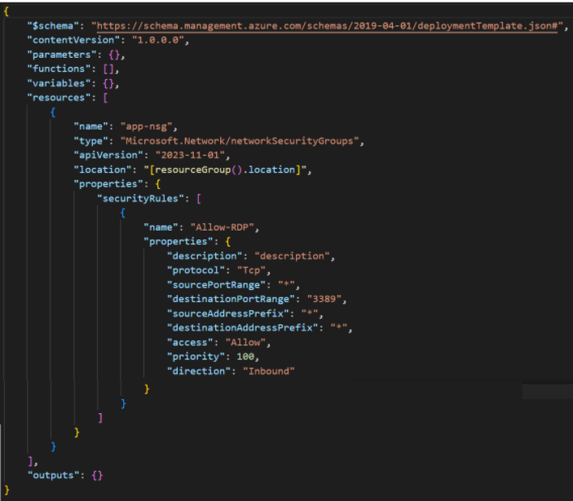

Step2: Run Below Command

New-AzResourceGroupDeployment -ResourceGroupName satrg -TemplateFile ./template11.json

1. **Create a Window Virtual Machine by ARM Template using Powershell CLI**

In Resource section need to write code of below resources

* 1. Vnet
  2. Subnet
  3. Public IP Address
  4. Network Interface
  5. NSG
  6. Storage Account
  7. VM

