**Azure VM creation with Bastion, Load Balancer and app-Gateway creation Step**

**Prerequisite to create Bastion**

1. **Need One Resource Group**
2. **Need One Virtual Network**
3. **Need Two subnet in same Virtual Network**
   1. **One Subnet is for two VM with name “BackendSubnet1” and “BackendSubnet2”**
   2. **One Subnet is for one AzureBastionSubnet with name “AzureBastionSubnet”**
4. **Need to create 2 VNIC for 2 Virtual machine with name “BackendVMNIC1” and “BackendVMNIC2”**
5. **Need to Create 2 VM with name “BackendVM1” and “BackendVM2”**
6. **Need to create one Public IP for Bastion.**
7. **Need to create on more public IP for LoadBalancer**
8. **Write terraform code for these specification**

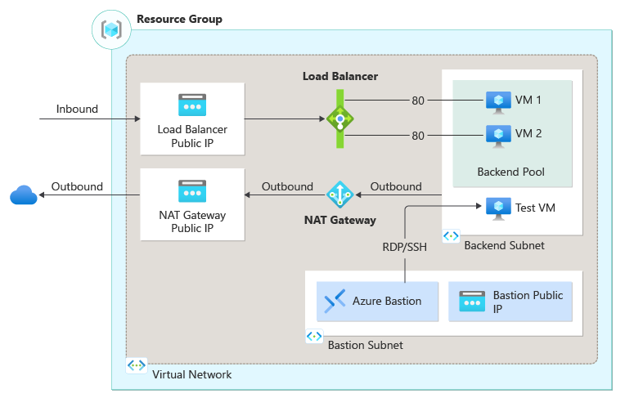

**Step1 : Create Infrastructure in Azure cloud for Bastion with two vm and bastion.**

**Step2 : Login in azure portal and login in both BackendVM1 and BackendVM2 VM through Bastion and run below command from portal:**

1. **Sudo apt update**
2. **Sudo apt install nginx**
3. **Cd /var/www/html**
4. **Vi index.html (Write VM1 in index.html and VM2 in index.html)**

**Step3: Go to each VM 🡪 Networking 🡪 add inbound rule for port 80 (used for http)**

**Step4: Create Load Balancer**

1. **Need to create Public Load balancer which will use to balance load over internet**

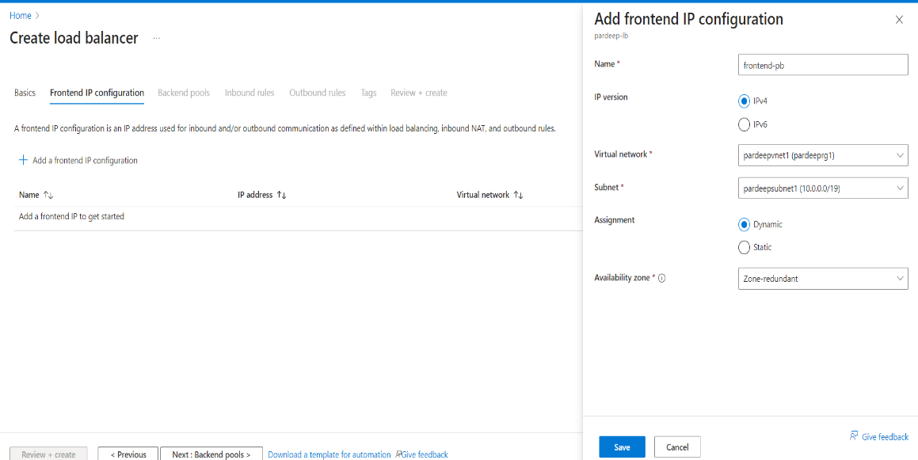

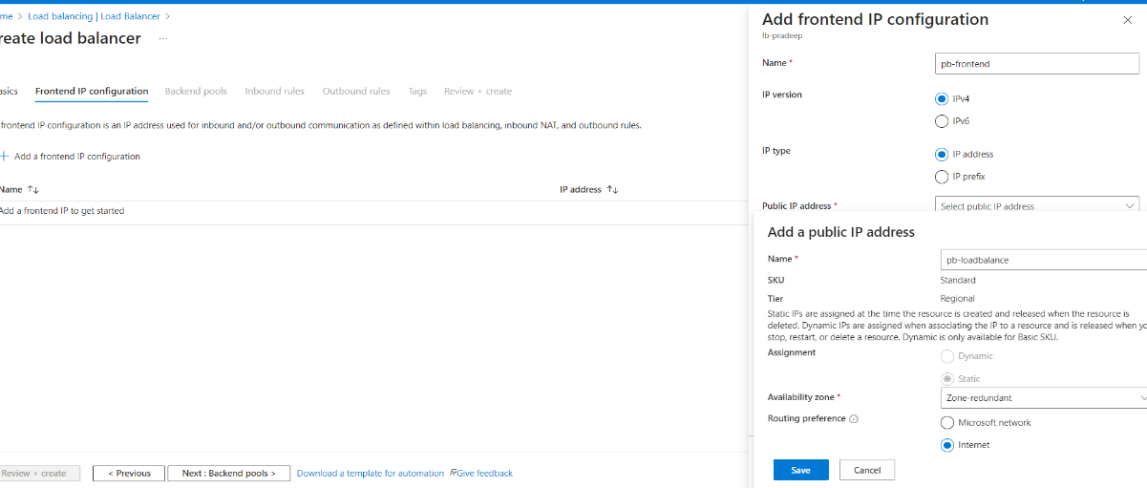

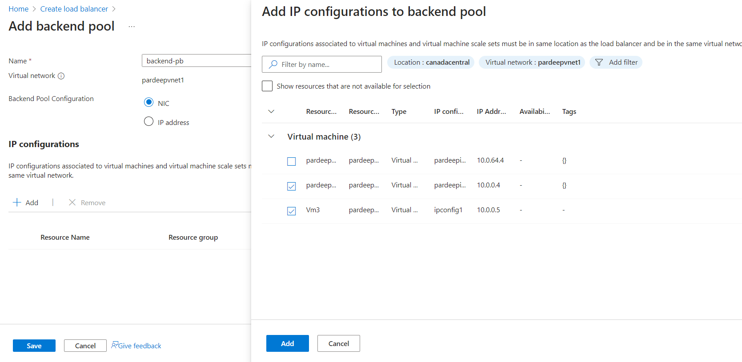

1. **Need to use load balancer public IP with port 80 and use in browser now we can show how load will distributed in both VM.**

**Document Link :** [**https://learn.microsoft.com/en-us/azure/load-balancer/quickstart-load-balancer-standard-public-portal**](https://learn.microsoft.com/en-us/azure/load-balancer/quickstart-load-balancer-standard-public-portal)

**Prerequisite to create AppGateway**

1. **Need One Resource Group**
2. **Need One Virtual Network**
3. **Need Three subnet in same Virtual Network**
   1. **One Subnet is for two VM with name “BackendSubnet1” and “BackendSubnet2”**
   2. **One Subnet is for one AzureBastionSubnet with name “AzureBastionSubnet”**
   3. **One Subnet is for App Gateway**
4. **Need to create 2 VNIC for 2 Virtual machine with name “BackendVMNIC1” and “BackendVMNIC2”**
5. **Need to Create 2 VM with name “BackendVM1” and “BackendVM2”**
6. **Need to create one Public IP for Bastion.**
7. **Need to create on more public IP for App Gateway**
8. **Write terraform code for these specification**

**Step 1 to Step 3 is same as above**

**Step4 : Now Create App Gateway**

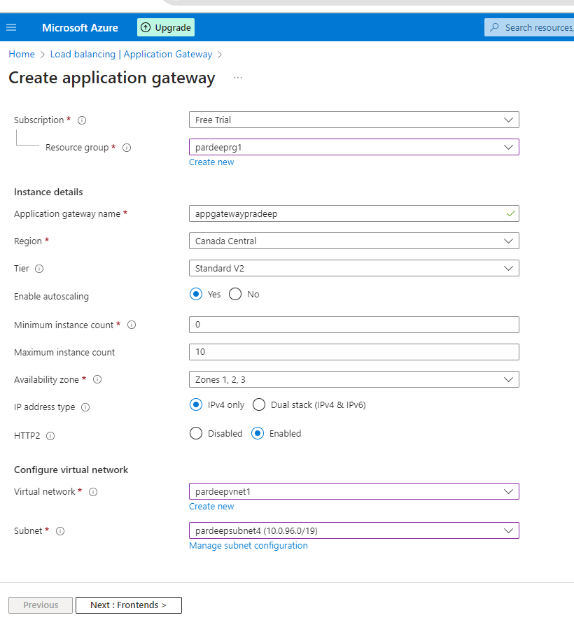

**Step5 : Update DNS Related Entry in Go daddy Site.**

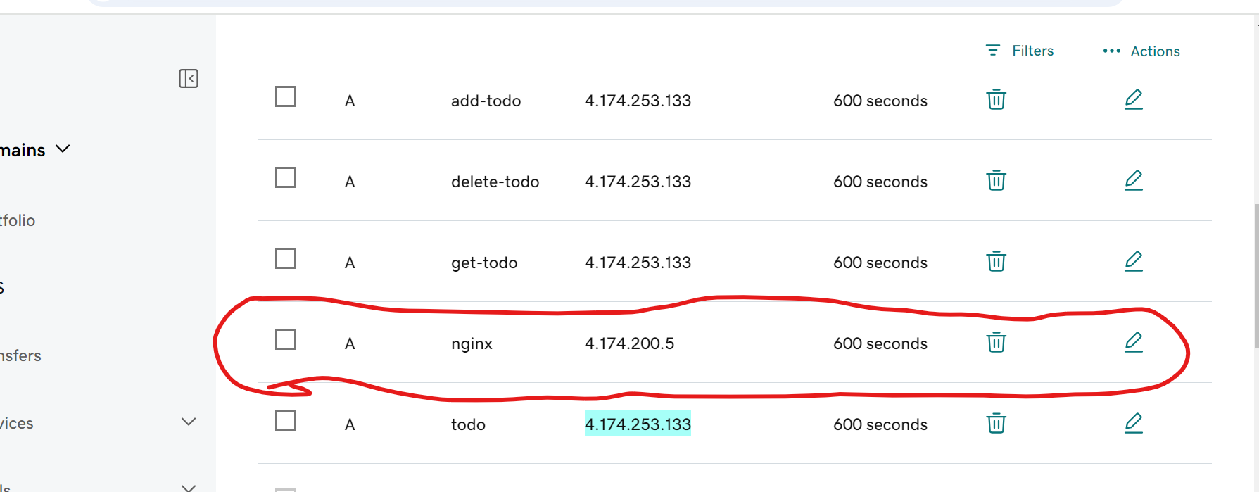

**Step6 : Wait some time, then check in browser :**

**https://nginx.satishonline.com**

**Document Link :** [**https://learn.microsoft.com/en-us/azure/web-application-firewall/ag/application-gateway-web-application-firewall-portal**](https://learn.microsoft.com/en-us/azure/web-application-firewall/ag/application-gateway-web-application-firewall-portal)