**Azure VNET Peering**

**Step1: Create Vnet1(Frontend) and Vnet2(Backend) with different IP pool range.**

**Frontend**

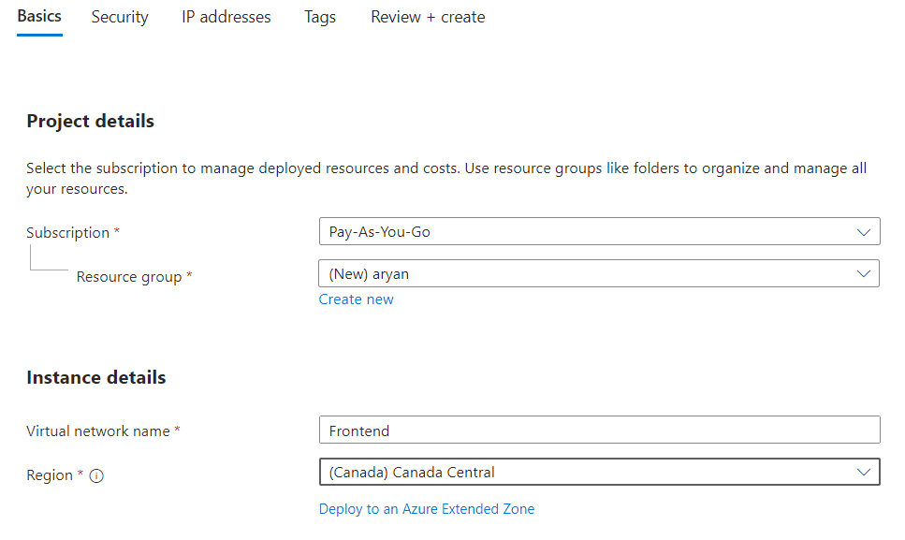

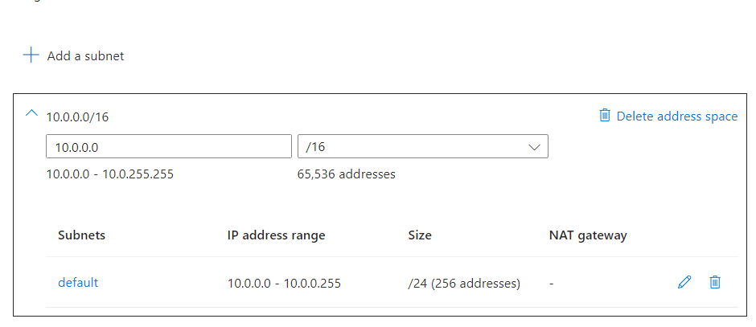

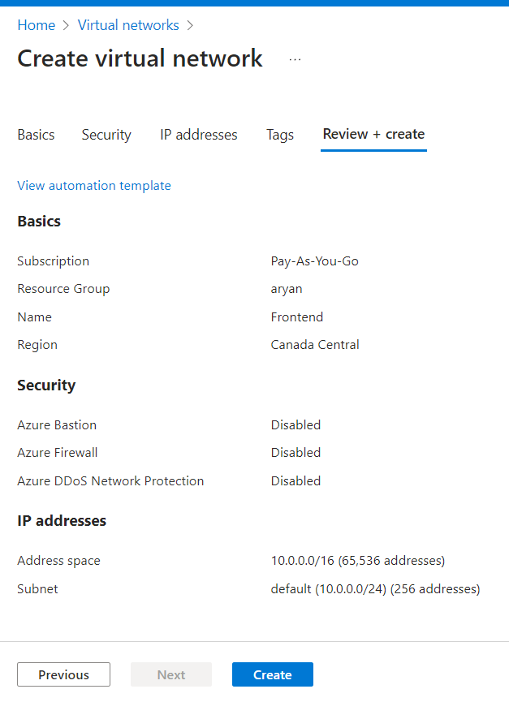

**Backend**

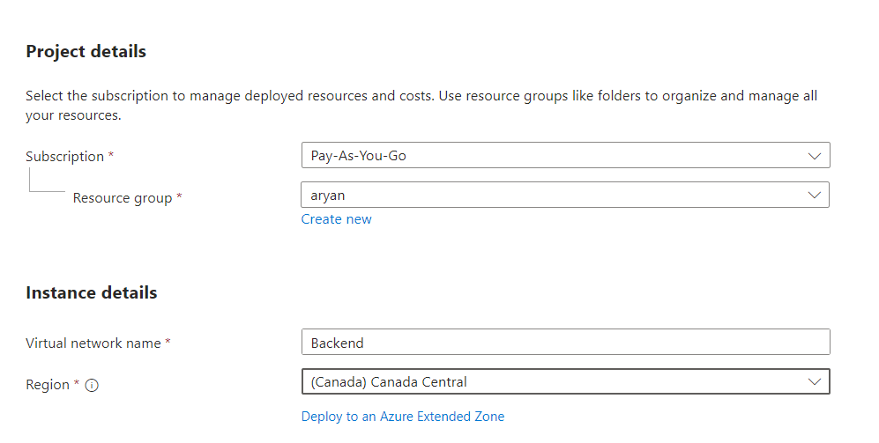

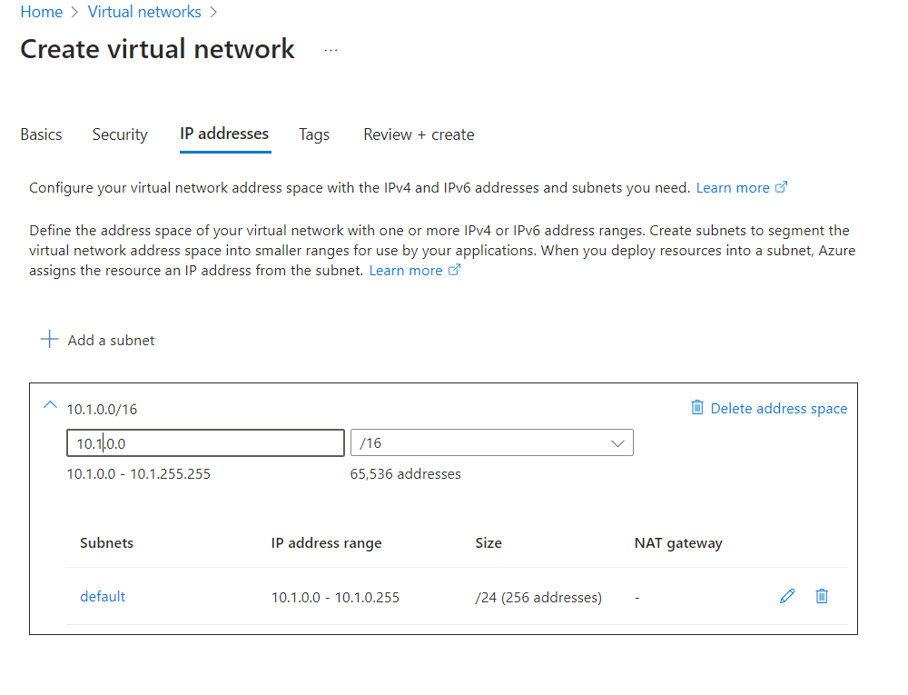

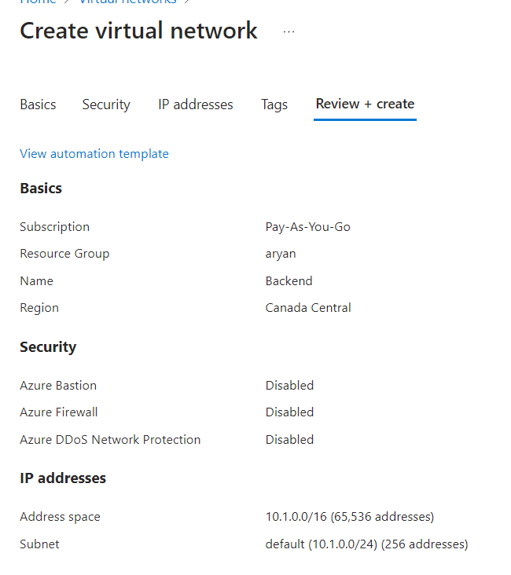

**Step2: Create virtual network peer, Go to Vnet🡪 click Frontend 🡪 click peering which is present at left side.**

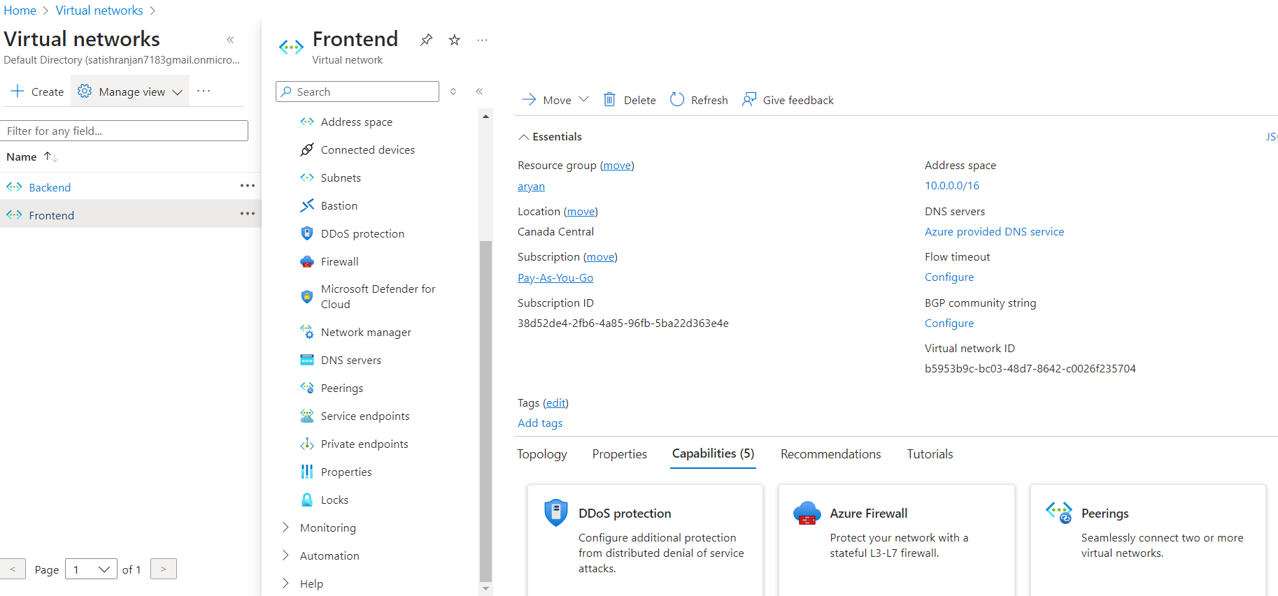

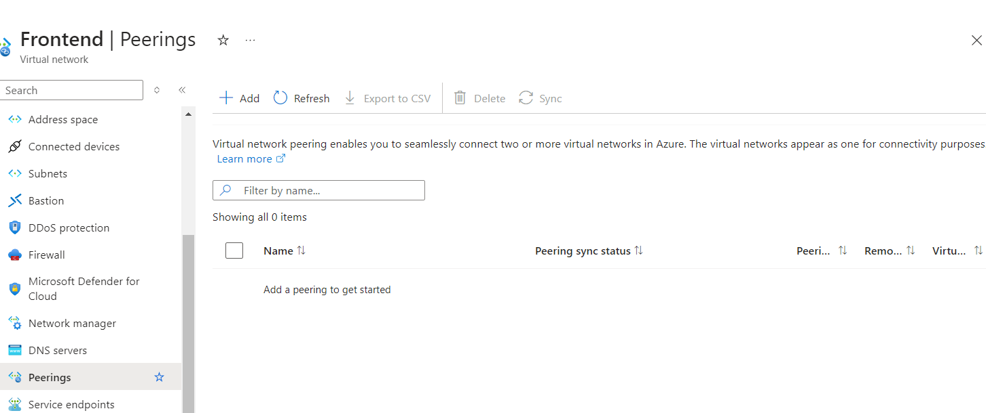

**Step3: Add Peering.**

**Details peering from remote (Vnet2_Backend) to local (Vnet1_Frontend)**

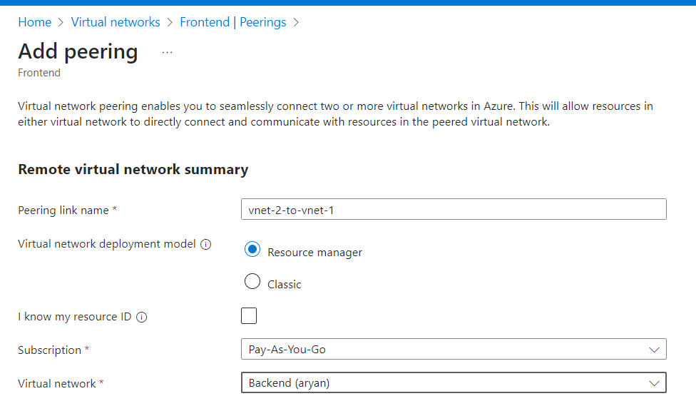

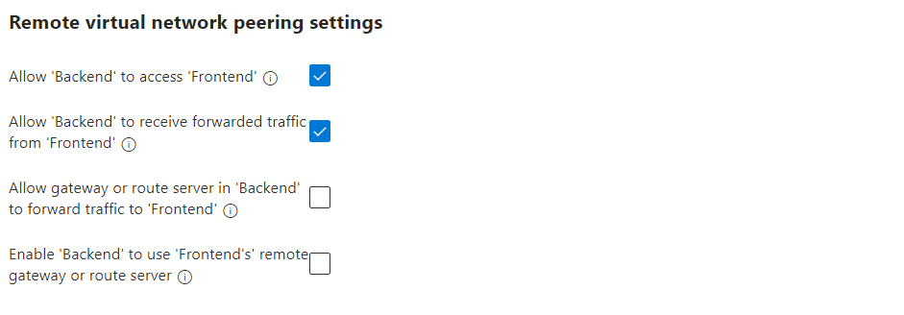

**Details peering from local (Vnet1_Fronted) to remote (Vnet2_Backend)**

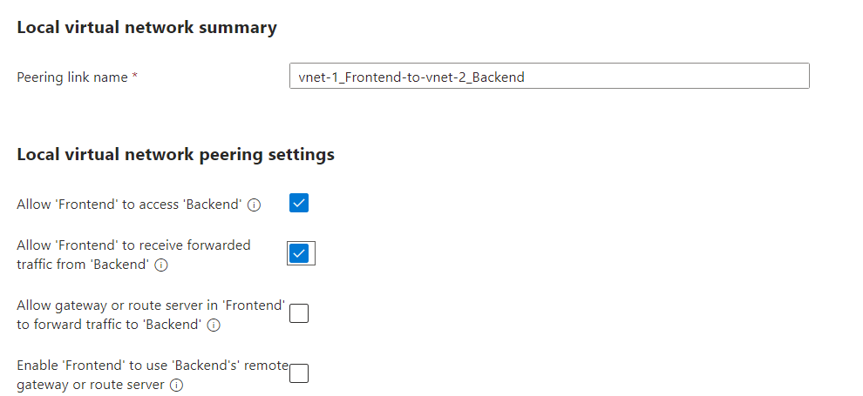

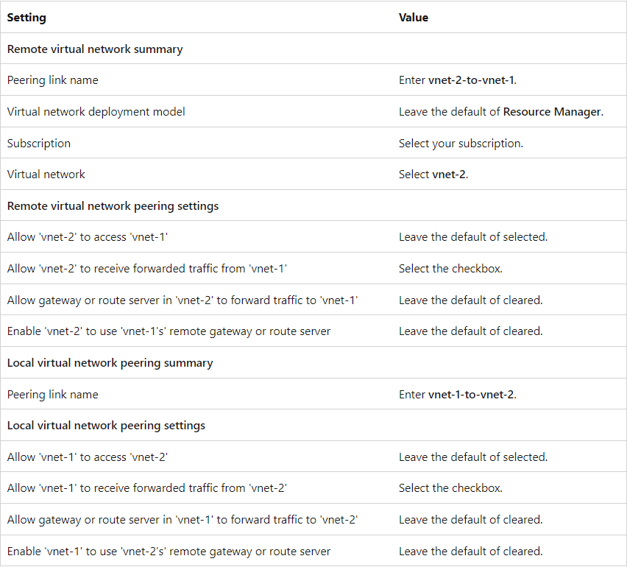

**Step4: Add Peering, now peering done**

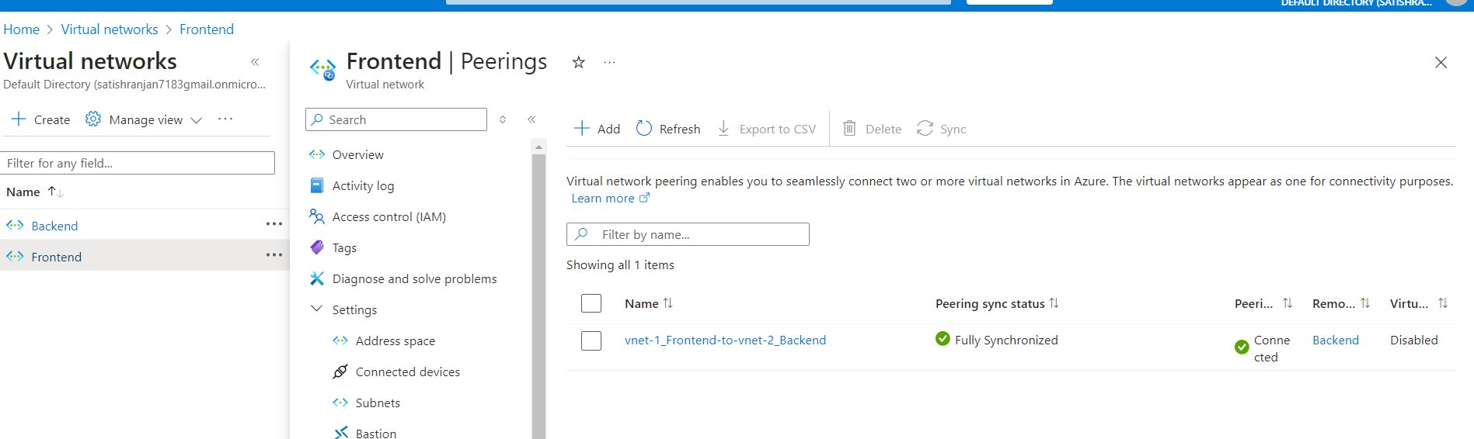

**Step5: If we want to check peering then need to create one-one vm in each vnet, then login in vm. Try to ping from one vnet to other, now we are able to ping.**