**Run Paraller pipeline at once**

**Step1 :** For parallelism, need to go to first organization setting on the left. Parallelism concept is available at organization level or company level.

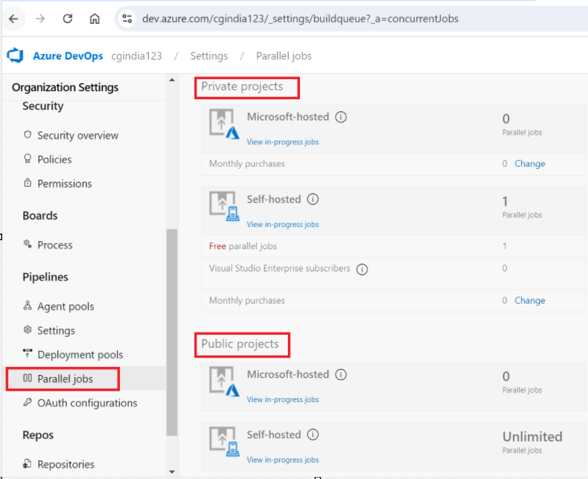

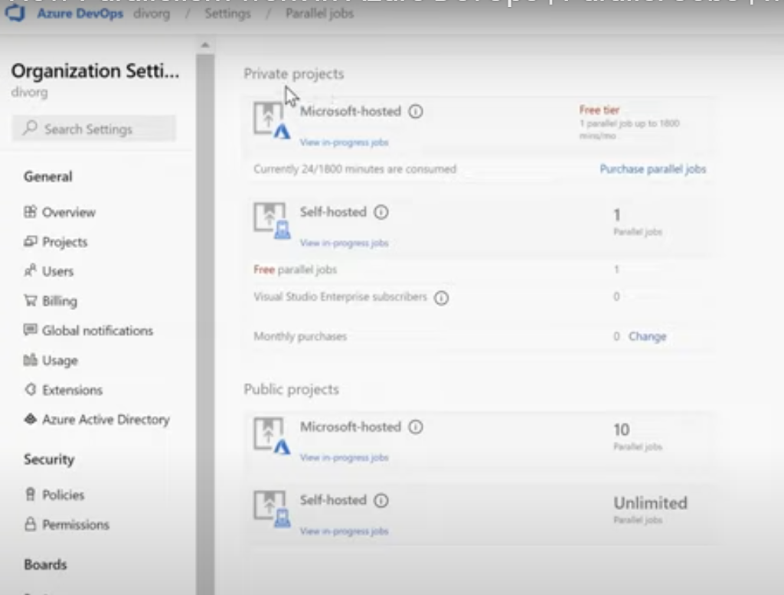

**Imp Note :**

1. **For private project only one pipeline can run at one time for Microsoft-hosted and self-hosted.**
2. **For Public Project we can run 10 parallel pipeline at same time for Microsoft-hosted and for self-hosted we can run Unlimited parallel pipeline.**

**Step2 :** If we want to achieve parallelism, then need to change private address to public address of any project and then check.

Select Project 🡪 Project Setting 🡪 Change visibility from private to public in Project details 🡪 then save it

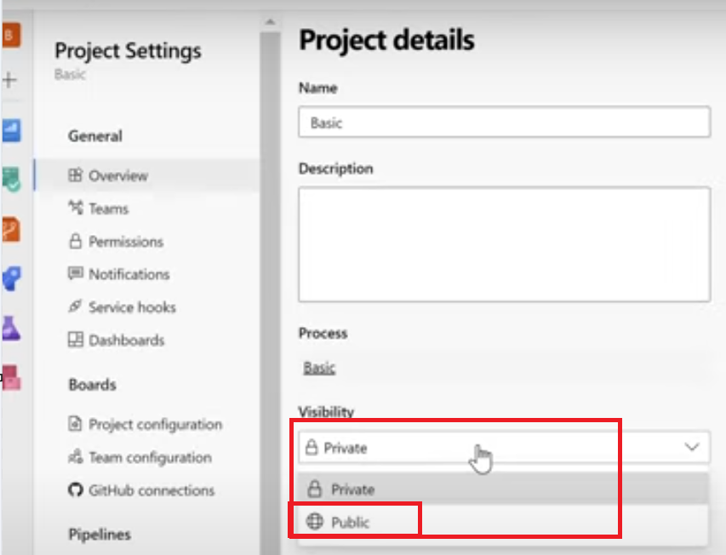

**Step3 :** Now we can run multiple pipeline in public project.

