**Scenario Based Question**

**1. As a devops Engineer, how will you automate all process?**

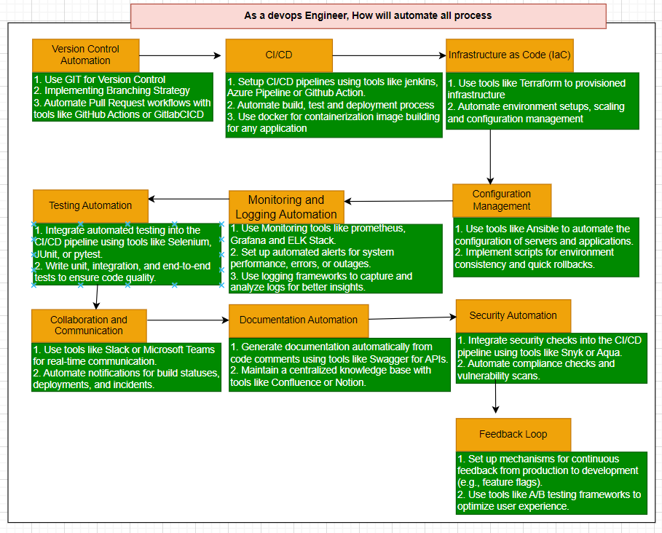**2. Can you describe any scenario where you can save cost for any project in azure devOps?**

Ans:

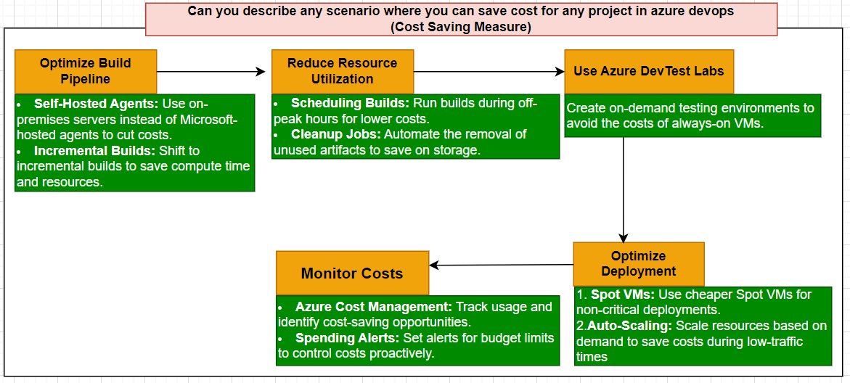

A company is using Azure DevOps for their CI/CD pipelines to deploy a web application. The initial setup uses multiple build agents and deployment slots, leading to high operational costs.

**Cost-Saving Measures**

1. **Optimize Build Pipeline**
   * **Self-Hosted Agents**: Instead of using Microsoft-hosted agents, the company sets up self-hosted agents on their existing on-premises servers. This can significantly reduce costs, especially if the workload is high and the number of builds is large.
   * **Incremental Builds**: Modify the build pipeline to use incremental builds instead of full builds. This reduces the compute time and resources used, resulting in lower costs.
2. **Reduce Resource Utilization**
   * **Scheduling Builds**: Schedule builds during off-peak hours to take advantage of lower compute resource costs, especially if the organization has a flexible work schedule.
   * **Cleanup Jobs**: Implement automated cleanup jobs to remove unused artifacts, old build logs, and test results. This reduces storage costs over time.
3. **Use Azure DevTest Labs**
   * For testing environments, utilize Azure DevTest Labs. This allows for the creation of environments on-demand, reducing the need for always-on VMs and saving costs on idle resources.
4. **Optimize Deployment Strategy**
   * **Spot VMs**: Use Azure Spot VMs for non-critical deployments. These VMs can be significantly cheaper than standard VMs, especially for workloads that can tolerate interruptions.
   * **Scale Down**: Implement auto-scaling for production environments to ensure that resources are only used when needed, reducing costs during low-traffic periods.
5. **Monitor and Analyze Costs**
   * **Azure Cost Management**: Utilize Azure Cost Management tools to monitor usage and identify areas where costs can be reduced. This can help in making data-driven decisions for resource allocation and budgeting.
   * **Alerts for Spending**: Set up alerts for budget thresholds to proactively manage costs.

**Outcome**

By implementing these cost-saving measures, the company reduces its Azure DevOps costs significantly, while still maintaining efficient CI/CD processes. Regular monitoring and adjustments based on usage patterns ensure ongoing cost optimization.

This scenario highlights the importance of resource management and optimization strategies in achieving cost efficiency in cloud environments.

**3. How do you ensure successful collaboration among team members in Azure Devops?**

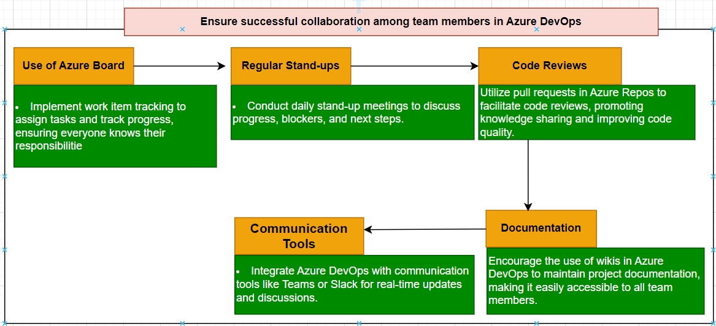

**4. How do you handle security and compliance in Azure DevOps?**

**5. How do you measure the success of a DevOps implementation?**

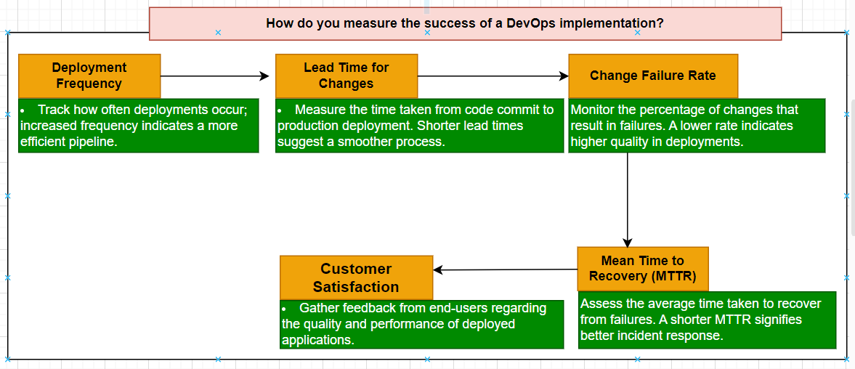

1. **How you would implement a CI/CD pipeline in Azure DevOps?**

