
CHANDIGARH UNIVERSITY
University Institute of Computing (UIC)
Master of Computer Applications (AI & ML)

A PROJECT REPORT

ON
SKILLBRIDGE – SKILL GAP ANALYZER
Skill Assessment, Gap Detection and Learning Recommendation Tool with an Interactive Web Dashboard
Submitted by

NANCY RAI
Enrollment No: 25MCI10364
In partial fulfillment for the award of the degree of Master of Computer Applications
Under the supervision of
Sanjeev Kumar (E20624)
Assistant Professor, UIC

OCTOBER 2026

ACKNOWLEDGEMENT

I deem it a pleasure to acknowledge my sense of gratitude to my project guide, Sanjeev Kumar (Assistant Professor, UIC), under whom I have carried out this project work. Her incisive and objective guidance and timely advice encouraged me with a constant flow of energy to continue the work.
I wish to reciprocate in full measure the kindness shown by the Head of the Department, University Institute of Computing, who inspired me with valuable suggestions in successfully completing the project work. I shall remain grateful to Dr. Manisha Malhotra, Additional Director, University Institute of Computing, for providing a strong academic atmosphere and for enforcing the discipline that allowed me to carry out the project work with utmost concentration and dedication.
I also acknowledge the open-source communities behind HTML, CSS, Bootstrap and JavaScript, whose documentation and tools made it possible to build and test every module of this project.
Finally, I must say that no height is ever achieved without some sacrifices made at some end, and it is here where I owe my special debt to my parents and my friends for showing their generous love and care throughout the entire period of time.
Date: 30.10.2026
Place: Chandigarh University, Mohali, Punjab
By:
Nancy Rai, UID – 25MCI10364
SIGNATURE | SIGNATURE
(Head of the Department) | (Assistant Professor) Sanjeev Kumar (E20624)

TABLE OF CONTENTS
Abstract 4
List of Figures and Tables 5
Chapter 1: Introduction 6
1.1 Identification of Need 6
1.2 Identification of Problem 6
1.3 Identification of Tasks 6
1.4 Timeline 7
1.5 Technologies Used 7
1.6 Organization of the Report 7
Chapter 2: Literature Review / Background Study 7
Chapter 3: Design Flow / Process 9
Chapter 4: Results Analysis and Validation 11
Chapter 5: Conclusion and Future Work 18
User Manual 18
References 19

ABSTRACT
SkillBridge – Skill Gap Analyzer is a web-based tool that compares a learner's current skills with the skills required for a chosen job role and shows, in numbers and visuals, what is missing. The user selects a target role, rates their own proficiency in each required skill, and the tool instantly calculates an overall match percentage, lists missing and weak skills, ranks them by the size of the gap, and suggests what to learn first.
The project is developed with HTML for structure, CSS and Bootstrap for a responsive interface, and JavaScript for all logic. It runs fully in the browser with no server, database or installation. The gap is calculated with a transparent formula: for each skill, the credited level is the smaller of the user's level and the required level, and the match percentage is the credited total divided by the required total. Results are displayed as progress bars, colourcoded skill cards and a prioritised learning list.
The project therefore works as a practical career-readiness tool for students and as a clear, verifiable example of a rule-based analyzer built only with core web technologies.

LIST OF FIGURES AND TABLES
Figures | Tables
Fig 1: Processing flow of SkillBridge | Table 1: Project timeline
Fig 2: Layered architecture | Table 2: Tools and technologies used
Fig 3: Flowchart of the analysis | Table 3: Comparison of existing solutions and the proposed system
Fig 4: Project folder structure | Table 4: Design option evaluation
Fig 5: Home and role selection screen | Table 5: Project components
Fig 6: Skill rating screen | Table 6: Sample role requirements
Fig 7: Gap analysis result | Table 7: Worked gap calculation
Fig 8: Learning recommendations | Table 8: Test cases
 | Table 9: Validation checks
 | Table 10: Possible future extensions

CHAPTER 1: INTRODUCTION
The job market changes faster than most course syllabi. Students often finish a degree without knowing which exact skills their dream role demands and how far their own skills are from it. A skill gap analysis answers this: it compares what a person has with what a role needs and points to the difference. SkillBridge turns this idea into a simple web tool. Fig 1 shows the flow it follows.
[Select Role] -> [Rate Skills 0-5] -> [Compare with Requirement]
-> [Calculate Match % and Gaps] -> [Rank and Recommend] -> [Result]

1.1 Identification of Need
Students and job seekers need a quick, honest way to measure their readiness for a role. The following needs were identified:
- A single tool that shows, for one chosen role, exactly which skills are strong, weak or missing.
- A numerical match score, so progress can be tracked and compared over time.
- A prioritised learning list, so effort goes to the biggest gaps first.
- A free, zero-installation interface that works on a phone or a laptop.

1.2 Identification of Problem
Existing career pages list required skills as plain text and leave the comparison to the reader. The main problems observed are:
- No immediate way to compare personal skills with role requirements.
- Skill lists do not say how deep each skill must be (basic or advanced).
- Self-assessment is vague without a score or a visual result.
- Many online assessment tools need sign-up, a server or payment.
Problem statement: to design and build a browser-based skill gap analyzer that takes a target role and the user's self-rated skills, calculates the gap using a clear formula, and presents the result with visuals and learning priorities.

1.3 Identification of Tasks
To solve the problem the following tasks were identified:
- Study job roles and prepare a skill-requirement dataset with required levels.
- Design the user interface wireframes (home, role selection, skill rating, result).
- Build the responsive layout with HTML and Bootstrap.
- Style the interface with custom CSS.
- Implement role selection and skill rating in JavaScript.
- Implement the gap calculation, match percentage and priority ranking.
- Display results with progress bars, colour-coded cards and recommendations.
- Test every feature, record outputs, and analyse the results.

1.4 Timeline
The project was carried out in six phases, summarised in Table 1.

Phase | Description | Duration
Phase 1 | Requirement analysis and study of job-role skills | Week 1
Phase 2 | UI design and wireframes | Week 2
Phase 3 | HTML structure and Bootstrap layout | Week 3
Phase 4 | JavaScript logic: role data, gap calculation | Week 4
Phase 5 | Results display, recommendations and styling | Week 5
Phase 6 | Testing, result analysis and report writing | Week 6

1.5 Technologies Used

Tool / Technology | Purpose
HTML5 | Page structure: forms, sections, result containers
CSS3 | Custom styling, colours, animations, responsive tweaks
Bootstrap 5 | Grid layout, cards, buttons, progress bars, navbar
JavaScript (ES6) | Role data, user input handling, gap logic, DOM updates
VS Code | Code editor
Web browser | Runtime and testing (Chrome, Edge, Firefox)

1.6 Organization of the Report
Chapter 1 gives the background, need, problem and tasks. Chapter 2 reviews existing tools and the research gap. Chapter 3 describes features, constraints, architecture, methodology and data. Chapter 4 presents the implementation, screenshots, results and validation. Chapter 5 concludes the report and lists future work, followed by the User Manual and References.

CHAPTER 2: LITERATURE REVIEW / BACKGROUND STUDY

2.1 Timeline of the Reported Problem
- 1909: Frank Parsons, in , described career guidance as matching a person's abilities with the requirements of an occupation. This matching idea is the base of every skill gap tool.
- 1959: John Holland's theory of vocational choice linked personality types to work environments and later grew into the RIASEC model.
- 1990s: Large occupation databases such as O NET (US Department of Labor) began listing skills and knowledge areas for each occupation in a structured way.
∗

2000: The Skills Framework for the Information Age (SFIA) defined levels of responsibility and skill for IT professionals, showing that skills must be described with levels, not only names.
- 2011: Bootstrap was released as an open-source front-end framework, making responsive web interfaces quick to build for small projects.
- Today: Job portals and learning platforms offer skill tests, but most are closed, need an account, or hide how the score is produced. This project addresses that gap.

2.2 Existing Solutions
Job portals and career sites. They list the skills a role needs, but the comparison with the user's own skills is left to the reader and no gap score is shown.
Online learning platforms. They offer skill assessments tied to their own courses. The result is useful but linked to one provider and often needs a login or payment.
Occupation databases (such as O NET). They give detailed skill data per occupation, but the data is meant for researchers and counsellors, not for an instant personal comparison.
∗
Spreadsheets and manual checklists. Flexible and free, but they need manual formulas and give no visual result.

2.3 Comparative Analysis
Table 3 compares the proposed system with the existing categories. The comparison is qualitative and reflects typical use of each category.

Parameter | Job portals | Learning platforms | Spreadsheets / checklists | SkillBridge (proposed)
Compares user skills with role | No | Partial | Manual | Yes
Match percentage | No | Sometimes | Manual formula | Yes
Shows level-wise gap | No | Limited | Manual | Yes
Prioritised learning list | No | Own courses only | No | Yes
Login or installation  needed | Often | Yes | No | No
Cost | Free | Free / paid | Free | Free
Visual result | No | Yes | Limited | Yes

2.4 Review Summary
The review shows that the idea of matching skills to roles is old and well accepted, and that large platforms exist. What is missing is a light, free and transparent tool that a student can open instantly. The proposed system improves on the existing options by:
- Comparing skills against a role at the level of each skill, not only by name.
- Using a simple formula that the user can verify by hand.
Showing the result as a score, visual bars and a ranked to-do list.
- Running in any browser with no account, server or database.

2.5 Problem Definition
Students need a quick, transparent way to measure readiness for a target role, but existing tools leave the comparison to the user or hide the calculation. A system is therefore required that lets the user choose a role, records skill levels, calculates the gap with a clear formula, and presents the result and a learning order.

2.6 Goals / Objectives
Primary objectives
- To build a skill gap analyzer for multiple job roles using HTML, CSS, Bootstrap and JavaScript.
- To calculate an overall match percentage and a per-skill gap from user ratings.
- To list missing and weak skills in priority order.
Secondary objectives
- To give a learning recommendation for each gap.
- To keep the interface responsive on mobile, tablet and desktop.
Measurable outcomes
- Calculated match percentage that agrees with a hand calculation for every test case.
- Result shown after one click with no page reload, and layout usable at phone width.

CHAPTER 3: DESIGN FLOW / PROCESS

3.1 Evaluation and Selection of Features
Based on the identified needs, the following features were selected:
- Role selection: a set of job roles, each with its own list of required skills and required levels.
- Skill rating: the user rates each required skill on a 0–5 scale (0 = none, 1 = beginner, 2 = basic, 3 = intermediate, 4 = advanced, 5 = expert).
- Gap analysis: per-skill comparison, overall match percentage, and a status for every skill (Strong, Weak or Missing).
- Prioritisation: skills ranked by size of gap, so the biggest gaps are shown first.
- Recommendations: a short learning suggestion for each weak or missing skill.
- Responsive dashboard: Bootstrap cards, progress bars and colour coding that work on mobile and desktop.

3.2 Design Constraints
- Technical: only HTML, CSS, Bootstrap and JavaScript; the tool must run from a plain HTML file in any modern browser, with no server or build step.
Data: the role dataset is small and hand-prepared; skill levels are self-rated, so results depend on honest input.
- Economic and performance: only free tools; the result must appear instantly because all processing happens in the browser.
- Usability: a first-time user must be able to finish an analysis in under two minutes without instructions.

3.3 Design Flow and Selection
The system follows a three-layer architecture (Fig 2). The presentation layer is the Bootstrap and CSS interface. The logic layer is JavaScript: it reads the form, runs the gap calculation and builds the result. The data layer holds the role and skill requirements as a JavaScript object.
+--------------------------------------------------+
| PRESENTATION LAYER (Browser) |
| index.html (structure) style.css (custom) |
| Bootstrap 5 (grid, cards, progress bars) |
+--------------------------------------------------+ | user input / results
+--------------------------------------------------+
| LOGIC LAYER (JavaScript - script.js) |
| role loader | rating reader | gap calculator |
| priority ranking | recommendation builder | +--------------------------------------------------+
| reads
+--------------------------------------------------+
| DATA LAYER |
| roles object: role -> skills -> required level |
| recommendation text for each skill |
+--------------------------------------------------+

Design selection – browser-only versus server-based. Two design options were considered: (a) a server-based system with a database and login, and (b) a browser-only system with the data inside the script. Option (b) was selected, as summarised in Table 4.

Parameter | Server-based | Browser-only (selected)
Setup effort | High | None
Works offline | No | Yes
Hosting cost | Needed | Free
Saving user history | Possible | Not in this version
Suitable for a college project | Medium | High

3.4 Implementation Methodology
The implementation follows these steps, which are also the processing order of the tool (flowchart in Fig 3):
- Input: the user chooses a role. If no role is chosen, a message asks for one.
- Load skills: the required skills of that role are shown as rating controls.

- Rating: the user rates each skill from 0 to 5.
- Validation: every skill must have a rating; empty or out-of-range values are rejected.
- Credit: for each skill, credited level = smaller of user level and required level.
- Match score: the credited total is divided by the required total and shown as a percentage.
- Gap and status: gap = required level minus user level (if positive). Level equal or above required is Strong; between 1 and required minus 1 is Weak; 0 is Missing.
- Ranking and display: skills are sorted by gap, results and recommendations are rendered on the page.
[Start] -> [Choose role] -> {Role chosen?} --No--> [Show message] -> back
|Yes v
[Show skills] -> [User rates 0-5] -> {All valid?} --No--> [Show message]
|Yes v
[Credit = min(user, required)] -> [Match %] -> [Gap + status]
| v
[Rank by gap] -> [Render result + recommendations] -> [End]
The
formulas used are:

Here u is the user's level and r is the required level for skill i, out of n skills.

3.5 Data Used
The tool uses a role dataset prepared by the developer, with several popular IT roles. Each role has a list of skills, and each skill has a required level (1–5) and a short learning recommendation. Sample requirements are listed in Table 6 in Chapter 4. All data is stored inside the JavaScript file, so no external file or network request is needed.

CHAPTER 4: RESULTS ANALYSIS AND VALIDATION

4.1 Implementation of Solution
The solution is implemented as a static web application made of three main files. The files are independent of any server: opening index.html is enough to run the tool. Table 5 gives the role of each component.

File | Role
index.html | Page structure: navbar, hero section, role selector, skill rating form, result section
style.css | Custom colours, card and progress-bar styling, animations, mobile adjustments
script.js | Role and skill data, input validation, gap calculation, ranking, result rendering
Bootstrap 5 (CDN) | Grid system, cards, buttons, form controls, progress bars
Role data. Each role is stored as a list of skills with a required level. Table 6 shows sample entries.

Role | Skills and required level
Web Developer | HTML 4, CSS 4, JavaScript 4, Bootstrap 3, Git 3
Data Analyst | Excel 4, SQL 4, Python 3, Statistics 3, Data Visualisation 3
UI/UX Designer | Wireframing 4, Prototyping 4, Colour and Typography 3, User Research 3
Software Tester | Test Cases 4, Manual Testing 4, Bug Reporting 3, Automation Basics 3
Gap calculation. For every skill the script takes the smaller of the user's level and the required level, sums these credited values, and divides by the sum of required levels. A user cannot score extra by rating above the requirement, so a strong skill does not hide a weak one.
Result display. The script builds one Bootstrap card per skill with a progress bar, a colourcoded status (green for Strong, amber for Weak, red for Missing) and a recommendation, then shows the overall match percentage at the top.
Folder structure. The project layout is shown in Fig 4.
SkillBridge/
|-- index.html
|-- css/
| `-- style.css
|-- js/
| `-- script.js
|-- images/
`-- README.md

4.2 System Outputs (Screenshots)
The screenshots below are to be captured from the running application (index.html) using the Web Developer role. Fig 5 to Fig 8 show the screens in order of use.


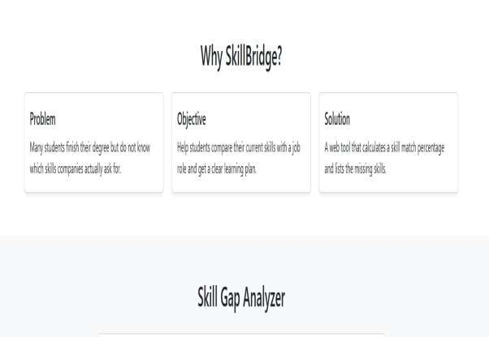
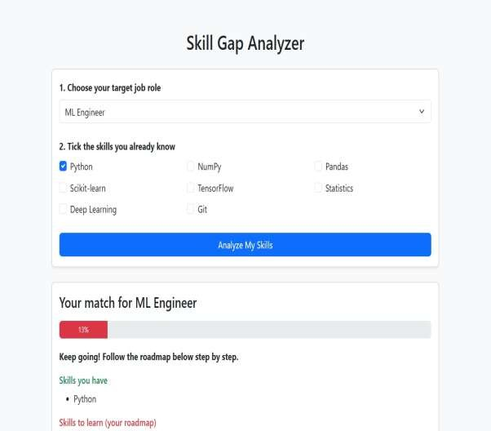

[
Paste screenshot here
]

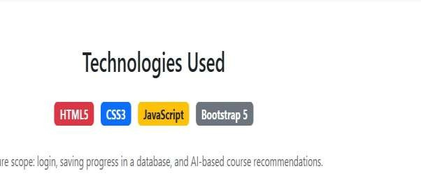

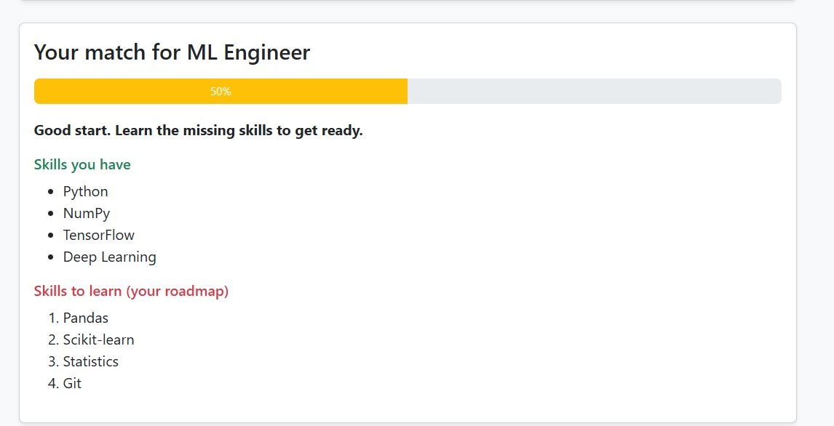

4.3 Results Analysis
- Worked example. For the Web Developer role the total required level is 4 + 4 + 4 + 3 + 3 = 18. A user rated HTML 4, CSS 3, JavaScript 2, Bootstrap 3 and Git 0. Table 7 shows the calculation.

Skill | Required | User | Credited |  | Gap | Status
HTML | 4 | 4 | 4 | 0 |  | Strong
CSS | 4 | 3 | 3 | 1 |  | Weak
JavaScript | 4 | 2 | 2 | 2 |  | Weak
Bootstrap | 3 | 3 | 3 | 0 |  | Strong
Git | 3 | 0 | 0 | 3 |  | Missing
Total | 18 |  | 12
The match percentage is 12 / 18 × 100 = 66.67%. Ranked by gap, the learning order is Git (gap 3), JavaScript (gap 2) and CSS (gap 1). Strong skills need no action.
- Test cases. Table 8 lists the cases used to test the tool, with the behaviour expected from the design.

No. | Test case | Expected behaviour
T1 | Every rating equals the required level | Match 100%, all skills Strong
T2 | Every rating is 0 | Match 0%, all skills Missing
T3 | A rating above the requirement (HTML 5, required 4) | Credit capped at 4, no bonus
T4 | Analyse pressed with no role chosen | Message asks the user to choose a role
T5 | Worked example of Table 7 | Match 66.67%, order Git, JavaScript, CSS
T6 | Open the page at phone width | Cards stack in one column, no horizontal scroll
- Observation. Because credit is capped at the required level, the score reflects readiness for the role rather than total skill. Because the percentage is weighted by required level, a gap in a highly required skill lowers the score more than a gap in a lightly required one. The ranked list lets the user act on the largest gap first.

4.4 Validation
The calculation was checked against hand-computed values (Table 9). Each expected value follows directly from the formula in Section 3.4, so the logic can be verified by anyone with a calculator.

Check | Expected (hand-calculated)
Sum of required levels, Web Developer | 4 + 4 + 4 + 3 + 3 = 18
Sum of credited levels for the worked example | 4 + 3 + 2 + 3 + 0 = 12
Match percentage for the worked example | 12 / 18 = 0.6667, shown as 66.67%
Credit when user level is above required (5 vs 4) | min(5, 4) = 4
Gap for Git (required 3, user 0) | 3 − 0 = 3, ranked first
All ratings 0 | 0 / 18 = 0%

CHAPTER 5: CONCLUSION AND FUTURE WORK

5.1 Conclusion
SkillBridge – Skill Gap Analyzer shows that a useful career-readiness tool can be built with only HTML, CSS, Bootstrap and JavaScript. It lets a user choose a role, rate their skills, and immediately see an overall match percentage, a status for every skill, and a ranked list of what to learn first. The calculation is simple and transparent, so every number on the screen can be verified by hand, as shown in the worked example (66.67% for the Web Developer case).
The project met its objectives: multiple roles are supported, the gap is computed per skill, the result appears without a page reload, and the interface is responsive. Capping credit at the required level keeps the score honest, and ranking by gap turns the result into a clear action plan.

5.2 Limitations
The tool depends on self-rated skill levels, which can be too high or too low. The role dataset is small and written by hand, so it may not match every employer's expectations. Results are not saved after the page is closed, and there is no user account or history. The recommendations are short text suggestions, not links to a live course catalogue.

5.3 Future Work

Extension | Technology | Benefit
Save progress and history | Local storage, then a database | Track improvement over time
Skill test instead of self-rating | Quiz questions in JavaScript | More reliable skill levels
Server-side API and login | Node.js / Flask with a database | Multiple users and larger role data
Course links and resume upload | Course APIs, resume parsing | Automatic skill detection and live recommendations
Charts and PDF report | Chart library, PDF export | Easy sharing of the result

USER MANUAL
Introduction and requirements. SkillBridge runs directly in a web browser; nothing needs to be installed. You need a PC, laptop or phone with a modern browser (Chrome, Edge, Firefox or Safari) and internet access only if Bootstrap is loaded from a CDN link.

How to Use the System
- Open index.html in a browser.
- Choose your target job role from the role selector.
- Rate each listed skill from 0 (none) to 5 (expert). Be honest, because the result depends on your ratings.
- Click Analyze.
- Read your overall match percentage at the top of the result.
- Check each skill card: green means Strong, amber means Weak, red means Missing.

REFERENCES
- Parsons, F. (1909). . Houghton Mifflin.
- Holland, J. L. (1959). A theory of vocational choice. ,
6(1), 35–45.
- O NET OnLine, U.S. Department of Labor (https://www.onetonline.org/).
- SFIA Foundation, Skills Framework for the Information Age (https://sfia-online.org/).
- Bootstrap Documentation (https://getbootstrap.com/docs/).
- MDN Web Docs: HTML, CSS and JavaScript (https://developer.mozilla.org/).

