I have a guess that the highest LDOS mode will localise at the nearest pi degree available site(as in pi is from that site to the vortex core, the line against x cartesian coords is pi?)

Define vor core as arctan2(y_avg, x_avg) + pi/6 offset
Not midpoint but [ Nx/2 and Ny/2, s = 0] . In reference code he did write so, but his uc definition is different, in our code this isn’t middle plaquette anymore.
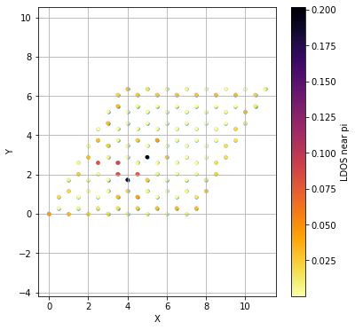
Insert x0, y0, s0 at 4,4,1, but plot rho(site) at rho(3,4,1)
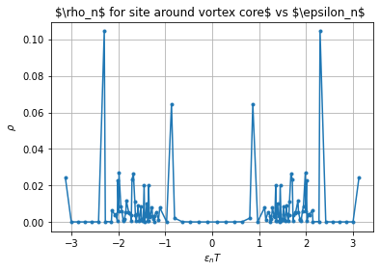
Insert x0, y0, s0 at 4,4,1, but plot rho(site) at rho(3,3,1), see if rho is smaller?

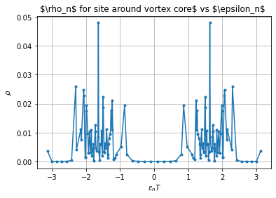
This is plot of Rho around site [3, 3, 1]
Both near-pi value is 3.131374369032255
4b: Hence obviously the vortex core is one uc( i) shifted from what you inserted.
Vortex core

Vortex core at [4, 4, 1]
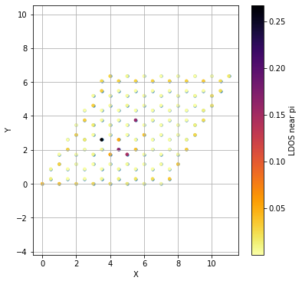

Now move vortex core position to [5, 4, 1]

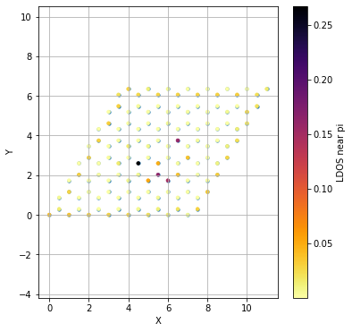
[5,4,1]

[5, 5, 1] as below
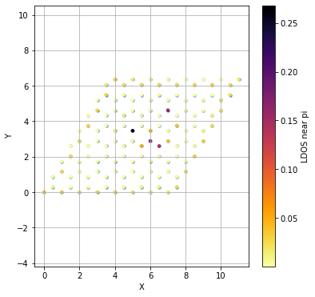
Core at [5, 5, 1] site index physically
Rho table | Sites Rho sum
------------------------------------------------------
0 | [1 1 1] 0.0431755912124774
1 | [1 1 2] 0.011406114441216121
2 | [2 1 1] 0.03751724176019692
3 | [2 1 2] 0.0006153313238644306
4 | [3 1 1] 0.028892097758227757
5 | [3 1 2] 0.0008612025470461091
6 | [4 1 1] 0.02733034936872405
7 | [4 1 2] 0.002223704857239069
8 | [5 1 1] 0.025685074969839475
9 | [5 1 2] 0.005486321054555618
10 | [6 1 1] 0.023104694553958596
11 | [6 1 2] 0.010075456731104732
12 | [7 1 1] 0.018374196059719246
13 | [7 1 2] 0.014170066015697973
14 | [8 1 1] 0.014233869726508388
15 | [8 1 2] 0.025380968483102916
16 | [1 2 1] 0.006516706549354755
17 | [1 2 2] 0.02803391441650071
18 | [2 2 1] 0.0008082088482359606
19 | [2 2 2] 0.0018738725927241666
20 | [3 2 1] 0.00019552429064566133
21 | [3 2 2] 3.236748312409456e-05
22 | [4 2 1] 0.00032044765113652227
23 | [4 2 2] 5.943211709949461e-05
24 | [5 2 1] 0.00032090147632324025
25 | [5 2 2] 0.00010950733010098727
26 | [6 2 1] 0.00026713501389473773
27 | [6 2 2] 0.00023661762278160602
28 | [7 2 1] 0.0007590871899087365
29 | [7 2 2] 0.0011111281741438394
30 | [8 2 1] 0.004106724070935389
31 | [8 2 2] 0.02705518497720171
32 | [1 3 1] 0.0019458426501898617
33 | [1 3 2] 0.026310999512181903
34 | [2 3 1] 3.139369186323394e-05
35 | [2 3 2] 0.001639966823823147
36 | [3 3 1] 0.00019357298308626445
37 | [3 3 2] 7.702745242048478e-05
38 | [4 3 1] 0.00014424066711943447
39 | [4 3 2] 2.7400139187461736e-05
40 | [5 3 1] 0.00030614164433330243
41 | [5 3 2] 0.0019948476312916692
42 | [6 3 1] 0.004383974317301939
43 | [6 3 2] 0.0041930888092891454
44 | [7 3 1] 0.001676925651197495
45 | [7 3 2] 0.0008078622269327986
46 | [8 3 1] 2.615053988380609e-05
47 | [8 3 2] 0.03165042942577599
48 | [1 4 1] 0.0007307310740070263
49 | [1 4 2] 0.027915629461647884
50 | [2 4 1] 1.4196240260654053e-05
51 | [2 4 2] 0.0019629627327596363
52 | [3 4 1] 0.000378909225507949
53 | [3 4 2] 5.792320541491749e-05
54 | [4 4 1] 0.007196356260572093
55 | [4 4 2] 0.00651731560410131
56 | [5 4 1] 0.051252823878572135
57 | [5 4 2] 0.1630578212661375
58 | [6 4 1] 0.14496480233855039
59 | [6 4 2] 0.038769754118945524
60 | [7 4 1] 0.0016792321190795645
61 | [7 4 2] 0.00039649007164618377
62 | [8 4 1] 0.003883482368621961
63 | [8 4 2] 0.03146102309288981
64 | [1 5 1] 0.00019588551680208943
65 | [1 5 2] 0.02850338888269206
66 | [2 5 1] 1.9064392046175764e-06
67 | [2 5 2] 0.0024793004245581025
68 | [3 5 1] 0.015631362970268084
69 | [3 5 2] 0.00012057533713798367
70 | [4 5 1] 0.2681638350918534
71 | [4 5 2] 0.001562523431412631
72 | [5 5 1] 0.04835397000836845
73 | [5 5 2] 0.00012249002187590506
74 | [6 5 1] 0.00414089873142622
75 | [6 5 2] 0.03887290268741174
76 | [7 5 1] 0.00014848386456025228
77 | [7 5 2] 0.0008615220225114713
78 | [8 5 1] 0.009419500084808637
79 | [8 5 2] 0.02564820996269996
80 | [1 6 1] 7.093086213908277e-05
81 | [1 6 2] 0.02880698070374116
82 | [2 6 1] 2.6871869607861757e-05
83 | [2 6 2] 0.0027079807452242807
84 | [3 6 1] 0.01533752608590232
85 | [3 6 2] 9.05499723177816e-05
86 | [4 6 1] 0.006812104763835539
87 | [4 6 2] 0.0016746728435217489
88 | [5 6 1] 0.0002519298305436209
89 | [5 6 2] 0.15800394289893505
90 | [6 6 1] 0.0002855767796134558
91 | [6 6 2] 0.0038409107888418997
92 | [7 6 1] 6.620961263479927e-05
93 | [7 6 2] 0.000278274608682699
94 | [8 6 1] 0.011576665576002749
95 | [8 6 2] 0.02281037235471038
96 | [1 7 1] 0.00030028427334529686
97 | [1 7 2] 0.03088682039917787
98 | [2 7 1] 0.00024328520500671504
99 | [2 7 2] 0.004273197603581335
100 | [3 7 1] 0.0013838367976613543
101 | [3 7 2] 0.00017623233950727723
102 | [4 7 1] 0.0025625211921327558
103 | [4 7 2] 0.006279680114114252
104 | [5 7 1] 0.0024950819079428174
105 | [5 7 2] 0.0017829760859596245
106 | [6 7 1] 0.0019660223241803818
107 | [6 7 2] 0.00013772487457409084
108 | [7 7 1] 0.004821303682826799
109 | [7 7 2] 0.00024030231452578217
110 | [8 7 1] 0.023270454800062762
111 | [8 7 2] 0.022205803628542443
112 | [1 8 1] 0.016643378898212914
113 | [1 8 2] 0.02879222301406132
114 | [2 8 1] 0.02498066176929197
115 | [2 8 2] 0.0158279453491961
116 | [3 8 1] 0.028788158600650184
117 | [3 8 2] 0.007914366918390623
118 | [4 8 1] 0.028444336369600698
119 | [4 8 2] 0.002470209602681789
120 | [5 8 1] 0.028432116863599734
121 | [5 8 2] 0.0003007001471813303
122 | [6 8 1] 0.029358568620087327
123 | [6 8 2] 1.900217214243041e-05
124 | [7 8 1] 0.031781028222037364
125 | [7 8 2] 0.0005388580551958191
126 | [8 8 1] 0.022259698353246732
127 | [8 8 2] 0.017566605835253032
[-3.13519558 3.13519558]-----------------------------
2
Made change to function: def sites_to_comp_index – the alpha in equation was wrong!
Tried put vortex in real coords, at (0,0), there seems no pi mode overall. – defect must be inserted in bulk?

sigma_current = np.pi - 3.13269 + 0.02 #offset
Rho_all_sites_epsilon_vor(8, 8, 50, 1, 3.5 , y_real_calculation, sigma_current, np.pi) #offset
Vortex core at real coords = (3.5, 11 sqrt(3)/6). (Below)
Both -pi and pi epsilon values were taken
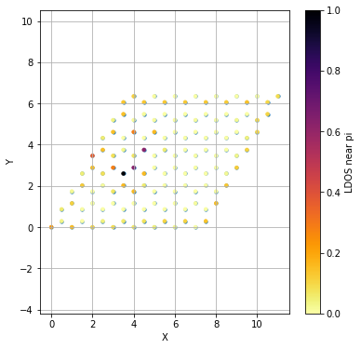
The above graph should see rho_table below:
| | Rho table | Sites Rho sum
| | ------------------------------------------------------
| | 0 | [1 1 1] 0.050570387799794565
| | 1 | [1 1 2] 0.007090871483097573
| | 2 | [2 1 1] 0.03472953706865935
| | 3 | [2 1 2] 0.0006723630217104254
| | 4 | [3 1 1] 0.02378206426135572
| | 5 | [3 1 2] 0.008928765447724946
| | 6 | [4 1 1] 0.02002924349449699
| | 7 | [4 1 2] 0.013553519000611101
| | 8 | [5 1 1] 0.014966584648250148
| | 9 | [5 1 2] 0.0169718237447625
| | 10 | [6 1 1] 0.009736035804853022
| | 11 | [6 1 2] 0.0231080649195797
| | 12 | [7 1 1] 0.006891325727704732
| | 13 | [7 1 2] 0.024414408567063582
| | 14 | [8 1 1] 0.0007541233534600345
| | 15 | [8 1 2] 0.03177749201757689
| | 16 | [1 2 1] 0.012462883772377975
| | 17 | [1 2 2] 0.025613689513968897
| | 18 | [2 2 1] 0.0010747688596946013
| | 19 | [2 2 2] 0.0005830984709029208
| | 20 | [3 2 1] 0.00010819581091090546
| | 21 | [3 2 2] 0.0003524731473380364
| | 22 | [4 2 1] 0.000361434878011765
| | 23 | [4 2 2] 0.0003611303211415825
| | 24 | [5 2 1] 0.0001320545867647531
| | 25 | [5 2 2] 0.0002959721420445783
| | 26 | [6 2 1] 0.0001440990092067969
| | 27 | [6 2 2] 0.0005412393863530108
| | 28 | [7 2 1] 1.8976474448269872e-05
| | 29 | [7 2 2] 0.0026368620017602944
| | 30 | [8 2 1] 9.770166401421314e-05
| | 31 | [8 2 2] 0.033627440082019955
| | 32 | [1 3 1] 0.0044592761676923625
| | 33 | [1 3 2] 0.027569333609544597
| | 34 | [2 3 1] 0.00010160098198589112
| | 35 | [2 3 2] 0.002861634930619265
| | 36 | [3 3 1] 0.015171181764076495
| | 37 | [3 3 2] 0.03637101141213886
| | 38 | [4 3 1] 0.036140693697670555
| | 39 | [4 3 2] 0.012794667262685546
| | 40 | [5 3 1] 0.0001878136873741619
| | 41 | [5 3 2] 9.892959107048692e-05
| | 42 | [6 3 1] 8.03885779167658e-05
| | 43 | [6 3 2] 0.0001514266591036553
| | 44 | [7 3 1] 5.0860729118951715e-05
| | 45 | [7 3 2] 0.0003932711464082906
| | 46 | [8 3 1] 0.0026382010827510497
| | 47 | [8 3 2] 0.0302870023626771
| | 48 | [1 4 1] 0.011053962556836973
| | 49 | [1 4 2] 0.03301338969123844
| | 50 | [2 4 1] 0.018560889617931307
| | 51 | [2 4 2] 0.06372018198017006
| | 52 | [3 4 1] 0.2263698550738935
| | 53 | [3 4 2] 0.1426096544606405
| | 54 | [4 4 1] 0.035771643290111926
| | 55 | [4 4 2] 3.8310417655229436e-05
| | 56 | [5 4 1] 3.307235944047412e-06
| | 57 | [5 4 2] 3.883763744940875e-05
| | 58 | [6 4 1] 3.518844659038874e-05
| | 59 | [6 4 2] 0.00014039739939654405
| | 60 | [7 4 1] 4.4040750905525793e-05
| | 61 | [7 4 2] 0.0003107055573422316
| | 62 | [8 4 1] 0.00466390420769869
| | 63 | [8 4 2] 0.027014103472764756
| | 64 | [1 5 1] 0.08199941298182381
| | 65 | [1 5 2] 0.03332588336919262
| | 66 | [2 5 1] 0.018338541662975362
| | 67 | [2 5 2] 0.005829860021732438
| | 68 | [3 5 1] 0.01530850845352422
| | 69 | [3 5 2] 0.13993015833817232
| | 70 | [4 5 1] 0.0001713086902914387
| | 71 | [4 5 2] 0.012296369152296182
| | 72 | [5 5 1] 9.080460863038203e-05
| | 73 | [5 5 2] 7.3721157131222775e-06
| | 74 | [6 5 1] 0.00010486169661472284
| | 75 | [6 5 2] 9.885942669723662e-05
| | 76 | [7 5 1] 3.834982413133858e-05
| | 77 | [7 5 2] 0.0002544390016536172
| | 78 | [8 5 1] 0.006731772712037387
| | 79 | [8 5 2] 0.024546927546784024
| | 80 | [1 6 1] 0.011602780094402115
| | 81 | [1 6 2] 0.03337032993936107
| | 82 | [2 6 1] 0.00015987046463447895
| | 83 | [2 6 2] 0.0643218320055208
| | 84 | [3 6 1] 0.00011210455589931703
| | 85 | [3 6 2] 0.03618090573647641
| | 86 | [4 6 1] 0.0001208139724475274
| | 87 | [4 6 2] 0.00014767100175395022
| | 88 | [5 6 1] 8.581948877953459e-05
| | 89 | [5 6 2] 4.50834811883691e-05
| | 90 | [6 6 1] 0.00019342200581522325
| | 91 | [6 6 2] 0.00010406106234805508
| | 92 | [7 6 1] 4.045118679680724e-05
| | 93 | [7 6 2] 0.00013618098284458405
| | 94 | [8 6 1] 0.009198715998292924
| | 95 | [8 6 2] 0.02232876805421942
| | 96 | [1 7 1] 0.00812551689515053
| | 97 | [1 7 2] 0.03332379618904274
| | 98 | [2 7 1] 0.003395834571760219
| | 99 | [2 7 2] 0.003273763618818556
| | 100 | [3 7 1] 0.0024887490872033016
| | 101 | [3 7 2] 4.9228237119789756e-05
| | 102 | [4 7 1] 0.002442923711797066
| | 103 | [4 7 2] 8.367364748395192e-05
| | 104 | [5 7 1] 0.002225829156893181
| | 105 | [5 7 2] 4.2820678625812625e-06
| | 106 | [6 7 1] 0.0017657130532390372
| | 107 | [6 7 2] 9.564079986182106e-05
| | 108 | [7 7 1] 0.004803930198395383
| | 109 | [7 7 2] 0.00024175587294787346
| | 110 | [8 7 1] 0.02110257771936474
| | 111 | [8 7 2] 0.02309665926820096
| | 112 | [1 8 1] 0.030195161312879106
| | 113 | [1 8 2] 0.025414900508171877
| | 114 | [2 8 1] 0.02951988259786842
| | 115 | [2 8 2] 0.002221547714977002
| | 116 | [3 8 1] 0.028932518967465674
| | 117 | [3 8 2] 4.954871008377369e-05
| | 118 | [4 8 1] 0.02883497717248417
| | 119 | [4 8 2] 2.7173440365849214e-06
| | 120 | [5 8 1] 0.028615937559955677
| | 121 | [5 8 2] 3.0444325255874713e-06
| | 122 | [6 8 1] 0.028049572829577235
| | 123 | [6 8 2] 4.4754791283797014e-06
| | 124 | [7 8 1] 0.03203376379340546
| | 125 | [7 8 2] 0.0007562904386871679
| | 126 | [8 8 1] 0.02246829159647786
| | 127 | [8 8 2] 0.020020959873020185
[-3.13269322 3.13269322]---------------------------------
2
This is vortex core: (5.5, 11(sqrt(3))/6; Rho_all_sites_epsilon_vor(8, 8, 50, 1, 5.5 , y_real_calculation, sigma_current, np.pi) sigma_current = sigma_current = np.pi - 3.13269 + 0.02
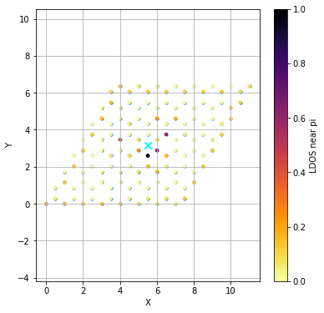
Rho table for graph above
| | Rho table | Sites Rho sum
| | ------------------------------------------------------
| | 0 | [1 1 1] 0.04331784221882493
| | 1 | [1 1 2] 0.011449925490341024
| | 2 | [2 1 1] 0.03741521345088818
| | 3 | [2 1 2] 0.0006080324136538682
| | 4 | [3 1 1] 0.028921165475380615
| | 5 | [3 1 2] 0.0008454056683369531
| | 6 | [4 1 1] 0.025756497760529518
| | 7 | [4 1 2] 0.002272228271382397
| | 8 | [5 1 1] 0.02388814512701465
| | 9 | [5 1 2] 0.007100980851838562
| | 10 | [6 1 1] 0.020333319269421578
| | 11 | [6 1 2] 0.012630177870917025
| | 12 | [7 1 1] 0.015526213462201871
| | 13 | [7 1 2] 0.017200201079869065
| | 14 | [8 1 1] 0.008218560127676591
| | 15 | [8 1 2] 0.029518935929951334
| | 16 | [1 2 1] 0.00635104922645926
| | 17 | [1 2 2] 0.028394403062263106
| | 18 | [2 2 1] 0.0008598585627443793
| | 19 | [2 2 2] 0.002162245627411943
| | 20 | [3 2 1] 0.00022406485790289513
| | 21 | [3 2 2] 3.220277211238973e-05
| | 22 | [4 2 1] 0.000253924830223513
| | 23 | [4 2 2] 9.898397212606943e-05
| | 24 | [5 2 1] 0.00031721325830869843
| | 25 | [5 2 2] 0.0001009225756591494
| | 26 | [6 2 1] 0.0003959995516879068
| | 27 | [6 2 2] 0.00028822090693487394
| | 28 | [7 2 1] 0.0003496965289731967
| | 29 | [7 2 2] 0.00115090771094731
| | 30 | [8 2 1] 0.0005575351388485362
| | 31 | [8 2 2] 0.030918746608225627
| | 32 | [1 3 1] 0.0011824575378688437
| | 33 | [1 3 2] 0.02850373678347446
| | 34 | [2 3 1] 5.201767709571988e-05
| | 35 | [2 3 2] 0.001551589934082088
| | 36 | [3 3 1] 0.00024275507548054742
| | 37 | [3 3 2] 0.00011534762081807378
| | 38 | [4 3 1] 0.00027967588015693817
| | 39 | [4 3 2] 0.0012276021825089224
| | 40 | [5 3 1] 0.015931971029641973
| | 41 | [5 3 2] 0.037770390086805355
| | 42 | [6 3 1] 0.03729299316505924
| | 43 | [6 3 2] 0.013068549245429153
| | 44 | [7 3 1] 0.0001977815629201941
| | 45 | [7 3 2] 0.00035779157951240935
| | 46 | [8 3 1] 0.0004458164539632968
| | 47 | [8 3 2] 0.032583578766957125
| | 48 | [1 4 1] 0.0007883055168839983
| | 49 | [1 4 2] 0.028071915512358325
| | 50 | [2 4 1] 8.450608156033102e-06
| | 51 | [2 4 2] 0.002111181099327401
| | 52 | [3 4 1] 0.012119364243890485
| | 53 | [3 4 2] 0.0002786794705857674
| | 54 | [4 4 1] 0.01985409026752765
| | 55 | [4 4 2] 0.05541943474501358
| | 56 | [5 4 1] 0.2325501546137566
| | 57 | [5 4 2] 0.14575802760866569
| | 58 | [6 4 1] 0.03672949963195389
| | 59 | [6 4 2] 0.00011456619648001034
| | 60 | [7 4 1] 7.707232009653989e-05
| | 61 | [7 4 2] 0.00043838018370844417
| | 62 | [8 4 1] 0.005063691220817278
| | 63 | [8 4 2] 0.02977381409205198
| | 64 | [1 5 1] 0.00011980002178551378
| | 65 | [1 5 2] 0.02869629406414219
| | 66 | [2 5 1] 0.0010622510161115975
| | 67 | [2 5 2] 0.0030222946889857066
| | 68 | [3 5 1] 0.08761981440056629
| | 69 | [3 5 2] 8.498622695931712e-05
| | 70 | [4 5 1] 0.01950182859168362
| | 71 | [4 5 2] 8.647261523888949e-05
| | 72 | [5 5 1] 0.01612381870197746
| | 73 | [5 5 2] 0.14331413632136009
| | 74 | [6 5 1] 0.0002878078338581025
| | 75 | [6 5 2] 0.012719327043359572
| | 76 | [7 5 1] 8.891781190519671e-05
| | 77 | [7 5 2] 0.0003131164009035086
| | 78 | [8 5 1] 0.009259115376054658
| | 79 | [8 5 2] 0.024238134010347967
| | 80 | [1 6 1] 6.375121379082637e-05
| | 81 | [1 6 2] 0.030647296017605755
| | 82 | [2 6 1] 0.0011308746527024383
| | 83 | [2 6 2] 0.0026275870666669188
| | 84 | [3 6 1] 0.012273376825178612
| | 85 | [3 6 2] 0.00011744340668877723
| | 86 | [4 6 1] 0.0001969787726150984
| | 87 | [4 6 2] 0.056571272489603
| | 88 | [5 6 1] 7.11427106159818e-05
| | 89 | [5 6 2] 0.03750417366091671
| | 90 | [6 6 1] 0.00026215532211601325
| | 91 | [6 6 2] 0.0002407892933458431
| | 92 | [7 6 1] 6.435692904448783e-05
| | 93 | [7 6 2] 0.00019614255660422715
| | 94 | [8 6 1] 0.011499166544348034
| | 95 | [8 6 2] 0.02092501120622276
| | 96 | [1 7 1] 0.00046992980345406273
| | 97 | [1 7 2] 0.031062229948398683
| | 98 | [2 7 1] 0.0008258504359115952
| | 99 | [2 7 2] 0.003996234003494106
| | 100 | [3 7 1] 0.0016981046667576024
| | 101 | [3 7 2] 0.00038944609573422144
| | 102 | [4 7 1] 0.0024253173523756657
| | 103 | [4 7 2] 0.0012443816188176164
| | 104 | [5 7 1] 0.0023323113938614644
| | 105 | [5 7 2] 1.2377202620604387e-05
| | 106 | [6 7 1] 0.0019032675576089132
| | 107 | [6 7 2] 9.367819416768674e-05
| | 108 | [7 7 1] 0.0050633738715089045
| | 109 | [7 7 2] 0.00022418388237225724
| | 110 | [8 7 1] 0.02337564102800309
| | 111 | [8 7 2] 0.022228569196698307
| | 112 | [1 8 1] 0.021206704103459956
| | 113 | [1 8 2] 0.02912173812654533
| | 114 | [2 8 1] 0.025399280687297306
| | 115 | [2 8 2] 0.013549268939501351
| | 116 | [3 8 1] 0.029611634266476207
| | 117 | [3 8 2] 0.004967300635661159
| | 118 | [4 8 1] 0.028680003229982105
| | 119 | [4 8 2] 0.0013592783413349616
| | 120 | [5 8 1] 0.028384652228388544
| | 121 | [5 8 2] 9.310135713515427e-05
| | 122 | [6 8 1] 0.029425801208716837
| | 123 | [6 8 2] 3.231015830595816e-05
| | 124 | [7 8 1] 0.031980179700348485
| | 125 | [7 8 2] 0.0004782759087527145
| | 126 | [8 8 1] 0.02237261339653983
| | 127 | [8 8 2] 0.017643826094358814
[-3.13469182 3.13469182]---------------------------------
2

