]SCHOOL OF COMPUTER SCIENCE AND ARTIFICIAL INTELLIGENCE |  |  |  |  | DEPARTMENT OF COMPUTER SCIENCE ENGINEERING
ProgramName:M. Tech |  |  |  | Assignment Type: Lab |  |  | AcademicYear:2025-2026
CourseCoordinatorName |  |  |  | Venkataramana Veeramsetty
rCourseCode |  |  | 24CS002PC215 | CourseTitle |  | AI Assisted Problem Solving Using Python
Year/Sem |  |  | II/I | Regulation |  | R24
Date and Day  of Assignment |  |  | 10.11.2025 | Time(s)
Duration |  |  | 2 Hours | Applicableto  Batches
AssignmentNumber:9.3(Present assignment number)/24(Total number of assignments)
 | Q.No. | Question |  |  |  |  |  | ExpectedTime  to complete
 | 1 | Lab 9: Documentation Generation: Automatic documentation and code comments  Lab Objectives:  - To understand the importance of documentation and code comments in software development.  - To explore how AI-assisted coding tools can generate meaningful documentation and inline comments.  - To practice generating function-level and module-level docstrings automatically.  - To evaluate the quality, accuracy, and limitations of AI-generated documentation.  - To develop a small automated tool for documentation generation in Python..  Lab Outcomes (LOs):  After completing this lab, students will be able to:  - Apply AI-assisted coding tools to generate docstrings and inline comments for Python code.  - Critically analyze AI-generated documentation for correctness, completeness, and readability.  - Create structured documentation (function-level, module-level) following standard formats.  - Design and implement a mini documentation generator tool to automate code commenting and docstring creation.  Task Description#1 Basic Docstring Generation  - Write python function to return sum of even and odd numbers in the given list.  - Incorporate manual docstring in code with Google Style  - Use an AI-assisted tool (e.g., Copilot, Cursor AI) to generate a docstring describing the function.  - Compare the AI-generated docstring with your manually written one.  Prompt : Write python function to return sum of even and odd numbers in the given list. to generate a docstring describing the function  Expected Outcome#1: Students understand how AI can produce function-level documentation.  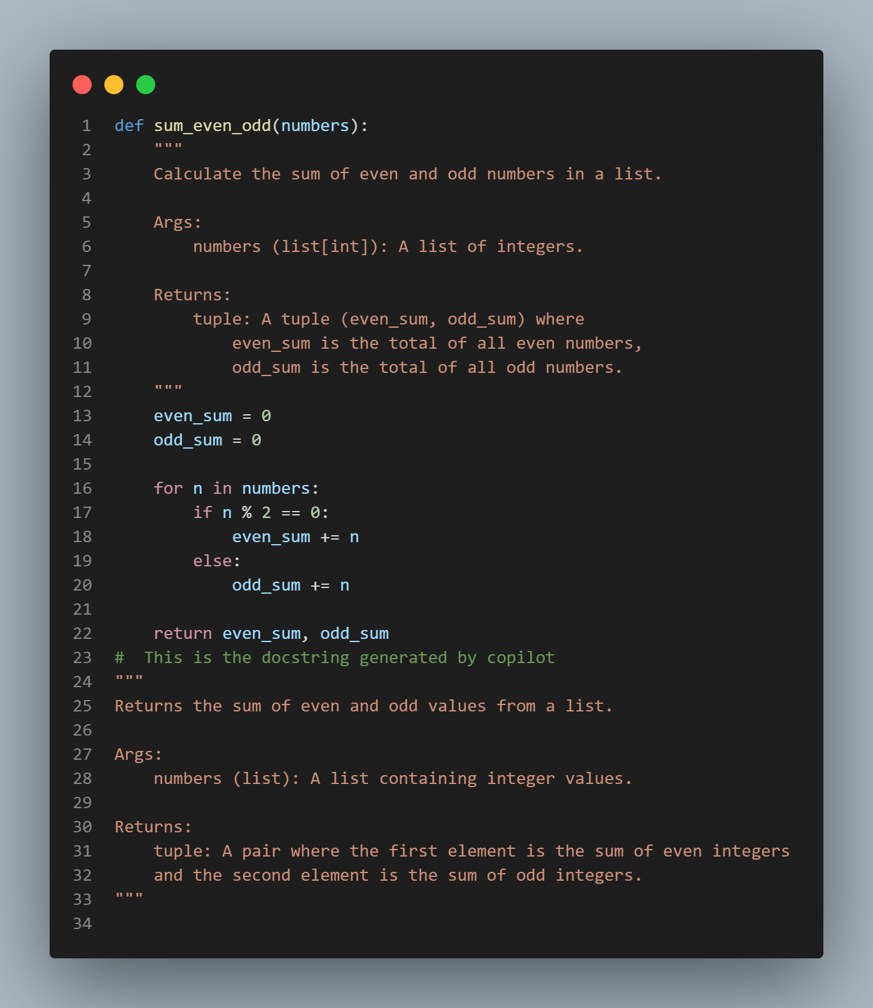  Comparison Between Manual vs AI-Generated Docstring  Aspect Manual Docstring (Google Style) AI-Generated Docstring  Style Strict Google convention with clear structure Generic, shorter, not format-strict  Detail Level More explicit (explains meaning of tuple values) Brief description  Variable Types Specifies list[int] Uses generic list  Readability Highly readable, formal Acceptable but less detailed  Summary  - Your manual docstring is more detailed and follows Google Style perfectly.  - The AI-generated docstring is shorter and less structured, but correct.  - Both communicate the function’s purpose, but the manual one is more professional and complete.  Task Description#2 Automatic Inline Comments  - Write python program for sru_student class with attributes like name, roll no., hostel_status and fee_update method and display_details method.  - Write comments manually for each line/code block  - Ask an AI tool to add inline comments explaining each line/step.  - Compare the AI-generated comments with your manually written one.  Prompt : Write python program for sru_student class with attributes like name, roll no., hostel_status and fee_update method and display_details method. add inline comments explaining each line/step.  Inline comment manually  :  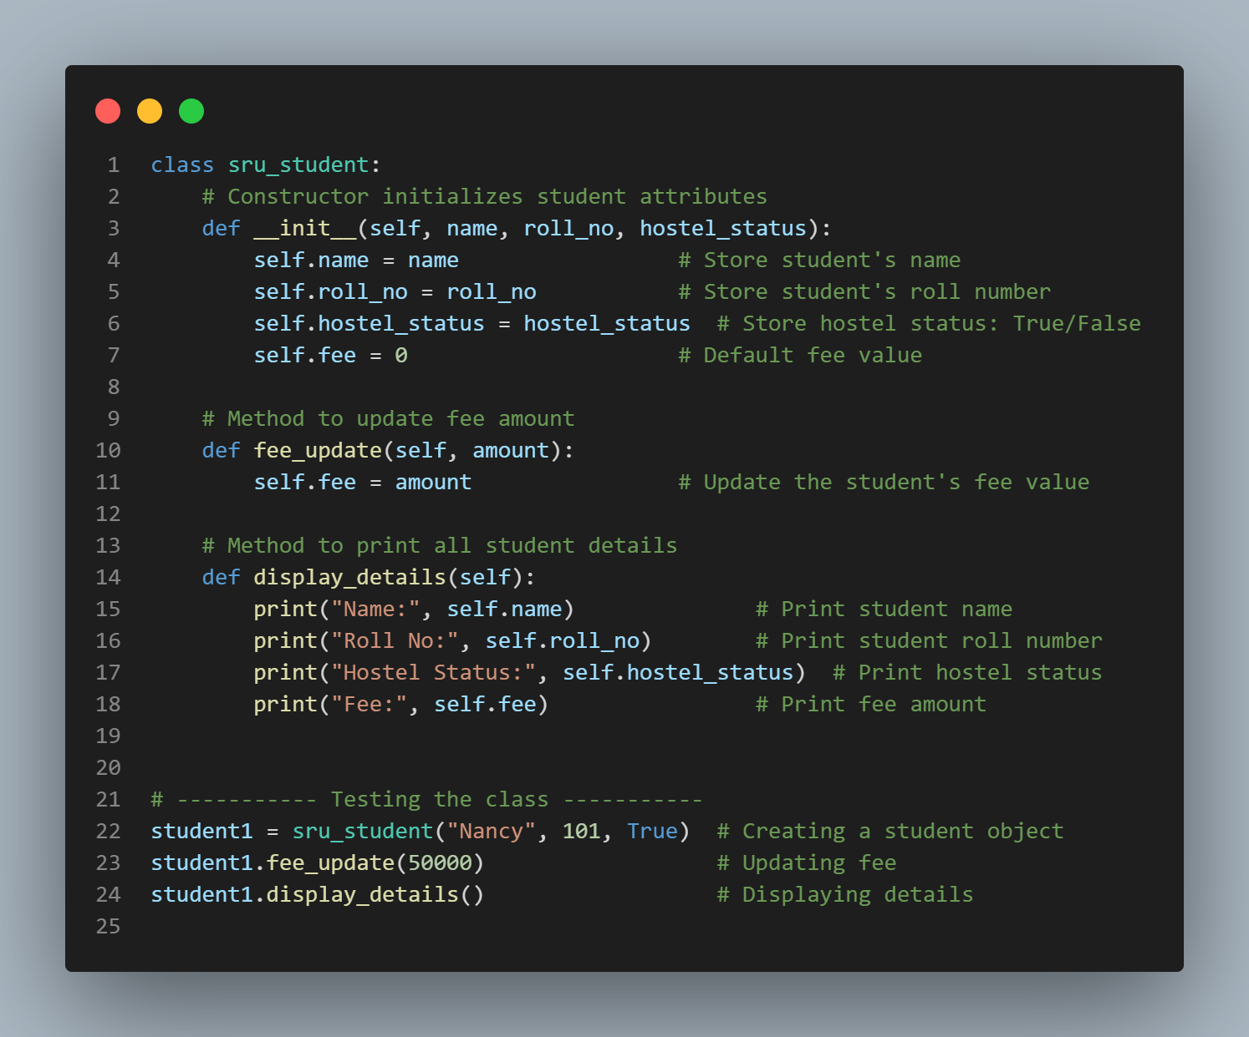  Inline comments explaining each line/step by Github Copillt :  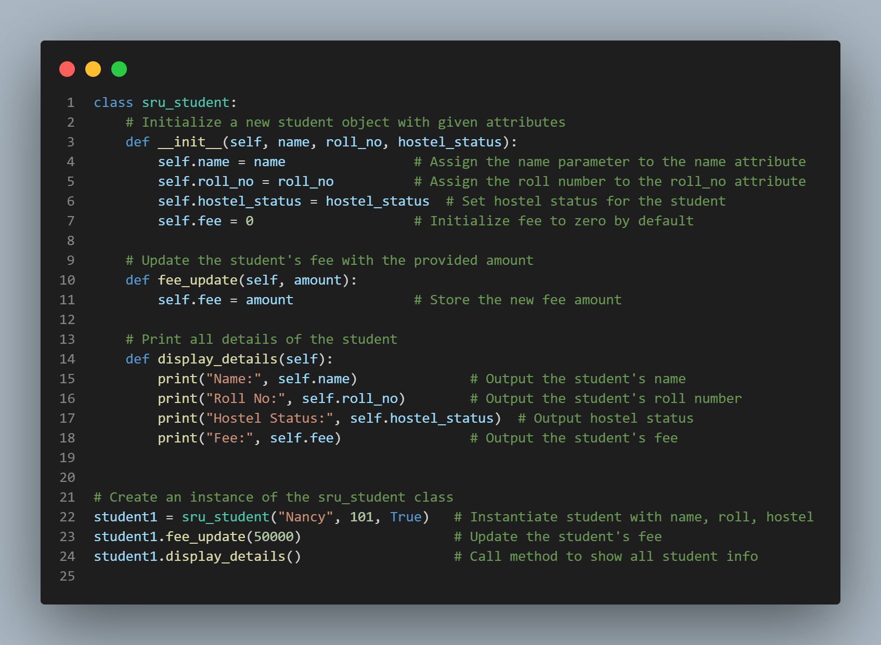  Expected Output#2: Students critically analyze AI-generated code comments.  Comparison (Point-Wise)  Manual Comments  - Short and clear — only important details are mentioned.  - More professional and suitable for clean production code.  - Avoid obvious explanations (e.g., “assigning variable”).  - Focus on purpose and intent, not step-by-step actions.  - Easier to read because comments are minimal.  AI-Generated Comments  - More detailed and sometimes overly verbose.  - Explain every line, even the obvious ones (e.g., “store name in attribute”).  - Good for beginners who need step-by-step understanding.  - Sometimes redundant or repetitive.  - Not always in a professional style—more like teaching/explaining.  Task Description#3  - Write a Python script with 3–4 functions (e.g., calculator: add, subtract, multiply, divide).  - Incorporate manual docstring in code with NumPy Style  - Use AI assistance to generate a module-level docstring + individual function docstrings.  - Compare the AI-generated docstring with your manually written one.  Manual docstring in code with NumPy Style  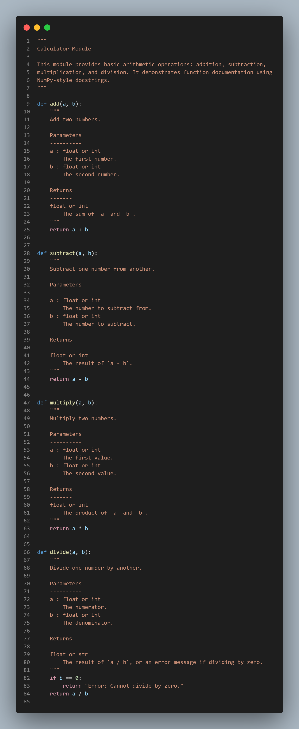  Module-level docstring + individual function docstrings.  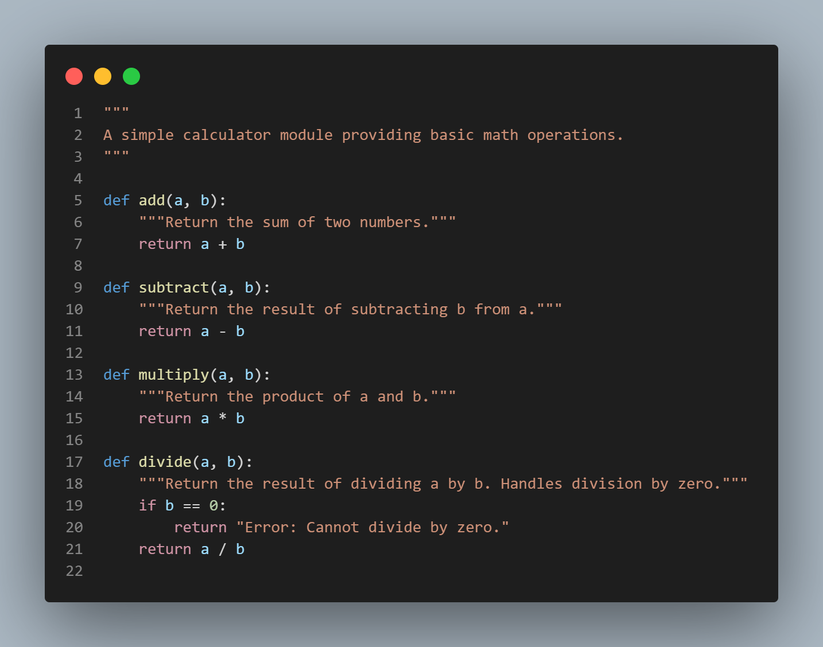  Expected Output#3: Students learn structured documentation for multi-function scripts  Comparison (Point-Wise)  Manual NumPy-Style Docstrings  - Very detailed — explains parameters and return values thoroughly.  - Follows a strict, professional documentation format (NumPy standard).  - Long but highly readable for developers.  - Ideal for real software documentation or academic projects.  - Provides precise type expectations and descriptions.  AI-Generated Docstrings  - Much shorter and more informal.  - Describes only the basic purpose of the function.  - Does not follow full NumPy formatting (no Parameters/Returns section).  - OK for simple scripts, but not ideal for large projects.  - Missing detailed type info, constraints, and structured formatting.  Push documentation whole workspace as .md file in GitHub Repository  Note: Report should be submitted a word document for all tasks in a single document with prompts, comments & code explanation, and output and if required, screenshots |  |  |  |  |  | Week4 - Wednesday

