SCHOOL OF COMPUTER SCIENCE AND ARTIFICIAL INTELLIGENCE |  |  |  |  | DEPARTMENT OF COMPUTER SCIENCE ENGINEERING
Program Name: M.Tech. and MCA |  |  |  | Assignment Type: Lab |  |  | AcademicYear:2025-2026
Course Coordinator Name |  |  |  | Venkataramana Veeramsetty
Course Code |  |  |  | Course Title |  | AI Assisted Problem Solving Using Python
Year/Sem |  |  | I/I | Regulation |  | R24
Date and Day  of Assignment |  |  | Week3 - Monday | Time(s)
Duration |  |  | 2 Hours | Applicable to  Batches |  | M.Tech. and MCA
AssignmentNumber:4.3(Present assignment number)/24(Total number of assignments)
 | Q.No. | Question |  |  |  |  |  | Expected Time  to complete
 | 1 | Lab 4: Advanced Prompt Engineering – Zero-shot, One-shot, and Few-shot Techniques  Lab Objectives:  - To explore and apply different levels of prompt examples in AI-assisted code generation.  - To understand how zero-shot, one-shot, and few-shot prompting affect AI output quality.  - To evaluate the impact of context richness and example quantity on AI performance.  - To build awareness of prompt strategy effectiveness for different problem types.  Lab Outcomes (LOs):  After completing this lab, students will be able to:  - Use zero-shot prompting to instruct AI with minimal context.  - Use one-shot prompting with a single example to guide AI code generation.  - Apply few-shot prompting using multiple examples to improve AI responses.  - Compare AI outputs across the three prompting strategies.  Task Description#1  - Zero-shot: Prompt AI to write a function that checks whether a given year is a leap year.  Prompt : write a user input function that checks whether a given year is a leap year.  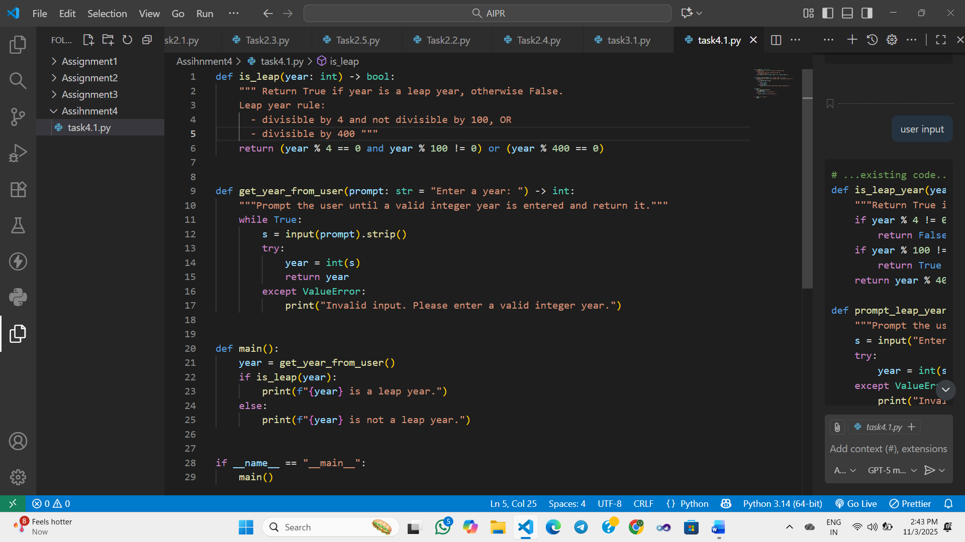  Expected Output#1  - AI-generated function with no examples provided  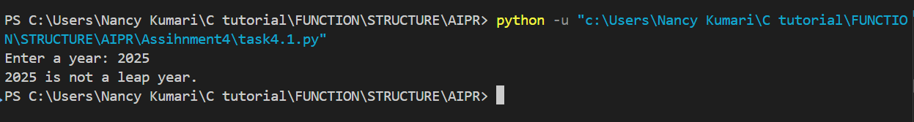  Task Description#2  - One-shot: Give one input-output example to guide AI in writing a function that converts centimeters to inches.  PROMPT : "Write a function to convert centimeters to inches.  Example: Input: 10 → Output: 3.937"  Expected Output#2  - Function with correct conversion logic  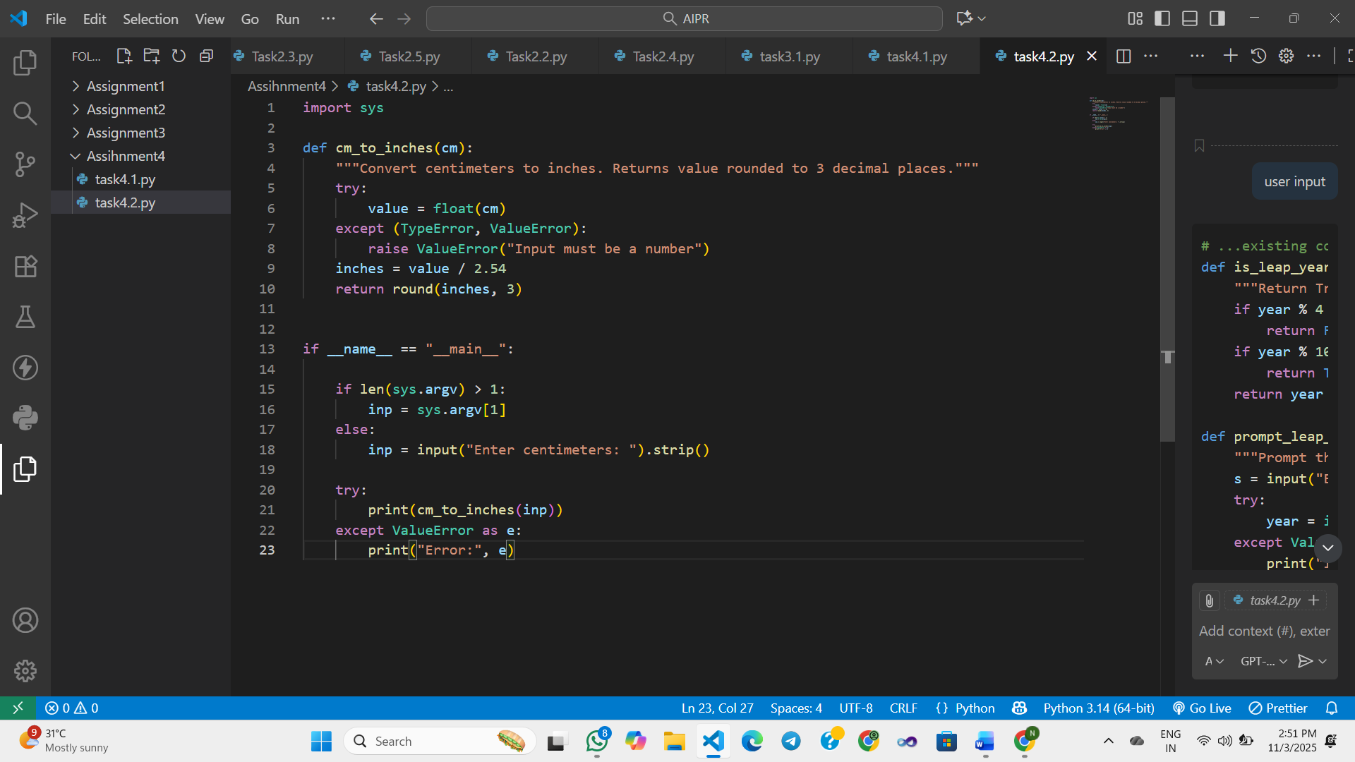  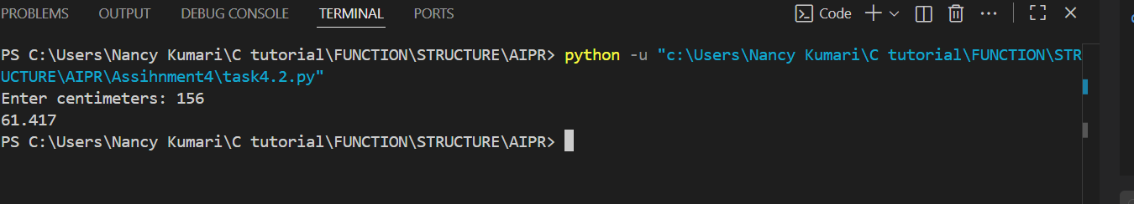  Task Description#3  - Few-shot: Provide 2–3 examples to generate a function that formats full names as “Last, First”.  Prompt : Write a user input function that takes a full name and returns it formatted as “Last, First”.  Example :  Input: "Janvi Kumari"  Output: "Kumari, Janvi"  Input: "Rahul Mehta"  Output: "Mehta, Rahul"  Expected Output#3  - Well-structured function respecting the examples  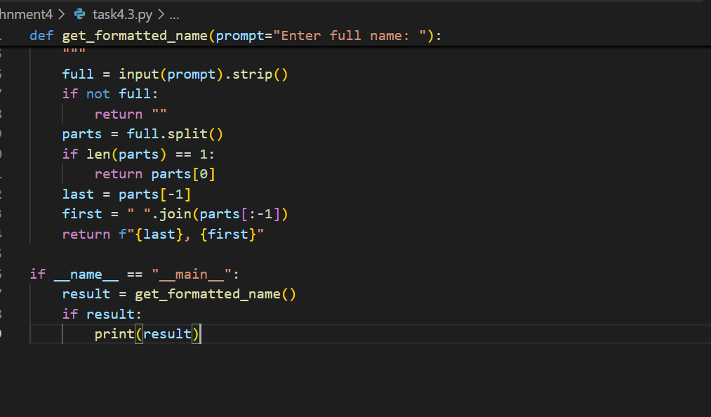  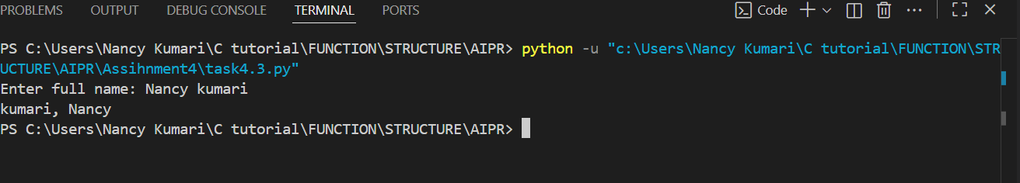  Task Description#4  - Compare zero-shot and few-shot prompts for writing a function that counts the number of vowels in a string  Prompt :  Zero-shot : write a function that counts the number of vowels in a string.  Few-shot : write a user input function that counts the number of vowels in a string.  Example :  Input: "hello"  Output: 2  Input: "sky"  Output: 0  Expected Output#4  - Functional output and comparative reflection  Zero-shot Code  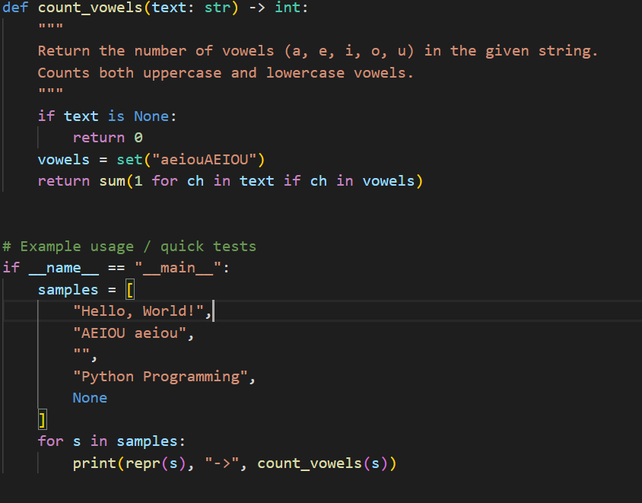  Few-shot Code :  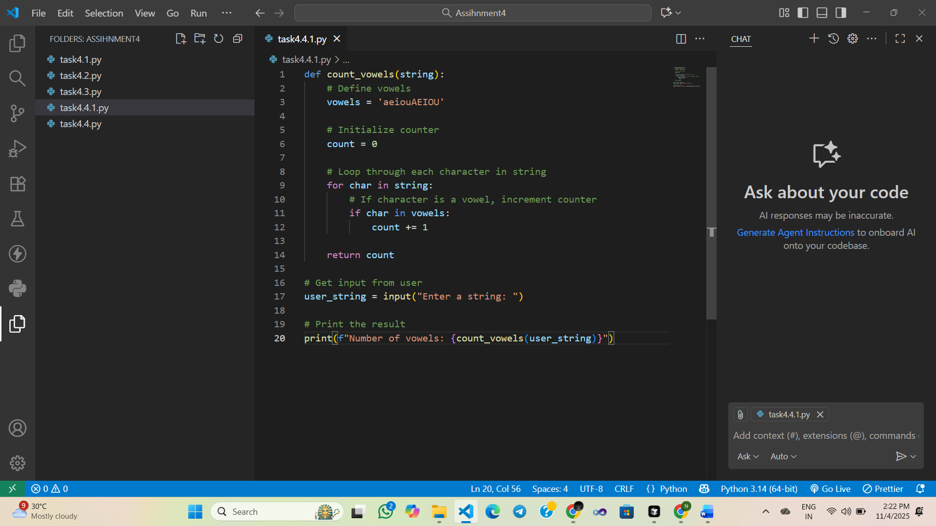  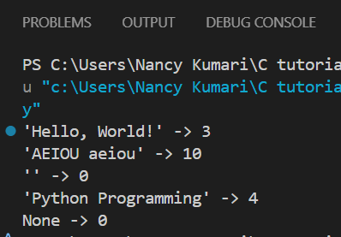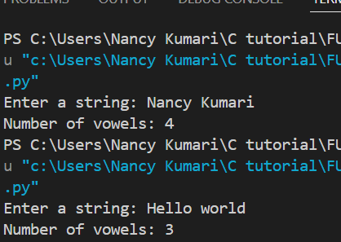  Feature One-shot prompt Few-shot prompt  Input Type Predefined test string User input at runtime  output Show single user result Show multiple test cases  Task Description#5  - Use few-shot prompting to generate a function that reads a .txt file and returns the number of lines.  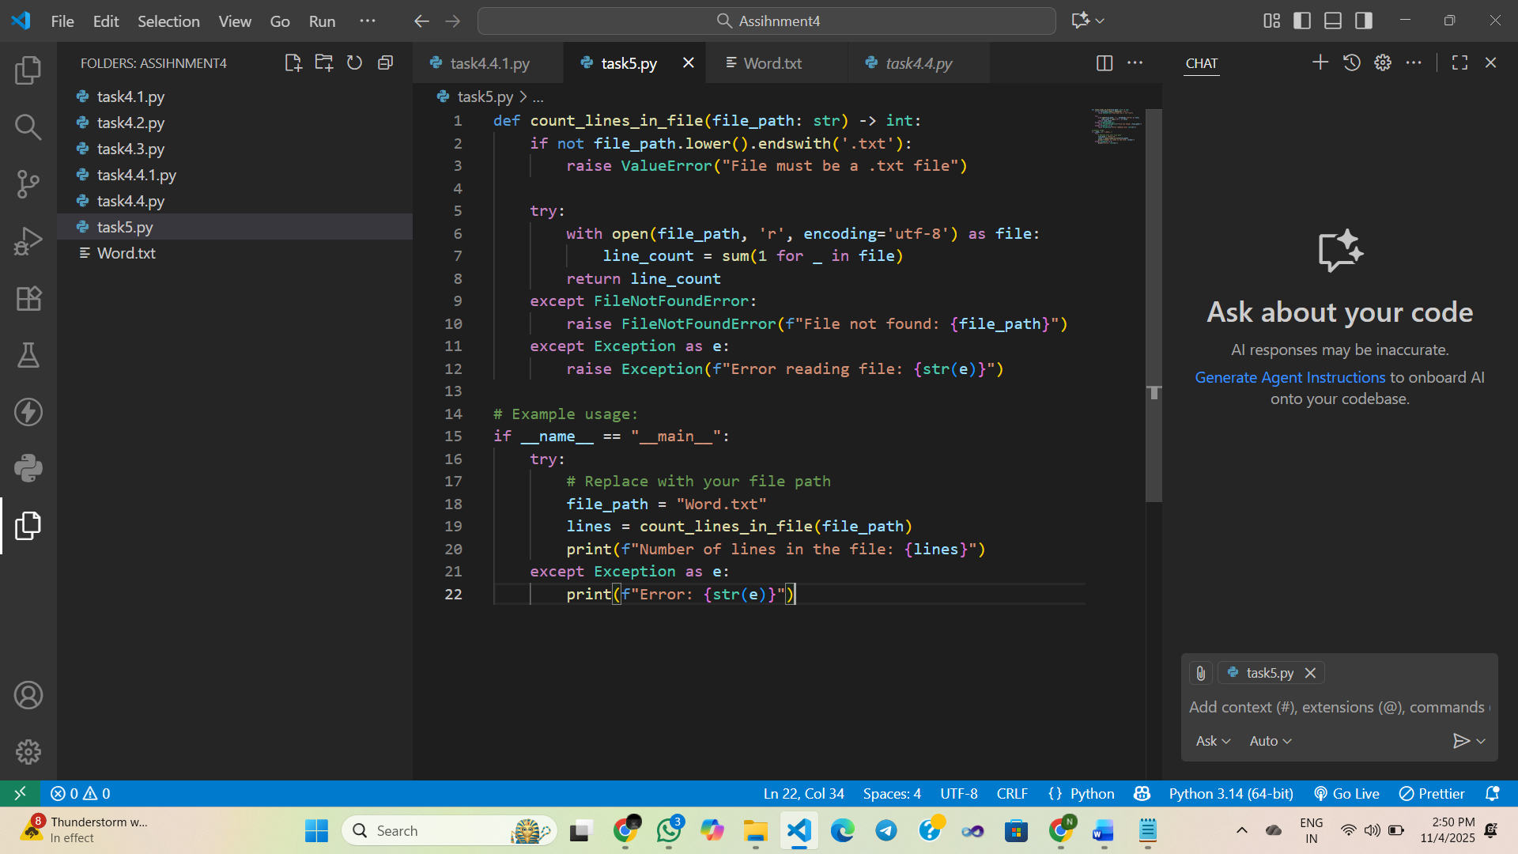  Expected Output#5  - Working file-processing function with AI-guided logic  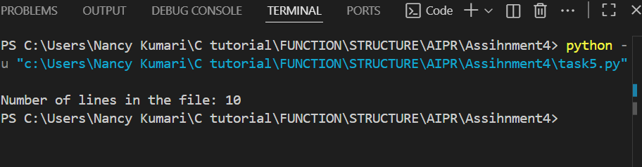  Note: Report should be submitted a word document for all tasks in a single document with prompts, comments & code explanation, and output and if required, screenshots  Evaluation Criteria:  Criteria Max Marks  Zero Shot (Task #1) 2.5  One Shot (Task#2) 2.5  Few Shot (Task#3 & Task #5) 2.5  Comparison (Task#4) 2.5  Total 10 Marks |  |  |  |  |  | Week3 - Monday

