

**DIGITAL DESIGN**

**ASSIGNMENTREPORT**

**ASSIGNMENT ID : II**

**Student Name: 郑鑫颖**

**Student ID: 11912039**

PART 1: DIGITAL design THEORY

Provide your answers here: 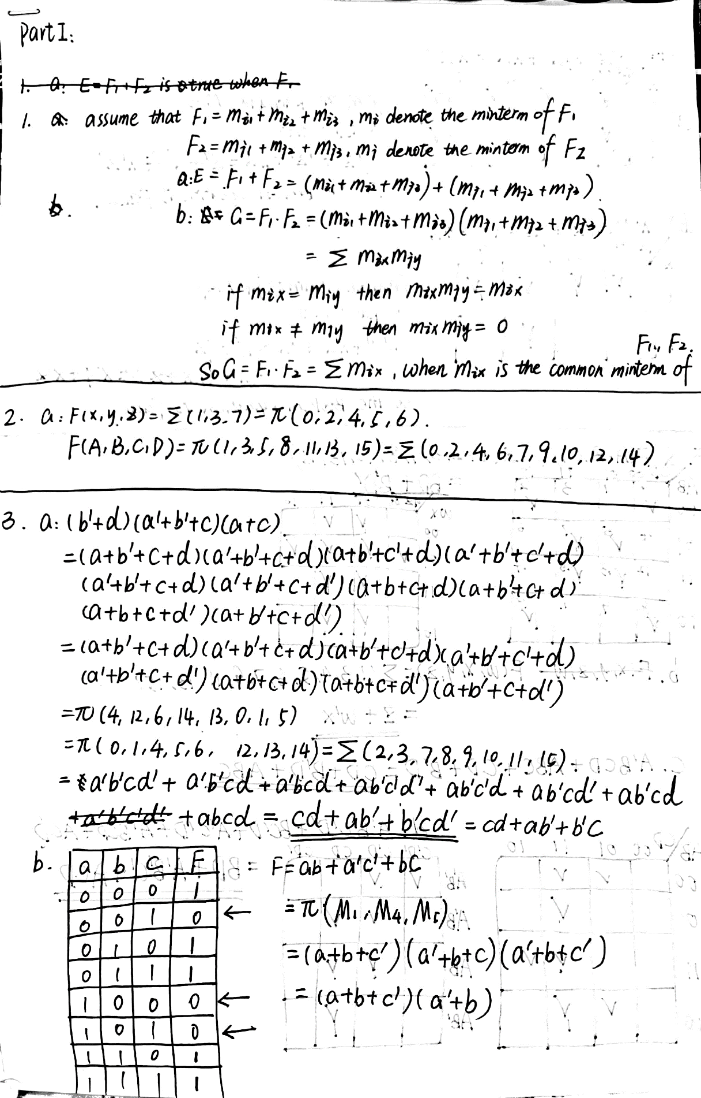

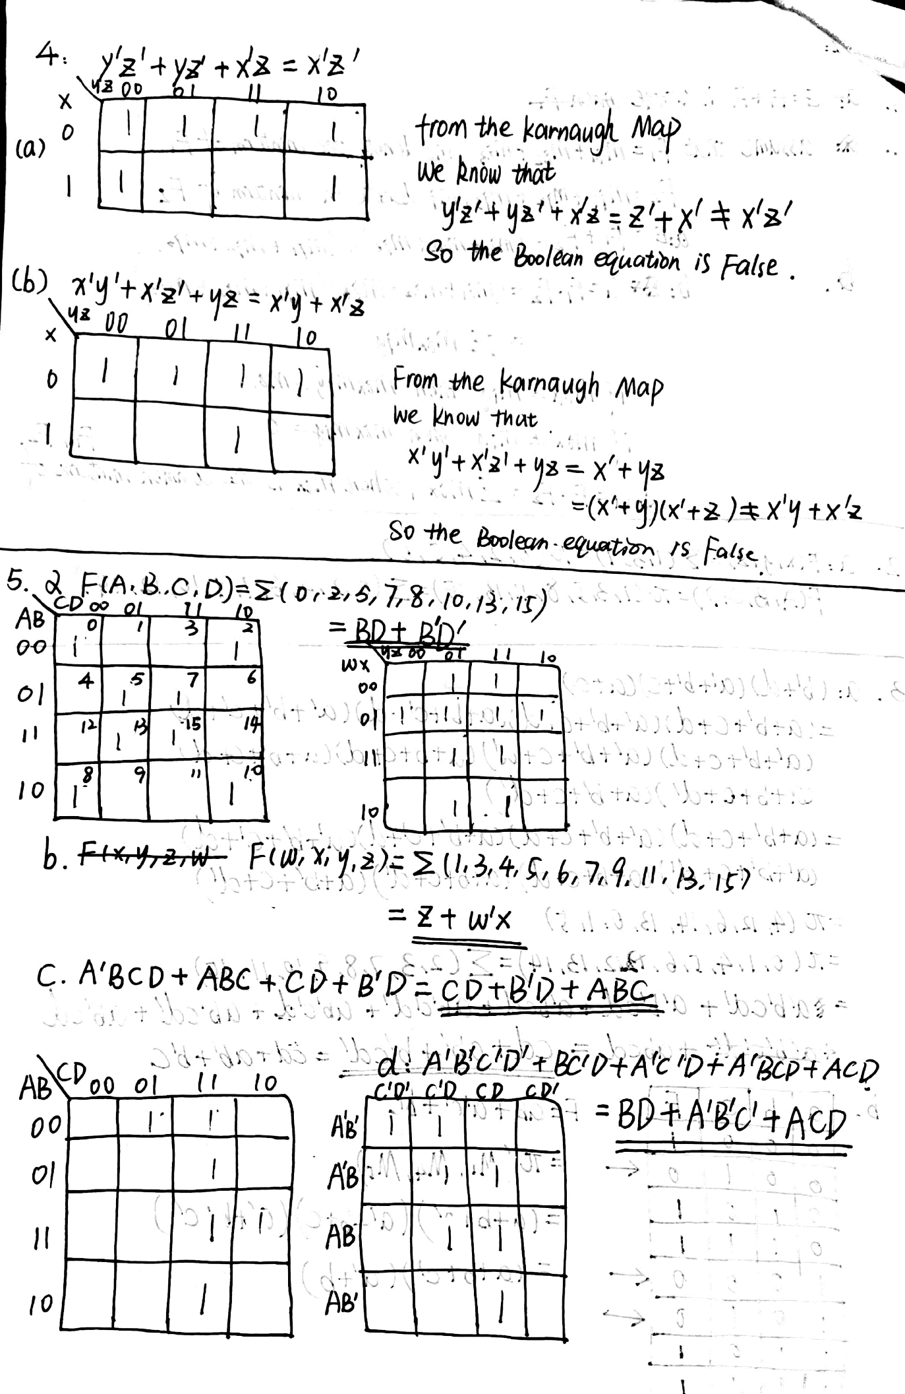

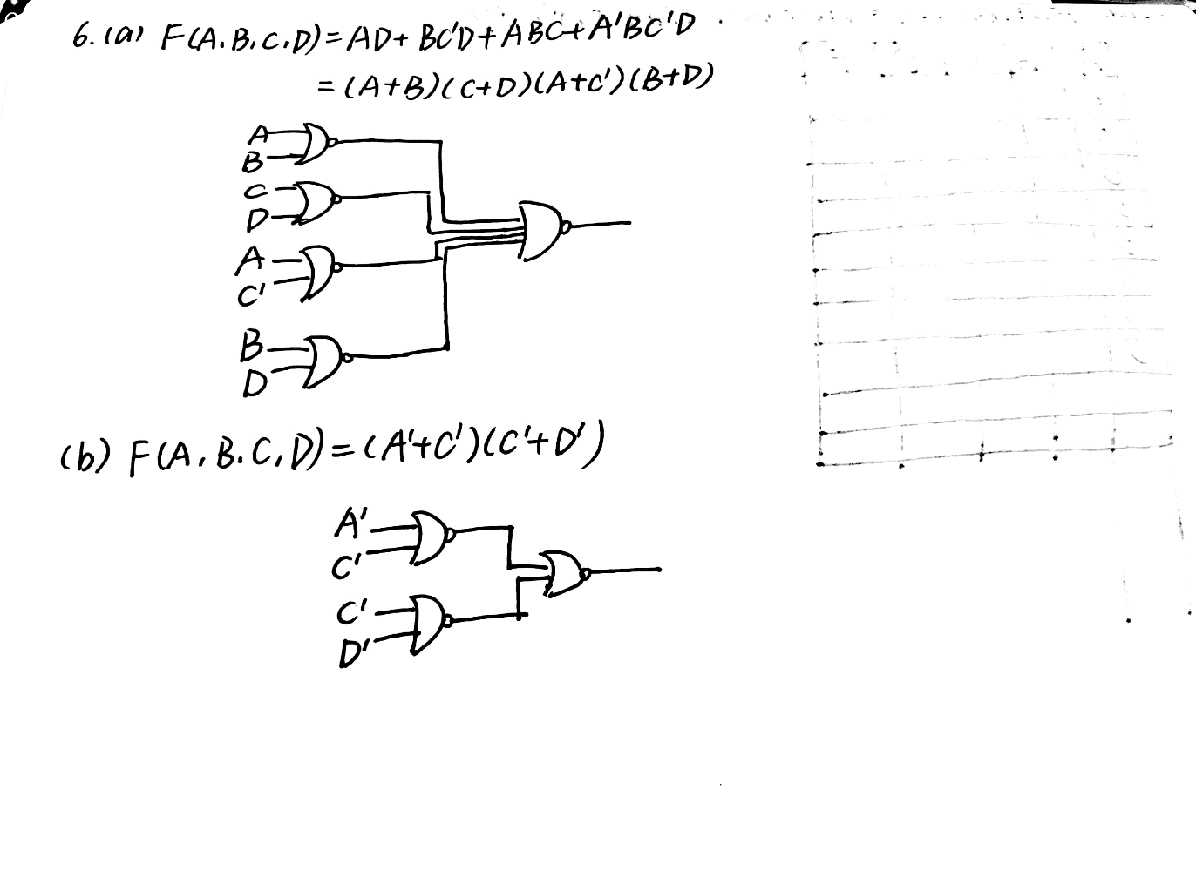

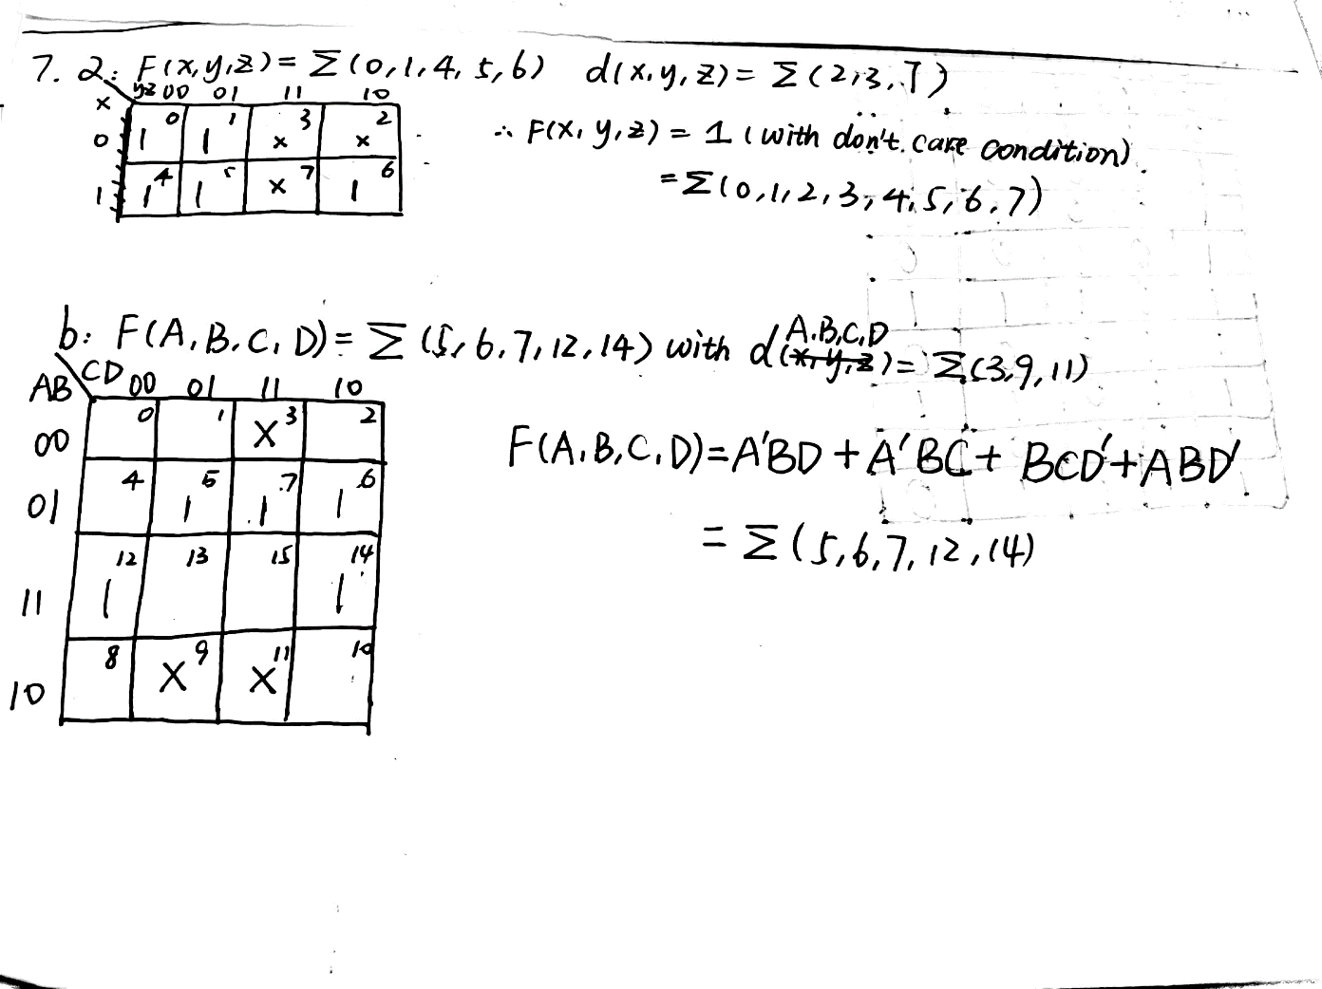

##### 

PART 2: DIGITAL design LAB (Task1)（已完成检查）

##### Design

*Describe the design of your system by providing the following information:*

* *Verilog design (provide the Verilog code)*
* *Truth-table*

##### simulation

*Describe how you build the test bench and do the simulation.*

* *Using Verilog (provide the Verilog code)*
* *Wave form of simulation result (provide screen shots)*
* *The description on whether the simulation result is same as the truth-table, is the function of the design meet the expectation.*

##### Constraint file and the testing

*Describe how you test your design on the Minisys Practice platform.*

* *Constraint file (provide the screen shots on the feature of a pin and the binding info between pins and the input /output ports)*
* *The testing result (provide the screen shots (at least 3 testing scene) to show state of inputs and outputs along with the related descriptions.*

##### the description of operation

*Describe the problem occurred while in the lab and your solution. Any suggestions are welcomed.*

* *Problems and solutions*

PART 2: DIGITAL design LAB (Task2)

##### Design

*Describe the design of your system by providing the following information:*

* *Verilog design while using data flow (provide the Verilog code)*
* *Verilog design while using structured design (provide the Verilog code)*
* *Block design (provide screen shots)*
* *Truth-table*

##### simulation

*Describe how you build the test bench and do the simulation.*

* *Using Verilog (provide the Verilog code)*
* *Wave form of simulation result (provide screen shots)*
* *The description on whether the simulation result is same as the truth-table, is the function of the design meet the expectation*

##### Constraint file and the testing

*Describe how you test your design on the Minisys Practice platform.*

* *Constraint file (provide the screen shots on the feature of a pin and the binding info between pins and the input /output ports)*
* *The testing result (provide the screen shots (at least 3 testing scene)) to show state of inputs and outputs along with the related descriptions.*

##### the description of operation

*Describe the problem occurred while in the lab and your solution. Any suggestions are welcomed.*

* *Problems and solutions*