**1.EC2 dashboard with instance listed**

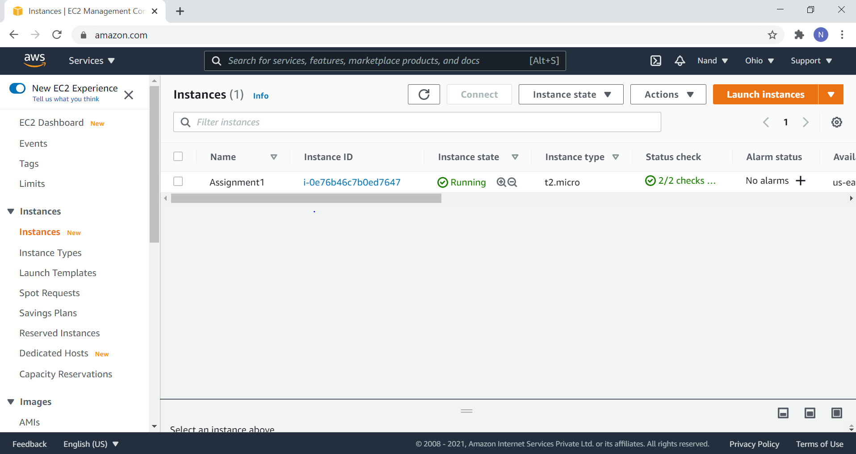

**2.EC2 instance details**

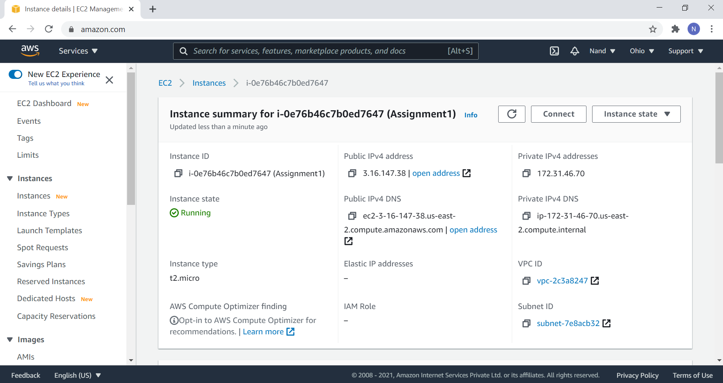

**3.Windows screen after successful launch**

