Number Plate Detection
In this project as per your request we have used Google COLAB GPU architecture to train YOLO model and in below screen showing training process of YOLO in COLAB. To train YOLO we have used same dataset given by you and in below screen showing training process

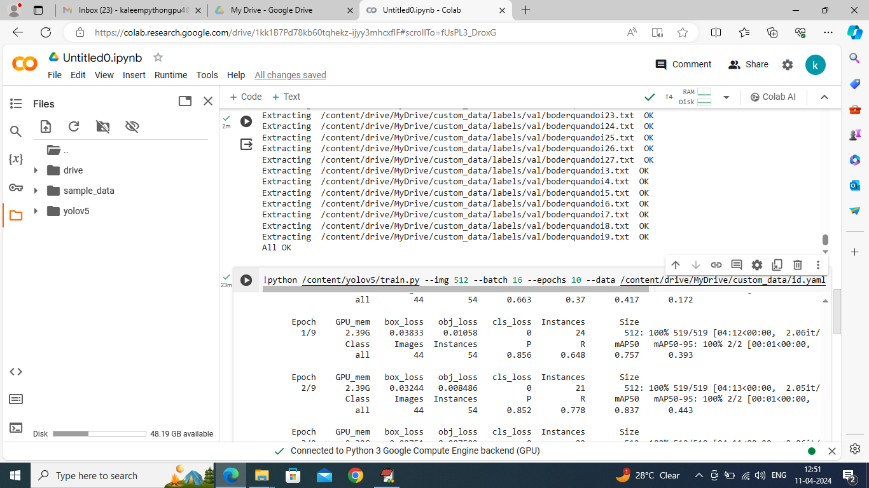

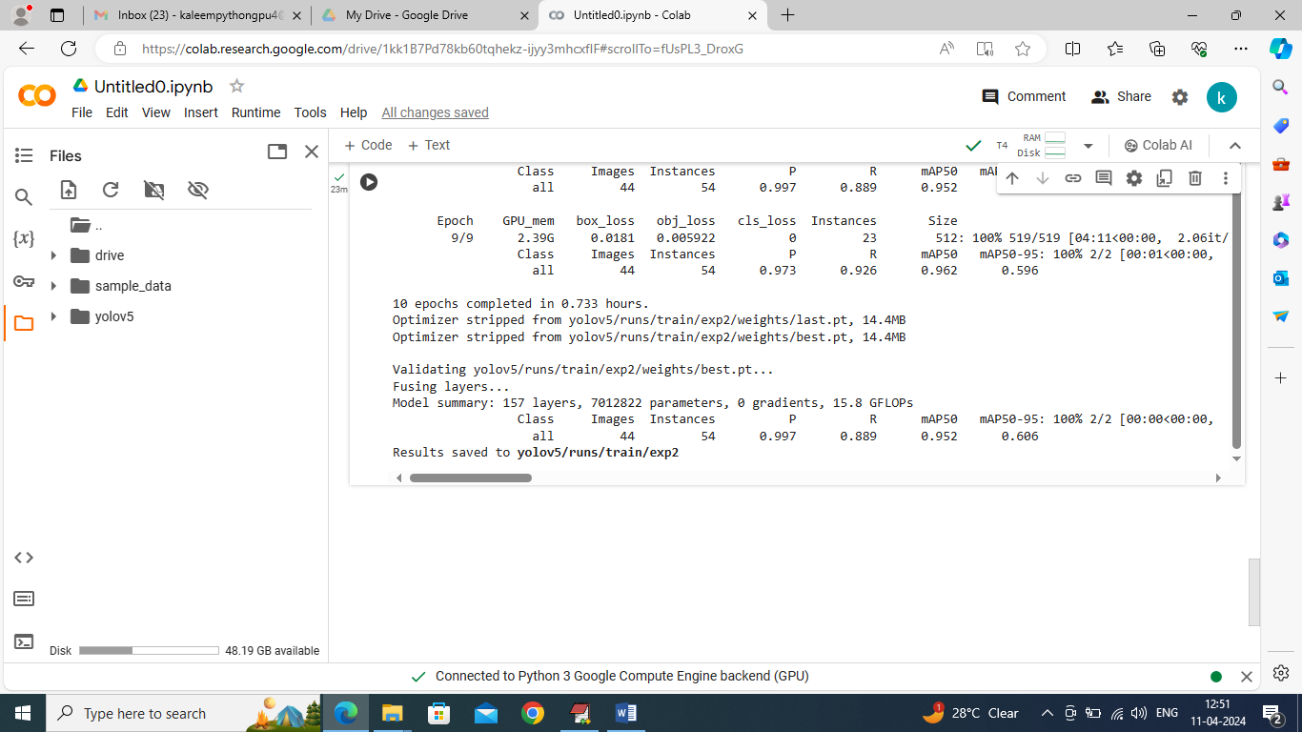
Now to detect and recognized number plat double click on run.bat file to get below page
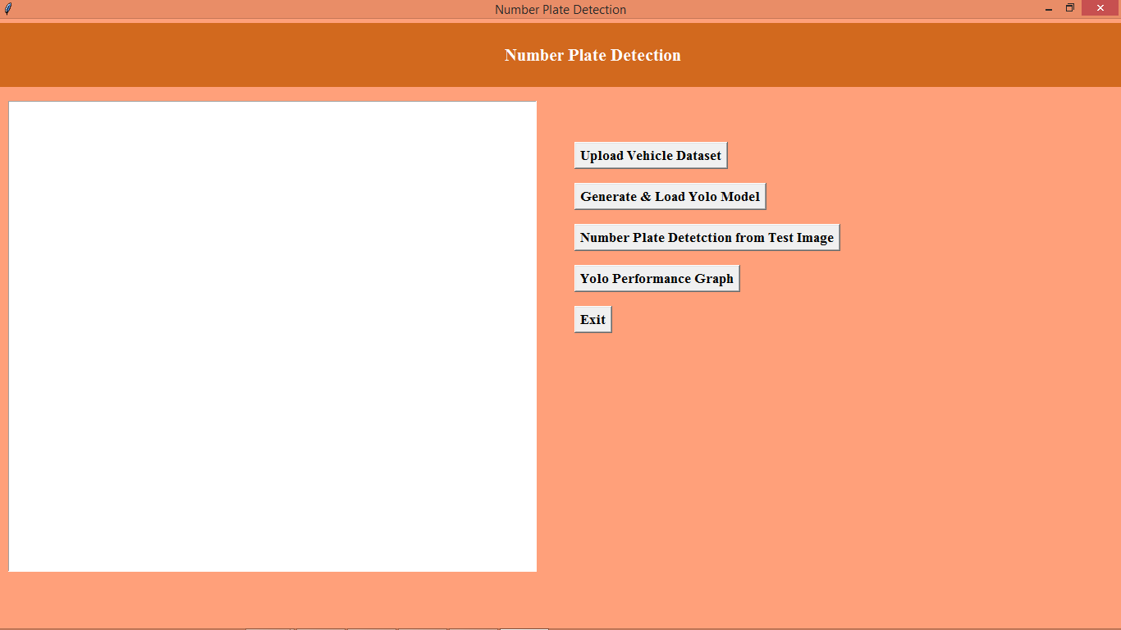
In above screen click on ‘Upload Vehicle Dataset’ button to upload dataset and get below output
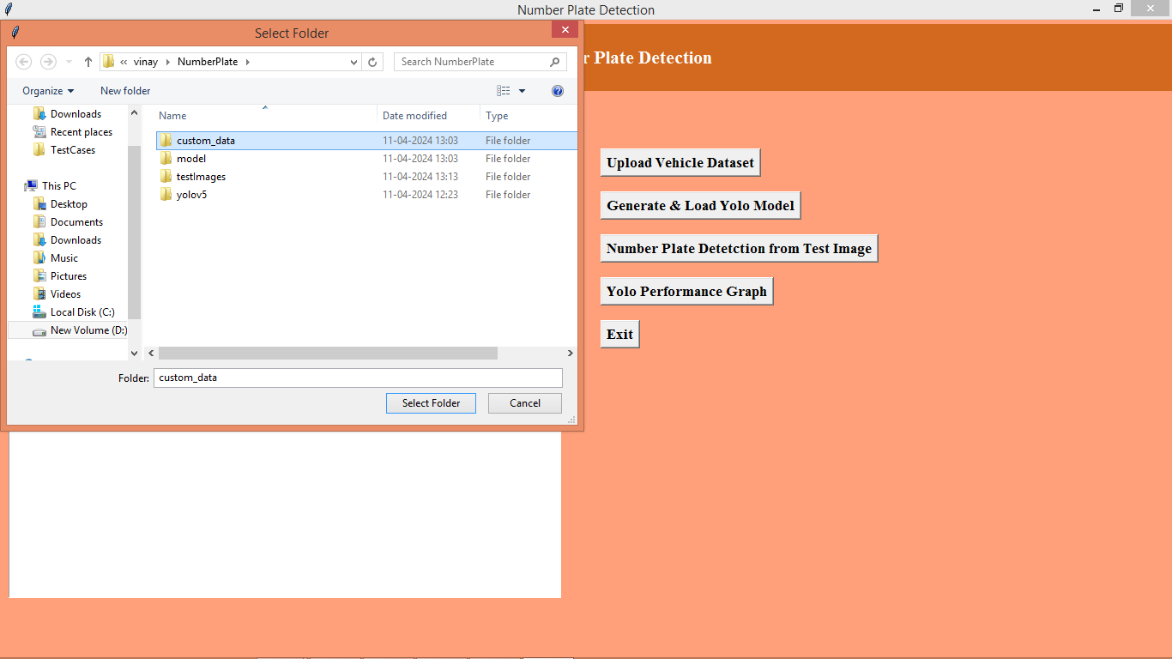
In above screen selecting and upload dataset folder and then click on ‘Select Folder’ button to load dataset and get below page
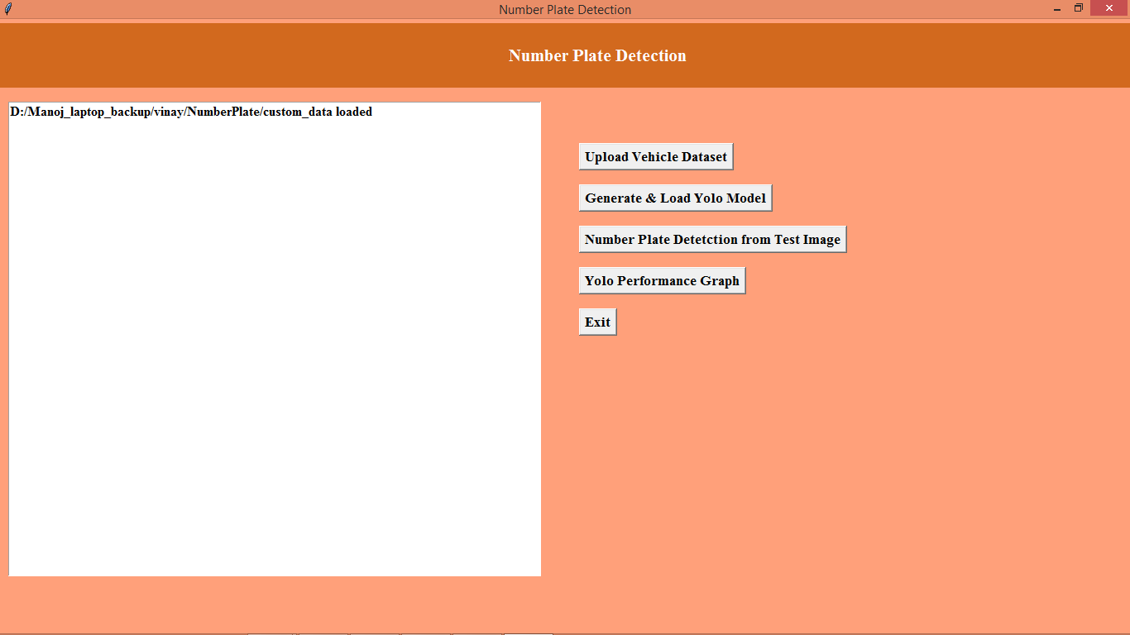
In above screen dataset loaded and now click on ‘Generate & Load YOLO Model’ button to load model and get below page
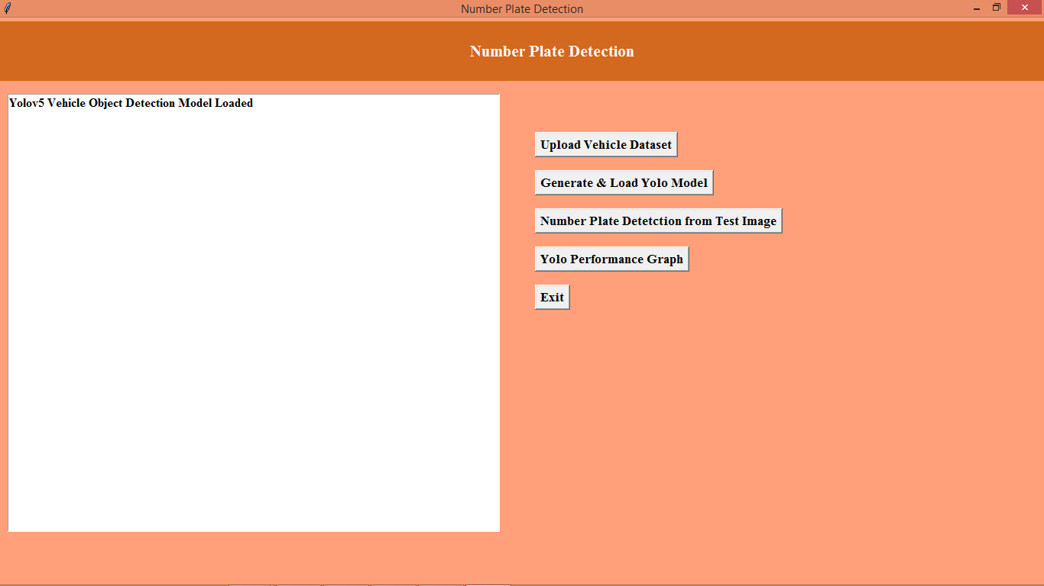
In above screen YOLO model loaded and now clicks on ‘Number Plate Detection from Test Image’ button to upload test image and get below output
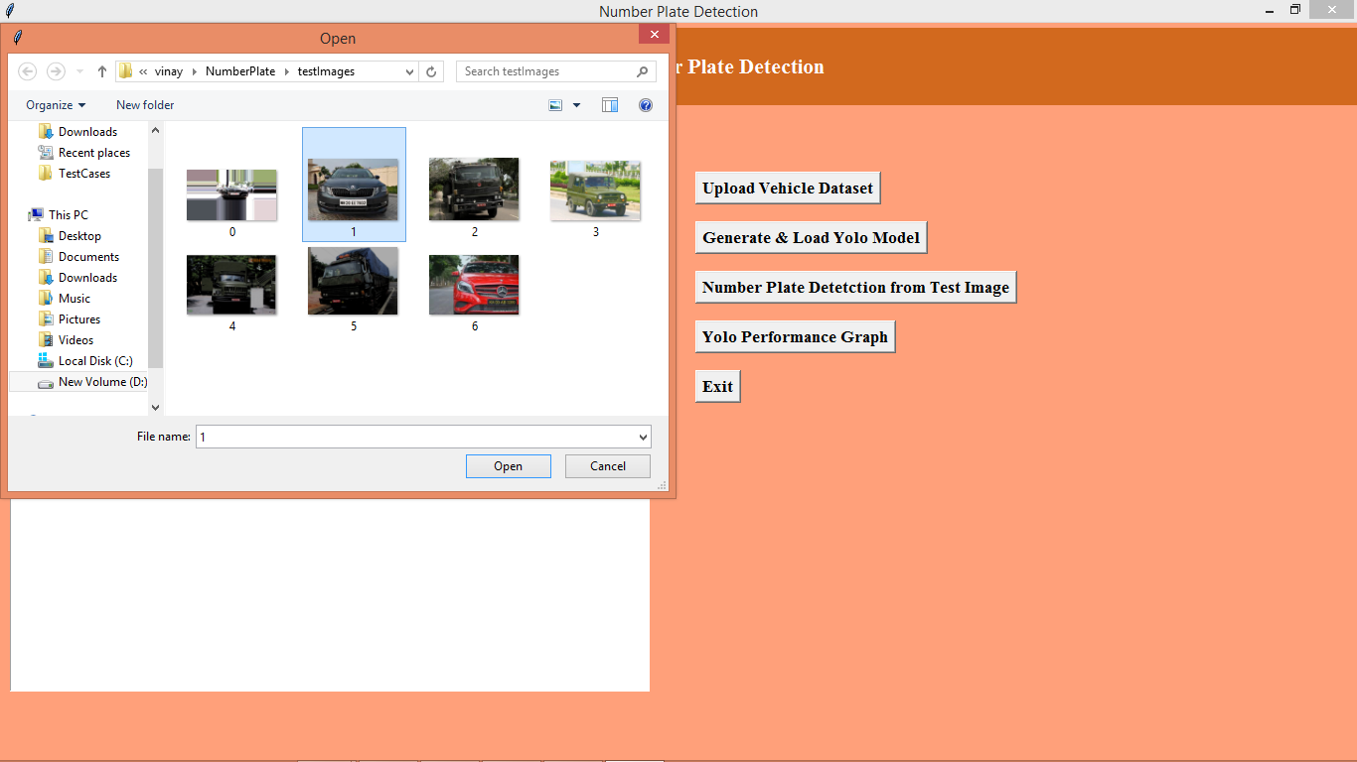
In above screen selecting and uploading ‘1.jpg’ image and then click on ‘Open’ button to get below page
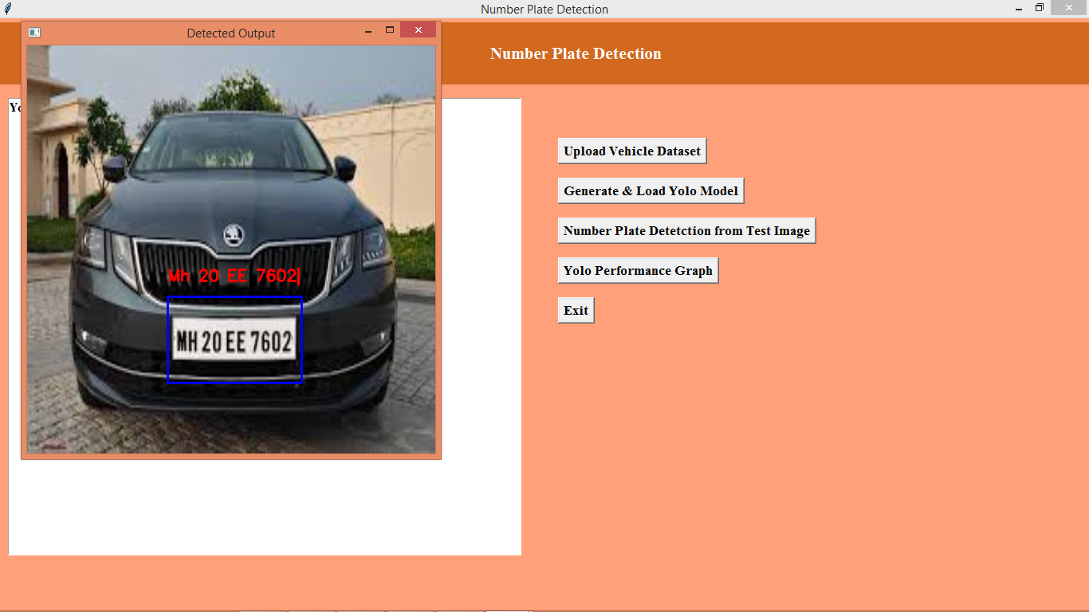
In above screen detected number plat e we are showing in blue colour bounding boxes and then detected plate number showing in red colour characters and this image we downloaded from below Google Page
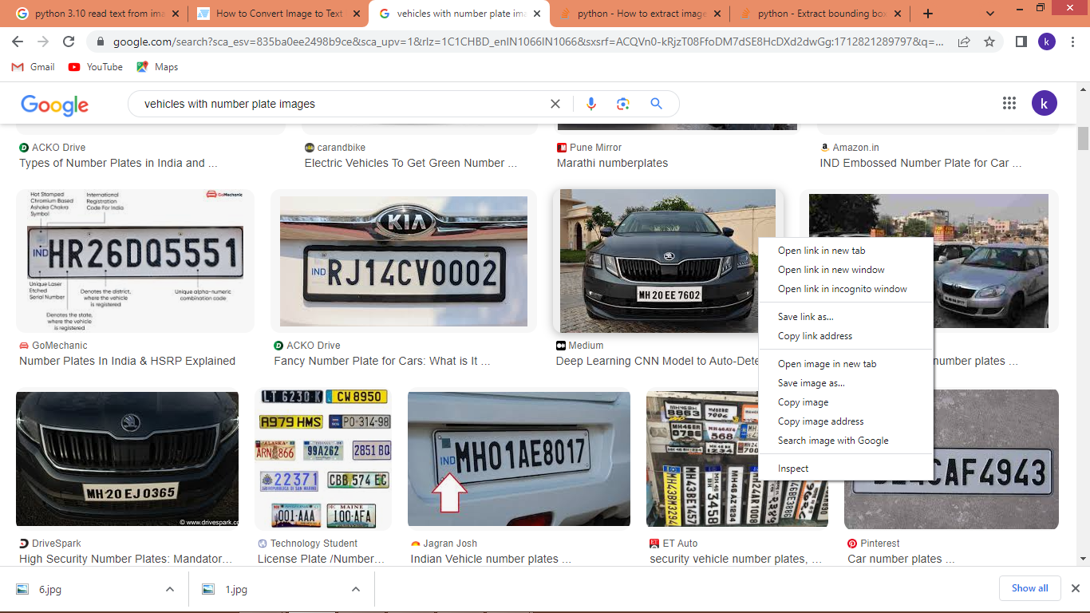
Similarly you can test with other images and below is another output
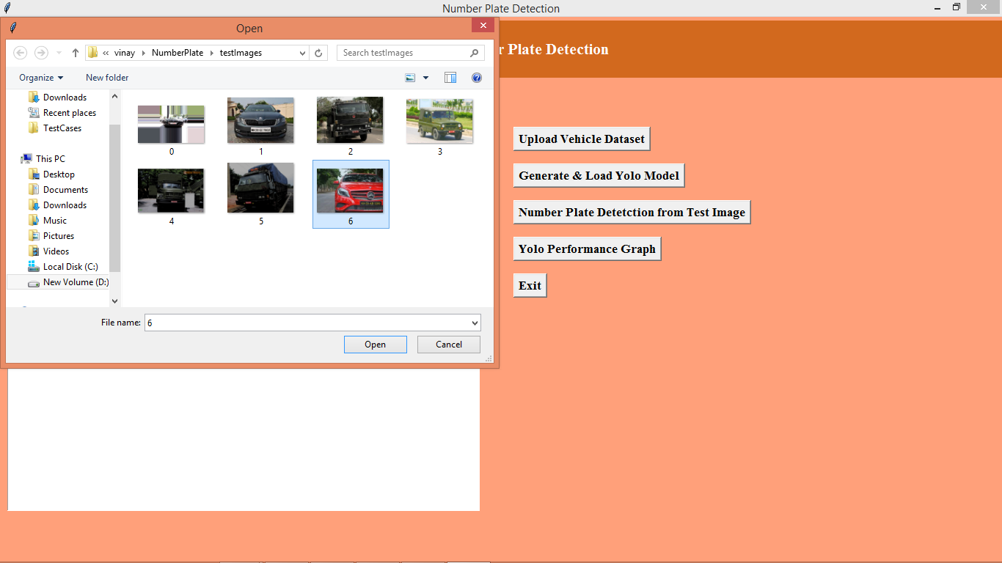
In above screen uploading another image and below is the output
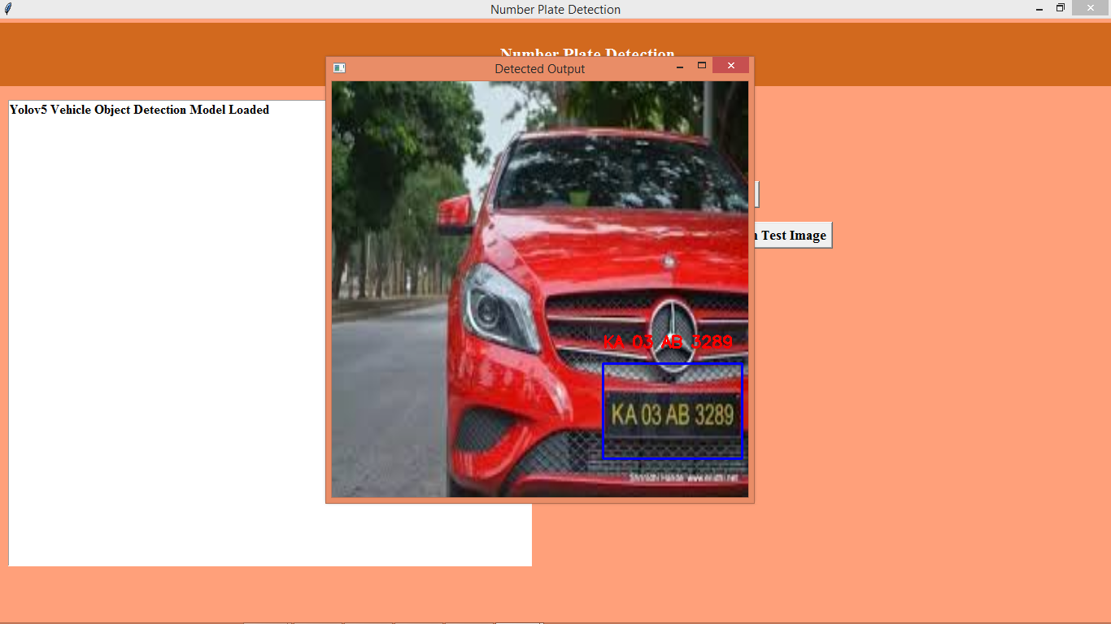
In above screen see red and blue colour output
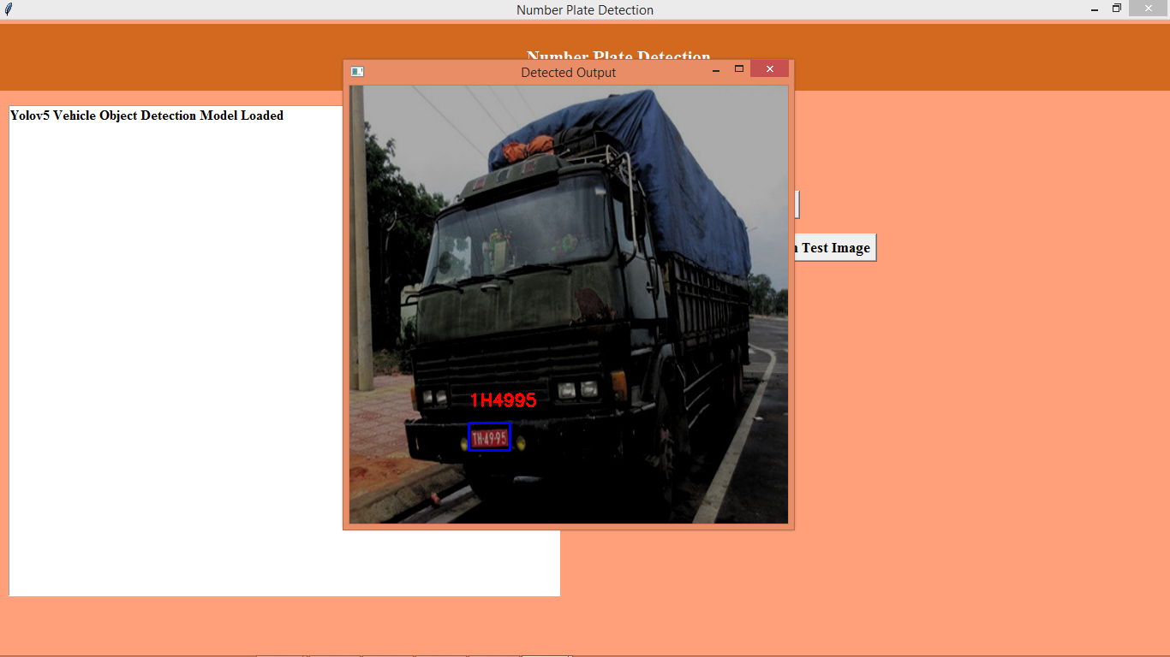
In above screen see red and blue colour output and now click on ‘Yolo Performance Graph’ button to get below graph
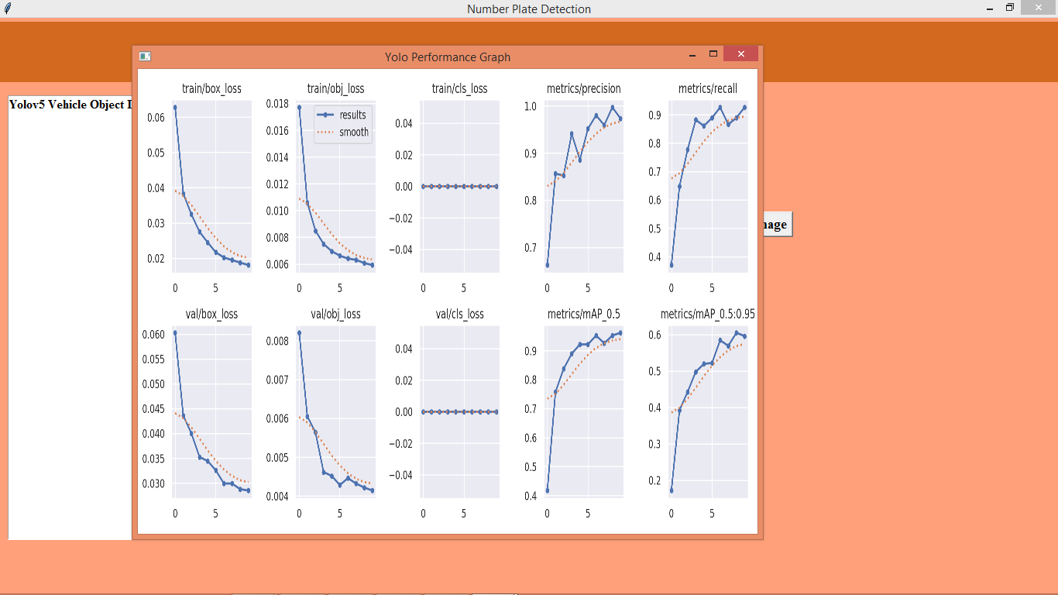
In above graph can see YOLO training loss, precision, recall and other graphs and can see loss values got decrease for each training and precision got increase.

