PROJECT TECHNICAL DOCUMENTATION
Flood Insurance Management System
A Microservices-Based Insurance Management Platform
Domain: Flood Insurance
Developer: Nanda Kishore
Documentation date: 07 October 2026
Organization / College: Not specified in the current project context

Table of Contents

Note: In Microsoft Word, right-click the Table of Contents and select “Update Field” to populate or refresh page numbers.

List of Figures
- Figure 1 — High-Level System Architecture
- Figure 2 — Entity and Cross-Service Relationship Model
- Figure 3 — UML Use Case Model
- Figure 4 — Authentication/User Management Class Model
- Figure 5 — Registration Sequence
- Figure 6 — Login/Authentication Sequence
- Figure 7 — Customer Linking / Identity Validation Sequence
- Figure 8 — API Gateway Request Sequence
- Figure 9 — Registration Flow
- Figure 10 — Login Flow
- Figure 11 — Authorization Flow
- Figure 12 — Customer Linking Flow
- Figure 13 — Insurance Business Flow
- Figure 14 — Inter-Service Communication Flow
- Figure 15 — Exception Handling Flow
- Figure 16 — Component Architecture
Deployment diagram — not generated because deployment infrastructure is insufficiently specified.

List of Tables
- Table 1 — Service Responsibilities
- Table 2 — Functional Requirements
- Table 3 — Business Rules
- Table 4 — Data Ownership and Cross-Service Access
- Table 5 — Data Model Overview
- Table 6 — Role-Based Access Control
- Table 7 — HTTP Status and Exception Mapping
- Table 8 — Technology Stack

1. Abstract
The Flood Insurance Management System is a domain-focused insurance platform designed to manage customers, insured properties, flood-risk assessment, insurance products, underwriting, quotations, policy issuance and claims. The system is implemented as a service-oriented/microservices solution with an Angular frontend, an API Gateway based on Ocelot, an authentication gateway, and independently organized backend services.
The principal engineering objective is to keep authentication, customer/property data, policy and claims responsibilities separated while allowing controlled API-mediated collaboration. The system uses JWT-based authentication and role-based authorization for Customer, Admin and ClaimManager roles. The backend follows Clean Architecture concepts, dependency injection, centralized exception handling and structured logging using Serilog.
The customer-facing business lifecycle is represented as: Property → Product → Risk Assessment → Underwriting → Quote → Policy → Claims. Underwriting may automatically make a case eligible for quote generation or route it to manual review. The Admin and ClaimManager workflows provide administrative and operational control over policies, underwriting and claims.
The project demonstrates practical application of microservice boundaries, API gateway routing, cross-service identity validation, domain-level business rules, secure authentication, RBAC, centralized error handling and Angular signal-based frontend state management.

2. Architecture Diagram

2.1 Architecture Overview
The system uses a layered microservices architecture. The Angular client communicates through the API Gateway rather than directly depending on every backend service. Authentication is handled through the authentication gateway/service boundary. Backend services own their respective data and expose APIs for controlled access.
Figure 1 — High-Level System Architecture
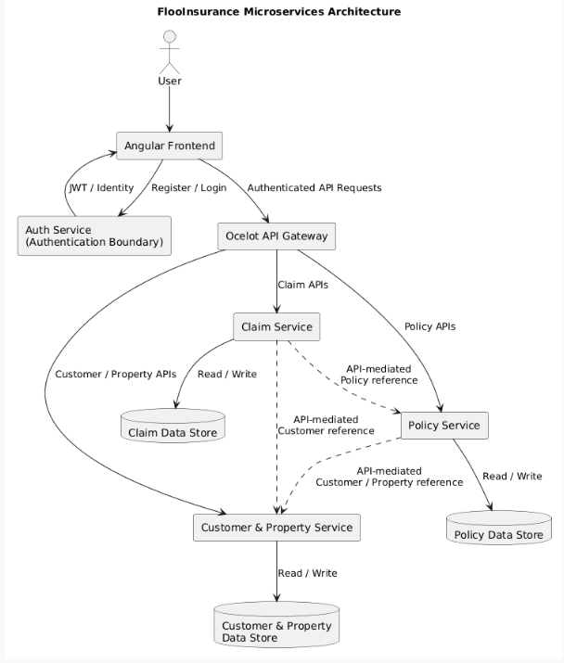
The exact physical database products/connection topology are not fully specified in the current project context; the diagram therefore expresses service-owned data stores rather than inventing specific database server topology.

2.2 Major Components and Responsibilities
Component | Responsibility
Angular Frontend | Customer, Admin and ClaimManager user interfaces; HTTP communication; route guards; signal-based UI state.
Auth Gateway / Authentication Boundary | Registration/login boundary and JWT issuance/identity handling as implemented in the project.
Ocelot API Gateway | Central API entry point and routing boundary for backend services.
Customer and Property Service | Customer identity/profile data and customer-related validation.
Policy Service | Insurance products, risk assessments, underwriting, quotes and policy-related business operations discussed in the project.
Claim Service | Claim creation, retrieval, assignment, review, approval/rejection, settlement and cancellation.
JWT / Authorization Middleware | Authentication and role/claim evaluation for protected requests.
Serilog / Logging | Structured application logging.
Global Exception Handling | Central translation of application exceptions into client-facing HTTP error responses.

2.3 Request and Authentication Flow
- A user interacts with the Angular application.
- Registration/login requests are sent to the authentication boundary.
- Successful login returns an access token; the frontend stores the token under the application's configured token key.
- Authenticated API calls are sent through the Ocelot gateway.
- JWT authentication and authorization policies determine whether the request may reach the target operation.
- The target microservice executes its application/domain logic and accesses only its owned persistence boundary.
- Where another service's identity or resource must be validated, the application uses a service/API-mediated reference rather than direct database ownership sharing.
- The result or a centralized error response is returned through the gateway to the Angular client.

3. ER Diagram
Because the system is organized around service boundaries, this ER representation distinguishes database-level ownership from logical cross-service references. Shared identifiers such as CustomerId, PropertyId or PolicyId must not be interpreted as physical foreign keys across separate service databases.
Figure 2 — Entity and Cross-Service Relationship Model
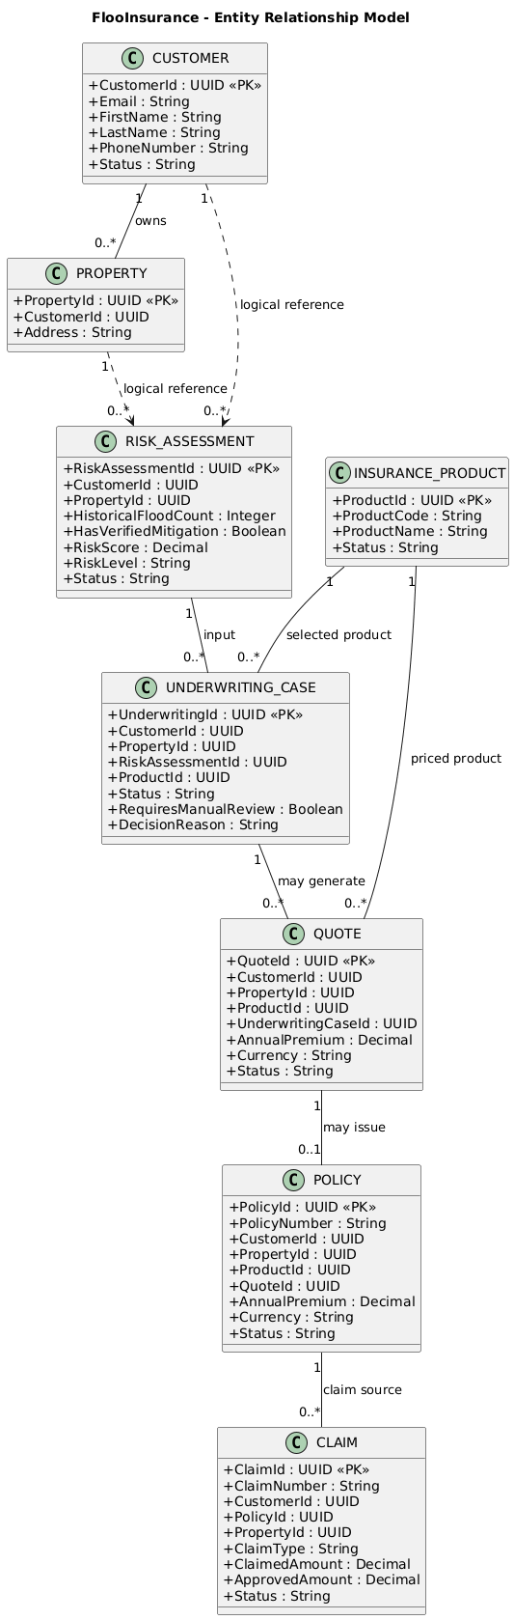

3.1 Ownership Interpretation
Entity | Logical Owner | Relationship Type
Customer | Customer and PropertyService | Database-level within Customer Service.
Property | Customer and Property Service | Database-level within Customer Service; CustomerId is a reference to customer identity.
InsuranceProduct | Policy Service | Database-level within Policy Service.
RiskAssessment | Policy Service | Database-level within Policy Service; references customer/property identifiers.
UnderwritingCase | Policy Service | Database-level within Policy Service; references assessment/product identifiers.
Quote | Policy Service | Database-level within Policy Service; references underwriting/customer/property/product identifiers.
Policy | Policy Service | Database-level within Policy Service; references quote/customer/property/product identifiers.
Claim | Claim Service | Database-level within Claim Service; PolicyId and related identifiers are cross-service references where applicable.

Note: The exact physical table names, database engine and EF Core migration schema are not specified in the current project context.

4. UML Diagrams

4.1 Use Case Diagram
Figure 3 — UML Use Case Model

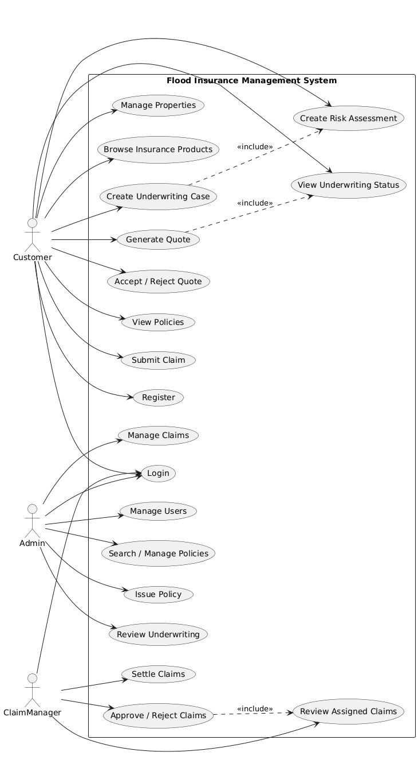4.2 Class Diagram — Authentication and Application Boundary
Figure 4 — Authentication/Us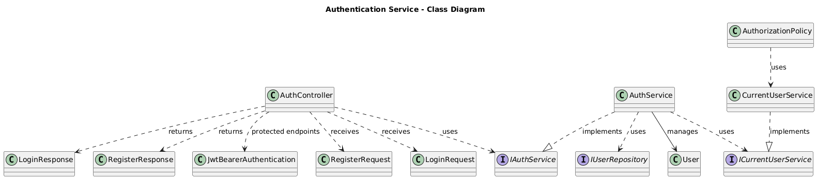User Management Class Model
DOMAIN:

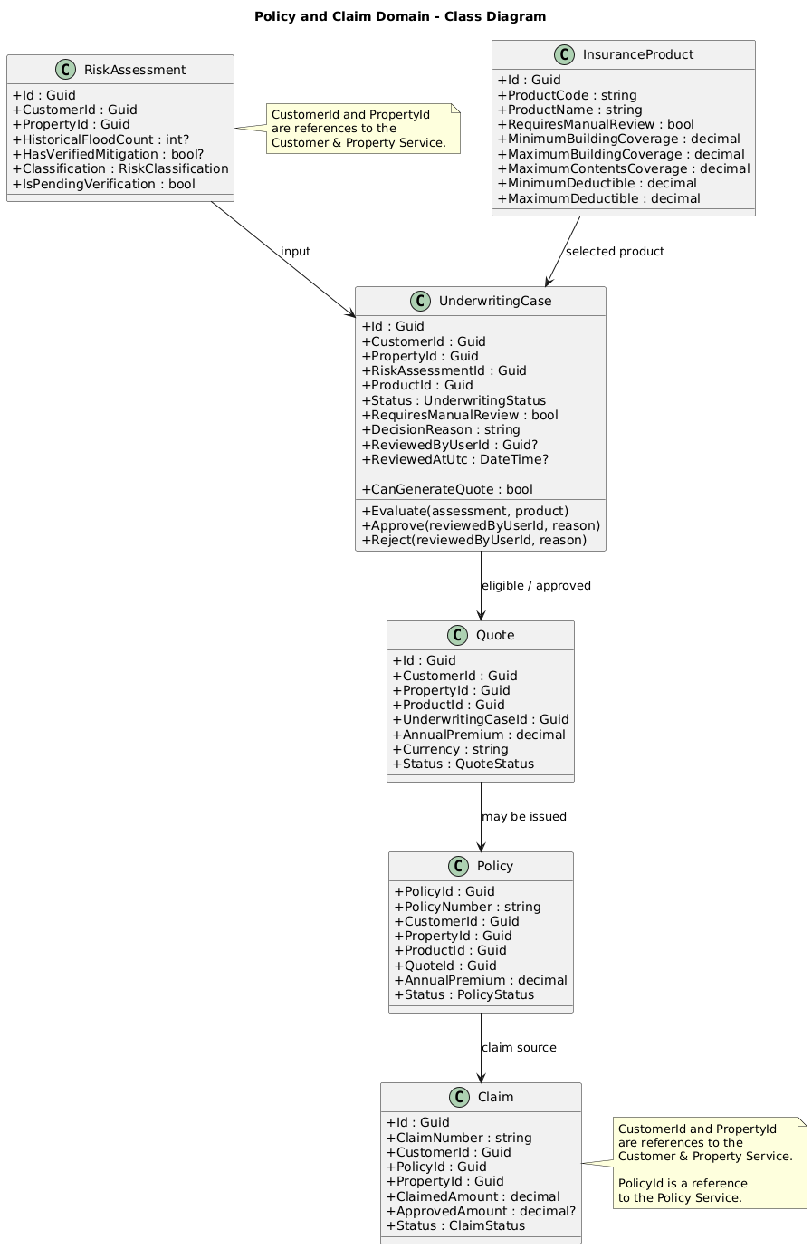

4.4 Sequence Diagram — User Registration
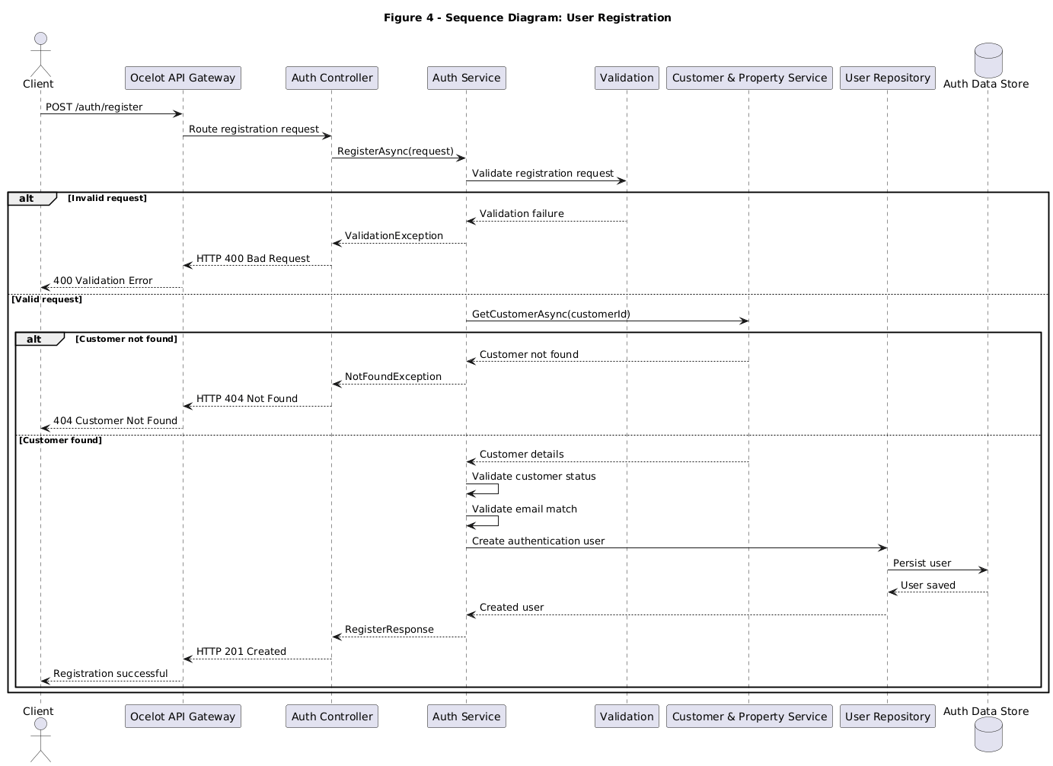

4.5 Sequence Diagram — Login / Authentication
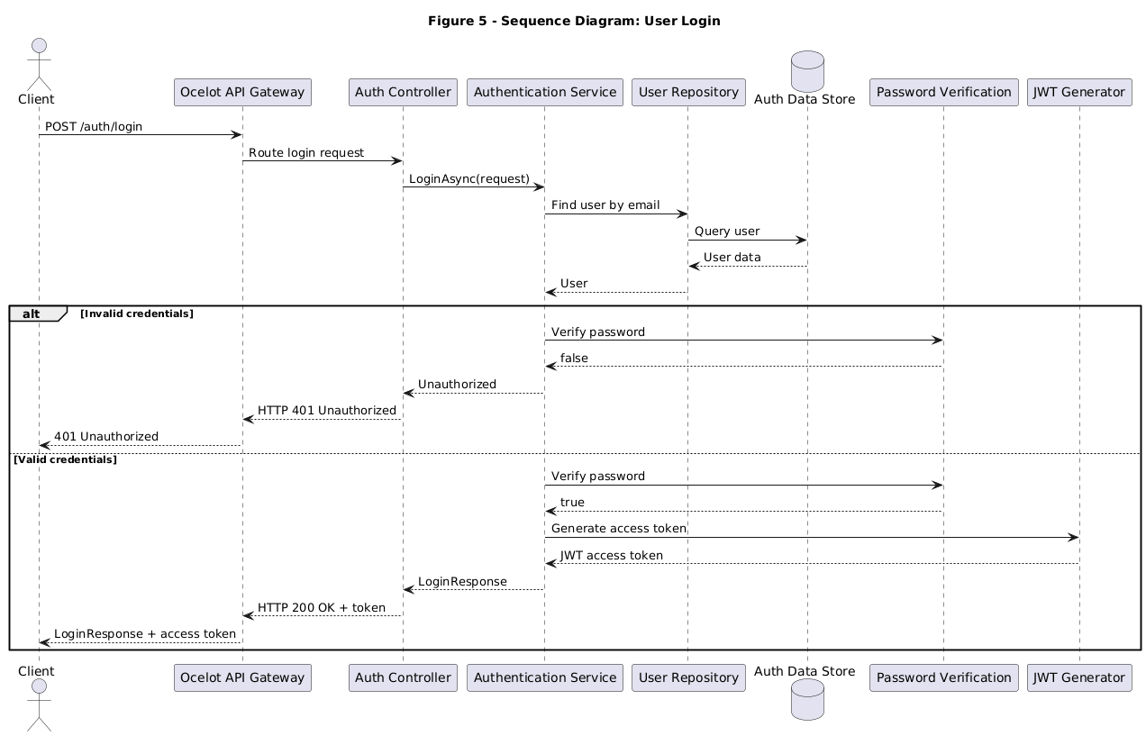

4.6 Sequence Diagram — Customer Linking / Identity Validation
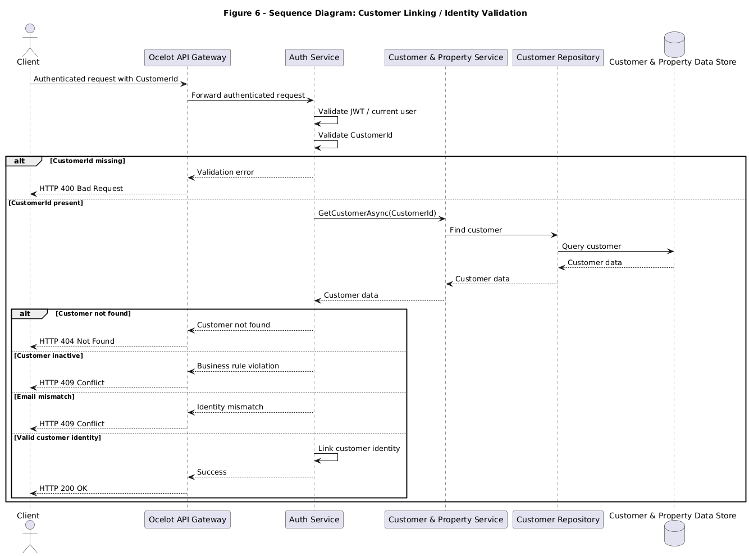
Figure 6 Sequence Diagram — Customer Linking / Identity Validation

4.7 Sequence Diagram — API Gateway Request Flow
Figure 7 Sequence Diagram — API Gateway Request Flow
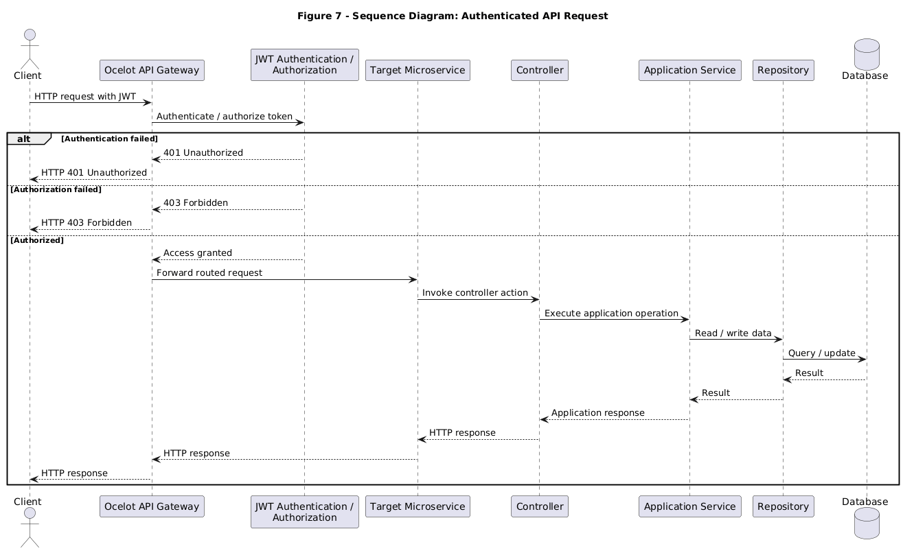

5. Flow Diagrams

5.1 User Registration Flow

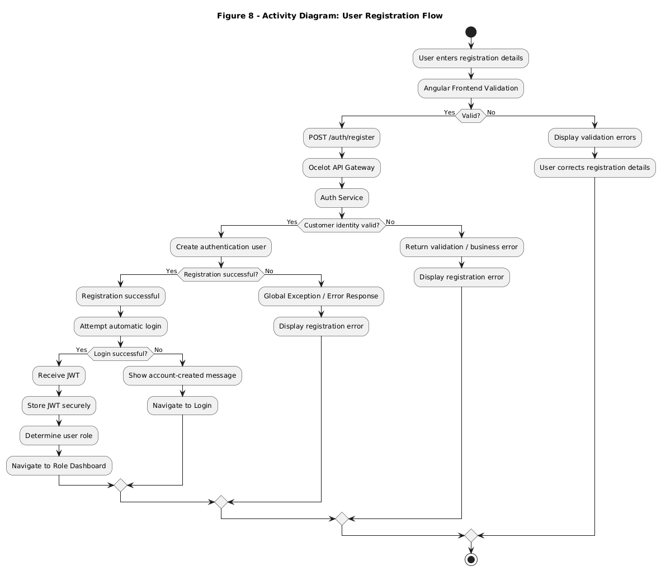5.2 Login Flow
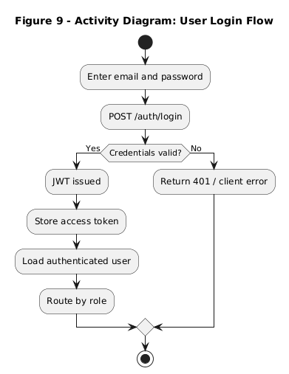

5.3 Authorization Flow
5.3 Authorization Flow

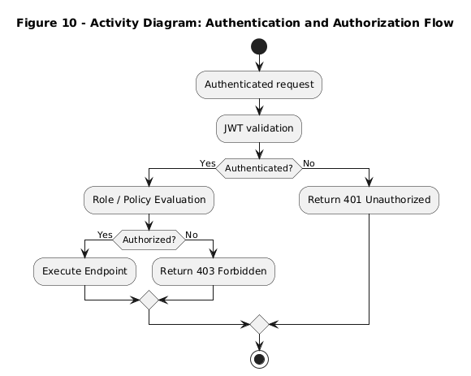

5.4 Customer Linking Flow
5.4 Customer Linking Flow

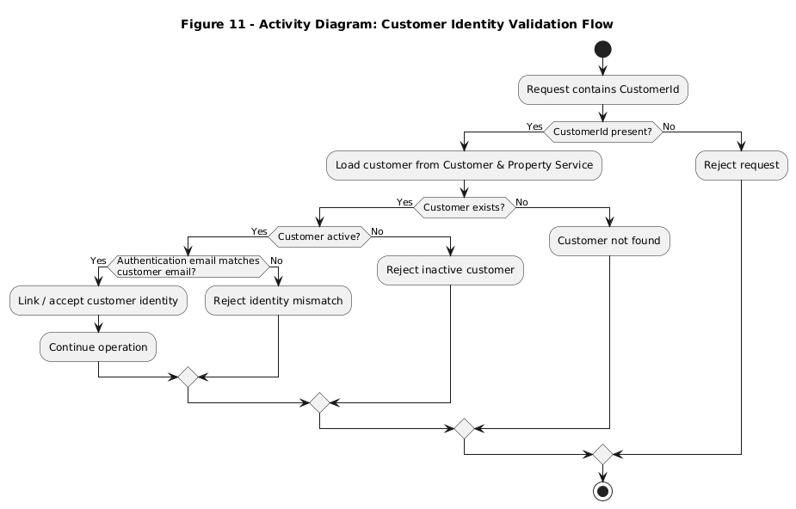

5.5 Important Insurance Business Flow
5.5 Important Insurance Business Flow

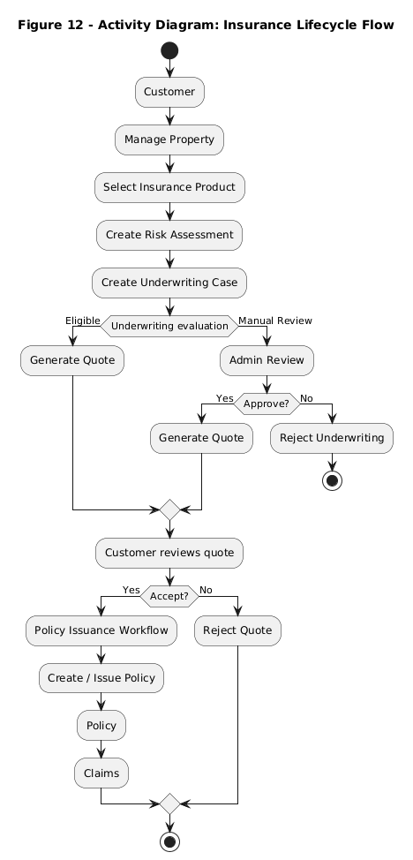

5.6 Inter-Service Communication Flow

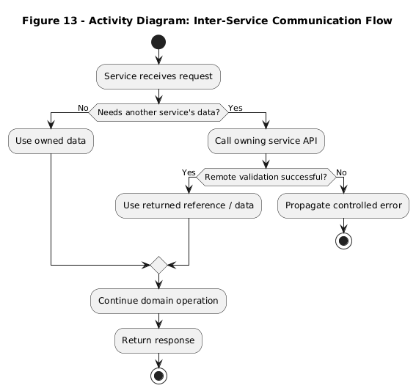

5.7 Exception Handling Flow

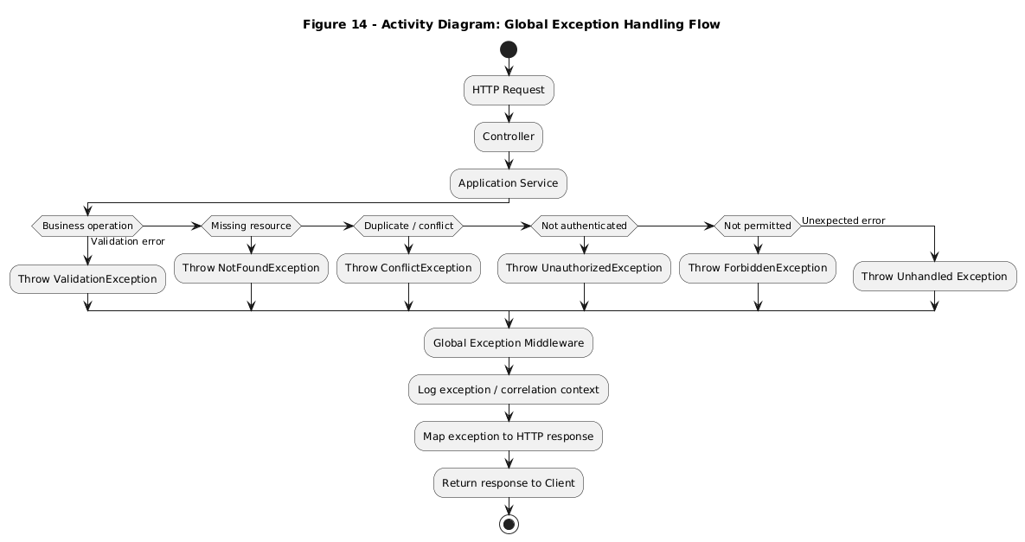

6. Functional Requirements
ID | Functional Requirement | Description | Actor/Role | Priority
FR-01 | Registration | Register an insurance-system user through the authentication boundary. | Customer | High
FR-02 | Login | Authenticate with credentials and obtain a JWT access token. | All authenticated roles | High
FR-03 | Role-based access | Restrict protected operations using JWT claims and authorization policies. | All roles | High
FR-04 | Property management | Create and view customer-owned properties. | Customer | High
FR-05 | Product browsing | Retrieve available insurance products. | Customer | High
FR-06 | Risk assessment | Create and retrieve customer risk assessments. | Customer | High
FR-07 | Underwriting | Create and view underwriting cases. | Customer | High
FR-08 | Manual underwriting review | Approve or reject pending underwriting cases. | Admin / ClaimManager | High
FR-09 | Quote generation | Generate quotes for eligible/approved underwriting cases. | Customer/System workflow | High
FR-10 | Quote decision | Allow the customer to accept or reject a quote. | Customer | High
FR-11 | Policy management | View customer policies and policy details. | Customer | High
FR-12 | Admin policy search | Search policies by policy number, customer ID or property ID. | Admin | High
FR-13 | Policy issuance | Support the administrative policy issuance workflow. | Admin | High
FR-14 | Claims | Create and view customer claims. | Customer | High
FR-15 | Claim operations | Assign, start review, approve/reject and settle claims. | Admin / ClaimManager | High
FR-16 | Claim cancellation | Allow supported claim cancellation workflow. | Customer / authorized workflow | Medium
FR-17 | Centralized errors | Return consistent client-facing errors from centralized exception handling. | System | High
FR-18 | Structured logging | Log application events/errors using Serilog. | System | Medium

7. Business Rules and Configurable Parameters

7.1 Business Rules
Rule ID | Business Rule | Rationale | Enforcement Location
BR-01 | A protected operation requires a valid authenticated identity. | Prevent unauthenticated access. | JWT authentication middleware / guards
BR-02 | Role claims determine access to role-specific operations. | Separate Customer, Admin and ClaimManager responsibilities. | Authorization policies / role guards
BR-03 | Customer identity must be validated against the authoritative Customer Service data when the workflow requires customer linking. | Prevent orphaned or mismatched customer identities. | Authentication/application service + Customer Service
BR-04 | Customer-specific policy/underwriting data is retrieved using the authenticated customer identity. | Prevent one customer from viewing another customer's resources. | Application service/controller + authorization
BR-05 | Duplicate underwriting cases for the same assessment/product are rejected. | Prevent duplicate business transactions. | Underwriting application service/repository
BR-06 | An underwriting case requiring manual review enters PendingReview. | Human review is required for elevated/manual-review conditions. | UnderwritingCase.Evaluate
BR-07 | An eligible underwriting case can generate a quote. | Only evaluated/approved underwriting cases may proceed. | UnderwritingCase.CanGenerateQuote
BR-08 | Approval of a pending underwriting case makes it eligible for quote generation. | Connect manual approval to quote workflow. | Underwriting domain/application logic
BR-09 | Claim-manager claim operations are restricted to appropriate claim-manager ownership/assignment where implemented. | Maintain operational accountability. | Claim service authorization/business logic
BR-10 | Indian phone validation in the frontend requires exactly 10 digits beginning 6–9. | Reject malformed mobile numbers at the UI boundary. | Angular registration validators
BR-11 | Indian PIN validation in the frontend requires a six-digit code beginning 1–9. | Reject malformed postal codes. | Angular registration validators
BR-12 | Registration password validation requires minimum length and upper/lowercase/number/special-character composition. | Provide a strong credential boundary. | Angular validation; backend validation should remain authoritative

7.2 Configurable Parameters
Parameter | Purpose | Current Project Context
API_CONFIG.baseUrl | Frontend backend/API base URL. | Used by Angular services; exact production value is not specified here.
JWT access token | Authenticated request credential. | Stored by the frontend under floo_access_token in the discussed implementation.
JWT validation settings | Signature/issuer/audience/token validation. | Configured in backend JWT bearer authentication; exact secret/issuer values are not specified.
Gateway routes | Route frontend API calls to backend services. | Ocelot is used; exact route configuration values are not fully specified.
CORS | Permit the frontend origin to call APIs. | Configured in backend; exact origin list is not specified.
Logging configuration | Serilog sinks/levels/output. | Serilog is used; exact sink configuration is not specified.

Note: Secrets, connection strings and token signing keys are intentionally not reproduced in this document.

8. Data Ownership and Cross-Service Rules
Service | Owns Data | Can Read | Can Modify | Cross-Service Access Method
Auth Gateway / Auth boundary | Authentication users/credentials and identity claims as implemented. | Own authentication data. | Authentication data. | API/application integration with Customer Service when identity linking is required.
Customer and Property Service | Customer profile/identity data and Property Records | Own customer data and data exposed by APIs. | Customer records and Property Records | API endpoints consumed by other services.
Policy Service | Products, risk assessments, underwriting, quotes and policy records within its bounded context. | Its own records and data exposed by other services. | Its own records. | API-mediated customer/property/claim references where needed.
Claim Service | Claim records and claim workflow state. | Claims and permitted referenced policy/customer data. | Claim records. | API-mediated references to Policy/Customer data; no direct database ownership sharing.

The authoritative owner of a business object should be the service that defines its lifecycle. Other services should store only the identifier/reference necessary for their workflow and validate the reference through an API when business correctness requires current data.

8.1 Customer Identity Linking
The project context emphasizes that an authentication user must not be associated with a randomly generated CustomerId when the business rule requires an existing customer. A valid linking workflow checks the supplied CustomerId, retrieves the customer from Customer Service, verifies that the customer exists and is active where required, compares identity attributes such as email when required by the implementation, and only then establishes the association.
- Customer Service remains authoritative for customer business identity.
- Authentication remains authoritative for login credentials and authenticated claims.
- A shared CustomerId is a logical cross-service reference unless both records belong to the same database boundary.
- Direct database access between services should be avoided.
- A failure to validate a customer reference should stop the dependent business operation rather than creating a dangling relationship.

9. Data Model Overview
Entity | Purpose | Primary Key | Important Attributes | Owner Service | Relationships
Customer | Represents insurance customer identity/profile. | CustomerId | Email, name, phone, status. | Customer Service | Customer → properties, risk/policy/claim references.
Property | Represents an insured/customer-owned property. | PropertyId | CustomerId, address/property information. | Property Service | Logical reference to Customer.
InsuranceProduct | Defines available flood insurance product/rules. | ProductId | ProductCode, ProductName, coverage/deductible limits, review flag. | Policy Service | Referenced by underwriting/quote/policy.
RiskAssessment | Captures flood-risk inputs and classification. | RiskAssessmentId | PropertyId, flood count, mitigation, score/level/status. | Policy Service | Input to underwriting.
UnderwritingCase | Represents underwriting decision state. | Id | CustomerId, PropertyId, RiskAssessmentId, ProductId, Status, DecisionReason, review fields. | Policy Service | Uses risk/product; may generate quote.
Quote | Represents premium offer. | QuoteId | UnderwritingCaseId, coverages, premiums, risk multiplier, fee, annual premium, expiry, status. | Policy Service | May be accepted/rejected; may lead to policy issuance.
Policy | Represents issued insurance contract. | PolicyId | PolicyNumber, customer/property/product/quote IDs, premium, dates, status. | Policy Service | Claims reference policy.
Claim | Represents reported insurance loss. | ClaimId | ClaimNumber, PolicyId, incident/report dates, claimed/approved amount, status, assignment/review/settlement. | Claim Service | References policy/customer/property.

9.1 Underwriting Domain State
The UnderwritingCase domain logic evaluates a RiskAssessment and InsuranceProduct. A pending-verification assessment, a product requiring manual review, or an elevated/high risk classification can result in PendingReview. Otherwise the case becomes EligibleForQuote. Manual approval changes a pending case to Approved; the domain exposes CanGenerateQuote when the status is EligibleForQuote or Approved.

10. API Documentation
The following APIs are documented because they were explicitly present in the project context. Where an exact request/response schema or authorization policy was not available, this is marked rather than inferred.

Authentication
Endpoint | Purpose | Auth | Request | Response | Status Codes | Important Validation
POST /api/auth/register | Register a new user/customer account. | Public | Registration request. | RegisterResponse; exact full schema available in frontend context. | 200/201; 400; 409; 500 | Validation and duplicate-account errors.
POST /api/auth/login | Authenticate credentials and issue access token. | Public | Email/password. | LoginResponse containing accessToken in the discussed frontend implementation. | 200; 401; 400; 500 | Invalid credentials.

Underwriting
Endpoint | Purpose | Auth | Request | Response | Status Codes | Important Validation
POST /api/underwriting | Create an underwriting case for a risk assessment/product. | Authenticated Customer / authorized caller | riskAssessmentId, productId. | UnderwritingCase response. | 200/201; 400; 403; 409; 500 | Duplicate assessment/product combination is rejected with ConflictException.
GET /api/underwriting/{underwritingId} | Get underwriting case details. | Authenticated | Route underwritingId. | UnderwritingCase response. | 200; 403; 404 | Missing/unauthorized resource.
GET /api/underwriting/customer/{customerId} | Get paged underwriting cases for a customer. | Authenticated Customer / authorized policy | customerId, pageNumber, pageSize. | PagedResult<UnderwritingCase>. | 200; 403; 404 | Customer identity/ownership validation.
GET /api/underwriting/pending-review | Get underwriting cases awaiting manual review. | Reviewer role | None. | Underwriting case collection/paged result depending on controller implementation. | 200; 401; 403 | Reviewer authorization.
POST /api/underwriting/{underwritingId}/approve | Approve a pending underwriting case. | Admin / ClaimManager workflow as configured | reason. | UnderwritingCase response. | 200; 400; 403; 404 | Case must be PendingReview.
POST /api/underwriting/{underwritingId}/reject | Reject a pending underwriting case. | Admin / ClaimManager workflow as configured | reason. | UnderwritingCase response. | 200; 400; 403; 404 | Case must be PendingReview.

Quotes
Endpoint | Purpose | Auth | Request | Response | Status Codes | Important Validation
POST /api/quotes | Generate a quote for an eligible/approved underwriting case. | Authenticated | underwritingCaseId, buildingCoverage, contentsCoverage, deductible. | QuoteResponse. | 200/201; 400; 403; 409 | Coverage/deductible/product/underwriting validation.
GET /api/quotes/{quoteId} | Retrieve quote details. | Authenticated | quoteId. | QuoteResponse. | 200; 403; 404 | Ownership/resource validation.
GET /api/quotes/customer/{customerId} | Retrieve paged customer quotes. | Authenticated | customerId, pageNumber, pageSize. | PagedResult<QuoteResponse>. | 200; 403; 404 | Customer ownership validation.
POST /api/quotes/{quoteId}/accept | Accept a quote. | Customer/authorized owner | quoteId. | Updated quote. | 200; 400; 403; 404; 409 | Quote state/expiry/ownership rules.
POST /api/quotes/{quoteId}/reject | Reject a quote. | Customer/authorized owner | quoteId. | Updated quote. | 200; 400; 403; 404; 409 | Quote state/ownership rules.

Claims
Endpoint | Purpose | Auth | Request | Response | Status Codes | Important Validation
POST /api/claims | Create a claim. | Authenticated Customer | policyId, claimType, incidentDateUtc, description, claimedAmount. | ClaimResponse. | 201/200; 400; 403; 404; 409 | Policy/customer ownership and claim validation.
GET /api/claims | Administrative/authorized claim listing. | Authorized role | Exact query schema not fully specified. | Claim collection/paged response. | 200; 401; 403 | Authorization.
GET /api/claims/my | Get current user's claims. | Authenticated | pageNumber, pageSize where supported. | PagedResult<ClaimResponse>. | 200; 403 | Customer or ClaimManager current-user logic.
GET /api/claims/{claimId} | Get claim details. | Authenticated/authorized | claimId. | ClaimResponse. | 200; 403; 404 | Ownership/assignment.
POST /api/claims/{claimId}/cancel | Cancel a claim. | Authorized customer/workflow | claimId. | Updated claim. | 200; 400; 403; 404 | Claim state validation.
GET /api/claims/claim-managers | List available claim managers. | Admin/authorized role | None. | Claim manager list. | 200; 401; 403 | Authorization.
POST /api/claims/{claimId}/assign | Assign a claim to a ClaimManager. | Admin | claimManagerUserId. | Updated claim. | 200; 400; 403; 404 | Manager existence and assignment rules.
POST /api/claims/{claimId}/start-review | Start claim review. | Assigned ClaimManager | claimId. | Updated claim. | 200; 400; 403; 404 | Assignment/state validation.
POST /api/claims/{claimId}/approve | Approve a claim. | Assigned ClaimManager | approvedAmount, reviewNotes. | Updated claim. | 200; 400; 403; 404 | Approved amount/state validation.
POST /api/claims/{claimId}/reject | Reject a claim. | Assigned ClaimManager | reviewNotes. | Updated claim. | 200; 400; 403; 404 | Claim state validation.
POST /api/claims/{claimId}/settle | Settle an approved claim. | Authorized ClaimManager/Admin workflow | claimId. | Updated claim. | 200; 400; 403; 404 | Claim must be in an appropriate state.

10.1 Policy APIs and Other Endpoints
Policy and product/risk-assessment endpoints are present in the project context, including customer policy retrieval, policy detail retrieval, product listing/detail, risk-assessment listing/detail/create, and administrative policy workflows. Exact route spellings beyond those explicitly recorded below are not reproduced where the conversation did not provide them.
Known Route | Purpose
GET /api/policies/customer/{customerId} | Paged customer policies.
GET /api/policies/{policyId} | Policy detail.
GET /api/products | Product listing.
GET /api/products/{productId} | Product detail.
GET /api/risk-assessments/customer/{customerId} | Customer risk assessments.
GET /api/risk-assessments/{riskAssessmentId} | Risk assessment detail.
GET /api/risk-assessments/property/{propertyId} | Property risk assessments.
POST /api/risk-assessments | Create risk assessment.

11. Role-Based Access Table
Feature/API | Admin | Customer | ClaimManager | Authentication
Register/Login | Login | Register/Login | Login | Register public; login public
Customer properties | Administrative context as exposed | Own properties | Not a primary function | Yes for protected operations
Products | View/admin context | View | Operational access as required | Yes for protected API
Risk assessments | Administrative access as configured | Create/view own | Not primary | Yes
Underwriting create | Authorized | Create/view own | Not primary | Yes
Underwriting pending review | Review | No | Review | Yes
Approve/reject underwriting | Yes | No | Yes where configured | Yes
Quotes | Administrative access as configured | Generate/view/accept/reject own | Not primary | Yes
Policies | Search/manage/issue | View own | Operational access where permitted | Yes
Claims create | Administrative context | Create/view own | No | Yes
Claim assignment | Yes | No | No | Yes
Claim review/approve/reject/settle | Administrative workflow | No | Assigned ClaimManager | Yes

Note: The project defines role names Admin, Customer and ClaimManager. Some historical code/comments used 'ClaimsManager'; the latest role naming uses ClaimManager.

12. Exception Handling Strategy
The backend follows centralized exception handling. Controllers and application services can raise domain/application exceptions such as validation, not-found, conflict, unauthorized and forbidden exceptions. A global exception middleware/handler translates these into consistent HTTP responses.
Exception Category | Typical Meaning | HTTP Status
ValidationException | Request or business input is invalid. | 400 Bad Request
NotFoundException | Requested resource does not exist. | 404 Not Found
ConflictException | Operation conflicts with current state or duplicate business data. | 409 Conflict
UnauthorizedException | No valid authenticated identity. | 401 Unauthorized
ForbiddenException | Identity exists but lacks permission or violates ownership. | 403 Forbidden
Unhandled exception | Unexpected server-side failure. | 500 Internal Server Error

The intended lifecycle is: Request → Controller → Application Service → Domain/Repository → exception if required → Global Exception Middleware → structured log → HTTP response → Angular error handling. Centralization avoids repeating try/catch blocks and gives clients a consistent error contract.
The frontend error handlers demonstrated in the project read fields such as detail, message and title from the returned error object and show a safe user-facing message while logging technical information to the browser console during development.

13. Technology Stack and Solution Layout
Category | Technology / Pattern | Use
Frontend | Angular | Standalone component-based frontend.
Frontend State | Angular Signals | Component/UI state such as loading, errors, lists and computed availability.
Frontend Forms | Angular Reactive Forms / FormsModule | Registration, create-property and other form workflows.
Frontend Routing | Angular Router | Role-protected customer/admin/claim-manager routes.
Backend | ASP.NET Core / .NET | REST API microservices.
Architecture | Clean Architecture | Separation of domain, application, infrastructure and API concerns.
Gateway | Ocelot | API gateway/routing boundary.
Authentication | JWT Bearer | Stateless authenticated API requests.
Authorization | ASP.NET Core policies/roles | Role and policy based access control.
Logging | Serilog | Structured logging.
Exception handling | Global exception handling middleware | Centralized error-to-HTTP mapping.
Persistence | Repository/data-access pattern | Service-owned persistence boundary.
Testing/Tools | Swagger/OpenAPI discussed | API inspection/testing.

13.1 Solution Layout
Flood Insurance Management System
│
├── Angular Frontend
│ ├── core/
│ │ ├── auth/
│ │ ├── guards/
│ │ └── API configuration
│ └── features/
│ ├── customer/
│ │ ├── properties/
│ │ ├── products/
│ │ ├── risk-assessments/
│ │ ├── underwriting/
│ │ ├── quotes/
│ │ ├── policies/
│ │ └── claims/
│ ├── admin/
│ │ ├── policies/
│ │ └── claims/
│ └── claim-manager/
│ ├── underwriting/
│ └── claims/
│
├── Auth Gateway / Authentication Service
├── Ocelot API Gateway
├── Customer and Property Service
├── Policy Service
└── Claim Service
Note: Exact physical solution-folder names, project-file names and database engine are not completely specified in the current project context.

14. Innovation Summary

14.1 Genuine Engineering Value
- Domain-aligned microservice decomposition separates customer identity, property, policy/underwriting and claims responsibilities.
- API gateway centralizes routing and provides a controlled entry point to backend services.
- Cross-service identity validation prevents an authentication identity from being linked to an invalid or unrelated business customer.
- Underwriting encapsulates meaningful flood-risk business rules instead of reducing underwriting to CRUD.
- Manual-review state is explicitly represented in the underwriting domain.
- JWT and role-based authorization provide distinct operational capabilities for Customer, Admin and ClaimManager.
- Global exception handling reduces duplicated error-handling logic across controllers.
- Angular signals provide explicit reactive state for modern standalone components.

14.2 Standard Engineering Practices
- Dependency injection.
- Repository/application-service patterns.
- REST APIs.
- JWT authentication.
- Serilog logging.
- Angular routing and guards.
- Reactive forms and validation.

14.3 Non-Claims
No AI/ML capability is claimed as part of this Flood Insurance Management System because such functionality was not established as part of the implementation discussed in the current project context.

15. Assumptions and Scope Limitations

15.1 Supported Scope
- Customer registration and authentication.
- Role-based navigation and access control.
- Customer property management.
- Flood insurance product selection.
- Risk assessment creation and retrieval.
- Underwriting case creation, evaluation and manual review.
- Quote generation and customer quote decisions.
- Policy viewing and administrative policy workflows.
- Claim creation and operational claim processing.
- Centralized backend exception handling and structured logging.

15.2 Limitations / Not Specified
- The exact production database engine and physical database topology are not specified in the current project context.
- The exact production deployment topology, cloud provider, Kubernetes configuration or CI/CD pipeline is not specified.
- External payment, government identity, weather, flood-map or third-party catastrophe-data integrations are not established in the available context.
- Complete automated test coverage and performance benchmarks are not specified.
- Exact gateway route configuration values and production environment secrets are not documented here.
- Some exact backend class names and complete DTO definitions are not available in the current context; the document marks such areas rather than inventing them.

15.3 Deployment Diagram Status

Appendix — UML and Diagram Source Code
Diagrams are to be manually created in StarUML by the developer. The document provides the corresponding UML/diagram source code and StarUML construction instructions. No generated diagram images are embedded.

A. Architecture Diagram

B. ER Diagram

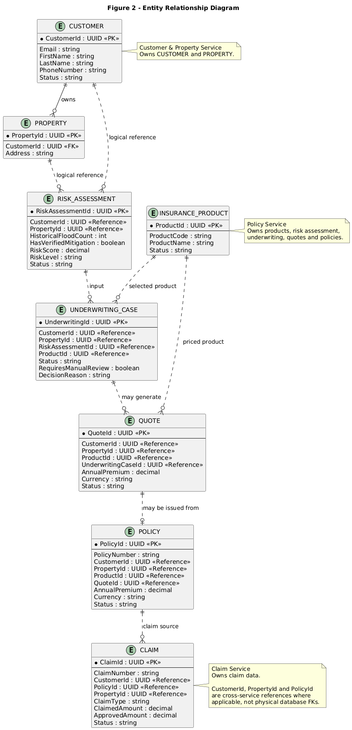

C. Use Case Diagram

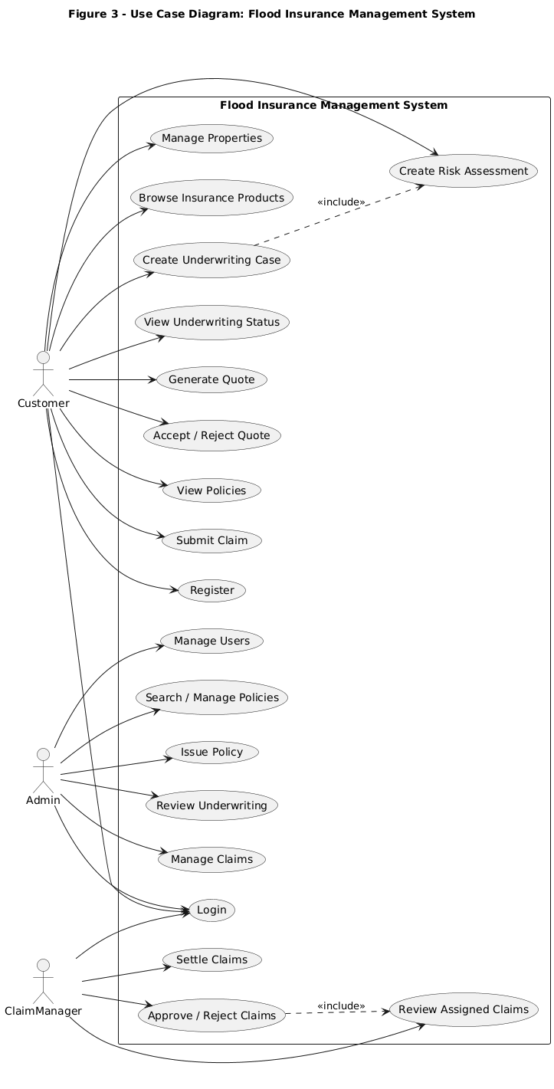

D. Class Diagram — Authentication
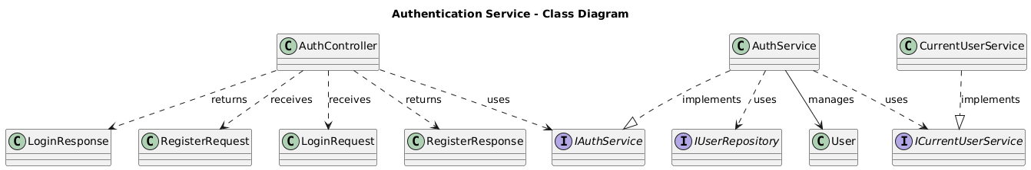

E. Class Diagram — Insurance Domain

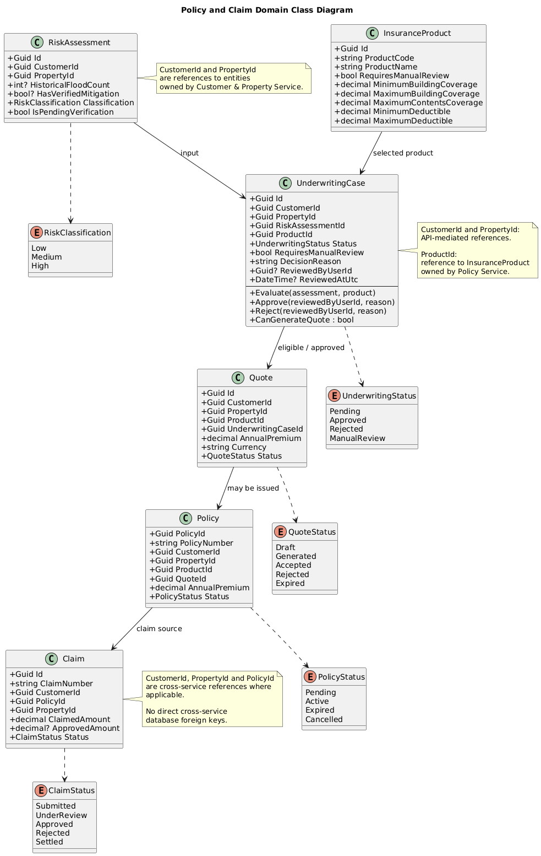

F. 4 Sequence Diagram — User Registration

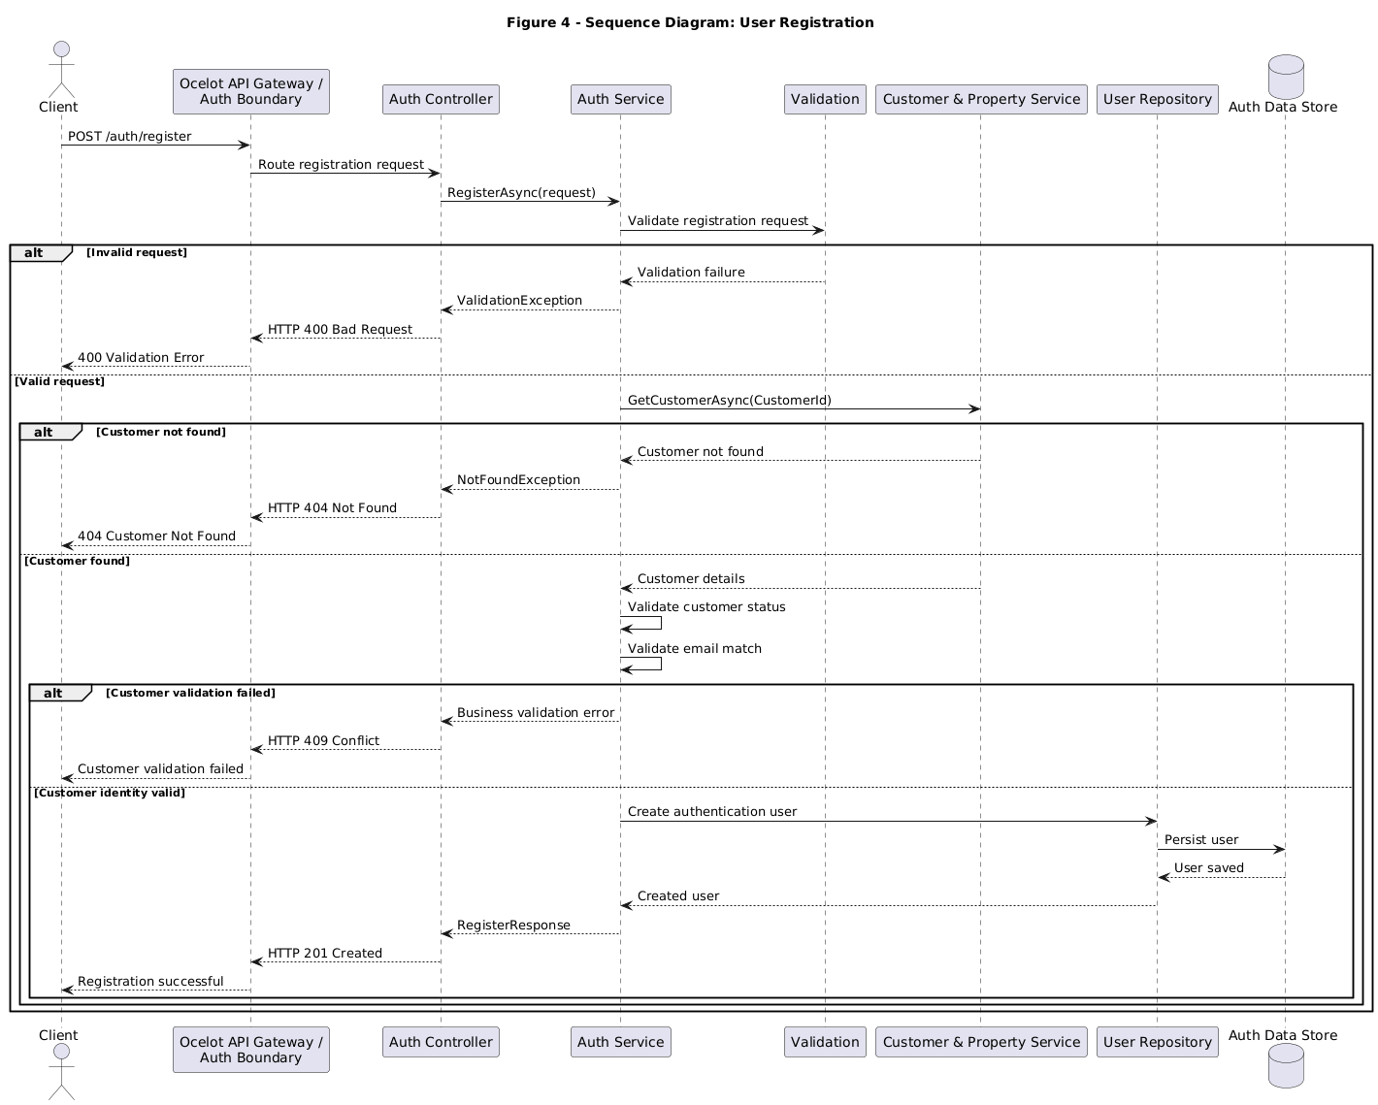.

G. 5 Sequence Diagram — Login / Authentication
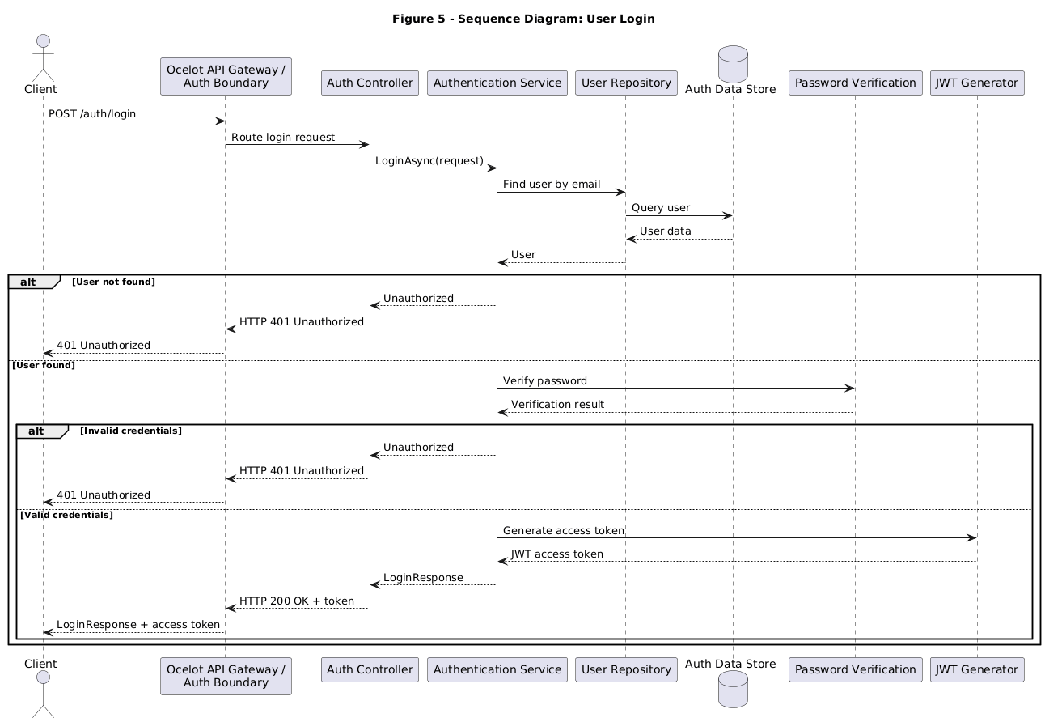.

H. Deployment Diagram
Deployment diagram cannot be accurately generated from the current project context. Concrete deployment nodes, container runtime, hosts, ports, cloud provider and production network topology were not sufficiently specified.

IEEE-Style Expanded Technical Specification
This expanded edition is organized as a professional engineering report using an IEEE-oriented front-matter/body/back-matter structure. IEEE documentation guidance emphasizes complete, consistent information items and professional report organization; this document adapts those principles to the specific Flood Insurance Management System rather than reproducing a proprietary IEEE template.

Project Identification
Field | Value
Project | Flood Insurance Management System
Developer | Nanda Kishore
Domain | Flood Insurance Management
Architecture | Microservices with Clean Architecture
Frontend | Angular standalone application
Backend | ASP.NET Core / .NET Web APIs
Gateway | Ocelot API Gateway
Authentication | JWT-based authentication
Roles | Customer, Admin, ClaimManager
Logging | Serilog
Documentation Style | IEEE-oriented technical/project documentation
Diagram Production | Manual StarUML recreation from supplied source

A. Executive Technical Summary
FIMS is designed as a controlled insurance lifecycle platform rather than a collection of unrelated CRUD interfaces. Its central architectural principle is bounded responsibility: authentication manages identity and tokens, Customer Service owns customer business identity, Customer and Property Service owns properties, Policy Service owns products/risk/underwriting/quotes/policies, and Claim Service owns claims.
The frontend reflects these boundaries through feature-oriented Angular routing. Customer, Admin and ClaimManager routes are protected by authentication and role guards. Customer-specific identifiers are derived from authenticated identity where appropriate, reducing the possibility of users manually supplying another customer's identifier.

B. Detailed System Context
+---------------------+
| Customer |
+----------+----------+
|
v
+---------------------+
| Angular Frontend |
| Standalone + Signals|
+----------+----------+
|
+--------------------------+
| |
v v
+---------------------+ +---------------------+
| Auth Gateway | | Ocelot API Gateway |
| Register / Login | | Routing / Security |
+----------+----------+ +----------+----------+
| |
| +----------+----------+
| | | |
v v v v
JWT identity Customer Property Claim
Service Service Service
| | |
Customer Property Claims

C. Architectural Principles
- Single Responsibility: each service owns a coherent business capability.
- Dependency Inversion: application logic depends on abstractions such as repositories rather than concrete persistence implementations.
- Encapsulation: underwriting state transitions are implemented in the UnderwritingCase domain entity.
- Least Privilege: role policies restrict protected operations.
- Data Ownership: each service is authoritative for its own business data.
- API Mediation: dependent services validate cross-service identifiers through APIs rather than direct database access.
- Centralized Error Handling: known exceptions are translated consistently by global exception handling.
- Frontend Separation: Angular features are organized by business capability and use signals for UI state.

D. Detailed Data Ownership Matrix
Business Data | Authoritative Owner | Reference Consumers | Modification Rule
Authentication identity | Authentication boundary | Gateway/frontend/backend authorization | Modified only by authentication/user-management workflows.
Customer profile | Customer Service | Property, Policy, Claim and authentication-linking workflows | Customer Service is authoritative.
Insurance product | Policy Service | Customer selection, underwriting and quote | Policy Service controls product configuration.
Risk assessment | Policy Service | Underwriting | Created/evaluated through Policy Service workflow.
Underwriting case | Policy Service | Quote/reviewer workflows | State changes only through domain/application operations.
Quote | Policy Service | Customer/policy issuance workflow | Quote state controls customer decision.
Policy | Policy Service | Customer/claim workflows | Policy Service controls policy lifecycle.
Claim | Claim Service | Customer/admin/ClaimManager workflows | Claim Service controls claim lifecycle.

E. Detailed Customer-to-Policy Lifecycle
1. Customer authenticates.
2. Customer registers or selects an existing property.
3. Customer selects an available flood insurance product.
4. Customer creates a risk assessment for a property.
5. Policy Service creates an underwriting case from:
- RiskAssessmentId
- ProductId
6. UnderwritingCase.Evaluate(...) determines:
- PendingReview, OR
- EligibleForQuote
7. If PendingReview:
- reviewer opens the case
- reviewer approves or rejects
8. Approved/eligible case can generate a quote.
9. Customer reviews quote and accepts/rejects it.
10. Policy issuance is performed by the policy-management workflow.
11. Customer can report a covered loss as a claim.
12. Admin assigns the claim to a ClaimManager.
13. ClaimManager starts review and approves/rejects.
14. Approved claim can proceed to settlement.

F. Detailed Underwriting Decision Logic
Evaluate(assessment, product)
IF assessment.IsPendingVerification
RequiresManualReview = true
Status = PendingReview
DecisionReason = "Important property information requires verification."
RETURN
IF product.RequiresManualReview
RequiresManualReview = true
Status = PendingReview
DecisionReason = "The selected product requires manual review."
RETURN
IF assessment.Classification == Elevated
OR assessment.Classification == High
RequiresManualReview = true
Status = PendingReview
DecisionReason = risk classification message
RETURN
RequiresManualReview = false
Status = EligibleForQuote
DecisionReason = "The risk assessment is eligible for quote generation."
This rule sequence is important to the technical integrity of the system because it keeps underwriting decisions in the domain model. The frontend presents the state but should not become the authoritative source for determining whether a quote can be generated.

G. Quote Eligibility Contract
CanGenerateQuote =
Status == EligibleForQuote
OR
Status == Approved
The backend response should expose CanGenerateQuote so that the Angular detail page can render the Generate Quote action from authoritative backend state. Approval should also clear the manual-review flag when the case transitions out of PendingReview.

H. Claims Lifecycle
Submitted
|
v
Assigned
|
v
Under Review
|
+----------------+
| |
v v
Approved Rejected
|
v
Settled
Customer may cancel only where claim state/authorization permits.
The Claim Service distinguishes customer-facing claim creation from operational assignment and review. An Admin assigns a ClaimManager, while the assigned ClaimManager performs review and decision operations.

I. Administrative Policy Search
The Admin Policies feature intentionally retains three search modes: Policy Number, Customer ID and Property ID. Policy Number is the most direct business-facing identifier for one policy. Customer ID supports customer-level policy retrieval, while Property ID supports property-level policy retrieval. Policy ID remains primarily an internal resource/navigation identifier and is not introduced as a fourth user-facing search mode.

J. Frontend Route Protection
Customer
/customer
/customer/properties
/customer/risk-assessments
/customer/underwriting
/customer/quotes
/customer/policies
|
+--> authGuard
+--> roleGuard(['Customer'])
ClaimManager
/claim-manager
/claim-manager/underwriting
/claim-manager/claims
|
+--> authenticated
+--> ClaimManager authorization
Admin
/admin
/admin/customers
/admin/users
/admin/policies
/admin/claims
|
+--> authenticated
+--> Admin authorization

K. Detailed Frontend State Pattern
readonly loading = signal(false);
readonly errorMessage = signal('');
readonly successMessage = signal('');
readonly records = signal<Record[]>([]);
readonly hasRecords = computed(
() => this.records().length > 0
);
load(): void {
this.loading.set(true);
this.errorMessage.set('');
this.service.get(...).subscribe({
next: result => {
this.records.set(result.items ?? []);
this.loading.set(false);
},
error: error => {
this.loading.set(false);
this.errorMessage.set(
this.getErrorMessage(error)
);
}
});
}

L. API Error Contract
Layer | Responsibility | Example Output
Domain | Reject invalid state transitions. | Conflict/validation domain exception.
Application Service | Validate use-case prerequisites and ownership. | NotFound/Forbidden/Conflict.
Controller | Expose operation through HTTP. | ActionResult/typed response.
Global Exception Handler | Map exception to status/body. | 400/401/403/404/409/500.
Angular Service | Receive HTTP error. | HttpErrorResponse.
Angular Component | Display safe user-facing message. | errorMessage signal.

M. Security Threat Considerations
Threat | Risk | Control in FIMS
Forged/invalid token | Unauthorized access | JWT validation.
Role escalation | Unauthorized administrative action | Role/policy authorization.
Cross-customer access | Data disclosure | Customer identity/ownership validation.
Random CustomerId linking | Identity corruption | Customer Service validation.
Duplicate underwriting | Duplicate transaction | ExistsForAssessmentAndProductAsync + ConflictException.
Password leakage in logs | Credential compromise | Redacted frontend diagnostic output; secrets should never be logged.
Direct cross-service DB access | Tight coupling/data corruption | API-mediated cross-service references.
Frontend-only authorization | Bypass through direct API calls | Backend authorization is authoritative.

N. Traceability Matrix
Requirement | Architecture | Implementation Evidence / Feature
FR-001 Registration | Auth boundary | Angular registration form + /auth/register.
FR-002 Login | Auth boundary + JWT | AuthService.login + access token handling.
FR-003 RBAC | Gateway/backend authorization | authGuard, roleGuard, ASP.NET policies.
FR-004 Properties | Customer and Property Service | Customer property feature and PropertyService.
FR-006 Risk Assessment | Policy Service | RiskAssessment service/model/workflow.
FR-007 Underwriting | Policy Service | UnderwritingCase + create endpoint.
FR-008 Review | Policy Service + reviewer role | Pending-review + approve/reject.
FR-009 Quote | Policy Service | GenerateQuoteRequest + quote APIs.
FR-011 Policies | Policy Service | CustomerPolicies + PolicyService.
FR-012 Admin Search | Policy Service/Admin UI | Policy Number + Customer ID + Property ID.
FR-014 Claims | Claim Service | Create/GetMyClaims + claim endpoints.
FR-016 Claim Review | Claim Service | Assignment/start-review/approve/reject.
FR-019 Exception handling | Global middleware | Exception mapping and Angular error extraction.

O. Known Implementation Decisions
- Angular standalone components are used throughout the discussed frontend features.
- Signals are preferred for component state.
- CustomerId for customer-specific screens comes from authenticated user state where appropriate.
- The customer underwriting endpoint is customer-specific and returns a paged result.
- Duplicate underwriting creation is intentionally blocked.
- Manual underwriting approval enables quote generation through backend state.
- The ClaimManager role is spelled ClaimManager in the latest role configuration.
- Admin policy search remains Policy Number, Customer ID and Property ID.
- The developer is Nanda Kishore.

P. Documentation Boundary
This report deliberately avoids asserting specific database engines, cloud infrastructure, Kubernetes deployment, CI/CD products, payment integrations, weather/flood-map integrations or automated testing coverage where the available project context does not establish them. Such information should be added when authoritative project artifacts become available.

IEEE-Style References
[1] IEEE Standards Association, “ISO/IEC/IEEE 15289-2019 — Systems and software engineering — Content of life-cycle information items (documentation),” IEEE SA, 2019.
[2] IEEE Professional Communication Society, “Write Effective Reports,” IEEE, accessed Oct. 7, 2026.
[3] IEEE Standards Association, “ISO/IEC/IEEE 42010-2022 — Systems and software engineering — Architecture description,” IEEE SA, 2022.
[4] IEEE Standards Association, “ISO/IEC/IEEE 12207-2026 — Systems and software engineering — Software life cycle processes,” IEEE SA, 2026.
[5] Project implementation context and source excerpts supplied during development of the Flood Insurance Management System, including Angular frontend, authentication, API Gateway, Customer, Property, Policy, Underwriting, Quote and Claim workflows.
IEEE terminology and documentation organization are used as professional guidance. The project-specific architecture and implementation facts in this report originate from the project context rather than from the external standards.

