EVA Analysis Application
  - By: Nandakishore Vinayakrishnan, SID 23070854

1. Summary
I inherited a single 122-line Python script that plots cumulative EVA (spacewalk) time and counts EVAs by duration. I worked on that code rather than replacing it. I assessed it, split it by responsibility into a small eva/ package, added a country comparison (--compare), and covered it with 55 automated tests. Two architectural decision records (ADRs) explain the main choices.

2. Activity 1: Assessment of the inherited code
evacodev2.py reads eva-data.json (375 EVAs, 330 usable once entries without a date, duration or country are dropped). It asks for a country and a year range, filters, builds a running total of hours, counts EVAs as short (under 4 h), standard (4 to under 7 h) or long (7 h+), saves and shows a plot, and prints the counts and percentages. The git history shows five rounds of work; each added to the same file.
Input | Observed result
USA, 1965 to 1975 | Works: 29 short, 9 standards, 7 long
No filters (all data) | Works: 71 short, 187 standards, 72 long
Unknown country (“Narnia”) | Quietly treated as all countries
No matches, reversed years, non-numeric year | Crashes (ZeroDivisionError or ValueError)

Responsibility | Location
Reading data | Module level, lines 5 to 6
Validating and preparing | Module level, lines 8 to 27
Calculating | aggregate_data, evaluate_duration_occurances, calculate_occurance_percentages
Presenting | plot_graph and the final print calls
Coordinating and input | get_clean_inputs and module-level lines 118 to 122

- Everything runs at import time and there is no main(). aggregate_data converts typed text, filters, totals and counts in one function. get_clean_inputs silently turns an unknown country into "all countries". calculate_occurance_percentages returns formatted strings, and plot_graph draws, saves and blocks.
- Functions read the shared globals, the records and the countries. aggregate_data assumes records are (date, hours, country) tuples built elsewhere, indexes them by position and expects years as strings, so the analysis depends on both the loader and the prompt. The file name, the "all countries" string and the 4 h / 7 h thresholds are hard-coded.
- Importing the file reads data, prompts and plots. aggregate_data, get_clean_inputs and plot_graph depend on globals, input() or the display. Only evaluate_duration_occurances is a pure function.

3. Activity 2: Proposed architecture
The script becomes the eva/ package, one module per responsibility. evacodev2.py stays as a thin entry point, so python evacodev2.py works as before.
Module | Responsibility
app.py | Coordinates a run: loads data, picks the mode, calls the others in order. No logic of its own
data_source.py | Reads the JSON file; knows the format and nothing else
preparation.py | Drops incomplete entries, converts dates and durations, sorts
models.py | EvaRecord (date, duration in hours, country), shared by preparation and analysis
analysis.py | Pure calculations and rules: filtering, running totals, duration categories, percentages, country selection, year-range check
comparison.py | Compares two countries, built on analysis
presentation.py | The plot and all text output
user_input.py | Prompts, the --compare flag, parsing typed text
errors.py | InvalidQueryError for requests that cannot be answered

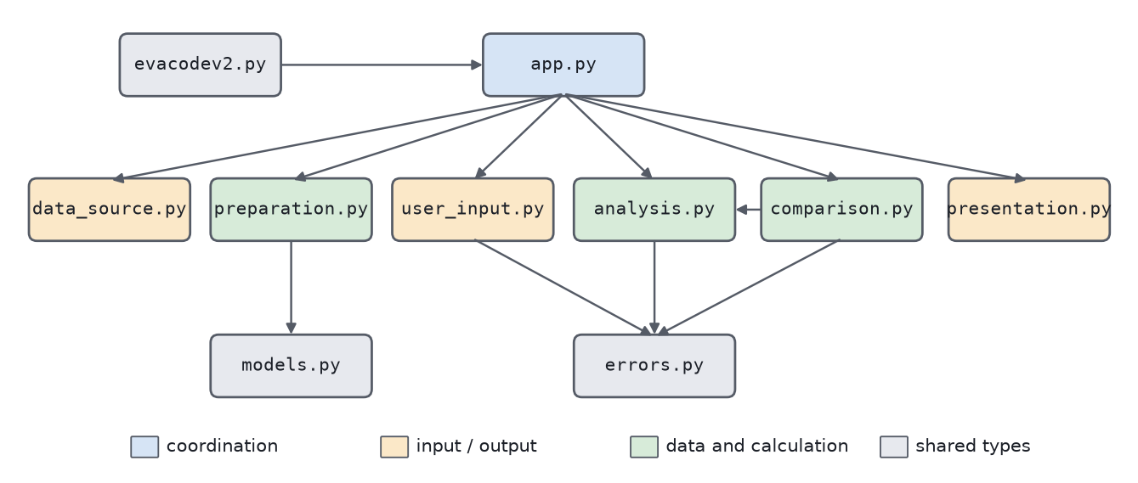
Figure 1. Module dependencies (an arrow means "imports"). app.py also imports errors.py to catch it.
Modules communicate through plain functions and one small data class. The main interfaces are load_raw_records(path), prepare_records(raw), filter_records(records, country, start_year, end_year), cumulative_duration(records), count_duration_categories(records), compare_countries(records, a, b, start, end), plot_cumulative_duration(...) and format_comparison(result). "All countries" is None rather than a magic string, and percentages stay numbers until presentation formats them.
- These boundaries follow what can change independently, since a new file format touches only data_source, a new cleaning rule only preparation, a new statistic only analysis, a new output only presentation, etc.
- Every function in a module serves it’s one job: preparation answers "is this entry usable, and what is its typed form?", analysis turns records into numbers, presentation turns results into something a person sees. EvaRecord has its own module, so preparation and analysis do not depend on each other.
- aggregate_data reads a global list, indexed it by position and expected year strings from input(). Now filter_records takes a list of EvaRecord and integer years, so the loader, prompt and analysis can each change alone, and tests can call it with handwritten records.

ADR-001: Split the single script into modules by responsibility
The app used to be one script where reading, cleaning, analysis, output and control flow were tangled. Importing it ran the whole program, the main functions read global variables, so they could not be run on test data, and one function took raw typed text and did the filtering, totalling and counting. A single file is not allowed, and the new feature needed to reuse the existing calculations.
Possible Alternatives.
- Keep one file and tidy it (add main(), remove globals). Cheap, but this doesn’t meet the spec.
- Split by the existing function list (functions.py, helpers.py). Several files and arbitrarily assigned boundaries.
- Split by responsibility into one flat package. Chosen.
- Classes, interfaces and dependency injection. Decouples well but adds machinery a program this size would not be justifiable.
Hence, we create the eva/ package with a module per responsibility, keep evacodev2.py as the entry point, use plain functions and one dataclass, no module-level state, and let only app depend on everything else.
Each module changes for one reason. Passing data as arguments removes the global-state coupling. Pure functions can be tested with a few handwritten records. Functions and one dataclass are the smallest thing that works. The comparison can sit on top of analysis without touching loading or preparation. Changes to the format, cleaning rules, statistics, output or prompts each stay in one module, and calculations can be unit tested. The costs are more files to follow, a shared dependency on the shape of EvaRecord, an app.py that must stay free of logic, and no tests at the start, so "behaviour unchanged" had to be shown by comparing outputs.

4. Activities 3 and 4: Restructuring and the new feature
The logic was moved, instead of being rewritten as per the project spec. For example, aggregate_data became filter_records, cumulative_duration and count_duration_categories, and plot_graph became plot_cumulative_duration. Before changing anything, I recorded the original's output on 12 inputs (output, exit status and a hash of the saved plot) to compare afterwards.
I also added a new feature, python evacodev2.py –compare, which asks for Country A, Country B, a start year and an end year (both inclusive) and reports, for each country, the total EVAs, total hours and average hours, then which country has more total time or a tie:
EVA comparison, 1990 to 2000 (inclusive)
USA:
Total EVAs: 36
Total duration (hours): 233.13
Average duration (hours): 6.48
Russia:
Total EVAs: 58
Total duration (hours): 272.45
Average duration (hours): 4.70
Result: Russia has the greater total EVA duration

- comparison.py builds on filter_records and cumulative_duration, so nothing is calculated twice. Loading, preparation and the calculation modules were not changed for the feature. Only app, presentation and user_input gained code.
- A country with no matching EVAs shows 0 EVAs, 0 hours and an average of "unavailable". Equal totals are reported as a tie, using math.isclose because 0.1 + 0.2 != 0.3 in floating point.
- Reversed years, non-numeric years and unknown countries print a message instead of crashing (ADR-002). Because the brief says the application must handle these, the original mode got the same handling.
- --compare keeps the original prompts and output exactly as they were.

ADR-002: Report bad requests with one exception, handled in app
The comparison must cope with reversed years, non-numeric years and unknown countries without crashing. user_input sees the typed text and comparison knows the rules, and either needs a way to say "this request is invalid" without printing, exiting or depending on the other. The inherited code just crashed with a raw ValueError or ZeroDivisionError.
Possible Alternatives.
- Re-prompt inside user_input until valid. Friendly, but it would need the data and the rules and could not be tested without a fake console.
- Return None or an error value. Every caller must remember to check, making future devs lives harder.
- Let ValueError bubble up and catch it in app. Simple but catching errors that broadly could also hide real bugs.
- A dedicated InvalidQueryError in its own small module. Chosen.
eva/errors.py defines InvalidQueryError(ValueError). analysis, comparison and user_input raise it. Only app catches it, prints “Cannot compare: <reason>” or “Cannot analyse: <reason>” and returns normally.
This way, comparison stays a pure function, and invalid input is tested with assertRaises, with no console. The lower layers describe the problem, and app decides how to tell the user. A narrow exception type does not swallow unrelated bugs, and user_input and comparison need not import each other.
Every invalid-input path in both modes has a test and ends in a readable message, and both modes share one year-range check. The costs are one more tiny module, a changed (improved) behaviour for inputs that used to crash, and an exit status of 0 after an error message, which a later change could make non-zero.

5. Activity 5: Verification and evaluation
python -m unittest -v runs 55 tests, all passing. Each uses known inputs and checks exact results.
Test file | Covers
test_comparison.py | Hand-worked counts, totals and averages; both end years included; no matches; ties (including float rounding); reversed years; unknown countries
test_analysis.py | Filtering, running totals, percentages, the 4 h / 7 h category boundaries, country selection, year-range check
test_preparation.py | Incomplete entries dropped, durations converted, records sorted
test_user_input_and_presentation.py | Both sets of prompts (blank and non-numeric years), the --compare flag, text output
test_app.py | Both modes end to end with scripted input; bad input is reported and nothing is plotted when there is nothing to plot
test_real_data.py | The real data file gives the numbers the original script gave (29/9/7 and 71/187/72), and the comparison matches an independent calculation

Q. Would the tests catch a mistake?
A. I broke the code four ways on a scratch copy (an exclusive end year, >= for the year check, 0 instead of "unavailable" for an empty average, a shifted category boundary). Each made tests fail.
Q. Does the old behaviour still work?
A. Of the 12 inputs recorded from the original script, 8 give identical output and plots. The other 4 are the inputs that used to crash (reversed years, a non-numeric year, two empty results). They now print a message, exit normally and draw no empty plot.
Measure | Before | After
Source files | 1 | 11
Lines (no blanks or comments) | 98 | 377
Functions | 5 | 24
Longest function | 37 lines | 32 lines
Statements run on import | 10 | 0
Functions reading shared globals | 2 | 0
Automated tests | 0 | 55
Features | 1 | 2

Q. What modules were changed?
A. Five files: two new (comparison.py, errors.py) and three extended (app, presentation, user_input). The old script would have meant editing the one file that holds everything.
Q. How do your changes affect dependencies and testing?
A. Figure 1 shows the dependencies, with no cycles. analysis and comparison take plain records, so they are tested without files or a display. Before, importing the script already read a file and prompted for input.
Q. Are responsibilities easier to identify?
A. Yes. Each of the five is now a named module.
Q. Are there any instances of code duplication?
A. The comparison reuses existing functions, the "all countries" string became None, and both modes share one year check. Some filter-then-total repetition remains.
Q. Is there any unnecessary complexity in the program?
A. Some. It is 11 files instead of 1 and nearly four times the lines (much of it docstrings and the new feature), and calls now span files. There are no frameworks or new dependencies. A two or three-module split would also have worked, but five responsibilities keep each module short and each boundary easy to explain.
Known limitations: An unknown country in the original mode still means "all countries", as it always did, whereas the comparison rejects it. EVAs recorded as 0:00 (cancelled ones) still count as EVAs with zero hours. Country names are case-sensitive. A missing data file stops the program with a normal Python error.

6. Activity 6: Hand-off
Another developer needs Python 3.10 or newer and the packages in requirements.txt (matplotlib). From the repository root:
pip install -r requirements.txt
python evacodev2.py # cumulative duration and categories
python evacodev2.py --compare # compare two countries
python -m unittest -v # run the tests

README.md has set-up and the module map, docs/ and docs/adr/ hold the written records, and tests/ holds the tests.

