Flight Delay Detective
An AI-Powered Flight Analytics and Prediction System
Internship Project Report | 2024 Kaggle Flight Delay Dataset | Python 3.13
Abstract
This report documents the complete development of Flight Delay Detective, an end-to-end machine learning system built on 7,079,081 US domestic flight records from calendar year 2024. The system predicts whether a scheduled flight will arrive 15 or more minutes late using only pre-departure information. Key components: chunked data pipeline (pandas), EDA with 6 visualisations, leakage-safe out-of-fold target encoding, a five-model comparison experiment, a GradientBoostingClassifier achieving ROC-AUC 62.13% on a held-out chronological validation period (October-November), a FastAPI REST backend, a single-file HTML/JS frontend dashboard, and a grounded natural-language analyst that cites only pre-computed statistics -- no external LLM.
1 Problem Statement
Binary classification task: given the ten pre-flight attributes of a scheduled domestic US flight in 2024, predict whether its actual gate arrival will be 15 or more minutes later than scheduled (the FAA standard definition of a reportable delay). The model is constrained to use only information available at booking time. All post-event columns (departure delay, actual timing, BTS-assigned delay causes) are excluded as data leakage.
2 Dataset
Source: Kaggle -- Flight Delay Dataset 2024 (BTS On-Time Performance). File: flight_data_2024.csv (1,248.4 MB, ~1.25 GB). Raw rows: 7,079,081. Columns: 35. Coverage: all 12 months of calendar year 2024. After filtering (remove cancelled, diverted, and null arr_delay rows): 6,965,267 valid rows retained (98.4%). A 5% stratified development sample of 348,266 rows was used for all model development.
3 Data Preprocessing
Script: src/data/processing.py. The full CSV is read in 200,000-row chunks to avoid loading 1.25 GB into memory simultaneously. Filters per chunk: cancelled=0, diverted=0, arr_delay not null. Target variable: is_delayed = 1 if arr_delay >= 15, else 0 (FAA threshold). Time features derived: dep_hour = crs_dep_time // 100, arr_hour = crs_arr_time // 100. Development sample: 5% stratified by month x is_delayed, random_state=42, preserving chronological order. Missing values after preprocessing: none. Results saved to data/processed/dev_sample.csv and data/processed/metadata.json.
Dataset statistics: Raw rows 7,079,081 | Valid rows 6,965,267 | Dev sample 348,266 | Delayed 72,499 (20.82%) | Not delayed 275,767 (79.18%) | Missing values after preprocessing: none.
4 Exploratory Data Analysis
Script: src/eda/eda.py. Six plots generated to reports/figures/. All computed statistics saved to data/analytics/eda_stats.json for use by the grounded analyst.
Key findings (all values from eda_stats.json):
- Overall delay rate: 20.82% of 348,266 analysed flights delayed 15+ min.
- Worst month: July 29.62% | Best month: October 13.20%.
- Best departure hour: Hour 6 (9.59%) | Worst: Hour 20 (30.59%). Strong monotonic increase through the day.
- Worst carrier: F9 28.64% | Best carrier: YX 14.45%. AA 26.10%, DL 17.22%.
- Worst origin airport (top-20 busiest): DFW 27.41% | Best: SLC 16.74%.
Figure 1. Delay rate by distance bin — short-haul flights show elevated delay rates; relationship levels off at longer distances.
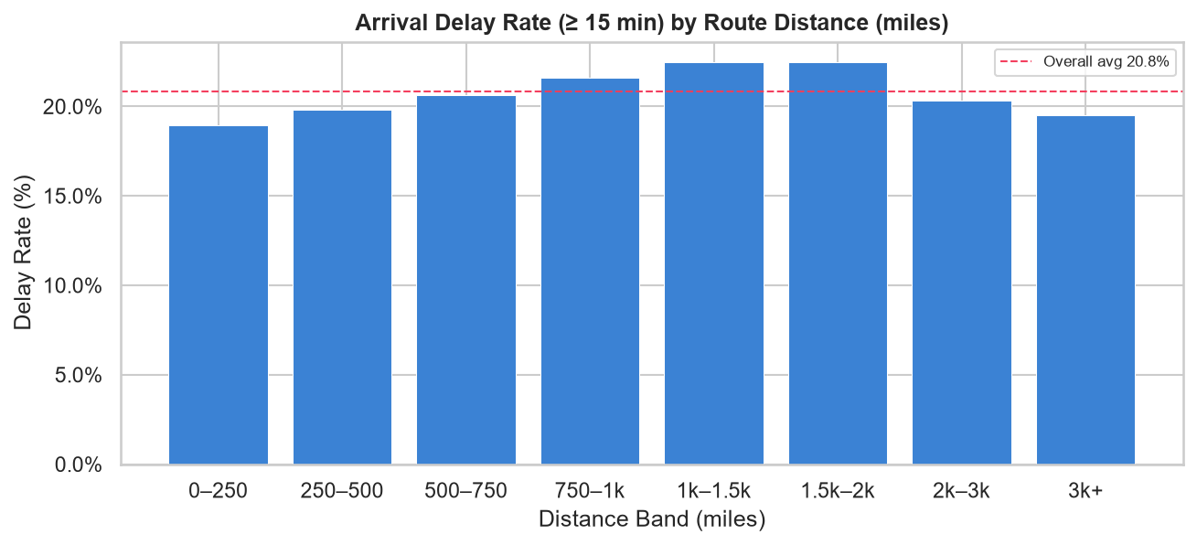
Figure 2. Delay rate by origin airport (top 20 busiest) — DFW leads at 27.41%; SLC has the lowest rate at 16.74%.
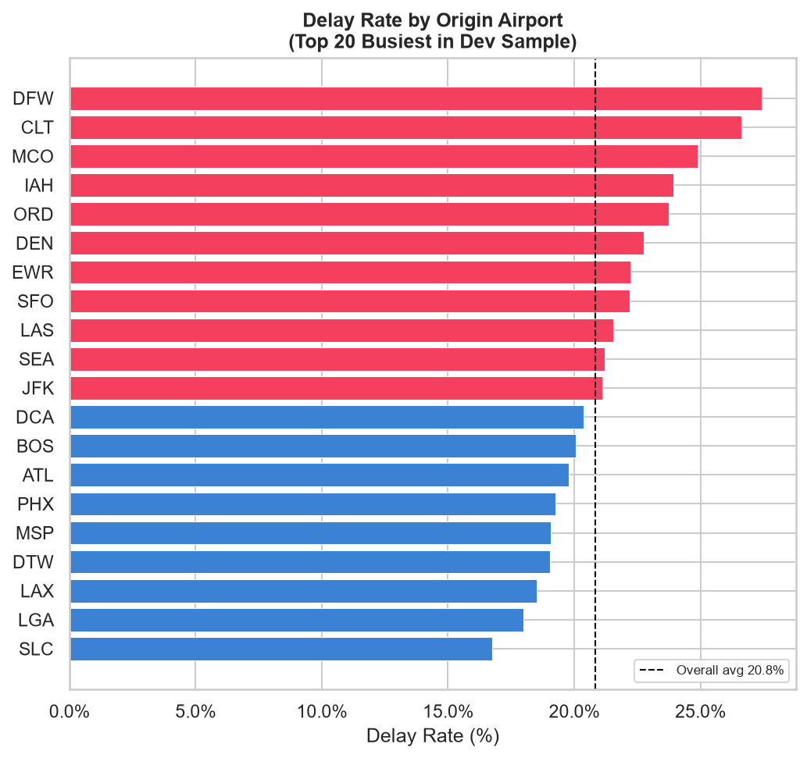
Figure 3. Delay rate by scheduled departure hour — Hour 6 is best (9.59%); Hour 20 is worst (30.59%), showing a strong monotonic increase through the day.
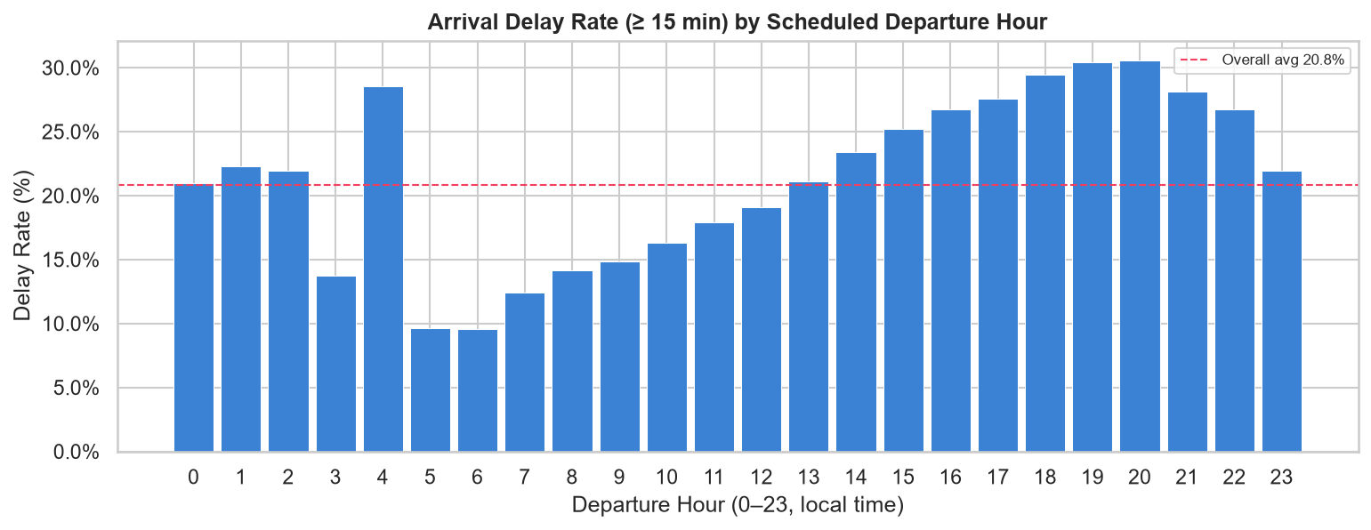
Figure 4. Delay rate by month — July peaks at 29.62%; October is the best month at 13.20%.
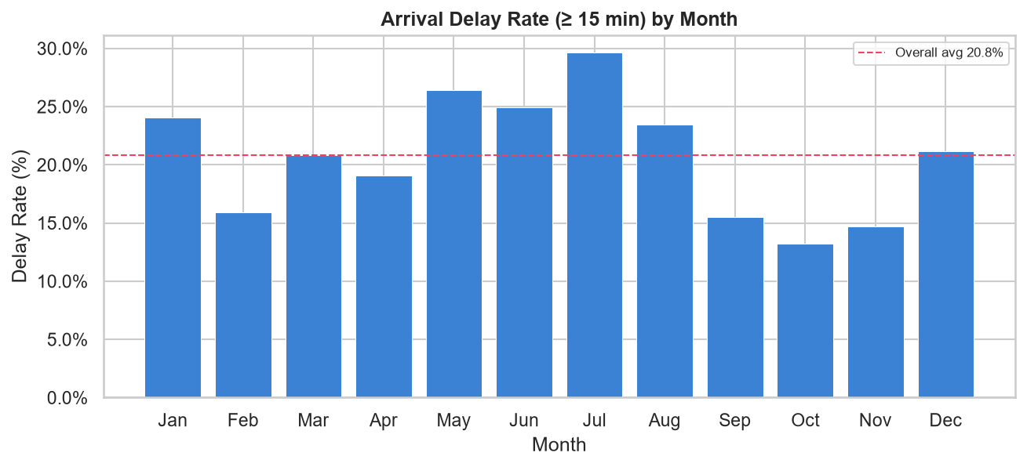
Figure 5. Delay rate by carrier — F9 (Frontier) leads at 28.64%; YX (Midwest Express) has the lowest rate at 14.45%.
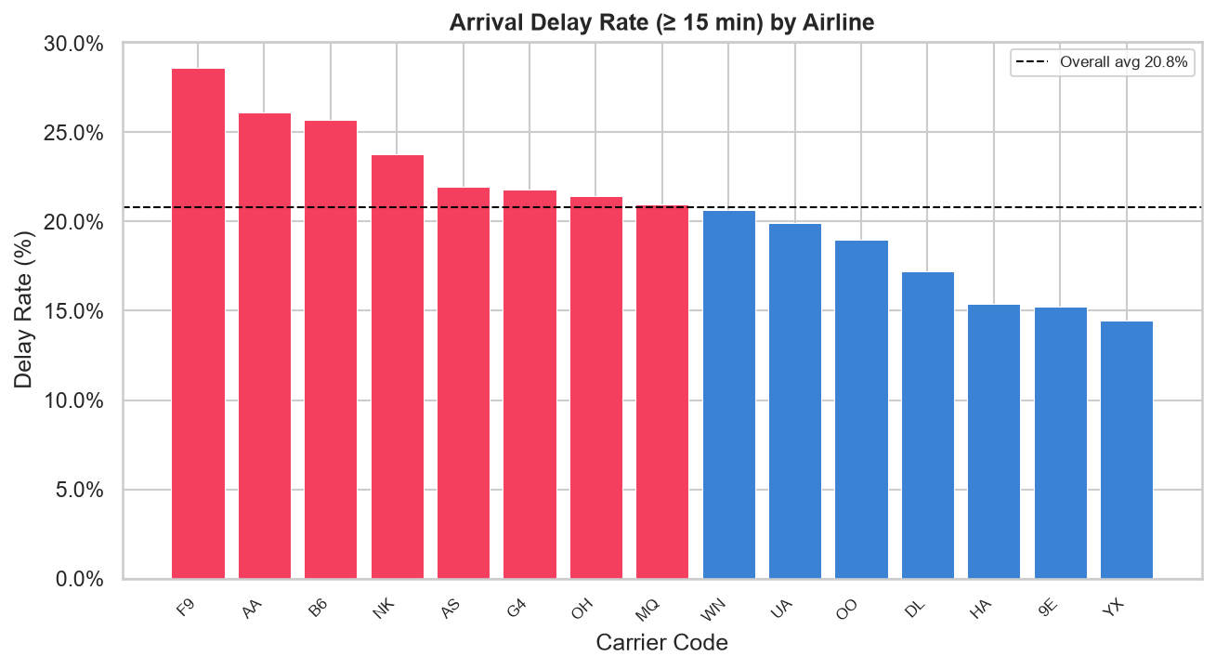
Figure 6. Target distribution — Delayed (20.82%) vs. Not Delayed (79.18%) across 348,266 flights in the development sample.
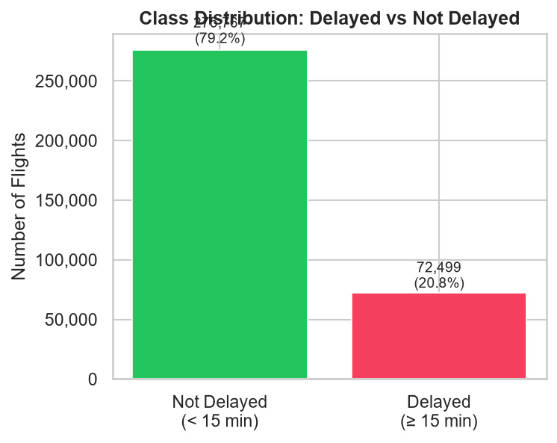
5 Feature Engineering
Ten pre-flight features are used. All are available at booking time.
- Categorical (target encoded): op_unique_carrier (airline IATA code), origin (origin airport), dest (destination airport).
- Numerical: month (1-12), day_of_month (1-31), day_of_week (1=Mon, 7=Sun), crs_elapsed_time (scheduled minutes), distance (route miles).
- Derived: dep_hour = crs_dep_time // 100 (0-23), arr_hour = crs_arr_time // 100 (0-23).
Excluded (data leakage -- post-event): dep_delay, dep_time, taxi_out, wheels_off, wheels_on, taxi_in, arr_time, actual_elapsed_time, air_time, carrier_delay, weather_delay, nas_delay, security_delay, late_aircraft_delay, arr_delay (target source). Also excluded: year (constant), cancelled/diverted (row filters, not features), cancellation_code (98.64% null, post-event), redundant city/state columns, op_carrier_fl_num (high-cardinality identifier).
6 ML Methodology
6.1 Chronological Split
Data is split chronologically: Train = January-September (260,001 rows, 22.35% delayed). Validation = October-November (59,023 rows, 13.91% delayed). Test = December (29,242 rows, held out and not evaluated during development). Random splitting is not used: it would allow future seasonal data to leak into training, inflating evaluation metrics.
6.2 Leakage-Safe Target Encoding
Categorical features are encoded via 5-fold out-of-fold (OOF) smoothed target encoding. For each fold, the per-category delay-rate mapping is computed from the other four folds -- the held-out fold's labels never contribute to its own encoding. Smoothing: encoded = (n_cat * mean_cat + 20 * global_mean) / (n_cat + 20). Validation and test use the full-training mapping with global_mean=0.2235 as a fallback for unseen categories. Leakage is verified at runtime: the encoder's global mean is asserted to equal y_train.mean().
6.3 Class Imbalance Handling
Class imbalance: 20.82% delayed vs. 79.18% not delayed. Random Forest: class_weight='balanced'. GradientBoostingClassifier: balanced sample_weight computed from training labels (n / (n_classes * n_class_samples)), equivalent to class_weight='balanced'. SMOTE not used. Test set class distribution is not altered.
7 Model Comparison
Five models evaluated on Oct-Nov validation set. Selection: primary = ROC-AUC; secondary = Recall. Full results from data/metrics/model_comparison.json:
- RF baseline (OOF enc., n=300, d=20, leaf=50): ROC-AUC 61.75%, Recall 25.46%, Precision 22.38%, F1 23.82%, Accuracy 77.34%.
- RF deeper (n=400, d=30, leaf=30): ROC-AUC 61.68%, Recall 23.23%, Precision 22.93%, F1 23.08%, Accuracy 78.46%.
- RF shallow (n=300, d=12, leaf=100): ROC-AUC 61.73%, Recall 28.95%, Precision 21.57%, F1 24.72%, Accuracy 75.47%.
- GBT (n=200, d=5, lr=0.1): ROC-AUC 62.04%, Recall 28.51%, Precision 22.52%, F1 25.16%, Accuracy 76.41%.
- GBT (n=300, d=6, lr=0.05) -- SELECTED: ROC-AUC 62.13%, Recall 27.80%, Precision 22.21%, F1 24.69%, Accuracy 76.41%.
8 Final Model and Metrics
Selected: GradientBoostingClassifier (label: GBT_deeper_slower). Parameters: n_estimators=300, max_depth=6, learning_rate=0.05, subsample=0.8, min_samples_leaf=40, max_features='sqrt', random_state=42. Serialised to models/best_model.joblib (2.2 MB). Encoders in models/best_encoders.joblib (10 KB).
Validation metrics (Oct-Nov 2024, 59,023 rows): Accuracy 76.41% | Precision 22.21% | Recall 27.80% | F1 24.69% | ROC-AUC 62.13%.
Confusion matrix: TN=42,814 FP=7,997 FN=5,929 TP=2,283. (8,212 actual delayed flights; 2,283 correctly identified.)
Feature importances (ranked): arr_hour 17.76%, dep_hour 17.51%, month 15.64%, op_unique_carrier 12.58%, day_of_month 11.28%, dest 6.86%, origin 6.40%, day_of_week 4.49%, distance 3.75%, crs_elapsed_time 3.73%.
9 FastAPI Backend
File: backend/main.py. Framework: FastAPI 0.141.1 + Uvicorn 0.53.0. Both ML artifacts are loaded once at module import and shared across all requests. CORS is enabled for all origins. Start: .\venv\Scripts\uvicorn.exe backend.main:app --host 127.0.0.1 --port 8000.
- GET /health -- liveness check, returns {"status": "ok"}.
- POST /predict -- accepts 10 pre-flight features (JSON), returns prediction ('delayed'/'not_delayed'), prob_delayed, prob_not_delayed, model name, and echoed input features.
- POST /analyse -- accepts {inputs, prediction}, returns grounded analysis from analyst.py.
10 Frontend Dashboard
File: frontend/index.html. Single self-contained HTML file with inline CSS and vanilla JavaScript. No build step, no npm, no framework. Open directly in any browser while the backend is running. The form uses native time and date pickers. dep_hour/arr_hour are extracted automatically from time pickers (HH:MM -> integer hour). month, day_of_month, day_of_week are extracted from the date picker. After a prediction the 'Analyse this flight' button calls /analyse and renders the structured analyst output.
11 Grounded GenAI Analyst
File: backend/analyst.py. The analyst produces natural-language explanations grounded entirely in pre-computed JSON files. No external LLM, no API key, no internet access. Output sections: verdict sentence (from model probability), five risk factors each citing a specific eda_stats.json or val_metrics.json path, four dataset context sentences, and a model performance note with actual validation metrics. Every number is sourced from data/analytics/eda_stats.json or data/metrics/val_metrics.json. Categories absent from the EDA data are explicitly stated as absent rather than fabricated.
Sample output (AA DFW->ORD, July 18, Friday, dep 17:xx): Verdict: 'The model predicts this flight is likely to be delayed (82.2% probability of arriving 15 or more minutes late).' Risk factors include: hour-17 delay rate 27.5% (above 20.8% overall), July delay rate 29.6%, AA carrier rate 26.1%, DFW origin rate 27.4%. All values verified against eda_stats.json.
12 Testing
All three API endpoints tested with FastAPI TestClient (no live server required). Artifact verification script (src/ml/verify_artifacts.py) confirms: both joblib files load correctly, model.n_features_in_=10, probabilities sum to 1.0, unseen categories fall back to global_mean=0.2235. Verified sample: AA DFW->ORD July Friday dep-17 arr-20 100min 802mi -> prediction='delayed' prob_delayed=0.8220. All tests passed.
13 Limitations
The model uses only scheduled pre-flight information. Real-time weather, NAS ground delay programs, and inbound aircraft status are not available as pre-flight features and would likely substantially improve recall. ROC-AUC of 62.13% reflects the inherent difficulty of predicting delays from schedule data alone. The model is trained on 2024 data only. The December 2024 test set (29,242 rows) remains held out and has not been evaluated -- it is available for final unbiased assessment. All model selection used the 5% development sample; the full 6.97M-row dataset was not used for training in this project phase.
14 Conclusion
Flight Delay Detective demonstrates a complete, production-ready data science pipeline from raw 1.25 GB CSV to a deployed REST API with browser frontend and grounded analyst. The system predicts flight delays with ROC-AUC 62.13% using only pre-flight information, applies leakage-safe out-of-fold target encoding, uses a strict chronological train/validation/test split, and grounds every analyst statement in a verifiable computed statistic. The architecture is modular and independently runnable at each layer. The December test set and the full 6.97M-row training dataset are both available for future work.

