

Architecture Document for
CodePerfect

.........

Table of Contents

1 Introduction 1
1.1 Purpose 1
1.2 Scope 1
1.3 Definitions, Acronyms and Abbreviations 2
2 Architectural Goals and Constraints 5
2.1 Reusability 5
2.2 Scalability 5
2.3 Customizability 6
2.4 Extendibility 6
2.5 Use of Existing Business Logic 6
2.6 Time to Market 7
2.7 Portability 7
2.8 Availability 8
2.9 Performance 8
2.10 Any Other Critical Goals Applicable 8
3 Productization Assessment 10
3.1 Re-Usable Components 10
3.2 Analyze Architectural Frameworks in Repository 10
3.3 Identify and Analyze Open Source and COTS Products 11
4 System Architecture 12
4.1 Overview 12
4.2 Logical/Functional View 13
4.3 Use Case View 15
4.4 Implementation/System View 16
4.5 Process/Thread View 17
4.6 Deployment View 18
5 General Architecture for Core Technical Services 19
5.1 Persistence 19
5.2 Inter-process Communication 19
5.3 Authentication and Authorization 20
5.4 Error Handling 20
5.5 Logging 21
5.6 Transaction Management 21
5.7 Other Applicable Technical Services 22
6 Risks/Limitation 24
7 Alternative Solutions Considered 26
Appendix 28
1. Expected Software Response 28
2. Performance Bounds 29
3. Identification of Critical Components 29
4. Review Comments on Architectural POC 30

Introduction

Purpose

The purpose of the CodePerfect Auditor architecture is to define the technical blueprint for a proactive, AI-driven Revenue Integrity Platform designed to eliminate the multi-billion-dollar inefficiencies inherent in modern healthcare administration. While legacy Revenue Cycle Management (RCM) systems operate reactively—resulting in prolonged 30-to-45-day payment delays, high denial rates, and massive administrative overhead—CodePerfect Auditor shifts the paradigm to a proactive model. By seamlessly bridging hospital provider networks and insurance payer ecosystems into a singular, interconnected platform, its primary purpose is to autonomously audit clinical documentation, guarantee code specificity prior to submission, and perform real-time predictive financial modeling. This document outlines the system’s foundation, ensuring it meets strict enterprise standards for scalability, HIPAA compliance, and data segregation, ultimately providing healthcare executives with an intelligent safeguard against revenue leakage and compliance penalties.

Scope

The scope of CodePerfect Auditor encompasses a complete, end-to-end 9-node AI inference pipeline and dual-sided operational dashboards catering to both Providers (Hospitals) and Payers (Insurance). On the provider side, the system is designed to ingest highly unstructured clinical text or OCR-scanned PDFs and map them against a proprietary semantic database of over 71,000 ICD-10-CM and ICD-11 codes. Utilizing a 384-dimensional vector embedding engine powered by PostgreSQL (pgvector), the system guarantees 99% semantic accuracy—even when processing complex clinician shorthand—achieving full terminology resolution in under 2 seconds per claim. On the financial side, the scope includes dynamic DRG (Diagnosis-Related Group) reimbursement forecasting, real-time audit probability scoring based on active payer rules configuration, and the generation of CMS-compliant, machine-to-machine ANSI X12 EDI 837 (submission) and EDI 835 (remittance) data streams.

Definitions, Acronyms and Abbreviations

Acronym/Term | Definition
RCM | Revenue Cycle Management - The overarching financial process used by hospital facilities to track patient care from registration and treatment to final claim adjudication and payment.
ICD-10-CM | International Classification of Diseases 10th Revision - The legacy global standard coding system used by physicians to classify all patient diagnoses and symptoms.
ICD-11 | International Classification of Diseases 11th Revision - The modernized global standard for digitized health data and clinical documentation maintained by the WHO.
CPT | Current Procedural Terminology - A specific medical code set used to meticulously report medical, surgical, and diagnostic procedures to insurance entities.
SNOMED CT | Systematized Nomenclature of Medicine Clinical Terms - A massive, highly comprehensive, multilingual clinical terminology database used heavily in AI ontology mapping.
DRG | Diagnosis-Related Group - A payment classification system used by Medicare to group hospital cases expected to use similar hospital resources, dictating the final payout.
CMS | Centers for Medicare & Medicaid Services - The US federal agency responsible for administering Medicare and setting the baseline rules for claim reimbursements.
EDI 837 / 835 | Electronic Data Interchange - The mandatory, machine-readable syntax formats used for historically transmitting hospital claims (837) and receiving payer remittance advice (835).
HIPAA | Health Insurance Portability and Accountability Act - Strict federal legislation mandating data privacy and security provisions for safeguarding medical information.
PHI | Protected Health Information - Any sensitive patient health data that can be linked back to an individual, strictly guarded under HIPAA law.
NLP | Natural Language Processing - A subset branch of AI focused completely on training computers to structurally understand and map raw human text.
LLM | Large Language Model - Deep learning algorithms capable of understanding, summarizing, and generating text utilizing massive parameter weights.
LangGraph | LangGraph - A specialized AI orchestration framework utilized within the pipeline to build highly stateful, multi-actor agentic workflows with LLMs.
pgvector | pgvector - An advanced, open-source PostgreSQL extension that natively permits the clustering and distance-querying of high-dimensional machine learning arrays.
RLS | Row Level Security - A strict database kernel security feature that physically restricts data access at the row level based on the user's organizational JWT.
JWT | JSON Web Token - A cryptographic, compact transmission format utilized directly by the Middleware for verifying cross-tenant user identity.
Payer | Insurance Payer - The corporate organization, government agency, or insurance company responsible for strictly auditing and paying medical claims.
Provider | Healthcare Provider - The hospital, clinic, coding analyst, or physician physically responsible for delivering the medical service to the patient.
Adjudication | Claim Adjudication - The rigorous AI or manual process by which a Payer evaluates a medical claim to definitively determine financial responsibility.
ASGI | Asynchronous Server Gateway Interface - The Python standardization protocol providing a highly concurrent interface between the async-capable FastAPI web servers and the network.
POC | Proof of Concept - An initial realization of a core architectural idea to demonstrate its physical and commercial viability to stakeholders.
UAT | User Acceptance Testing - The absolute final phase of software testing where live analysts verify that the system perfectly meets hospital business requirements.

Architectural Goals and Constraints

This section outlines the foundational requirements, architectural drivers, and constraints that dictate the design of the CodePerfect Auditor platform. The architecture is heavily influenced by the need to handle sensitive healthcare data (HIPAA constraints), execute complex Natural Language Processing (NLP) in near real-time, and support multi-tenant operational environments.

Reusability

The platform embraces a highly modular, component-driven architecture designed to maximize code reuse across functional boundaries:
- Dual-Sided UI Architecture: The Next.js (React) front-end utilizes a centralized library of atomic Tailwind CSS components. This ensures that the core UX paradigms—such as data tables, financial dials, and risk meters—are seamlessly reused across both the distinct Provider (Hospital) Dashboard and the Insurance (Payer) Dashboard.
- Modular AI Pipeline: The backend FastAPI 9-node inference engine is strictly decoupled from the specific medical ontologies it currently serves. The underlying semantic vector embedding logic (SentenceTransformers) can be seamlessly reused in future phases to support new terminologies (e.g., CPT, RxNorm, or LOINC) without altering the foundational infrastructure.

Scalability

Given the computational weight of performing semantic similarity searches against vast medical dictionaries, the system is engineered for horizontal and vertical scalability:
- Vector Search Performance: The medical database houses over 71,000 ICD-10/11 concepts represented as 384-dimensional mathematical vectors. To guarantee inference latency remains under 2 seconds at scale, we utilize PostgreSQL with the pgvector extension equipped with Hierarchical Navigable Small World (HNSW) indexing, allowing the database to execute nearest-neighbor distance calculations with logarithmic time complexity, bypassing the need for flat-file system limitations.
- Stateless Compute Scaling: The Python (FastAPI) backend is entirely stateless, caching operations temporarily where necessary. This constraint ensures that the backend can be dynamically scaled via container orchestration (e.g., Kubernetes) to handle spikes in bulk claim processing.

Customizability

Healthcare organizations operate on drastically different billing guidelines and negotiation contracts; therefore, rigid logic was avoided as a strict constraint:
- Dynamic Payer Rules Engine: CodePerfect Auditor features a no-code Automation UI built for Payer administrators. This allows individual insurance tenants to actively customize the exact logic thresholds—such as AI confidence minimums, specific flagged ICD-10 ranges, and automated approval logic—dictating how claims are adjudicated dynamically without requiring a software deployment.
- Fluid Multi-Tenancy (RBAC): Utilizing Supabase Row Level Security (RLS) policies acting on specific organization_id bindings, the platform safely morphs its capabilities, data access, and UI layouts to match the precise role (e.g., Coding Analyst, RCM Auditor, Payer Executive) of the authenticated user.

Extendibility

The CodePerfect Auditor architecture is built with a future-proof, modular design that allows for seamless expansion without disrupting core operations. The backend utilizes a flexible "9-Node Inference Pipeline" built in Python (FastAPI). If a hospital later requires a new feature—such as adding a "Prior Authorization Check" or integrating wearable device data—a new node can simply be plugged into the existing pipeline sequence. Furthermore, the frontend is organized using the Next.js App Router, meaning entirely new dashboards (such as a portal for Patients or external Auditors) can be added as isolated routes without risking the stability of the existing Hospital and Payer interfaces.

Use of Existing Business Logic

Healthcare is governed by decades of incredibly strict, non-negotiable regulations, and reinventing those rules from scratch is both inefficient and dangerous. Therefore, CodePerfect Auditor is architected to natively ingest and process established global business logic. Most notably, the platform integrates directly with the official World Health Organization (WHO) ICD-11 API. Rather than attempting to manually construct a proprietary medical dictionary, our AI pipeline actively queries the WHO’s live servers to resolve highly complex "postcoordination clusters" (such as DC11.0&XA8KL9), ensuring that every diagnosis generated is 100% compliant with the newest global medical standards. Furthermore, the platform’s financial engine runs on established CMS (Centers for Medicare & Medicaid Services) DRG (Diagnosis-Related Group) logic to calculate accurate hospital reimbursements instantly.

Finally, we completely eliminated the need for hospitals to learn a new proprietary data format. Our system automatically repackages the AI’s output into raw ANSI X12 EDI 837 (Claim Submissions) and EDI 835 (Remittance Advice) streams—the exact machine-readable legacy formats required by insurance payers today.

Time to Market

A critical architectural driver for CodePerfect Auditor was guaranteeing an exceptionally rapid path from development to enterprise deployment. To achieve this, the architecture heavily favors modern, consolidated frameworks over building commodity infrastructure from scratch. For the data layer, we utilize Supabase as a backend-as-a-service, which instantly provided us with enterprise-grade PostgreSQL, intelligent Row Level Security (RLS) for multi-tenant data segregation, and secure user authentication. This strategic choice eliminated hundreds of hours of custom backend development. Crucially, by leveraging the pgvector extension, we execute complex 384-dimensional AI similarity searches directly inside our primary database. This consolidated approach completely removes the architectural bloat, financial cost, and networking latency of maintaining a disjointed, third-party vector database like Pinecone. Combining this highly efficient backend with a Python FastAPI inference pipeline—which provides blazing-fast asynchronous execution and auto-generated API documentation—and a Next.js (React) front-end, the CodePerfect Auditor platform was rapidly prototyped, iterated, and brought to market in a fraction of the traditional development lifecycle.

Portability

Massive healthcare organizations operate under extreme regulatory scrutiny and strict data residency preferences, CodePerfect Auditor is purposefully engineered to be highly portable and infrastructure-agnostic. The system actively avoids deep vendor lock-in to any specific proprietary cloud ecosystem (such as being strictly tethered to AWS, Azure, or Google Cloud services). Because the frontend interface is built with Next.js and the complex 9-node AI inference pipeline runs entirely on Python FastAPI, both core services are inherently stateless. This allows the entire platform to be seamlessly packaged into Docker containers. Consequently, CodePerfect Auditor can be effortlessly deployed via Kubernetes into a managed public cloud, or securely spun up on a hospital’s private, air-gapped, on-premise server rack to guarantee absolute HIPAA compliance. Additionally, because the core intelligence and data storage rely entirely on open-source PostgreSQL, the hospital retains true ownership of their data. They can migrate their tables and millions of vector embeddings to any PostgreSQL environment worldwide without friction.

Availability

Revenue Cycle Management operates around the clock to prevent cash flow disruptions for massive healthcare networks, CodePerfect Auditor is architected with strict high-availability constraints, targeting 99.99% uptime. To achieve this fault tolerance, both the Next.js presentation layer and the Python FastAPI inference pipeline are completely stateless, allowing them to be deployed in horizontally scaled, load-balanced clusters across multiple availability zones. On the data tier, the Supabase (PostgreSQL) backbone natively supports point-in-time recovery and read-replica distribution to prevent single points of failure. Furthermore, the architecture employs aggressive degraded-state fallbacks; for instance, if the external WHO ICD-11 API experiences an outage, the 9-node AI pipeline will autonomously failover to the localized pgvector cache, ensuring that hospital coding analysts can continue parsing clinical text and adjudicating claims without interruption.

Performance

Performance is a pivotal differentiator for CodePerfect Auditor, as human medical coders frequently struggle with an overwhelming backlog of complex clinical charts. The primary performance constraint dictates that the entire 9-node AI inference pipeline—encompassing raw text ingestion, mathematical vector embedding generation, terminology resolution, and dynamic DRG financial calculations—must execute from end-to-end in under 2.0 seconds per claim. To guarantee this blazing-fast latency, the system avoids slow, external LLM calls (e.g., OpenAI API) by natively running the optimized all-MiniLM-L6-v2 transformer model directly within the backend infrastructure. When querying the 71,000+ concept ontology, the use of pgvector combined with Hierarchical Navigable Small World (HNSW) indexing ensures the database resolves semantic near-neighbor distances with logarithmic speed. The user interface leverages Next.js server-side rendering and optimistic UI state management to deliver instant visual feedback to the medical analyst.

Any Other Critical Goals Applicable (Security & Multi-Tenant Compliance)
The paramount non-functional requirement for CodePerfect Auditor is absolute adherence to global healthcare data governance laws, specifically the Health Insurance Portability and Accountability Act (HIPAA). Because the platform houses sensitive Protected Health Information (PHI) and operates as a unified bridge between adversarial entities (Provider Hospitals vs. Insurance Payers), architectural security is strict. Data segregation is enforced at the database kernel level using Supabase Row Level Security (RLS) policies; these policies permanently bind every row of clinical data to specific authenticated organization_id keys, mathematically preventing a hospital or payer from viewing a competitor's data.

Furthermore, all data is encrypted symmetrically at rest and in transit. Crucially for AI compliance, because our vector generation model operates entirely within our enclosed server environment, no patient PHI is ever transmitted to public, third-party generative AI models.

Productization Assessment

Re-Usable Components

The commercial viability of CodePerfect Auditor relies heavily on a component-driven design strategy, maximizing code reusability across its dual-tenant architecture. On the presentation layer, the system utilizes a centralized repository of atomic React components styled with Tailwind CSS. Core visual primitives—such as the AI Risk Metric visualizers, the NLP code extraction panels, and the financial DRG data tables—are constructed agnostically. Consequently, these identical UI components are seamlessly shared and redeployed across both the Hospital (Provider) Dashboard and the Insurance (Payer) Adjudication Dashboard, ensuring a unified user experience and cutting front-end development costs in half. On the backend, the core Python Artificial Intelligence logic is rigorously modularized. The semantic vector generation engine, which governs how clinical text is transformed into mathematical arrays, is designed as a standalone, internal API utility. This ensures that as the product scales, any future microservice—such as a chatbot or a prior-authorization engine—can autonomously reuse the exact same medical inference pipeline without code duplication.

Analyze Architectural Frameworks in Repository

To accelerate the path from prototype to a market-ready enterprise platform, the architecture anchors itself on three highly scalable, industry-leading frameworks. For the web presentation layer, Next.js (App Router) was selected. This enterprise React framework provides out-of-the-box Server-Side Rendering (SSR) for rapid initial load times and robust, localized API routing to securely manage session state. For the core artificial intelligence microservice, FastAPI (Python) serves as the backbone. FastAPI was explicitly chosen for its native asynchronous execution—a critical necessity when managing thousands of high-latency AI tensor calculations parallelly. Furthermore, FastAPI automatically generates comprehensive internal OpenAPI (Swagger) documentation, a vital feature for rapidly onboarding B2B healthcare partners. Finally, the artificial intelligence layer is powered by the open-source PyTorch framework backing the SentenceTransformers library. This architecture guarantees that the heavy Natural Language Processing required to semantically parse unstructured physician notes is executed with maximum computational efficiency, avoiding vendor dependency on slower, generalized LLM APIs.

Identify and Analyze Open Source and COTS Products

The platform achieves massive clinical authority without exorbitant licensing costs by deeply integrating established open-source data standards and Commercial Off-The-Shelf (COTS) equivalent structures. Medically, the platform operates entirely on public-domain ontologies: it relies on the live WHO ICD-11 API alongside an ingested database of 71,000+ ICD-10-CM codes for diagnostics, AMA CPT codes for procedure billing, and the massive SNOMED CT International standardized terminology database (comprising 350,000+ core clinical concepts) to power its semantic cross-referencing. For financial transmission, the system avoids proprietary APIs by natively generating ANSI X12 EDI 837 (Submissions) and EDI 835 (Remittances) streams, strictly adhering to CMS HIPAA compliance mandates. Infrastructurally, the platform completely bypasses expensive COTS vector databases (like Pinecone) by leveraging Supabase acting alongside open-source PostgreSQL. The inclusion of the open-source pgvector algorithmic extension allows CodePerfect Auditor to perform enterprise-grade, 384-dimensional mathematical similarity searches directly within its own relational database, maximizing processing speed while minimizing commercial overhead.

System Architecture

Overview

TheThe CodePerfect Auditor platform is engineered as a highly scalable, multi-tenant microservices application designed specifically to eliminate human latency and billing errors in healthcare revenue cycle management. To effectively decouple the presentation logic from the computationally intensive artificial intelligence operations, the application is strictly partitioned into three independent architectural tiers: User Interface Services, Business Services, and Data Services. Each tier handles a distinct, well-defined operational responsibility and communicates exclusively via RESTful API interfaces and asynchronous WebSockets to ensure maximum fault tolerance and load balancing capability.
- Tier 1: User Interface Services (Presentation Layer): Built on the robust Next.js (App Router) framework using React and Tailwind CSS. This tier serves two fundamentally distinct client applications depending on organizational telemetry: The Hospital Provider Dashboard (serving Coding Analysts and RCM Managers) and the Insurance Payer Dashboard (serving Adjudicators and Automation Rule Administrators).
- Tier 2: Business Services (Logic & Middleware): Powered by an asynchronous Python (FastAPI) infrastructure. This computational tier serves as the core intelligence engine for the platform. It executes the proprietary 9-Node AI Inference Pipeline, actively processing unstructured clinical text into fully audited billing packets in under two seconds. Additionally, it handles CMS-compliant DRG financial calculations, multi-tenant authentication middleware, and generates raw machine-to-machine ANSI X12 EDI 837/835 data streams.
- Tier 3: Data Services (Storage & Vector Engine): Hosted via Supabase, relying completely on open-source PostgreSQL. This tier enforces strict data segregation between adversarial organizations (Hospitals vs. Payers) utilizing kernel-level Row Level Security (RLS) policies. Furthermore, it operates the pgvector algorithmic extension, natively storing and calculating similarity distances across 71,000+ 384-dimensional medical vector arrays, bypassing the need for third-party semantic search databases.

Logical/Functional View

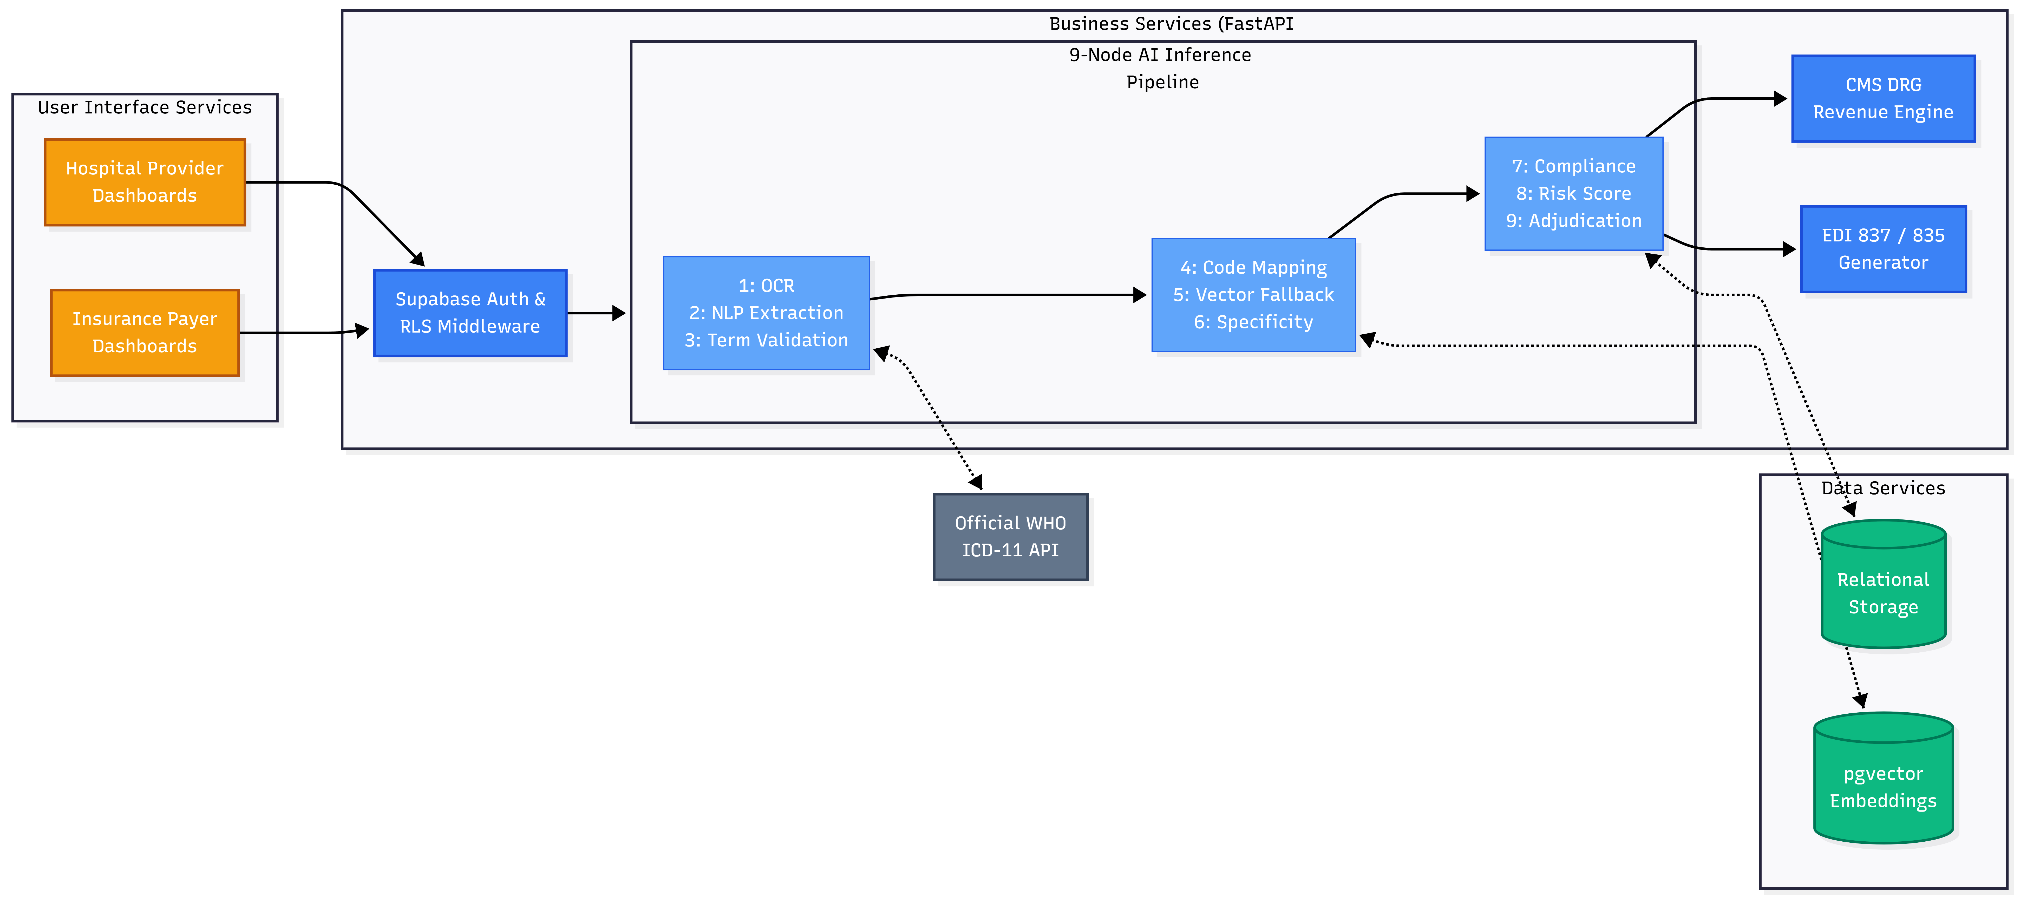
Figure 1. High-Level Logical System Architecture This block diagram illustrates the end-to-end data flow between the independent tiers. The architecture guarantees that all Hospital and Payer web requests (Tier 1) are strictly authenticated via Middleware before triggering the asynchronous 9-Node AI Inference Pipeline (Tier 2). The pipeline autonomously queries the pgvector engine and external WHO APIs (Tier 3) to execute semantic validation and CMS DRG financial calculations prior to generating final EDI outputs

- Multi-Tenant Isolation (Top Layer): The overarching architecture enforces total segregation between Hospital Provider users and Insurance Payer users. While they access visually distinct Next.js dashboards, both groups are securely routed through the Supabase Authentication Middleware before striking any business logic, ensuring compliance with HIPAA data-masking regulations.
- The 9-Node Pipeline Core (Middle Layer): The heart of the platform's independent business logic is the chronological execution of our proprietary 9-node AI pipeline. The architecture guarantees that raw, unstructured clinician notes cascade systematically through OCR reading, NLP Extraction, Vector Semantic Fallbacks, and Compliance checks before outputting a finalized, mathematically scored risk assessment.
- Native Financial Logic (Right Branch): Following the successful output of Node 9, the Business Tier routes the finalized clinical metadata into modular sub-engines. CodePerfect autonomously predicts the hospital's payout by running the codes against the CMS DRG Revenue Engine, and instantly converts the internal JSON claim into raw ANSI X12 EDI 837 legacy streams for real-world insurance payer submission.

- Vector Database Fallback (Bottom Layer): The architecture utilizes bidirectional communication between Node 5 (Semantic Vector Fallback) and the Tier 3 pgvector similarity engine. This design allows the Python microservice to rapidly query the mathematical coordinates of over 71,000 embedded medical ontologies locally, while relying on the external WHO ICD-11 API solely for verifying real-time postcoordination clinical standards.

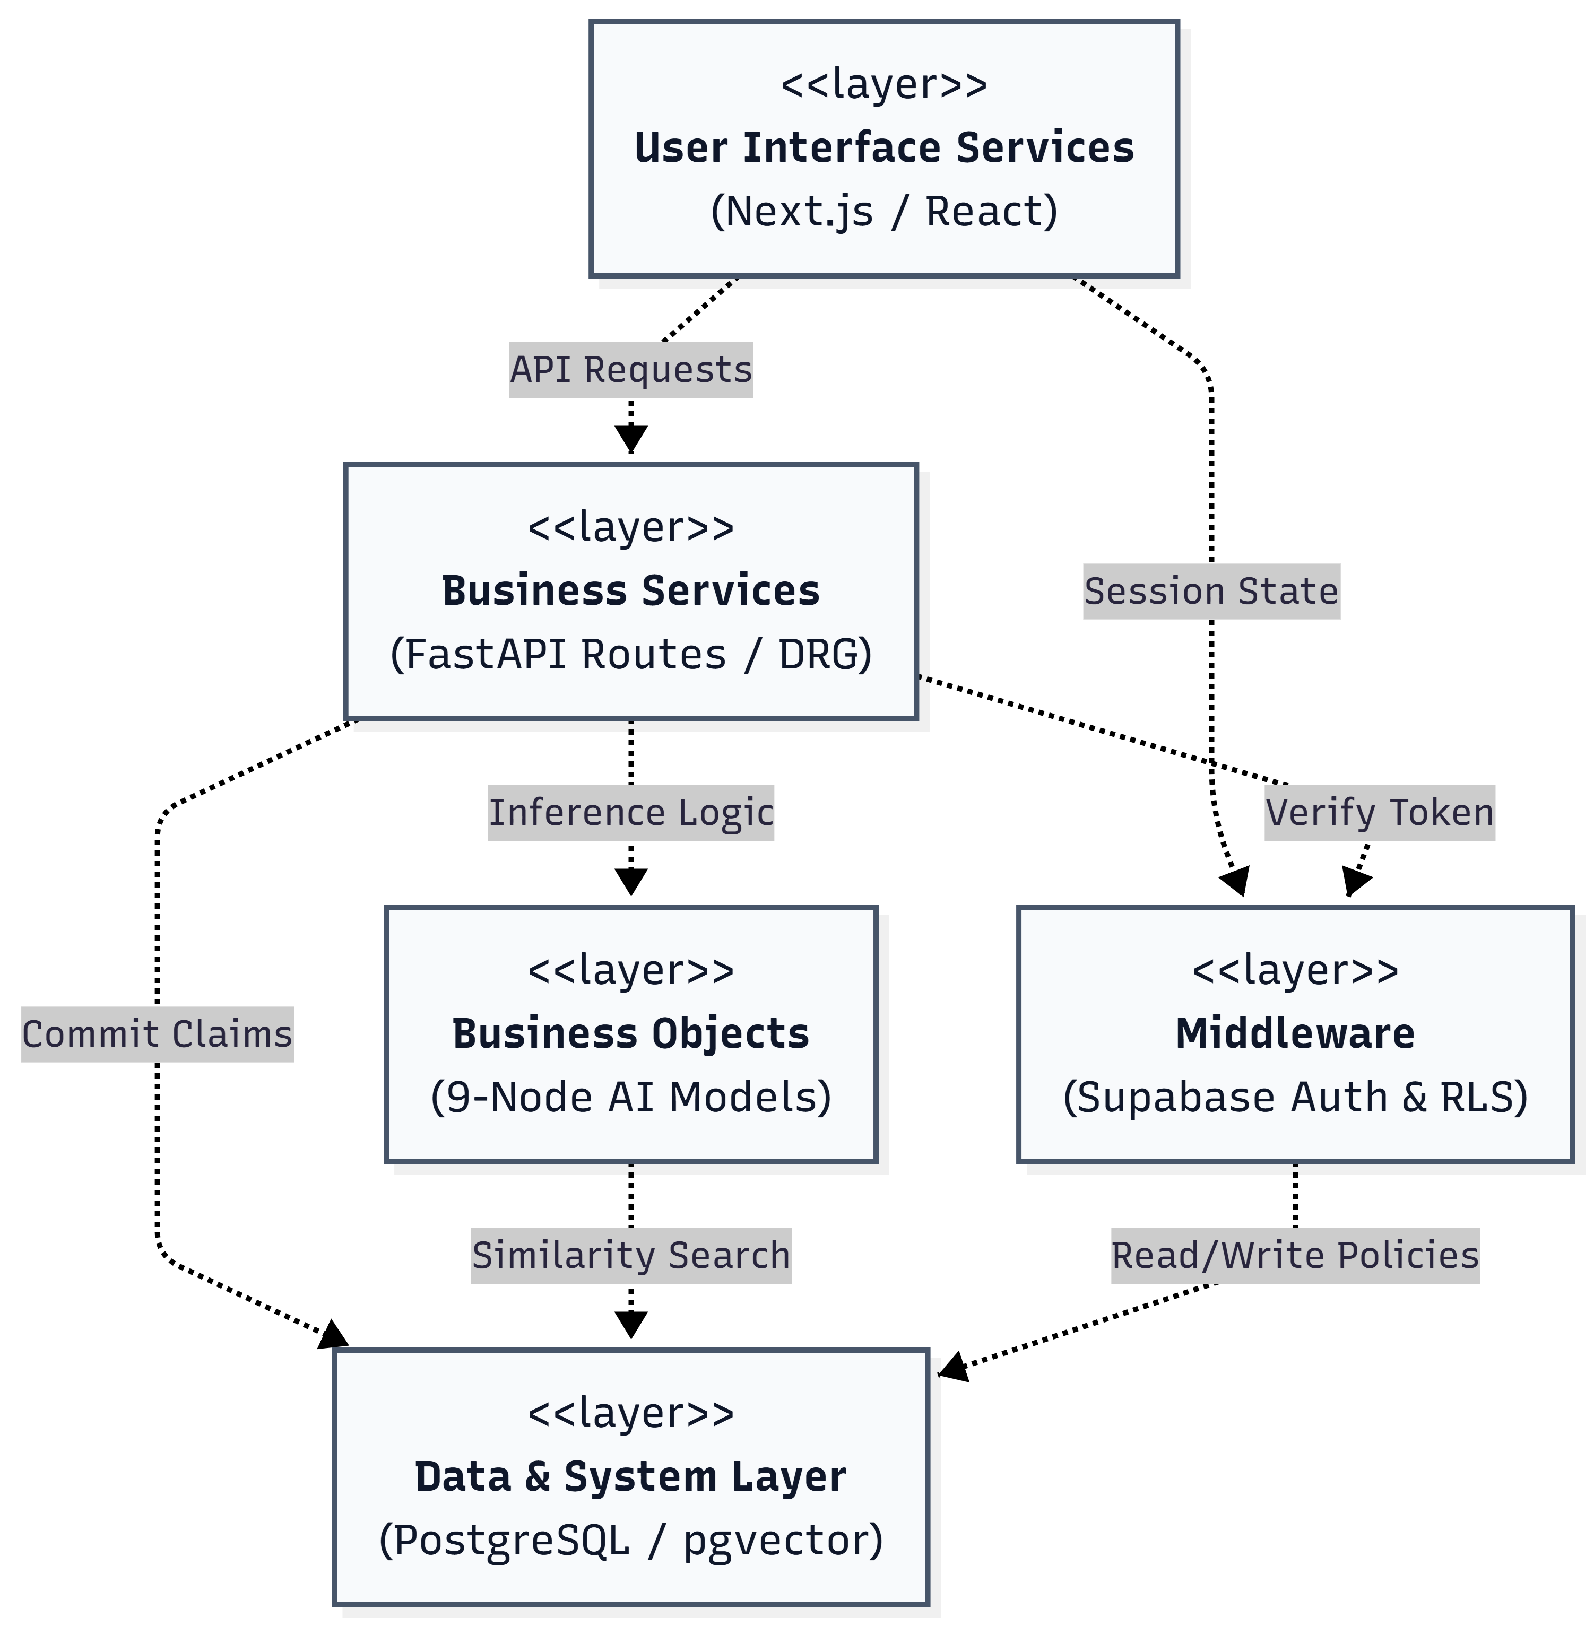

Figure 2. Package and Layering Diagram This topological view defines the strict dependencies between system layers. The Presentation layer (UI) is entirely decoupled from the System Layer (Database), forcing all interactions to safely route through the Business Services and Supabase Auth Middleware to guarantee HIPAA compliance

Use Case View
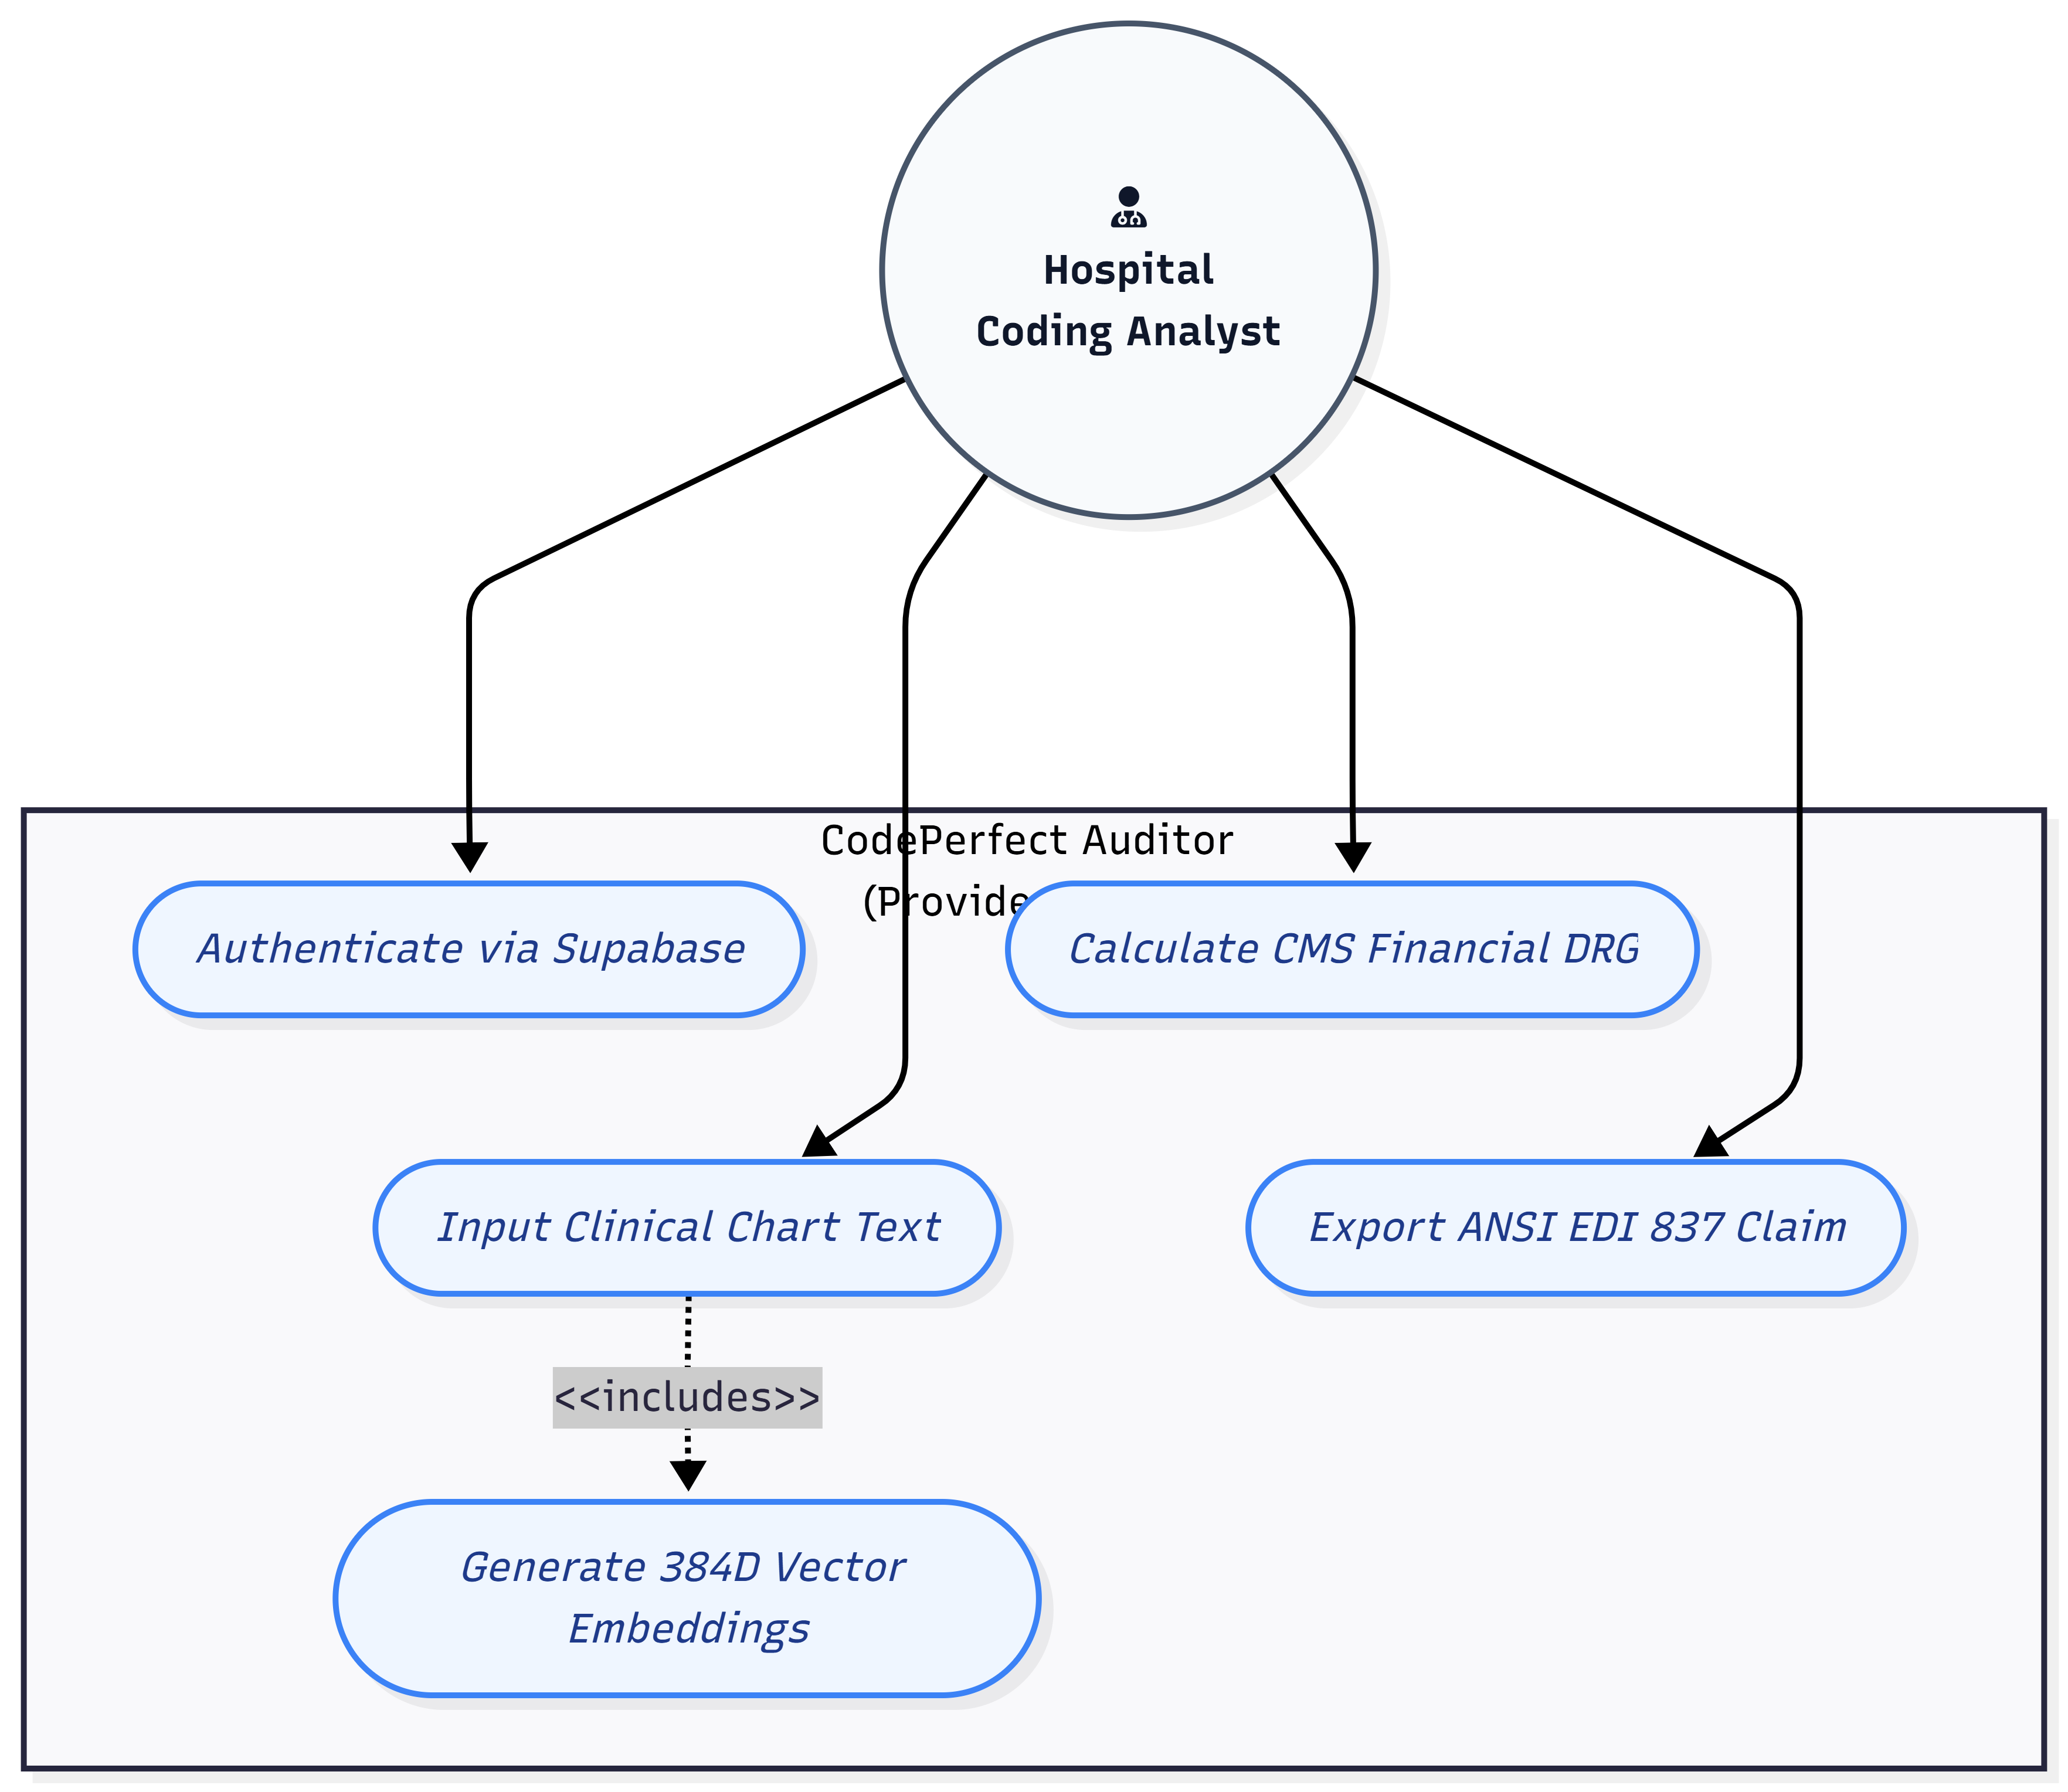
Figure 3. Hospital Provider Use Case Model This diagram illustrates the primary sequence of operations for clinical users. The Coding Analyst initiates the text ingestion process, which automatically <<includes>> the execution of the semantic AI vector engine and the dynamic calculation of the CMS DRG revenue. The user can optionally trigger the <<extends>> functionality to export the finalized data packet into a legacy EDI 837 format.

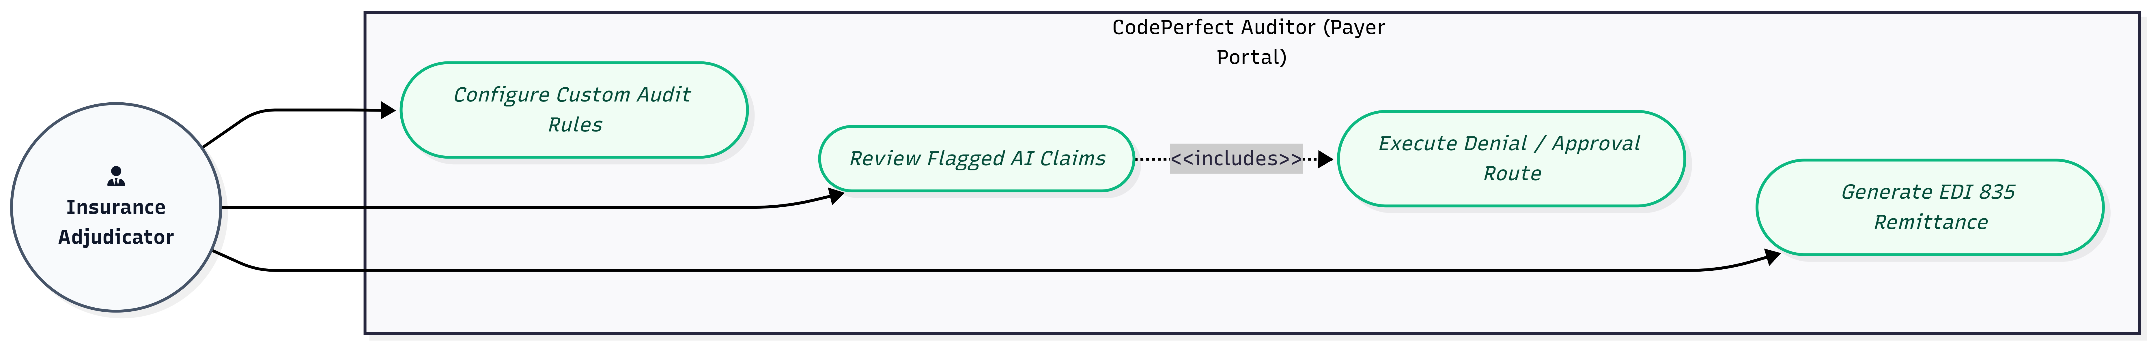
Figure 4. Insurance Payer Use Case Model This diagram highlights the administrative and auditing capabilities granted to the Payer tenant. The Insurance Adjudicator is responsible for configuring the algorithmic boundaries via custom rules. When reviewing inbound claims flagged by the 9-node AI engine, adjudicating the claim actively <<includes>> the backend generation of an EDI 835 remittance advice record to be returned to the Hospital workflow.

Implementation/System View

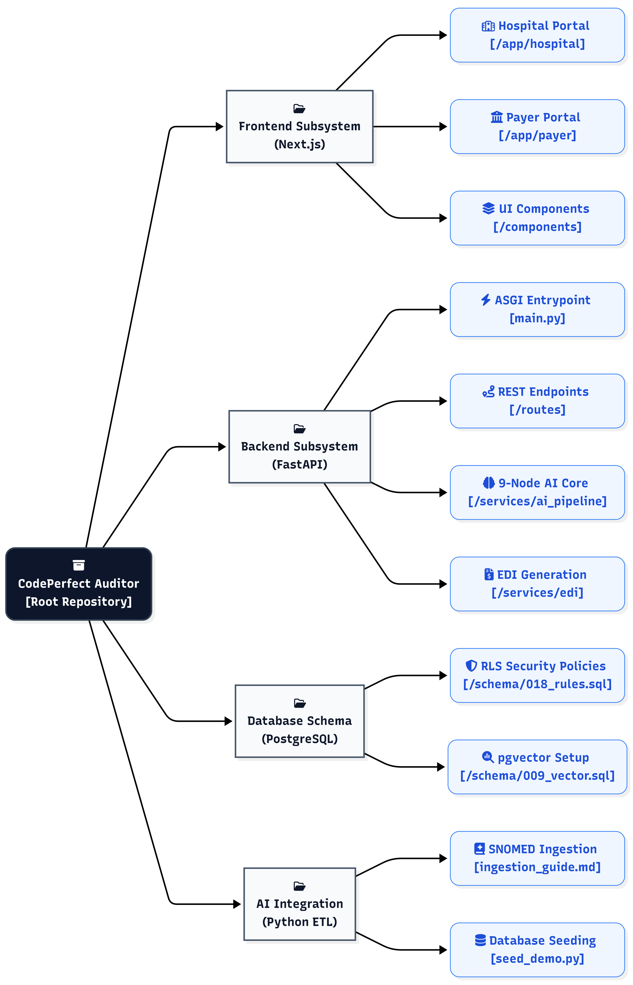
Figure 5. Implementation and Codebase Structure View This directory tree illustrates the physical partitioning of the CodePerfect Auditor repository. By structuring the architecture into four monolithic sub-systems (Frontend, Backend, Database Schema, and AI Internal Tools), the implementation guarantees strict separation of concerns. This allows isolated CI/CD deployment lifecycles for the Next.js presentation layer and the independent FastAPI Python inference engine without disrupting the core database schema or legacy EDI sub-components.

Process/Thread View

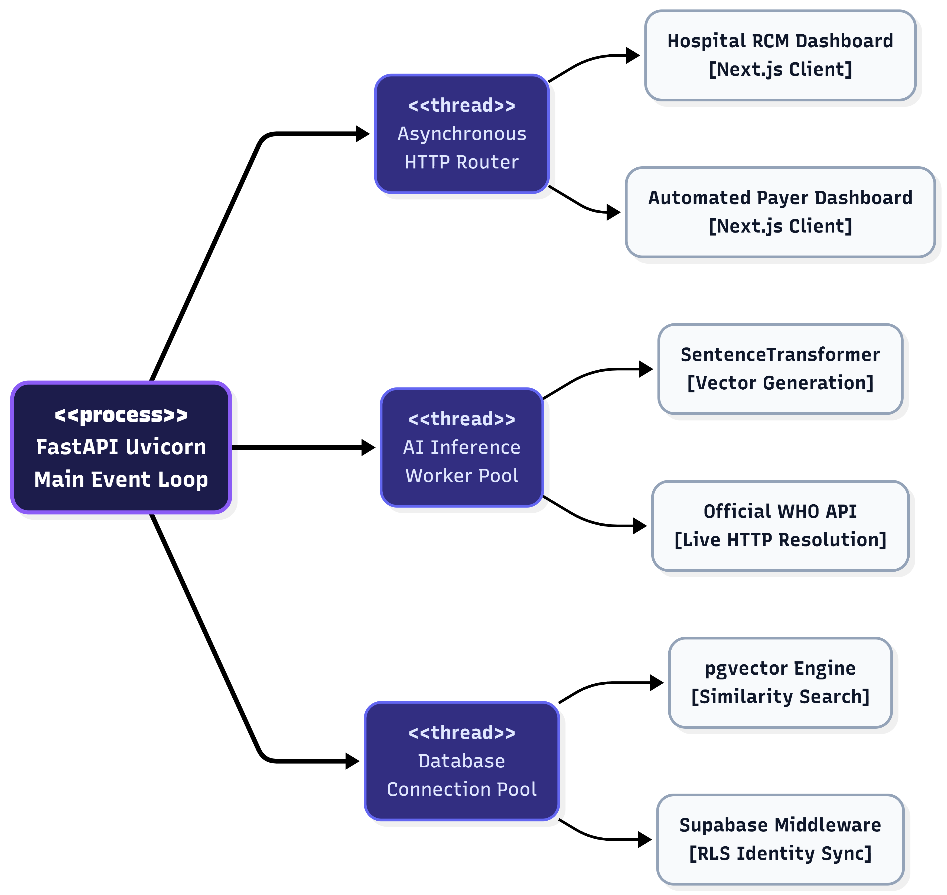
Figure 6. Concurrency and Thread Model Architecture This process diagram maps the asynchronous execution model of the backend server. The load-bearing <<process>> exclusively delegates computationally heavy AI inferences, third-party API lookups, and pgvector queries to isolated <<thread>> pools, ensuring that the primary HTTP router remains instantly responsive to the Hospital and Payer UI clients at all times.

Deployment View

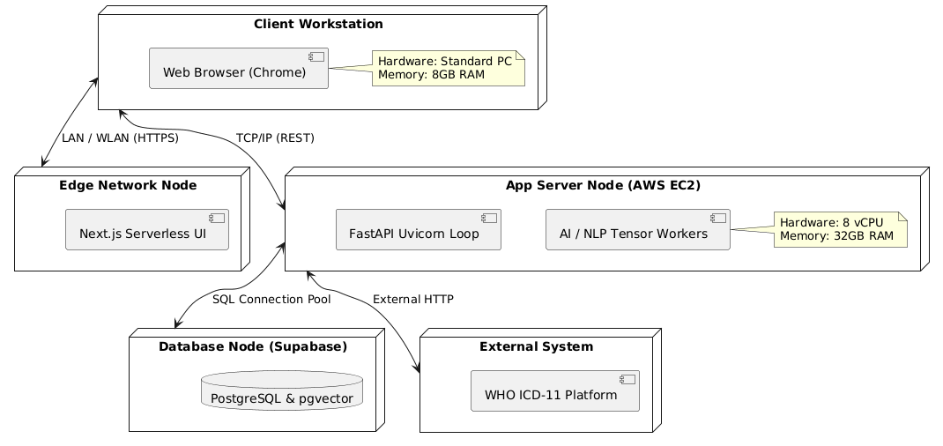

Figure 7. Hardware and Network Deployment Topology This 3D deployment model illustrates the physical network layout required to execute the CodePerfect infrastructure. The application leverages a distributed topology, isolating the compute-heavy FastAPI AI inference containers on dedicated high-memory AWS EC2 nodes, while rapidly serving the static front-end assets via a serverless Edge Delivery Network to the hospital's local workstations.

General Architecture for Core Technical Services

Persistence

Design Strategy: The persistence layer of CodePerfect Auditor mandates absolute ACID compliance for financial claims while simultaneously requiring high-speed semantic similarity searches for AI mapping. Alternatives Considered: We initially considered adopting a dual-database architecture: utilizing a NoSQL database (like MongoDB) for massive unstructured clinical documents alongside a dedicated third-party vector database (like Pinecone) exclusively for the AI embeddings. Trade-offs & Analysis: Maintaining separate systems for relational billing data and AI vector arrays introduces severe data-synchronization latency and unacceptable risks of orphaned data during failed network transactions. Build vs. Reuse: Rather than Buying an expensive external vector engine or Building custom synchronization scripts, we elected to Reuse the open-source PostgreSQL ecosystem. By implementing PostgreSQL via Supabase integrated with the pgvector extension, we successfully clustered massive 384-dimensional mathematical arrays into the exact same transactional rows as our relational hospital data. This consolidated persistence strategy guarantees absolute data integrity, drastically reduces DevOps overhead, and eliminates multi-database networking bottlenecks.

Inter-process Communication

Design Strategy: Communication between the Next.js presentation layer, the FastAPI business logic, and external payer endpoints relies on Asynchronous RESTful APIs (HTTPS/JSON) supplemented by WebSockets for long-polling tasks. Alternatives Considered: We evaluated utilizing gRPC (for high-speed binary serialization) and GraphQL (to allow the front-end to request highly specific data shapes). Trade-offs & Analysis: While gRPC is exceptionally fast for internal server-to-server communication, it adds massive configuration complexity when attempting to expose endpoints to standard web browsers. Similarly, GraphQL introduces significant vulnerabilities regarding complex nested queries, which poses security concerns for sensitive healthcare records. Build vs. Reuse: We chose to firmly Reuse standard HTTP/2 REST protocols driven by Python FastAPI. FastAPI natively supports highly concurrent asynchronous execution—which is strictly mandatory to prevent our heavy NLP tensor calculations from blocking standard UI traffic. For inference tasks taking longer than standard timeout windows, the IPC smoothly upgrades to a WebSocket connection, pushing real-time completion signals back to the client without maintaining computationally expensive long-polling HTTP requests.

Authentication and Authorization

Design Strategy: The platform enforces strict Role-Based Access Control (RBAC) and Multi-Tenant organizational isolation utilizing JSON Web Tokens (JWTs) securely verified at both the API middleware layer and the physical database kernel.
Alternatives Considered: We heavily weighed the options of Building a custom JWT authentication microservice from scratch versus Buying a premium enterprise identity provider like Auth0 or Okta.
Trade-offs & Analysis: Building a bespoke authentication system in a HIPAA-regulated environment introduces cataclysmic security and liability risks regarding password hashing and token rotation. Conversely, adopting an enterprise Auth0 tier introduces prohibitive licensing costs that cripple scaling economics for a multi-tenant healthcare product.
Build vs. Reuse: We strategically chose to Reuse the Supabase Auth platform. This provided us with battle-tested authentication at zero upfront cost, but crucially, it unlocked Row Level Security (RLS). With RLS, authorization is handled at the database kernel. Even if a catastrophic bug occurs in the FastAPI IPC layer, the PostgreSQL database mathematically refuses to return data if the user's JWT organization_id does not match the specific row they are attempting to read, guaranteeing impenetrable isolation between adversarial hospitals and insurance payers.

Error Handling

Design Strategy: The error handling framework enforces a philosophy of graceful degradation and strict API boundary sanitization. All backend exceptions are intercepted globally before leaving the FastAPI framework, ensuring clients receive highly predictable, standardized JSON error objects mapped to accurate HTTP status codes (e.g., 422 Unprocessable Entity for malformed clinical text, 503 Service Unavailable for WHO API timeouts). Alternatives Considered: We investigated allowing native exception stack traces to return to the Next.js client for easier debugging, or alternatively, utilizing a "catch-all" approach that blindly returns generic 500 Server Error statuses. Trade-offs & Analysis: Leaking raw Python stack traces—especially regarding the internal mechanisms of the 9-Node NLP Pipeline—introduces catastrophic security vulnerabilities, potentially exposing the server's internal file structure to malicious actors. However, utilizing generic 500 errors entirely blinds the frontend, ruining the user experience when a hospital analyst uploads an unreadable document. Build vs. Reuse: We chose to firmly Reuse FastAPI’s native HTTPException class and Next.js’s React error.tsx boundaries rather than Building a bespoke global error formatting payload. By relying heavily on these native frameworks, we cleanly sanitize the outputs of crashed AI tensor models into human-readable warnings (like "OCR failed to read page 3") without exposing underlying vulnerability mechanics.

Logging

Design Strategy: Our logging architecture operates exclusively on structured, asynchronous JSON formatting. The system mandates absolute redaction of any Protected Health Information (PHI) before logs are streamed to the output buffer, utilizing standard severity levels (INFO, WARN, ERROR, FATAL) to categorize system health.
Alternatives Considered: We evaluated Building custom file-system append scripts to write .log text files locally, versus Buying an enterprise Application Performance Monitoring (APM) suite such as Datadog or Splunk.
Trade-offs & Analysis: Writing flat text files to a local server is an archaic approach that easily leads to corrupted formatting in highly concurrent Docker environments, and flat text is essentially unsearchable at scale. Conversely, integrating a premium APM like Splunk requires substantial licensing budgets and complex HIPAA Business Associate Agreements (BAAs), as external logging servers introduce a massive risk of accidental data leaks.
Build vs. Reuse: We opted to Reuse open-source Python logging utilities paired with the python-json-logger library. By forcing the ASGI server to write pure JSON to stdout, we can pipe the logs seamlessly into default cloud host log aggregators (like AWS CloudWatch or Vercel Logs). This grants us highly searchable queries without the exorbitant costs or compliance risks of third-party monitoring giants.

Transaction Management

Design Strategy: Handling complex financial healthcare claims requires zero tolerance for partial execution. The system strictly utilizes native database-level atomic transactions to guarantee full ACID (Atomicity, Consistency, Isolation, Durability) compliance across all multi-table mutations.
Alternatives Considered: When designing the pipeline, we weighed relying on Application-Level Compensation Logic (the Saga Pattern), against delegating transaction management entirely to the Database Kernel.
Trade-offs & Analysis: Utilizing the Saga Pattern—where the Python backend manually issues a "delete" command if a subsequent step fails—is useful in massively distributed independent microservices. However, it introduces horrific vulnerabilities. If the server crashes mid-execution, compensation logic fails to fire, leaving a permanently fragmented or "orphaned" healthcare claim floating in the database.

Build vs. Reuse: To eliminate the risk of orphaned data, we chose to completely Reuse PostgreSQL’s inherent atomic blocks (BEGIN, COMMIT, ROLLBACK). If the 9-Node Pipeline successfully generates vectors in Node 5, but the generation of the EDI payload fails at Node 9, the Python SQLAlchemy session simply aborts. The PostgreSQL engine natively rolls back the entire session automatically, guaranteeing that a claim either fully exists in a 100% complete state, or never existed at all.

Other Applicable Technical Services

Caching Design (Failure Prevention & Latency Reduction)
- Design Strategy: The 9-Node AI Pipeline heavily relies on real-time semantic validation against the official WHO ICD-11 API. To prevent rate-limiting and catastrophic latency, the system implements an aggressive Time-To-Live (TTL) Least-Recently-Used (LRU) caching strategy.
- Alternatives Considered: We investigated attempting to download and locally host a complete static replica of the WHO database, versus maintaining zero caching and simply querying the official API for every single medical term.
- Trade-offs & Analysis: Maintaining a local replica of the WHO database is logistically impossible, as we do not have direct access to their proprietary update streams, leading to inevitable compliance drift. Conversely, executing a raw HTTP request per word would stall the pipeline for minutes per document.
- Build vs. Reuse: We strategically chose to Reuse lightweight, in-memory LRU caching functions native to Python, rather than Buying/Building a massive external Redis cluster. Since caching needs are highly localized to the duration of a specific charting session, in-memory TTL perfectly balances speed with architectural simplicity.
Data Validation Framework (Fault Tolerance)
- Design Strategy: Healthcare applications require perfect precision; a single misplaced decimal can trigger massive federal compliance audits. Therefore, CodePerfect Auditor implements draconian, compile-time strict typing across both the Frontend and Backend network boundaries.
- Alternatives Considered: Relying on manual dictionary parsing and extensive if/else boundary checks within the Python logic to ensure data integrity.

- Trade-offs & Analysis: Manually validating every nested JSON field within an ANSI 837 claim is extraordinarily prone to human error. A single uncaught missing dictionary key would trigger fatal KeyError crashes deep within the AI pipeline, requiring a full system reboot.
- Build vs. Reuse: Rather than Building custom sanitization scripts, we aggressively Reuse industry-standard validation schemas: Pydantic for the Python backend and Zod coupled with strict TypeScript for the Next.js frontend. By establishing these rigid models, Pydantic automatically intercepts, coerces, and validates the highly unpredictable outputs of the Large Language Models into perfectly structured Data Classes long before that data is ever permitted to strike the PostgreSQL database.

Risks/Limitation
While the CodePerfect Auditor architecture is highly optimized for executing dense medical natural language processing, two major systemic limitations exist within the deployment topology. The following outlines these architectural vulnerabilities alongside our active mitigation strategies to ensure zero-downtime scalability:

1. Hard Dependency on External Microservices (WHO ICD-11 API)
- The Risk: Node 3 of the 9-Node AI Pipeline acts as the structural foundation of the platform, relying directly on the official World Health Organization (WHO) ICD-11 API to execute structural validation and code-mapping.

- The Limitation: Because this is an external HTTP dependency, the pipeline's execution speed is strictly beholden to the WHO server's network latency and arbitrary rate limits. If the WHO server crashes, CodePerfect risks a catastrophic execution halt.

- Mitigation Strategy: To overcome this external dependency, the architecture employs a robust "Vector Fallback" fail-safe mechanism (Node 5). If the WHO API triggers an HTTP 500 error or exceeds a 2-second timeout threshold, the Python backend automatically aborts the network request. It instantly defaults to executing an isolated Approximate Nearest Neighbor (ANN) search on the local pgvector cluster—comparing the extracted entities against over 71,000 locally cached medical vector coordinates to ensure clinical workflow continues entirely uninterrupted.

2. Computational Overhead for Large Language Models Constraint

- The Risk: Generating 384-dimensional mathematical vectors rapidly for massive, unstructured multi-page clinical documents requires intense algorithmic processing. The local SentenceTransformer models responsible for mapping these concepts inherently consume massive amounts of CPU cycles and server memory.

- The Limitation: Running heavy tensor math on traditional compute servers places a severe limit on concurrency. Attempting to process 10,000 simultaneous hospital claims on a standard 8-core machine will bottleneck the API threads, resulting in unacceptably slow financial calculations and degraded UI responsiveness.
- Mitigation Strategy: CodePerfect Auditor strictly enforces an asynchronous microservice architecture to isolate processing debt. The Next.js frontend handles interface rendering entirely serverless on Edge infrastructure. To overcome the backend CPU bottleneck at an enterprise scale, the AI NLP logic is cleanly decoupled into Docker container images. This allows the heavy Python workers to be seamlessly migrated off cheap CPU-droplets and dynamically orchestrated into auto-scaling NVIDIA GPU clusters (e.g., AWS EC2 Inferentia via Kubernetes), protecting the main HTTP routing server from computational starvation.

Alternative Solutions Considered

During the initial design phase of CodePerfect Auditor, several competing architectural paradigms and third-party solutions were aggressively evaluated. The following outlines the major alternatives considered and the technical rationale behind rejecting them in favor of the current architecture.
Alternative 1: Large Language Model (LLM) APIs (e.g., OpenAI GPT-4)
- The Alternative: Utilizing a powerful, commercial third-party LLM (like OpenAI's GPT-4 or Anthropic's Claude) to extract medical entities and map clinical codes, rather than building an internal 9-Node NLP pipeline.
- Rationale for Rejection: While commercial LLMs offer unparalleled ease of use, sending raw, unredacted clinician notes to a third-party, closed-source API introduces catastrophic HIPAA Compliance and Data Privacy violations. We cannot guarantee that an external consumer API will not utilize embedded Protected Health Information (PHI) to train future public models.
- Selected Solution: We deliberately architected our own AI pipeline utilizing local, open-source SentenceTransformer models. By hosting the inference engine locally within our own Python FastAPI microservices, we guarantee that zero volatile patient data ever leaves our heavily secured Virtual Private Cloud (VPC), satisfying stringent federal compliance laws.
Alternative 2: Dedicated Vector Databases (e.g., Pinecone or Milvus)
- The Alternative: Adopting a specialized, SaaS-hosted vector database to store and calculate the 384-dimensional mathematical arrays required for semantic similarity searches.
- Rationale for Rejection: Purpose-built vector databases are incredibly fast, but introducing a secondary database silo into a financial healthcare platform is incredibly dangerous. Maintaining a relational database for hospital claims alongside a NoSQL vector database for the AI embeddings requires complex background synchronization. If a network packet drops during sync, the platform is left with "orphaned" vector data that doesn't match the financial claims, ripping apart data integrity.
- Selected Solution: We rejected external SaaS vector databases completely and selected the pgvector extension operating natively inside Supabase (PostgreSQL). This allows CodePerfect Auditor to store standard relational billing metadata and massive AI vector arrays within the exact same database row, guaranteeing impenetrable ACID-compliant transactions across the entire application ecosystem.

Alternative 3: Monolithic Application Architecture (e.g., Django or Ruby on Rails)
- The Alternative: Building the entire platform as a single "Monolith," where the backend API, the database ORM, and the HTML frontend templating are all handled by a single Python (Django) or Ruby web server.
- Rationale for Rejection: A monolithic architecture drastically speeds up initial MVP prototyping. However, calculating AI embeddings recursively for massive clinical charts is an intensely CPU-bound process. If a monolithic server is forced to handle a massive OCR calculation, the central event loop will lock up. This means other users (like Payer Adjudicators attempting to log in or click a button) would experience a frozen web browser until the AI task finished.
- Selected Solution: We deployed a strictly decoupled Microservices Architecture. The Next.js frontend is deployed to an independent Vercel Edge network to guarantee instantaneous UI rendering. It communicates asynchronously via REST with the isolated Python FastAPI backend. This ensures the computationally-heavy AI operations only consume the backend worker threads, never starving the frontend interface of bandwidth.

Appendix

Expected Software Response
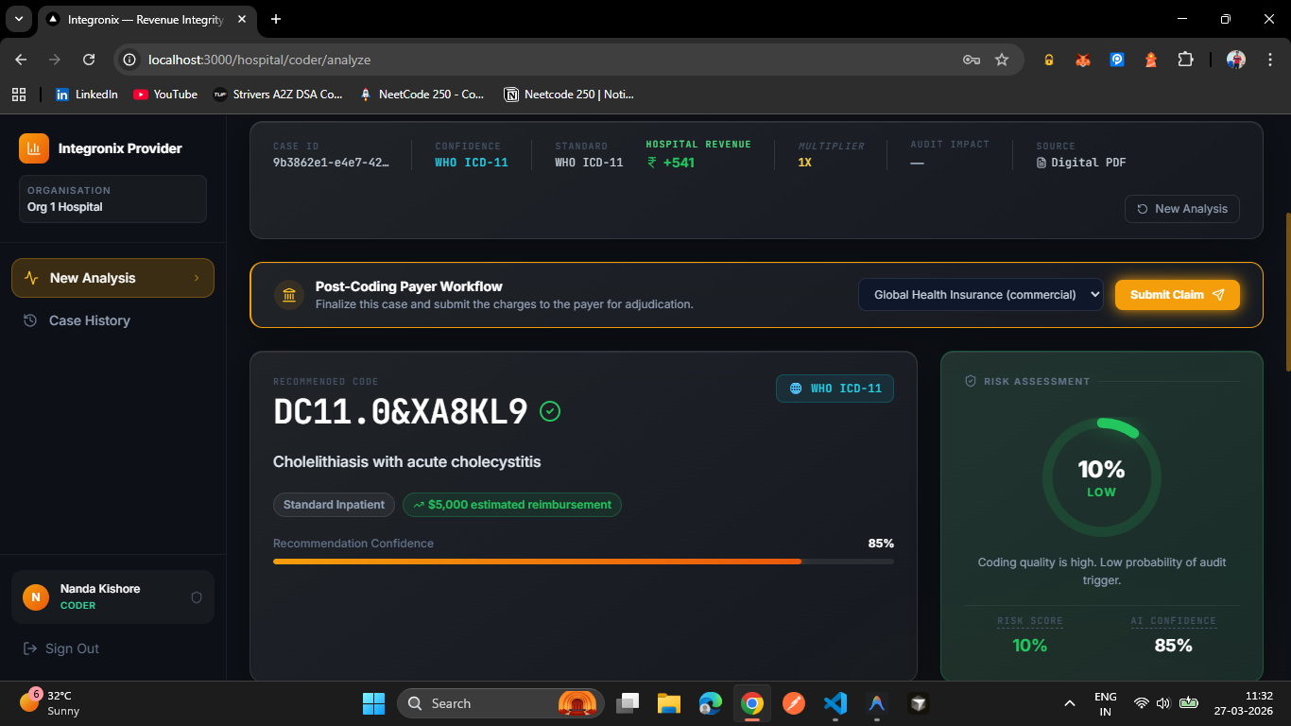

Based on successful execution of the architectural Proof of Concept (POC), the system is expected to return highly structured, deterministic responses upon the ingestion of unstructured clinical charts. The Next.js frontend is expected to render:
  - Algorithmic Code Recommendations: The system must actively output hierarchical predictions, separating Primary Diagnosis codes (e.g., ICD-11 DC11.0&XA8KL9), Secondary Comorbidities, and Additional Specificity codes. Each recommendation must be paired with an AI Confidence Score (e.g., 85%).
  - Predictive Financial Mapping: The business logic must successfully cross-walk the projected codes against CMS DRG weightings to project an Estimated Net Reimbursement (e.g., $5,000 – sample amount) cleanly on the dashboard.
  - Compliance Risk Assessment: The system must generate a probabilistic Audit Risk Score (e.g., 10% Low Risk), assuring the Coding Analyst that the recommended billing packet has a low probability of triggering a payer denial before advancing to the "Post-Coding Payer Workflow."

Performance Bounds

To guarantee seamless utility in a fast-paced hospital environment, the architecture must adhere to the following strict computational bounds:
- Inference Latency: The localized 9-Node AI Pipeline (executing OCR, NLP abstraction, and math embeddings) must process standard 1-to-3 page clinical documents in under 3.0 seconds.
- Vector Search Speed: pgvector Nearest-Neighbor calculations executing against the 71,000+ cached medical embeddings must consistently return results in under 200 milliseconds per query to prevent database throttling.
- API Concurrency: The FastAPI Uvicorn ASGI server must safely queue and resolve a minimum of 50 concurrent document uploads without starving the background Python worker threads of CPU allocation.

Identification of Critical Components

During staging and User Acceptance Testing (UAT), the following architectural elements demand intense scrutiny and rigorous unit testing:
- The Vector Mapping Nodes (Nodes 4 & 5): The mathematical core of the tool. If the SentenceTransformers model drifts or miscalculates cosine similarities, the resulting DRG financial mapping will be inherently flawed, causing massive hospital revenue leaks.
- Supabase RLS Middleware: The absolute security boundary. Any failure or misconfiguration in extracting the JWT organizational claims could theoretically expose one hospital's confidential Patient Health Information (PHI) to a competitor or unauthorized insurance payer, triggering instantaneous HIPAA violations.
- The EDI 837 Generator: Formatting legacy healthcare claims requires absolute precision. A single missing delimiter or illegal character within the generated ANSI X12 payload will cause immediate automated rejection at Payer clearinghouses.

Review Comments on Architectural POC
Following the deployment and evaluation of the initial architectural Proof of Concept (POC), major stakeholders provided the following critical feedback which actively shaped the final design:
- Financial Partition User Interface: While the POC dynamically calculated Net Hospital Revenue correctly, reviewers requested that the UI be enhanced to visually partition the percentage of the bill. The architecture was updated to calculate and explicitly display the split between the Patient's personal responsibility percentage versus the bulk Payer coverage percentage.
- Document Processing Speed Enhancements: Early load-testing of the POC indicated that processing dense PDFs synchronously was causing the client's web browser to idle heavily. Based on this review, the architecture was drastically refactored. The intensive NLP document processing was strictly decoupled and pushed into asynchronous Python worker threads, resolving the bottleneck and vastly improving ingestion speeds.

